Boosting
- Ensemble technique
- Combines multiple weak learners to form a strong learner
- 1997
- Classification, regression, ranking problems too

Boosting works by training model sequentially
Each new model focus on the errors made by previous one
The final prediction is weighted sum of all models

AdaBoost – adaptive boosting
It assigns weights to training instances – misclassified points get higher weights

Final prediction formula

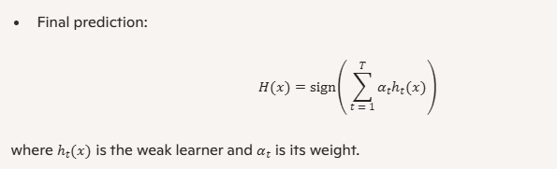

sign function is a mathematical operator that determines final class label based on weighted sum of predictions from all weak learners
- It returns
  - +1 if the sum is positive
  - -1 if the sum is negative
- Class labels are encoded as +1 and -1

Pros
Simple and effective
Work well with clean data
Cons
Sensitive to noisy data and outliers

Gradient boosting
- More flexible and powerful boosting method
- It builds models sequentially, each one try to minimize the residuals of the previous model
- It uses gradient descent for optimization a loss function
It works like
- Start with a base prediction (ex: mean)
- Train a model to predict the residuals
- Add the residual predictions to the base
- Repeat
Ex
Predicting house prices – each model corrects the errors of previous one, refining the prediction step by step

Pros
- Handles both classification and regression

Cons
Slower to train
Chance of overfitting

XGBoost – extreme gradient boosting
- XGBoost is an optimized implementation of gradient boosting
- It’s designed for speed and performance
- Includes regularization, parallel processing

Key features
- Regularization, robust to overfitting
- Handling missing values
- Built in cross – validation
- Early stopping

Overall
AdaBoost focus on misclassified points. Use case: clean data
Gradient boosting focus on residual errors: use case: regression, classification
XGBoost focus on speed + regularization use case: large scale problems

Ensemble models
- Diversity
- Capture important patterns in the data
- Avoid over fitting
a model might be too simple – high bias or too complex – high variance
- Ensemble helps to right balance by aggregating diverse perspectives

Bias vs variance trade-off
- High bias – model is too simple, misses patterns
- High variance – model is too complex, memorizes noise
Ensemble reduce
- Bias by combining diverse models (eg: boosting)
- Variance by averaging predictions (eg: bagging)

Bagging – bootstrap aggregating
- Creating multiple training subsets from original data using sampling with replacemen
- Training the same algorithm on each subset
- Aggregating predictions
  - Average for regression
  - Majority vote for classification

Ex
Predicting house prices: each model sees a slightly different version of the data and makes its own predictions. The final price is the average of all predictions

Pros
- Reduces variance
- Improves stabililty
- Handles noisy data
Cons
- Requires more computation

Random forest – bagging with trees
- Train hundreds of trees on bootstrapped data
- Each tree votes on final prediction
- The forest output is the majority vote(classification) or mean(regression)
Ex
Classifying loan default risk one tree might focus on income, another on credit history. The forest blends their insights

Pros
- High accuracy
- Robust to overfitting
- Handles large data sets and feature spaces

When to use bagging vs boosting ?
Feature | Bagging | Boosting
Model type | Parallel | Sequential
Focus | Variance reduction | Bias reduction
Best with | High variance models | Weak leaners
Ex algorithm | Random forest | AdaBoost, Gradient Boosting
Training speed | Faster | Slower
Robust to noise | Yes | No

Weak learners
- It’s model whose error is less than 0.5 on a binary classification task
Ex
A decision stump is a decision tree with depth=1
It makes a single split based on one feature
Predicting loan default
- Stump1: Is income < Rs.30000?
- Stump2: Is age > 45?
- Stump3: Has credit card debt?
Boosting with weak learners
- Boosting connects weak learners sequentially
- Each model
  - Learns from the errors of previous model
  - Focus on hard to predict instances
- Final model is a weighted combination of all weak learners
Pros
- Reduce variance more generalization
- Faster training simpler models
- Improves accuracy through error correction

Weak learners are the building blocks of boosting

Adaboost – adaptive boosting
AdaBoost adapts in two ways
- It adjusts the weights of training samples – giving more importance to misclassified points
- It adjusts the weight of each weak learners –giving more influence to accurate models and less to poor/high error ones

Steps / algorithm
- Initialize weights: all training samples start with equal weight
- Train weak learner: use a simple model (ex decision stump) to make predictions
- Evaluate error: identify misclassified points and evaluate error
- Update weights
  - Increase weights for misclassified samples
  - Decrease weights for correctly classified ones
- Normalize
- Assign learner weight
  - Learners with lower error get higher influence
- Resample data: based on updated weights, train the next learner
- Repeat: continue for a fixed number of iterations
- Final prediction : combine all learners using a weighted sum

Compute leaner weight
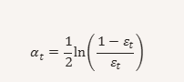

Exercise
Points | x | y
A | 1 | -1
B | 2 | -1
C | 3 | +1
D | 4 | +1
E | 5 | -1
F | 6 | +1

Step-1
Points | x | y | weight
A | 1 | -1 | 1/6
B | 2 | -1 | 1/6
C | 3 | +1 | 1/6
D | 4 | +1 | 1/6
E | 5 | -1 | 1/6
F | 6 | +1 | 1/6

Iteration-1
Threshold=3.5
If x>=3.5
h1(x)=+1
else
h1(x)=-1

predictions h1:

A -1
B -1
C -1
D +1
E +1
F +1

C(x=3) predicted -1 but true +1 misclassified
E(x=5) predicted +1 but true -1 misclassified
Error
- error1 = Wc+We = 1/6 + 1/6 = 2/6=1/3 = 0.3333

= 1/2ln(1-0.333/0.3333) = 1/2ln(2) = 0.3465

Update raw weights

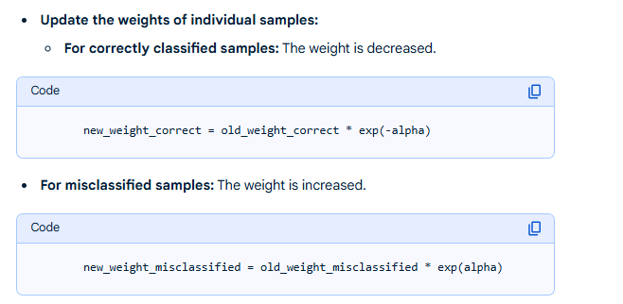

For correctly classified sample –
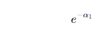
For misclassified samples
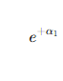
= e ^ - 0.3465 = 0.707
= e ^ +0.3465 = 1.414

New weight correct for classified samples(A,B,D,F) Wcs(1)= 1/6 * 0.707 = 0.117
New weight missclassifed (C,E) Wmc(1)= 1/6 * 1.414 = 0.235

Sum Z1 (normalizer) = 4 * 0.117 + 2 * 0.235 = 0.9428
Normalized weights w(1) =
 | w(1)
A | =0.117 / 0.9428 = 0.125
B | 0.125
C | =0.235/0.9428 = 0.25
D | 0.125
E | 0.25
F | 0.125

Iteration-2
Threshold = 2.5

If x>=2.5
h2(x)=+1
else
h2(x)=-1

predictions of h2 for above points
..

Error=

Compute alpha2 =

Calculate exponentials –

Update raw weights –

Sum Z2

Normalize

Now you have the new weights from iteration-2

Iteriation-3
Threshold = 4.5

