PYTHON

Creator – Guido van Rossum, 1989 >1990
Simple, readable and powerful
Productivity
Java – 1 hour , 1000 lines
Python – 5 mins, 10 lines

Key Milestones
1991 Basic
2000 2.x , data structures
2008 3.x, improvised syntax, consistency, mathematical concepts
>2005 + AI/ML
>2020 Gen AI, APIs, Open AI , LLM -

JAVA and Python

Criteria | Python | Java
Syntax | Human readable | Structured
Speed | Interpreted - slower | Byte code-faster
Use cases | ML, AI, DS, WEB, | Enterprise app,
AI , ML | Numpy, Pandas, Scikit-Learn, TensorFlow, OpenAI API | Limited support for AI

Real – Time / AI ML

Industry | Example use case
IT | Microsoft APPs , git hub copilot
eCommerce / Retail | Demand forecasting
Finance | Fraud detection
Cyber security | Finding vulnerabilities in apps
Automobiles | Tesla / autonomous vehicle
Healthcare | Disease prediction, medical imaging

Jyupiter notebook key board short cuts

Help - screen shot for reference

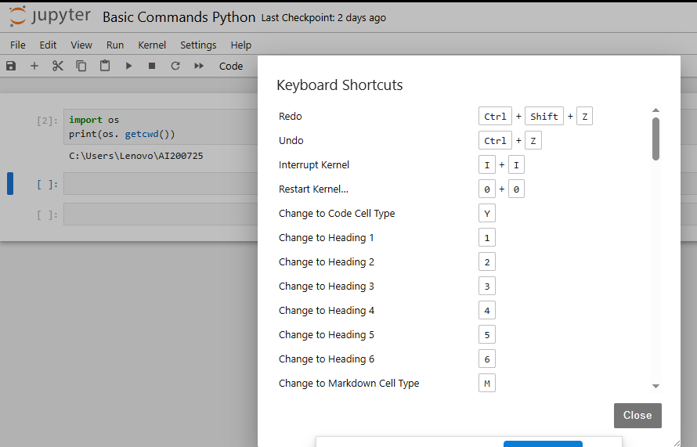

Latex equations

https://en.wikibooks.org/wiki/LaTeX/Mathematics

Lists, Tuples, Sets and Dictionaries

Lists

Ordered, Mutable (you can change the elements), Allows duplicates, can store mixed data types
Syntax
models = [‘Linear Regression’, ‘Decision Tree’, ‘Random Forest’]
Print ( models[0] )
Linear Regression

ML examples
ML pipeline
Evaluation metrics [‘Accuracy’, ‘Precision’, ‘Recall’]
Batch of input data rows for iterative processing

Tuples

Ordered, Immutable (cannot change elements), allows duplicates, used when data is fixed and group together logically
Coordinates = (10.5, 20.3)
Print (Coordinates[0]) 10.5

ML examples
(latitude, longitude) pairs for location-based models
Model parameters that should not change during iteration
- Params = (‘learning rate’, 0.01)
Immutable – (feature name, feature type) tuples

Sets

UnOrdered, mutable (change elements), No duplicates, testing – set logic (union, intersection,…)
Syntax
features = { ‘age’, ‘salary’, ‘age’}
print(features) = age, salary

ML examples
Unique categories in feature column for categorical encoding
Removing duplicate labels or classes
Check intersection of features across data sets
Dataset1_features = {‘age’, ‘gender’, ‘income’}
Dataset2_features = {‘income’, ‘education’, ‘gender’}
Common income, gender

Dictionaries

Key-value pairs, unordered, keys must be unique, very fast for lookups and mapping

Model_scores = { ‘ Linear Regression ‘: 0.85, ‘Decision Tree’: 0.80}
Print(Model_scores[‘Linear Regression’]) 0.85

ML examples
- Mapping model names to accuracy scores
- Mapping features to important values
  - Feature_importance = {‘age’:0.2, ‘salary’:0.3, ‘education’: 0.5}
- Storing configurations or hyperparameters
  - Config = {‘learning rate’:0.01, ‘batch_size’: 32}

Summary of Learning

Data Structure | Ordered | Mutable | Duplicates | Common Usage
List | Yes | Yes | Yes | Sequences, Collections
Tuple | Yes | No | Yes | Fixed groups of items
Set | No | Yes | No | Unique items, fast operations
Dictionary | No | Yes | Keys (No) Values (Yes) | Mappings, fast lookups

Lists as your notebook of things to process in order
Tuples like coordinates on a map – once defined, can’t change
Sets like group where everyone is unique – no duplicates allowed
Dictionaries like a- Phone book – lookup is fast because you know the key

R | Python | SAS | Scala | 42
0 | 1 | 2 | 3 | 4
-5 | -4 | -3 | -2 | -1

List

Common methods
append(x) add an item to the end of the list
extend(iterable) add elements from another iterable
insert (i, x) insert the item at a given position
remove(x) remove first occurrence of the value
pop([i]) remove and return item at the index (default last)
clear() remove all items
index(x) return index
count(x) return no.of occurrences
sort() sorting
reverse() reverse order
copy() return a copy

common operations
len (list) | Length
list[i] | Indexing
List[i:j] | Slicing
List1 + list2 | Concatenation

Set

Common methods
add(x) | Add an element
update | Adding multiple elements
remove(x) | Remove an element
discard(x) | Remove
Pop()
Clear() | Remove all elements
Copy()

common operations
union | Elements in either
intersection | Elements in both
difference | Elements in self but not other
symmetric_difference | In either but not both
Issubset
Issuperset
isdisjoint

Tuple
Common methods
count(x) | Count of occurrences
index(x) | Index of first occurrence

Common operations
len(tpl)
Tpl[i]
Tpl[i:j]
Tpl1 + tpl2
X in tpl
For item in tpl

dict

Common methods
get(key[, default v]) | Return value or a default value
Keys() | Return dict keys
Values() | Return dict values
Items() | Return dict items
Update | Updating from other dict
Pop(key[,default v) | Remove and return item by key
Popitem() | Remove and return last added pair
Clear()
Setdefault(key)
Copy

Common operations
len(d)
d[key]
d[key] = value
Del d[key]
key in d
for k,v in d.items()

Control Structures in Python

If and Else statements
- To make decisions – execute certain code block based on condition
- Feature engineering, model evaluation, rule based classification
- Rule based classification
Age = 45
If age < 18:
label = ‘Teen’
elif 18 <= age < 50:
label = ‘Adult’
else:
label = ‘Senior’
print(label)

For loop
Used to iterate over a sequence (lists, arrays…)
AI/ML
Helpful in looping through features, epochs, layers in a model or predictions

Accurance calculation
y_true = [1, 0, 1, 1, 0]
y_pred = [1, 0, 0, 1, 1]
correct = 0
for true, pred in zip(y_true, y_pred):
if true == pred:
correct += 1
accuracy = correct / len(y_true)
print(“Accuracy =”, accuracy)

for evaluating model performance manually

while loop
repeats a block of code as long as condition is true
AI/ML iterative optimization, convergence checking, simulation

loss = 1.0
threshold = 0.01
epoch =0

while loss > threshold:
loss *= 0.6 # optimization
epoch += 1
print(f”Epoch {epoch}, Loss: {loss}”)

ML models from scratch, convergence criteria
List Comprehension
A way to create lists using loops
AI/Ml
Pre-processing, feature extraction, cleaning
features = [1, 2, 3, 4]
squared = [ x ** 2 for x in features]
print(squared)

product_list = []
for i in range(10):
for j in range(10,20):
product_list.append(i*j)
in the form of list comprehension
product_list = [ i*j for i in range(10) for j in range(10, 20) ]

Dictionary Comprehension
Similar to list comprehension but for dictionaries
AI / ML mapping feature names to values, feature encoding

Feature normalization
features = { ‘f1’: 10, ‘f2’:20, ‘f3’: 30}
normalized = { k: v/30 for k, v in features.items() }
print(normalized)
especially during pre-model steps

Functions
Reusable block of code
Scaling, transforming, predicting

def cal_accuracy ( y_true, y_pred):
correct = << remaining block of code>>
return correct

accuracy = cal_accuracy([1, 0, 1], [1, 1, 1])

lambda expressions
another way of defining functions
function_name = lambda <space> input_parameters : output_paramters
join_by_comma = lambda x : ‘,’.join(x)

map(), filter(), sorted()

Can have multiple expressions | Can have only one expression
More readable, | Inline use

Using def
def square(x):
return x * x
print(square(4)) 16

Using lambda
Square = lambda x : x * x
print(square(4)) 16

lambda x: a = x + 1; return a

Map
Applies a function to every item in a sequence
AI/ML used for transforming features, converting labels, applying activation function
celsius = [0, 10, 20, 30]
fahrenheit = list(map(lambda x: (x * 9/5) + 32, Celsius))
print(Fahrenheit)

filter
filter elements from a sequence based on condition
AI / ML data cleaning – removing outliers,
Filter predictions above a threshold
predictions = [0.1, 0.8, 0.4, 0.95, 0.2]
Confidence_level = list(filter(lambda x: x > 0.7, predictions))
Print(Confidence_level)

reduce
computations on pair of values (sum, averages, ….)
AI / ML cumulative results total loss, product of probabilities
from functools import reduce
prob = [0.8, 0.9, 0.95]
joint_prob = reduce(lambda x, y: x * y, prob)
print(joint_prob)

