Numpy

- Stands for numerical python
- Basic data structure – array

Create Numpy arrays
- Similar ot python lists, it make the difference being more efficient and numerical computation
- Arrays – np.array(), np.zeros(), np.ones(), np.arange()
- Also supports multi dimensional arrays – 1D, 2D, 3D etc unlike python lists

For example
Import numpy as np
Arr1 = np.array([1,2,3])
Arr2 = np.zeros((2,3)) 2x3 matrix of zeros
Arr3 = np.arange(0, 10, 2) [0, 2, 4, 6, 8]

Convert Lists and Tuples to numpy arrays
np.array()

py_list = [10,20,30]
numpy_array = np.array(py_list)

py_tuple = (10,20,30)
numpy_array = np.array(py_tuple)
why ?
speed , performance
once converted, one can apply vectorized operations like numpy_array * 2 or numpy_array + 5

Inspecting structure and content of arrays
After reading the data, its imp to understand its shape, size, type..

Attributes | details
arr. shape | return dimensions ex: (2,3)
arr. size | Total no.of elements
arr. ndim | Number of dimensions
arr. dtype | Data type of elements
arr. itemsize | Bytes per elements
arr. nbytes | Total bytes consumed

ar1 = np.array([[1,2],[3,4]])
print(ar1. shape) (2, 2)
print(ar1. ndim) 2

helpful when debugging or reshaping arrays during ML model development

subset, slice, index..

a = np.array([10,20,30,40,50])
print(a[1:4]) [20 30 40]
print(a[::-1]) [50 40 30 20 10]

2D
b = np.array ([[1,2], [3,4], [5,6]])
print(b[1, 0]) 3
print(b[:, 1]) [2 4 6] – all rows, column 1

np.ones() | Create an array of 1’s
np.zeros() | Create an array of 0’s
np.random.randint() | Random array of integers within a range
np.arange() | Array with increments of fixed step size
np.linspace() | Array of fixed length
np.eye() | Identity matrix of any dimension

AI / ML efficient indexing and slicing are critical for data cleaning, feature extraction and matrix operations

Multidimensional arrays
Numpy arrays can have any number of dimensions (1D, 2D, 3D etc.,)
2D like a table / excel
3D like stack of tables

import numpy as np
arr_3D = np.array([
[ #tabel-1
[1, 2, 3],
[4, 5, 6]
],
[ # table-2
[7, 8, 9],
[10, 11, 12]
]
])

print(arr_3D.shape) (2, 2, 3)
2 no.of layers / depth
2 each layer/table has 2 rows
3 each row has 3 columns

arr_3D[0] first 2D table
arr_3D[1][0] first row of second table
arr_3D[1][0][2] [1] table2 , [1][0] 0 index, [1][0][2] – column 2 9

1D [1,2,3,4]
Shape (4,)
2D
[
[1,2,3],
[4,5,6]
]
Shape (2,3)

Manipulate arrays
Combine arrays vertically or horizontally
np.vstack vertical stack row-wise
np.hstack horizontal stack column wise

a = np.array([1,2,3])
b = np.array([4,5,6])
result = np.vstack((a,b))
print(result)
[ [ 1 2 3]
[4 5 6]]
Shape (2,3) 2 rows 3 columns

a = np.array([1,2,3])
b = np.array([4,5,6])
result = np.hstack((a,b))
print(result)
[ 1 2 3 4 5 6 ]
Shape (6) single rows with 6 elements

For 2D

a = np.array ( [[1,2], [3,4]] ) # shape (2,2)
b = np.array( [[5,6], [7,8]]) # shape (2,2)
result1 = np.vstack((a,b))
print(result1) shape (4,2)
[ [ 1 2]
[3 4]
[5 6]
[7 8]
]

result2 = np.hstack((a,b))
print(result2) shape(2, 4)
[ [1 2 5 6]
[3 4 7 8]
]

arr1 = np.arange(6) [0, 1, 2, 3, 4, 5]
reshaped = arr1.reshape(2,3) # 2x3 array

arr1 = np.array([1, 2, 3])
print(arr1 + 2) [3, 4, 5]
print(arr1 * 3) [3,6,9]

np.power(arr1,2) squares of each element
absolute np.abs(arr1) for absolute values

trigonometric
np.sin(arr)
np.cos(arr)
np.exp(arr)
np.log(arr)

angles = np.array([0,np.pi/2])
print(np.sin(angles)) [0,1]
Mathematical terms/concepts
Vectors quantity with both direction and magnitude
ML represent data points or features
Velocity vector – 10 m/h east
Import numpy as np
X = np.array([2,3]) 2D vector
ML example
Each row is dataset – vector of features
- Housing price model might represent one house [area, bedrooms, age] = [1200, 3, 10]

Linear combination
Combination of vectors involves multiplying them by scalars and adding.
Watch this video -- https://www.youtube.com/watch?v=3eAQ4CqzzBs
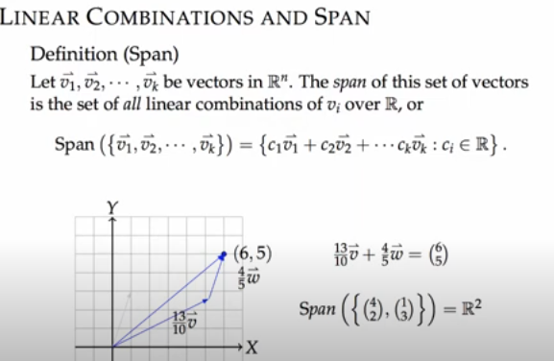

v=(1,2) and w =(3,1) , a=2, b=-1
linear combination = 2(1,2) + (-1)(3,1) = (2,4) + (-3,-1) = (-1, 3)
python
v1 = np.array([1,0])
v2=np.array([0,1])
span_vector = 2*v1 + 3*v2 = [2,3]
ML creating new features is like forming a linear combination of existing ones

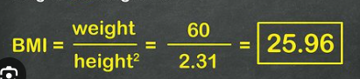
Deriving new features from existing ones

Linear dependence and independence
Vectors are linearly dependent if one can be formed from others. Independent vectors span more directions
a = np.array([1,2])
b = np.array([2,4])
- b = 2 * a depedent
ML multicollinearity in features means some are dependent, which can reduce model performance
How to address? – if some features are combinations of others, its like redundancy – removing them often improves model generalization

Vector Dot and cross products
Dot product measures similarity
a = np.array([1,2])
b = np.array([3,4])
dot = np.dot (a, b) 1*3 + 2*4 = 11
ML used in similarity – product recommendation system , NLP
Cross product only for 3D vectors –
a = np.array([1,0,0])
b = np.array([0,1,0])
cross1 = np.cross (a, b) HW
AI robotics use cross products

Solving equations by elimination
2x + y = 8
X + 3y = 13

from numpy.linalg import solve
a = np.array([[2,1], [1,3]])
b = np.array([8,13])
x = solve(a,b)
ML linear regression uses to find best fit line

Transformations
Matrix transformation is a function that takes vectors and transforms it using matrix multiplications
- rotating, scaling an image – applying matrix transformations

python
A = np.array([2,0], [0,3]]) # scale x by 2, y by 3
v = np.array([1,2])
transformed_v = A @ v
print(“Transformed vector:”, transformed_v)
example scaling pixel values in an image

HW dot (.), *, @

Transpose of a matrix
Transposing flips rows and columns
M = np.array([[1,2,3],[4,5,6]])
print(“Transpose—“, M.T)
ML transposing feature matrices for batch computations in model training

