- Which AI tool(s) you used.
- Github Copilot using the agent “Claude Haiku 4.5”

- Two or three prompts that helped you the most.
- Following pages have some screenshots.
- One concrete example where the AI’s suggestion was wrong or not ideal, and how you detected and corrected it.
- Here is the screenshot, where I asked Copilot –
Add a private method to read the dates from the text file dates.txt. Iterating through the dates, pass each date from the text file as startData and endDate in the inputs to the GetHistoricalWeatherAsync method called in the GetWeatherAsync method.
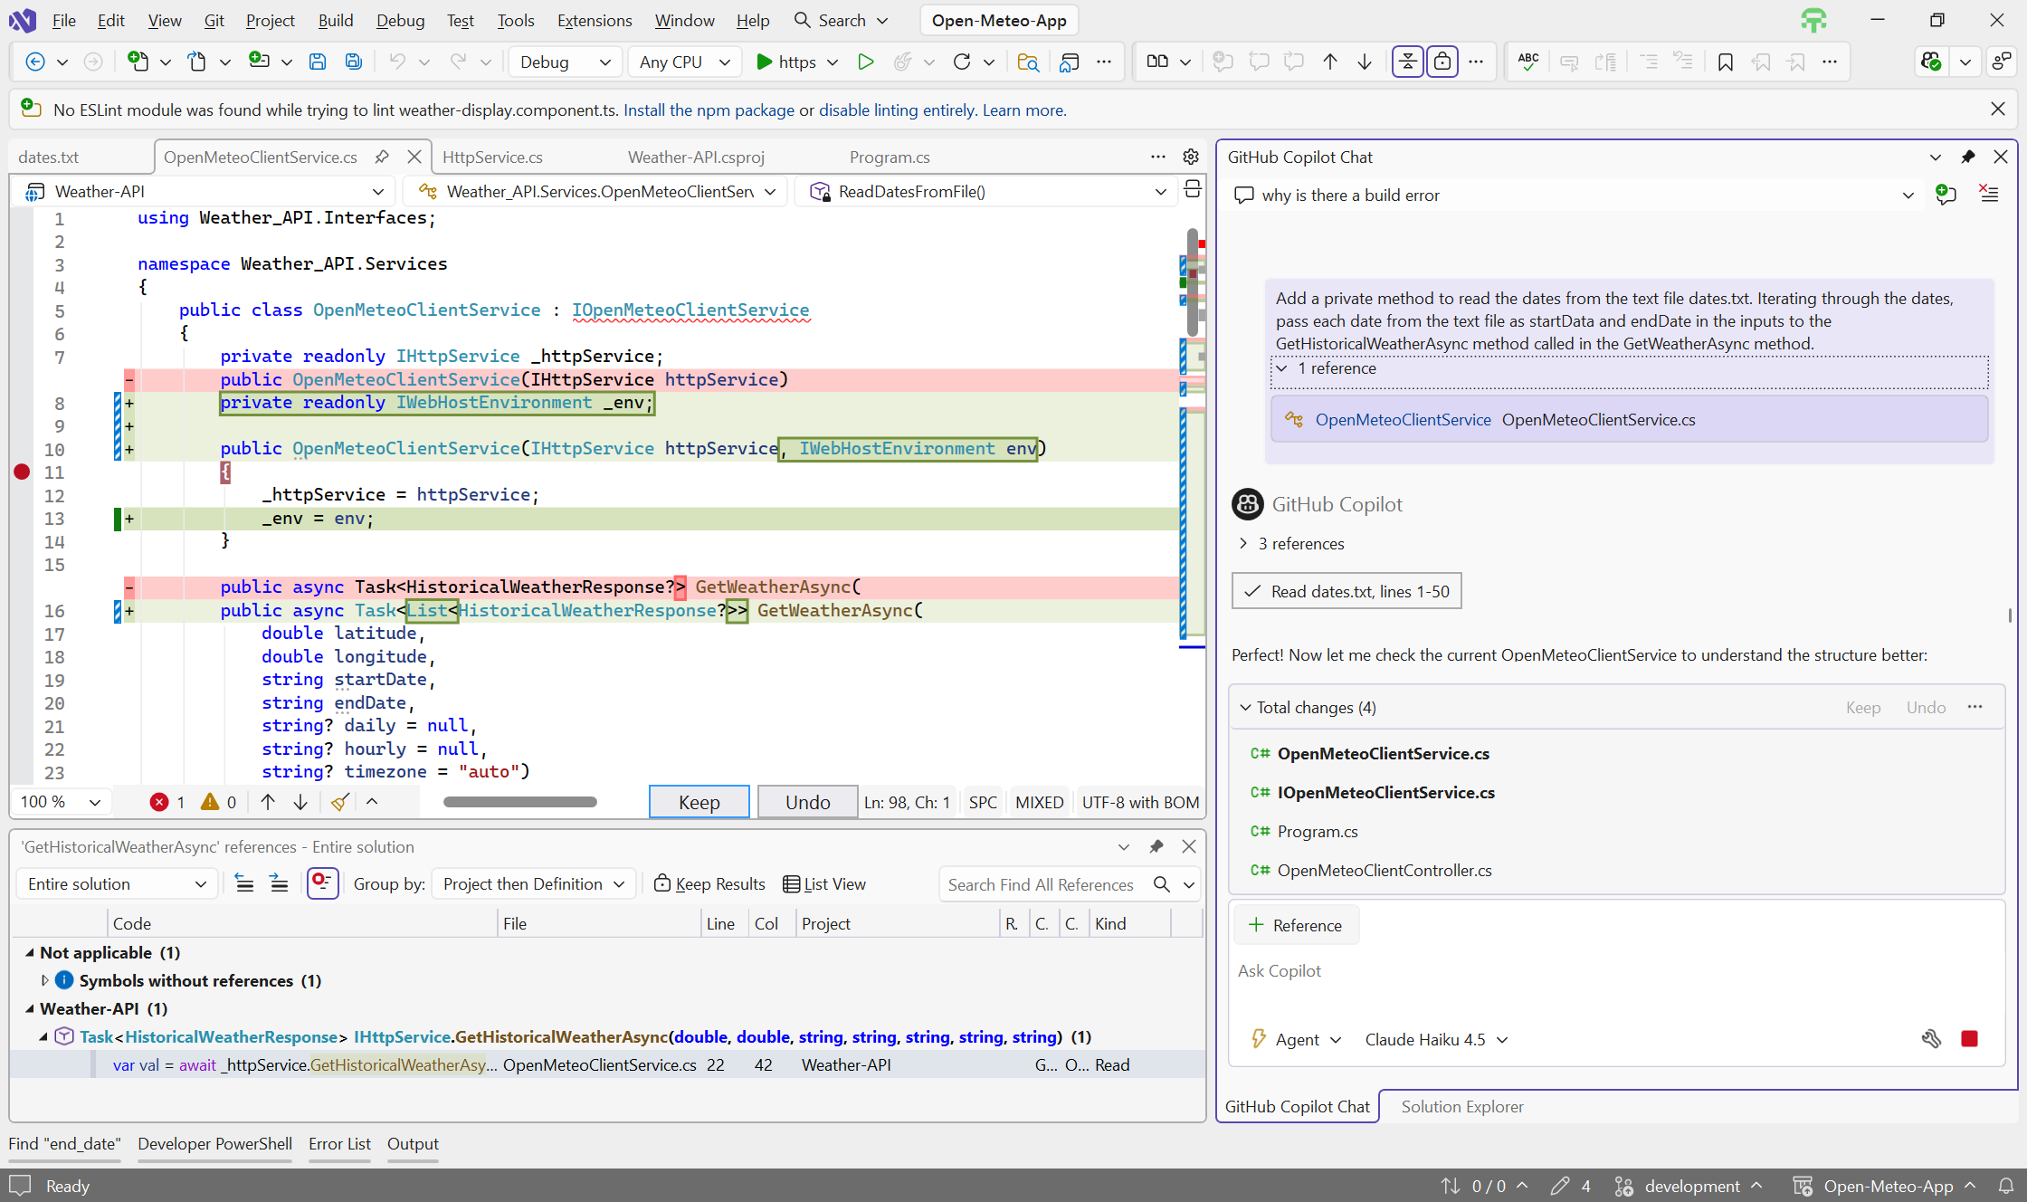

Copilot picked-up date-1 as start-date and date-2 as end-date from the dates.txt file, rather than both holding same date.

- Parts of the solution where you chose to write code yourself rather than rely on AI, and why.
- Had challenges explaining the error handling scenarios and the strategy I thought of collecting those errors (handling gracefully without exception being thrown) and returning the API-response including errors as an object to UI. Although, Copilot helped with exception handling – try/catch block.

Two or three prompts that helped you the most.
- Here are the screenshots – right side are the prompts to Copilot.

