Efficient In-Line Data Deduplication for Non-Volatile Memory Storage Using I/O Causality

ABSTRACT
I/O causality-based in-line data deduplication (ICID) is a novel approach designed to enhance deduplication efficiency in non-volatile memory (NVM)-enabled storage systems. Traditional chunk-based offline deduplication methods suffer from significant performance overhead due to data chunking and indexing, making them unsuitable for NVM-based storage, which benefits from fine-grained, byte-addressable operations. Unlike conventional in-line deduplication schemes that rely on hash indexes, ICID leverages a B-tree structure to record memory copy operations, enabling causality-based deduplication. To optimize efficiency, ICID introduces two key techniques: grouping memory-copy records targeted to the same page within a B-tree node to enhance data locality and exploiting spatial locality to identify and remove outdated memory-copy records, thereby reducing memory consumption. Evaluations conducted on a system with Intel Optane DC Persistent Memory Modules demonstrate that ICID significantly improves deduplication performance, achieving up to 16× higher deduplication ratios and reducing deduplication time by an average of 47% compared to state-of-the-art methods, particularly benefiting key-value stores like LevelDB.

LIST OF CONTENT
CHAPTER NO. | TITLE | PAGE NO.
1. | CHAPTER 1 : INTRODUCTION  - General  - Scope Of The Project  - Objective  - Problem Statement  - Existing System  1.5.1 Existing System Disadvantages  1.5.2 Literature Survey  1.6 Proposed System  1.6.1 Proposed System Advantages
2. | CHAPTER 2 : PROJECT DESCRIPTION  - General  2.2 Methodologies  2.2.1 Modules Name  2.2.2 Modules Explanation  2.2.3 Given Input and Expected Output  2.3 Technique Or Algorithm
3. | CHAPTER 3 : REQUIREMENTS  3.1 General  3.2 Hardware Requirements  3.3 Software Requirements  3.4 Functional Specification  3.5 Non-Functional Specification
4. | CHAPTER 4 : SYSTEM DESIGN  4.1 General  4.1.1 Use Case Diagram  4.1.2 Class Diagram  4.1.3 Object Diagram  4.1.4 State Diagram  4.1.5 Sequenced Diagram  4.1.6 Collaboration Diagram  4.1.7 Activity Diagram  4.1.8 Component Diagram  4.1.9 E-R Diagram  4.1.01 Data Flow Diagram  4.1.11 Deployment Diagram  4.2 System Architecture
5. | CHAPTER 5: SOFTWARE SPECIFICATION  5.1 General  5.2 Features Of Java  5.2.1 The Java Framework  5.2.2 Objective Of Java  5.2.3 Java Swing Overview  5.2.4 Evolution Of Collection Framework  5.3 Conclusion
6. | CHAPTER 6 : IMPLEMENTATION  6.1 General  6.2 Implementation
7. | CHAPTER 7 : SNAPSHOTS  7.1 General  7.2 Various Snapshots
8. | CHAPTER 8 : SOFTWARE TESTING  8.1 General  8.2 Developing Methodologies  8.3 Types Of Testing  8.3.1 Unit testing  8.3.2 Functional test  8.3.3 System Test  8.3.4 Performance Test  8.3.5 Integration Testing  8.3.6 Acceptance Testing  8.3.7 Build the test plan
9. | CHAPTER 9 : APPLICATIONS AND FUTURE ENHANCEMENT  9.1 General  9.2 Future Enhancements
10. | CHAPTER 10 :  10.1 Conclusion  10.2 References

LIST OF FIGURE
FIGURE NO | NAME OF THE FIGURE | PAGE NO.
2.3.2 | Module Diagram
4.2 | Use case Diagram
4.3 | Class Diagram
4.4 | Object Diagram
4.5 | State Diagram
4.6 | Sequence Diagram
4.7 | Collaboration Diagram
4.8 | Activity Diagram
4.9 | Component Diagram
4.10 | Data flow Diagram
4.11 | E-R Diagram
4.12 | Deployment Diagram
4.13 | System Architecture
7.1 | Home Page

LIST OF NOTATIONS
S.NO | NAME | NOTATION |  | DESCRIPTION
1. | Class | Class Name  -attribute-attribute  +operation  +operation  +operation  + public  -private  # protected |  | Represents a collection of similar entities grouped together.
2. | Association | name  Class B  Class A  Class A  Class B |  | Associations represents static relationships between classes. Roles represents the way the two classes see each other.
3. | Aor | Class A  Class A  Class B  Class B |  | It aggregates several classes into a single classe
5. | Aggregation |  |  | Interaction between the system and external environment
5. | Relation  (uses) |  | Uses |  | Used for additional process communication.
6. | Relation  (extends) |  | extends |  | Extends relationship is used when one use case is similar to another use case but does a bit more.
7. | Communication |  |  |  | Communication between various use cases.
8. | State |  | State |  | State of the process.
9. | Initial State |  |  |  | Initial state of the object
10. | Final state |  |  |  | Final state of the object
11. | Control flow |  |  |  | Represents various control flow between the states.
12. | Decision box |  |  |  | Represents decision making process from a constraint
13. | Usecase |  | Uses case |  | Interact ion between the system and external environment.
14. | Component |  |  |  | Represents physical modules which is a collection of components.
15. | Node |  |  |  | Represents physical modules which are a collection of components.
16. | Data Process/State |  |  |  | A circle in DFD represents a state or process which has been triggered due to some event or action.
17. | External entity |  |  |  | Represents external entities such as keyboard, sensors, etc.
18. | Transition |  |  |  | Represents communication that occurs between processes.
19. | Object Lifeline |  |  |  | Represents the vertical dimensions that the object communications.
20. | Message |  | Message |  | Represents the message exchanged.

LIST OF ABBREVATION
S.NO | ABBREVATION | EXPANSION
1. | DB | Data Base
2. | JVM | Java Virtual Machine
3. | JSP | Java Server Page
4. | CB | Collective Behavior
5. | RSSS | Ramp secret sharing scheme
6. | JRE | Java Runtime Environment

CHAPTER 1
INTRODUCTION
1.1 GENERAL
DATA deduplication techniques have long been studied for space saving in storage systems. They eliminate duplicate data at file or chunk levels by identifying the same data using cryptographic hash functions such as SHA-1 or MD5. Data deduplication can be performed in an offline or inline mode. The offline deduplication is conducted after the data has been written to the storage device, and thus usually causes write amplification. In contrast, the inline deduplication detects the duplicate data before writing it back into storage, and thus can reduce data redundancy and the wear of storage devices. More importantly, inline deduplication has the potential to explore the correlation among I/O operations at runtime, and may significantly improve the deduplication ratio. Non-volatile memory (NVM) technologies such as Intel 3D Xpoint offer much lower cost, higher density and energy efficiency than traditional DRAM technologies. They have become a promising complement to DRAM to bridge the performance gap between main memory and SSD/HDD storage devices However, NVMs often suffer from limited write endurance, a typical PCM cell can only sustain 107-108 writes. Inline deduplication is a promising approach for reducing the storage consumption and the wear of NVM devices. Unfortunately, existing inline deduplication schemes are not efficient for new NVM devices. Since previous data deduplication techniques are designed for block devices such as HDD and SSD, they suffer from high computation and storage overhead due to data chunking and indexing. For example, to chunk 1 TB data without any redundancy using 4 KB blocks, Content-Defined Chunking (CDC) algorithm has to compute rolling hashes for almost 1012 times during the chunking stage. Moreover, the SHA-1 algorithm introduces 5 GB fingerprints (20 bytes per fingerprint) to index those chunks. Since DRAM resource is expensive and limited, many recent proposals store most fingerprints on disk. Thus, it is expensive to search those fingerprints in storage. Moreover, existing inline deduplication schemes have to make a tradeoff between the deduplication ratio and the read throughput. Since the performance difference between the sequential read and the random read is significant for SSD/HDD devices, as shown in Table I, using big chunks (such as 4 KB or 8 KB) can mitigate the performance degradation due to random accesses to SSD/HDD, and also avoids read amplification if the chunk is larger than the disk block. Moreover, using big chunks can also mitigate the total size of fingerprints and the cost of indexing. In contrast, using small chunks can improve the deduplication ratio, but lowers the read throughput and increase the cost of indexing. Currently, most deduplication systems tend to use big chunks to improve the read throughput and to mitigate the cost of indexing, at the expense of a lower deduplication ratio.

1.2 SCOPE OF THE PROJECT
In order to improve the effectiveness and performance of deduplication technology in non-volatile memory (NVM)-based storage systems, the ICID (I/O Causality based In-line Deduplication) project's scope includes multiple important aspects. In order to achieve finer granularity in data deduplication, it first seeks to improve and optimize deduplication algorithms designed specifically for NVM by utilizing its byte-addressability capability. Creating data structures and algorithms, like the causality-based B-tree technique, is one way to effectively handle memory-copy operations inline during data writes. Second, the project enhances data localization and memory management techniques inside the deduplication framework to solve the scalability issues present in large-scale storage environments.
.

OBJECTIVE
The objective of the ICID (I/O Causality based In-line Deduplication) project is to pioneer a novel approach to deduplication tailored specifically for non-volatile memory (NVM)-based storage systems, such as Intel Optane DC Persistent Memory Modules. The primary goal is to overcome the limitations of traditional deduplication methods that are inefficient and impractical for NVM due to their reliance on chunking and offline processing. ICID aims to achieve this by introducing an inline deduplication mechanism that operates concurrently with data writes, leveraging the byte-addressability feature of NVM for fine-grained deduplication. Key objectives include developing and implementing a causality-based approach using a B-tree structure to record memory-copy operations in real-time, ensuring that deduplication decisions are based on the order of data accesses. This approach not only maximizes deduplication ratios but also minimizes performance overhead, thereby improving overall system efficiency and responsiveness.

1.4 PROBLEM STATEMENT
The problem addressed by this project Managing memory-copy operations is crucial for optimizing data handling and performance in various computing processes. This involves strategically organizing data to minimize unnecessary copying while ensuring efficient access and modification. Techniques such as using pointers instead of duplicating data, employing memory pools, and implementing efficient algorithms can significantly reduce overhead. Additionally, leveraging batch processing can enhance throughput by reducing the number of individual copy operations. Effective management of memory-copy operations not only improves system performance but also helps in maintaining data integrity and responsiveness, making it essential for applications that rely on high-speed data processing and deduplication tasks.
  - EXISTING SYSTEM

- Traditional chunk-based offline deduplication methods are not efficient for NVM-based storage due to their inability to fully utilize the byte-addressability feature of NVMs. These methods typically incur significant performance overhead due to chunking and indexing.
- Deduplication processes can be resource-intensive, potentially impacting performance during execution.
- Regular deduplication requires ongoing maintenance and monitoring, which can increase administrative workload.

    - EXISTING SYSTEM DISADVANTAGES
- Increased Memory Consumption.
- High overhead from memory-copy operations can slow down processing, especially in high-volume environments.
- Continuous memory allocation and deallocation may lead to fragmentation, reducing available memory and performance.
1.5.2 LITERATURE SURVEY
Title: UCat: Heterogeneous memory management for unikernels.
Author: C. Tian, H. Liu, X. Liao, and H. Jin.
Year: 2022.
Description:
Unkennels provide an efficient and lightweight way to deploy cloud computing services in application-specialized and single-address-space virtual machines (VMs). They can efficiently deploy hundreds of unikernel-based VMs in a single physical server. In such a cloud computing platform, main memory is the primary bottleneck resource for high-density application deployment. Recently, non-volatile memory (NVM) technologies has become increasingly popular in cloud data centres because they can offer extremely large memory capacity at a low expense. However, there still remain many challenges to utilize NVMs for unikernel-based VMs, such as the difficulty of heterogeneous memory allocation and high-performance overhead of address translations.
In this paper, we present UCat, a heterogeneous memory management mechanism that support multi-grained memory allocation for unikernels. We propose front-end/back-end cooperative address space mapping to expose the host memory heterogeneity to unikernels. UCat exploits large pages to reduce the cost of two-layer address translation in virtualization environments, and leverages slab allocation to reduce memory waste due to internal memory fragmentation. We implement UCat based on a popular unikernel—OSv and conduct extensive experiments to evaluate its efficiency. Experimental results show that UCat can reduce the memory consumption of unikernels by 50% and TLB miss rate by 41%, and improve the throughput of real-world benchmarks such as memslap and YCSB by up to 18.5% and 14.8%, respectively.

Title: FFCCD: Fence-free crash consistent concurrent defragmentation for persistent memory
Author: Xu, C. Ye, Y. Solihin, and X. Shen.
Year: 2022.
Description:
Persistent Memory (PM) is increasingly supplementing or substituting DRAM as main memory. Prior work have focused on reusability and memory leaks of persistent memory but have not addressed a problem amplified by persistence, persistent memory fragmentation, which refers to the continuous worsening of fragmentation of persistent memory throughout its usage. This paper reveals the challenges and proposes the first systematic crash-consistent solution, Fence-Free Crash-consistent Concurrent Defragmentation (FFCCD). FFCCD resues persistent pointer format, root nodes and typed allocation provided by persistent memory programming model to enable concurrent defragmentation on PM. FFCCD introduces architecture support for concurrent defragmentation that enables a fence-free design and fast read barrier, reducing two major overheads of defragmenting persistent memory. The techniques is effective (28–73% fragmentation reduction) and fast (4.1% execution time overhead).
Title: Pattern-guided file compression with user-experience enhancement for log-structured file system on mobile devices.
Author: C. Ji et al.
Year: 2021.
Description:
Mobile applications exhibit unique file access patterns, often involving random accesses of write-mostly files and read-only files. The high write stress of mobile applications significantly impacts on the lifespan of flash-based mobile storage. To reduce write stress and save space without sacrificing user-perceived latency, this study introduces FPC, file access pattern guided compression. FPC is optimized for the random-writes and fragmented-reads of mobile applications. It features dual-mode compression: Foreground compression handles write-mostly files for write stress reduction, while background compression packs random-reading file blocks for boosted read performance. FPC exploits the out-of-place updating design in F2FS, a log-structured file system for mobile devices, for the best effect of the proposed dual-mode compression. Experimental results showed that FPC reduced the volume of total write traffic and executable file size by 26.1% and 23.7% on average, respectively, and improved the application launching time by up to 14.8%.
Title: HMvisor: Dynamic hybrid memory management for virtual machines.
Author: D. Yang, H. Liu, H. Jin, and Y. Zhang.
Year: 2021
Description:
Emerging non-volatile memory (NVM) technologies promise high density, low cost and dynamic random access memory (DRAM)-like performance, at the expense of limited write endurance and high write energy consumption. It is more practical to use NVM combining with the traditional DRAM. However, the hybrid memory management such as page migration becomes more challenging in a virtualization environment because virtual machines (VMs) are unaware of the memory heterogeneity. In this paper, we propose HMvisor, a hypervisor and VM coordinated hybrid memory management mechanism to better utilize DRAM and NVM resources. HMvisor exposes the memory heterogeneity to VMs by mapping virtual NUMA nodes to different physical NUMA nodes. We propose a lightweight and efficient page migration mechanism by decoupling page hotness tracking from page migration. HMvisor performs those operations in the hypervisor and VMs separately, without disrupting the execution of VMs. We also propose a memory resource trading policy to adjust the capacity of DRAM and NVM for each VM, with the monetary cost unchanged. We implement our prototype system based on QEMU/KVM and evaluate it with several benchmarks. Experimental results show that HMvisor can reduce 50% of write traffic to NVM with less than 5% performance overhead. Moreover, the hybrid memory adjustment scheme in HMvisor can significantly improve application performance by up to 30 ×.

Title: “NV-Dedup: High-performance inline deduplication for non-volatile memory.
Author: C. Wang, Q. Wei, J. Yang, C. Chen, Y. Yang, and M. Xue,
Year: 2018.
Description:
The byte-addressable non-volatile memory (NVM) is a promising medium for data storage. NVM-oriented file systems have been designed to explore NVM's performance potential. Meanwhile, applications may write considerable duplicate data. For NVM, a removal of duplicate data can promote space efficiency, improve write endurance, and potentially improve the performance by avoidance of repeatedly writing the same data. However, we have observed severe performance degradations when implementing a state-of-the-art inline deduplication algorithm in an NVM-oriented file system. A quantitative analysis reveals that, with NVM, 1) the conventional way to manage deduplication metadata for block devices, particularly in light of consistency, is inefficient, and, 2) the performance with deduplication becomes more subject to fingerprint calculations. We hence propose a deduplication algorithm called NV-Dedup. NV-Dedup manages deduplication metadata in a fine-grained, CPU and NVM-favored way, and preserves the metadata consistency with a lightweight transactional scheme. It also does workload-adaptive fingerprinting based on an analytical model and a transition scheme among fingerprinting methods to reduce calculation penalties. We have built a prototype of NV-Dedup in the Persistent Memory File System (PMFS). Experiments show that, NV-Dedup not only substantially saves NVM space, but also boosts the performance of PMFS by up to 2.1x.
PROPOSED SYSTEM
- DATA deduplication techniques have long been studied for space saving in storage systems. They eliminate duplicate data at file or chunk levels by identifying the same data using cryptographic hash functions such as SHA-1 or MD5.
- In this paper, we propose I/O Causality based In-line Deduplication (ICID) to maximize the deduplication ratio for NVM-based storage systems. Unlike previous inline deduplication schemes that use hash indexes to identify duplicate data slices, ICID records memorycopy operations in a B-tree structure to achieve causality-based inline deduplication.
- In contrast, the inline deduplication detects the duplicate data before writing it back into storage, and thus can reduce data redundancy and the wear of storage devices..

1.6.1 PROPOSED SYSTEM ADVANTAGES
- Maximized Deduplication Ratio.
- Improved Performance.
- Efficient Memory Management.
- Causality-based Approach.

CHAPTER 2
PROJECT DESCRIPTION
2.1 GENERAL
The ICID (I/O Causality based In-line Deduplication) project introduces a cutting-edge approach to data deduplication designed specifically for non-volatile memory (NVM)-based storage systems. Unlike traditional methods that rely on chunking and offline processing, ICID implements deduplication inline during data writes, leveraging the byte-addressability feature of NVM for precise and efficient deduplication. Central to ICID is its causality-based approach using a B-tree structure, which records memory-copy operations in real-time.
2.2 METHODOLOGIES
2.2.1 MODULES NAME:
- User Interface Design
- Admin
- Hospital
- Health Sector
- Patient/User
- Encryption

2.2.2 MODULES EXPLANATION AND DIAGRAM

- User Interface Design
To connect with server user must give their username and password then only they can able to connect the server. If the user already exits directly can login into the server else user must register their details such as username, password, Email id, City and Country into the server. Database will create the account for the entire user to maintain upload and download rate. Name will be set as user id. Logging in is usually used to enter a specific page. It will search the query and display the query.

User
Login Page
Server
Error Message
User Page
Database
- Hospital
Hospital is the second module in our project, Hospital first login with Username and password then view patient details and symptoms or request and approve the patient and join. After hospital management accepting the patient, he will view send the symptoms to health sector for scanning the patient and that data will be send to Hospital. Hospital management will send the reports to patient in encrypted format for security purpose. Patient have to request hos management and send keys to decrypt the reports.

Database
Login
Hospital Home Page
Hospital
View Patient details
Approve
Send Health Sector
Health sector Login
Scan/upload medical image
Send to Hospital

- Admin
This is the third module in our project where Admin Controls all the of the project role. Administration managers ensure an organization's activities run smoothly and efficiently. The primary goals of an administration manager are to direct, control and supervise the support services of the organization to facilitate its success.

Login
Database
Admin
Patient details
Hospital Registeration
Home Page
Hospital Details Details
- Health Sector

This is the fourth module in our project is Health Sector. Here Health Sector view patient symptoms where hospital management has sent. Based on patient data he will scan the patient and those reports as sent to Hospital Management.

Login
Database
Health Sector
View data
Scan Patient
Home Page
Send to Hospital

- Encryption

The encryption of medical images using Elliptic Curve Cryptography (ECC) and the Blum-Goldwasser cryptosystem provides a robust framework for ensuring the confidentiality and integrity of sensitive medical data. ECC offers a high level of security with smaller key sizes, making it ideal for resource-constrained environments typical in medical applications.
Register / Login
Database
Hospital
View reports sent by health sector
Send to patient in encryption format
Home page
If patient request sends keys to decrypt

2.2.3 GIVEN INPUT EXPECTED OUTPUT:
- Admin
Input : Enter admin email and password, verify all details.
Output : Admin verify all data and maintenance and organisation of company records.
- Patient
Input : patient will Login name and Password
Output: If valid username and password then directly patient login page then enters to patient symptoms and send data to requested hospital.
- Hospital
Input: Hospital login and with his hid and password verify all data.
Output: Hospital will check patient symptoms or request and approve.
- Health Sector
Input: Enter Login name and Password (User, Router, CA, Publisher)
Output: If valid user name and password then directly open the home page otherwise show error message. Here health sector will generate or scan patient based on symptoms, and send to hospital.

  - TECHNIQUE USED OR ALGORITHM USED

Elliptic Curve Cryptography (ECC) and the Blum-Goldwasser Cryptosystem (BGC).
A. Elliptic Curve Cryptography (ECC).
Elliptic Curve Cryptography (ECC) is a powerful encryption technique that utilizes the mathematical properties of elliptic curves over finite fields to provide secure communication. ECC is particularly valued for its ability to deliver strong security with smaller key sizes compared to traditional cryptographic methods like RSA, making it efficient and suitable for resource-constrained environments. This efficiency leads to faster computations and reduced storage requirements, which are essential for applications in mobile devices and embedded systems. ECC is widely used in various security protocols, including SSL/TLS for secure web communications, digital signatures, and key exchange mechanisms, ensuring robust protection for sensitive data and communications in an increasingly interconnected digital landscape.
Blum-Goldwasser Cryptosystem (BGC).
The Blum-Goldwasser Cryptosystem (BGC) is a probabilistic public-key encryption scheme that is founded on the difficulty of factoring large composite numbers. Developed by Manuel Blum and Shafi Goldwasser, BGC is notable for its strong theoretical security properties, as it produces ciphertext that is indistinguishable from random noise. The system operates using a pair of large prime numbers to generate a modulus, and it relies on the quadratic residues of these primes to encrypt messages. This unique approach allows BGC to provide a robust level of security while maintaining simplicity in its design. Due to its security foundations, the Blum-Goldwasser Cryptosystem is particularly suitable for applications requiring high assurance in confidentiality and integrity, making it an essential tool in the field of cryptography.

CHAPTER 3
REQUIREMENTS ENGINEERING
3.1 GENERAL
Recommendation System with high accuracy and prediction can lead to highly efficient productivity. Here, an efficient recommendation system with good throughput resulting in a valued process for users.

3.2 HARDWARE REQUIREMENTS
The hardware requirements may serve as the basis for a contract for the implementation of the system and should therefore be a complete and consistent specification of the whole system. They are used by software engineers as the starting point for the system design. It shoulds what the system do and not how it should be implemented.

HARDWARE
- PROCESSOR : PENTIUM IV 2.6 GHz, Intel Core 2 Duo.
- RAM : 512 MB DD RAM
- MONITOR : 15” COLOR
- HARD DISK : 40 GB

3.3 SOFTWARE REQUIREMENTS
The software requirements document is the specification of the system. It should include both a definition and a specification of requirements. It is a set of what the system should do rather than how it should do it. The software requirements provide a basis for creating the software requirements specification. It is useful in estimating cost, planning team activities, performing tasks and tracking the teams and tracking the team’s progress throughout the development activity.

  - Front End : J2EE (JSP, SERVLET)
  - Back End : MY SQL 5.5
  - Operating System : Windows 10
  - IDE : Eclipse

3.4 FUNCTIONAL REQUIREMENTS
A functional requirement defines a function of a software-system or its component. A function is described as a set of inputs, the behaviour, and outputs. The outsourced computation is data is more secured.
ADMIN
- View Patients details
- View Hospital details
Hospital
- patient Request.
- View Symptoms
- View Reports
- Send to patient.
USER/Patient
- Login
- Search Hospital request with symptoms
- View reports and request key to decrypt image
- View key and decrypt

3.5 NON-FUNCTIONAL REQUIREMENTS
The major non-functional Requirements of the system are as follows
- Usability
The system is designed with completely automated process hence there is no or less user intervention.
- Reliability
The system is more reliable because of the qualities that are inherited from the chosen platform java. The code built by using java is more reliable.
- Performance
This system is developing in the high level languages and using the advanced front-end and back-end technologies it will give response to the end user on client system with in very less time.
- Supportability
The system is designed to be the cross platform supportable. The system is supported on a wide range of hardware and any software platform, which is having JVM, built into the system.
- Implementation
The system is implemented in web environment using struts framework. The apache tomcat is used as the web server and windows xp professional is used as the platform. Interface the user interface is based on Struts provides HTML Tag

CHAPTER 4
DESIGN ENGINEERING
4.1 GENERAL
Design Engineering deals with the various UML [Unified Modelling language] diagrams for the implementation of project. Design is a meaningful engineering representation of a thing that is to be built. Software design is a process through which the requirements are translated into representation of the software. Design is the place where quality is rendered in software engineering. Design is the means to accurately translate customer requirements into finished product.

4.1.1 Use Case Diagram
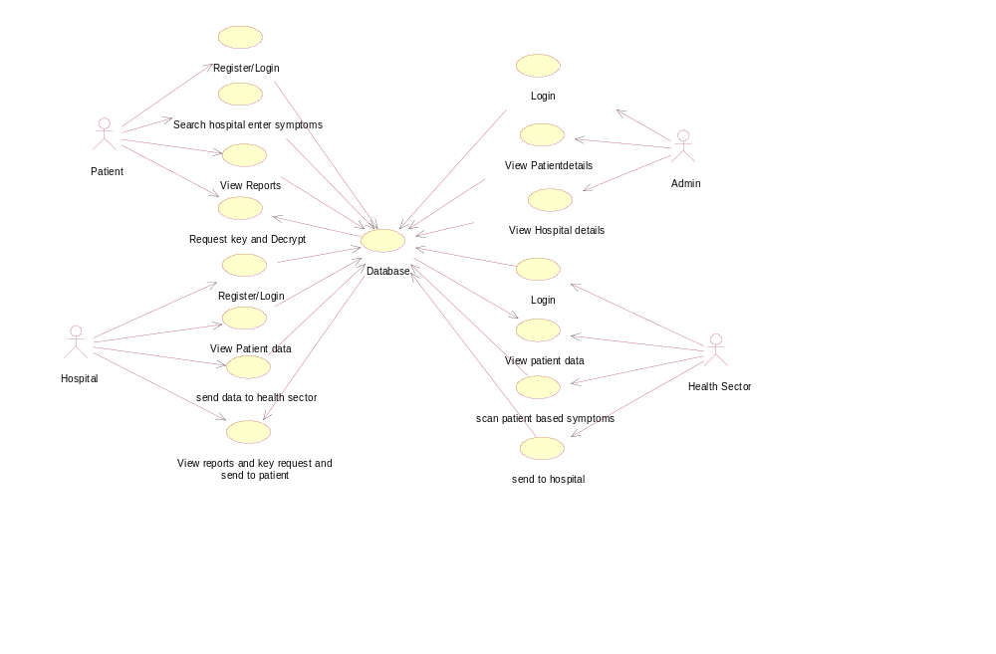
EXPLANATION:
The main purpose of a use case diagram is to show what system functions are performed for which actor. Roles of the actors in the system can be depicted. The above diagram consists of user as actor. Each will play a certain role to achieve the concept.

4.1.2 Class Diagram
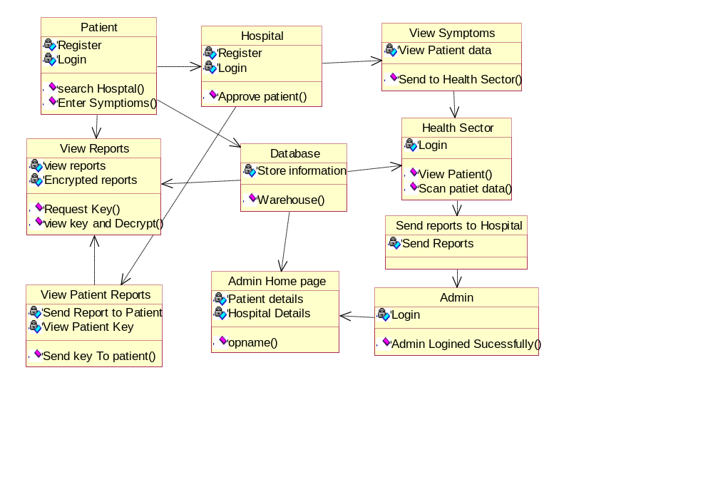
EXPLANATION
In this class diagram represents how the classes with attributes and methods are linked together to perform the verification.

4.1.3 Object Diagram

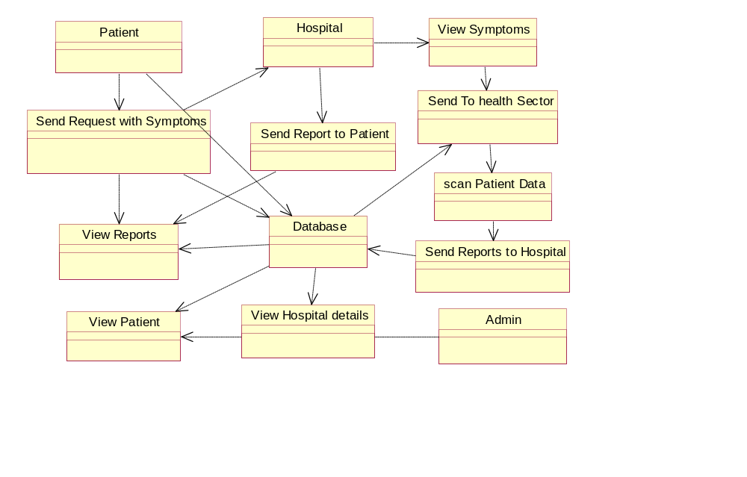

EXPLANATION:
In the above digram tells about the flow of objects between the classes. It is a diagram that shows a complete or partial view of the structure of a modeled system. In this object diagram represents how the classes with attributes and methods are linked together to perform the verification with security.

4.1.4 State Chart Diagram
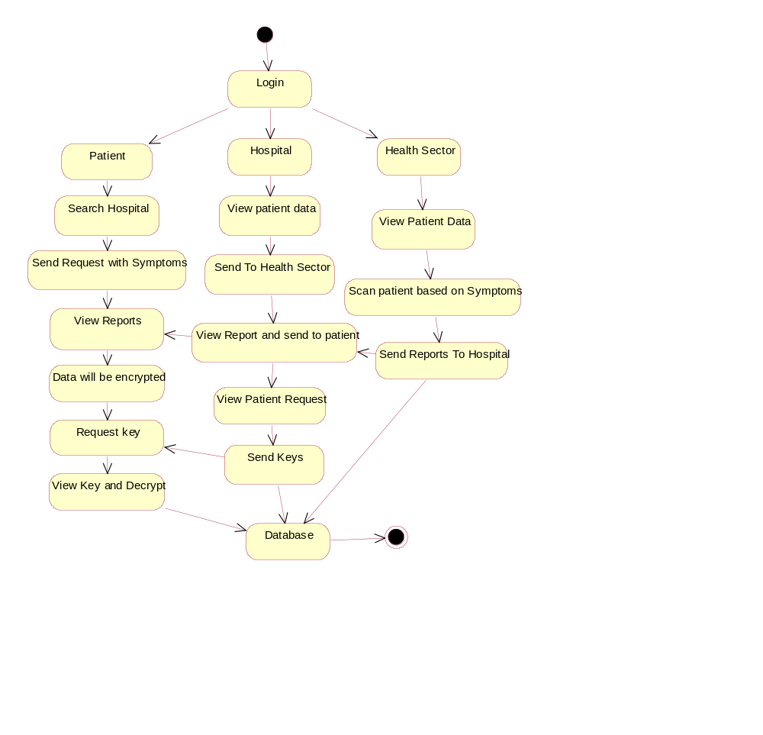
EXPLANATION:
State diagram are a loosely defined diagram to show workflows of stepwise activities and actions, with support for choice, iteration and concurrency. State diagrams require that the system described is composed of a finite number of states; sometimes, this is indeed the case, while at other times this is a reasonable abstraction. Many forms of state diagrams exist, which differ slightly and have different semantics.
4.1.5 Sequence Diagram
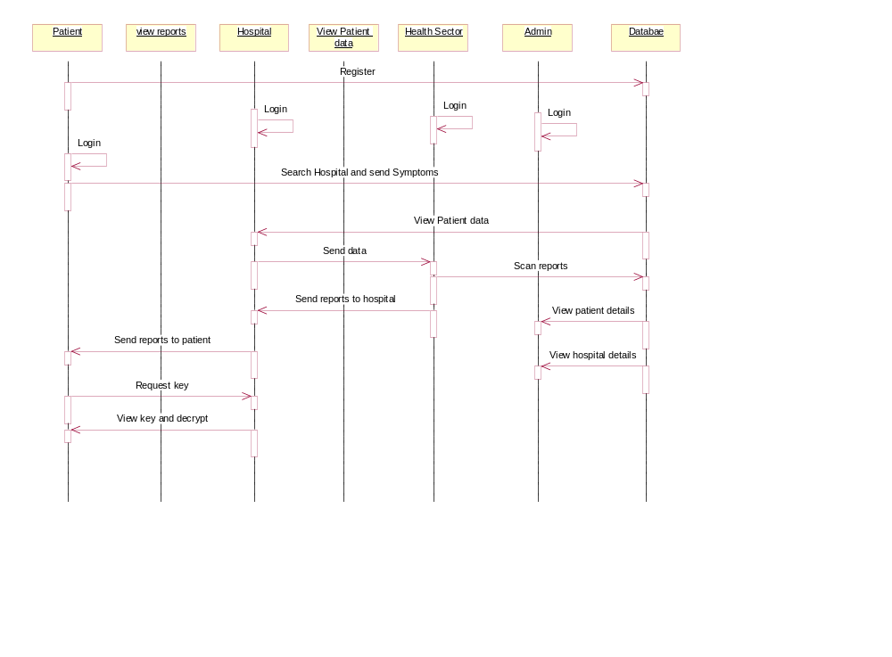
EXPLANATION:
A sequence diagram in Unified Modeling Language (UML) is a kind of interaction diagram that shows how processes operate with one another and in what order. It is a construct of a Message Sequence Chart. A sequence diagram shows object interactions arranged in time sequence. It depicts the objects and classes involved in the scenario and the sequence of messages exchanged between the objects needed to carry out the functionality of the scenario.
4.1.6 Collaboration Diagram

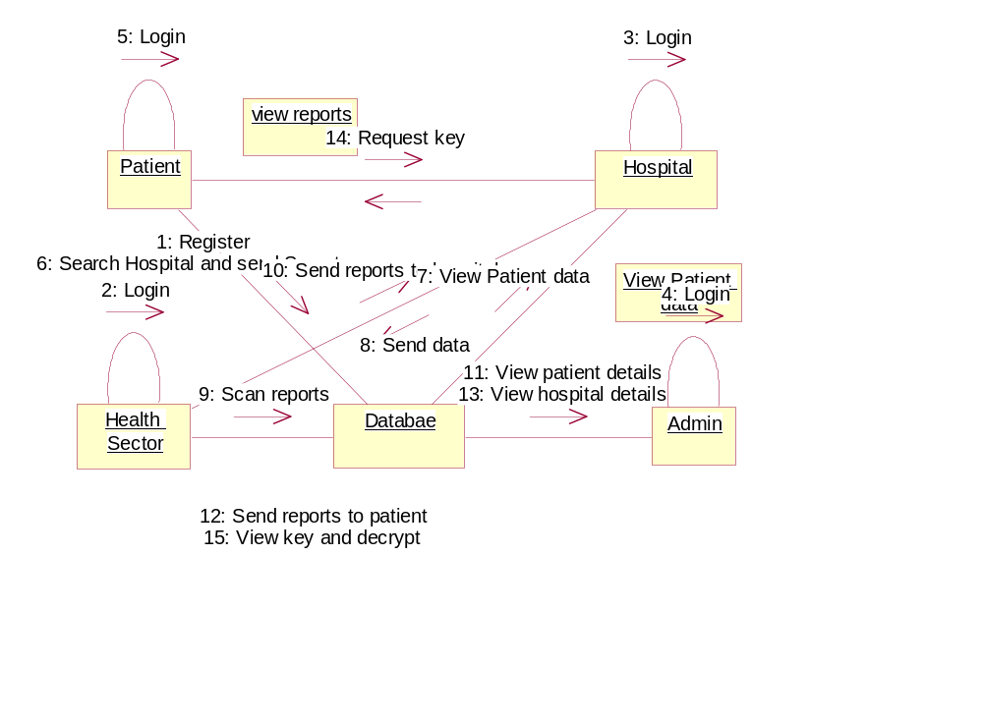

EXPLANATION:
A collaboration diagram, also called a communication diagram or interaction diagram, is an illustration of the relationships and interactions among software objects in the Unified Modeling Language (UML). The concept is more than a decade old although it has been refined as modeling paradigms have evolved.

4.1.7 Activity Diagram
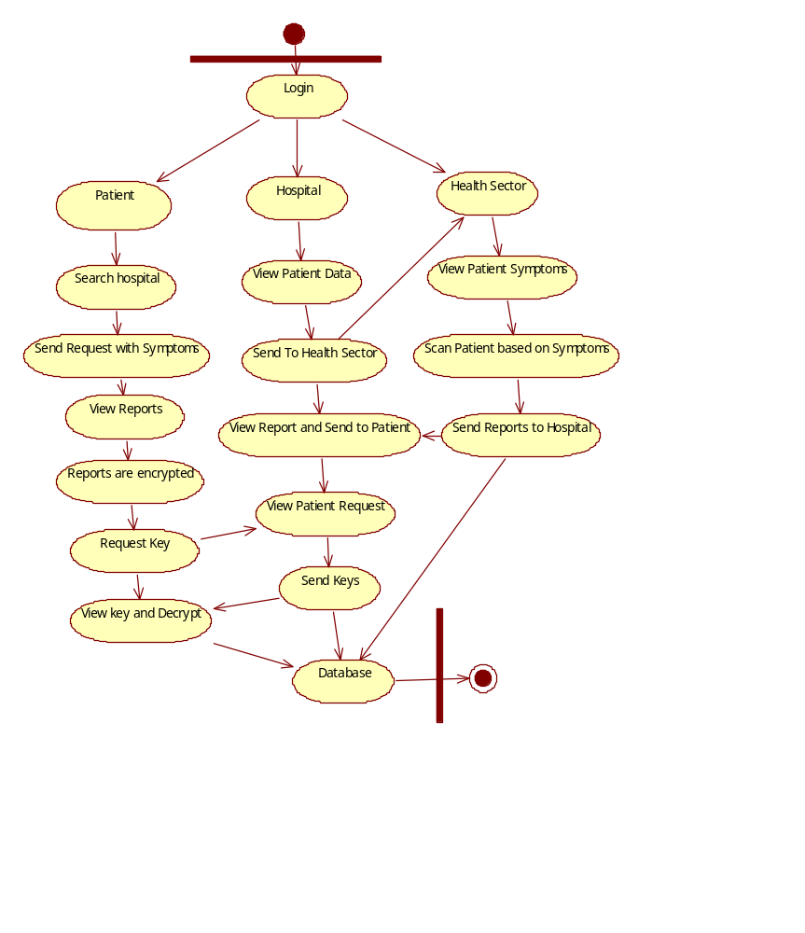
EXPLANATION:
Activity diagrams are graphical representations of workflows of stepwise activities and actions with support for choice, iteration and concurrency. In the Unified Modeling Language, activity diagrams can be used to describe the business and operational step-by-step workflows of components in a system. An activity diagram shows the overall flow of control.

4.1.8 Component Diagram

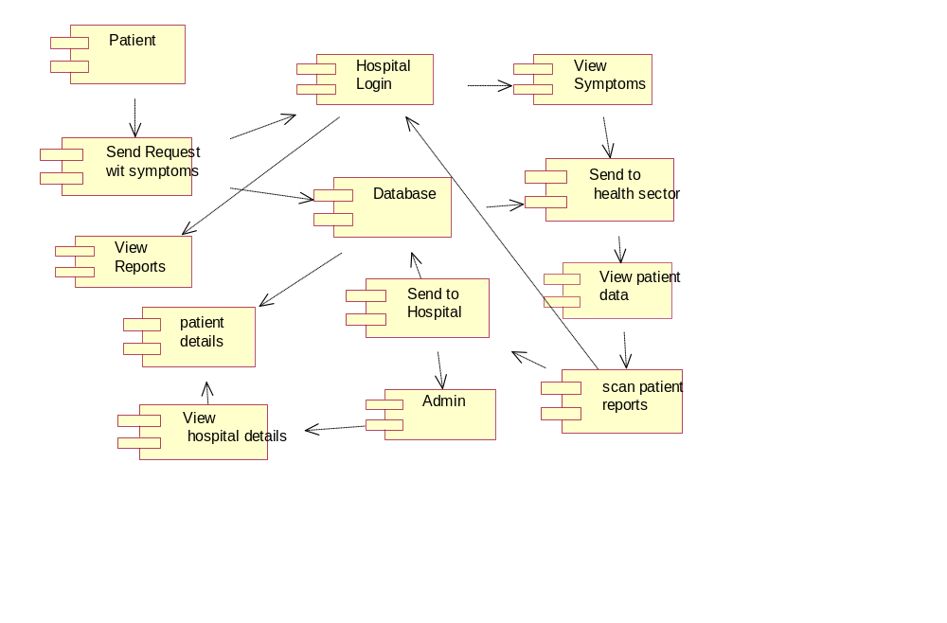

EXPLANATION:
In the Unified Modeling Language, a component diagram depicts how components are wired together to form larger components and or software systems. They are used to illustrate the structure of arbitrarily complex systems. User gives main query and it converted into sub queries and sends through data dissemination to data aggregators. Results are to be showed to user by data aggregators. All boxes are components and arrow indicates dependencies.

4.1.9 E-R Diagram:
Patient/user
Login
Hospital
Health Sector
Send Symptoms Request To Hospital
View Report
View Patient Data
Send Report To Health Sector
View patient Data
Scan patient Data
Send Reports To Hospital
Send Reports to User
Admin Login
Database
Request Key
Decrypt Reports with Key
Patient Details
Hospital Details

EXPLANATION:
Entity-Relationship Model (ERM) is an abstract and conceptual representation of data. Entity-relationship modeling is a database modeling method, used to produce a type of conceptual schema or semantic data model of a system, often a relational database.
4.1.10 Data Flow Diagram:

Level 0:

Patient
Login Page
Server
Error Message
Patient Page
Database

Level 1:

Database
Login
Home Page
Hospital
View patient symptoms
Send to health sector
View Reports
Patient Login
View reports and request for key
View key and decrypt reports

EXPLANATION:
A data flow diagram (DFD) is a graphical representation of the "flow" of data through an information system, modeling its process aspects. Often they are a preliminary step used to create an overview of the system which can later be elaborated. DFDs can also be used for the visualization of data processing (structured design).
A DFD shows what kinds of data will be input to and output from the system, where the data will come from and go to, and where the data will be stored. It does not show information about the timing of processes, or information about whether processes will operate in sequence or in parallel.

4.1.11 Deployment Diagram:

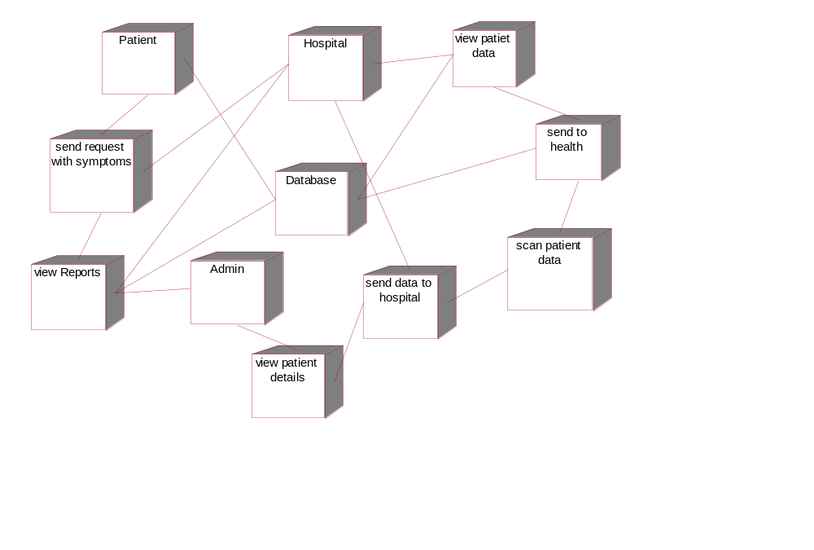

EXPLANATION:
In the Unified Modeling Language, a component diagram depicts how components are wired together to form larger deployment and or software systems. They are used to illustrate the structure of arbitrarily complex systems. User gives main query and it converted into sub queries and sends through data dissemination. Results are to be showed to user by data aggregators. All boxes are arrow indicates dependencies.
4.2 System Architecture
Patient
Register/Login
Search hospital and enter symptoms
View Reports data will be Encrypted. Request keys
Use Key and Decrypt Reports
Hospital
Login
View patient Data
Send Data to Health Sector
Share Reports with patient and generate Keys if patient requested
Health Sector
Login
View symptoms
Scan patient data
Send Reports to Hospital
DataBase
Admin
Login
Patient Details
Hospital details
CHAPTER 5
DEVELOPMENT TOOLS
  - GENERAL
This chapter is about the software language and the tools used in the development of the project. The platform used here is JAVA. The Primary languages are JAVA, J2EE and J2ME. In this project J2EE is chosen for implementation.
5.2 FEATURES OF JAVA
5.2.1 THE JAVA FRAMEWORK
Java is a programming language originally developed by James Gosling at Microsystems and released in 1995 as a core component of Sun Microsystems' Java platform. The language derives much of its syntax from C and C++ but has a simpler object model and fewer low-level facilities. Java applications are typically compiled to byte code that can run on any Java Virtual Machine (JVM) regardless of computer architecture. Java is general-purpose, concurrent, class-based, and object-oriented, and is specifically designed to have as few implementation dependencies as possible. It is intended to let application developers "write once, run anywhere".
Java is considered by many as one of the most influential programming languages of the 20th century, and is widely used from application software to web applications the java framework is a new platform independent that simplifies application development internet. Java technology's versatility, efficiency, platform portability, and security make it the ideal technology for network computing. From laptops to datacenters, game consoles to scientific supercomputers, cell phones to the Internet, Java is everywhere!

5.2.2 OBJECTIVES OF JAVA
To see places of Java in Action in our daily life, explore java.com.

Why Software Developers Choose Java
Java has been tested, refined, extended, and proven by a dedicated community. And numbering more than 6.5 million developers, it's the largest and most active on the planet. With its versatility, efficiency, and portability, Java has become invaluable to developers by enabling them to:
- Write software on one platform and run it on virtually any other platform
- Create programs to run within a Web browser and Web services
- Develop server-side applications for online forums, stores, polls, HTML forms processing, and more
- Combine applications or services using the Java language to create highly customized applications or services
- Write powerful and efficient applications for mobile phones, remote processors, low-cost consumer products, and practically any other device with a digital heartbeat

Some Ways Software Developers Learn Java
Today, many colleges and universities offer courses in programming for the Java platform. In addition, developers can also enhance their Java programming skills by reading Sun's java.sun.com Web site, subscribing to Java technology-focused newsletters, using the Java Tutorial and the New to Java Programming Center, and signing up for Web, virtual, or instructor-led courses.
ObjectOriented
To be an Object Oriented language, any language must follow at least the four characteristics.
1. Inheritance: It is the process of creating the new classes and using the behavior of the existing classes by extending them just to reuse the existing code and adding addition a features as needed.
2. Encapsulation: It is the mechanism of combining the information and providing the abstraction.
3. Polymorphism: As the name suggest one name multiple form, Polymorphism is the way of providing the different functionality by the functions having the same name based on the signatures of the methods.
4. Dynamic binding: Sometimes we don't have the knowledge of objects about their specific types while writing our code. It is the way of providing the maximum functionality to a program about the specific type at runtime.
5.2.3 JAVA SWING OVERVIEW
Abstract Window Toolkit (AWT) is cross-platform
Swing^{[1]} provides many controls and widgets to build user interfaces with. Swing class names typically begin with a J such as JButton, JList, JFrame. This is mainly to differentiate them from their AWT counterparts and in general is one-to-one replacements. Swing is built on the concept of Lightweight components vs AWT and SWT's concept of Heavyweight components. The difference between the two is that the Lightweight components are rendered (drawn) using purely Java code, such as drawLine and drawImage, whereas Heavyweight components use the native operating system to render the components.
Some components in Swing are actually heavyweight components. The top-level classes and any derived from them are heavyweight as they extend the AWT versions. This is needed because at the root of the UI, the parent windows need to be provided by the OS. These top-level classes include JWindow, JFrame, JDialog and JApplet. All Swing components to be rendered to the screen must be able to trace their way to a root window of one of those classes.

Note: It generally it is not a good idea to mix heavyweight components with lightweight components (other than as previously mentioned) as you will encounter layering issues, e.g., a lightweight component that should appear "on top" ends up being obscured by a heavyweight component. The few exceptions to this include using heavyweight components as the root pane and for popup windows. Generally speaking, heavyweight components will render on top of lightweight components and will not be consistent with the look and feel being used in Swing. There are exceptions, but that is an advanced topic. The truly adventurous may want to consider reading this article from Sun on mixing heavyweight and lightweight components.
5.2.4 EVOLUTION OF COLLECTION FRAMEWORK:
Almost all collections in Java are derived from the java.util.Collection interface. Collection defines the basic parts of all collections. The interface states the add() and remove() methods for adding to and removing from a collection respectively. Also required is the toArray() method, which converts the collection into a simple array of all the elements in the collection. Finally, the contains() method checks if a specified element is in the collection. The Collection interface is a sub interface of java.util.Iterable, so the iterator() method is also provided. All collections have an iterator that goes through all of the elements in the collection. Additionally, Collection is a generic. Any collection can be written to store any class. For example, Collection<String> can hold strings, and the elements from the collection can be used as strings without any casting required.
There are three main types of collections:
- Lists: always ordered, may contain duplicates and can be handled the same way as usual arrays
- Sets: cannot contain duplicates and provide random access to their elements
- Maps: connect unique keys with values, provide random access to its keys and may host duplicate values

LIST:
Lists are implemented in the JCF via the java.util.List interface. It defines a list as essentially a more flexible version of an array. Elements have a specific order, and duplicate elements are allowed. Elements can be placed in a specific position. They can also be searched for within the list. Two concrete classes implement List. The first is java.util.ArrayList, which implements the list as an array. Whenever functions specific to a list are required, the class moves the elements around within the array in order to do it. The other implementation is java.util.LinkedList. This class stores the elements in nodes that each have a pointer to the previous and next nodes in the list. The list can be traversed by following the pointers, and elements can be added or removed simply by changing the pointers around to place the node in its proper place.
SET:
Java's java.util.Set interface defines the set. A set can't have any duplicate elements in it. Additionally, the set has no set order. As such, elements can't be found by index. Set is implemented by java.util.HashSet,java.util.LinkedHashSet, and java.util.TreeSet. HashSet uses a hash table. More specifically, it uses a java.util.HashMap to store the hashes and elements and to prevent duplicates. Java.util.LinkedHashSet extends this by creating a doubly linked list that links all of the elements by their insertion order. This ensures that the iteration order over the set is predictable. java.util.TreeSet uses a red-black tree implemented by a java.util.TreeMap. The red-black tree makes sure that there are no duplicates. Additionally, it allows Tree Set to implement java.util.SortedSet.
The java.util.Set interface is extended by the java.util.SortedSet interface. Unlike a regular set, the elements in a sorted set are sorted, either by the element's compareTo() method, or a method provided to the constructor of the sorted set. The first and last elements of the sorted set can be retrieved, and subsets can be created via minimum and maximum values, as well as beginning or ending at the beginning or ending of the sorted set. The SortedSet interface is implemented by java.util.TreeSet

java.util.SortedSet is extended further via the java.util.NavigableSet interface. It's similar to SortedSet, but there are a few additional methods. The floor(), ceiling(), lower(), and higher() methods find an element in the set that's close to the parameter. Additionally, a descending iterator over the items in the set is provided. As with SortedSet, java.util.TreeSet implements NavigableSet.
MAP:
Maps are defined by the java.util.Map interface in Java. Maps are simple data structures that associate a key with a value. The element is the value. This lets the map be very flexible. If the key is the hash code of the element, the map is essentially a set. If it's just an increasing number, it becomes a list. Maps are implemented by java.util.HashMap, java.util.LinkedHashMap, and java.util.TreeMap. HashMap uses a hash table. The hashes of the keys are used to find the values in various buckets. LinkedHashMap extends this by creating a doubly linked list between the elements. This allows the elements to be accessed in the order in which they were inserted into the map. TreeMap, in contrast to HashMap and LinkedHashMap, uses a red-black tree. The keys are used as the values for the nodes in the tree, and the nodes point to the values in the map
THREAD:
Simply put, a thread is a program's path of execution. Most programs written today run as a single thread, causing problems when multiple events or actions need to occur at the same time. Let's say, for example, a program is not capable of drawing pictures while reading keystrokes. The program must give its full attention to the keyboard input lacking the ability to handle more than one event at a time. The ideal solution to this problem is the seamless execution of two or more sections of a program at the same time.

CREATING THREADS:
Java's creators have graciously designed two ways of creating threads: implementing an interface and extending a class. Extending a class is the way Java inherits methods and variables from a parent class. In this case, one can only extend or inherit from a single parent class. This limitation within Java can be overcome by implementing interfaces, which is the most common way to create threads. (Note that the act of inheriting merely allows the class to be run as a thread. It is up to the class to start() execution, etc.)
Interfaces provide a way for programmers to lay the groundwork of a class. They are used to design the requirements for a set of classes to implement. The interface sets everything up, and the class or classes that implement the interface do all the work. The different set of classes that implement the interface have to follow the same rules.
5.3 CONCLUSION
Swing's high level of flexibility is reflected in its inherent ability to override the native host operating system (OS)'s GUI controls for displaying itself. Swing "paints" its controls using the Java 2D APIs, rather than calling a native user interface toolkit. The Java thread scheduler is very simple. All threads have a priority value which can be changed dynamically by calls to the threads setPriority() method . Implementing the above concepts in our project to do the efficient work among the Server.

CHAPTER 6
IMPLEMENTATION
6.1 GENERAL
The Implementation is nothing but sores code of project.
6.2 IMPLEMENTATION
Coding:
Html.jsp

<%@ page language="java" contentType="text/html; charset=ISO-8859-1"
pageEncoding="ISO-8859-1"%>
<!DOCTYPE html>
<html>
<head>
<meta charset="ISO-8859-1">
<title>Home Page</title>
</head>
<body>
<jsp:include page="common/header1.jsp"></jsp:include>
<center style="color:white"><h1>
</h2></center>
</body>
</html>

Login.jsp

<%@ page language="java" contentType="text/html; charset=ISO-8859-1"
pageEncoding="ISO-8859-1"%>

<!DOCTYPE html>
<html>
<head>
<meta charset="ISO-8859-1">
<title>Login Form</title>
<style>
body {
margin: 0px;
padding: 0px;
background: url('image/b1.jpg');
background-size: cover;
bacground-position: center;
font-family: sans-serif;
background-repeat:no-repeat;
padding:;
}

.loginbox {
width: 320px;
height: 420px;
background: rgba(255, 255, 255, 0.3);
color: #fff;
top: 52%;
left: 50%;
position: absolute;
transform: translate(-50%, -50%);
box-sizing: border-box;
padding: 70px 30px;
margin-top: 4%;
}

.avatar {
width: 100px;
height: 100px;
border-radius: 50%;
position: absolute;
top: -50px;
left: 100px;
left: calc(50% -50px);
}

h1 {
margin: 0;
padding: 0 0 20px;
text-aligh: center;
font-size: 22px;
text-align: center;
}

.loginbox p {
margin: 0;
padding: 0;
font-weight: bold;
}

.loginbox input {
width: 100%;
margin-bottom: 20px;
}

.loginbox input[type="text"], input[type="password"] {
border: none;
border-bottom: 1px;
background: transparent;
outline: none;
height: 40px;
color: #fff;
font-size: 16px;
}

.loginbox input[type="submit"] {
border: none;
outline: none;
height: 40px;
background: #fb2525;
color: #fff;
font-size: 18px;
border-radius: 20px;
}

.loginbox input[type="submit"]:hover {
cursor: pointer;
background: gray;
color: #000;
}

.loginbox a {
text-decoration: none;
font-size: 12px;
line-height: 20px;
color: darkgrey;
}

.side {
float: left;
width:898px ;
height:425px;
margin-top: 2%;
margin-left: 1%;
}
</style>
</head>
<body>
<jsp:include page="common/header1.jsp"></jsp:include>
<div class="loginbox">
<center style="color: yellow">${alert }</center>
<br>
<h1 style="color: red">User Login </h1>
<form action="./login" method="post">
<p>User Name</p>
<input type="text" name="uname" placeholder="Enter Username">
<p>Password</p>
<input type="password" name="password" placeholder="Enter Password">
<input type="Submit" name="submit" value="Login">
<a href="forget.jsp" style="color:white">Lost Your Password</a><br>
<a href="register.jsp" style="color:white">Don't Have an Account</a>
</form>
</div>

</body>
</html>

MyPickedDataController.java

package controller;
import java.io.IOException;
import java.util.List;
import javax.servlet.ServletException;
import javax.servlet.annotation.WebServlet;
import javax.servlet.http.HttpServlet;
import javax.servlet.http.HttpServletRequest;
import javax.servlet.http.HttpServletResponse;
import javax.servlet.http.HttpSession;
import bean.DataSetBean;
import service.ManageDataSetService;
import service.ManageDataSetServiceImpl;
@WebServlet("/myPicked")
public class MyPickedDataController extends HttpServlet {
private static final long serialVersionUID = -7814006161653354225L;

@Override
protected void doGet(HttpServletRequest req, HttpServletResponse resp) throws ServletException, IOException {
doPost(req, resp);
}
@Override
protected void doPost(HttpServletRequest req, HttpServletResponse resp) throws ServletException, IOException {
HttpSession session = req.getSession();
String uname = (String) session.getAttribute("uname");

ManageDataSetService service = new ManageDataSetServiceImpl();
List<DataSetBean> list = service.getMyPicked(uname);

if (list != null) {
req.setAttribute("list", list);
}
req.getRequestDispatcher("myPicked.jsp").forward(req, resp);
}
}

UploadDatasetController.java

package controller;
import java.io.IOException;
import javax.servlet.ServletException;
import javax.servlet.annotation.WebServlet;
import javax.servlet.http.HttpServlet;
import javax.servlet.http.HttpServletRequest;
import javax.servlet.http.HttpServletResponse;
import javax.servlet.http.HttpSession;
import bean.DataSetBean;
import service.ManageDataSetService;
import service.ManageDataSetServiceImpl;
@WebServlet("/uploadDataset")
public class UploadDatasetController extends HttpServlet {
private static final long serialVersionUID = -6316003392660605616L;
@Override
protected void doGet(HttpServletRequest req, HttpServletResponse resp) throws ServletException, IOException {
doPost(req, resp);
}
@Override
protected void doPost(HttpServletRequest req, HttpServletResponse resp) throws ServletException, IOException {
DataSetBean bean = new DataSetBean();
bean.setFrom_user(req.getParameter("name"));
bean.setDataset_name(req.getParameter("dataSetName"));
bean.setDataset(req.getParameter("dataSet"));
bean.setSubject(req.getParameter("subject"));
bean.setMessage(req.getParameter("message"));
HttpSession session = req.getSession();
bean.setFrom_user((String) session.getAttribute("uname"));
;
ManageDataSetService service = new ManageDataSetServiceImpl();
boolean result = service.uploadDataSet(bean);
if (result != false) {
req.setAttribute("alert", "Uploaded Successfull");
} else {
req.setAttribute("alert", "Uploaded Failed");
}
req.getRequestDispatcher("uploadDataSet.jsp").forward(req, resp);
}
}

SimilarityValueController.java

package controller;
import java.io.IOException;
import javax.servlet.ServletException;
import javax.servlet.annotation.WebServlet;
import javax.servlet.http.HttpServlet;
import javax.servlet.http.HttpServletRequest;
import javax.servlet.http.HttpServletResponse;
import service.AdminManageService;
import service.AdminManageServiceImpl;
@WebServlet("/similarityValue")
public class SimilarityValueController extends HttpServlet {
@Override
protected void doGet(HttpServletRequest req, HttpServletResponse resp) throws ServletException, IOException {
doPost(req, resp);
}
@Override
protected void doPost(HttpServletRequest req, HttpServletResponse resp) throws ServletException, IOException {
AdminManageService service = new AdminManageServiceImpl();
int[] i = service.getSimilarityValue();
System.out.println(i[0]);//print the value
if (i != null) {
int Romance = i[0] * 10;
int Comedy = i[1] * 10;
int Drama = i[2] * 10;
int Animation = i[3] * 10;
int Fantasy = i[4] * 10;
int Action = i[5] * 10;
req.setAttribute("Romance", Romance);
req.setAttribute("Comedy", Comedy);
req.setAttribute("Drama", Drama);
req.setAttribute("Animation", Animation);
req.setAttribute("Fantasy", Fantasy);
req.setAttribute("Action", Action);
} req.getRequestDispatcher("similarValue.jsp").forward(req, resp);
}

}

CHAPTER 7
SNAPSHOTS
7.1 GENERAL
This project is implements like web application using COREJAVA and the Server process is maintained using the SOCKET & SERVERSOCKET and the Design part is played by Cascading Style Sheet.
7.2 VARIOUS SNAPSHOTS

CHAPTER 8
SOFTWARE TESTING

8.1 GENERAL
The purpose of testing is to discover errors. Testing is the process of trying to discover every conceivable fault or weakness in a work product. It provides a way to check the functionality of components, sub-assemblies, assemblies and/or a finished product It is the process of exercising software with the intent of ensuring that the Software system meets its requirements and user expectations and does not fail in an unacceptable manner. There are various types of test. Each test type addresses a specific testing requirement.

8.2 DEVELOPING METHODOLOGIES
The test process is initiated by developing a comprehensive plan to test the general functionality and special features on a variety of platform combinations. Strict quality control procedures are used. The process verifies that the application meets the requirements specified in the system requirements document and is bug free. The following are the considerations used to develop the framework from developing the testing methodologies.

8.3 Types of Tests

8.3.1 Unit testing
Unit testing involves the design of test cases that validate that the internal program logic is functioning properly, and that program input produce valid outputs. All decision branches and internal code flow should be validated. It is the testing of individual software units of the application .it is done after the completion of an individual unit before integration. This is a structural testing, that relies on knowledge of its construction and is invasive. Unit tests perform basic tests at component level and test a specific business process, application, and/or system configuration. Unit tests ensure that each unique path of a business process performs accurately to the documented specifications and contains clearly defined inputs and expected results.

8.3.2 Functional test
Functional tests provide systematic demonstrations that functions tested are available as specified by the business and technical requirements, system documentation, and user manuals.
Functional testing is centered on the following items:
Valid Input : identified classes of valid input must be accepted.
Invalid Input : identified classes of invalid input must be rejected.
Functions : identified functions must be exercised.
Output : identified classes of application outputs must be exercised.
Systems/Procedures : interfacing systems or procedures must be invoked.

8.3.3 System Test
System testing ensures that the entire integrated software system meets requirements. It tests a configuration to ensure known and predictable results. An example of system testing is the configuration oriented system integration test. System testing is based on process descriptions and flows, emphasizing pre-driven process links and integration points.

8.3.4 Performance Test
The Performance test ensures that the output be produced within the time limits, and the time taken by the system for compiling, giving response to the users and request being send to the system for to retrieve the results.

8.3.5 Integration Testing
Software integration testing is the incremental integration testing of two or more integrated software components on a single platform to produce failures caused by interface defects.
The task of the integration test is to check that components or software applications, e.g. components in a software system or – one step up – software applications at the company level – interact without error.

8.3.6 Acceptance Testing
User Acceptance Testing is a critical phase of any project and requires significant participation by the end user. It also ensures that the system meets the functional requirements.

Acceptance testing for Data Synchronization:
- The Acknowledgements will be received by the Sender Node after the Packets are received by the Destination Node
- The Route add operation is done only when there is a Route request in need
- The Status of Nodes information is done automatically in the Cache Updation process

8.3.7 Build the test plan

Any project can be divided into units that can be further performed for detailed processing. Then a testing strategy for each of this unit is carried out. Unit testing helps to identity the possible bugs in the individual component, so the component that has bugs can be identified and can be rectified from errors.

CHAPTER 9
APPLICATION
9.1 GENERAL
Finally, a rank of data containing the filtered data with correlation value is given as the data feed.
9.2 FUTURE ENHANCEMENT
Existing data deduplication systems face severe fragmentation problems. The fragmentation can cause random reads and lowers the throughput of data restoration. Some proposals exploit rewriting schemes to relocate unique chunks, and thus can mitigate the fragmentation problem to some extent. A few proposals exploit other optimizations such as caching to accelerate the data restoration due to fragmentation. However, the fragmentation problem is always accompanied with the data deduplication. We can explore defragmentation technologies to mitigate this problem in an offline manner. On the other hand, since the random read performance of NVMs is much higher than that of SSDs/HDDs the fragmentation is no longer a critical problem for NVM-based storage systems.
CHAPTER 10
CONCLUSION & REFERENCE
10.1 CONCLUSION
In this paper, we present an I/O Causality-based Inline Deduplication (ICID) scheme for NVM-based storage. ICID records the I/O causality among in-memory file operations to achieve in-line data deduplication, and avoid the time-consuming calculation of fingerprints caused by previous chunk-based deduplication schemes. We advocate two key technologies to manage memory-copy operations in a B-tree efficiently, i.e., a hybrid data structure to store memory-copy records, and a location-dependent garbage collection scheme for deleting outdated memory-copy records. Our experimental result demonstrates that ICID achieves up to 16× higher deduplication ratio than state-of-the-art deduplication schemes, and also reduces the time overhead of data deduplication by 47% on average.
10.2 REFERENCE
[1] K. Srinivasan, T. Bisson, G. Goodson, and K. Voruganti, “iDedup: Latency-aware, inline data deduplication for primary storage,” in Proc. 10th USENIX Conf. File Storage Technol. (FAST), vol. 12, 2012, pp. 1–14.
[2] “IntelR OptaneTM Technology.” 2021. Accessed: Dec. 29, 2023. [Online]. Available: https://www.intel.com/content/www/us/en/products/ docs/memory-storage/optane-persistent-memory/overview.html
[3] D. Yang, H. Liu, H. Jin, and Y. Zhang, “HMvisor: Dynamic hybrid memory management for virtual machines,” Sci. China Inf. Sci., vol. 64, no. 9, pp. 192 104 1–16, 2021.
[4] Y. Xie, “Modeling, architecture, and applications for emerging memory technologies,” IEEE Des. Test Comput., vol. 28, no. 1, pp. 44–51, Jan./Feb. 2011.
[5] C. Tian, H. Liu, X. Liao, and H. Jin, “UCat: Heterogeneous memory management for unikernels,” Frontiers Comput. Sci., vol. 17, no. 1, pp. 171204–171215, 2022.
[6] M. K. Qureshi, J. Karidis, M. Franceschini, V. Srinivasan, L. Lastras, and B. Abali, “Enhancing lifetime and security of PCM-based main memory with start-gap wear leveling,” in Proc. Annu. IEEE/ACM Int. Symp. Microarchit. (MICRO), 2009, pp. 14–23.
[7] M. Fu et al., “Design tradeoffs for data deduplication performance in backup workloads,” in Proc. 13th USENIX Conf. File Storage Technol. (FAST), 2015, pp. 331–344.
[8] S. Mandal et al., “Using hints to improve inline block-layer deduplication,” in Proc. 14th USENIX Conf. File Storage Technol. (FAST), 2016, pp. 315–322.
[9] A. Muthitacharoen, B. Chen, and D. Mazieres, “A low-bandwidth network file system,” Proc. 18th ACM Symp. Operating Syst. Princ. (SOSP), 2001, pp. 174–187.
[10] W. Xia et al., “A comprehensive study of the past, present, and future of data deduplication,” Proc. IEEE, vol. 104, no. 9, pp. 1681–1710, Sep. 2016.
[11] W. Xia, H. Jiang, D. Feng, and Y. Hua, “Similarity and locality based indexing for high performance data deduplication,” IEEE Trans. Comput., vol. 64, no. 4, pp. 1162–1176, Apr. 2015. 1340 IEEE TRANSACTIONS ON COMPUTERS, VOL. 73, NO. 5, MAY 2024
[12] F. Guo and P. Efstathopoulos, “Building a high-performance deduplication system,” in Proc. USENIX Conf. USENIX Annu. Tech. Conf. (ATC), 2011, pp. 25–39.
[13] C. Yu, C. Zhang, Y. Mao, and F. Li, “Leap-based content defined chunking—Theory and implementation,” in Proc. IEEE 31st Symp. Mass Storage Syst. Technol. (MSST), 2015, pp. 1–12.
[14] J. Park, J. Kim, Y. Kim, S. Lee, and O. Mutlu, “DeepSketch: A new machine learning-based reference search technique for post-deduplication delta compression,” in Proc. 20th USENIX Conf. File Storage Technol. (FAST), 2022, pp. 247–264.
[15] “libfuse.” GitHub. Accessed: Dec. 29, 2023. [Online]. Available: https:// github.com/libfuse/libfuse.git
[16] G. Fan, L. Yongkun, X. Yinlong, J. Song, and J. C. S. Lui, “SmartMD: A high performance deduplication engine with mixed pages,” in Proc. USENIX Annu. Tech. Conf. (ATC), 2017, pp. 733–744.
[17] X. Nai, T. Chen, L. Yan, L. Hang, and W. Xiaoliang, “UKSM: Swift memory deduplication via hierarchical and adaptive memory region distilling,” in Proc. 16th USENIX Conf. File Storage Technol. (FAST), 2018, pp. 325–340.
[18] F. Chen, T. Luo, and X. Zhang, “CAFTL: A Content-Aware flash translation layer enhancing the lifespan of flash memory based solid state drives,” in Proc. 9th USENIX Conf. File Stroage Technol. (FAST), 2011, pp. 6–20.
[19] S. Quinlan and S. Dorward, “Venti: A new approach to archival data storage,” in Proc. Conf. File Storage Technol. (FAST), 2002, pp. 7–21.
[20] C. Wang, Q. Wei, J. Yang, C. Chen, Y. Yang, and M. Xue, “NV-Dedup: High-performance inline deduplication for non-volatile memory,” IEEE Trans. Comput., vol. 67, no. 5, pp. 658–671, May 2018.
[21] Y. Zhang et al., “AE: An asymmetric extremum content defined chunking algorithm for fast and bandwidth-efficient data deduplication,” in Proc. IEEE Conf. Comput. Commun. (INFOCOM), 2015, pp. 1337–1345.
[22] W. Xia et al., “FastCDC: A fast and efficient content-defined chunking approach for data deduplication,” in Proc. USENIX Annu. Tech. Conf. (ATC), 2016, pp. 101–114.
[23] L. Aronovich, R. Asher, E. Bachmat, H. Bitner, M. Hirsch, and S. T. Klein, “The design of a similarity based deduplication system,” in Proc. Israeli Exp. Syst. Conf. (SYSTOR), 2009, pp. 1–14.
[24] B. Zhu, K. Li, and H. Patterson, “Avoiding the disk bottleneck in the data domain deduplication file system,” in Proc. 6th USENIX Conf. File Storage Technol. (FAST), 2008, pp. 269–282.
[25] A. Gupta, R. Pisolkar, B. Urgaonkar, and A. Sivasubramaniam, “Leveraging value locality in optimizing NAND flash-based SSDs,” in Proc. 9th USENIX Conf. File Stroage Technol. (FAST), 2011, pp. 7–20.
[26] V. Tarasov et al., “Dmdedup: Device mapper target for data deduplication,” in Proc. Ottawa Linux Symp. (OLS), 2014, pp. 1–13.
[27] C. Ji et al., “Pattern-guided file compression with user-experience enhancement for log-structured file system on mobile devices,” in Proc. 19th USENIX Conf. File Storage Technol. (FAST), 2021, pp. 127–140.
[28] M. Seo and S. Lim, “Deduplication flash file system with PRAM for non-linear editing,” IEEE Trans. Consum. Electron., vol. 56, no. 3, pp. 1502–1510, Aug. 2010.
[29] K.-K. Muniswamy-Reddy et al., “Layering in provenance systems,” in Proc. USENIX Annu. Tech. Conf. (ATC), 2009, pp. 10–24.
[30] “GNU Patch.” Accessed: Dec. 29, 2023. [Online]. Available: https:// savannah.gnu.org/projects/patch/
[31] “FFmpeg.” Accessed: Dec. 29, 2023. [Online]. Available: https://www. ffmpeg.org/
[32] S. Ghemawat and J. Dean, “Google LevelDB.” GitHub, 2016. Accessed: Dec. 29, 2023. [Online].
[33] C. Lee, D. Sim, J. Hwang, and S. Cho, “F2FS: A new file system for flash storage,” in Proc. USENIX Conf. File Storage Technol. (FAST), 2015, pp. 273–286.
[34] J. Xu and S. Swanson, “NOVA: A log-structured file system for hybrid volatile/non-volatile main memories,” in Proc. 14th USENIX Conf. File Storage Technol. (FAST), 2016, pp. 323–338.
[35] “XXHash.” GitHub. Accessed: Dec. 29, 2023. [Online].
[36] A. Z. Broder, “Some applications of Rabin’s fingerprinting method,” in Proc. Sequences II Methods Commun., Secur., Comput. Sci., 1993, pp. 143–152.
[37] B. Mao, H. Jiang, S. Wu, Y. Fu, and L. Tian, “Read-performance optimization for deduplication-based storage systems in the cloud,” ACM Trans. Storage, vol. 10, no. 2, pp. 6:1–6:22, 2014.
[38] Y. Xu, C. Ye, Y. Solihin, and X. Shen, “FFCCD: Fence-free crashconsistent concurrent defragmentation for persistent memory,” in Proc. 49th Annu. Int. Symp. Comput. Archit. (ISCA), 2022, pp. 274–288.

