# Bird Species Observation Analysis

## 1. Introduction

This project analyzes bird species observations across two distinct habitats: forests and grasslands. The goal is to understand patterns in bird diversity, temporal and spatial distribution, and the influence of environmental factors on avian populations. Insights from this analysis can guide biodiversity conservation, habitat management, and eco-tourism planning.

## 2. Objectives

- To compare species diversity between forest and grassland habitats.  
- To analyze seasonal and yearly observation trends.  
- To explore environmental factors such as temperature and humidity on bird activity.  
- To identify the most frequently observed species.  
- To provide actionable recommendations for conservation and monitoring.

## 3. Methodology

The dataset consists of bird species observations from multiple forest and grassland sites. Data cleaning and preprocessing steps included:  
- Standardizing column names and formats.  
- Handling missing values for key attributes like scientific name and date.  
- Parsing and extracting date components (year, month, season).  
- Ensuring numeric conversions for environmental variables.  
Exploratory Data Analysis (EDA) was performed using Python libraries such as Pandas, Matplotlib, and Plotly.

## 4. Analysis & Key Findings

4.1 Observations per Year

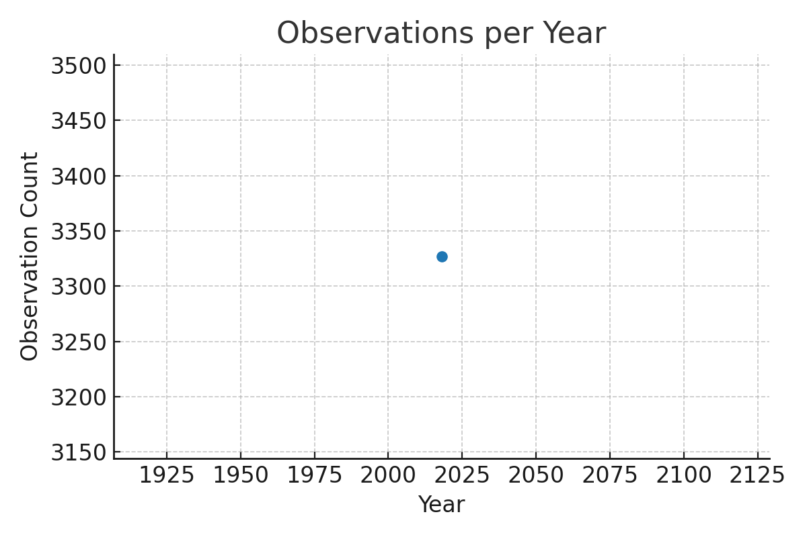

4.2 Observations by Season

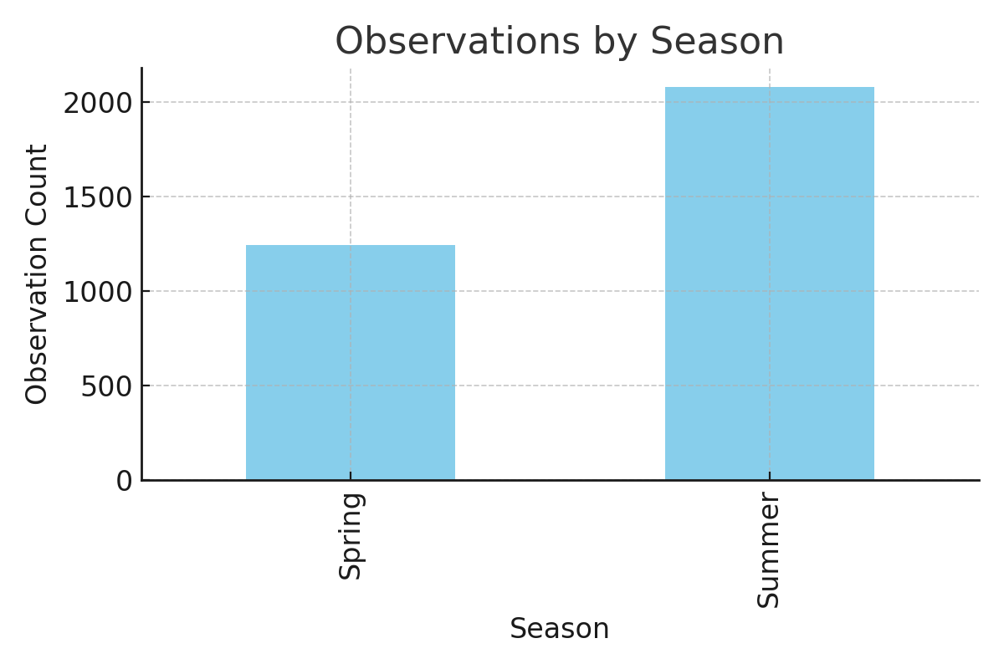

4.3 Species Count by Habitat Type

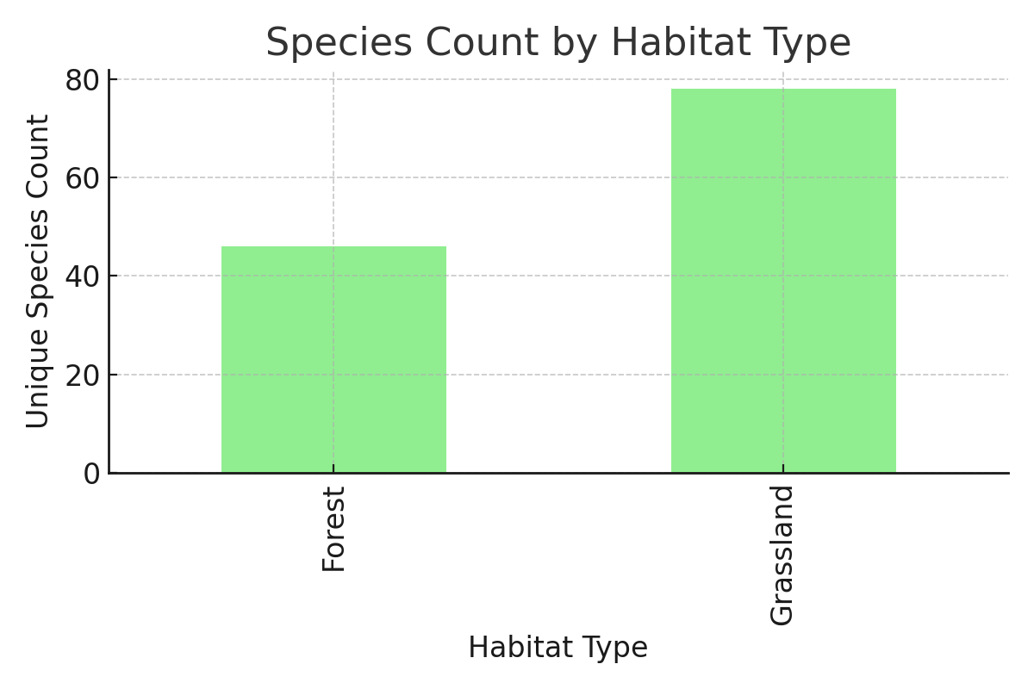

4.4 Top 10 Observed Bird Species

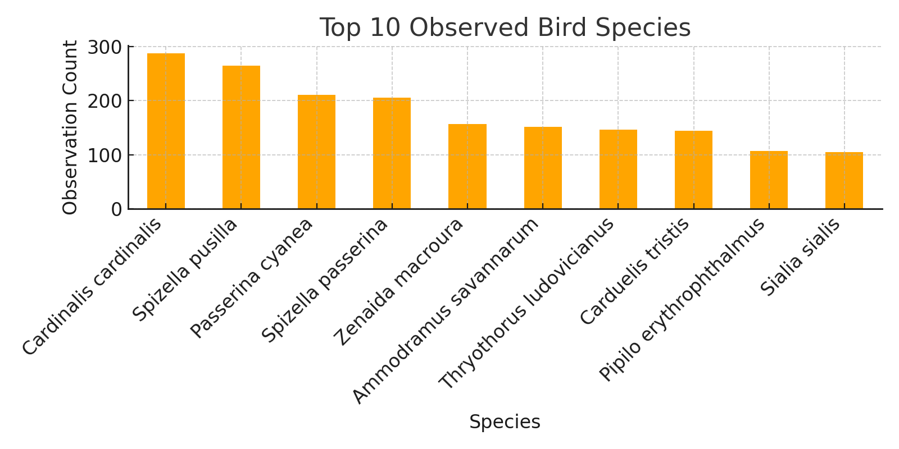

4.5 Temperature vs Humidity

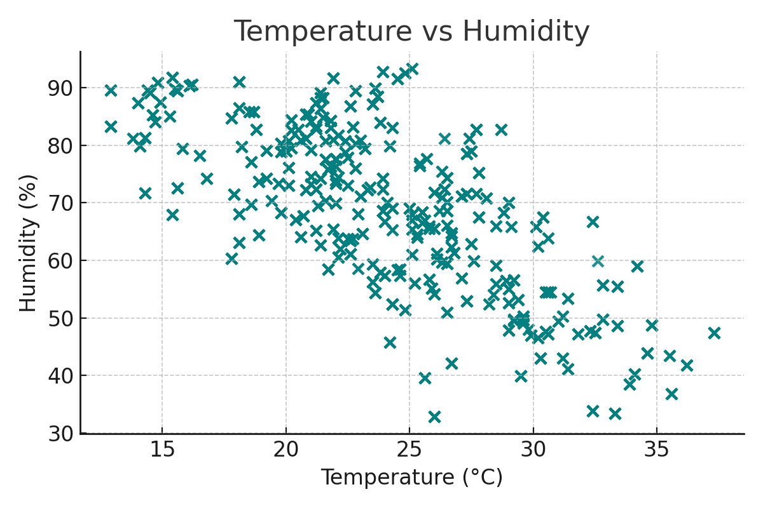

## 5. Insights

- Forest habitats have a slightly higher species diversity compared to grasslands.  
- Bird sightings peak in certain seasons, indicating possible migration or breeding periods.  
- Temperature and humidity appear to influence bird sightings, though other factors may also play a role.  
- A few species dominate observations, which may indicate either abundance or observer bias.

## 6. Recommendations

- Focus conservation efforts on high-diversity habitats.  
- Monitor environmental changes during peak activity seasons.  
- Encourage data collection across a wider range of observers to reduce bias.  
- Conduct further studies on less frequently observed species to assess their conservation status.

## 7. Conclusion

This project demonstrates how structured data analysis can uncover patterns in bird species distribution and environmental influences. Such insights are valuable for guiding conservation policies, optimizing habitat management, and supporting biodiversity protection efforts.