Task 1:

1. Create database techshop

Use techshop

1. Create table Customers ( CustomerID int primary key, Firstname varchar(55), Lastname varchar(55), Email Text, Phone varchar(10), address text);

Create table Products ( ProductID int primary key, productname varchar(55), description text , Price int);

Create table Orders ( OrderID int primary key, CustomerID int foreign key references Customers(CustomerID),OrderDate date , totalamount int);

Create table OrderDetails (OrderDetailID int primary key, OrderID int foreign key references Orders(OrderID), ProductID int foreign key references Products(ProductID), Quantity int);

Create table Inventory( InventoryID int primary key , ProductID int foreign key references Products(ProductID), Quantityinstock int, LastStockupdate date);

2. Primary key and foreign key constraints given in the create queries

a) insert into Customers values (1,'Theo','Ron','theo@gmail.com','12345678','2nd street abc');

insert into Customers values (2,'Sai','Rithesh','sai@gmail.com','23212342','Chennai'),(3, 'Ricardo', 'Kaka', 'rk@gmail.com', '3456789012', 'Milano san siro'),

(4, 'Leo', 'Messi', 'lm@gmail.com', '4567890123', 'Barcelona camp nou'),

(5, 'Cristiano', 'Ronaldo', 'cr7@gmail.com', '5678901234', 'Santiago bernabeau Madrid Spain'),

(6, 'Neymar', 'Silva', 'njr@gmail.com', '6789012345', 'Santos Urbano caldeira Brazil'),

(7, 'Lamine', 'Yamal', 'ly@gmail.com', '7890123456', 'Barca Spain Le Rambla'),

(8, 'Paolo', 'Maldini', 'rm@gmail.com', '8901234567', 'Via del corso Italy'),

(9, 'Sergio', 'Ramos', 'sr@gmail.com', '9012345678', 'Galacticos Madridista Spain'),

(10, 'Thierry', 'henry', 'th@gmail.com', '0123456789', 'Arsenal Emirates England');

b) insert into Products values (1, 'Laptop', '15-inch laptop with 16GB RAM', 1000),

(2, 'Smartphone', 'Latest model smartphone with 128GB storage', 800),

(3, 'Tablet', '10-inch tablet', 500),

(4, 'Headphones', 'Noise-cancelling ear headphones', 500),

(5, 'Smartwatch', 'Water-resistant smartwatch', 1200),

(6, 'Bluetooth Speaker', 'Portable Bluetooth speaker with great sound', 650),

(7, 'Camera', 'DSLR camera with 24MP', 900),

(8, 'Monitor', '27-inch 4K UHD monitor', 1150),

(9, 'Keyboard', 'Mechanical keyboard with RGB lighting', 200),

(10, 'Mouse', 'Wireless mouse', 80);

c) insert into Orders values (1, 1, '2025-03-01', 1200),

(2, 2, '2025-03-02', 800),

(3, 3, '2023-03-03', 700),

(4, 4, '2023-03-04', 1200),

(5, 5, '2023-03-05', 550),

(6, 6, '2023-03-06', 250),

(7, 7, '2023-03-07', 1100),

(8, 8, '2023-03-08', 400),

(9, 9, '2023-03-09', 200),

(10, 10, '2023-03-10', 70);

d) insert into OrderDetails values (1, 1, 1, 1),

(2, 1, 4, 2),

(3, 2, 2, 1),

(4, 3, 3, 1),

(5, 4, 4, 1),

(6, 5, 5, 1),

(7, 6, 6, 3),

(8, 7, 7, 1),

(9, 8, 8, 2),

(10, 9, 9, 1);

e) insert into Inventory values (1, 1, 50, '2025-03-01'),

(2, 2, 100, '2025-03-02'),

(3, 3, 75, '2025-03-03'),

(4, 4, 200, '2025-03-04'),

(5, 5, 150, '2025-03-05'),

(6, 6, 80, '2025-03-06'),

(7, 7, 30, '2025-03-07'),

(8, 8, 40, '2025-03-08'),

(9, 9, 60, '2025-03-09'),

(10, 10, 90, '2025-03-10');

Task 2:

1. Select Firstname,Email From Customers;
2. Select Firstname,OrderDate,OrderID From Customers,Orders where Orders.CustomerID=Customers.CustomerID;
3. insert into Customers values (11,'Jamal','Musiala','jamal@gmail.com','342323454','Bayern Germany');
4. update Products set Price=Price+0.1\*Price;
5. delete From Orders where OrderID=’11’;
6. insert into Orders values (11,11,’2025-03-11’,800);
7. update Customers set email=’abc@gmail.com’,address=’abc street’ where CustomerID=’10’;
8. Select
9. Delete From orders where OrderID=8;

Delete From OrderDetails where OrderID

1. Insert into products values (11,’AC’,’2 ton AC with self-cleaning’,1500);
2. Update orders set status = ‘pending’ where OrderID=8;

Task 3

1. Select \* From Orders join Customers on Orders.CustomerID=Customers.CustomerID;

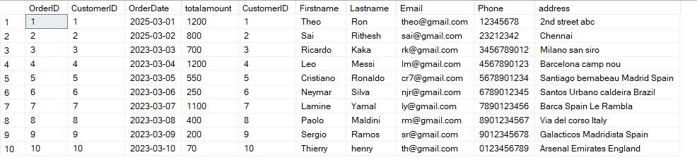

1. Select productname,(Products.Price\*OrderDetails.Quantity) as totalrevenue From Products join OrderDetails on OrderDetails.ProductID=Products.ProductID;

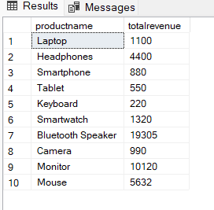

1. Select \* From Customers where customerID in (Select customerID From Orders group by CustomerID having Count(CustomerID)>=1)

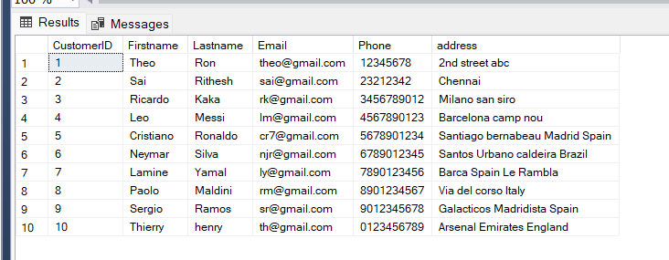

1. Select Productname From Products where ProductID=(Select ProductID From OrderDetails where quantity=(Select max(Quantity) From OrderDetails)) ;



1. Select \* From Products where Category='Electronics';

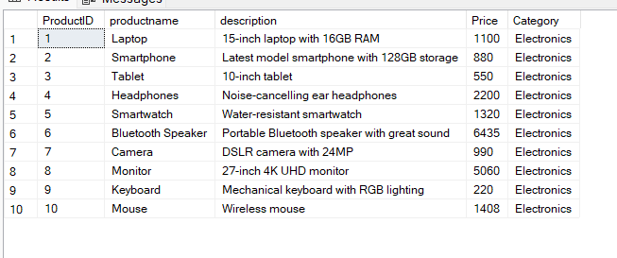

1. Select FirstName,LastName,avg(Orders.totalamount) as averageordervalue From Customers join Orders on Orders.CustomerID=Customers.CustomerID group by FirstName,LastName;

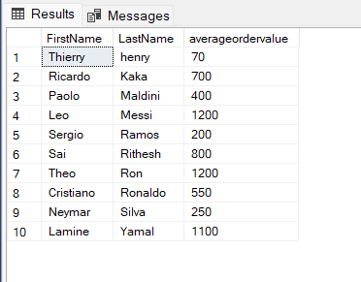

1. select FirstName,LastName,Orders.OrderID,Orders.totalamount from Customers join Orders on Orders.CustomerID=Customers.CustomerID where Orders.totalamount in (select max(totalamount) from Orders);

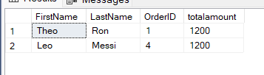

1. select Products.productname,OrderDetails.Quantity from Products join OrderDetails on OrderDetails.ProductID=Products.ProductID;

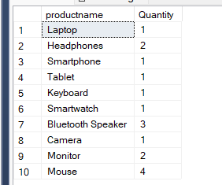

2. select OrderID,totalamount,CustomerID from Orders where OrderDate between '2025-03-01' and '2025-03-05';

