Assignment 2: 25-3-25

1. select * from sys.databases;

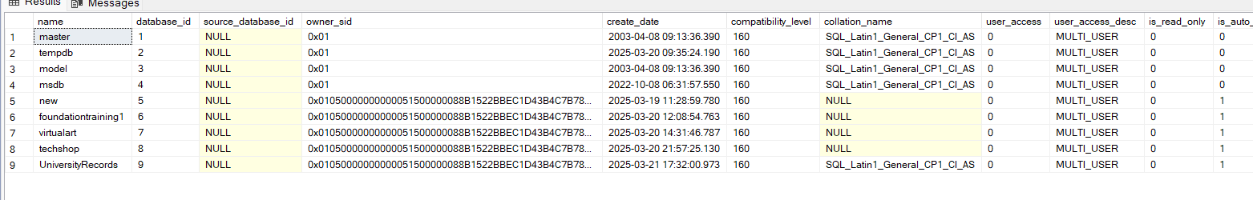

1. exec sp_helpfile;

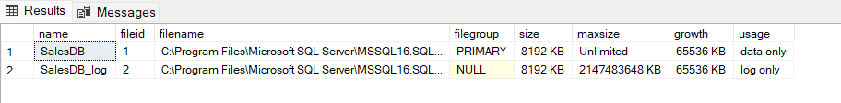

2. exec sp_renamedb InventoryDB, StockDB;
3. DROP DATABASE SalesDB;
4. select name from sys.types order by name;

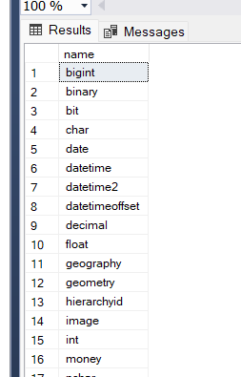

1. create table Products (productname nvarchar(50) not null , price decimal(6,2), stockquanity int default 0);
2. alter table Products add producttype varchar (30);
3. exec sp_rename Products,Inventory;
4. drop table Inventory;
5. select * from sys.databases;
6. select * from sys.database_files;
8. Exec sp_renamedb SalesDB,RetailDB;
9. Alter database RetailDB set offline;

Drop database RetailDB;

Assignment-3

1. Select * from sys.databases;
2. Select * from sys.master_files;
4. Exec sp_renamedb HRDB,EmployeeDB;
5. Drop database EmployeeDB
6. Select * from sys.types;
7. create table employees (EmpID int primary key , EmpName nvarchar(100) not null , JoinDate date not null , Salary decimal(6,2) default 30000.00);
8. alter table employees add Department varchar(50);
9. exec sp_rename employees,staff;
10. drop table staff;

Assignment-5

1. a.create table Employees (employeeid int identity(1,1) primary key, name varchar(100) not null, age int , department varchar(100), salary decimal(10,2));

b.insert into Employees values ('Alice Johnson', 30, 'Finance', 75000.50),('Bob Smith', 45, 'IT', 95000.75),('Charlie Brown', 28, 'Marketing', 68000.00),('Beckham',28,'HR',80000.00);

1. update Employees set salary=salary+0.1*salary where department='HR';
2. delete from Employees where department='IT';
3. a. insert into Employees values ('Rohan',35,'Sales',40000.00);

b. update Employees set department='Senior Staff' where salary>50000;

c. delete from Employees where age>60;

1. select name,salary from employees;
2. select * from employees where department=’HR’ and salary>50000;
3. select * from employees order by salary desc;
4. a.select * from employees where age>30;

b.select * from employees where department=’HR’ or department=’Finance’;

1. a.select * from employees where salary between 30000 and 60000;

b. select * from employees where name like ‘A%’;

c. select* from Employees where not department='IT';

d.select * from employees where department in (‘Sales’,’Marketing’);

e.select distinct department from employees;

1. select name , salary as Monthly income , employeeid as ID from employees;
2. Select * from employees where name like ‘%John%’ and salary>40000;