<https://rpfrtv.csb.app/restaruant.html>

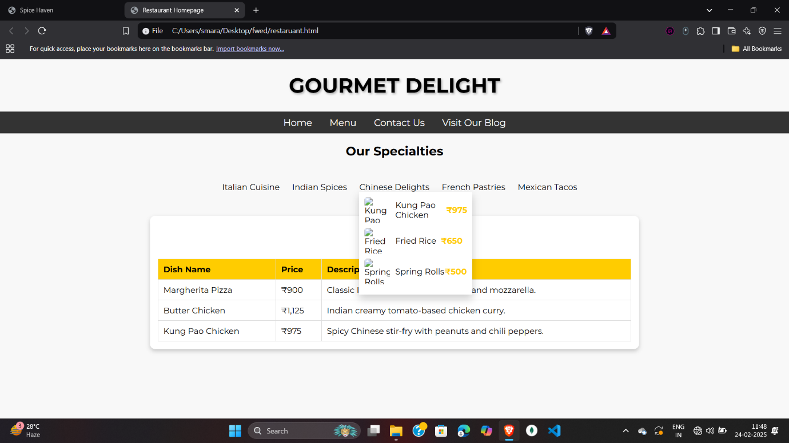

<!DOCTYPE html>

<html lang="en">

<head>

<meta charset="UTF-8">

<meta name="viewport" content="width=device-width, initial-scale=1.0">

<title>Restaurant Homepage</title>

<link href="https://fonts.googleapis.com/css2?family=Montserrat:wght@400;700&display=swap" rel="stylesheet">

<style>

body {

font-family: 'Montserrat', sans-serif;

margin: 0;

padding: 0;

background-color: #f8f8f8;

text-align: center;

}

#restaurant-name {

font-size: 2.5em;

text-transform: uppercase;

text-shadow: 2px 2px 4px rgba(0,0,0,0.3);

}

.nav-menu {

background-color: #333;

padding: 10px;

}

.nav-menu a {

color: white;

text-decoration: none;

margin: 0 15px;

font-size: 18px;

}

.nav-menu a:hover {

color: #ffcc00;

}

.menu-card {

width: 60%;

margin: 20px auto;

padding: 15px;

background: white;

border-radius: 10px;

box-shadow: 0px 4px 8px rgba(0, 0, 0, 0.2);

}

table {

width: 100%;

border-collapse: collapse;

margin-top: 15px;

background-color: #fff;

}

table, th, td {

border: 1px solid #ddd;

padding: 10px;

text-align: left;

}

th {

background-color: #ffcc00;

}

tr:hover {

background-color: #f1f1f1;

}

.dropdown {

position: relative;

display: inline-block;

margin: 10px;

cursor: pointer;

}

.dropdown-content {

display: none;

position: absolute;

background-color: #fff;

min-width: 200px;

box-shadow: 0px 8px 16px rgba(0,0,0,0.2);

z-index: 1;

text-align: left;

padding: 10px;

}

.dropdown-content img {

width: 50px;

height: 50px;

object-fit: cover;

margin-right: 10px;

border-radius: 5px;

}

.dropdown-content div {

display: flex;

align-items: center;

margin-bottom: 10px;

}

.dropdown-content div span {

flex-grow: 1;

}

.dropdown-content div .price {

color: #ffcc00;

font-weight: bold;

}

ol {

list-style-type: upper-roman;

padding-left: 20px;

text-align: left;

display: inline-block;

}

ol li {

margin: 5px 0;

}

</style>

</head>

<body>

<h1 id="restaurant-name">Gourmet Delight</h1>

<div class="nav-menu">

<a href="#home">Home</a>

<a href="#menu">Menu</a>

<a href="#contact">Contact Us</a>

<a href="https://example.com" target="_blank">Visit Our Blog</a>

</div>

<section id="specialties">

<h2>Our Specialties</h2>

<ol>

<li class="dropdown">

Italian Cuisine

<div class="dropdown-content">

<div>

<img src="https://via.placeholder.com/50" alt="Margherita Pizza">

<span>Margherita Pizza</span>

<span class="price">₹900</span>

</div>

<div>

<img src="https://via.placeholder.com/50" alt="Spaghetti Carbonara">

<span>Spaghetti Carbonara</span>

<span class="price">₹850</span>

</div>

<div>

<img src="https://via.placeholder.com/50" alt="Lasagna">

<span>Lasagna</span>

<span class="price">₹950</span>

</div>

</div>

</li>

<li class="dropdown">

Indian Spices

<div class="dropdown-content">

<div>

<img src="https://via.placeholder.com/50" alt="Butter Chicken">

<span>Butter Chicken</span>

<span class="price">₹1,125</span>

</div>

<div>

<img src="https://via.placeholder.com/50" alt="Palak Paneer">

<span>Palak Paneer</span>

<span class="price">₹700</span>

</div>

<div>

<img src="https://via.placeholder.com/50" alt="Biryani">

<span>Biryani</span>

<span class="price">₹800</span>

</div>

</div>

</li>

<li class="dropdown">

Chinese Delights

<div class="dropdown-content">

<div>

<img src="https://via.placeholder.com/50" alt="Kung Pao Chicken">

<span>Kung Pao Chicken</span>

<span class="price">₹975</span>

</div>

<div>

<img src="https://via.placeholder.com/50" alt="Fried Rice">

<span>Fried Rice</span>

<span class="price">₹650</span>

</div>

<div>

<img src="https://via.placeholder.com/50" alt="Spring Rolls">

<span>Spring Rolls</span>

<span class="price">₹500</span>

</div>

</div>

</li>

<li class="dropdown">

French Pastries

<div class="dropdown-content">

<div>

<img src="https://via.placeholder.com/50" alt="Croissant">

<span>Croissant</span>

<span class="price">₹200</span>

</div>

<div>

<img src="https://via.placeholder.com/50" alt="Éclair">

<span>Éclair</span>

<span class="price">₹150</span>

</div>

<div>

<img src="https://via.placeholder.com/50" alt="Macaron">

<span>Macaron</span>

<span class="price">₹120</span>

</div>

</div>

</li>

<li class="dropdown">

Mexican Tacos

<div class="dropdown-content">

<div>

<img src="https://via.placeholder.com/50" alt="Tacos al Pastor">

<span>Tacos al Pastor</span>

<span class="price">₹300</span>

</div>

<div>

<img src="https://via.placeholder.com/50" alt="Chiles Rellenos">

<span>Chiles Rellenos</span>

<span class="price">₹350</span>

</div>

<div>

<img src="https://via.placeholder.com/50" alt="Enchiladas">

<span>Enchiladas</span>

<span class="price">₹400</span>

</div>

</div>

</li>

</ol>

</section>

<section id="menu" class="menu-card">

<h2>Menu</h2>

<table>

<tr>

<th>Dish Name</th>

<th>Price</th>

<th>Description</th>

</tr>

<tr>

<td>Margherita Pizza</td>

<td>₹900</td>

<td>Classic Italian pizza with fresh basil and mozzarella.</td>

</tr>

<tr>

<td>Butter Chicken</td>

<td>₹1,125</td>

<td>Indian creamy tomato-based chicken curry.</td>

</tr>

<tr>

<td>Kung Pao Chicken</td>

<td>₹975</td>

<td>Spicy Chinese stir-fry with peanuts and chili peppers.</td>

</tr>

</table>

</section>

<script>

document.addEventListener('DOMContentLoaded', function() {

const dropdowns = document.querySelectorAll('.dropdown');

dropdowns.forEach(dropdown => {

dropdown.addEventListener('click', function() {

const content = this.querySelector('.dropdown-content');

if (content.style.display === 'block') {

content.style.display = 'none';

} else {

content.style.display = 'block';

}

});

});

});

</script>

</body>

</html>