Mims

Allerta – Allerta 10 mg 4+1 Tablet

₱89.00

Generic Name : Loratadine

Indication : Symptomatic relief of allergic rhinitis. Treatment of chronic idiopathic urticaria & other allergic dermatologic disorders.

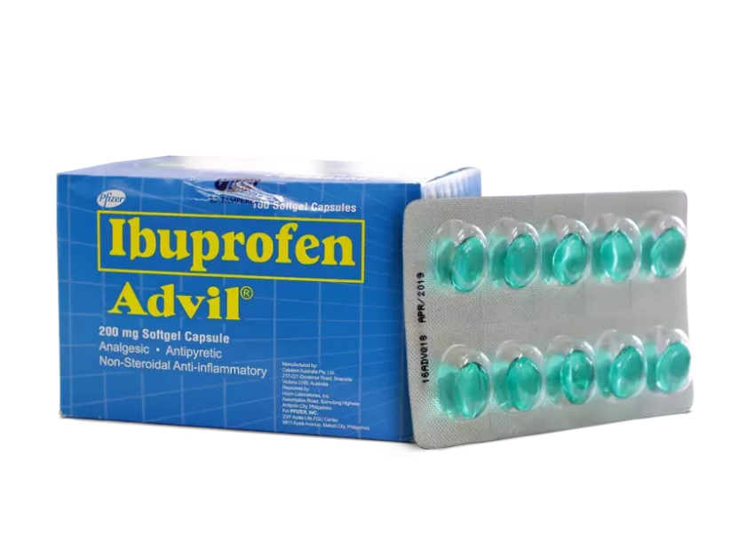

Advil – Advil 200 mg Soft Gel Capsule 10pcs P85

Generic Name : Ibuprofen

Indication : Reduction of fever. Relief of mild to moderate pain & inflammation associated w/ dysmenorrhea, headache including migraine, post-op & dental pain, musculoskeletal & joint disorders

Aspilets 80 mg Tablet

₱3.50

Generic Name : Aspirin

Indication : Primary prevention of thromboembolic disorders & CV events eg, ischemic stroke, transient ischemic attack, prevention of recurrent MI; unstable & chronic stable angina pectoris.

Imodium Imodium 2 mg Capsule 10pcs

₱172.50

loperamide ; Belongs to the class of antipropulsives. Used in the treatment of diarrhea.

Diatabs Diatabs 5 + 1 Capsule

₱37.50

Generic Name : Loperamide

Indication : Acute non-specific diarrhea; chronic diarrhea associated w/ inflammatory bowel disease. Reduction of number & vol of discharge in patients w/ ileostomies & colostomies.

Gaviscon 10ml P33.50

Generic Name : calcium carbonate + sodium alginate + sodium bicar...

Indication : Symptoms of GERD eg, acid regurgitation, heartburn due to reflux of stomach content.

Bioflu Bioflu 5 + 1 Tablet

₱37.50

Generic Name : chlorphenamine maleate + paracetamol + phenylephri...

Indication : Relief of clogged nose, itchy & watery eyes, sneezing, headache, body aches & fever associated w/ flu, common cold, allergic rhinitis, sinusitis & other minor resp tract infections;

Calmoseptine Calmoseptine 3.5 g Ointment

₱37.75

Generic Name : calamine + chlorothymol + glycerin + lanolin + men...

Indication : Protects, soothes & helps promote healing in those w/ impaired skin integrity related to: Feeding tube site leakage; wound drainage; urinary & fecal incontinence, bedsores;

Tempra Tempra 325 mg Tablet - 20s

₱77.00

Generic Name : Paracetamol

Indication : Fever, headache, muscular aches & pain, toothache, colds, ear ache, fever due to tonsillectomy, inoculations & vaccinations.

Hydrite Hydrite 4.1 g Granules for Solution - 10s

₱157.50

Generic Name : glucose + potassium chloride + sodium chloride + t...

Indication : Dehydration due to diarrhea in childn & adults (except those w/ severe dehydration). Replaces fluid & electrolytes lost due to diarrhea &/or vomiting.

Neozep Neozep Forte 8 + 2 Tablet

₱40.00

Generic Name : chlorphenamine maleate + phenylephrine hydrochlori... , chlorphenamine maleate + paracetamol + phenylephri...

Indication : Relief of runny nose, nasal congestion, post-nasal drip, itchy & watery eyes, fever, body pains & headache associated w/ common cold, flu, upper resp infections, allergic rhinitis & sinusitis

Solmux Solmux 500 mg 5 + 1 Capsule

₱52.50

Generic Name : Carbocisteine

Indication: Relief of cough characterized by excessive or sticky sputum or phlegm to help treat resp tract disorders eg, acute bronchitis. Reduces exacerbations associated w/ COPD & inhibits adherence of bacteria & virus to human resp cells. Otitis media w/ effusion (glue ear).

Biogesic Biogesic 500 mg 8+2 Tablet

₱30.00

Generic Name : Paracetamol

Indication : Relief of minor aches & pains eg, headache, backache, menstrual cramps, muscular aches, minor arthritis pain, toothache & pain associated w/ common cold & flu.