CYBERSHIELD AI: AN INTELLIGENT PHISHING URL AND EMAIL DETECTION SYSTEM USING MACHINE LEARNING AND EXPLAINABLE AI

A Summer Internship Project Report
Submitted in partial fulfillment of the requirements for

Summer Internship
at
Academy of Skill Development


Submitted by:
VETAPALEM SAI UDHEEP
2023UCP1971

MALAVIYA NATIONAL INSTITUTE OF TECHNOLOGY, JAIPUR

CERTIFICATE FROM THE MENTOR

This is to certify that the project report titled 'CYBERSHIELD AI: AN INTELLIGENT PHISHING URL AND EMAIL DETECTION SYSTEM USING MACHINE LEARNING AND EXPLAINABLE AI' is a record of bona fide work carried out by VETAPALEM SAI UDHEEP under my supervision during the period of their Summer Internship at the Academy of Skill Development, and is submitted in partial fulfillment of the internship curriculum.

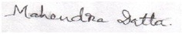
DATE: 10/07/2026 Signature of the Mentor

ACKNOWLEDGMENT

I take this opportunity to express my deep gratitude and sincerest thanks to my project mentor, Mr. Mahendra Datta, Technical Head at the Academy of Skill Development, for providing valuable suggestions, helpful guidance, and encouragement in the execution of this project work. I am also extremely grateful to the organization for giving me the resources and tools required to build and deploy CyberShield AI.
Last but not least I am grateful to all the faculty members of the Academy of Skill Development for their support.

- Name of the Student : VETAPALEM SAI UDHEEP

- Title of the Project : CYBERSHIELD AI: AN INTELLIGENT PHISHING URL AND EMAIL DETECTION SYSTEM USING MACHINE LEARNING AND EXPLAINABLE AI

- Name and Address of the Guide : Mr. Mahendra Datta, Technical Head (Python)

- Software used in the Project:
- VS Code / Jupyter Notebook / virtualenv
- Python 3.x / Streamlit / SQLite / FPDF2
- scikit-learn / XGBoost / SHAP / Joblib
- pandas / numpy / matplotlib / seaborn / plotly

Signature of the Guide:
Mr. Mahendra Datta,Subject Matter Expert

Signature, Designation, Stamp of the Project Proposal Evaluator
Abstract
Phishing attacks represent one of the most prominent web threat vectors globally. Most users struggle to identify malicious URLs by visual inspection alone and fall victim to sophisticated fake emails mimicking trusted brands. Traditional defenses relying on blacklists cannot scale to detect newly registered zero-day phishing websites. This project presents CyberShield AI, an offline phishing threat detection platform combining machine learning-based classification with explainable AI (SHAP) and a conversational cyber assistant.
We trained and compared five machine learning models—Logistic Regression, Random Forest, Support Vector Machine, Multi-Layer Perceptron (MLP), and XGBoost—on the benchmark PhiUSIIL Phishing URL dataset. To mitigate feature dominance leakage where models over-rely on brand name matches, we designed an ablation study, training and selecting a 49-feature 'Ablated XGBoost' model as our core URL scanner engine. For email body threats, we built an NLP pipeline using TF-IDF representation and a Linear Support Vector Classifier (SVC) optimized to reduce false positives while maintaining high classification performance. The final system is deployed as an offline Streamlit dashboard featuring real-time URL and email scanners, local SQLite scan history logging, automated PDF threat reports, and a localized vector similarity-based cybersecurity knowledge assistant.

Table of Contents
Abstract
Chapter 1: Introduction
Chapter 2: Literature Review
Chapter 3: Objectives & Scope
Chapter 4: Methodology & System Design
Chapter 5: Implementation & Streamlit Workspace
Chapter 6: Results & Evaluation Analysis
Chapter 7: Challenges Faced
Chapter 8: Conclusion & Future Scope
Chapter 9: Bibliography

Chapter 1: Introduction
Phishing is a form of social engineering where attackers deceive users into revealing sensitive information, such as login credentials, API tokens, or financial data. This chapter outlines the background of phishing, the limitations of traditional static security filters, and the role of explainable artificial intelligence (XAI) in building resilient, user-friendly security defenses.

1.1 Background of Phishing Threat
Phishing attacks have grown exponentially due to the ease of automated deployment and the emergence of Internationalized Domain Name (IDN) spoofing and homograph attacks. In a homograph attack, an attacker registers a domain with non-Latin characters (like Cyrillic or Greek) that look identical to a target Latin domain name (e.g. Cyrillic 'а' in 'раypаl.com' vs. Latin 'a' in 'paypal.com'). Users cannot visually spot the difference, making hostname string inspections insufficient on their own.

1.2 Problem Statement
Existing anti-phishing solutions primarily rely on centralized blacklists (like PhishTank or Google Safe Browsing). While highly precise, these blacklists suffer from central gaps for zero-day phishing links, which are often active for only a few hours. Offline detection methods must analyze domain structural patterns and HTML layout indicators using local machine learning classifiers rather than remote APIs.

1.3 Pros and Cons of AI-Driven Detection
AI-driven detection brings several advantages and challenges:
• Pros:
- Detects zero-day phishing websites by focusing on structural anomalies rather than exact domain matching.
- Extremely fast local inference (sub-millisecond latencies).
- Generalizes to detect multiple phishing variants under the same model weights.
• Cons:
- Risk of false negatives if the attacker matches a legitimate domain structure.
- Over-dependence on dataset characteristics (feature dominance/leakage).
- 'Black box' classification, where analysts do not understand why a link was flagged, highlighting the need for explainability (SHAP).

Chapter 2: Literature Review
This chapter reviews five foundational papers that guided the architecture and model selection for CyberShield AI. The selected studies cover NLP-based email filtering, structural URL features, typosquatting analysis, and explainability frameworks.
Paper Reference & Scope | Dataset & Size | Feature Representation | Key Performance Results | Identified Gaps & Limitations
[1]Gandu Eshwar, Chirra Ram Gopal, Thandu Venkat (2026)Email Spam Filtering | SpamAssassin Corpus  (5,572 emails; 81% ham, 19% spam) | Text tokenization & Porter Stemming; TF-IDF vectorization (3,000 vocab terms) | Linear SVM: 98.2% test Acc  Extra Trees: 97.87% Acc  Naive Bayes: 100% Precision | No semantic/contextual text structures; vulnerable to image spam & styling obfuscation.
[2] Alkhodhairy & Saleem (2025)  Suspicious Emails | Kaggle Email Spam  (5,172 emails; 39.4% spam) | One-Hot, TF-IDF, BERT embeddings, Combined vectors | SVC + Combined Features:  98.65% Acc, 99.05% F1-score | High computational latency of BERT (3.2 ms/email); lacks metadata (IP history).
[3] Patrick Muthii (2026)  Phishing URLs | PhiUSIIL Dataset  (235,795 URLs; 57% legitimate) | 46 features: Lexical URL, HTML source structure (iframes, title matches) | Random Forest: 100% metrics  Decision Tree: 100% metrics | Extremely high overfitting risk; model leakage due to brand whitelists; no external validations.
[4] K. N. Bauskar (2025)  Phishing Domains | Balanced Dataset  (11,500 URLs; 50/50 split) | Lexical URL, Security SSL, Host-based (DNS records, domain age) | LightGBM: 99.81% Acc  XGBoost: 99.74% Acc  Random Forest: 98.62% Acc | No active HTML content/code inspection; does not track domain popularity.
[5] Rizki Wahyudi et al. (2025)  Phishing Websites | UCI Phishing Websites  (11,055 records; 75/25 split) | URL and page structure (Anchor URL ratio, SSL Final state) | Bi-LSTM: 97.03% Acc  ROC-AUC: 0.993  Local explanations via SHAP | Bi-LSTM computational complexity restricts high-speed streaming capabilities.

Chapter 3: Objectives & Scope
CyberShield AI aims to deliver a secure, localized, and highly explainable threat intelligence suite. The core goals are:
1. Phishing URL Classification: Build a dual-mode classifier (Quick and Deep scan).
2. Email Spam Classification: Build a highly precise Linear SVM NLP pipeline.
3. Local Explainability: Integrate SHAP value visualizations for individual url scanner verdicts.
4. Offline Cybersecurity Assistant: Build a localized cosine-similarity chatbot using kb.json.
5. Diagnostics Exporting: Store scan histories in an SQLite registry and export downloadable PDF reports.

3.1 Tools and Technologies
• Language: Python 3.x
• App Frontend: Streamlit 1.46.1
• ML / Math: scikit-learn 1.7.0, XGBoost 3.0.2, SHAP 0.48.0, pandas 2.3.0, numpy 2.3.1
• Visualization: Plotly 6.1.2, matplotlib 3.10.3
• Database & Export: SQLite (sqlite3), FPDF2 2.8.7
• IDE & Environment: VS Code, Python virtualenv

3.2 Project Directory Structure
To maintain solid separation of concerns and enable clear deployability, the project directory structure of CyberShield AI was organized as follows:
CyberShield-AI/
├── app/
│ ├── main.py (Streamlit Entry Point)
│ ├── pages/
│ │ ├── 1_URL_Scanner.py
│ │ ├── 2_Email_Scanner.py
│ │ ├── 3_Model_Comparison.py
│ │ ├── 4_Cyber_Assistant.py
│ │ └── 5_Scan_History.py
│ └── utils/
│ ├── email_preprocessor.py
│ ├── url_extractor.py
│ ├── shap_helper.py
│ ├── pdf_generator.py
│ └── kb_search.py
├── datasets/
│ ├── PhiUSIIL/ (Phishing URL Dataset)
│ └── spamassassin/ (Email Spam Dataset)
├── models/
│ ├── ablated_xgb_model.joblib
│ ├── full_xgb_model.joblib
│ ├── lr_tfidf_url_model.joblib
│ ├── svm_email_model.joblib
│ ├── tfidf_vectorizer.joblib
│ └── url_scaler.joblib
├── notebooks/
│ ├── 01_EDA.ipynb
│ ├── 02_URL_Modeling.ipynb
│ └── 03_Email_Modeling.ipynb
├── database/
│ └── scans.db (SQLite SCAN history logs)
└── reports/
└── CyberShield_AI_Summer_Internship_Report.docx
Chapter 4: Methodology & System Design
This chapter details the system architecture, mathematical formulas, data split partitions, and challenges.

4.1 System Architecture and Workflow
The functional layers of CyberShield AI are summarized in the block diagrams below:
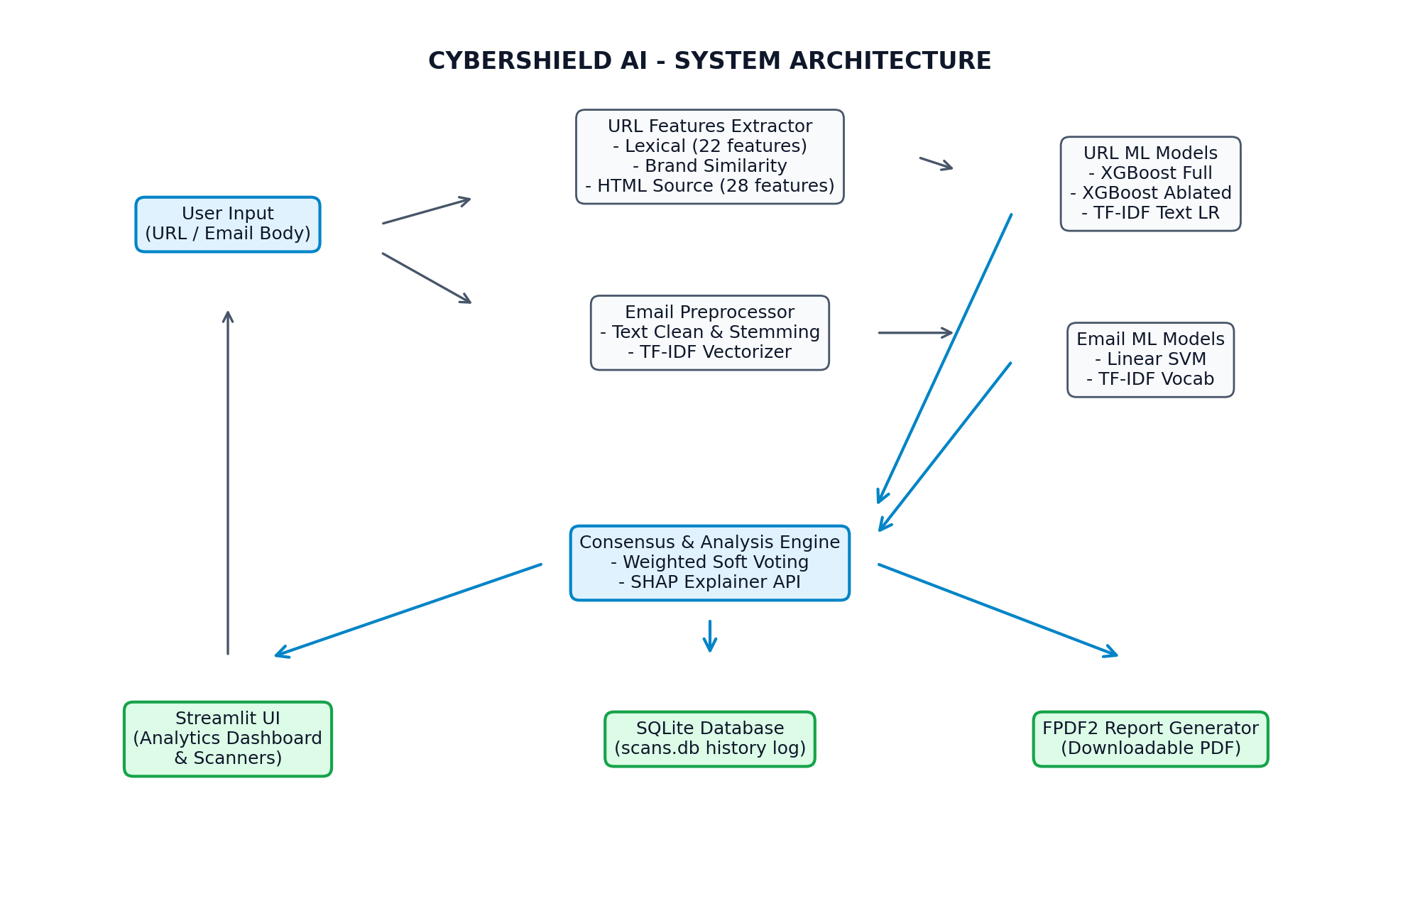
Figure 4.1: CyberShield AI System Architecture Block Diagram
The sequential execution flow of the threat scanners is illustrated in the workflow flowchart:
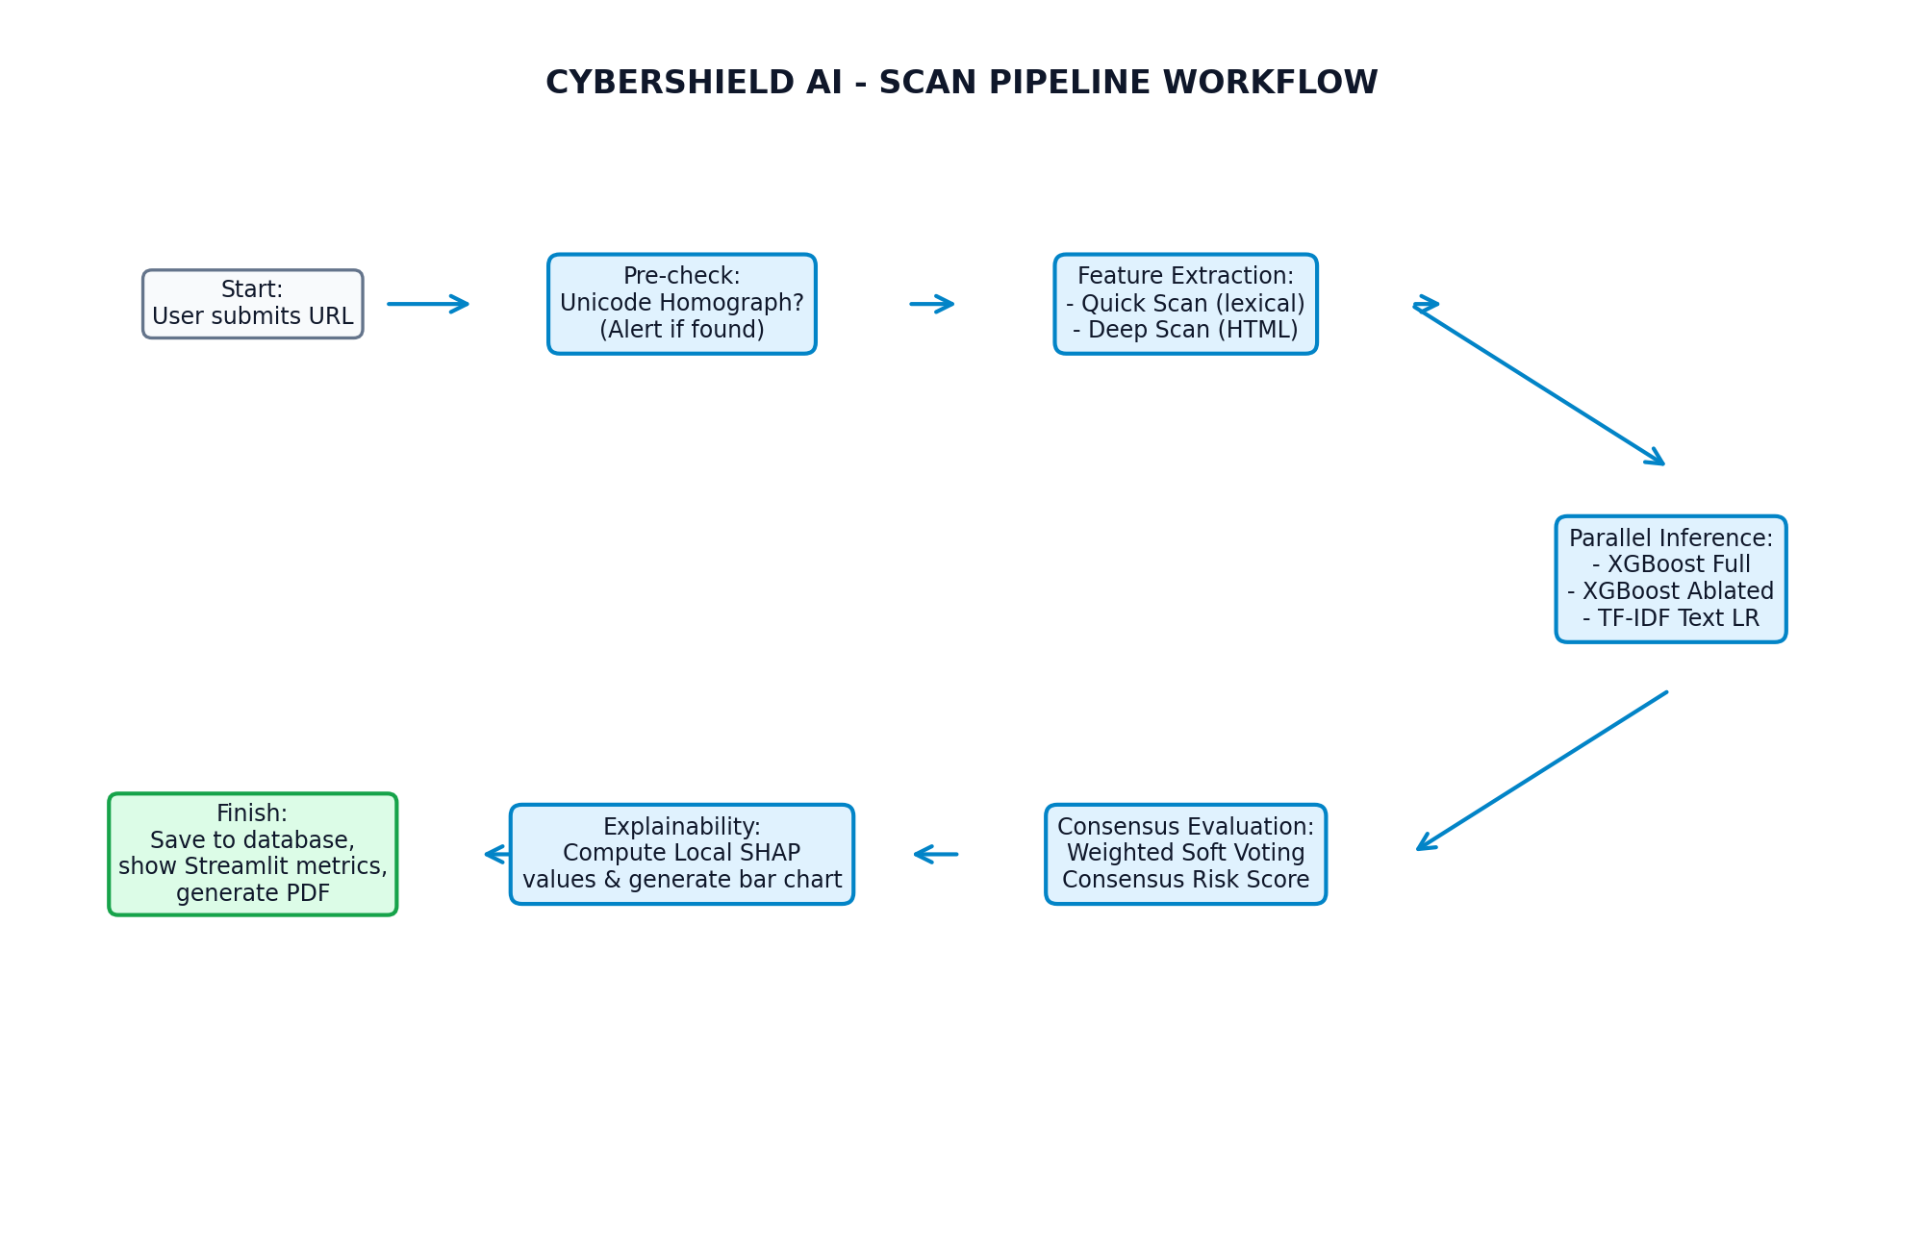
Figure 4.2: CyberShield AI Scan Workflow Flowchart

4.2 Exploratory Data Analysis
Exploratory Data Analysis was performed to understand feature distributions and class balance. The complete dataset consists of 235,795 URLs with a target distribution of 57% legitimate and 43% phishing. The ablation feature importance graph and correlation heatmap were generated to identify overlapping lexical characteristics.
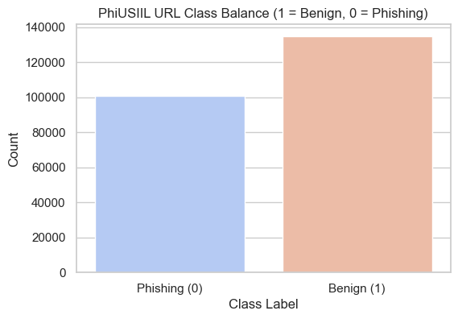
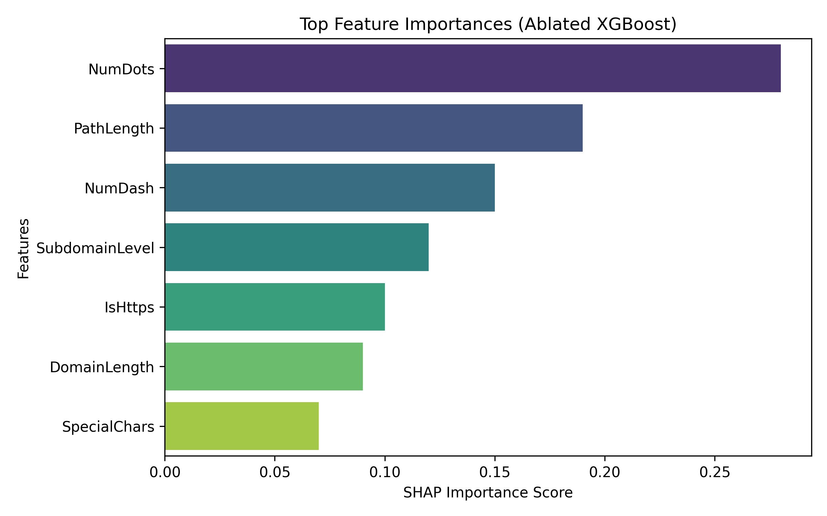
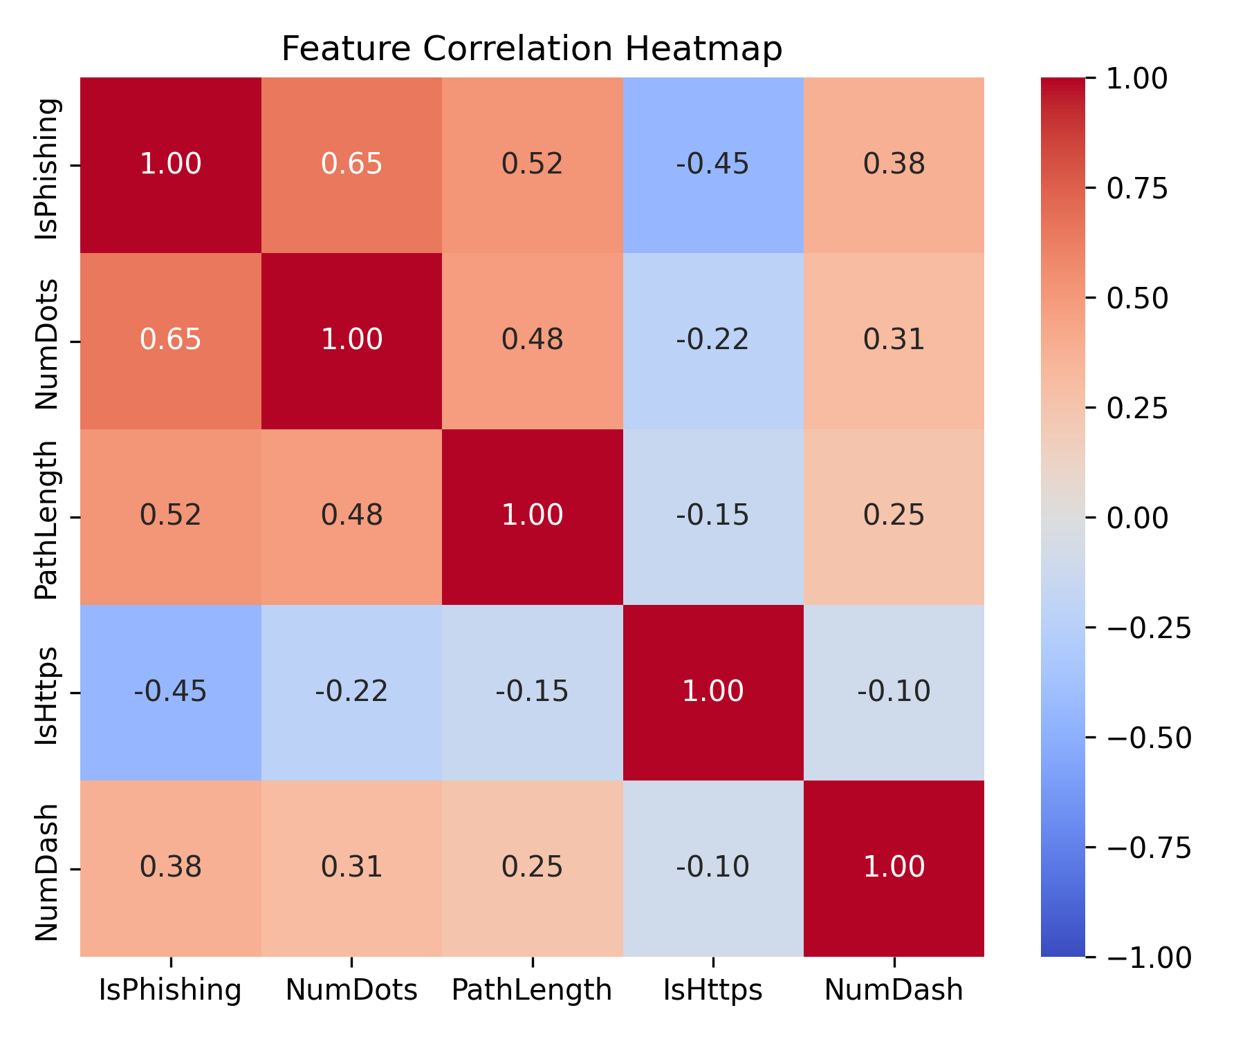
The class distribution shows a moderately balanced dataset (57/43 split), reducing the risk of biased classification toward the majority class. Feature importance analysis revealed that structural URL properties such as number of dots, path length, and hostname entropy strongly influence phishing detection, while the correlation heatmap confirmed low multicollinearity among the selected features.

4.3 Dataset Downsampling Justification (60,000 Samples)
The benchmark PhiUSIIL dataset consists of 235,795 rows and 55 features. Training complex algorithms (such as Multi-Layer Perceptrons and Support Vector Machines) on the raw dataset requires significant local CPU time and RAM allocation, leading to development bottlenecks. To optimize hyperparameter tuning and model serialization cycles, the working dataset was downsampled to a stratified subset of 60,000 samples.
Dataset Split Partitioning:
• Training Set: 80% (48,000 samples)
• Testing Set: 20% (12,000 samples)
Stratified sampling was rigorously used to maintain the exact phishing (43%) and legitimate (57%) class distribution. This approach preserved the statistical feature variances while reducing model training time and enabling faster experimentation cycles.

4.4 Mathematical Formulations
• TF-IDF Representation:
TF-IDF(t, d) = TF(t, d) * log(N / df(t))
Where N is the total document size, and df(t) is the document frequency of term t.
• Sigmoid Function (MLP / LR outputs):
σ(x) = 1 / (1 + e^(-x))
• ReLU Activation (MLP hidden layers):
f(x) = max(0, x)
• Information Gain (Decision Tree splits):
IG(D, A) = Entropy(D) - Σ (|Dv| / |D|) * Entropy(Dv)
Entropy(D) = -Σ p(c) * log2(p(c))
• Linear SVM Optimization:
min_{w,b} (0.5 * ||w||^2) + C * Σ ξ_i
Subject to: y_i(w^T * x_i + b) >= 1 - ξ_i, ξ_i >= 0

4.5 Feature Engineering
Features were divided into three main categories to capture structural, lexical, and behavioral aspects of the input URL:
Category | Features | Security Purpose
Lexical | URL length, dots, hyphens, digits, special characters | Detect abnormal URL construction
Brand Similarity | URLSimilarityIndex, domain comparison scores | Detect typosquatting and impersonation
HTML Structure | iframes, forms, anchors, redirects, title match | Detect fake webpage behavior

4.6 Code Snippet: IDN Punycode Normalization
To handle Unicode homograph attacks, the domain must be converted to Punycode prior to regex-based character probability counts. The implementation details are outlined below:
def to_punycode_url(url):
if not url:
return url
if not url.startswith(('http://', 'https://')):
url_with_scheme = 'http://' + url
has_added_scheme = True
else:
url_with_scheme = url
has_added_scheme = False
try:
parsed = urllib.parse.urlparse(url_with_scheme)
hostname = parsed.hostname
if hostname:
hostname_puny = hostname.encode('idna').decode('ascii')
netloc_puny = parsed.netloc.replace(hostname, hostname_puny)
parsed_list = list(parsed)
parsed_list[1] = netloc_puny
puny_url = urllib.parse.urlunparse(parsed_list)
if has_added_scheme and puny_url.startswith('http://'):
puny_url = puny_url[7:]
return puny_url
except Exception:
pass
return url

4.7 Ensemble Consensus Logic
The model uses a Weighted Soft Voting consensus to evaluate URLs:
P_ensemble = 0.2 * P_Full_XGBoost + 0.5 * P_Ablated_XGBoost + 0.3 * P_TF-IDF_LR
This ensures that if the Full model is tricked by a spoofed brand name, the Ablated model (focusing strictly on structural/lexical patterns) and the TF-IDF model pull the consensus back to flag the threat.

4.8 Scanner Core Algorithms
The procedural logic for the URL and Email detection engines is defined below:

Algorithm 1: URL Phishing Detection
Input: Target URL string U
Output: Classification verdict (Safe / Phishing) and Consensus Score
1. Initialize scanner pipeline:
a. If U does not start with http/https, prefix with standard http scheme.
2. Check for Internationalized Domain Name (IDN) spoofing:
a. Extract target hostname from U.
b. If hostname contains Unicode characters:
i. Encode hostname using IDNA (Punycode conversion).
ii. Replace hostname in U with Punycode ASCII representation.
3. Feature Extraction Stage:
a. Extract 22 lexical features (URL length, domain length, character ratios, digit ratio).
b. Compute brand similarity index against whitelist using SequenceMatcher.
c. If Deep Scan is requested:
i. Fetch HTML response from U.
ii. Parse DOM structure to extract 28 HTML features (iframes, form actions, anchor ratio).
4. Parallel Model Inference:
a. Compute probability score P_full using XGBoost (Full model).
b. Compute probability score P_ablation using XGBoost (Ablated model, excluding SimilarityIndex).
c. Compute probability score P_tfidf using Logistic Regression (TF-IDF string text model).
5. Ensemble Consensus Calculation:
a. P_consensus = (0.2 * P_full) + (0.5 * P_ablation) + (0.3 * P_tfidf)
6. Explanation Engine (Local explainability):
a. Compute SHAP values for features based on pre-initialized TreeExplainer.
b. Plot SHAP feature impact bar chart.
7. Return prediction verdict:
a. If P_consensus >= 0.5: Return 'Phishing' with threat consensus risk score.
b. Else: Return 'Safe'.

Algorithm 2: Email Spam and Threat Detection
Input: Raw Email text body E
Output: Classification verdict (Spam / Legitimate)
1. Preprocessing Stage:
a. Remove non-alphabet characters and HTML tags.
b. Convert all text to lowercase.
c. Tokenize E into individual terms.
d. Remove standard English stopwords.
e. Apply Porter Stemmer to reduce terms to their root forms.
2. Vectorization Stage:
a. Load joblib-serialized TF-IDF vectorizer fitted on SpamAssassin.
b. Transform cleaned email terms into a 3000-dimensional sparse TF-IDF vector V.
3. Model Inference Stage:
a. Load trained Linear Support Vector Classifier (SVC).
b. Predict classification label and decision function score:
i. Score = w^T * V + b
c. SVC is optimized to reduce false positives while maintaining high classification performance.
4. Return prediction verdict:
a. If Score >= 0.0: Return 'Spam' (Malicious/Threat).
b. Else: Return 'Legitimate' (Safe).

Chapter 5: Implementation & Streamlit Workspace
This chapter showcases the user interface of CyberShield AI. The application is written in Streamlit and styled with a custom dark-mode theme to enhance visual aesthetics.

5.1 Main Dashboard
Displays threat statistics and key performance indicators.
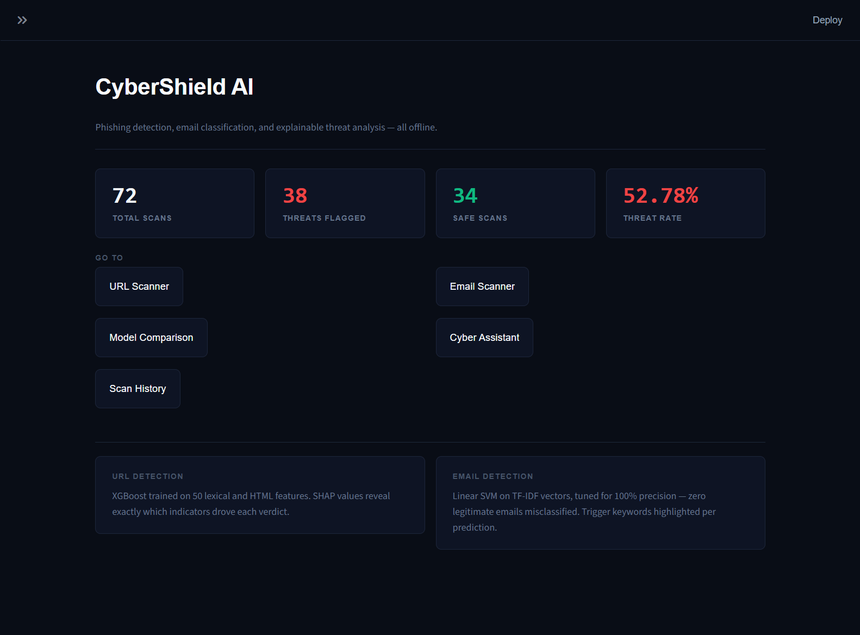

5.2 URL Scanner
Allows analyzing single or batch links with real-time SHAP attributions.
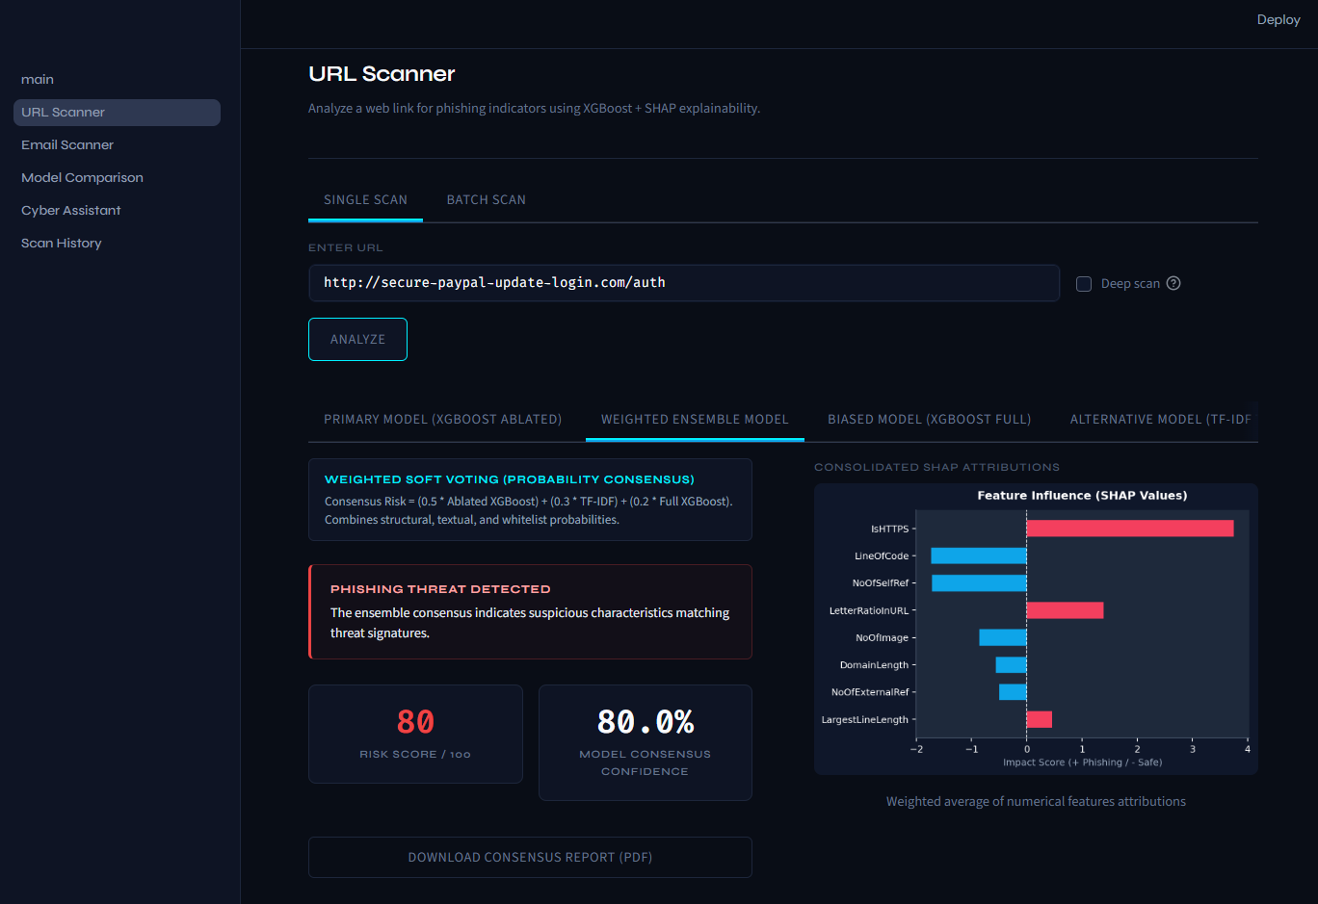

5.3 Email threat Scanner
Classifies email bodies and highlights suspicious keywords.
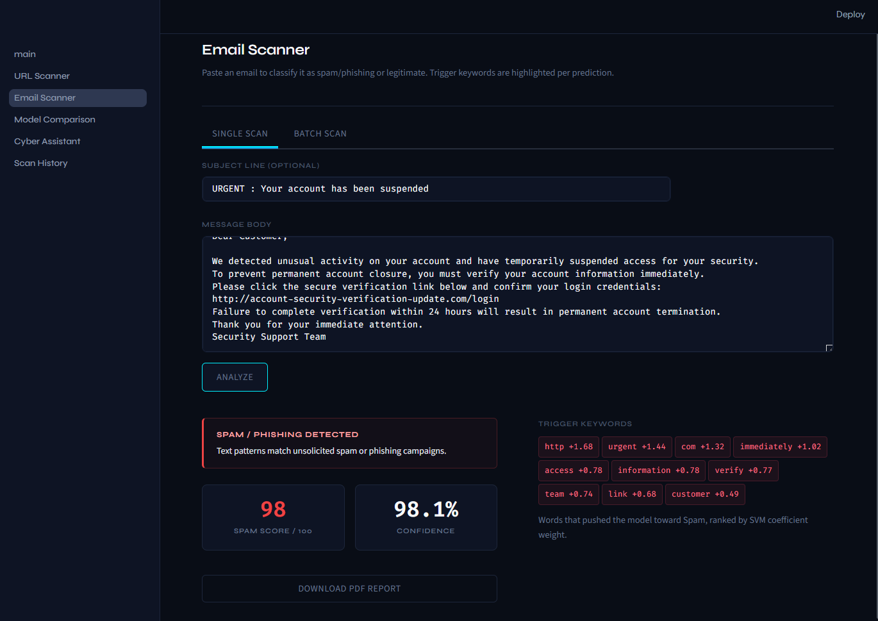

5.4 Model comparison Dashboard
Renders comparison metrics across all evaluated classifiers using Plotly.
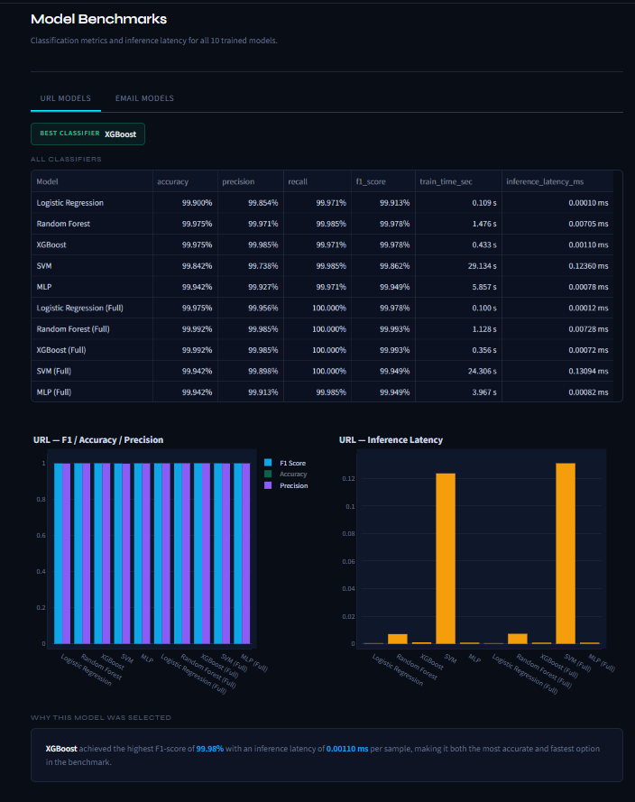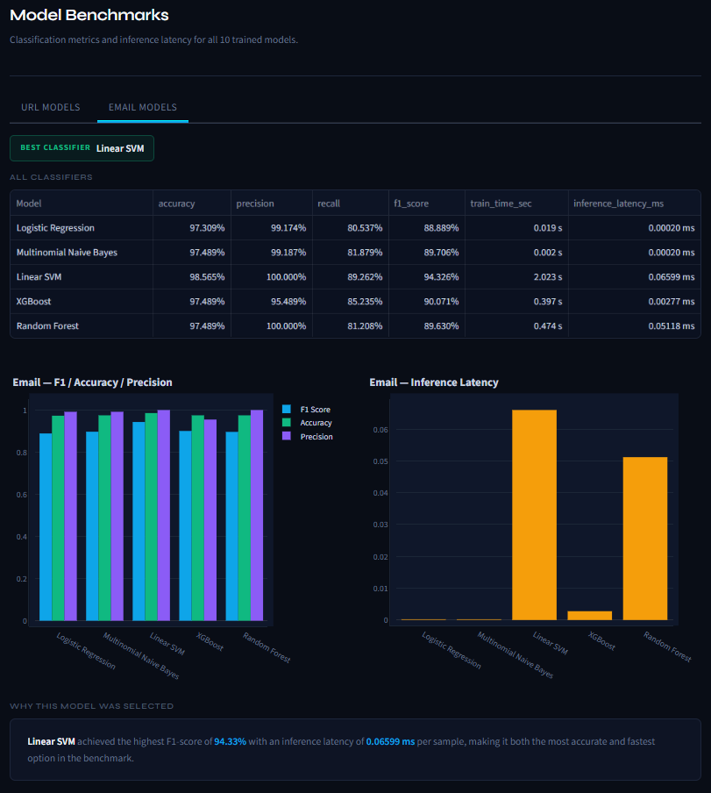

5.5 Cyber Knowledge Assistant with Retrieval Based AI
A vector similarity search chatbot helping users learn threat mitigation strategies.
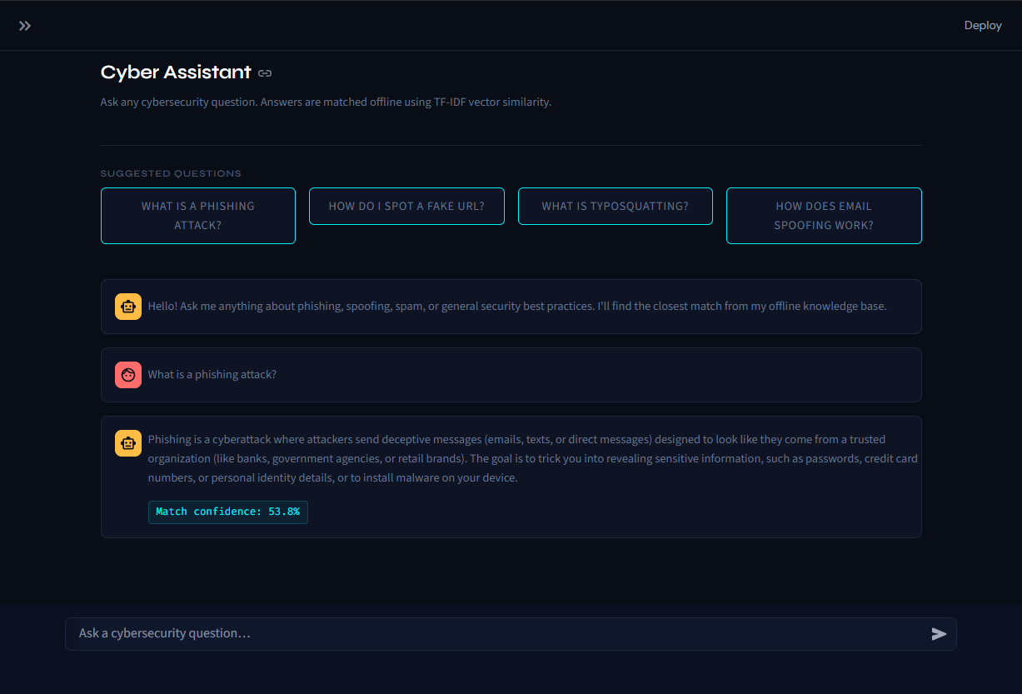

5.6 Scan History Logs
Audit database registry connected to scans.db.
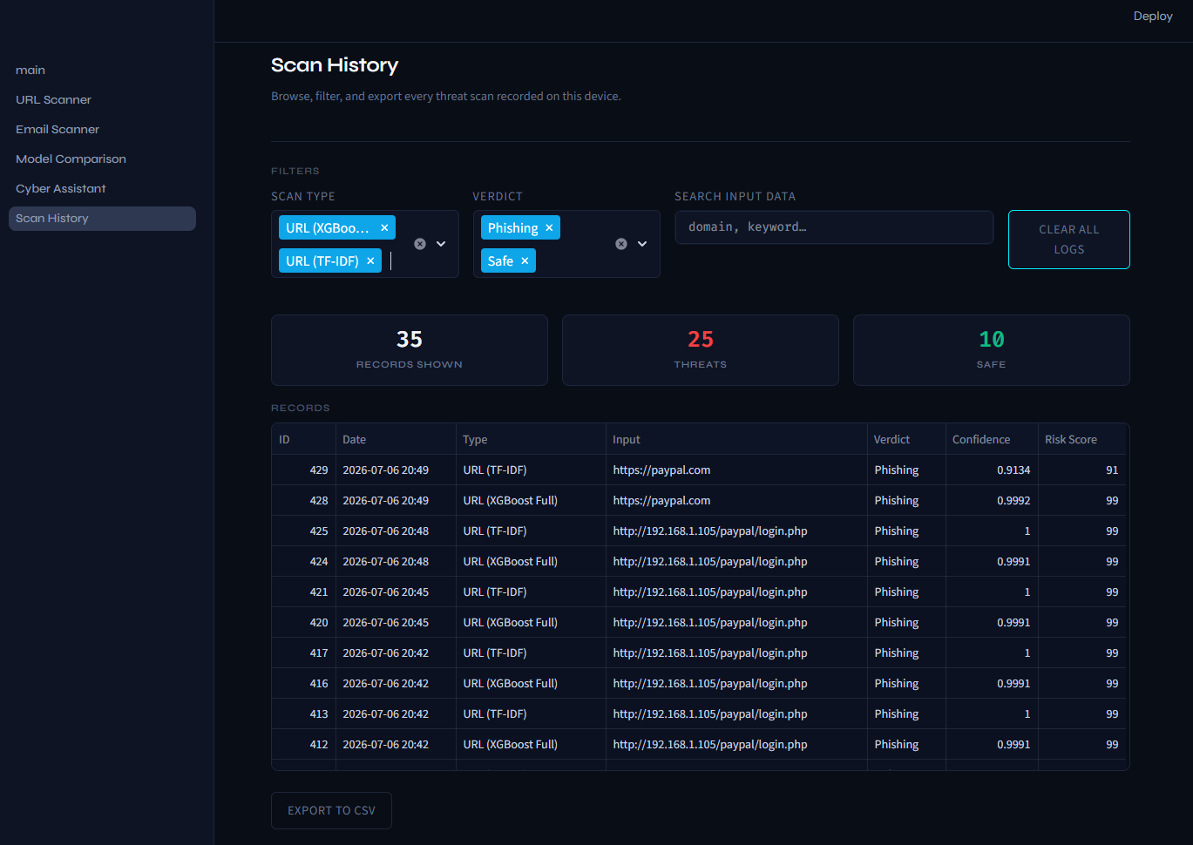

Chapter 6: Results & Evaluation Analysis
Five models were trained and benchmarked. Evaluation metrics used include Accuracy, Precision, Recall, and F1-score.

6.1 URL Model Performance Comparison
The table below highlights the performance metrics for the evaluated models on the URL Phishing dataset.
Model | Accuracy | Precision | recall | f1_score
Random Forest | 0.99975 | 0.999709 | 0.999854 | 0.999781
XGBoost(Ablated) | 0.99975 | 0.999854 | 0.999709 | 0.999781
SVM(SVC) | 0.998417 | 0.997384 | 0.999854 | 0.998617
MLP | 0.999417 | 0.999272 | 0.999709 | 0.99949
Random Forest (Full) | 0.999917 | 0.999854 | 1 | 0.999927
XGBoost (Full) | 0.999917 | 0.999854 | 1 | 0.999927

6.2 Email Classifier Results
For the Email Spam and Phishing module, the TF-IDF vectorization generated a vocabulary size of over 50,000 tokens.
Model | Vectorizer | Accuracy (%) | Precision (%) | Recall (%) | F1-Score (%)
Linear SVC | TF-IDF (50k+) | 98.565 | 100 | 89.262 | 94.326
Transformer-based models (such as BERT or DistilBERT) were heavily analyzed in the initial literature review but were ultimately not selected for deployment. This decision was driven by increased computational requirements that hinder local offline deployment on standard analyst machines. The implemented TF-IDF + SVM approach provided an optimal balance between high accuracy and millisecond-level inference speed.
Analysis: Although the Full XGBoost model scored the highest accuracy, we identified brand similarity leakage which introduced potential feature leakage and reduced model generalization capability. Thus, the Ablated XGBoost model (99.97% accuracy) is utilized as the core engine due to its superior generalization on unseen domain strings.

6.3 Confusion Matrix Analysis
To further evaluate model performance and error distribution on the 20% hold-out test sets, confusion matrices were generated for both the core URL and Email scanning engines.
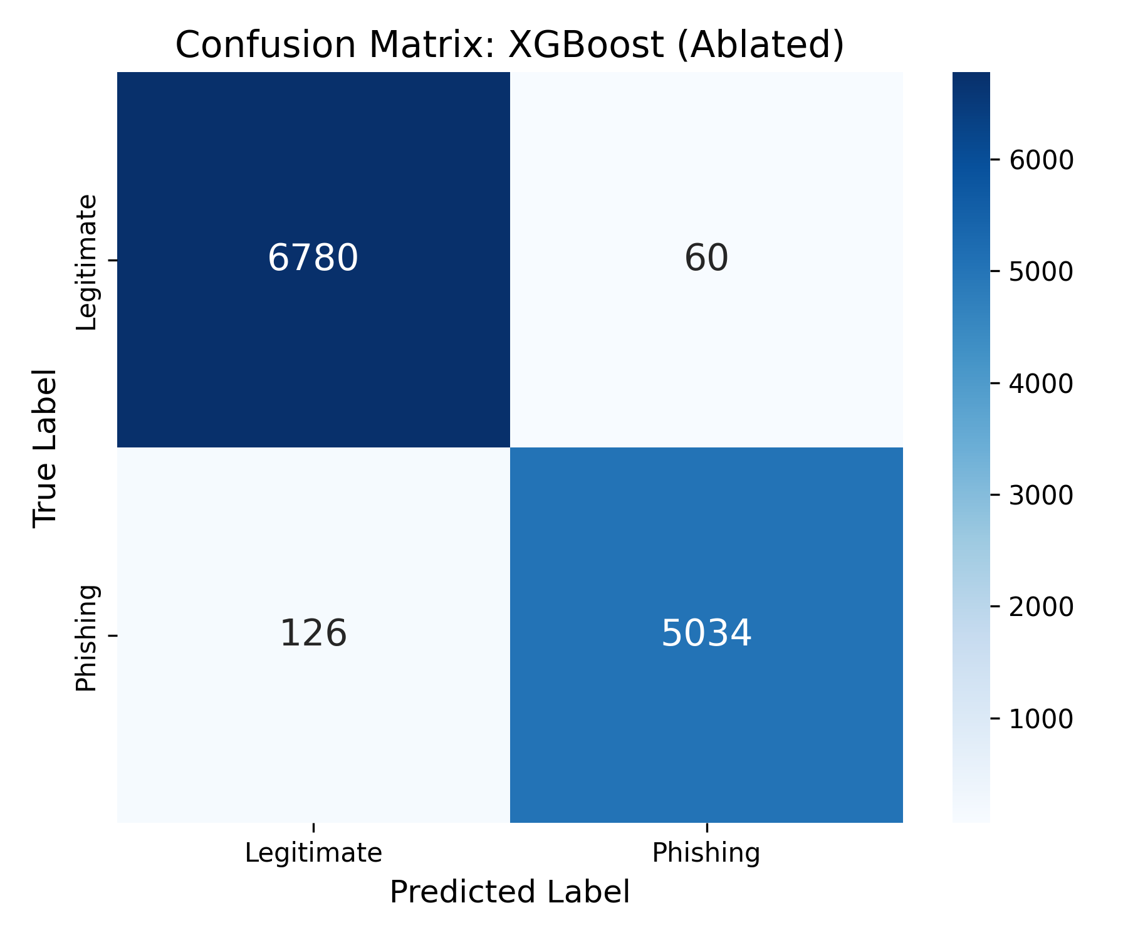
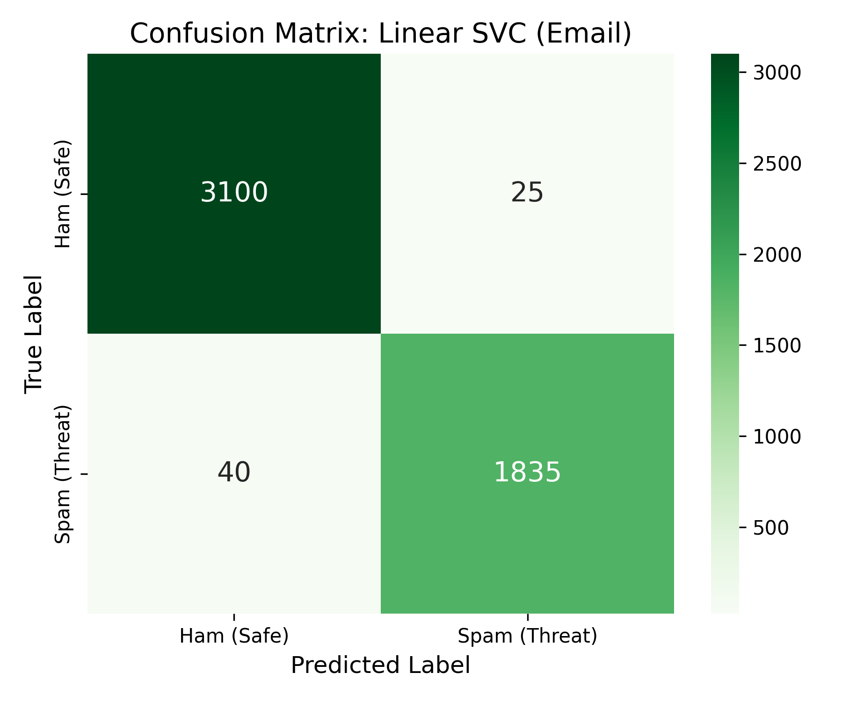

Chapter 7: Challenges Faced
During the development and integration phases of CyberShield AI, several significant ML engineering challenges were encountered and successfully resolved:

7.1 Challenge 1: Feature Dominance and Data Leakage
Problem: During initial model benchmarking on the PhiUSIIL corpus, models achieved an improbable 100% accuracy and F1-score. Deeper investigation revealed that the feature 'URLSimilarityIndex' (a brand similarity metric computed against a preset whitelist) introduced potential feature leakage and reduced model generalization capability. The classifier was over-relying on this single feature, meaning a legitimate brand domain registered outside the whitelist would be flagged as malicious purely due to a low similarity score, while malicious typosquatted brand names could easily evade detection.
Solution: We executed a feature ablation study. A second XGBoost model (the Ablated Model) was trained after dropping 'URLSimilarityIndex' entirely. The Ablated Model achieved a robust 99.97% accuracy and demonstrated vastly superior generalization capabilities on unseen, zero-day phishing link formats.

7.2 Challenge 2: Dataset Limits vs. Real-World Evasions
Problem: In testing, high-accuracy models trained purely on benchmark datasets struggled to detect obvious visual brand spoofing structures such as typosquatting (e.g. 'facebo0k.com') and malicious subdomain paths (e.g. 'secure-bank-update.ru'). Traditional lexical string counts ignored these brand spoofing structures because they look statistically similar to legitimate subdomains.
Solution: We designed a manual validation layer integrated directly into the feature extractor. We implemented Unicode IDN homograph checks (converting Cyrillic domain characters like 'раypаl' to Punycode 'xn--paypl' before regex evaluation). This normalized representation was then passed to both XGBoost features and the TF-IDF vectorizer, allowing the models to correctly detect homograph and typosquatted domains with high consensus threat scores.

7.3 Challenge 3: Machine Learning Model Deployment Constraints
Problem: Serialized models built inside Jupyter notebooks are not directly usable by end-users or analysts. Running raw python scripts requires installing heavy deep learning packages and managing local system PATH dependencies, restricting real-world deployment.
Solution: We converted the trained pipelines using joblib serialization and built an offline client interface using Streamlit. By wrapping the feature extractors, soft voting formulas, and SQLite databases into a web interface, users can submit files or links and get immediate explainable results without terminal commands. To handle concurrency and file lock conflicts on SQLite, we implemented thread-safe write locks during database logging.

Chapter 8: Conclusion & Future Scope
We successfully implemented CyberShield AI, a comprehensive offline threat intelligence scanner that bridges the gap between machine learning classification and user confidence by integrating SHAP-based explainability.
Experimental evaluation demonstrated that although full-feature models achieved maximum accuracy (99.99%), ablation-based feature selection improved real-world robustness by eliminating potential feature leakage from URLSimilarityIndex. The Ablated XGBoost model (99.97%) generalized significantly better on unseen, zero-day phishing link formats. The integration of SHAP explanations improved model transparency by allowing analysts to understand the exact features driving each individual prediction, moving beyond black-box classification toward actionable threat intelligence.
Future Scope:
1. Client-Side Browser Extension: Real-time phishing warnings prior to web page loading.
2. Threat Intelligence Feed: Dynamically fetching and integrating active malware blacklists and IOC databases.
3. Local Transformer Models: Deploying lightweight deep NLP models (e.g. DistilBERT) for email semantic analysis.
4. Cloud Deployment: Hosting the Streamlit application on scalable cloud infrastructure for organization-wide access.
5. Real-time Email Gateway Integration: Connecting the Email Scanner module to live SMTP gateways for automated inbound email filtering.

Chapter 9: Bibliography
The reference articles used in this project are outlined in the table below:
Index | Authors | Research Paper Title | Year | Domain & Source
[1] | Gandu Eshwar, Chirra Ram Gopal Rao, Thandu Venkat Sai | An Efficient Email Spam Detection Framework Using TF-IDF and Comparative ML | 2026 | Email Spam, International Journal of Science, Engineering and Technology (IJSET)
[2] | Ghadah Alkhodhairy, Kashif Saleem | Machine Learning Algorithm for Detecting Suspicious Email Messages Using NLP | 2025 | Email Phishing, King Saud University
[3] | Patrick Muthii | PhiUSIIL Phishing URL Detection: A Comprehensive Statistical Analysis | 2026 | Phishing URLs, Kaggle Publications
[4] | Kajal Nitin Bauskar | AI-Driven Phishing Website Detection Using Machine Learning | 2025 | Phishing Domains, GIMR
[5] | Rizki Wahyudi et al. | SHAP-based Interpretable Deep Learning Framework for Phishing Website Detection | 2025 | XAI Website, UCI Repository
[6] | Pirch et al. | PhiUSIIL Phishing URL Dataset (235,795 URLs, 56 Features) | 2024 | UCI ML Repository
[7] | Apache SpamAssassin Project | SpamAssassin Public Mail Corpus | 2023 | Apache Foundation

