Data Science ToolBox: Python Programming
PROJECT REPORT
(Project Semester January-April 2026)

Air Quality Analysis DashBoard

Submitted by
Sai Krishna Velicheti

Registration No: 12406705

Programme and Section 4M029
Course Code: INT375

Under the Guidance of

Dr.Savleen Kaur(18306)

Discipline of CSE/IT

Lovely School of Computer Science and Engineering

Lovely Professional University, Phagwara

CERTIFICATE

This is to certify that Sai Krishna Velicheti bearing Registration no. 12406705 has completed INT375 project titled Air Quality Analysis Dashboard under my guidance and supervision. To the best of my knowledge, the present work is the result of his/her original development, effort and study.

Signature and Name of the Supervisor
Designation of the Supervisor
School of Computer Science and Engineering
Lovely Professional University
Phagwara, Punjab.

Date: 23-04-2026

DECLARATION

I, Sai Krishna Velicheti, student of Btech CSE under CSE/IT Discipline at, Lovely Professional University, Punjab, hereby declare that all the information furnished in this project report is based on my own intensive work and is genuine.

Date: Signature: V.Sai Krishna
Registration No. 12406705 Name of the student: Sai Krishna Velicheti

DATA SCIENCE MINOR PROJECT REPORT

CONTENTS OF THE REPORT
- Cover page
- Declaration
- Certificate
- Acknowledgement
- Table of Content

1. Introduction
2. Source of dataset
3. Dataset Preprocessing
4. Analysis on dataset (for each objective)
- General Description
- Specific Requirements
- Analysis results
- Visualization
5. Conclusion
6. Future scope
7. References

ACKNOWLEDGEMENT
I would like to express my sincere gratitude to all those who have contributed to the successful completion of this project.
First and foremost, I am deeply grateful to my project supervisor, Dr. Savleen Kaur, for her valuable guidance, continuous support, and encouragement throughout this project. Her insights and suggestions played a crucial role in shaping this work and improving its quality.
I would also like to thank the Department of Computer Science and Engineering, Lovely Professional University, for providing the necessary resources and infrastructure required for this project. The access to tools such as Power BI Desktop greatly supported the development of this analysis.
I would like to acknowledge the government open data platform (data.gov.in) for providing the Air Quality dataset used in this project. This dataset formed the foundation for all the analysis and insights presented.
I am also thankful to my classmates and friends for their support and valuable suggestions during different stages of this project.
Finally, I express my heartfelt gratitude to my family for their constant encouragement, patience, and support throughout this journey. Their belief in me has always been a source of motivation.

1. Introduction
Air pollution has become a major environmental issue, particularly in urban areas where industrialization and vehicle emissions are increasing rapidly. Monitoring air quality is essential to understand pollution levels and their impact on human health.
The Air Quality Index (AQI) is a standardized metric used to represent the level of air pollution. It combines the concentration of different pollutants into a single value that indicates how safe or hazardous the air is.
In this project, air quality data from multiple cities in India is analyzed using Python. The dataset includes pollutant measurements such as PM2.5, PM10, NO2, SO2, CO, O3, and NH3. Since the dataset does not directly provide AQI values, they are approximated using pollutant concentrations.
The processed data is visualized through an interactive dashboard built using Panel and hvPlot. The dashboard helps in understanding AQI distribution, identifying highly polluted cities, and analyzing the impact of different pollutants on air quality.

2. Source of Dataset
The dataset used in this project was obtained from the Government of India’s open data platform, data.gov.in. It provides real-time air quality data collected from monitoring stations across different cities.
The dataset includes the following key attributes:
- City
- Last Update (timestamp)
- Pollutant ID
- Pollutant Average Value
The data is initially in a long format, where each row represents a pollutant measurement for a specific city and time. This structure requires transformation before performing analysis.
LINK: https://www.data.gov.in/resource/real-time-air-quality-index-various-locations
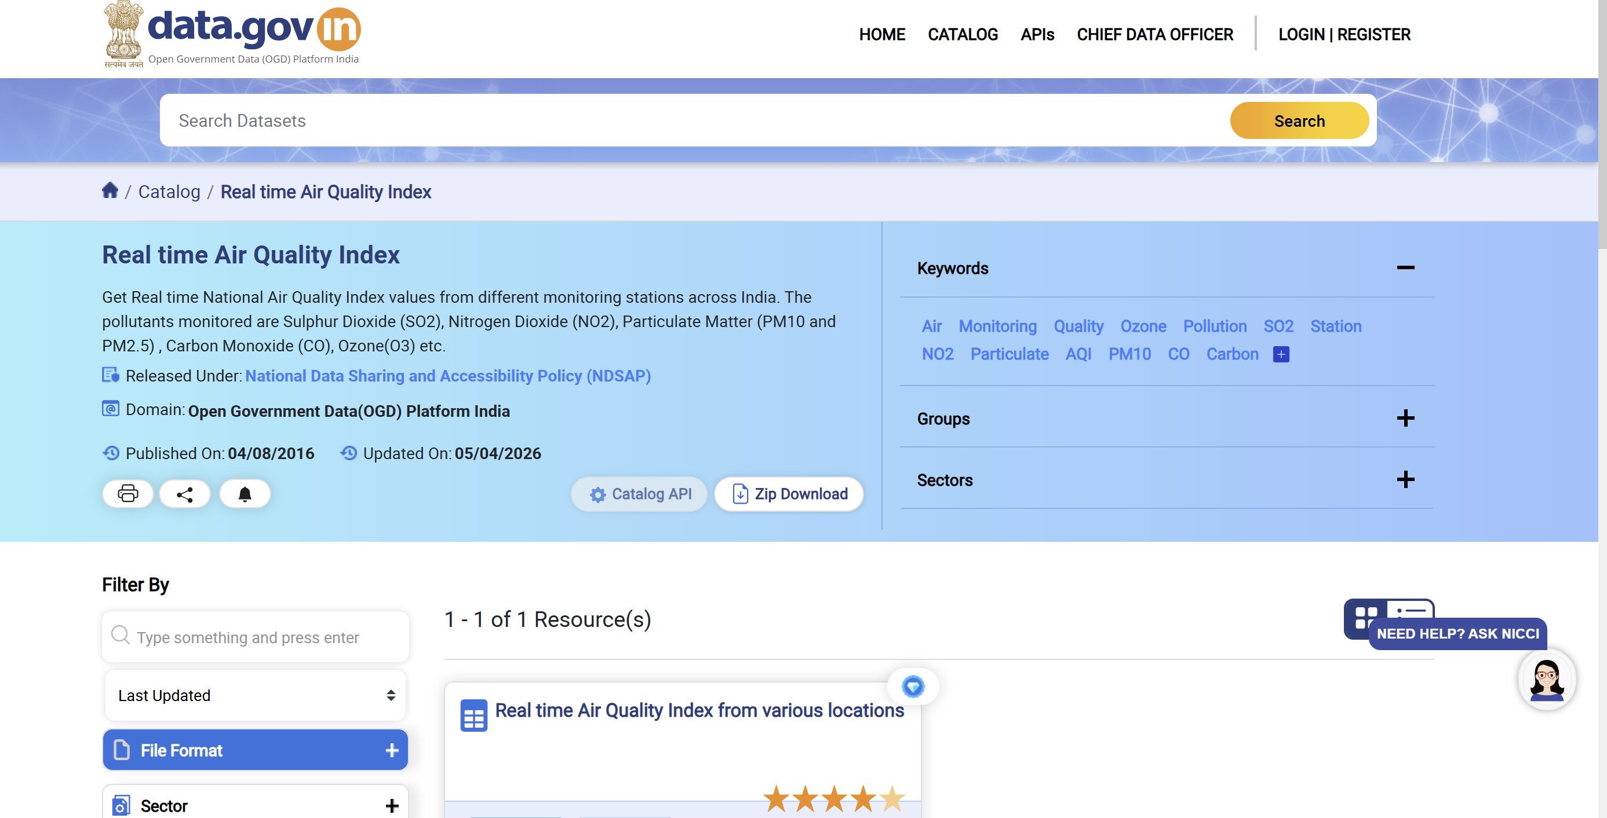

3. Dataset Preprocessing
The dataset required multiple preprocessing steps to make it suitable for analysis and visualization.

🔹 Handling Missing Values
Some entries in the pollutant values were missing. These values were replaced using the mean of the respective pollutant column to maintain data consistency.

🔹 Data Type Conversion
The last_update column was converted into datetime format to ensure proper handling of time-related data. Pollutant values were ensured to be in numeric format.

🔹 Removing Duplicates
Duplicate rows were removed from the dataset to avoid repeated observations and ensure accurate analysis.

🔹 Data Transformation (Pivot Operation)
The dataset was originally in long format, where each row represented a single pollutant measurement. To make analysis easier, the dataset was transformed into wide format using a pivot operation.
After transformation:
- Each pollutant becomes a separate column
- Each row represents a city with all pollutant values
This step is crucial because it allows comparison between pollutants and simplifies AQI calculation.

Data Prepocessing:

Raw Data:
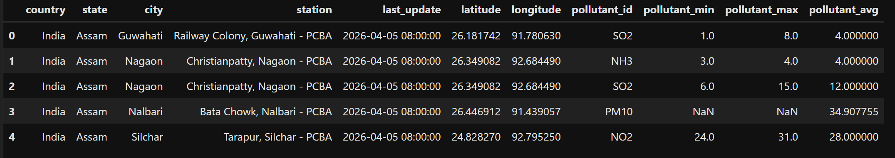

After:
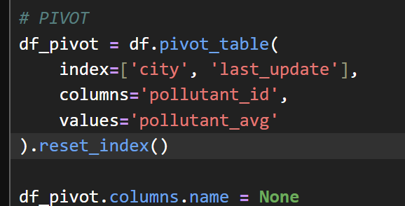

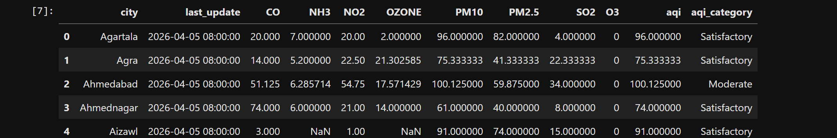

🔹 Feature Engineering (AQI Calculation)
Since AQI values were not directly available in the dataset, they were approximated using the maximum value among all pollutants for each record.
This approach is based on the AQI principle, where the dominant pollutant determines the AQI value.
Additionally, AQI categories such as Good, Satisfactory, Moderate, Poor, Very Poor, and Severe were assigned based on standard AQI ranges.

4. Analysis on Dataset

🔷 General Description
The dataset represents air quality measurements across multiple cities in India. The analysis focuses on identifying pollution patterns, comparing cities, and understanding the contribution of different pollutants to AQI.

🔷 Specific Requirements
- Identify the most polluted cities
- Analyze AQI category distribution
- Study the relationship between pollutants and AQI
- Compare average pollutant levels
- Visualize insights using an interactive dashboard

Objective 1: AQI Category Distribution
i. General Description
This analysis aims to understand how AQI values are distributed across different categories.
ii. Specific Requirement
Count the number of observations in each AQI category.
iii. Analysis Result
The analysis shows that most AQI values fall under the Satisfactory and Moderate categories. This indicates moderate pollution levels in most regions.
iv. Visualization
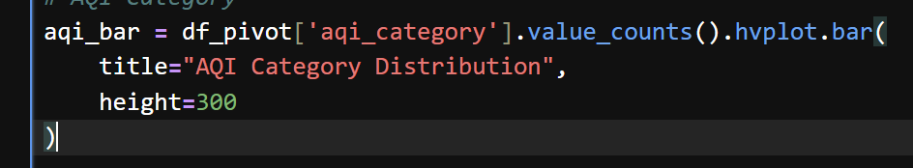
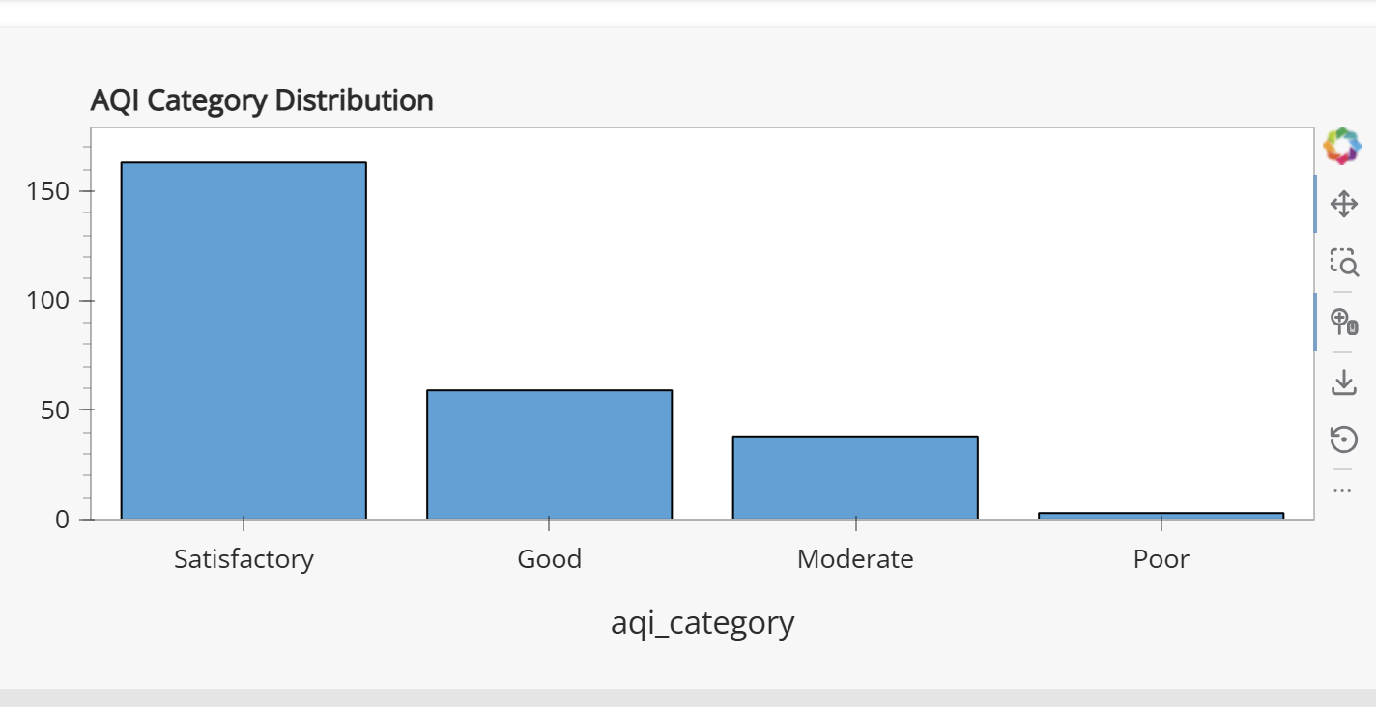
Objective 2: Top Polluted Cities
i. General Description
This analysis identifies cities with the highest pollution levels.
ii. Specific Requirement
Calculate the average AQI for each city and rank them.
iii. Analysis Result
Some cities consistently show higher AQI values, indicating severe pollution levels likely due to urbanization and industrial activity.
iv.Visualization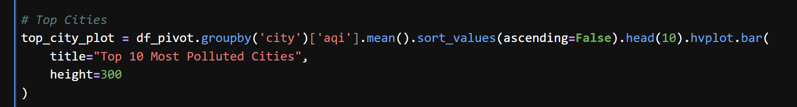

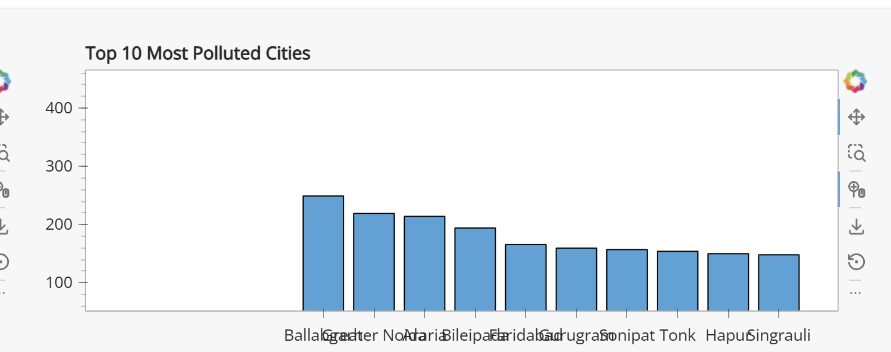

Objective 3: Pollutant Impact (PM2.5 vs AQI)
i. General Description
This analysis examines the relationship between PM2.5 and AQI.
ii. Specific Requirement
Plot PM2.5 values against AQI.
iii. Analysis Result
A strong positive relationship is observed between PM2.5 and AQI, indicating that it is a major contributor to air pollution.
iv. Visualization
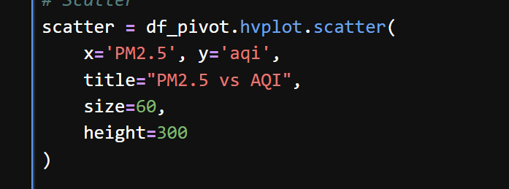
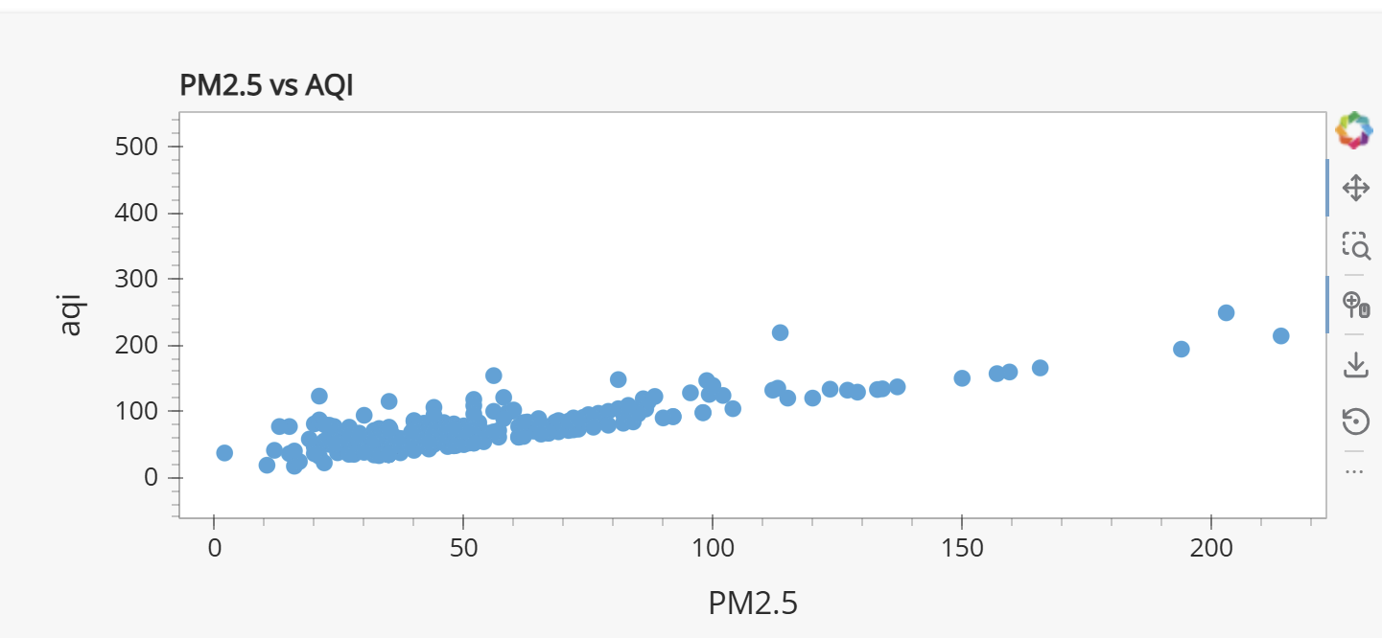

Objective 4: Pollutant Comparison
i. General Description
This analysis compares the average levels of different pollutants.
ii. Specific Requirement
Calculate mean values for each pollutant.
iii. Analysis Result
PM2.5 and PM10 have higher average concentrations compared to other pollutants, making them the dominant contributors to AQI.
iv. Visualization
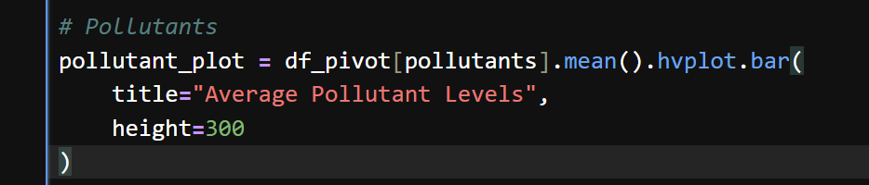
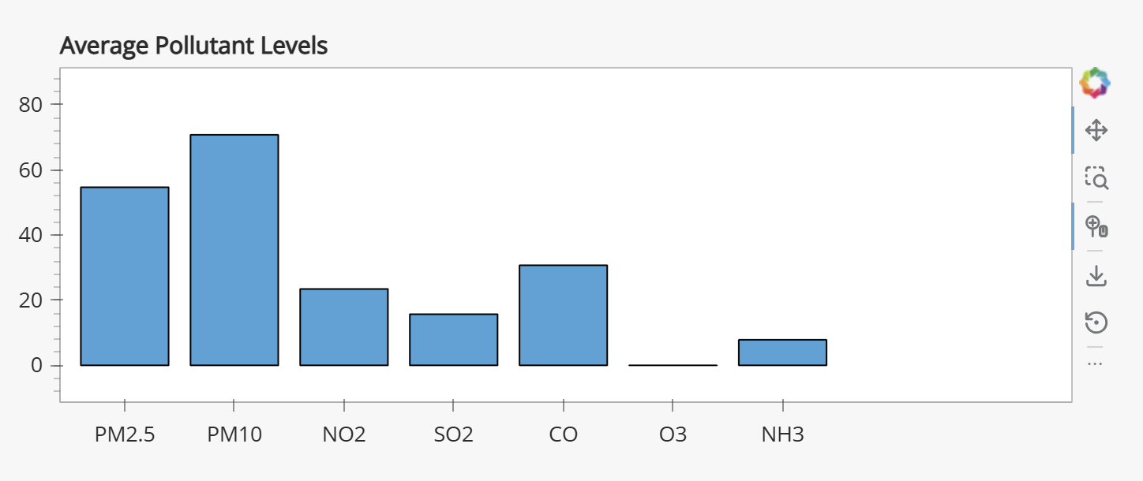

Objective 5: Dashboard Overview
i. General Description
This section presents the overall dashboard developed for the project.
ii. Specific Requirement
Combine all visualizations into a single interface.
iii. Analysis Result
The dashboard provides a clear and interactive view of AQI data, enabling easy understanding of pollution patterns and trends.
iv. Visualization


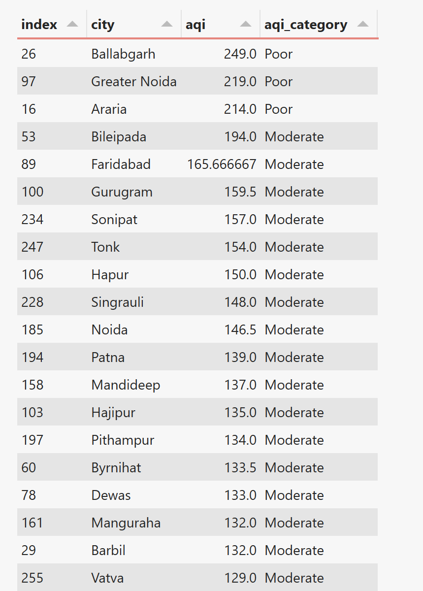
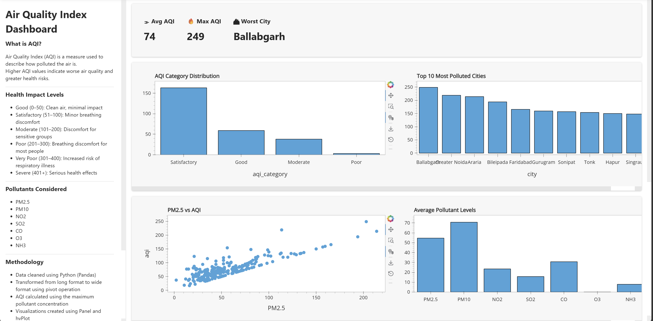

5. Conclusion
The analysis of AQI data highlights significant variations in air quality across different cities. It was observed that PM2.5 is the most influential pollutant affecting AQI levels. Several cities exhibit high pollution levels, indicating the need for stricter environmental regulations.
The dashboard developed using Python provides an effective way to visualize and interpret air quality data, making it useful for understanding pollution trends and supporting decision-making.

6. Future Scope
The project can be further improved by:
- Integrating real-time AQI data using APIs
- Applying machine learning models to predict AQI
- Adding geographical map visualizations
- Performing time-based trend analysis
- Enhancing the dashboard with more advanced features

Github Link: https://github.com/Sai07079999/AQI-Dashboard

LINKEDIN POST: https://www.linkedin.com/posts/sai-krishna-velicheti_python-datascience-dataanalytics-ugcPost-7452769981077016577-Q4iX?utm_source=share&utm_medium=member_android&rcm=ACoAAFFWWkwBGJFYLlD8qgFdVva7yMbIfa4d_3U

