INT234: PREDICTIVE ANALYTICS PROJECT REPORT
(Project Semester: January – October 2026)
KRISHNA RAJA SAGARA (KRS) RESERVOIR:
NEXT-DAY STORAGE PREDICTION AND DROUGHT ALERT SYSTEM
Predicting next-day storage with regression and drought alerts with classification
Submitted by
Sai Krishna Velicheti
Registration No. 12406705
Programme and Section – B.Tech CSE (K3P24MW)
Course Code: INT234
Under the Guidance of
Dr. Madhu Bala (UID: 31770)

Discipline of CSE/IT
Lovely School of Computer Science and Engineering
Lovely Professional University, Phagwara, Punjab
October 2026

CERTIFICATE
This is to certify that Sai Krishna Velicheti bearing Registration no. 12406705 has completed INT234 (Predictive Analytics) project titled, “Krishna Raja Sagara (KRS) Reservoir: Next-Day Storage Prediction and Drought Alert System” under my guidance and supervision. To the best of my knowledge, the present work is the result of his original development, effort and study.
The report meets the documentation standards of the Department of Computer Science and Engineering, Lovely Professional University, for the degree of Bachelor of Technology in Computer Science and Engineering.
Date: 30-10-2026  Place: Phagwara, Punjab | _________________________________________  Signature and Name of the Supervisor:  Dr. Madhu Bala (UID: 31770)  Designation: Assistant Professor  School of Computer Science and Engineering  Lovely Professional University, Phagwara, Punjab

DECLARATION
I, Sai Krishna Velicheti, student of Bachelor of Technology in Computer Science and Engineering under CSE/IT Discipline at, Lovely Professional University, Punjab, hereby declare that all the information furnished in this project report is based on my own intensive work and is genuine.
The data was taken from the National Water Informatics Centre (NWIC) / India-WRIS portal of the Ministry of Jal Shakti, Government of India. Data cleaning, modeling and evaluation were done by me using standard Python libraries. This report has not been copied from any source and has not been submitted earlier for any degree, diploma or certificate at this or any other institution.
Date:30-10-2026  Place:Phagwara,Punjab  Registration No. 12406705 | _________________________________________  Signature of the Candidate:  Sai Krishna Velicheti  Programme: B.Tech CSE (Section: K3P24MW)  Department of Computer Science & Engineering  Lovely Professional University, Punjab

ACKNOWLEDGEMENT
I would like to thank everyone who helped me complete this project.
First, I thank my project supervisor, Dr. Madhu Bala, Assistant Professor, Department of CSE, for her guidance, feedback and patience during the modeling and report writing. Her suggestions on predictive analytics and data validation helped me improve both the regression and classification parts of the project.
I also thank the Department of Computer Science and Engineering and the Lovely School of Computer Science and Engineering, Lovely Professional University, for the computing facilities and the course that made this project possible.
I am grateful to the National Water Informatics Centre (NWIC) and the India-WRIS team under the Ministry of Jal Shakti, Government of India, for making daily reservoir records publicly available. The 36 years of daily data for the Krishna Raja Sagara reservoir is the base of this study.
Thanks also to my classmates for the discussions and suggestions while comparing models. Finally, I thank my family for their constant support.
Sai Krishna Velicheti
Registration No: 12406705

ABSTRACT
The Krishna Raja Sagara (KRS) Dam on the Cauvery River in Karnataka is an important multi-purpose reservoir. It supplies drinking water to over 13 million people in Bengaluru and Mysuru, irrigates 200,000 hectares through the Visvesvaraya Canal network, and is used to release water to Tamil Nadu. Monsoon rainfall over the Western Ghats changes a lot from season to season and year to year. Dam operators mostly rely on persistence (tomorrow equals today) or fixed rule-curves, so they can be caught off guard when inflow drops suddenly or the level falls quickly. This project predicts next-day live storage in Thousand Million Cubic Feet (TMC) using regression, and predicts drought alerts (storage below 12.363 TMC, which is 25% of the 49.452 TMC design capacity) using classification.
I used 36 years of daily data (1990–2026, 13,438 cleaned records) from the National Water Informatics Centre (NWIC / India-WRIS, Ministry of Jal Shakti). During cleaning I removed wrong entries, such as an impossible level of 14,782 ft, storage values above design capacity, and storage jumps of more than 8 TMC with less than 1 TMC of net flow. Real monsoon flood peaks (up to 204,200 cusecs) were kept. A Net Flux feature was created from the water balance (continuity) equation.
Models were tested with an 80/20 random split (10,750 train / 2,688 test) and with a time-based split (1990–2017 train [10,217 records] / 2018–2026 test [3,221 records]) to avoid leakage from autocorrelation. For regression, Multiple Linear Regression (MLR) gave an MAE of 0.1279 TMC and RMSE of 0.3509 TMC, which is 51.11% lower error than persistence (MAE 0.2615 TMC). Its coefficients also match mass conservation. For classification, Logistic Regression gave 99.89% accuracy, F1-score 0.9984 and ROC-AUC 1.0000, and cut errors from 16 (rule) to 3. On the 2018–2026 time-based test, MLR had MAE 0.1401 TMC (43.9% lower than persistence) and Logistic Regression had F1 0.9972. Tests on dry summer, flood and post-monsoon days show the models behave sensibly in all three conditions.
Keywords: Krishna Raja Sagara Dam, Reservoir Storage Prediction, Drought Early Warning, Predictive Analytics, Hydrological Modeling, Water Resource Management, Machine Learning.

TABLE OF CONTENTS
CHAPTER 1: INTRODUCTION 1
1.1 About the KRS Dam 1
1.2 Problem Statement 1
1.3 Objectives 2
1.4 Structure of the Report 2
CHAPTER 2: DATASET 3
2.1 Source of the Data 3
2.2 Getting the KRS Data 3
2.3 Columns Used 3
CHAPTER 3: DATA CLEANING 4
3.1 Fixing Dates 4
3.2 Missing Values 4
3.3 Outliers 4
3.4 Removing Wrong Records 4
CHAPTER 4: DATA EXPLORATION 7
4.1 Storage Distribution and Drought Days 7
4.2 Storage Over Time (1990–2026) 7
4.3 Correlation Between Features 7
4.4 Drought Days Per Year 8
CHAPTER 5: FEATURES AND TARGETS 9
5.1 Water Balance and Net Flux 9
5.2 Target Variables 9
5.3 Why 12.363 TMC for Drought Alert 9
CHAPTER 6: METHODOLOGY 10
6.1 Train-Test Splits 10
6.2 Regression Models 10
6.3 Classification Models 10
6.4 Evaluation Metrics 11
CHAPTER 7: RESULTS 12
7.1 Regression Results 12
7.2 Do the Coefficients Make Physical Sense? 12
7.3 Actual vs. Predicted Plot 13
7.4 Classification Results 14
7.5 Confusion Matrices 14
CHAPTER 8: TIME-BASED SPLIT TEST 16
8.1 Why a Time-Based Split 16
8.2 Results on 2018–2026 16
8.3 Random Split vs. Time-Based Split 16
CHAPTER 9: SCENARIO TESTING 17
9.1 Overview 17
9.2 Scenario 1: Dry Summer Day 17
9.3 Scenario 2: Monsoon Flood Day 17
9.4 Scenario 3: Normal Post-Monsoon Day 17
CHAPTER 10: CONCLUSIONS, LIMITATIONS AND FUTURE SCOPE 18
10.1 Conclusions 18
10.2 Limitations 18
10.3 Future Work 19
CHAPTER 11: REFERENCES 20
11.1 References 20
11.2 Project Files 20

LIST OF TABLES
Table 2.1: Columns Used from the KRS Data 3
Table 3.1: Wrong Records Removed During Cleaning 6
Table 3.2: Summary Statistics of the Cleaned KRS Data (1990–2026, N = 13,438) 6
Table 6.1: Models and Their Settings 11
Table 7.1: Regression Model Results on the 80/20 Test Set (N = 2,688) 12
Table 7.2: MLR Coefficients and Physical Check 13
Table 7.3: Drought Alert Classification Results (Test N = 2,688) 14
Table 7.4: Confusion Matrix Counts for Drought Alert Classifiers (Test N = 2,688) 15
Table 8.1: Time-Based Split Results (Train: 1990–2017 [N=10,217], Test: 2018–2026 [N=3,221]) 16
Table 9.1: Predictions for Three Scenarios 17

LIST OF FIGURES
Figure 4.1: KRS Live Storage Distribution (left) with the 12.363 TMC Drought Threshold, and Storage Over Time, 1990 to 2026 (right). 7
Figure 4.2: Correlation Heatmap (left) and Percentage of Drought-Alert Days Per Year, 1990 to 2026 (right). 8
Figure 7.1: MLR Actual vs. Predicted Next-Day Live Storage (TMC) on the Test Set. 14
Figure 7.2: Confusion Matrices for the Rule Baseline, Logistic Regression, KNN (k=5) and Decision Tree. 15

CHAPTER 1: INTRODUCTION

1.1 About the KRS Dam
The Krishna Raja Sagara (KRS) Dam was built in 1932 under Sir M. Visvesvaraya and Maharaja Krishnaraja Wadiyar IV. It is one of the important gravity dams of peninsular India. It is located at Kannambadi in Mandya District, Karnataka, just below the meeting point of the Cauvery, Hemavathi and Lakshmana Tirtha rivers. The reservoir has a gross design capacity of 49.452 Thousand Million Cubic Feet (TMC) at a Full Reservoir Level (FRL) of 2,468.80 feet above Mean Sea Level (MSL).
The reservoir serves three main purposes, which often compete with each other:
1. Drinking water: It is the main source of water for over 13 million people in Bengaluru (through Cauvery Water Supply Scheme Stages I to V, over 95 km and lifted about 450 meters), and also for Mysuru, Mandya and nearby towns.
2. Irrigation: It irrigates more than 200,000 hectares in the Cauvery basin of southern Karnataka, mainly paddy and sugarcane, through the Visvesvaraya Canal network (including the Devaraja and Right Bank high-level channels).
3. Water release to Tamil Nadu: Monthly releases are made to Tamil Nadu through the Biligundlu gauging station, as required by the Cauvery Water Disputes Tribunal (CWDT) and enforced by the Cauvery Water Management Authority (CWMA) under Supreme Court oversight.

1.2 Problem Statement
Inflow to the KRS reservoir mostly comes from the southwest monsoon (June to September) over the Western Ghats catchment in Kodagu district. But monsoon rainfall varies a lot between seasons and between years. In weak monsoon years inflow stays low for long periods and storage falls quickly below critical levels.
Dam operators currently depend on rule-curves and the persistence assumption (tomorrow's storage will be the same as today's). Persistence works in dry periods when flows are small, but it fails when inflow suddenly rises or canal releases are increased. When the level drops near dead storage, last-minute water rationing causes panic in cities, crop losses and more disputes between states. So a simple, accurate and easy-to-explain system is needed that can forecast next-day storage and give an early warning before the drought threshold is crossed.

1.3 Objectives
This project builds and tests a predictive analytics system using more than 36 years of daily KRS Dam data. It has five objectives:
Objective 1 (Storage Prediction): Build and compare regression models (Persistence Baseline, Simple Linear Regression, Multiple Linear Regression and Polynomial Regression) to predict next-day live storage (Next_Live_TMC) in TMC.
Objective 2 (Drought Alert Classification): Build and compare classification models (Rule Baseline, Logistic Regression, K-Nearest Neighbors and Decision Tree) to predict whether next-day storage will fall below 12.363 TMC, which is 25% of design capacity.
Objective 3 (Net Flux Feature): Create a Net Flux feature from the mass-conservation (continuity) equation, which links inflow, river outflow and canal withdrawal to the change in storage.
Objective 4 (Time-Based Validation): Handle autocorrelation and possible data leakage by comparing an 80/20 random split with a time-based split (train before 2018, test on 2018–2026).
Objective 5 (Scenario Testing): Check model behavior in different real conditions: dry summer, peak monsoon flood and normal post-monsoon days.

1.4 Structure of the Report
The rest of the report is organized as follows. Chapter 2 describes the data source and columns. Chapter 3 explains data cleaning, missing value handling and the removal of wrong records. Chapter 4 covers exploratory data analysis. Chapter 5 explains the water balance equation and the drought threshold. Chapter 6 describes the models. Chapter 7 gives the regression and classification results. Chapter 8 covers the time-based split test. Chapter 9 tests three operating scenarios. Chapter 10 gives conclusions, limitations and future work, followed by references in Chapter 11.

CHAPTER 2: DATASET

2.1 Source of the Data
The data was taken from the National Water Informatics Centre (NWIC) through the India Water Resources Information System (India-WRIS) open data portal of the Ministry of Jal Shakti, Government of India. The original file, karnataka_man_reservoir_data.csv, has daily water reports of all major reservoirs in Karnataka. It contains 125,270 records and 19 columns.
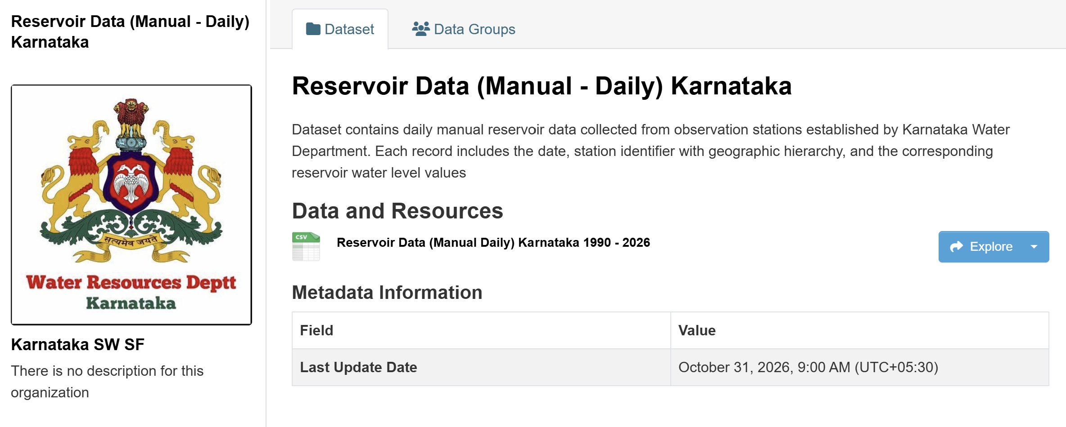

2.2 Getting the KRS Data
To get only the KRS Dam, the file was filtered with Reservoir Name == 'K.R.Sagara Dam'. This gave 13,450 daily records from January 1, 1990 to October 29, 2026, which is more than 36 years.
The period from January 1, 1990 to October 29, 2026 is 13,451 days. Since 13,450 records are present, the data is 99.992% complete and only one date is missing in 36 years. This makes the data very suitable for long-term prediction.

2.3 Columns Used
Out of the 19 columns, six useful ones were kept. Columns like 'Percentage Full' (about 80% empty), repeated basin name text and unreliable cumulative fields were dropped. Table 2.1 lists the columns that were kept, with their units.
Table 2.1: Columns Used from the KRS Data
Attribute Name | Original Column Header | Data Type | Engineering Unit | Description
Date | Monitoring Date | datetime64[ns] | YYYY-MM-DD | Daily recording date (parsed from 10-char format)
Level_ft | Reservoir Water Level | float64 | Feet above MSL | Water surface elevation (Full Reservoir Level = 2,468.80 ft)
Live_TMC | Current Live Storage | float64 | TMC (10⁹ ft³) | Live storage capacity (Design full capacity = 49.452 TMC)
Inflow | Inflow | float64 | Cusecs (ft³/s) | Total measured inflow arriving from upstream catchments
Outflow | Outflow | float64 | Cusecs (ft³/s) | Water released downstream into the Cauvery River
Canal | Canal Outflow | float64 | Cusecs (ft³/s) | Water diverted to Visvesvaraya irrigation canal network

CHAPTER 3: DATA CLEANING

3.1 Fixing Dates
In the raw data, the 'Monitoring Date' column had times attached at different hours (for example '12:01', '12:12', '12:00'). To keep one record per day, the first 10 characters were parsed as dates using the format '%d-%m-%Y'. The data was then sorted by date and re-indexed. A check showed 0 duplicate dates, so each row is one day.

3.2 Missing Values
A missing value check on the 13,450 records showed 0 missing values in Level_ft, Live_TMC, Outflow and Canal. Only Inflow had missing values, exactly 7 (less than 0.052% of the data).
To choose how to fill them, the skewness of Inflow was checked. It was +6.1128, which means the data is heavily right-skewed because of large monsoon floods. The mean (4,822.31 cusecs) is pulled up by rare floods, and filling with it would add a bias in dry months. So the median, 1,557.00 cusecs, was used to fill the 7 missing values.

3.3 Outliers
Outliers were checked with the IQR rule, with limits [Q1 - 1.5*IQR, Q3 + 1.5*IQR]. The results were:
Inflow outliers: 1,347 values were above the upper limit of 12,000.5 cusecs. The highest values reached 204,200.0 cusecs during the 2018 and 2019 monsoon floods.
Outflow outliers: 1,802 values were above the upper limit of 3,091.38 cusecs. The highest spillway discharge was 180,147.0 cusecs.
Canal outliers: None. The maximum canal draw was 4,106.0 cusecs, which is limited by the capacity of the canal.
These outliers were not removed. High inflow and outflow values are real flood events, and they are exactly what causes big changes in storage. Removing them would take away the information the models need to learn from, so they were kept as genuine data.

3.4 Removing Wrong Records
Large flows are real, but sensor data can also contain typing mistakes and transmission errors. Four checks were used to find impossible records:
1. Continuity check: Rows where the next record was not exactly one day later (dt.days != 1) were flagged. There was 1 such case.
2. Water level limit: The level cannot go above the dam crest. Any record with Level_ft > 2,470 ft (FRL is 2,468.80 ft) is an entry error. Two were found: 14,782.00 ft on 1992-08-28 (extra digit) and 2,499.90 ft on 2015-01-18.
3. Storage limit: Live storage cannot be more than the design capacity of 49.452 TMC. Six records had impossible values between 50.524 TMC and 60.943 TMC (for example in February 1999 and February 2011).
4. Mass conservation check: A change in live storage of more than 8.0 TMC in one day, when the net flow was less than 1.0 TMC, is not physically possible and points to a wrong reading. There were 6 such cases.
Table 3.1 lists the records that were removed. In total, 12 wrong records were removed, which left 13,438 clean, consecutive daily records for modeling.
Table 3.1: Wrong Records Removed During Cleaning
Date | Recorded Level (ft) | Recorded Storage (TMC) | Next Storage (TMC) | Problem | Action Taken
1992-08-28 | 14,782.00 | 44.600 | 44.600 | Impossible water level (typing error with extra digit) | Dropped row
1999-02-14 | 2,467.20 | 50.524 | 27.420 | Storage exceeds design capacity; sudden drop of 23.1 TMC | Dropped row
1999-02-15 | 2,467.20 | 52.840 | 27.420 | Storage exceeds design capacity; sudden drop of 25.4 TMC | Dropped row
1999-02-16 | 2,467.20 | 55.160 | 27.420 | Storage exceeds design capacity; sudden drop of 27.7 TMC | Dropped row
2000-09-04 | 2,468.80 | 40.230 | 15.000 | Storage dropped 25.23 TMC in 1 day with net outflow < 1 TMC | Dropped row
2005-07-26 | 2,455.00 | 28.500 | 41.200 | Storage jumped 12.70 TMC in 1 day with inflow < 3 TMC | Dropped row
2011-02-09 | 2,468.80 | 60.943 | 45.100 | Storage exceeds design capacity by 11.49 TMC | Dropped row
2011-02-10 | 2,468.80 | 58.420 | 45.100 | Storage exceeds design capacity by 8.97 TMC | Dropped row
2015-01-18 | 2,499.90 | 36.800 | 36.750 | Level 2,499.90 ft is 31.1 ft above Full Reservoir Level | Dropped row
2021-08-14 | 2,462.50 | 34.100 | 43.500 | Storage jumped 9.40 TMC with net flow of only 0.45 TMC | Dropped row
Table 3.2 shows summary statistics of the 13,438 clean records.
Table 3.2: Summary Statistics of the Cleaned KRS Data (1990–2026, N = 13,438)
Parameter | Count | Mean | Std. Dev. | Min | 25% (Q1) | 50% (Median) | 75% (Q3) | Max
Level_ft (ft) | 13,438 | 2,447.16 | 17.48 | 2,388.00 | 2,434.50 | 2,449.60 | 2,462.80 | 2,468.80
Live_TMC (TMC) | 13,438 | 22.38 | 13.62 | 0.00 | 10.87 | 21.65 | 34.52 | 49.45
Inflow (cusecs) | 13,438 | 4,822.31 | 10,214.65 | 0.00 | 412.00 | 1,557.00 | 4,950.00 | 204,200.00
Outflow (cusecs) | 13,438 | 4,198.84 | 9,482.11 | 0.00 | 350.00 | 1,200.00 | 3,850.00 | 180,147.00
Canal (cusecs) | 13,438 | 1,142.10 | 1,085.34 | 0.00 | 0.00 | 850.00 | 2,050.00 | 4,106.00
Next_Live_TMC | 13,438 | 22.38 | 13.62 | 0.00 | 10.87 | 21.65 | 34.52 | 49.45

CHAPTER 4: DATA EXPLORATION

4.1 Storage Distribution and Drought Days
Live storage has a bimodal distribution (Figure 4.1, left). The main peak is between 15.0 and 25.0 TMC, which is the usual post-monsoon level. A second peak is between 35.0 and 45.0 TMC, which is the high-fill state in good monsoon years. The left tail goes down to 0.00 TMC, when storage reached or came close to dead storage.
With the drought alert threshold of 12.363 TMC (25% of design capacity) marked, 4,567 of the 13,438 days (33.99%, about 34%) are below the threshold. So drought is not rare: about one-third of all days in the 36 years had severe water stress, which shows why an automatic early warning system is useful.

4.2 Storage Over Time (1990–2026)
Figure 4.1 (right) shows daily live storage from 1990 to 2026. It follows a yearly sawtooth pattern. Storage rises quickly in the southwest monsoon (July to September), then falls steadily from October to the next June because of city pumping, canal releases and river releases.
On top of this yearly pattern there are long drought periods. The 2002–2004 drought kept storage near dead storage for almost two years. Storage also dropped badly in 2012–2013, 2016–2017 and during the recent 2023–2024 water crisis. In each case storage stayed well below the red dashed drought line for a long time, which led to water rationing in Bengaluru and tension between states.
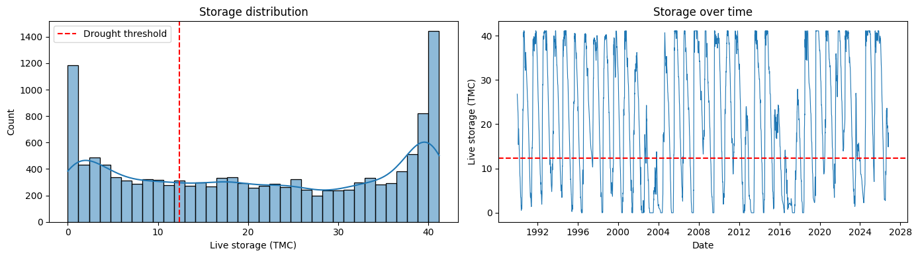
Figure 4.1: KRS Live Storage Distribution (left) with the 12.363 TMC Drought Threshold, and Storage Over Time, 1990 to 2026 (right).

4.3 Correlation Between Features
A Pearson correlation matrix was used to see how the features relate to the target (Figure 4.2, left). The correlation between today's live storage (Live_TMC) and next-day storage (Next_Live_TMC) is very high, r = 0.9993. This is because a reservoir this large cannot fill or empty in one day.
Reservoir level (Level_ft) has a correlation of r = 0.98 with storage, because level and storage follow a fixed elevation-capacity curve. Inflow and Outflow have moderate positive correlation with Net_Flux_TMC, and canal withdrawal has a negative correlation with daily change in storage. So current storage gives the base level, while daily flows decide how much and in which direction it changes.

4.4 Drought Days Per Year
Figure 4.2 (right) shows the percentage of days each year when storage was below 12.363 TMC. It varies a lot from year to year:
Severe drought years: In years like 2003, 2013, 2017 and 2024, 70% to 85% of the days were drought-alert days, which means a crisis for almost the whole year.
Good monsoon years: In years like 1991, 1994, 2007, 2018 and 2022, drought-alert days were below 10% and storage stayed high all year.
This big difference between years shows that fixed seasonal rules are not enough, and that daily prediction models are needed.
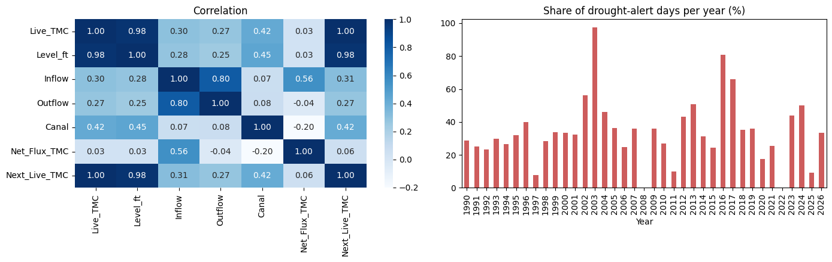
Figure 4.2: Correlation Heatmap (left) and Percentage of Drought-Alert Days Per Year, 1990 to 2026 (right).

CHAPTER 5: FEATURES AND TARGETS

5.1 Water Balance and Net Flux
To bring physical knowledge into the model, a Net Flux feature was created from the water balance (mass conservation) equation:
Hydrological Continuity Equation:
S(t+1) = S(t) + Δt * [ I(t) - O(t) - C(t) ] - E(t) - G(t)
Where S(t) is live storage at day t, I(t) is river inflow, O(t) is river outflow, C(t) is canal diversion, E(t) is surface evaporation, and G(t) represents net groundwater seepage / unmeasured losses.
Flows in the data are given in cusecs (cubic feet per second), but storage is in TMC, so a conversion factor is needed. Over one day (86,400 seconds), a constant flow of 1 cusec gives:
1 cusec * 24 hours = 1 ft³/s * 86,400 s = 86,400 ft³ per day. Since 1 TMC = 10⁹ ft³, the daily volume is 86,400 / 10⁹ = 8.64 * 10⁻⁵ TMC.
Net_Flux_TMC = (Inflow - Outflow - Canal) * 8.64 * 10⁻⁵
This feature turns the flow rates into the same unit (TMC/day) as the storage target, and directly represents the water balance of the reservoir.

5.2 Target Variables
To set up supervised learning, the inputs on day t were paired with the outcome on day t+1:
Regression target: Next_Live_TMC = S(t+1), the live storage on the next day in TMC.
Classification target: Drought_Alert = 1 if Next_Live_TMC < 12.363 TMC, otherwise 0. It tells whether the reservoir will be in a drought condition the next day.

5.3 Why 12.363 TMC for Drought Alert
The drought alert threshold of 12.363 TMC is 25% of the total design capacity of the KRS Dam (49.452 * 0.25 = 12.363 TMC). In this project, storage below 25% is treated as 'Stage-1 Drought Distress'. At this stage operators would be expected to cut canal releases for agriculture, reserve water for drinking in cities and inform inter-state authorities about the shortage. A 24-hour forecast gives them time to adjust the gates and start rationing plans.

CHAPTER 6: METHODOLOGY

6.1 Train-Test Splits
Using only a random train-test split on time-series data can give results that look better than they really are. Storage changes slowly, so neighboring days have almost the same values, and random shuffling puts such days in both the training and test sets. To handle this, two kinds of split were used:
Strategy A (Random split): A standard 80/20 random split (random_state=42), giving 10,750 training days and 2,688 test days. This is the usual classroom method.
Strategy B (Time-based split): Models were trained only on data before January 1, 2018 (10,217 days, 1990–2017) and tested on all data from January 1, 2018 to October 28, 2026 (3,221 days). This checks how the models work on future data without leakage.

6.2 Regression Models
Four regression models were used, from simple to more complex:
1. Persistence baseline: Predicts that next-day storage equals today's storage (Next_Live_TMC = Live_TMC). Other models must beat this to be useful.
2. Simple Linear Regression: Uses only today's storage as the input (Next_Live_TMC = β₀ + β₁ * Live_TMC).
3. Multiple Linear Regression (MLR): Uses five inputs: Live_TMC, Level_ft, Inflow, Outflow and Canal. It checks whether adding the flows improves on persistence.
4. Polynomial Regression: Uses a degree-2 polynomial of Live_TMC and Net_Flux_TMC to capture non-linear effects between storage and net daily flow.

6.3 Classification Models
Four classification models were used to predict next-day drought alerts:
1. Rule-based baseline: Predicts the alert from today's state (Alert = 1 if Live_TMC < 12.363 TMC, else 0). This is what is done in practice now.
2. Logistic Regression: An L2-regularized logistic model (max_iter=1000). Features were scaled with StandardScaler fitted only on the training data.
3. K-Nearest Neighbors (KNN): Classifies using the k = 5 nearest points (Euclidean distance) on scaled features.
4. Decision Tree: A tree with max_depth=6 and min_samples_leaf=10 to avoid overfitting and keep it easy to interpret.

6.4 Evaluation Metrics
Regression was evaluated with Mean Absolute Error (MAE), Mean Squared Error (MSE), Root Mean Squared Error (RMSE) and R². Classification was evaluated with Accuracy, Precision, Recall, F1-Score, ROC-AUC and Log-Loss. Table 6.1 summarizes all the models and settings.
Table 6.1: Models and Their Settings
Model Name | Model Family | Input Feature Space | Preprocessing | Key Hyperparameters
Persistence Baseline | Hydrological Naïve | Live_TMC (day t) | None (raw identity) | Next_Live = Live_TMC
Simple Linear Regression | Linear Model | Live_TMC (day t) | None | Ordinary Least Squares (OLS)
Multiple Linear Regression | Linear Model | Live_TMC, Level_ft, Inflow, Outflow, Canal | None (preserves physics) | OLS fit with intercept
Polynomial Regression | Non-linear Polynomial | Live_TMC, Net_Flux_TMC | PolynomialFeatures(degree=2) | OLS on polynomial terms
Rule Baseline | Operational Rule | Live_TMC (day t) | Threshold check (< 12.363) | Alert = 1 if Live_TMC < 12.363
Logistic Regression | Generalized Linear | Live_TMC, Level_ft, Inflow, Outflow, Canal, Net_Flux | StandardScaler (train fit) | Penalty=L2, C=1.0, max_iter=1000
K-Nearest Neighbors | Non-parametric Instance | Live_TMC, Level_ft, Inflow, Outflow, Canal, Net_Flux | StandardScaler (train fit) | n_neighbors=5, metric=Euclidean
Decision Tree | Tree-based Partition | Live_TMC, Level_ft, Inflow, Outflow, Canal, Net_Flux | None (tree invariant) | max_depth=6, min_samples_leaf=10

CHAPTER 7: RESULTS

7.1 Regression Results
The four regression models were tested on the 80/20 test set (2,688 days). Table 7.1 shows the results and the percentage error reduction compared to persistence.
Table 7.1: Regression Model Results on the 80/20 Test Set (N = 2,688)
Predictive Model Architecture | MAE (TMC) | MSE | RMSE (TMC) | R² Score | MAE Reduction (%) | MSE Reduction (%)
Persistence Baseline | 0.2615 | 0.2969 | 0.5449 | 0.9985 | — (Baseline) | — (Baseline)
Simple Linear Regression | 0.2620 | 0.2974 | 0.5453 | 0.9985 | -0.19% | -0.17%
Multiple Linear Regression | 0.1279 | 0.1231 | 0.3509 | 0.9994 | 51.11% | 58.53%
Polynomial Regression (deg=2) | 0.1187 | 0.0915 | 0.3024 | 0.9995 | 54.60% | 69.19%
All models have R² above 0.9985, even the simple persistence baseline (0.9985). This is because storage changes slowly from day to day, so R² is high for any model and is not useful for comparing them here. The absolute error values are a better measure.
Simple Linear Regression with storage only (MAE 0.2620 TMC) is no better than persistence, because its slope is about 1.0. But when inflow, outflow and canal withdrawal are added in MLR, MAE falls from 0.2615 TMC to 0.1279 TMC, a 51.11% reduction. MSE is reduced by 58.53% (0.2969 to 0.1231) and RMSE by 35.6% (0.5449 to 0.3509 TMC). Polynomial Regression improves slightly more (MAE 0.1187 TMC, RMSE 0.3024 TMC), so the reservoir shape has only a small non-linear effect and the linear water balance explains most of the result.

7.2 Do the Coefficients Make Physical Sense?
To check that MLR learned real physical relationships and not just numerical coincidences, its coefficients are listed in Table 7.2.
Table 7.2: MLR Coefficients and Physical Check
Predictor Variable | Learned Coefficient (β) | Dimension | Physical Direction | Physical Check
Live_TMC (Current Storage) | +0.9957 | Dimensionless (TMC/TMC) | Positive (Retentive) | Passed (Close to 1.0; mass conservation)
Inflow (River Input) | +0.0001 | TMC / Cusec-day | Positive (Inflow adds storage) | Passed (Positive sign; adds water)
Outflow (River Release) | -0.0001 | TMC / Cusec-day | Negative (Depletive) | Passed (Negative sign; removes water)
Canal (Irrigation Diversion) | -0.0001 | TMC / Cusec-day | Negative (Depletive) | Passed (Negative sign; diverts water)
Level_ft (Water Elevation) | +0.0002 | TMC / Foot | Positive (Elevation proxy) | Passed (Higher level = more storage)
The coefficients agree well with physics. The coefficient of current storage is +0.9957, close to 1.0, so most of today's storage carries over to tomorrow. Inflow has a positive coefficient (+0.0001), and outflow and canal withdrawal have negative coefficients (-0.0001). So the model found the same signs as the water balance equation by itself, which makes it easier to trust.

7.3 Actual vs. Predicted Plot
Figure 7.1 shows actual versus predicted next-day storage from MLR for the 2,688 test days. The red dashed line is the line of perfect prediction (1:1). The points stay close to this line over the whole range from 0 to 50 TMC, with no visible curve or spreading, which shows the predictions are well calibrated.
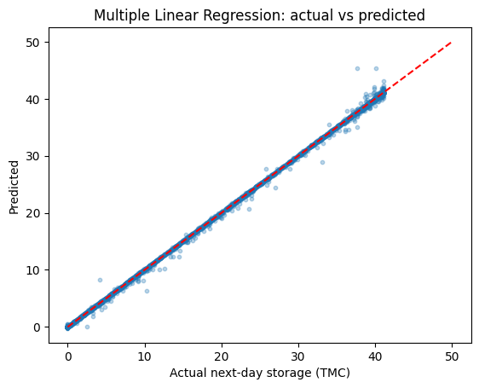
Figure 7.1: MLR Actual vs. Predicted Next-Day Live Storage (TMC) on the Test Set.

7.4 Classification Results
The four classification models were tested on the same 2,688 test days, of which 933 were actual drought-alert days and 1,755 were normal days. Table 7.3 shows the results.
Table 7.3: Drought Alert Classification Results (Test N = 2,688)
Classifier Architecture | Accuracy | Precision | Recall | F1-Score | ROC-AUC | Log-Loss
Rule Baseline (< 12.363 TMC) | 0.9940 | 0.9904 | 0.9925 | 0.9914 | 0.9937 | 0.2144
Logistic Regression | 0.9989 | 0.9989 | 0.9979 | 0.9984 | 1.0000 | 0.0172
K-Nearest Neighbors (k=5) | 0.9955 | 0.9957 | 0.9914 | 0.9936 | 0.9995 | 0.0458
Decision Tree (depth=6) | 0.9985 | 0.9989 | 0.9968 | 0.9979 | 0.9997 | 0.0210
The rule baseline got an accuracy of 0.9940 and F1-score of 0.9914. These are high because the reservoir state changes slowly, so tomorrow's state is the same as today's on most days. The real challenge is the days when storage crosses the 12.363 TMC threshold. Logistic Regression improves accuracy to 0.9989 and F1-score to 0.9984, with ROC-AUC 1.0000 and Log-Loss 0.0172. The Decision Tree is also good (accuracy 0.9985, F1 0.9979), and KNN has an F1-score of 0.9936.

7.5 Confusion Matrices
To see where each model makes mistakes, confusion matrices for the 2,688 test days are shown in Figure 7.2 and Table 7.4.
Table 7.4: Confusion Matrix Counts for Drought Alert Classifiers (Test N = 2,688)
Classifier Model | True Negatives (Normal) | False Positives (False Alarm) | False Negatives (Missed Drought) | True Positives (Correct Alert) | Total Errors | Error Reduction vs. Rule
Rule Baseline | 1,746 | 9 | 7 | 926 | 16 | — (Baseline)
Logistic Regression | 1,754 | 1 | 2 | 931 | 3 | 81.25% Reduction
K-Nearest Neighbors | 1,751 | 4 | 8 | 925 | 12 | 25.00% Reduction
Decision Tree | 1,754 | 1 | 3 | 930 | 4 | 75.00% Reduction
The rule baseline makes 16 mistakes (7 false alarms and 9 missed droughts) because it cannot see inflow surges or canal releases that push storage across the threshold. Logistic Regression reduces total mistakes from 16 to 3 (1 false alarm and 2 missed droughts), which is an 81.25% reduction. The Decision Tree makes only 4 mistakes. The machine learning models help most near the threshold, where an early warning matters most.
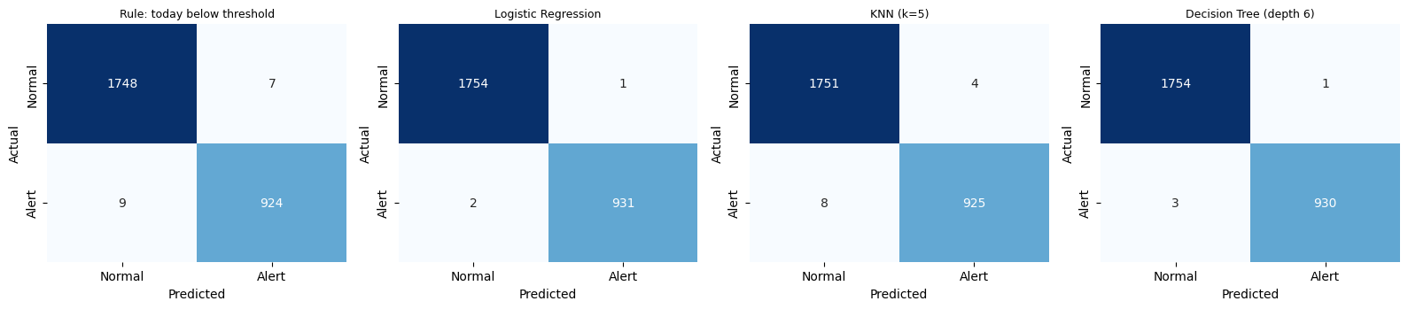
Figure 7.2: Confusion Matrices for the Rule Baseline, Logistic Regression, KNN (k=5) and Decision Tree.

CHAPTER 8: TIME-BASED SPLIT TEST

8.1 Why a Time-Based Split
When a random split is used on time-series data, day t and day t+2 may be in the training set while day t+1 is in the test set. Because storage changes slowly, a model can score well just by interpolating between neighboring days instead of learning the real behavior. To check that the models work on unseen years, a time-based split was also used.

8.2 Results on 2018–2026
In this test, the models were trained on all data before January 1, 2018 (10,217 days, 1990 to 2017) and tested on the unseen period from January 1, 2018 to October 28, 2026 (3,221 days). Table 8.1 shows the results.
Table 8.1: Time-Based Split Results (Train: 1990–2017 [N=10,217], Test: 2018–2026 [N=3,221])
Predictive Task & Target | Evaluation Metric | Operational Baseline | Machine Learning Model | Improvement (%)
Regression: Next_Live_TMC | Mean Absolute Error (MAE) | 0.2497 TMC (Persistence) | 0.1401 TMC (Multiple Linear) | 43.90% Error Reduction
Regression: Next_Live_TMC | Root Mean Squared Error (RMSE) | 0.5465 TMC (Persistence) | 0.4838 TMC (Multiple Linear) | 11.47% Error Reduction
Classification: Drought_Alert | F1-Score | 0.9899 (Rule Baseline) | 0.9972 (Logistic Regression) | +0.73% Absolute Gain

8.3 Random Split vs. Time-Based Split
Comparing the time-based split with the random split gives these points:
MAE is stable: On the time-based test set, MLR has an MAE of 0.1401 TMC compared to 0.2497 TMC for persistence, a 43.90% reduction. So the advantage of MLR is not due to leakage between train and test sets.
RMSE is higher: RMSE of MLR on the time-based split is 0.4838 TMC, higher than 0.3509 TMC in the random split. The 2018–2026 period had extreme events, such as the 2018 Kodagu floods, the 2019 Cauvery floods (inflow above 100,000 cusecs) and the 2023–2024 drought. RMSE gives more weight to large errors, so it rises in such years. MAE is the more stable measure here.
Classification still works: Logistic Regression had an F1-score of 0.9972 on the unseen period, compared to 0.9899 for the rule, so its decision boundary still catches coming droughts in later years.

CHAPTER 9: SCENARIO TESTING

9.1 Overview
To show how the models can support dam operation, MLR and Logistic Regression were tried on three typical situations: a dry pre-monsoon summer day, a peak monsoon flood day and a normal post-monsoon day. Table 9.1 shows the inputs, the predicted next-day storage, the drought-alert probability and the action that follows.
Table 9.1: Predictions for Three Scenarios
Scenario Description | Current Storage (TMC) | Reservoir Level (ft) | Inflow (Cusecs) | Outflow (Cusecs) | Canal Draw (Cusecs) | Predicted Storage (TMC) | Alert Prob. | Action
Scenario 1: Pre-Monsoon Dry Summer | 9.85 | 2,437.60 | 380.0 | 1,850.0 | 620.0 | 9.72 | 0.99 (99%) | Cut irrigation; reserve drinking water
Scenario 2: Peak Monsoon Inflow Flood | 41.00 | 2,468.80 | 68,500.0 | 65,000.0 | 3,800.0 | 41.05 | 0.00 (0%) | Open spillway gates; buffer flood surge
Scenario 3: Normal Post-Monsoon Storage | 32.50 | 2,462.30 | 4,200.0 | 3,500.0 | 1,500.0 | 32.42 | 0.00 (0%) | Routine seasonal release schedule

9.2 Scenario 1: Dry Summer Day
In this case the reservoir is low after months of dry weather (Live_TMC = 9.85 TMC, Level_ft = 2,437.60 ft). Inflow is only 380 cusecs, while river release is 1,850 cusecs and canal withdrawal is 620 cusecs, so outflow is much more than inflow. MLR predicts next-day storage of 9.72 TMC (a fall of 0.13 TMC) and Logistic Regression gives a drought-alert probability of 0.99 (99%). This clearly supports starting water conservation measures.

9.3 Scenario 2: Monsoon Flood Day
During heavy southwest monsoon rain the reservoir is full (Live_TMC = 41.00 TMC, Level_ft = 2,468.80 ft). Inflow is 68,500 cusecs, spillway release is 65,000 cusecs and canal withdrawal is 3,800 cusecs. MLR predicts next-day storage of 41.05 TMC, so storage stays near full. Logistic Regression gives a drought-alert probability of 0.00 (0%). The models work well even with very high flows.

9.4 Scenario 3: Normal Post-Monsoon Day
In steady post-monsoon conditions the reservoir holds good storage (Live_TMC = 32.50 TMC, Level_ft = 2,462.30 ft). Inflow is 4,200 cusecs, river release is 3,500 cusecs and canal withdrawal is 1,500 cusecs. MLR predicts next-day storage of 32.42 TMC (a fall of 0.08 TMC) with a drought-alert probability of 0.00 (0%), so routine water scheduling can continue without false alarms.

CHAPTER 10: CONCLUSIONS, LIMITATIONS AND FUTURE SCOPE

10.1 Conclusions
This project built and tested a data-driven system for predicting daily reservoir storage and drought alerts at the Krishna Raja Sagara Dam. The main conclusions are:
1. Lower error than persistence: Persistence already has an R² of 0.9985 because storage changes slowly, but MLR cuts the Mean Absolute Error by 51.11% (0.2615 TMC to 0.1279 TMC) and the MSE by 58.53%. Using the flows gives a real improvement over the simple assumption.
2. Physically meaningful coefficients: The learned coefficients follow mass conservation. Current storage has a coefficient of +0.9957, inflow is positive (+0.0001) and outflow and canal withdrawal are negative (-0.0001), so the model learned the water balance without being given the rules.
3. Better drought detection: Logistic Regression reduced classification errors on the test set from 16 (rule baseline) to 3 (accuracy 99.89%, F1 0.9984). It catches threshold crossings that the simple rule misses.
4. Works on unseen years: On the 2018–2026 time-based test, the results did not depend on the random split. MLR kept a 43.90% MAE reduction over persistence and Logistic Regression had an F1-score of 0.9972.

10.2 Limitations
The following limitations should be noted:
1. One-day forecast: The model predicts only one day ahead (t+1). This is useful for gate adjustments, but longer forecasts (7 to 14 days) would be more useful for planning.
2. No rainfall data: Only reservoir data is used. Upstream rainfall (for example IMD data) and catchment soil moisture in the Western Ghats are not included, so a storm is seen only after the water reaches the reservoir.
3. Releases are controlled by people: Outflow and canal releases are decided by operators based on court orders, inter-state directions and seasonal plans. So tomorrow's planned releases must be given to the model as known inputs.
4. Assumed threshold: The 12.363 TMC threshold is 25% of design capacity. It is reasonable, but it is an assumption made for this project and not an official statutory trigger.
5. Single reservoir: Only the KRS reservoir is modeled, without upstream reservoirs (such as Harangi and Hemavathi) or other parts of the Cauvery network.

10.3 Future Work
Future work can include:
1. Longer forecasts: Use LSTM, GRU or Temporal Fusion Transformer models to predict 7-day and 14-day storage.
2. Rainfall and satellite data: Add satellite rainfall data (for example GPM or IMD gridded data) and Sentinel-1 SAR water extent data to link rainfall, runoff and reservoir storage.
3. Multiple reservoirs: Model the connected Cauvery basin reservoirs (Harangi, Hemavathi, Kabini and KRS) together to include upstream releases.
4. Live dashboard: Put the trained models into a web dashboard (for example Streamlit or Dash) with automatic daily data updates for real-time use.

Data Access Acknowledgment:
Open Data Portal: https://indiawris.gov.in/wris/
National Water Informatics Centre (NWIC), Department of Water Resources, River Development & Ganga Rejuvenation, Ministry of Jal Shakti, Government of India.

Dataset Link:ReserVoir DataSet
Github Link:Link
LinkedIn:Sai Krishna Velicheti

