**Chapter - 3**

DATA ANALYSIS AND

INTERPRETATION

**GENDER**

**Table 3.1**

|  |  |  |  |
| --- | --- | --- | --- |
| SL NO | GENDER | NUMBER OF RESPONDENT | PERCENTAGE |
| 1 | MALE | **35** | **58.3%** |
| 2 | FEMALE | **25** | **41.7%** |
| 3 | PREFER NOT TO SAY | **NIL** | **NIL** |
| TOTAL |  | **60** | **100** |

Sources: Primary Data

**INFERENCE: 58.3% of respondents are male,41.7% of respondents are female and prefer**

**Not to say respondents are nil.**

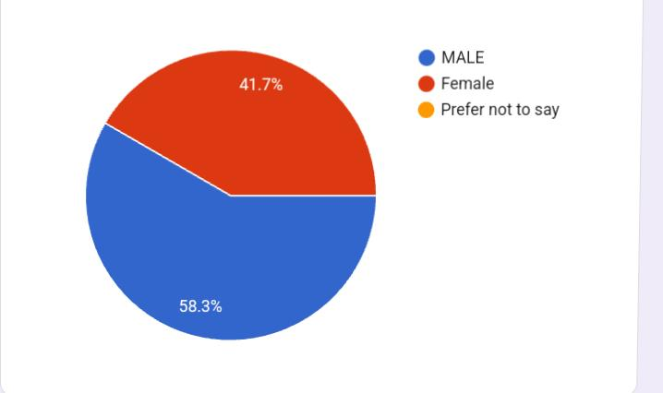

**AGE**

**Table 3.2**

|  |  |  |  |
| --- | --- | --- | --- |
| SI NO | AGE | NO OF RESPONDENT | PERCENTAGE |
| **1** | **18-26** | **43** | **70.7%** |
| **2** | **26-40** | **8** | **13.8%** |
| **3** | **40+** | **9** | **15.5%** |
| **TOTAL** |  | **60** | **100** |

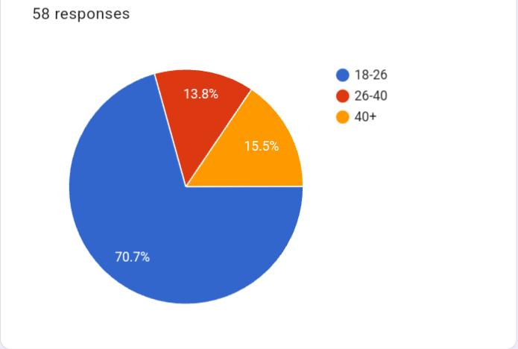**INFERENCE: 70.7%** of respondents are 18-26, 13.8% of respondents are 26-40, 15.5% of respondents are 40**+**

**EDUCATION LEVEL**

**Table 3.3**

|  |  |  |  |
| --- | --- | --- | --- |
| **SL NO** | **EDUCATION**  **LEVEL** | **NO OF RESPONDENT** | **PERCENTAGE** |
| **1** | Degree-PG | **31** | **54.4%** |
| **2** | Diploma | **11** | **12.3%** |
| **3** | Others | **18** | **31.6%** |
| **TOTAL** |  | **60** | **100** |

**INFERENCE: 54.4%** of respondents are Degee-Pg, 12.3% of respondents are Diploma 31.6% of respondents are Others.

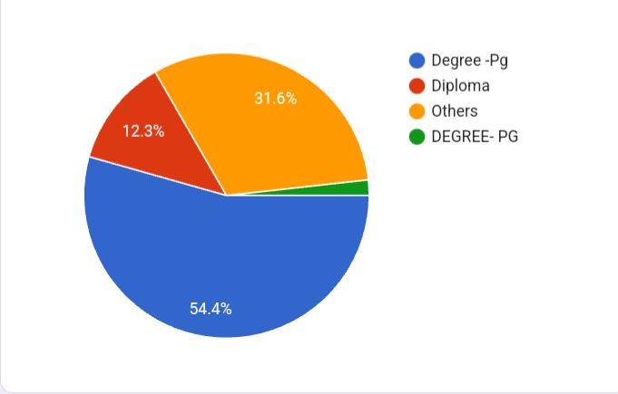

**OCCUPATION**

**Table 3.4**

|  |  |  |  |
| --- | --- | --- | --- |
| **SL NO** | **OCCUPATION** | **NO OF RESPONDENT** | **PERCENTAGE** |
| **1** | **Private** | **19** | **33.3%** |
| **2** | **Government** | **8** | **14%** |
| **3** | **Studying** | **30** | **52.6%** |
| **TOTAL** |  | **60** | **100** |

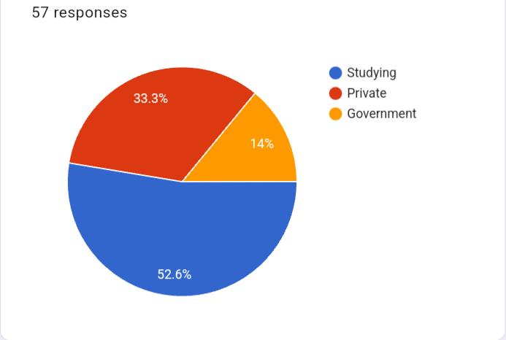

**INFERENCE : 33.3% of respondents are Private,14% of respondents are Government , 52.6% of respondents are Studying.**

**INCOME LEVEL**

**Table 3.5**

|  |  |  |  |
| --- | --- | --- | --- |
| **SL NO** | **INCOME LEVEL** | **NO RESPONDENT** | **PERCENTAGE** |
| **1** | **10k-20k** | **19** | **36.5%** |
| **2** | **Above 25k** | **5** | **9.6%** |
| **3** | **Below 10k** | **27** | **51.9%** |
| **4** | **25k-50k** | **1** | **1.9%** |
| **TOTAL** |  | **60** | **100** |

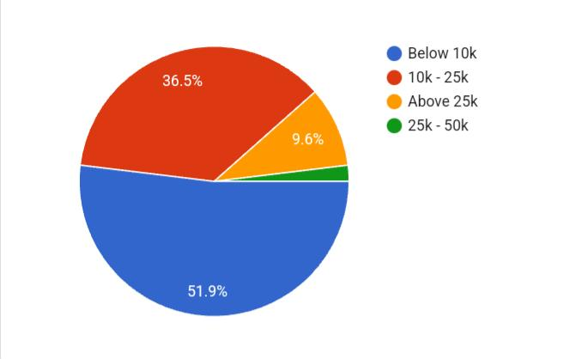**INFERENCE: 36.5%** Of respondents are 10k-20k, 9.6% of respondents are Above 25k,51.9% of respondents are Below 10k ,1.9% of respondents are 25k-50k

**HOW FAMILIAR ARE TOU WITH ELECTRIC CAR ?**

**Table 3.6**

|  |  |  |  |
| --- | --- | --- | --- |
| **SL NO** | **RESPONSE** | **No OF RESPONDENT** | **PERCENTAGE** |
| **1** | **Very familiar** | **24** | **41.1%** |
| **2** | **Here about them but not know** | **36** | **58.6%** |
| **Total** |  | **60** | **100** |

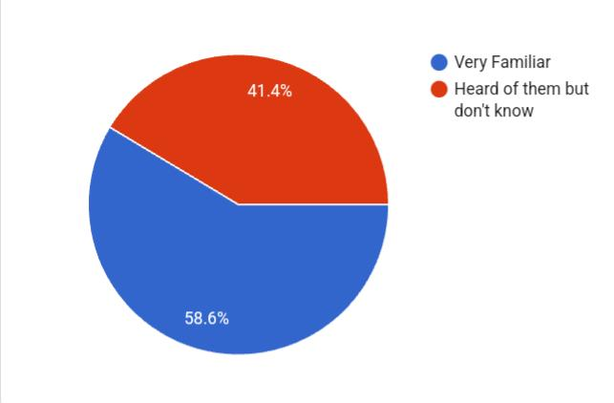**INFERENCE: 41.1% Of respondents are very familiar,58.6% of respondents are Here about them but not know.**

**What is your overall opinion of electric car?**

**Table 3.7**

|  |  |  |  |
| --- | --- | --- | --- |
| **SL NO** | **Response** | **No OF RESPONDENT** | **PERCENTAGE** |
| **1** | **Very positive** | **30** | **46.6%** |
| **2** | **Negative** | **27** | **51.7%** |
| **3** | **Neutral** | **3** | **1.7%** |
| **TOTAL** |  | **60** |  |

**INFERENCE: 46.6 % of respondents are very positive ,51.7% of respondents are Negative,1.7% of respondents are neutral.**

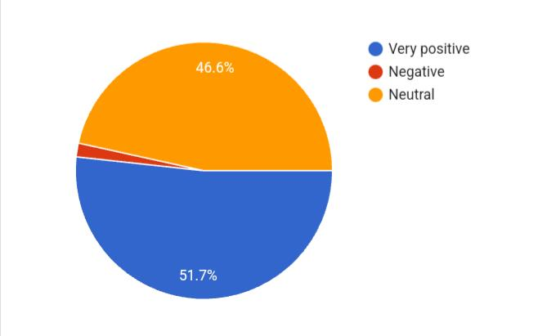

Do **you believe EV-Car are better for the environment than traditional car?**

**Table 3.8**

|  |  |  |  |
| --- | --- | --- | --- |
| **SL NO** | **Response** | **No OF RESPONDENT** | **PERCENTAGE** |
| **1** | **Definitely yes** | **41** | **70.7%** |
| **2** | **No** | **6** | **10.3%** |
| **3** | **Not sure** | **13** | **19%** |
| **Total** |  | **60** |  |

**INFERENCE: 70.7% of respondents are Definitely yes ,10.3% of respondents are No,19% of respondents are Not sure.**

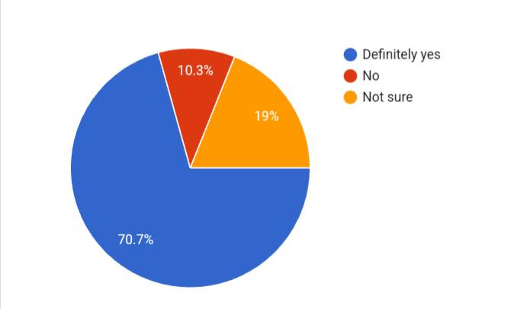

**What is the biggest factor that influences your EV- car buying decision?**

**Table 3.9**

|  |  |  |  |
| --- | --- | --- | --- |
| **SL NO** | **Response** | **No OF RESPONDENT** | **PERCENTAGE** |
| **1** | **Price** | **15** | **26.8%** |
| **2** | **Charging infrastructure** | **7** | **12.5%** |
| **3** | **Driving range** | **13** | **23.2%** |
| **4** | **Maintanence and reliability** | **8** | **14.3%** |
| **5** | **Social influence and image** | **12** | **21.4%** |
| **6** | **Environment impact** | **5** | **1.8** |
| **Total** | **Total** | **60** | **100%** |

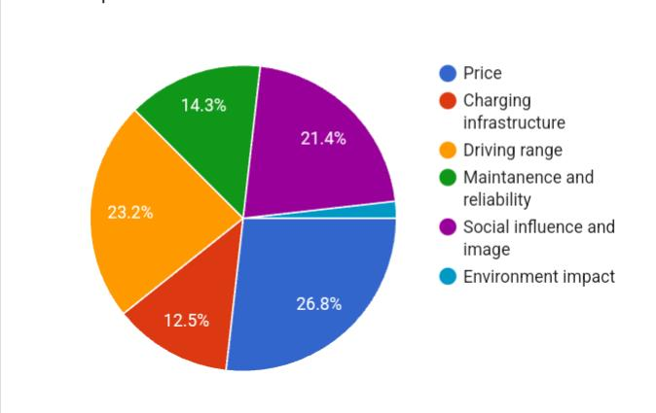

**The cost of charging an electric car is less than petrol or CNG**

**Table 4.0**

|  |  |  |  |
| --- | --- | --- | --- |
| **SL NO** | **Response** | **No OF RESPONDENT** | **PERCENTAGE** |
| **1** | **YES** | **55** | **91.7%** |
| **2** | **NO** | **5** | **8.3%** |
| **Total** |  | **60** | **100** |

**INFERENCE: 91.7% Of respondents are Yes,8.3% of respondents are NO.**

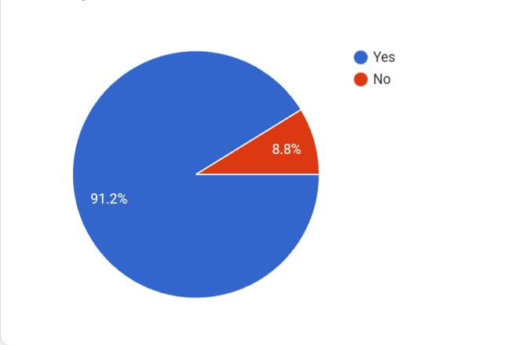

**What sources did you get the most of your knowledge about electric car**

Table 4.1

|  |  |  |  |
| --- | --- | --- | --- |
| **SL NO** | **Response** | **NO OF RESPONDENT** | **PERCENTAGE** |
| **1** | **Internet** | **39** | **62.9%** |
| **2** | **Television** | **2** | **3.2%** |
| **3** | **Personal communication** | **13** | **21%** |
| **4** | **Outdoor advertisement** | **5** | **8.1%** |
| **5** | **Magazine** | **1** | **1.6%** |
| **6** | **Newspaper** | **1** | **1.6%** |
| **7** | **Lack of charging station** | **1** | **1.6%** |
|  |  |  |  |

**INFERENCE: 62.9% of respondents are Internet,3.2% of respondents are Television,21% of respondents are Personal communication,8.1% of respondents are Outdoor advertisement, 1.6% of respondents are Magazine, 1.6% of respondents are Lack of charging station.**

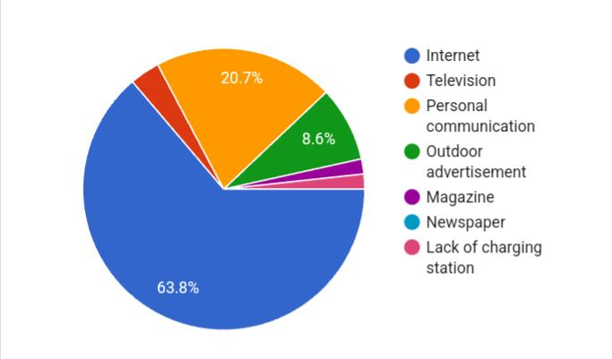

**How sufficient do you think the EV- Car charging infrastructure is in your area**

**Table 4.2**

|  |  |  |  |
| --- | --- | --- | --- |
| **SL NO** | **Response** | **NO OF RESPONDENT** | **PERCENTAGE** |
| **1** | **Very sufficient** | **22** | **36.7%** |
| **2** | **Adequate** | **28** | **46.7%** |
| **3** | **Inadequate** | **10** | **16.6%** |
| **ToTal** |  | **60** | **100%** |

**INFERENCE: o36.7% of respondents are Very sufficient, 46.7% of respondents are Adequate, 16.6% of respondents are Inadequate.**

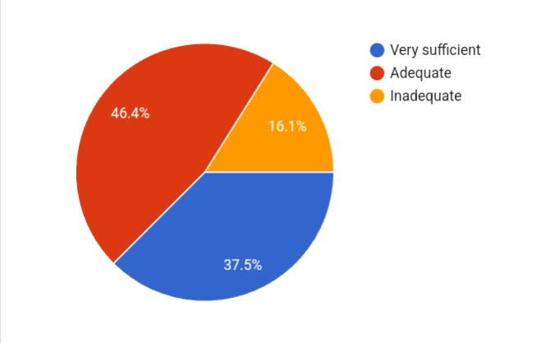

**Which type of brand do you trust more for EV –CAR**

**Table 4.3**

|  |  |  |  |
| --- | --- | --- | --- |
| **SL NO** | **Response** | **NO OF RESPONDENT** | **PERCENTAGE** |
| **1** | **Tata motors** | **34** | **56.7%** |
| **2** | **MG motors India** | **4** | **6.7%** |
| **3** | **Mahindra electric** | **14** | **23.3%** |
| **4** | **Mercebes- benz** | **8** | **13.3%** |
| **5** | **Citroen** | **-** | **-** |
| **Total** |  | **60** | **100** |

**INFERENCE: 56.7% of respondents are TATA Motors, 6.7% of respondents are MG Motors India, 23.3% of respondents are Mahindra Electric, 13.3% of respondents are Mercedes-Benz ,There is no respondents in Citroen**

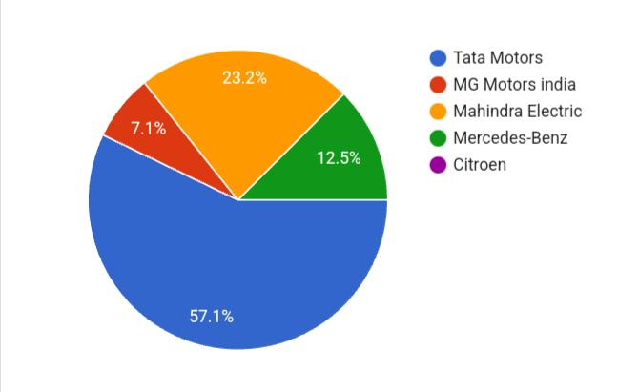

**How important is protecting the environment when making CAR choice?**

**Table 4.4**

|  |  |  |  |
| --- | --- | --- | --- |
| **SL NO** | **Response** | **NO OF RESPONDENT** | **PERCENTAGE** |
| **1** | **Extremely important** | **40** | **70.2%** |
| **2** | **Moderately important** | **14** | **24.6%** |
| **3** | **Slightly important** | **6** | **5.2** |
| **Total** |  | **60** | **100** |

**INFERENCE: 70.2% of respondents are Extremely important, 24.6% of respondents are Moderately Important,5.2% of respondents are Slightly important.**

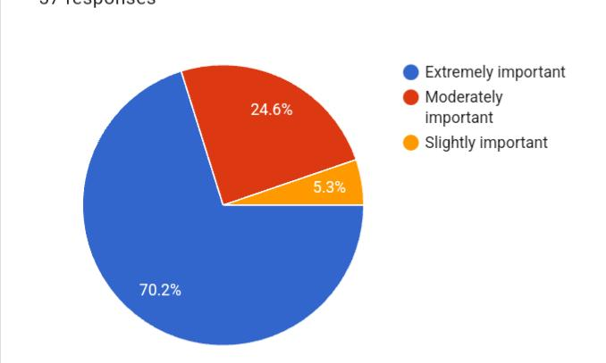

**Do you believe EV- Car help reduce air pollution**

**Table 4.5**

|  |  |  |  |
| --- | --- | --- | --- |
| **SL NO** | **Response** | **NO OF RESPONDENT** | **PERCENTAGE** |
| **1** | **YES, Significantly** | **40** | **79.3%** |
| **2** | **YES, Somewhat** | **8** | **13.8%** |
| **3** | **NOT Really** | **12** | **6.9%** |
| **Total** |  | **60** | **100** |

**INFERENCE: 79.3% of respondents are YES, Significantly , 13.8% of respondents are Yes somewhat, 6.9% of respondents are Not Really.**

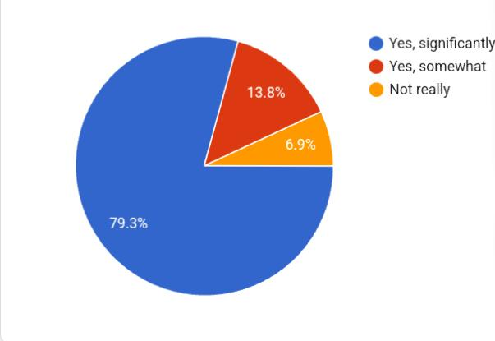

**How do you the environmental impact of producing EV- Car batteries**

**Table 4.6**

|  |  |  |  |
| --- | --- | --- | --- |
| **SL NO** | **Response** | **NO OF RESPONDENT** | **PERCENTAGE** |
| **1** | **Very concerning** | **31** | **55.4%** |
| **2** | **Somewhat concerning** | **21** | **39.3%** |
| **3** | **Not very concerning** | **8** | **5.4%** |
| **TOTAL** |  | **60** | **100** |

**INFERENCE: 55.4% of respondents are very concerning, 39.3% of respondents are Somewhat concerning, 5.4% of respondents are Not very concerning.**

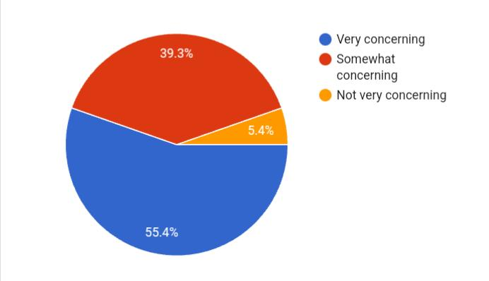

**Do you think switching to EV-Car can help reduce climate change effects**

**Table 4.7**

|  |  |  |  |
| --- | --- | --- | --- |
| **SL NO** | **Response** | **NO OF RESPONDENT** | **PERCENTAGE** |
| **1** | **Strongly agree** | **30** | **52.6%** |
| **2** | **Somewhat agree** | **24** | **42.1%** |
| **3** | **Disagree** | **6** | **5.3** |
| **Total** |  | **60** | **100** |

**INFERENCE: 52.6% of respondents are Strongly agree, 42.1% of respondents are Somewhat agree, 5.3% of respondents are Disagree.**

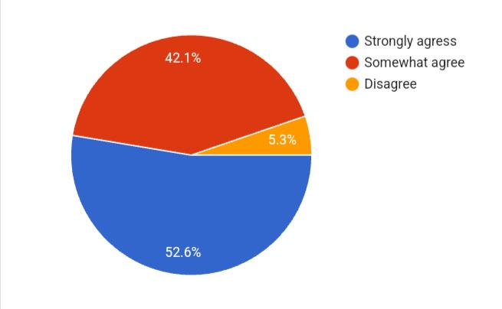

**Do you think driving EV-Car contributes positively to nature and wild life**

**Table 4.8**

|  |  |  |  |
| --- | --- | --- | --- |
| **SL NO** | **Response** | **NO OF RESPONDENT** | **PERCENTAGE** |
| **1** | **YES, definitely** | **27** | **47.4%** |
| **2** | **possible** | **15** | **21.1%** |
| **3** | **Maybe** | **18** | **31.6%** |
| **Total** |  | **60** | **100** |

**INFERENCE: 47.4% Of respondents are Yes, definitely, 21.1% of respondents are Possible, 31.6% of respondents are Maybe.**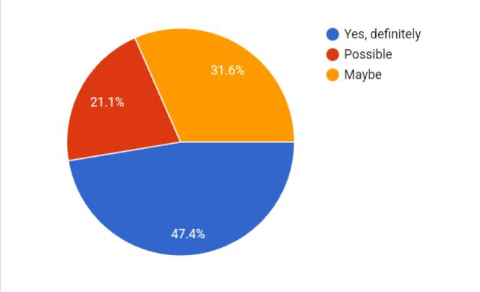

**Which of the following best describes your reason for considering an EV-Car?**

**Table 4.9**

|  |  |  |  |
| --- | --- | --- | --- |
| **SL NO** | **Response** | **NO OF RESPONDENT** | **PERCENTAGE** |
| **1** | **TO reduce my carbon footprint** | **23** | **39.7%** |
| **2** | **TO save fuel cost** | **28** | **48.3%** |
| **3** | **TO follow a trend/ technology** | **9** | **12.1%** |
| **Total** |  | **60** | **100** |

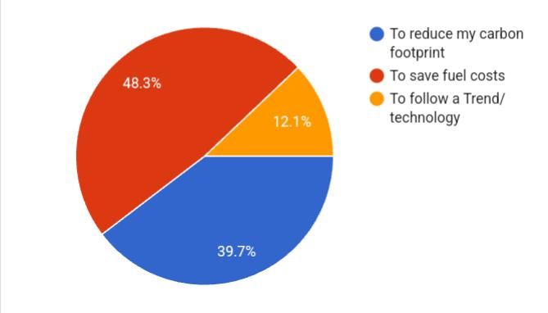**INFERENCE: 39.7% of respondents are To reduce my carbon footprint, 48.3% of respondents are To save fuel cost , 12.1% of respondents are To follow a Trend / technology.**