|  |
| --- |
| LockedMe  Application Screenshots |

|  |  |
| --- | --- |
| Author | Sai Vineeth Tata |
| Purpose | Screenshot of the Application |
| Date | 14th August 2021 |
| Version | 1.0 |

**Version History :**

# Main Menu Screenshot

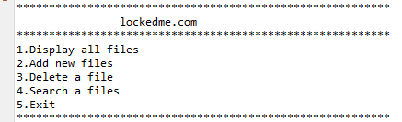

# Displaying all Files

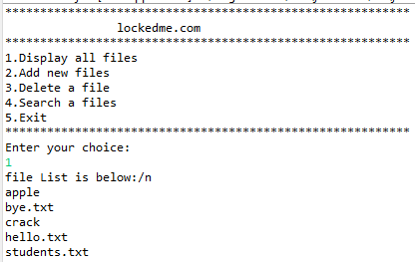

# 3.Adding a new File

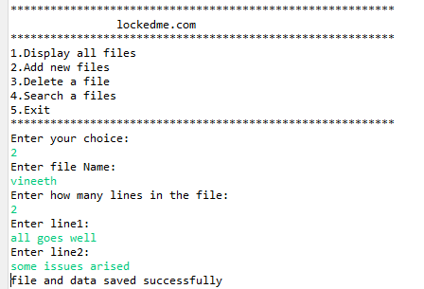

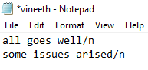

# Deleting a File

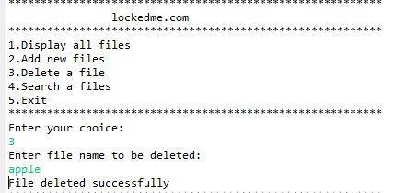

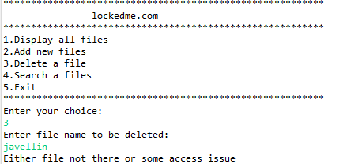

# Searching a File

