Final Project - Data Analytics Case Study Visual

NAME: DEEPAK RAMBARKI
STUDENT ID: 11703304

Background:
The University of North Texas Admissions Office is collaborating with the Data and Marketing team to identify a pool of possible students who can academically succeed in college. They aim at an exact understanding of how high school GPA and college GPA relate to each other as a trusted predictor variable for academic performance. This shall help the university apply effective recruitment strategies while focusing on the students who are more likely to perform well based on their previous academics.
Objective:
The average college GPA and high school GPA by gender for the three academic fields of arts and letters, business and economics, and math and science are shown in the stacked bar comparison chart below. The data below is disaggregated by gender to observe trends in academic performance for every discipline from high school through college.
Key Insights:
- Gender-Based Performance Differences:
Female students consistently have higher College GPAs than male students across all three disciplines:
  - In Arts & Letters, the average college GPA for females is 3.23, whilst the average for boys is 3.02.

  - Women's average college GPA in business and economics is 3.15, whereas men's is 2.96.

  - In math and science, women do better than men, with an average college GPA of 3.71 rather than 3.54.
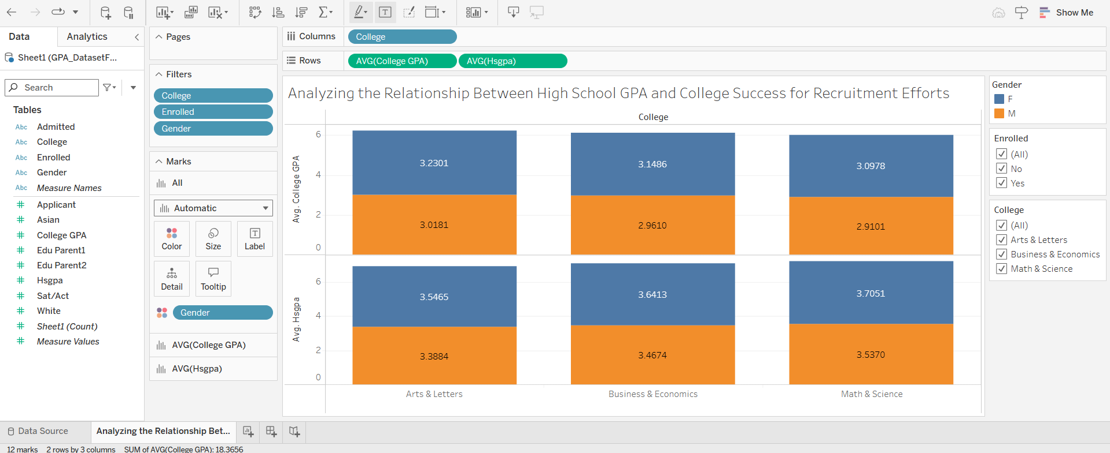

At high female performances are closer as compared to college which evidences that during college education, the gap in academic performances increases.

Discipline-Based Performance:
  - Students in the Math & Science discipline have the highest College GPAs, especially for female students, who achieve the highest overall average at 3.71.

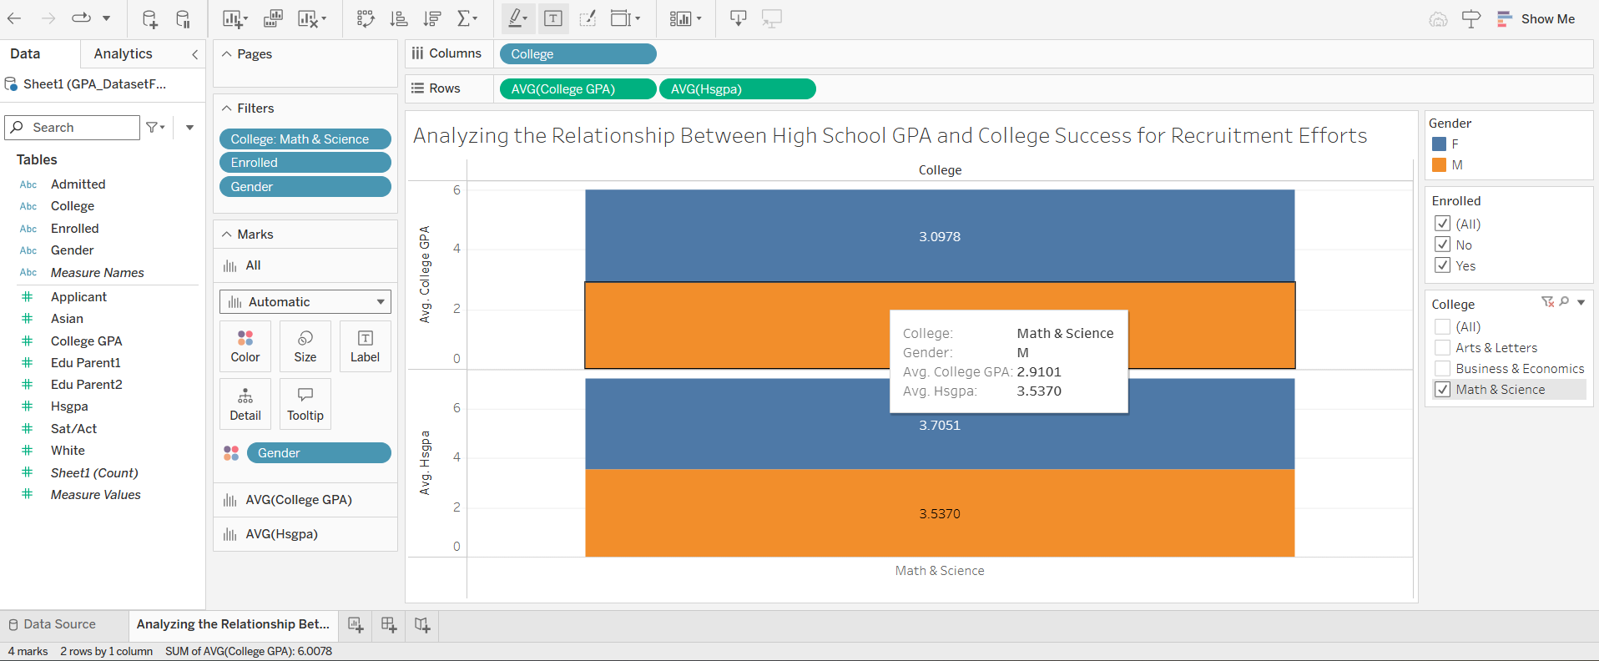

In contrast, Business & Economics shows the lowest average GPAs, particularly for male students, indicating that this discipline may require additional academic support or intervention to improve student outcomes.

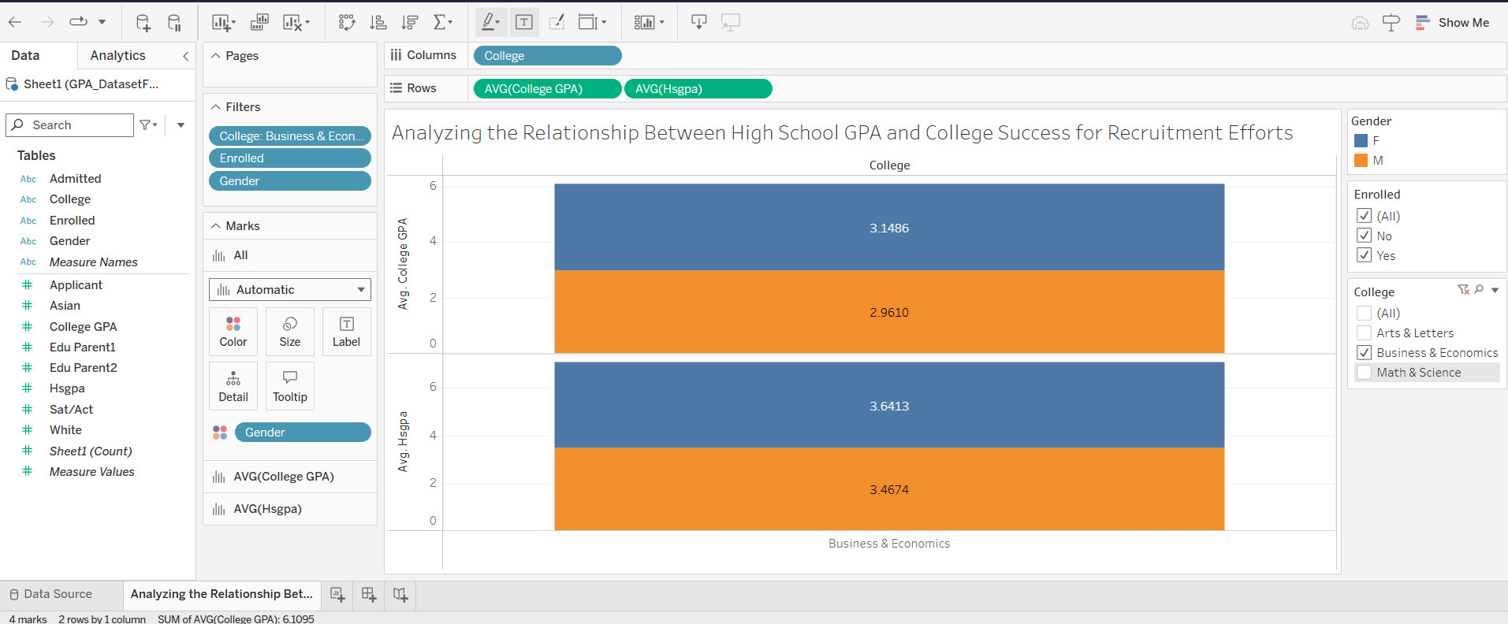
- High School vs. College GPA:
  - There is a relatively well-balanced High School GPA by gender. Collected data on college attendance suggest an increase in differences by gender: female students improve or maintain better than their male peers.
  - The GPA trends extracted across disciplines indicate that while high school performance may be an important predictor, college environments shape the academic trajectory in one's life; and among these changes, females are more successful adaptors in all fields.
Implications:
- By showing higher College GPA for female students across disciplines, perhaps the needed call is targeted at male students who underperform, particularly in some strong disciplines such as Business & Economics.
- The Math & Science departments will likely require more resources to accommodate the needs of their female students, who are performing at higher levels to keep them competitive academically.
- This information can be used by the Career Services and academic advising departments in structuring gender-specific intervention programs that are designed to aid in advancing the performance of male students to help narrow the gap in academic performance.

