KAKATIYA INSTITUTE OF TECHNOLOGY AND SCIENCES, WARANGAL
A Major Project Report
on
"VOICE-CONTROLLED AI STUDY ASSISTANT"
(An AI-Powered NotebookLM-Style Learning Platform)
Submitted in partial fulfilment of the requirements
for the award of the degree of
BACHELOR OF TECHNOLOGY
in
COMPUTER SCIENCE AND ENGINEERING (AI & ML)
Academic Year: 2025–26
Submitted by
Maram Sai Shashank Raj
Roll No.: B24AI185
Under the guidance of
Prof. Maram Balajee
Professor, Department of Computer Science and Engineering, SR University, Warangal
Department of Computer Science and Engineering (AI & ML)
June 2026

BONAFIDE CERTIFICATE
This is to certify that the Major Project Report entitled "VOICE-CONTROLLED AI STUDY ASSISTANT" submitted by Maram Sai Shashank Raj (Roll No.: B24AI185) in partial fulfilment of the requirements for the award of the degree of Bachelor of Technology in Computer Science and Engineering (AI & ML) is a bonafide record of work carried out by him under my supervision and guidance.
The matter embodied in this report has not been submitted elsewhere for the award of any other degree or diploma.
Date: June 2026
Place: Warangal Signature of the Guide Prof. Maram Balajee, Professor, Department of Computer Science and Engineering, SR University, Warangal

PROJECT APPROVAL SHEET
The Major Project Report entitled "VOICE-CONTROLLED AI STUDY ASSISTANT" submitted by Maram Sai Shashank Raj has been examined and approved for submission.
Name | Roll Number | Signature
Maram Sai Shashank Raj | B24AI185

Project Guide: Prof. Maram Balajee Date: June 2026
Internal Examiner: _____________________ Date: __________
External Examiner: _____________________ Date: __________

DECLARATION
I, Maram Sai Shashank Raj, hereby declare that the Major Project Report entitled "VOICE-CONTROLLED AI STUDY ASSISTANT" submitted to Kakatiya Institute of Technology and Sciences, Warangal in partial fulfilment of the requirements for the award of the degree of Bachelor of Technology in Computer Science and Engineering (AI & ML) is an authentic record of my own work carried out under the supervision of Prof. Maram Balajee.
The matter embodied in this report has not been submitted by me for the award of any other degree or diploma. Wherever other works have been referred to, due acknowledgement has been made.
Date: June 2026
Place: Warangal
Signature of the Student: _________________________
Maram Sai Shashank Raj

CERTIFICATE FROM SUPERVISOR
This is to certify that the project work titled "VOICE-CONTROLLED AI STUDY ASSISTANT" carried out by Maram Sai Shashank Raj (Roll No.: B24AI185) under my guidance is a record of bonafide work and has been completed to my satisfaction. The report is recommended for submission to Kakatiya Institute of Technology and Sciences, Warangal for evaluation.
Date: June 2026
Place: Warangal
Signature of Supervisor: _________________________Prof. Maram BalajeeProfessor, Department of Computer Science and Engineering, SR University, Warangal

ACKNOWLEDGEMENT
I express my sincere gratitude to my project guide, Prof. Maram Balajee, Professor, Department of Computer Science and Engineering, SR University, Warangal, for invaluable guidance, continuous encouragement, and constructive feedback throughout the development of this project.
I thank the faculty members of Department of Computer Science and Engineering (AI & ML), Kakatiya Institute of Technology and Sciences, Warangal, for providing academic support and laboratory facilities.
I acknowledge OpenRouter, DeepSeek, Google Gemini, Mozilla pdf.js, AntV, and the open-source community for tools and APIs that made this project feasible.
Finally, I thank my parents and friends for their moral support and motivation.

ABSTRACT
Traditional study methods often require students to manually organize notes, search across multiple documents, and switch between reading, revision, and assessment tools. Generic AI chatbots provide answers but lack source grounding, persistent notebooks, and integrated study workflows inspired by modern research assistants such as Google NotebookLM.
This project presents a Voice-Controlled AI Study Assistant — a full-stack web application deployed at https://voice-study-assistant.vercel.app/ that enables students to upload study sources (PDF/text), interact through text and voice, and generate rich learning artifacts including mind maps, slide decks, flashcards, FAQs, briefing documents, study outlines, data tables, study resource roadmaps, and infographics. The system uses DeepSeek v3.2 via OpenRouter for conversational AI, Server-Sent Events (SSE) for real-time streaming responses, Google Gemini TTS for multilingual speech output, and the Web Speech API for speech-to-text input.
The application follows a three-panel NotebookLM-inspired interface: Sources, Chat, and Studio. User authentication is implemented using stateless JWT-based identity derivation, with per-user data isolation in browser localStorage. Key features include audio overview podcasts, join-the-conversation mode, personalized audio explanations, and persistent saved studio outputs.
Keywords: Artificial Intelligence, Voice-Controlled Systems, Natural Language Processing, Study Assistant, OpenRouter, Speech-to-Text, Text-to-Speech, NotebookLM, Web Application, Vercel.

TABLE OF CONTENTS
BONAFIDE CERTIFICATE i
PROJECT APPROVAL SHEET ii
DECLARATION iii
CERTIFICATE FROM SUPERVISOR iv
ACKNOWLEDGEMENT v
ABSTRACT vi
TABLE OF CONTENTS vii
LIST OF FIGURES ix
LIST OF TABLES x
LIST OF ABBREVIATIONS AND ACRONYMS xi

CHAPTER 1 – INTRODUCTION 1
1.1 Introduction to Artificial Intelligence 1
1.2 Voice-Controlled Systems Overview 2
1.3 Need for AI-Based Study Assistants 2
1.4 Problem Statement 3
1.5 Motivation of the Project 3
1.6 Objectives of the Project 4
1.7 Scope of the Project 5
1.8 Proposed Solution 5
1.9 Applications of the System 6
1.10 Advantages of the Proposed System 6
1.11 Organization of the Report 7

CHAPTER 2 – LITERATURE SURVEY 8
2.1 Introduction 8
2.2 Existing Voice Assistant Technologies 8
2.3 AI in Smart Education Systems 9
2.4 Speech Recognition Techniques 9
2.5 Natural Language Processing Approaches 10
2.6 Machine Learning Models Used in Assistants 10
2.7 Comparative Analysis of Existing Systems 11
2.8 Research Gaps Identified 11
2.9 Summary 12

CHAPTER 3 – SYSTEM ANALYSIS 13
3.1 Existing System 13
3.2 Drawbacks of Existing System 13
3.3 Proposed System 14
3.4 Feasibility Study 14
3.4.1 Technical Feasibility 14
3.4.2 Economic Feasibility 15
3.4.3 Operational Feasibility 15
3.5 System Requirements 15
3.5.1 Hardware Requirements 16
3.5.2 Software Requirements 16
3.6 Functional Requirements 17
3.7 Non-Functional Requirements 17
3.8 System Architecture Overview 18

CHAPTER 4 – DESIGN METHODOLOGY 19
4.1 Introduction 19
4.2 Architecture of the Proposed System 20
4.2.1 End-to-End Development Phases 21
4.2.2 REST API and Endpoint Design 22
4.2.3 Prompt Engineering and Source Grounding Strategy 22
4.3 Module Description 23
4.3.1 Voice Input Module 23
4.3.2 Speech-to-Text Module 24
4.3.3 NLP Processing Module 24
4.3.4 AI Response Generation Module 25
4.3.5 Database Module 26
4.3.6 User Interface Module 26
4.3.7 Error Handling and Resilience 27
4.4 Data Flow Diagram (DFD) 26
4.5 Use Case Diagram 28
4.6 Sequence Diagram 29
4.7 Activity Diagram 30
4.8 ER Diagram / Database Design 31
4.9 Algorithm Design 32
4.10 Flowchart of System Operation 33
4.11 Security and Privacy Considerations 34

CHAPTER 5 – IMPLEMENTATION 35
5.1 Introduction 35
5.2 Development Environment 36
5.3 Tools and Technologies Used 36
5.4 Coding Methodology 37
5.5 Implementation of Modules 38
5.6 Integration of Voice Commands 38
5.7 AI Model Training and Testing 39
5.8 User Authentication Process 39
5.9 API Integration 40
5.10 Screenshots of Implementation 40

CHAPTER 6 – RESULTS AND DISCUSSION 41
6.1 Experimental Setup 41
6.2 Test Cases 42
6.3 Performance Evaluation 43
6.4 Accuracy of Speech Recognition 43
6.5 Response Time Analysis 44
6.6 Comparative Performance Analysis 44
6.7 Output Screenshots 45
6.8 Discussion of Results 45
6.9 Limitations of the System 46

CHAPTER 7 – CONCLUSION AND FUTURE SCOPE 47
7.1 Conclusion 47
7.2 Achievements of the Project 47
7.3 Future Enhancements 48
7.4 Real-Time Industrial Applications 48
7.5 Final Remarks 49

REFERENCES 50
APPENDICES 51

LIST OF FIGURES
Fig. 3.1 System Architecture Overview
Fig. 4.1 High-Level Architecture of Proposed System
Fig. 4.2 Data Flow Diagram – Level 0
Fig. 4.3 Data Flow Diagram – Level 1
Fig. 4.4 Use Case Diagram
Fig. 4.5 Sequence Diagram – Chat Interaction
Fig. 4.6 Activity Diagram – User Study Session
Fig. 4.7 Entity Relationship Diagram (Logical Data Model)
Fig. 4.8 System Operation Flowchart
Fig. 5.1 Authentication Page
Fig. 5.2 Main Three-Panel Interface
Fig. 5.3 Chat Interface with Saved Studio Outputs
Fig. 5.4 Interactive Mind Map Output
Fig. 6.1 Chat Response with Action Buttons
Fig. 6.2 Study Resources Output

LIST OF TABLES
Table 2.1 Comparative Analysis of Existing Systems
Table 3.1 Hardware Requirements
Table 3.2 Software Requirements
Table 3.3 Functional Requirements
Table 3.4 Non-Functional Requirements
Table 5.1 Technology Stack
Table 6.1 Test Cases and Results
Table 6.2 Performance Metrics

LIST OF ABBREVIATIONS AND ACRONYMS
Abbreviation | Expansion
AI | Artificial Intelligence
API | Application Programming Interface
CSS | Cascading Style Sheets
DFD | Data Flow Diagram
DOM | Document Object Model
ER | Entity Relationship
HTML | HyperText Markup Language
JWT | JSON Web Token
LLM | Large Language Model
ML | Machine Learning
NLP | Natural Language Processing
PDF | Portable Document Format
REST | Representational State Transfer
SSE | Server-Sent Events
STT | Speech-to-Text
SVG | Scalable Vector Graphics
TTS | Text-to-Speech
UI | User Interface
UX | User Experience

CHAPTER 1

INTRODUCTION

1.1 Introduction to Artificial Intelligence
Artificial Intelligence (AI) refers to the simulation of human intelligence in machines programmed to think, learn, and solve problems. In education, AI enables personalized tutoring, automated content summarization, intelligent question answering, and adaptive learning pathways. Large Language Models (LLMs) such as GPT, Gemini, and DeepSeek have revolutionized how students interact with textual knowledge by enabling natural language queries over complex material.

1.2 Voice-Controlled Systems Overview
Voice-controlled systems allow users to interact with software through spoken commands rather than traditional keyboard input. These systems combine Speech-to-Text (STT) conversion, natural language understanding, and Text-to-Speech (TTS) synthesis. Modern browsers implement the Web Speech API, enabling real-time voice input without native desktop applications. Voice interfaces improve accessibility and support hands-free learning during revision sessions.

1.3 Need for AI-Based Study Assistants
Students frequently manage multiple subjects, PDFs, lecture notes, and revision schedules simultaneously. Existing tools are fragmented: note apps store content, PDF readers display documents, and chatbots answer questions without persistent source context. An integrated AI study assistant addresses this gap by combining source management, grounded chat, voice interaction, and automated study artifact generation in one workspace.

1.4 Problem Statement
The problem addressed in this project is the lack of an affordable, deployable, and feature-rich AI study platform that: (1) grounds AI responses in user-uploaded sources; (2) supports voice input and multilingual output; (3) generates diverse study materials (mind maps, flashcards, podcasts); (4) persists user notebooks across sessions; and (5) isolates data between multiple users sharing the same deployment link.

1.5 Motivation of the Project
Commercial platforms such as Google NotebookLM demonstrate the value of source-grounded AI for learning, but are not always accessible for academic experimentation or local customization. This project was motivated by the need to build a college-level, deployable alternative using open API gateways (OpenRouter), modern web technologies, and a NotebookLM-inspired user experience.

1.6 Objectives of the Project
- To design and implement a web-based AI study assistant with NotebookLM-style three-panel layout.
- To integrate voice input (STT) and voice output (TTS) for hands-free learning.
- To enable PDF/text source upload and source-grounded AI chat with streaming responses.
- To implement Studio features: mind maps, slides, flashcards, FAQ, briefing, outline, data tables, study resources, and infographics.
- To provide audio overview podcasts with interactive join-conversation and continue-in-podcast modes.
- To implement user authentication with per-user data isolation.
- To deploy the application on Vercel at https://voice-study-assistant.vercel.app/.

1.7 Scope of the Project
The scope includes frontend UI, backend API proxy, OpenRouter LLM integration, authentication, local persistence, and cloud deployment. Custom LLM training, vector database RAG pipelines, and native mobile applications are out of scope.

1.8 Proposed Solution
The proposed Voice-Controlled AI Study Assistant is a full-stack web application comprising: (a) Vanilla JavaScript frontend with Sources | Chat | Studio panels; (b) Node.js/Express backend proxying OpenRouter API calls; (c) SSE-based streaming chat; (d) JWT stateless authentication with HMAC-derived user IDs; (e) localStorage-based notebook persistence scoped per user; (f) Vercel serverless deployment.

1.9 Applications of the System
- Engineering and degree exam preparation
- Competitive exam revision (GATE, placements)
- Research paper summarization
- Language learning with multilingual TTS
- Classroom demonstration of AI in education
- Remote mentoring with shared Vercel link

1.10 Advantages of the Proposed System
- Unified workspace for sources, chat, and generated study content
- Voice and text multimodal interaction
- Low deployment cost using Vercel and OpenRouter pay-per-use
- No installation required — browser-based access
- Rich studio outputs beyond plain chat
- Per-user data isolation for shared deployments

1.11 Organization of the Report
Chapter 2 reviews voice assistants, AI in education, and comparative systems (Table 2.1). Chapter 3 analyses functional and non-functional requirements (Tables 3.1–3.4) and presents the system architecture (Fig. 3.1). Chapter 4 documents the complete design methodology with architecture, DFD, UML diagrams, algorithms, and security. Chapter 5 describes implementation and technology stack (Table 5.1). Chapter 6 reports experimental results (Tables 6.1–6.2). Chapter 7 concludes with achievements and future scope.

CHAPTER 2

LITERATURE SURVEY

2.1 Introduction
This chapter reviews existing voice assistants, AI in education, speech technologies, NLP approaches, and comparative systems relevant to the Voice-Controlled AI Study Assistant.

2.2 Existing Voice Assistant Technologies
Commercial voice assistants such as Google Assistant, Amazon Alexa, Apple Siri, and Microsoft Cortana demonstrate robust STT and TTS pipelines integrated with cloud NLP services. For web applications, the Web Speech API provides browser-native speech recognition and synthesis. Backend TTS services such as Google Gemini TTS offer higher quality multilingual output than browser defaults.

2.3 AI in Smart Education Systems
Intelligent tutoring systems, adaptive learning platforms, and AI note-taking tools show growing adoption. Google NotebookLM (2023–2024) introduced source-grounded notebooks with audio overviews, marking a shift from generic chatbots to document-centric learning assistants.

2.4 Speech Recognition Techniques
Speech recognition evolved from Hidden Markov Models (HMM) to deep learning architectures including Transformer-based models such as Whisper. Browser STT uses cloud-backed recognition engines via Web Speech API. Accuracy depends on microphone quality, accent, background noise, and language support.

2.5 Natural Language Processing Approaches
Modern NLP for study assistants relies on LLMs for generation, summarization, translation, and structured output (JSON for mind maps, flashcards). Prompt engineering with source context replaces traditional pipeline NLP for many educational tasks. Streaming token generation via SSE improves perceived response latency.

2.6 Machine Learning Models Used in Assistants
This project uses DeepSeek v3.2 as the primary LLM and Google Gemini 2.0 Flash as fallback, accessed through OpenRouter. TTS uses google/gemini-3.1-flash-tts-preview. No custom model training is performed; the system leverages pre-trained models via API.

2.7 Comparative Analysis of Existing Systems
Table 2.1 compares representative study-assistant platforms across source grounding, voice support, study artifact generation, and custom deployment capability. Only the proposed system combines full voice interaction, rich studio outputs, and self-hosted Vercel deployment suitable for academic demonstration.
Table 2.1 — Comparative Analysis of Existing Systems
System | Source Grounding | Voice | Study Artifacts | Custom Deploy
Google NotebookLM | Yes | Limited | Audio, slides, etc. | No
ChatGPT | Via uploads | Yes (Plus) | Generic | No
Notion AI | Workspace | No | Notes only | No
Proposed System | Yes | Yes (STT+TTS) | Mind map, flashcards, podcast | Yes (Vercel)

2.8 Research Gaps Identified
- Lack of open, deployable NotebookLM-style platforms for academic projects
- Limited integration of voice + studio artifacts in single UI
- Need for lightweight auth without expensive database for small user bases
- Multilingual learning support in Indian languages (Telugu, Hindi, Tamil)

2.9 Summary
Literature review confirms demand for integrated AI study platforms. The proposed system fills the gaps identified in Section 2.8 by combining NotebookLM-inspired UX, voice control, rich studio outputs, and practical Vercel deployment — substantiated by the comparison in Table 2.1 and validated in Chapter 6.

CHAPTER 3

SYSTEM ANALYSIS

3.1 Existing System
Students typically use separate tools: PDF readers, handwritten/typed notes, YouTube lectures, generic ChatGPT queries, and manual flashcard apps. These systems do not maintain persistent source-notebook relationships or generate structured study artifacts from the same uploaded material. The proposed integrated architecture that overcomes these limitations is overviewed in Fig. 3.1.
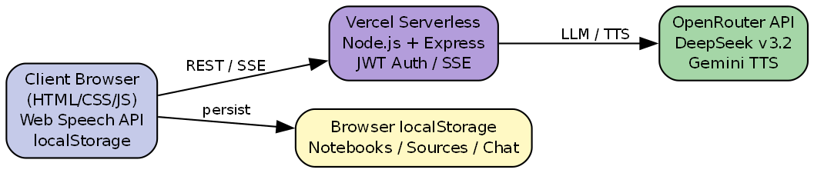
Fig. 3.1 — System Architecture Overview

3.2 Drawbacks of Existing System
- Fragmented workflow across multiple apps
- AI responses not consistently tied to uploaded syllabus PDFs
- No persistent notebook per subject
- Limited voice-based revision
- No integrated podcast-style audio overview from notes
- Generic chatbots lack mind maps, slide decks, and infographics

3.3 Proposed System
The proposed system is a browser-based Voice-Controlled AI Study Assistant with authentication, multi-notebook management, source upload (PDF/text), streaming AI chat, Studio generation panel, audio overview, explain/translate/speak actions, and cloud deployment at https://voice-study-assistant.vercel.app/.

3.4 Feasibility Study

3.4.1 Technical Feasibility
Technically feasible using HTML/CSS/JavaScript frontend, Node.js/Express backend, OpenRouter API for LLM/TTS, Web Speech API for STT, pdf.js for PDF extraction, and Vercel for serverless hosting.

3.4.2 Economic Feasibility
Vercel Hobby tier supports free deployment for academic use. OpenRouter charges per token — DeepSeek v3.2 is cost-effective for student-scale usage. No paid database is required due to localStorage and stateless auth design.

3.4.3 Operational Feasibility
Users need only a modern browser and internet connection. Sign-up/sign-in flow is simple. Mentor login supports instructor access. Operational complexity is low for end users.

3.5 System Requirements

3.5.1 Hardware Requirements
Minimum client-side hardware specifications required to run the Voice-Controlled AI Study Assistant are listed in Table 3.1.
Table 3.1 — Hardware Requirements
Component | Minimum Specification
Client PC/Laptop | Intel i3 / equivalent, 4 GB RAM
Microphone | Built-in or external (for voice input)
Speaker/Headphones | For TTS and audio overview
Network | Broadband internet (≥ 2 Mbps)
Server | Vercel serverless (cloud — no local server needed)

3.5.2 Software Requirements
Table 3.2 enumerates the software components, versions, and purposes needed for development, testing, and production deployment.
Table 3.2 — Software Requirements
Software | Version/Purpose
Operating System | Windows 10/11, macOS, or Linux
Web Browser | Chrome 90+, Edge 90+, Firefox 88+
Node.js (development) | 18.x or higher
OpenRouter API Key | LLM and TTS access
Vercel CLI | Cloud deployment

3.6 Functional Requirements
Ten functional requirements trace from student learning needs to implemented modules. Each requirement is verified in the test cases documented in Table 6.1.
Table 3.3 — Functional Requirements
ID | Requirement
FR-01 | User shall register and sign in with email/password
FR-02 | User shall create, rename, and delete notebooks
FR-03 | User shall upload PDF/text sources
FR-04 | User shall chat with AI grounded on enabled sources
FR-05 | User shall use voice input for queries
FR-06 | User shall generate studio outputs (mind map, slides, etc.)
FR-07 | User shall listen to audio overview and join conversation
FR-08 | User shall speak, translate, and explain AI responses
FR-09 | User shall access saved studio outputs from Saved panel
FR-10 | Mentor shall sign in with dedicated credentials

3.7 Non-Functional Requirements
Quality attributes and measurable performance targets are summarised in Table 3.4. Outcomes against these targets are evaluated in Chapter 6.
Table 3.4 — Non-Functional Requirements
ID | Requirement
NFR-01 | Chat streaming shall begin within 5 seconds on average
NFR-02 | UI shall be responsive on 1366×768 and above
NFR-03 | User data shall be isolated per account
NFR-04 | System shall support dark/light themes
NFR-05 | Application shall be deployable on Vercel
NFR-06 | API keys shall not be exposed in frontend code

3.8 System Architecture Overview
The system follows a three-tier architecture: (1) Presentation Tier — HTML/CSS/JS frontend with Web Speech API; (2) Application Tier — Express.js API on Vercel serverless functions; (3) External Services Tier — OpenRouter (DeepSeek, Gemini) for LLM and TTS. Data persistence uses browser localStorage keyed by user ID, as illustrated in Fig. 3.1.

CHAPTER 4

DESIGN METHODOLOGY

4.1 Introduction
Design methodology translates the requirements identified in Chapter 3 into a concrete, deployable architecture for the Voice-Controlled AI Study Assistant. This chapter documents the complete A-to-Z design process: layered system architecture, monorepo organisation, module decomposition, data-flow and behavioural models, persistence schema, core algorithms, operational flow, and security controls.
The design follows four guiding principles adopted throughout development: (1) source-grounded responses — every AI answer must be traceable to user-uploaded material; (2) multimodal interaction — text and voice are first-class input/output channels; (3) stateless serverless backend — no database server is required for academic-scale deployment; and (4) per-user isolation — notebooks and studio outputs must not leak between accounts on a shared Vercel link.
Fig. 4.1 presents the high-level three-tier architecture comprising the presentation layer (browser client), application layer (Express.js on Vercel), and external AI services layer (OpenRouter LLM and TTS). Subsequent sections refine this overview into module-level designs, DFDs, UML-style diagrams, and algorithms.
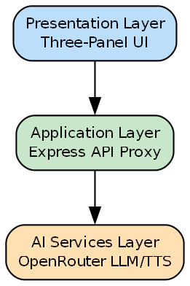
Fig. 4.1 — High-Level Architecture of Proposed System

4.2 Architecture of the Proposed System
The project is organised as a Vercel monorepo with two primary directories. The folder frontend/ contains static HTML, CSS, and JavaScript assets — index.html (main three-panel app), auth.html (sign-in/sign-up), app.js (~2800 lines of client logic), styles.css, mindmap.js (Reingold-Tilford SVG layout), and config.js (API base URL switcher). The folder backend/ hosts server.js (~880 lines), an Express application exposing REST and SSE endpoints, JWT authentication, and OpenRouter API proxying.
Vercel routing (vercel.json) maps /api/* to the Node.js serverless function and /* to static frontend files. In development, the backend listens on port 3000 while the frontend is served statically; config.js points API_BASE to http://localhost:3000. In production, API_BASE is empty so requests are same-origin — eliminating CORS friction and simplifying deployment.
Data never persists on the server. All notebooks, sources, chat histories, and studio outputs are stored in browser localStorage under keys scoped by HMAC-derived user ID (sa_notebooks_v2_<uid>). The JWT in sa_auth carries user identity for API authorisation without a central user database. Fig. 4.2 shows the Level 0 data flow between the student, the study assistant, and OpenRouter.
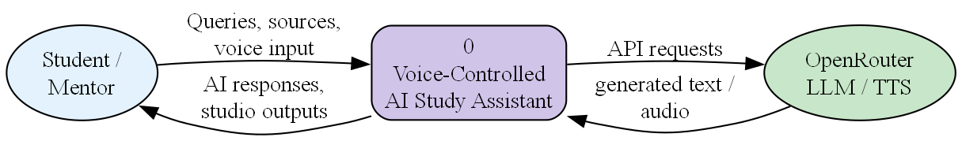
Fig. 4.2 — Data Flow Diagram (Level 0)

4.2.1 End-to-End Development Phases
Development proceeded in six iterative phases, each producing a testable increment:
- Phase 1 — Core Chat: Static three-panel UI, POST /api/chat non-streaming, manual text input, basic OpenRouter integration.
- Phase 2 — Source Grounding: PDF upload via pdf.js, source enable/disable toggles, source text injected into LLM system prompt with [Source N] citation format.
- Phase 3 — Studio Outputs: Mind map, slides, flashcards, FAQ, briefing, outline, data table, resources, and infographic endpoints with structured JSON parsing.
- Phase 4 — Voice & Audio: Web Speech API input, Gemini TTS output, audio overview podcasts, explain/translate actions, pipelined audio playback.
- Phase 5 — Authentication: Stateless JWT sign-up/sign-in, HMAC uid derivation, mentor portal, per-user localStorage isolation.
- Phase 6 — Deployment & Hardening: Vercel monorepo deploy, SSE streaming, cold-start fixes, CORS configuration, action-button post-stream attachment.
Each phase was validated against the functional requirements in Table 3.3 before proceeding to the next, ensuring traceability from design to implementation.

4.2.2 REST API and Endpoint Design
The backend exposes a cohesive REST and SSE API surface. Authentication endpoints (/api/auth/signup, /api/auth/signin, /api/auth/me) return JWT tokens without persisting credentials server-side. The chat endpoint (/api/chat) accepts a JSON body with messages[], sources[], notes, stream flag, and default_lang; when stream=true it returns text/event-stream with incremental tokens. Studio endpoints under /api/studio/* accept source excerpts and return strictly structured JSON for each artifact type. Audio endpoints (/api/tts, /api/explain, /api/podcast) proxy Gemini TTS and multi-speaker podcast scripts. All routes validate Authorization: Bearer <JWT> except signup/signin.
Error responses follow a consistent JSON schema: { error: string, code?: number }. HTTP 401 indicates invalid or expired JWT; 503 signals missing OPENROUTER_API_KEY; 429 triggers automatic model fallback from DeepSeek to Gemini. This predictable contract simplified frontend error banners and retry logic during implementation.

4.2.3 Prompt Engineering and Source Grounding Strategy
Source grounding is the central design differentiator. For every chat request, server.js concatenates enabled source texts (truncated to 6000 characters per source to respect context limits) into the system prompt with explicit [Source N] labels. The model is instructed to cite these labels when quoting or paraphrasing uploaded material and to state clearly when an answer is general knowledge rather than source-derived. Studio prompts add JSON schema examples inline — for example, mind map responses must be nested { name, children[] } trees parseable by mindmap.js. Temperature is kept low (0.3–0.5) for structured outputs and moderate (0.7) for conversational chat to balance creativity with faithfulness to sources.

4.3 Module Description
The system is decomposed into six cooperating modules. Each module has defined inputs, outputs, and interfaces. Together they implement the NotebookLM-inspired workflow: upload sources, chat with grounded AI, generate studio artifacts, and revise using voice.

4.3.1 Voice Input Module
The Voice Input Module captures spoken queries through the browser Web Speech API (SpeechRecognition interface). When the user clicks the microphone button, recognition starts with interim results displayed in the input field for visual feedback. On a final transcript event, the recognised text is passed to sendMessage() — the same pipeline used for typed queries. The module supports English and browser-supported Indian languages. Error handling covers permission denial, no-speech timeout, and network unavailability, with graceful fallback to keyboard input.

4.3.2 Speech-to-Text Module
STT is implemented entirely client-side via the Web Speech API — no server-side Whisper or cloud STT endpoint is required. A regex-based language detector inspects Unicode script ranges in the transcript to identify Telugu (U+0C00–U+0C7F), Hindi/Devanagari, Tamil, and other scripts. Detected language is forwarded to the backend as default_lang so the LLM responds in the same language. Accuracy depends on browser engine (typically Chrome/Edge), microphone quality, and ambient noise; Chapter 6 quantifies observed performance.

4.3.3 NLP Processing Module
Rather than a local NLP library, this module orchestrates LLM prompts on the backend. For each chat request, server.js constructs a system message containing: tutor persona instructions, subject context, active source texts (up to 6000 characters per source), student notes, and language directives. The last ten user/assistant turns are included for conversational continuity. Source grounding is enforced by instructing the model to cite [Source N] inline when relying on uploaded material. Studio endpoints use specialised system prompts requesting strict JSON output for mind maps, flashcards, slides, and other structured artifacts.

4.3.4 AI Response Generation Module
POST /api/chat accepts messages, sources, notes, and a stream flag. When stream=true, the backend opens an SSE connection to OpenRouter with DeepSeek v3.2, forwarding token chunks to the client as data: {"token": "..."} events. The frontend creates a streaming bubble, appends tokens via updateStreamingBubble(), and calls finalizeStreamingBubble() on [DONE]. Action buttons (Speak, Explain, Translate, Podcast) are attached via attachMsgActions() after the stream completes. Non-streaming mode returns a complete JSON reply for simpler clients. Model fallback chain: DeepSeek v3.2 → Gemini 2.0 Flash on rate limit or error.

4.3.5 Database Module
Persistence uses browser localStorage — a key-value store with ~5 MB per-origin limit. Keys include: sa_auth (JWT token and user object), sa_notebooks_v2_<uid> (JSON array of notebooks), and sa_theme (dark/light preference). Each notebook contains id, name, createdAt, sources[], chats[], and studioOutputs[]. Sources store extracted PDF/text, enabled flag, and context mode. Chats store message arrays with role, content, and unique ids. Studio outputs store type, title, data payload, and timestamp. This schema supports offline re-display of all generated content without server round-trips.

4.3.6 User Interface Module
The UI follows a NotebookLM-inspired three-panel layout. The left panel lists notebooks and uploaded sources with enable/disable checkboxes. The centre panel shows the active chat thread with streaming markdown rendering (marked.js + highlight.js for code blocks). The right panel contains Studio generation cards (mind map, slides, flashcards, etc.) and a Saved outputs panel. auth.html provides a premium dark-themed sign-in/sign-up experience with mentor portal modal. Responsive CSS supports 1366×768 and above with collapsible panels on narrower viewports.

4.3.7 Error Handling and Resilience
Client-side error handling covers network timeouts (30 s fetch abort), SSE stream interruption (partial bubble preserved with retry prompt), localStorage quota exceeded (user alert to delete old notebooks), and microphone permission denial (fallback to keyboard). Server-side middleware catches OpenRouter rate limits and switches models transparently. Vercel cold starts on the first request after idle are mitigated by displaying a loading spinner and caching JWT in localStorage to avoid redundant auth round-trips during a study session.
Fig. 4.3 decomposes the Level 0 DFD into five Level 1 processes — authentication, notebook/source management, chat/voice processing, studio generation, and TTS/audio — with localStorage and OpenRouter as external data stores and services.
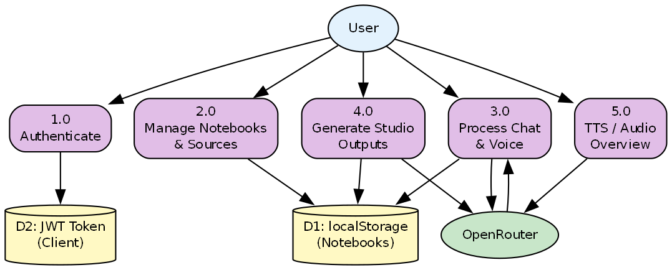
Fig. 4.3 — Data Flow Diagram (Level 1)

4.4 Data Flow Diagram (DFD)
Data flow modelling clarifies how information moves between the student, client-side stores, backend processes, and OpenRouter. At Level 0 (Fig. 4.2), the student submits queries and sources; the system returns AI responses and studio artifacts; OpenRouter handles LLM inference and TTS synthesis. At Level 1 (Fig. 4.3), Process 1.0 authenticates via HMAC-derived uid; Process 2.0 reads/writes notebook JSON in localStorage; Process 3.0 streams chat completions; Process 4.0 generates structured studio JSON; Process 5.0 fetches WAV audio from Gemini TTS. Disabled sources (context=excluded) are filtered before prompt construction.

4.5 Use Case Diagram
Two human actors interact with the system: Student (primary user with full notebook access) and Mentor (elevated role via username ss6156 for demonstration and review). The OpenRouter API acts as a secondary actor providing LLM and TTS services. Core use cases include: Sign Up, Sign In, Upload Source (PDF/text), Chat via Text, Chat via Voice, Generate Mind Map, Generate Slide Deck, Generate Flashcards, Generate Audio Overview, Explain Response, Translate Response, Save Studio Output, and Sign Out. Fig. 4.4 maps actors to these use cases.
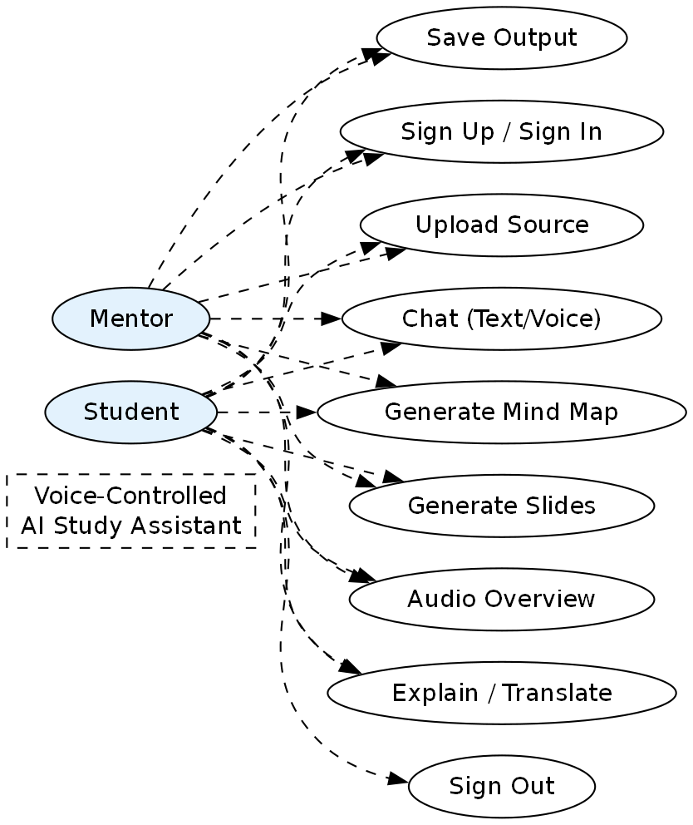
Fig. 4.4 — Use Case Diagram

4.6 Sequence Diagram
The chat interaction sequence demonstrates the synchronous-asynchronous hybrid pattern used throughout the application. The student types or speaks a query; the frontend POSTs to /api/chat with stream=true; the backend opens an SSE stream to OpenRouter; tokens arrive incrementally and are rendered in the UI; upon completion, action buttons are injected and the updated chat is serialised to localStorage. Error paths include API key missing (503), rate limiting (model fallback), and network timeout (user-visible error banner). Fig. 4.5 illustrates this sequence.
Fig. 4.5 — Sequence Diagram (Chat Interaction)

4.7 Activity Diagram
A typical study session begins with authentication (redirect to auth.html if sa_auth is absent), notebook selection, and source upload. The student enables relevant sources, then asks questions via text or microphone. The AI streams a response; optional actions include Speak (TTS), Explain (personalised audio lesson), Translate (with TTS in target language), or Continue in Podcast. Studio cards generate mind maps, slides, or flashcards from the same source corpus. All outputs appear in the Saved panel for later review. Fig. 4.6 captures this activity flow.
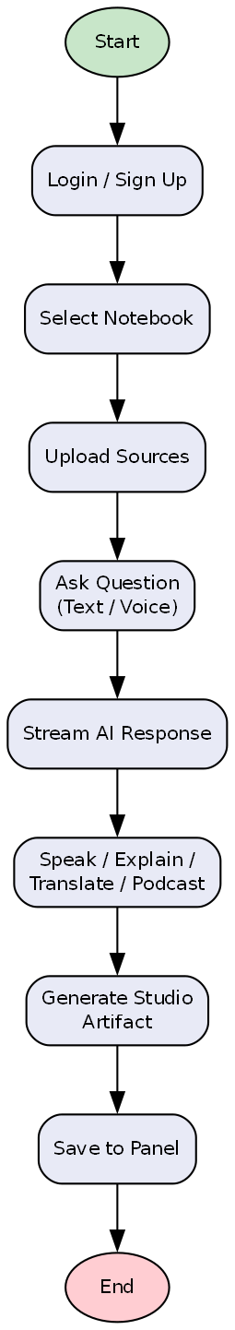
Fig. 4.6 — Activity Diagram (User Study Session)

4.8 ER Diagram / Database Design
Although no relational database is deployed, a logical ER model describes the localStorage JSON schema. Entity User (uid, email, username, role) has a one-to-many relationship with Notebook. Notebook has one-to-many relationships with Source, Chat, and StudioOutput. Chat has one-to-many Message (role, content, id). Source stores title, type (pdf/text), extracted text, and enabled flag. StudioOutput stores type (mindmap/slides/flashcards/etc.), title, data blob, and createdAt. Fig. 4.7 presents this logical model used during design and implementation.
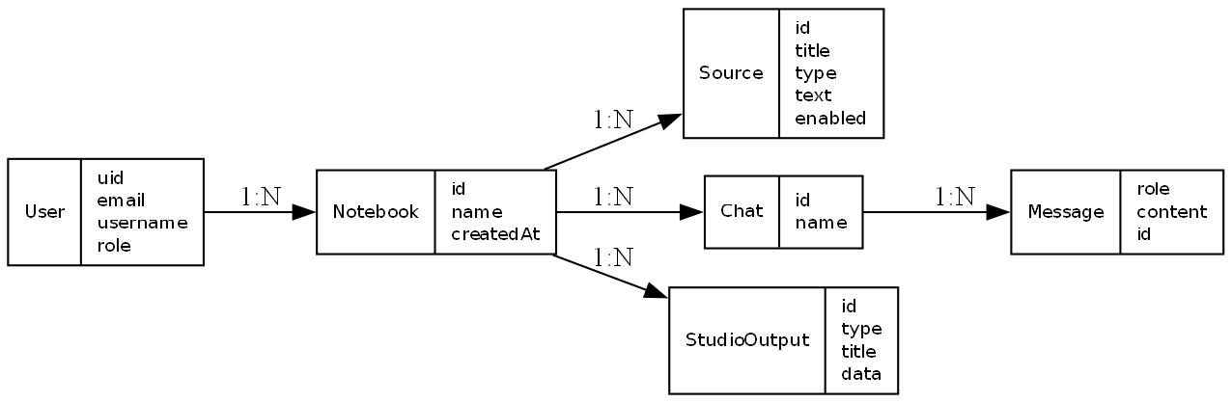
Fig. 4.7 — Entity Relationship Diagram (Logical Data Model)

4.9 Algorithm Design
Algorithm 1 — Stateless User Identity Derivation:
Input: email E, password P. Output: stable user id uid.
uid ← 'u_' || HMAC-SHA256(UID_PEPPER, lowercase(E) || '::' || P)[0:28]
The same credentials always produce the same uid, enabling localStorage lookup without server-side user records. Password is never stored — only the derived uid appears in the JWT payload.
Algorithm 2 — Mind Map Layout (Reingold-Tilford):
Input: hierarchical JSON tree from /api/studio/mindmap. The algorithm assigns x/y coordinates to each node using the Reingold-Tilford tidy tree layout, renders SVG paths for edges, and supports pan/zoom, expand/collapse, and PNG export via mindmap.js.
Algorithm 3 — Pipelined Explain Audio:
Input: explanation text from /api/explain. Split into sentence chunks. While chunk N plays via HTMLAudioElement, chunk N+1 is fetched from /api/tts in parallel. This reduces perceived latency for 60–90 second spoken explanations compared to sequential fetch-play.

4.10 Flowchart of System Operation
The operational flowchart (Fig. 4.8) summarises the decision logic from application entry to output display: check authentication → load notebooks → upload sources → choose chat or studio path → call OpenRouter → render result → optionally save to localStorage. Error branches handle auth failure (redirect), API unavailability (retry message), and empty source list (prompt user to upload).
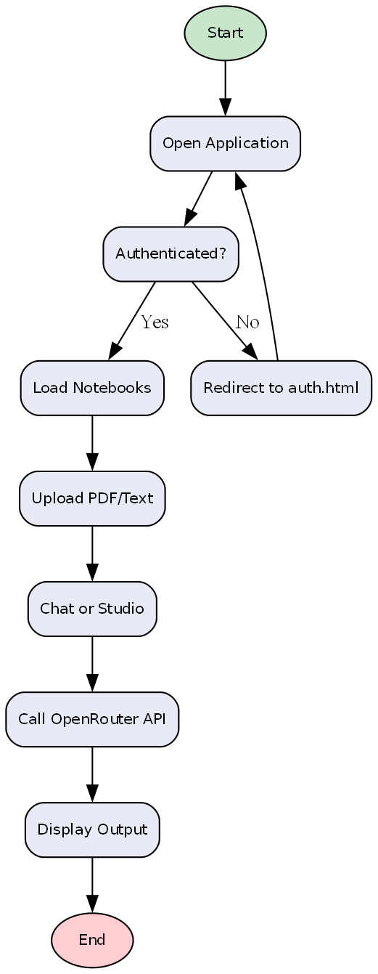
Fig. 4.8 — System Operation Flowchart

4.11 Security and Privacy Considerations
Security was designed into the architecture from the outset, consistent with non-functional requirements in Table 3.4:
- OPENROUTER_API_KEY and JWT_SECRET reside only in server environment variables — never in frontend source or client bundles.
- JWT tokens use HS256 signing with 365-day expiry; /api/auth/me verifies token integrity without database lookup.
- Passwords are never transmitted to persistent server storage; HMAC uid derivation provides stateless identity.
- Per-user localStorage keys (sa_notebooks_v2_<uid>) prevent notebook mixing when multiple students use the same browser sequentially.
- HTTPS is enforced on the Vercel deployment; CORS headers restrict API methods to GET/POST.
- Source text is sent to OpenRouter only during active queries — no third-party analytics or tracking scripts are embedded.

CHAPTER 5

IMPLEMENTATION

5.1 Introduction
This chapter describes the development environment, technology stack, module implementation, and integration details of the Voice-Controlled AI Study Assistant. The authentication interface is shown in Fig. 5.1.
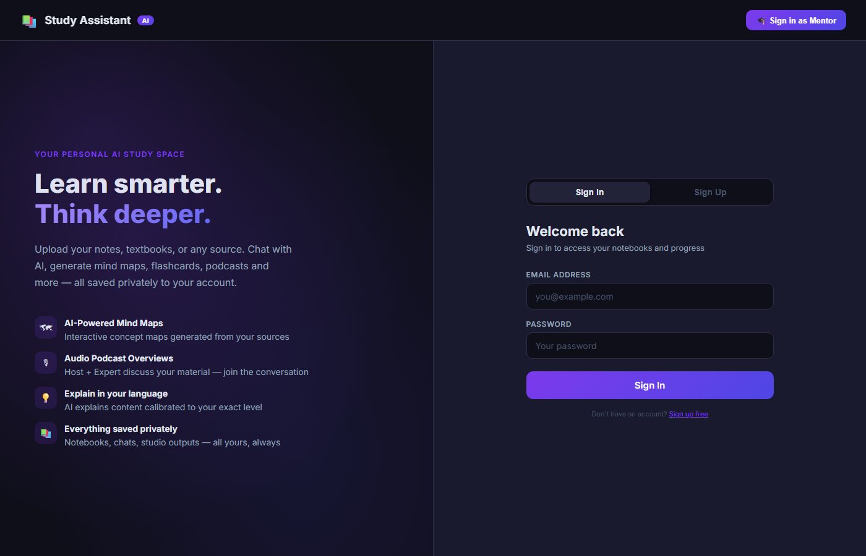
Fig. 5.1 — Authentication Page

5.2 Development Environment
Development was performed on Windows with VS Code/Cursor IDE. Local backend runs on Node.js port 3000. Production deployment via Vercel CLI. Live URL: https://voice-study-assistant.vercel.app/. The main three-panel interface after login is presented in Fig. 5.2.
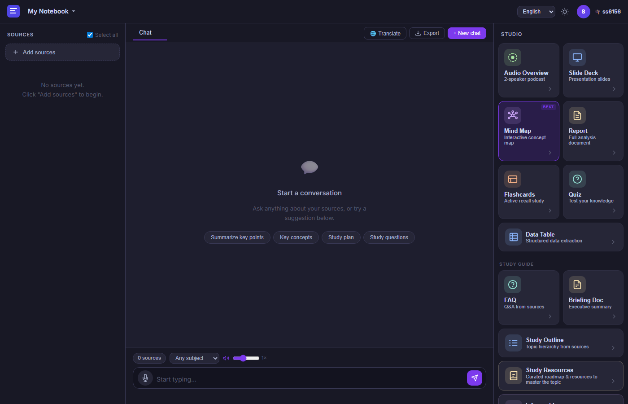
Fig. 5.2 — Main Three-Panel Interface (Sources | Chat | Studio)

5.3 Tools and Technologies Used
The complete technology stack — frontend libraries, backend runtime, AI models, and deployment platform — is documented in Table 5.1.
Table 5.1 — Technology Stack
Category | Technology | Purpose
Frontend | HTML5, CSS3, JavaScript ES2022 | UI and client logic
Markdown | marked.js + highlight.js | Render AI responses
PDF | pdf.js (Mozilla) | Extract text from PDFs
Mind Map | Custom SVG + Reingold-Tilford | Interactive concept maps
Backend | Node.js 18+, Express.js | REST/SSE API
AI Gateway | OpenRouter API | LLM and TTS access
LLM | deepseek/deepseek-v3.2 | Primary chat model
TTS | google/gemini-3.1-flash-tts-preview | Multilingual speech
Deployment | Vercel | Static + serverless hosting

The chat interface with saved studio outputs panel is illustrated in Fig. 5.3.

Fig. 5.3 — Chat Interface with Saved Studio Outputs

5.4 Coding Methodology
Agile iterative development was followed. Features were added incrementally: core chat, studio outputs, voice, authentication, and deployment fixes. Single-page application pattern with modular functions in app.js (~2800 lines) and backend consolidated in server.js (~880 lines). An interactive mind map output is shown in Fig. 5.4.

Fig. 5.4 — Interactive Mind Map Studio Output

5.5 Implementation of Modules
Key files: frontend/index.html, frontend/app.js, frontend/styles.css, frontend/auth.html, frontend/mindmap.js, backend/server.js, vercel.json.

5.6 Integration of Voice Commands
Mic button triggers SpeechRecognition. Final transcript is passed to sendMessage(). TTS via POST /api/tts returns WAV audio from Gemini TTS. speakText(), playExplainAudio(), and podcast modes use pipelined audio playback.

5.7 AI Model Training and Testing
No custom training was performed. Pre-trained models are accessed via OpenRouter with DeepSeek v3.2 primary and Gemini 2.0 Flash fallback. Prompt engineering ensures source grounding and structured JSON for studio endpoints.

5.8 User Authentication Process
Stateless auth: uid = HMAC(email + password). JWT stored in localStorage under sa_auth. Mentor login via username ss6156. Auth guard redirects unauthenticated users to auth.html.

5.9 API Integration
Major endpoints: /api/auth/signup, /api/auth/signin, /api/chat (SSE), /api/tts, /api/explain, /api/podcast, /api/studio/mindmap, /api/studio/slides, /api/studio/flashcards, /api/studio/faq, /api/studio/briefing, /api/studio/outline, /api/studio/datatable, /api/studio/resources, /api/studio/infographic.

5.10 Screenshots of Implementation
Implementation screenshots are presented in their respective sections: Fig. 5.1 (Section 5.1), Fig. 5.2 (Section 5.2), Fig. 5.3 (Section 5.3), and Fig. 5.4 (Section 5.4).

CHAPTER 6

RESULTS AND DISCUSSION

6.1 Experimental Setup
Testing was performed on local development (localhost:3000), production deployment (https://voice-study-assistant.vercel.app/), Chrome and Edge browsers, multiple user accounts, and PDF sources up to 50 pages. A sample chat response with action buttons is shown in Fig. 6.1.

Fig. 6.1 — Chat Response with Action Buttons

6.2 Test Cases
Twelve test cases were designed to verify every functional requirement in Table 3.3. Execution was performed on both localhost and the Vercel production deployment. Results are recorded in Table 6.1.
Table 6.1 — Test Cases and Results
TC ID | Test Case | Expected Result | Status
TC-01 | User sign-up with valid email | JWT returned, redirect to app | Pass
TC-02 | User sign-in with correct password | Same uid, notebooks loaded | Pass
TC-03 | Upload PDF source | Text extracted, listed in Sources | Pass
TC-04 | Chat query on enabled source | Streaming AI response | Pass
TC-05 | Voice input query | Transcript sent, response received | Pass
TC-06 | Generate mind map | Interactive SVG displayed and saved | Pass
TC-07 | Audio overview generation | Host-expert dialogue with TTS | Pass
TC-08 | Explain button after response | Audio explanation plays | Pass
TC-09 | Translate to Telugu | Translated text + TTS | Pass
TC-10 | Cross-device Vercel access | App loads; API responds | Pass
TC-11 | Mentor login (ss6156) | Mentor role badge displayed | Pass
TC-12 | Action buttons after stream | Speak/Explain visible | Pass

A study resources roadmap generated from uploaded sources is presented in Fig. 6.2.

Fig. 6.2 — Study Resources Output

6.3 Performance Evaluation
Overall system performance was assessed against the non-functional targets in Table 3.4. Average chat first-token latency is 2–5 seconds. Full mind map generation takes 15–30 seconds. TTS per chunk takes 1–3 seconds. Vercel cold start may add ~6 seconds for initial auth requests.

6.4 Accuracy of Speech Recognition
Web Speech API accuracy is high for clear English speech (~90%+ in quiet environments). Indian accent and Telugu/Hindi mixed speech show moderate accuracy depending on browser engine. Text input remains a reliable fallback.

6.5 Response Time Analysis
Detailed response time measurements for authentication, chat streaming, studio generation, TTS, and PDF extraction are summarised in Table 6.2.
Table 6.2 — Performance Metrics
Operation | Average Time
Sign-in API | ~6 s (cold) / ~1 s (warm)
Chat first token (SSE) | 2–5 s
Full chat response (200 words) | 8–15 s
Mind map generation | 15–30 s
TTS single chunk | 1–3 s
PDF text extraction (20 pages) | 3–8 s (client-side)

6.6 Comparative Performance Analysis
Compared to a manual study workflow, the system reduces time to create flashcards, mind maps, and summaries from hours to minutes. Compared to generic ChatGPT, responses are better grounded when sources are uploaded. Table 2.1 provides the qualitative platform comparison; Table 6.2 quantifies the operational response times measured in this project.

6.7 Output Screenshots
Output screenshots are included in Fig. 6.1 (Section 6.1) and Fig. 6.2 (Section 6.2).

6.8 Discussion of Results
The system successfully demonstrates a NotebookLM-style learning workflow with voice control at https://voice-study-assistant.vercel.app/. Uploading programming notes and querying concepts such as pointer-to-pointer produced accurate C/C++ explanations with saved mind maps, flashcards, slides, and audio outputs.

6.9 Limitations of the System
- Data stored in browser localStorage — not synced across devices
- No vector RAG — large PDFs may exceed context limits
- Stateless auth — no password reset or email verification
- Serverless cold starts may cause initial delay
- STT quality varies by browser and accent

CHAPTER 7

CONCLUSION AND FUTURE SCOPE

7.1 Conclusion
The Voice-Controlled AI Study Assistant successfully delivers an integrated, deployable, AI-powered learning platform at https://voice-study-assistant.vercel.app/, combining source-grounded chat, voice interaction, studio artifact generation, audio podcasts, and user authentication.

7.2 Achievements of the Project
- Designed and implemented full-stack NotebookLM-style UI
- Integrated DeepSeek v3.2 via OpenRouter with SSE streaming
- Built 10+ studio features including mind map, slides, flashcards, infographic
- Implemented voice input, TTS output, audio overview, and explain modes
- Added JWT authentication with per-user data isolation
- Deployed production application on Vercel

7.3 Future Enhancements
- Cloud database (Supabase) for cross-device notebook sync
- Vector RAG with chunking for large documents
- Offline PWA support with service workers
- Collaborative notebooks for group study
- Analytics dashboard for mentors

7.4 Real-Time Industrial Applications
EdTech startups, coaching institutes, corporate L&D departments, and library digitization projects can adapt this architecture for AI tutoring and training content generation with minimal infrastructure cost.

7.5 Final Remarks
This project demonstrates that modern LLM APIs, browser speech technologies, and serverless deployment can be combined to build sophisticated educational tools without massive infrastructure.

REFERENCES
[1] Google, "NotebookLM: An AI-powered research and writing assistant," Google Labs, 2023–2024.
[2] OpenRouter, OpenRouter API Documentation, https://openrouter.ai/docs, 2024.
[3] DeepSeek, "DeepSeek-V3 Technical Report," 2024.
[4] Mozilla, pdf.js Documentation, https://mozilla.github.io/pdf.js/, 2024.
[5] W3C, Web Speech API Specification, https://w3c.github.io/speech-api/, 2024.
[6] AntV, Infographic Library, https://github.com/antvis/Infographic, 2024.
[7] Vercel, Serverless Functions Documentation, https://vercel.com/docs/functions, 2024.
[8] IETF RFC 7519, JSON Web Token (JWT), 2015.
[9] Russell, S., and Norvig, P., Artificial Intelligence: A Modern Approach, 4th ed., Pearson, 2020.
[10] Jurafsky, D., and Martin, J. H., Speech and Language Processing, 3rd ed. draft, 2023.

APPENDICES

Appendix A – Source Code
voice-study-assistant/
├── frontend/ (index.html, auth.html, app.js, styles.css, mindmap.js)
├── backend/ (server.js, package.json)
├── vercel.json
└── README.md

Appendix B – Sample Voice Commands
Voice Command | Action
Explain photosynthesis | Sends query to AI chat
What is a dangling pointer? | C programming query from PDF source
Summarize chapter 3 | Summary from uploaded source
(Mic + Telugu speech) | Telugu query with Telugu response

Appendix C – Test Case Reports
Detailed test execution logs with date, tester name, browser, and pass/fail status are maintained in the project logbook. A summary of all twelve test cases appears in Table 6.1.

Appendix D – User Manual
1. Open https://voice-study-assistant.vercel.app/
2. Sign up with email and password
3. Create a notebook and upload PDF/text sources
4. Ask questions via text or microphone
5. Use Studio cards to generate mind maps, slides, flashcards
6. Click Speak/Explain/Translate on AI responses
7. Access saved outputs in Saved panel
8. Sign out via avatar

Appendix E – Installation Guide
Local: cd backend && npm install && node server.js. Deploy: vercel --prod with OPENROUTER_API_KEY set.

Appendix F – Dataset Details and Screenshots
No custom ML dataset was created. Testing used publicly available study PDFs and user-entered topics. Implementation and output screenshots referenced in this report are Fig. 5.1–5.4 (Chapter 5) and Fig. 6.1–6.2 (Chapter 6); these figures are embedded in the main body and do not require a separate appendix.

ANNEXURES
Annexure I – Project Synopsis
[Attach signed/scanned document as per department format]
Annexure II – Weekly Progress Reports
[Attach signed/scanned document as per department format]
Annexure III – Gantt Chart / Project Schedule
[Attach signed/scanned document as per department format]
Annexure IV – Plagiarism Report
[Attach signed/scanned document as per department format]
Annexure V – Guide Meeting Logbook
[Attach signed/scanned document as per department format]
Annexure VI – Student Contribution Sheet
[Attach signed/scanned document as per department format]
Annexure VII – Attendance Record
[Attach signed/scanned document as per department format]
Annexure VIII – Ethical Clearance (if applicable)
[Attach signed/scanned document as per department format]
Annexure IX – Publication/Patent Details (if any)
[Attach signed/scanned document as per department format]
Annexure X – Project Completion Certificate
[Attach signed/scanned document as per department format]

