KAKATIYA INSTITUTE OF TECHNOLOGY AND SCIENCES, WARANGAL

A Major Project Report
on
"VOICE-CONTROLLED AI STUDY ASSISTANT"
(An AI-Powered NotebookLM-Style Learning Platform)

Submitted in partial fulfilment of the requirements
for the award of the degree of
BACHELOR OF TECHNOLOGY
in
COMPUTER SCIENCE AND ENGINEERING (AI & ML)

Academic Year: 2025–26

Submitted by
Maram Sai Shashank Raj
Roll No.: B24AI185

Under the guidance of
Prof. Maram Balajee
Professor, Department of Computer Science and Engineering, SR University, Warangal
Department of Computer Science and Engineering (AI & ML)
Kakatiya Institute of Technology and Sciences, Warangal

June 2026

BONAFIDE CERTIFICATE
This is to certify that the Major Project Report entitled "VOICE-CONTROLLED AI STUDY ASSISTANT" submitted by Maram Sai Shashank Raj (Roll No.: B24AI185) in partial fulfilment of the requirements for the award of the degree of Bachelor of Technology in Computer Science and Engineering (AI & ML) is a bonafide record of work carried out by him under my supervision and guidance.
The matter embodied in this report has not been submitted elsewhere for the award of any other degree or diploma.
Date: June 2026
Place: Warangal Signature of the Guide Prof. Maram BalajeeProfessor, Department of Computer Science and Engineering, SR University, Warangal

PROJECT APPROVAL SHEET
The Major Project Report entitled "VOICE-CONTROLLED AI STUDY ASSISTANT" submitted by Maram Sai Shashank Raj has been examined and approved for submission.
Name | Roll Number | Signature
Maram Sai Shashank Raj | B24AI185

Project Guide: Prof. Maram Balajee Date: June 2026
Internal Examiner: _____________________ Date: __________
External Examiner: _____________________ Date: __________

DECLARATION
I, Maram Sai Shashank Raj, hereby declare that the Major Project Report entitled "VOICE-CONTROLLED AI STUDY ASSISTANT" submitted to Jawaharlal Nehru Technological University, Hyderabad through Kakatiya Institute of Technology and Sciences, Warangal in partial fulfilment of the requirements for the award of the degree of Bachelor of Technology in Computer Science and Engineering (AI & ML) is an authentic record of my own work carried out under the supervision of Prof. Maram Balajee.
The matter embodied in this report has not been submitted by me for the award of any other degree or diploma. Wherever other works have been referred to, due acknowledgement has been made.
Date: June 2026
Place: Warangal
Signature of the Student: _________________________
Maram Sai Shashank Raj

CERTIFICATE FROM SUPERVISOR
This is to certify that the project work titled "VOICE-CONTROLLED AI STUDY ASSISTANT" carried out by Maram Sai Shashank Raj (Roll No.: B24AI185) under my guidance is a record of bonafide work and has been completed to my satisfaction. The report is recommended for submission to Kakatiya Institute of Technology and Sciences, Warangal for evaluation.
Date: June 2026
Place: Warangal
Signature of Supervisor: _________________________Prof. Maram BalajeeProfessor, Department of Computer Science and Engineering, SR University, Warangal

ACKNOWLEDGEMENT
I express my sincere gratitude to my project guide, Prof. Maram Balajee, Professor, Department of Computer Science and Engineering, SR University, Warangal, for invaluable guidance, continuous encouragement, and constructive feedback throughout the development of this project.
I thank the faculty members of Department of Computer Science and Engineering (AI & ML), Kakatiya Institute of Technology and Sciences, Warangal, for providing academic support and laboratory facilities.
I acknowledge OpenRouter, DeepSeek, Google Gemini, Mozilla pdf.js, AntV, and the open-source community for tools and APIs that made this project feasible.
Finally, I thank my parents and friends for their moral support and motivation.

ABSTRACT
Traditional study methods often require students to manually organize notes, search across multiple documents, and switch between reading, revision, and assessment tools. Generic AI chatbots provide answers but lack source grounding, persistent notebooks, and integrated study workflows inspired by modern research assistants such as Google NotebookLM.
This project presents a Voice-Controlled AI Study Assistant — a full-stack web application deployed at https://voice-study-assistant.vercel.app/ that enables students to upload study sources (PDF/text), interact through text and voice, and generate rich learning artifacts including mind maps, slide decks, flashcards, FAQs, briefing documents, study outlines, data tables, study resource roadmaps, and infographics. The system uses DeepSeek v3.2 via OpenRouter for conversational AI, Server-Sent Events (SSE) for real-time streaming responses, Google Gemini TTS for multilingual speech output, and the Web Speech API for speech-to-text input.
The application follows a three-panel NotebookLM-inspired interface: Sources, Chat, and Studio. User authentication is implemented using stateless JWT-based identity derivation, with per-user data isolation in browser localStorage. Key features include audio overview podcasts, join-the-conversation mode, personalized audio explanations, and persistent saved studio outputs.
Keywords: Artificial Intelligence, Voice-Controlled Systems, Natural Language Processing, Study Assistant, OpenRouter, Speech-to-Text, Text-to-Speech, NotebookLM, Web Application, Vercel.

TABLE OF CONTENTS
CHAPTER 1 – INTRODUCTION .............................. 1
CHAPTER 2 – LITERATURE SURVEY ........................ 12
CHAPTER 3 – SYSTEM ANALYSIS .......................... 22
CHAPTER 4 – DESIGN METHODOLOGY ....................... 32
CHAPTER 5 – IMPLEMENTATION ........................... 48
CHAPTER 6 – RESULTS AND DISCUSSION ................... 60
CHAPTER 7 – CONCLUSION AND FUTURE SCOPE .............. 72
REFERENCES ........................................... 78
APPENDICES ........................................... 80

LIST OF FIGURES
Fig. 3.1 System Architecture Overview
Fig. 4.1 High-Level Architecture of Proposed System
Fig. 4.2 Data Flow Diagram – Level 0
Fig. 4.3 Data Flow Diagram – Level 1
Fig. 4.4 Use Case Diagram
Fig. 4.5 Sequence Diagram – Chat Interaction
Fig. 4.6 Activity Diagram – User Study Session
Fig. 4.7 Entity Relationship Diagram (Logical Data Model)
Fig. 4.8 System Operation Flowchart
Fig. 5.1 Authentication Page
Fig. 5.2 Main Three-Panel Interface
Fig. 5.3 Chat Interface with Saved Studio Outputs
Fig. 5.4 Interactive Mind Map Output
Fig. 6.1 Chat Response with Action Buttons
Fig. 6.2 Study Resources Output

LIST OF TABLES
Table 2.1 Comparative Analysis of Existing Systems
Table 3.1 Hardware Requirements
Table 3.2 Software Requirements
Table 3.3 Functional Requirements
Table 3.4 Non-Functional Requirements
Table 5.1 Technology Stack
Table 6.1 Test Cases and Results
Table 6.2 Performance Metrics

LIST OF ABBREVIATIONS AND ACRONYMS
Abbreviation | Expansion
AI | Artificial Intelligence
API | Application Programming Interface
CSS | Cascading Style Sheets
DFD | Data Flow Diagram
DOM | Document Object Model
ER | Entity Relationship
HTML | HyperText Markup Language
JWT | JSON Web Token
LLM | Large Language Model
ML | Machine Learning
NLP | Natural Language Processing
PDF | Portable Document Format
REST | Representational State Transfer
SSE | Server-Sent Events
STT | Speech-to-Text
SVG | Scalable Vector Graphics
TTS | Text-to-Speech
UI | User Interface
UX | User Experience

CHAPTER 1

INTRODUCTION

1.1 Introduction to Artificial Intelligence
Artificial Intelligence (AI) refers to the simulation of human intelligence in machines programmed to think, learn, and solve problems. In education, AI enables personalized tutoring, automated content summarization, intelligent question answering, and adaptive learning pathways. Large Language Models (LLMs) such as GPT, Gemini, and DeepSeek have revolutionized how students interact with textual knowledge by enabling natural language queries over complex material.

1.2 Voice-Controlled Systems Overview
Voice-controlled systems allow users to interact with software through spoken commands rather than traditional keyboard input. These systems combine Speech-to-Text (STT) conversion, natural language understanding, and Text-to-Speech (TTS) synthesis. Modern browsers implement the Web Speech API, enabling real-time voice input without native desktop applications. Voice interfaces improve accessibility and support hands-free learning during revision sessions.

1.3 Need for AI-Based Study Assistants
Students frequently manage multiple subjects, PDFs, lecture notes, and revision schedules simultaneously. Existing tools are fragmented: note apps store content, PDF readers display documents, and chatbots answer questions without persistent source context. An integrated AI study assistant addresses this gap by combining source management, grounded chat, voice interaction, and automated study artifact generation in one workspace.

1.4 Problem Statement
The problem addressed in this project is the lack of an affordable, deployable, and feature-rich AI study platform that: (1) grounds AI responses in user-uploaded sources; (2) supports voice input and multilingual output; (3) generates diverse study materials (mind maps, flashcards, podcasts); (4) persists user notebooks across sessions; and (5) isolates data between multiple users sharing the same deployment link.

1.5 Motivation of the Project
Commercial platforms such as Google NotebookLM demonstrate the value of source-grounded AI for learning, but are not always accessible for academic experimentation or local customization. This project was motivated by the need to build a college-level, deployable alternative using open API gateways (OpenRouter), modern web technologies, and a NotebookLM-inspired user experience.

1.6 Objectives of the Project
- To design and implement a web-based AI study assistant with NotebookLM-style three-panel layout.
- To integrate voice input (STT) and voice output (TTS) for hands-free learning.
- To enable PDF/text source upload and source-grounded AI chat with streaming responses.
- To implement Studio features: mind maps, slides, flashcards, FAQ, briefing, outline, data tables, study resources, and infographics.
- To provide audio overview podcasts with interactive join-conversation and continue-in-podcast modes.
- To implement user authentication with per-user data isolation.
- To deploy the application on Vercel at https://voice-study-assistant.vercel.app/.

1.7 Scope of the Project
The scope includes frontend UI, backend API proxy, OpenRouter LLM integration, authentication, local persistence, and cloud deployment. Custom LLM training, vector database RAG pipelines, and native mobile applications are out of scope.

1.8 Proposed Solution
The proposed Voice-Controlled AI Study Assistant is a full-stack web application comprising: (a) Vanilla JavaScript frontend with Sources | Chat | Studio panels; (b) Node.js/Express backend proxying OpenRouter API calls; (c) SSE-based streaming chat; (d) JWT stateless authentication with HMAC-derived user IDs; (e) localStorage-based notebook persistence scoped per user; (f) Vercel serverless deployment.

1.9 Applications of the System
- Engineering and degree exam preparation
- Competitive exam revision (GATE, placements)
- Research paper summarization
- Language learning with multilingual TTS
- Classroom demonstration of AI in education
- Remote mentoring with shared Vercel link

1.10 Advantages of the Proposed System
- Unified workspace for sources, chat, and generated study content
- Voice and text multimodal interaction
- Low deployment cost using Vercel and OpenRouter pay-per-use
- No installation required — browser-based access
- Rich studio outputs beyond plain chat
- Per-user data isolation for shared deployments

1.11 Organization of the Report
Chapter 2 presents literature survey. Chapter 3 covers system analysis and requirements. Chapter 4 describes design methodology and diagrams. Chapter 5 explains implementation details. Chapter 6 discusses results and testing. Chapter 7 concludes with future scope. References and appendices follow.

CHAPTER 2

LITERATURE SURVEY

2.1 Introduction
This chapter reviews existing voice assistants, AI in education, speech technologies, NLP approaches, and comparative systems relevant to the Voice-Controlled AI Study Assistant.

2.2 Existing Voice Assistant Technologies
Commercial voice assistants such as Google Assistant, Amazon Alexa, Apple Siri, and Microsoft Cortana demonstrate robust STT and TTS pipelines integrated with cloud NLP services. For web applications, the Web Speech API provides browser-native speech recognition and synthesis. Backend TTS services such as Google Gemini TTS offer higher quality multilingual output than browser defaults.

2.3 AI in Smart Education Systems
Intelligent tutoring systems, adaptive learning platforms, and AI note-taking tools show growing adoption. Google NotebookLM (2023–2024) introduced source-grounded notebooks with audio overviews, marking a shift from generic chatbots to document-centric learning assistants.

2.4 Speech Recognition Techniques
Speech recognition evolved from Hidden Markov Models (HMM) to deep learning architectures including Transformer-based models such as Whisper. Browser STT uses cloud-backed recognition engines via Web Speech API. Accuracy depends on microphone quality, accent, background noise, and language support.

2.5 Natural Language Processing Approaches
Modern NLP for study assistants relies on LLMs for generation, summarization, translation, and structured output (JSON for mind maps, flashcards). Prompt engineering with source context replaces traditional pipeline NLP for many educational tasks. Streaming token generation via SSE improves perceived response latency.

2.6 Machine Learning Models Used in Assistants
This project uses DeepSeek v3.2 as the primary LLM and Google Gemini 2.0 Flash as fallback, accessed through OpenRouter. TTS uses google/gemini-3.1-flash-tts-preview. No custom model training is performed; the system leverages pre-trained models via API.

2.7 Comparative Analysis of Existing Systems
Table 2.1 compares representative study-assistant platforms across grounding, voice support, artifact generation, and deployability dimensions.
Table 2.1 — Comparative Analysis of Existing Systems
System | Source Grounding | Voice | Study Artifacts | Custom Deploy
Google NotebookLM | Yes | Limited | Audio, slides, etc. | No
ChatGPT | Via uploads | Yes (Plus) | Generic | No
Notion AI | Workspace | No | Notes only | No
Proposed System | Yes | Yes (STT+TTS) | Mind map, flashcards, podcast | Yes (Vercel)

2.8 Research Gaps Identified
- Lack of open, deployable NotebookLM-style platforms for academic projects
- Limited integration of voice + studio artifacts in single UI
- Need for lightweight auth without expensive database for small user bases
- Multilingual learning support in Indian languages (Telugu, Hindi, Tamil)

2.9 Summary
Literature review confirms demand for integrated AI study platforms. The proposed system fills gaps by combining NotebookLM-inspired UX, voice control, rich studio outputs, and practical Vercel deployment suitable for B.Tech major projects.

CHAPTER 3

SYSTEM ANALYSIS

3.1 Existing System
Students typically use separate tools: PDF readers, handwritten/typed notes, YouTube lectures, generic ChatGPT queries, and manual flashcard apps. These systems do not maintain persistent source-notebook relationships or generate structured study artifacts from the same uploaded material. The proposed integrated architecture that overcomes these limitations is overviewed in Fig. 3.1.
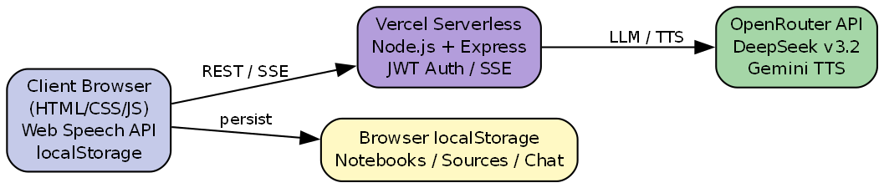
Fig. 3.1 — System Architecture Overview

3.2 Drawbacks of Existing System
- Fragmented workflow across multiple apps
- AI responses not consistently tied to uploaded syllabus PDFs
- No persistent notebook per subject
- Limited voice-based revision
- No integrated podcast-style audio overview from notes
- Generic chatbots lack mind maps, slide decks, and infographics

3.3 Proposed System
The proposed system is a browser-based Voice-Controlled AI Study Assistant with authentication, multi-notebook management, source upload (PDF/text), streaming AI chat, Studio generation panel, audio overview, explain/translate/speak actions, and cloud deployment at https://voice-study-assistant.vercel.app/.

3.4 Feasibility Study

3.4.1 Technical Feasibility
Technically feasible using HTML/CSS/JavaScript frontend, Node.js/Express backend, OpenRouter API for LLM/TTS, Web Speech API for STT, pdf.js for PDF extraction, and Vercel for serverless hosting.

3.4.2 Economic Feasibility
Vercel Hobby tier supports free deployment for academic use. OpenRouter charges per token — DeepSeek v3.2 is cost-effective for student-scale usage. No paid database is required due to localStorage and stateless auth design.

3.4.3 Operational Feasibility
Users need only a modern browser and internet connection. Sign-up/sign-in flow is simple. Mentor login supports instructor access. Operational complexity is low for end users.

3.5 System Requirements

3.5.1 Hardware Requirements
Table 3.1 — Hardware Requirements
Component | Minimum Specification
Client PC/Laptop | Intel i3 / equivalent, 4 GB RAM
Microphone | Built-in or external (for voice input)
Speaker/Headphones | For TTS and audio overview
Network | Broadband internet (≥ 2 Mbps)
Server | Vercel serverless (cloud — no local server needed)

3.5.2 Software Requirements
Table 3.2 — Software Requirements
Software | Version/Purpose
Operating System | Windows 10/11, macOS, or Linux
Web Browser | Chrome 90+, Edge 90+, Firefox 88+
Node.js (development) | 18.x or higher
OpenRouter API Key | LLM and TTS access
Vercel CLI | Cloud deployment

3.6 Functional Requirements
Table 3.3 — Functional Requirements
ID | Requirement
FR-01 | User shall register and sign in with email/password
FR-02 | User shall create, rename, and delete notebooks
FR-03 | User shall upload PDF/text sources
FR-04 | User shall chat with AI grounded on enabled sources
FR-05 | User shall use voice input for queries
FR-06 | User shall generate studio outputs (mind map, slides, etc.)
FR-07 | User shall listen to audio overview and join conversation
FR-08 | User shall speak, translate, and explain AI responses
FR-09 | User shall access saved studio outputs from Saved panel
FR-10 | Mentor shall sign in with dedicated credentials

3.7 Non-Functional Requirements
Table 3.4 — Non-Functional Requirements
ID | Requirement
NFR-01 | Chat streaming shall begin within 5 seconds on average
NFR-02 | UI shall be responsive on 1366×768 and above
NFR-03 | User data shall be isolated per account
NFR-04 | System shall support dark/light themes
NFR-05 | Application shall be deployable on Vercel
NFR-06 | API keys shall not be exposed in frontend code

3.8 System Architecture Overview
The system follows a three-tier architecture: (1) Presentation Tier — HTML/CSS/JS frontend with Web Speech API; (2) Application Tier — Express.js API on Vercel serverless functions; (3) External Services Tier — OpenRouter (DeepSeek, Gemini) for LLM and TTS. Data persistence uses browser localStorage keyed by user ID, as illustrated in Fig. 3.1.

CHAPTER 4

DESIGN METHODOLOGY

4.1 Introduction
This chapter describes the architectural design, module decomposition, diagrams, algorithms, and security considerations for the Voice-Controlled AI Study Assistant. The high-level layered design is shown in Fig. 4.1.
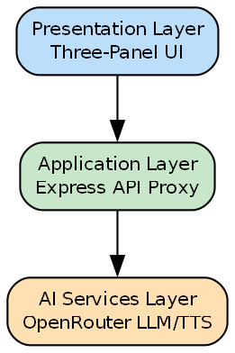
Fig. 4.1 — High-Level Architecture of Proposed System

4.2 Architecture of the Proposed System
The monorepo structure contains frontend/ (static assets) and backend/ (Express server.js). Vercel routes /api/* to serverless backend and /* to static frontend. config.js switches API_BASE between localhost:3000 (development) and same-origin (production). The Level 0 data flow is presented in Fig. 4.2.
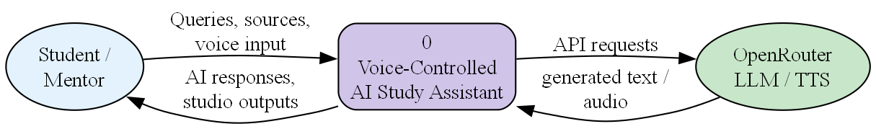
Fig. 4.2 — Data Flow Diagram (Level 0)

4.3 Module Description

4.3.1 Voice Input Module
Captures microphone input via Web Speech API. On final transcript, sends text to chat pipeline with visual mic-button feedback.

4.3.2 Speech-to-Text Module
Browser-native STT through SpeechRecognition interface. Regex-based language detection identifies Telugu, Hindi, Tamil, and other scripts.

4.3.3 NLP Processing Module
LLM prompt orchestration injects sources, notes, and chat history into OpenRouter requests for grounded understanding and generation.

4.3.4 AI Response Generation Module
POST /api/chat with SSE streaming. Tokens appended to UI in real-time; action buttons attached after stream completion.

4.3.5 Database Module
Client-side localStorage keys: sa_auth (JWT), sa_notebooks_v2_<uid> for notebooks, sources, chats, and studioOutputs.

4.3.6 User Interface Module
Three-panel layout: Sources | Chat | Studio with premium auth.html login page and dark/light themes.
The Level 1 data flow diagram decomposing these modules into processes and data stores is given in Fig. 4.3.
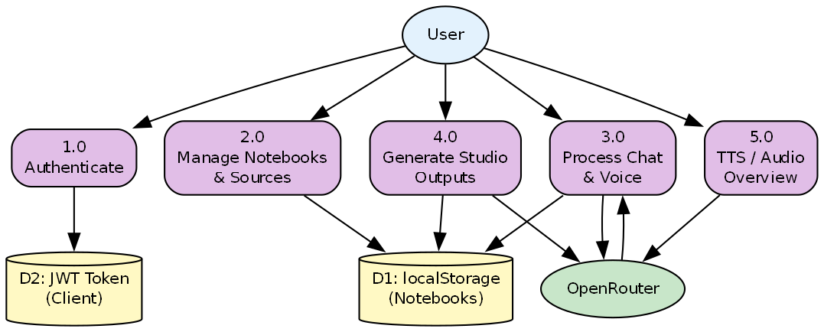
Fig. 4.3 — Data Flow Diagram (Level 1)

4.4 Data Flow Diagram (DFD)
The DFD models at Level 0 and Level 1 (Fig. 4.2 and Fig. 4.3) show how user inputs, localStorage persistence, and OpenRouter API calls interact across authentication, notebook management, chat, studio generation, and TTS sub-processes. The use case model for the system is presented in Fig. 4.4.
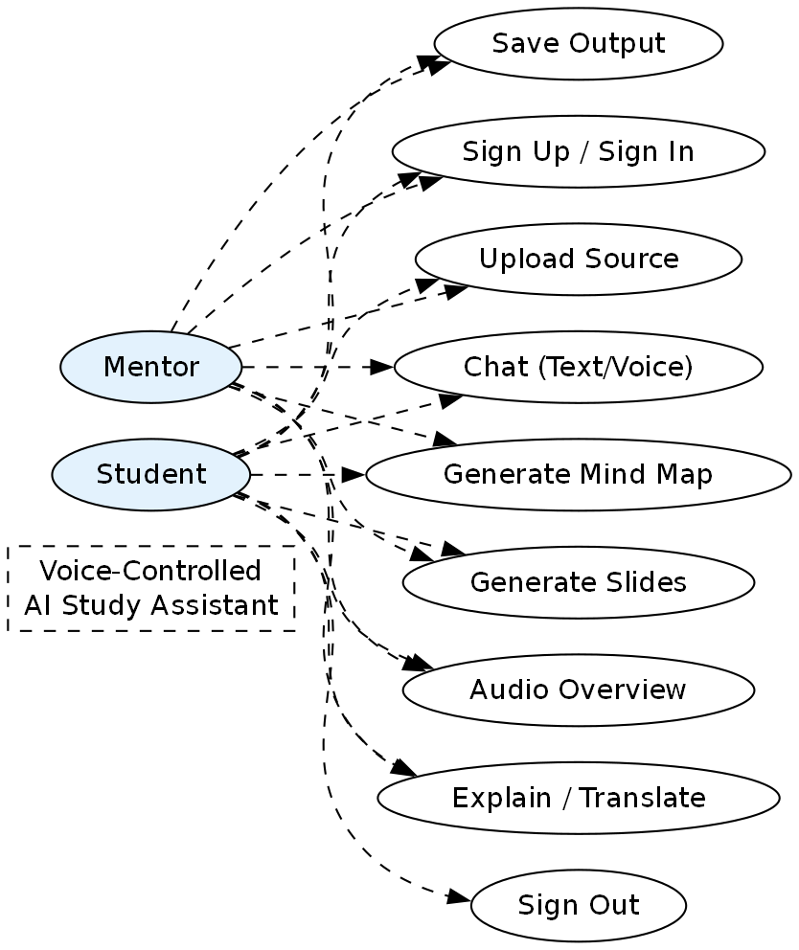
Fig. 4.4 — Use Case Diagram

4.5 Use Case Diagram
Actors include Student, Mentor, and OpenRouter API. Primary use cases cover authentication, source upload, text/voice chat, studio artifact generation, audio overview, and sign-out. The chat interaction sequence is illustrated in Fig. 4.5.
Fig. 4.5 — Sequence Diagram (Chat Interaction)

4.6 Sequence Diagram
The sequence from user query through SSE streaming to rendered response demonstrates real-time token delivery. A typical user study session flow is shown in Fig. 4.6.
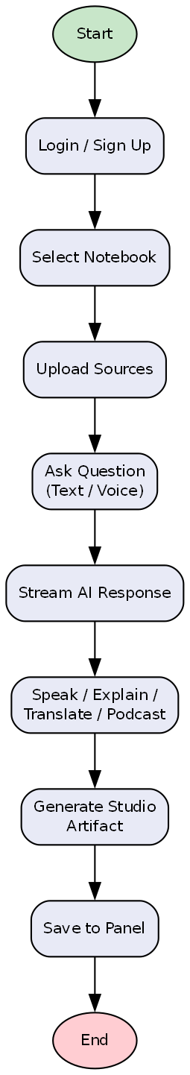
Fig. 4.6 — Activity Diagram (User Study Session)

4.7 Activity Diagram
The activity flow covers login, notebook selection, source upload, questioning via text or voice, response actions, and studio artifact generation. The logical data model is given in Fig. 4.7.
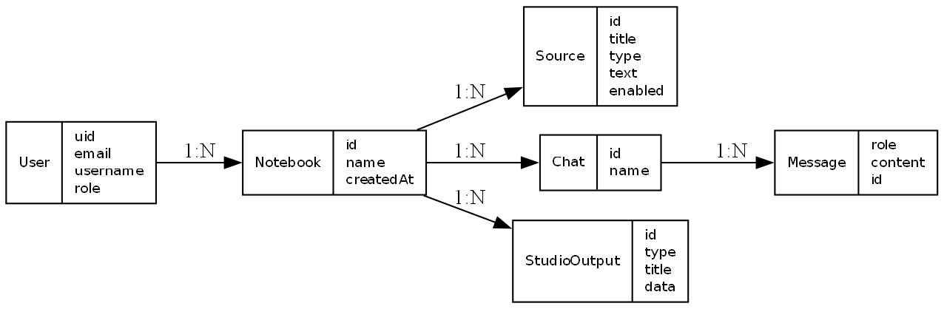
Fig. 4.7 — Entity Relationship Diagram (Logical Data Model)

4.8 ER Diagram / Database Design
Logical entities stored in localStorage JSON include User, Notebook, Source, Chat, Message, and StudioOutput. Relationships follow User → Notebooks → Sources/Chats/StudioOutputs. The system operation flowchart is presented in Fig. 4.8.
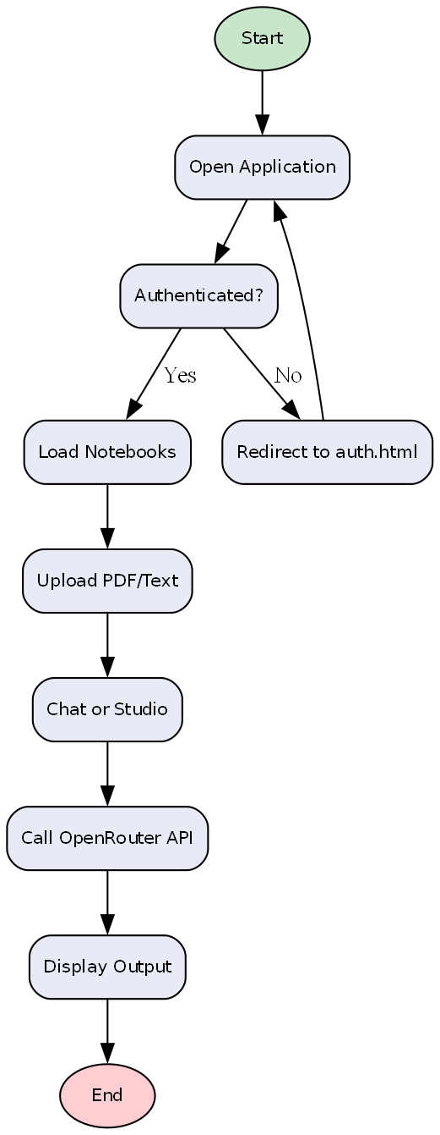
Fig. 4.8 — System Operation Flowchart

4.9 Algorithm Design
Algorithm 1 — Stateless User ID: uid = 'u_' + HMAC-SHA256(UID_PEPPER, email + '::' + password)[0:28]. Algorithm 2 — Mind Map Layout: Reingold-Tilford tree on JSON hierarchy with SVG pan/zoom. Algorithm 3 — Explain Audio Pipeline: sentence-chunked pipelined TTS fetch for seamless playback.

4.10 Flowchart of System Operation
The end-to-end operational flow from application start through authentication, source upload, chat/studio processing, and output display is summarized in Fig. 4.8.

4.11 Security and Privacy Considerations
- OpenRouter API key stored only in server environment variables
- JWT signed with HS256; 365-day expiry
- Password never stored on server — HMAC-derived uid only
- Per-user localStorage keys prevent data mixing
- HTTPS enforced via Vercel deployment

CHAPTER 5

IMPLEMENTATION

5.1 Introduction
This chapter describes the development environment, technology stack, module implementation, and integration details of the Voice-Controlled AI Study Assistant. The authentication interface is shown in Fig. 5.1.
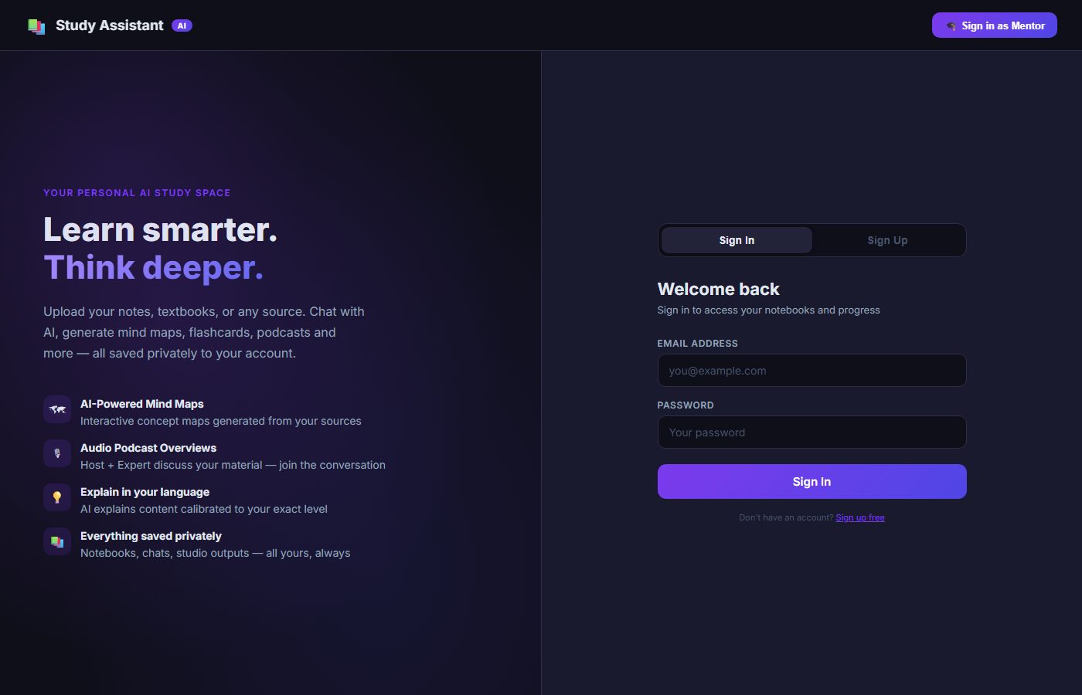
Fig. 5.1 — Authentication Page

5.2 Development Environment
Development was performed on Windows with VS Code/Cursor IDE. Local backend runs on Node.js port 3000. Production deployment via Vercel CLI. Live URL: https://voice-study-assistant.vercel.app/. The main three-panel interface after login is presented in Fig. 5.2.
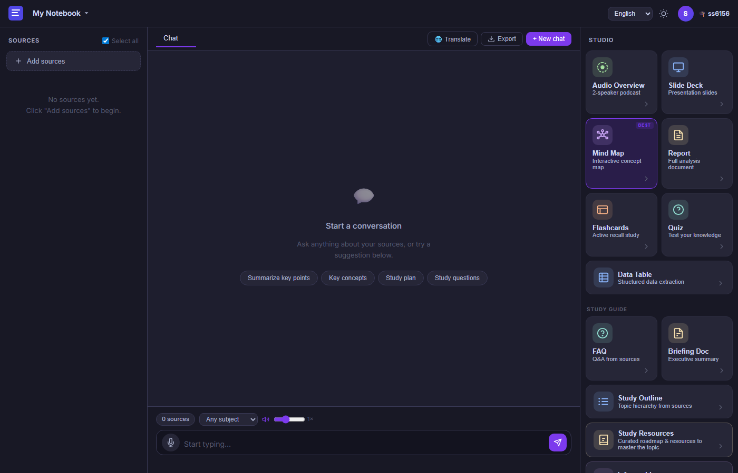
Fig. 5.2 — Main Three-Panel Interface (Sources | Chat | Studio)

5.3 Tools and Technologies Used
Table 5.1 — Technology Stack
Category | Technology | Purpose
Frontend | HTML5, CSS3, JavaScript ES2022 | UI and client logic
Markdown | marked.js + highlight.js | Render AI responses
PDF | pdf.js (Mozilla) | Extract text from PDFs
Mind Map | Custom SVG + Reingold-Tilford | Interactive concept maps
Backend | Node.js 18+, Express.js | REST/SSE API
AI Gateway | OpenRouter API | LLM and TTS access
LLM | deepseek/deepseek-v3.2 | Primary chat model
TTS | google/gemini-3.1-flash-tts-preview | Multilingual speech
Deployment | Vercel | Static + serverless hosting

The chat interface with saved studio outputs panel is illustrated in Fig. 5.3.

Fig. 5.3 — Chat Interface with Saved Studio Outputs

5.4 Coding Methodology
Agile iterative development was followed. Features were added incrementally: core chat, studio outputs, voice, authentication, and deployment fixes. Single-page application pattern with modular functions in app.js (~2800 lines) and backend consolidated in server.js (~880 lines). An interactive mind map output is shown in Fig. 5.4.

Fig. 5.4 — Interactive Mind Map Studio Output

5.5 Implementation of Modules
Key files: frontend/index.html, frontend/app.js, frontend/styles.css, frontend/auth.html, frontend/mindmap.js, backend/server.js, vercel.json.

5.6 Integration of Voice Commands
Mic button triggers SpeechRecognition. Final transcript is passed to sendMessage(). TTS via POST /api/tts returns WAV audio from Gemini TTS. speakText(), playExplainAudio(), and podcast modes use pipelined audio playback.

5.7 AI Model Training and Testing
No custom training was performed. Pre-trained models are accessed via OpenRouter with DeepSeek v3.2 primary and Gemini 2.0 Flash fallback. Prompt engineering ensures source grounding and structured JSON for studio endpoints.

5.8 User Authentication Process
Stateless auth: uid = HMAC(email + password). JWT stored in localStorage under sa_auth. Mentor login via username ss6156. Auth guard redirects unauthenticated users to auth.html.

5.9 API Integration
Major endpoints: /api/auth/signup, /api/auth/signin, /api/chat (SSE), /api/tts, /api/explain, /api/podcast, /api/studio/mindmap, /api/studio/slides, /api/studio/flashcards, /api/studio/faq, /api/studio/briefing, /api/studio/outline, /api/studio/datatable, /api/studio/resources, /api/studio/infographic.

5.10 Screenshots of Implementation
Implementation screenshots are presented in their respective sections: Fig. 5.1 (Section 5.1), Fig. 5.2 (Section 5.2), Fig. 5.3 (Section 5.3), and Fig. 5.4 (Section 5.4).

CHAPTER 6

RESULTS AND DISCUSSION

6.1 Experimental Setup
Testing was performed on local development (localhost:3000), production deployment (https://voice-study-assistant.vercel.app/), Chrome and Edge browsers, multiple user accounts, and PDF sources up to 50 pages. A sample chat response with action buttons is shown in Fig. 6.1.

Fig. 6.1 — Chat Response with Action Buttons

6.2 Test Cases
Table 6.1 — Test Cases and Results
TC ID | Test Case | Expected Result | Status
TC-01 | User sign-up with valid email | JWT returned, redirect to app | Pass
TC-02 | User sign-in with correct password | Same uid, notebooks loaded | Pass
TC-03 | Upload PDF source | Text extracted, listed in Sources | Pass
TC-04 | Chat query on enabled source | Streaming AI response | Pass
TC-05 | Voice input query | Transcript sent, response received | Pass
TC-06 | Generate mind map | Interactive SVG displayed and saved | Pass
TC-07 | Audio overview generation | Host-expert dialogue with TTS | Pass
TC-08 | Explain button after response | Audio explanation plays | Pass
TC-09 | Translate to Telugu | Translated text + TTS | Pass
TC-10 | Cross-device Vercel access | App loads; API responds | Pass
TC-11 | Mentor login (ss6156) | Mentor role badge displayed | Pass
TC-12 | Action buttons after stream | Speak/Explain visible | Pass

A study resources roadmap generated from uploaded sources is presented in Fig. 6.2.

Fig. 6.2 — Study Resources Output

6.3 Performance Evaluation
Average chat first-token latency is 2–5 seconds. Full mind map generation takes 15–30 seconds. TTS per chunk takes 1–3 seconds. Vercel cold start may add ~6 seconds for initial auth requests.

6.4 Accuracy of Speech Recognition
Web Speech API accuracy is high for clear English speech (~90%+ in quiet environments). Indian accent and Telugu/Hindi mixed speech show moderate accuracy depending on browser engine. Text input remains a reliable fallback.

6.5 Response Time Analysis
Table 6.2 — Performance Metrics
Operation | Average Time
Sign-in API | ~6 s (cold) / ~1 s (warm)
Chat first token (SSE) | 2–5 s
Full chat response (200 words) | 8–15 s
Mind map generation | 15–30 s
TTS single chunk | 1–3 s
PDF text extraction (20 pages) | 3–8 s (client-side)

6.6 Comparative Performance Analysis
Compared to manual study workflow, the system reduces time to create flashcards, mind maps, and summaries from hours to minutes. Compared to generic ChatGPT, responses are better grounded when sources are uploaded, as summarized in Table 2.1.

6.7 Output Screenshots
Output screenshots are included in Fig. 6.1 (Section 6.1) and Fig. 6.2 (Section 6.2).

6.8 Discussion of Results
The system successfully demonstrates a NotebookLM-style learning workflow with voice control at https://voice-study-assistant.vercel.app/. Uploading programming notes and querying concepts such as pointer-to-pointer produced accurate C/C++ explanations with saved mind maps, flashcards, slides, and audio outputs.

6.9 Limitations of the System
- Data stored in browser localStorage — not synced across devices
- No vector RAG — large PDFs may exceed context limits
- Stateless auth — no password reset or email verification
- Serverless cold starts may cause initial delay
- STT quality varies by browser and accent

CHAPTER 7

CONCLUSION AND FUTURE SCOPE

7.1 Conclusion
The Voice-Controlled AI Study Assistant successfully delivers an integrated, deployable, AI-powered learning platform at https://voice-study-assistant.vercel.app/, combining source-grounded chat, voice interaction, studio artifact generation, audio podcasts, and user authentication.

7.2 Achievements of the Project
- Designed and implemented full-stack NotebookLM-style UI
- Integrated DeepSeek v3.2 via OpenRouter with SSE streaming
- Built 10+ studio features including mind map, slides, flashcards, infographic
- Implemented voice input, TTS output, audio overview, and explain modes
- Added JWT authentication with per-user data isolation
- Deployed production application on Vercel

7.3 Future Enhancements
- Cloud database (Supabase) for cross-device notebook sync
- Vector RAG with chunking for large documents
- Offline PWA support with service workers
- Collaborative notebooks for group study
- Analytics dashboard for mentors

7.4 Real-Time Industrial Applications
EdTech startups, coaching institutes, corporate L&D departments, and library digitization projects can adapt this architecture for AI tutoring and training content generation with minimal infrastructure cost.

7.5 Final Remarks
This project demonstrates that modern LLM APIs, browser speech technologies, and serverless deployment can be combined to build sophisticated educational tools without massive infrastructure.

REFERENCES
[1] Google, "NotebookLM: An AI-powered research and writing assistant," Google Labs, 2023–2024.
[2] OpenRouter, OpenRouter API Documentation, https://openrouter.ai/docs, 2024.
[3] DeepSeek, "DeepSeek-V3 Technical Report," 2024.
[4] Mozilla, pdf.js Documentation, https://mozilla.github.io/pdf.js/, 2024.
[5] W3C, Web Speech API Specification, https://w3c.github.io/speech-api/, 2024.
[6] AntV, Infographic Library, https://github.com/antvis/Infographic, 2024.
[7] Vercel, Serverless Functions Documentation, https://vercel.com/docs/functions, 2024.
[8] IETF RFC 7519, JSON Web Token (JWT), 2015.
[9] Russell, S., and Norvig, P., Artificial Intelligence: A Modern Approach, 4th ed., Pearson, 2020.
[10] Jurafsky, D., and Martin, J. H., Speech and Language Processing, 3rd ed. draft, 2023.

APPENDICES

Appendix A – Source Code
voice-study-assistant/
├── frontend/ (index.html, auth.html, app.js, styles.css, mindmap.js)
├── backend/ (server.js, package.json)
├── vercel.json
└── README.md

Appendix B – Sample Voice Commands
Voice Command | Action
Explain photosynthesis | Sends query to AI chat
What is a dangling pointer? | C programming query from PDF source
Summarize chapter 3 | Summary from uploaded source
(Mic + Telugu speech) | Telugu query with Telugu response

Appendix C – Test Case Reports
Detailed test execution logs maintained in project logbook. Summary provided in Table 6.1.

Appendix D – User Manual
1. Open https://voice-study-assistant.vercel.app/
2. Sign up with email and password
3. Create a notebook and upload PDF/text sources
4. Ask questions via text or microphone
5. Use Studio cards to generate mind maps, slides, flashcards
6. Click Speak/Explain/Translate on AI responses
7. Access saved outputs in Saved panel
8. Sign out via avatar

Appendix E – Installation Guide
Local: cd backend && npm install && node server.js. Deploy: vercel --prod with OPENROUTER_API_KEY set.

Appendix F – Dataset Details
No custom ML dataset was created. Testing used publicly available study PDFs and user-entered topics.

Appendix G – Screenshots and Outputs
See Fig. 5.1–5.4 and Fig. 6.1–6.2 in Chapters 5 and 6.

ANNEXURES
Annexure I – Project Synopsis
[Attach signed/scanned document as per department format]
Annexure II – Weekly Progress Reports
[Attach signed/scanned document as per department format]
Annexure III – Gantt Chart / Project Schedule
[Attach signed/scanned document as per department format]
Annexure IV – Plagiarism Report
[Attach signed/scanned document as per department format]
Annexure V – Guide Meeting Logbook
[Attach signed/scanned document as per department format]
Annexure VI – Student Contribution Sheet
[Attach signed/scanned document as per department format]
Annexure VII – Attendance Record
[Attach signed/scanned document as per department format]
Annexure VIII – Ethical Clearance (if applicable)
[Attach signed/scanned document as per department format]
Annexure IX – Publication/Patent Details (if any)
[Attach signed/scanned document as per department format]
Annexure X – Project Completion Certificate
[Attach signed/scanned document as per department format]

