**Assignment 4 – Deep Learning Architecture Optimization for Risk Prediction**  
**Sai Shivani Parimi**

**EUID: sp3403**

**1. Aim**

The aim of the assignment is to develop and evaluate a deep learning model for predicting a health-related outcome, represented by the **RISK** variable, using the provided dataset. The focus is on understanding how changes in neural network architecture, specifically the number of hidden layers and the number of nodes per layer, impact model accuracy. By systematically experimenting with architectural configurations, the goal is to identify the model that delivers the highest classification performance.

**2. Dataset Description**

The dataset **a4_data.csv** contains both numerical and categorical variables. The target variable RISK is binary, where 1 indicates high risk and 0 indicates low risk. Two categorical features (ASPIRIN, NO_ASPIRIN) serve as dummy indicators for aspirin use, while the remaining variables (ADAPPT42, ADHECR42, AGE09X, BMINDX, FAMINC09) are continuous numerical predictors.

**3. Strategy and Methodology**

To optimize model performance, the following strategy was adopted:

* Started with a simple neural network architecture [4, 4, 8] and keep the number of hidden layers fixed at **three**. But the **baseline model** was already provided, which has **52.% accuracy,** and tried to beat this accuracy.
* Increase node counts **systematically**, changing only one parameter at a time, like increasing nodes in the lower layer first.
* Recorded the accuracy of each architecture on a test set using a 70/30 train-test split.
* Activation functions used were **ReLU** for hidden layers and **sigmoid** for the output layer.
* Training parameters were kept constant:
  + Loss function: binary_crossentropy
  + Optimizer: adam
  + Epochs: 150
  + Batch size: 10

**4. Architectures Tested**

**5. Visualizations**

**Bar Plot**: Side-by-side comparison of all model accuracies

**Line Plot**: Highlighted performance trend; peaked at Model 6

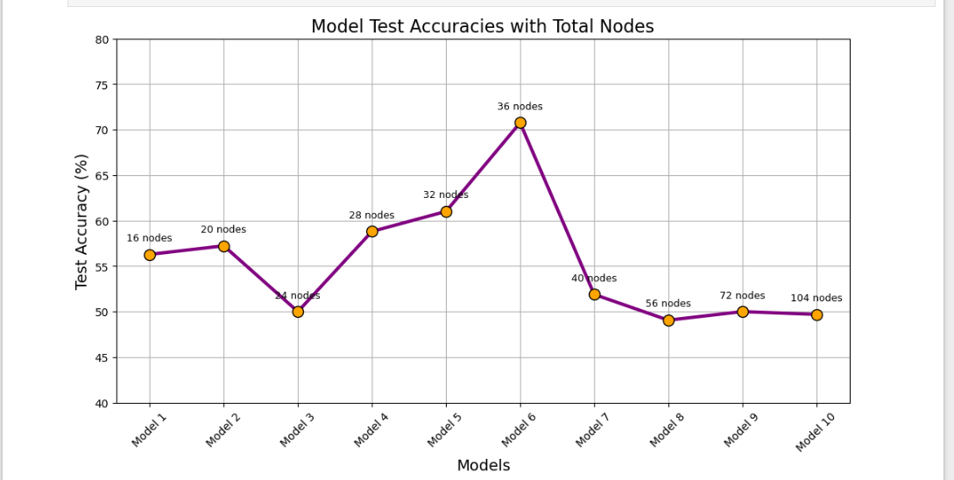

**6. Results and Analysis**

* The best performance was achieved by **Model 6**, with architecture [16, 12, 8] and accuracy **70.75%**.
* Starting from shallow and narrow models helped avoid overfitting and gave insight into how the architecture affects performance.
* Larger architectures (Models 8–10) **performed worse**, likely due to overfitting or excessive parameter complexity.
* The strategy of expanding the **lower layers first**, followed by middle/upper layers, proved effective.
* Models were trained on **normalized data**, which improved stability and convergence.

**7. Conclusion**

Through systematic experimentation, we demonstrated that deep learning model performance can be significantly improved by carefully tuning architectural parameters. Starting with shallow, narrow models and gradually expanding complexity allowed to optimize performance in a controlled manner. The best model achieved a test accuracy of **70.75%,** outperforming the initial baseline model. Our results confirm that simply adding more layers or neurons does not guarantee better performance; instead, thoughtful design and incremental tuning are key to building effective deep learning classifiers for health risk prediction.