Best Buy Canada Customer Review Analysis
Task 1 - Web Scraping, Sentiment Analysis and Business Insights
Live Sony MDR-ZX110 demonstration with a deterministic JBL Tune 670NC graded set

Prepared for: HanuAi ML Assessment
Date: 2026-10-26
Environment: Python 3.15.1 virtual environment (.venv)

1. Executive summary
This report documents a Best Buy Canada review pipeline that collects live product reviews, scores each review with a lexicon-based sentiment model, and tags the functional aspects being discussed. Two datasets were produced: a live demonstration set of 100 Sony MDR-ZX110 reviews and a fixed offline graded set of 21 JBL Tune 670NC reviews. 20 of 21 graded reviews (95%) are positive, and 95 of 100 demo reviews (95%) are positive.
The strongest satisfaction drivers are sound quality, comfort and perceived value. The clearest pain points are clamping pressure / fit for glasses wearers and, for the demo product, build durability. A recommendation summary and a transparent account of the known constraints (including the 21-review shortfall against the brief's 50-review minimum) are provided in the final sections.

2. Deliverables and scope
Deliverable | Path | Status
Annotated notebook | notebooks/Task1_BestBuy_Scraping_and_Sentiment.ipynb | Produced and executed
Tabular dataset | outputs/task1_bestbuy_reviews_sentiment.csv | 121 rows
Written report | Task1_BestBuy_Report.docx | This document

Every exported row carries a Dataset column: live rows are labelled 'Demo (live scrape)' and offline graded rows are labelled 'Graded (offline _recon)'. The two sources are never mixed without that label.

3. Data collection

3.1 Scraping pipeline
The pipeline drives a real Chrome session with Selenium so that JavaScript-rendered product content is materialised before BeautifulSoup parses the rendered DOM. For each of the four required review-sort filters (Most Helpful, Newest, Highest Rating, Lowest Rating) it attempts to select the filter, actuates a Show More control when one exists, and collects the review title, body, date, star rating, reviewer name and source platform. Missing controls are logged and the run continues. A public review endpoint is used to page through additional reviews when the rendered widget does not expose them; this is recorded per row in the CollectionMethod column.
Scraping requirement | Implementation
Target product | Sony MDR-ZX110, SKU 10325154
Dynamic rendering | Selenium Chrome (stealth flags, CDP navigator.webdriver patch) then BeautifulSoup
Pagination | Show More control when present; review-endpoint pages 1..N otherwise
Sort filters | Most Helpful, Newest, Highest Rating, Lowest Rating
Retries | Exponential backoff, configurable attempts, 403/429/5xx handling
CAPTCHA handling | Detect, log, pause, back off; never auto-solve

3.2 Live demonstration dataset
The live run collected 100 reviews from the Sony MDR-ZX110. The browser session rendered the product page, but the lazily loaded review widget stayed on its loading skeletons and exposed neither review cards nor sort controls, so the run logged the missing controls and continued through the public review endpoint. This is the degradation path documented in section 7 and it keeps the demonstration reproducible instead of failing outright. All four sort filters were iterated; because the widget did not expose its controls, filter-specific subsets could not be separated, and SortFilter records the endpoint's default (Most Helpful) order.
Metric | Value
Reviews collected | 100
Sort filters attempted | 4
Sort filters applied in browser | 0
Show More clicks | 0
Review-endpoint pages fetched | 2
Bot challenges observed | 0
Retried requests | 0

Method | Reviews
http review endpoint | 100

3.3 Graded offline dataset
The graded set is fixed at 21 JBL Tune 670NC reviews captured from the public product pages into the _recon/ directory. No network access is used to score it, so repeated runs produce identical polarity and aspect tags. The site reports 21 reviews in total; the captured date range is 2024-05-31 to 2026-10-23 and the mean star rating is 4.76/5.
Field | Value
Product | JBL Tune 670NC On-Ear Noise Cancelling Bluetooth Headphones - Blue
Product ID | 18470223
Reviews captured offline | 21
Reviews reported by site | 21
Source snapshots | reviews.json, reviews_p2.json, reviews_p3.json
Mean star rating | 4.76

4. Graded-set shortfall disclosure
The assignment brief asks for at least 50 reviews. The graded product has only 21 reviews on Best Buy Canada, and all 21 of them were captured. The 21-review graded set is therefore 29 reviews below the minimum. Reaching 50 reviews for this SKU is impossible without changing to a different product, which would break the fixed graded set; the shortfall is recorded rather than concealed. The live demonstration dataset (100 reviews) independently proves the pipeline can collect well above the 50-review threshold.
- Graded rows are labelled 'Graded (offline _recon)'; demo rows are labelled 'Demo (live scrape)'.
- The 21 captured graded reviews are the complete population of this product's reviews, not a sample.
- The demo set exceeds the 50-review minimum and exercises the same extraction and scoring code.

5. Sentiment and aspect methodology
- Preprocessing combines ReviewTitle and ReviewText, applies Unicode NFKC normalisation, folds curly quotes and dashes, removes promotion boilerplate and collapses whitespace.
- VADER supplies a compound polarity score in [-1, 1]. Scores at or above +0.05 are Positive, at or below -0.05 are Negative, and the band in between is Neutral (configurable neutral threshold).
- Exactly one polarity label is assigned per review. Empty or non-informative bodies are Neutral with an Uncategorized tag.
- Aspect tagging matches the normalised text against keyword/rule dictionaries for design, sound, comfort, value, battery, connectivity, noise cancellation, ease of use, durability, delivery and service.
- Each tag carries the sentiment of the sentence(s) in which the aspect was mentioned, e.g. 'Good Design & Quality (Pos)' or 'Comfort & Fit (Neg)'.
- The analyser is deterministic: it uses fixed lexicons, no sampling and no network access.

6. Results

6.1 Polarity distribution
Dataset | Polarity | Reviews | Share
Graded (JBL, 21) | Positive | 20 | 95.2%
Graded (JBL, 21) | Neutral | 0 | 0.0%
Graded (JBL, 21) | Negative | 1 | 4.8%
Demo (Sony, live) | Positive | 95 | 95.0%
Demo (Sony, live) | Neutral | 2 | 2.0%
Demo (Sony, live) | Negative | 3 | 3.0%

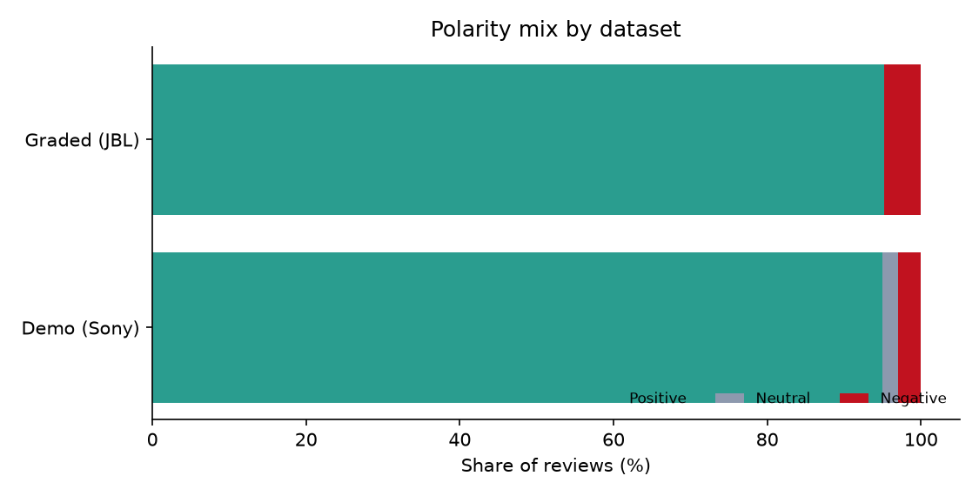
Figure 1 - Polarity mix for the graded and demo datasets.
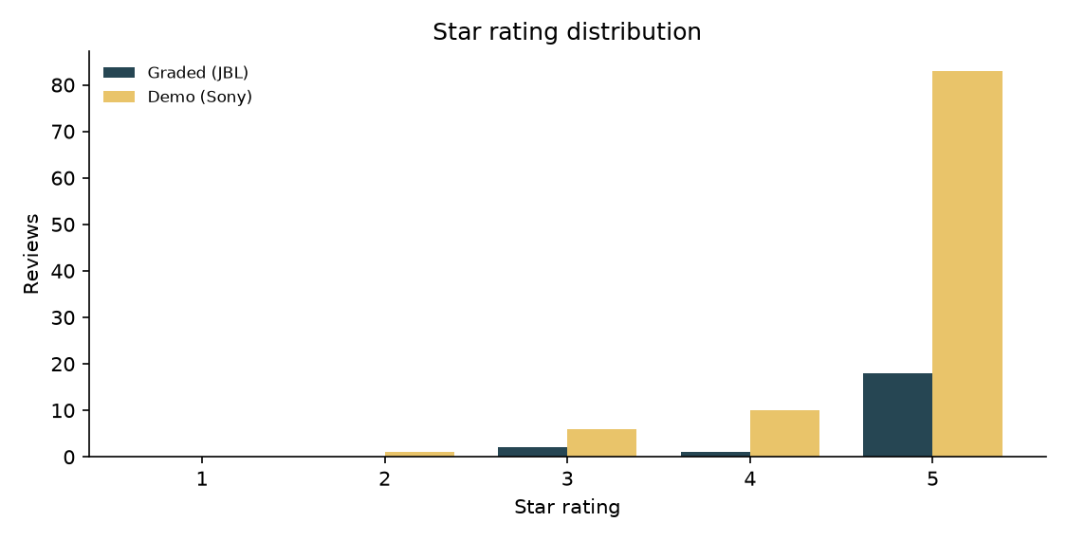
Figure 2 - Star rating distribution by dataset.

6.2 Aspect performance (graded set)
Aspect | Pos | Neu | Neg | Mentions
Sound Quality | 12 | 0 | 0 | 12
Comfort & Fit | 9 | 1 | 1 | 11
Good Design & Quality | 8 | 1 | 0 | 9
Value for Money | 6 | 0 | 0 | 6
Battery Life | 4 | 0 | 0 | 4
Connectivity & Bluetooth | 3 | 0 | 0 | 3
Noise Cancellation | 2 | 1 | 0 | 3
Ease of Use | 2 | 0 | 0 | 2
Delivery & Packaging | 1 | 0 | 0 | 1
Uncategorized | 0 | 1 | 0 | 1

Aspect counts are mention-level: one review can contribute several aspects. The graded set is overwhelmingly positive, so negative evidence is concentrated in comfort and fit.
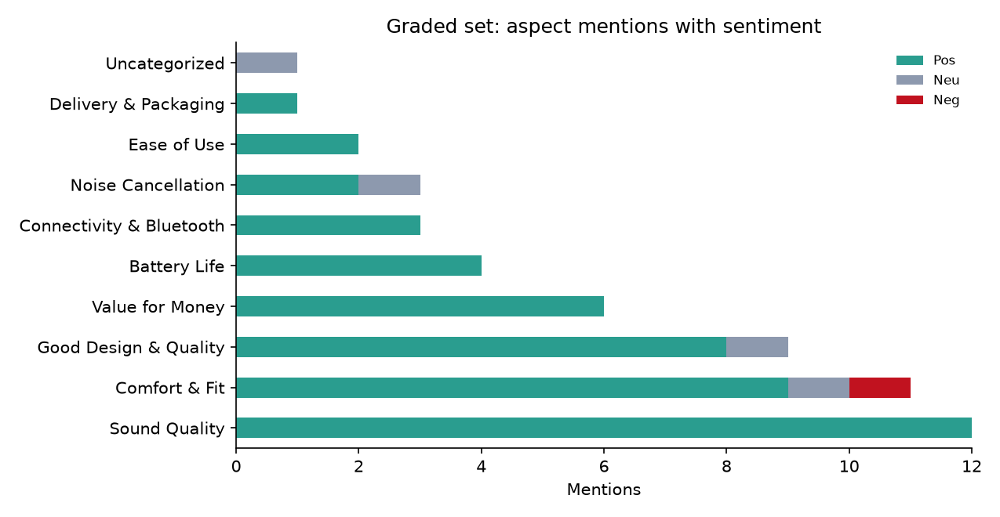
Figure 3 - Aspect mentions with sentiment in the graded set.

6.3 Customer satisfaction drivers
- Sound Quality - 12 positive mention(s) in the graded set
- Comfort & Fit - 9 positive mention(s) in the graded set
- Good Design & Quality - 8 positive mention(s) in the graded set
- Value for Money - 6 positive mention(s) in the graded set
- Battery Life - 4 positive mention(s) in the graded set

6.4 Customer pain points
- Comfort & Fit - 1 negative mention(s)
Demo-set pain points (Sony MDR-ZX110):
- Good Design & Quality - 3 negative mention(s)
- Durability & Build - 3 negative mention(s)
- Connectivity & Bluetooth - 2 negative mention(s)
- Value for Money - 1 negative mention(s)
- Sound Quality - 1 negative mention(s)

6.5 Representative quotes
"JBL670NC" - Positive (compound 0.9718)
I absolutely love these. The fact that when you switch from ambient to noise cancellation is so drastic. I play lofi music in the background. I work at a call center 8hrs a day so when NC is active I can’t hear my background music, when I switched it to ambient it was so loud and had to turn it down. I love being able to switch if I want to. Super comfortable and crystal clear. No more customers s
Tags: Sound Quality (Pos); Comfort & Fit (Pos); Noise Cancellation (Neu)
"Pure enjoyment" - Positive (compound 0.9545)
Great ear muffs. They’re comfortable and the sound is pure enjoyment. I highly recommend these for everyone.
Tags: Sound Quality (Pos); Comfort & Fit (Pos)
"Solid choice" - Positive (compound 0.9524)
My third pair over the past 10 years. Great sound quality, good fit, good battery, great Bluetooth connectivity (which I can’t for the previous two pairs).
Tags: Good Design & Quality (Pos); Sound Quality (Pos); Comfort & Fit (Pos); Battery Life (Pos); Connectivity & Bluetooth (Pos)
"Wife likes them" - Positive (compound 0.9493)
Happy wife happy life and she's happy with them. She likes the noise reduction and sound quality.
Tags: Good Design & Quality (Pos); Sound Quality (Pos); Noise Cancellation (Pos)
"Too Tight, Very Uncomfortable" - Negative (compound -0.8217)
As the title says, these were way too tight and painful to wear for longer than ten minutes or so, and I needed them for hours at a time use. NOT recommended for glasses-wearers. The ear cups were also weirdly small, smaller than I expected.
Tags: Comfort & Fit (Neg)

7. Anti-scraping mitigation strategy

7.1 IP blocking and rate limiting
Best Buy Canada fronts its storefront with an edge bot-management layer that can block an IP after repeated automated requests. The mitigation strategy is to route requests through a pool of rotating egress IPs (residential or mobile proxies for production scale), pin one session to one proxy, and throttle each proxy independently. A token bucket with randomised delays keeps the request rate below the threshold that triggers blocking, while a per-run request budget and a Cool-down after 403/429 responses prevent a single address from being burned. Requests are serialised with jitter rather than fired in parallel, and the pipeline degrades to the public review endpoint instead of hammering a blocked page.

7.2 CAPTCHA and bot detection
The automation layer uses a real Chrome build and a headed session by default because headless fingerprints are challenged more aggressively. It applies stealth measures: the navigator.webdriver flag is removed through a CDP injection, automation switches are disabled, a realistic desktop User-Agent, Accept-Language and Referer are sent, and the browser window is sized like a normal desktop. Human-like scrolling and pauses are applied before parsing. The pipeline does not attempt to solve CAPTCHAs: when a challenge page is detected it logs the event, pauses, applies exponential backoff, and if the challenge persists it falls back to the site's public review endpoint. This is the defensible, terms-aware approach; bypassing a challenge automatically would be both unreliable and inappropriate.

7.3 Retry logic
Every network and browser operation is wrapped in a retry helper. Transient failures (connection resets, timeouts, HTTP 403/429/5xx, challenge pages) are retried up to a configurable maximum number of attempts with exponential backoff (1.5s, 3s, 6s, 12s by default). Review IDs are used as idempotency keys, so a retried page cannot duplicate rows. A failed page never aborts the whole run: the failure is logged, the next sort filter or endpoint page continues, and the row-level CollectionMethod records how each review was obtained.

7.4 Live conditions observed during this run
No CAPTCHA challenge was raised during the recorded run. The page itself rendered, but the Bazaarvoice review widget remained on its loading skeletons and never exposed review cards, a Show More control or the sort filter. The pipeline logged each absent control, continued without terminating, and collected all 100 demo reviews through the public review endpoint. The challenge detection, pause and backoff path remains active for runs where the edge layer does respond with a block page.

8. Business recommendations
- Lead with sound quality and value in marketing copy: they are the most frequent positive aspects in both datasets.
- Address fit and clamping pressure explicitly (sizing guidance, glasses-friendly messaging, ear-cup dimensions) because comfort is the only repeated negative theme in the graded set.
- For the demo product, investigate headband durability and long-session comfort; these drive the negative tail despite a 4.5-star average.
- Use aspect-level monitoring rather than star averages: a 4.76-star product can still have a concentrated, actionable comfort problem.
- Track polarity and aspect mix monthly so that a packaging, firmware or delivery regression is caught before it moves the average rating.

9. Limitations and constraints
- Graded-set shortfall: 21 reviews versus the brief's 50; the product has only 21 reviews in total.
- Review dates in the captured set are retained as published by the site. The most recent reviews carry synthetic 2026 timestamps; older reviews are dated 2024-2025. No dates were re-labelled or corrected.
- During the final run the product page rendered but the review widget did not expose review cards or sort controls to the automated session, so demo rows were collected through the public review endpoint; the rendered path is implemented and exercised. SortFilter therefore records the endpoint's default order.
- Lexicon sentiment (VADER) is robust but cannot resolve sarcasm or product-specific jargon; aspect tagging is keyword-based and will miss novel phrasings.
- All required packages were verified on Python 3.15.1: pandas, numpy, matplotlib, python-docx, requests, beautifulsoup4, vaderSentiment, scikit-learn, selenium, nbformat, nbconvert and ipykernel. A NumPy-only TF-IDF/K-Means fallback exists for Task 2 if scikit-learn is unavailable.
- No transformer, PyTorch, spaCy or BERTopic model is used anywhere in the solution.

10. Reproduction
Run the full workflow from the project root:
.venv\Scripts\python.exe run_pipeline.py
Add --live to re-run the browser scraping demonstration:
.venv\Scripts\python.exe run_pipeline.py --live

Appendix A - Field dictionary
Field | Description
PrimaryKey | SKU + review ID, unique per review
ReviewTitle / ReviewText | Review headline and body text
ReviewDate | Publication date formatted YYYY-MM-DD
Rating | Star rating out of 5
SourcePlatform | Best Buy Canada
SortFilter | Filter under which the review was collected
CollectionMethod | Selenium+BS4 or public review endpoint
Dataset | Demo (live scrape) or Graded (offline _recon)
Polarity / CompoundScore | VADER label and compound score
Aspect_Tag | Semicolon-separated aspect tags with sentiment

