Automotive Warranty Complaint Analysis
Task 2 - Exploratory Data Analysis, Text Mining and Root-Cause Analysis
1000 service records, four issue families and five complaint clusters

Prepared for: HanuAi ML Assessment
Date: 2026-10-26
Environment: Python 3.15.1 virtual environment (.venv)

1. Executive summary
The dataset contains 1000 warranty complaints across 4 makes, 23 models and 8 build plants, opened between 2019-08-27 and 2021-06-01. Free-text mining found the radio/display assembly at the centre of almost every complaint (Radio is mentioned in 985 records), with 'Inoperative' the most frequent symptom (257 records). The largest primary issue family is Electrical Issue (552 records, 55%).
Five TF-IDF clusters separate distinct failure narratives: blank/black screen display failures, SPS/USB programming failures, missing SD-card and navigation faults, XM/satellite radio replacement, and camera/wiring communication faults. The clustering and the category trends point to a small number of recurring root causes rather than random component noise, which makes targeted engineering and supplier action feasible.

2. Dataset and deliverables
Deliverable | Path | Status
Annotated notebook | notebooks/Task2_EDA_TextMining_and_RootCause.ipynb | Produced and executed
Tagged dataset | outputs/task2_tagged_complaints.csv | 1000 rows
Cluster summary | outputs/task2_cluster_summary.csv | 5 clusters
Written report | Task2_Stakeholder_Report.docx | This document

Dataset attribute | Value
Rows x columns | 1000 x 20
Duplicate rows | 0
Model year | 2020
Opened-date range | 2019-08-27 to 2021-06-01
Makes | NovaSprint, NebulaCruiser, ThunderVolt, TurboFlux

3. Data quality and EDA

3.1 Column profile
Every column was profiled for data type, non-null fraction, cardinality and analysis role. The three VERBATIM columns are treated as text, never as numeric or categorical. Six structured list columns are 99.5% empty (non-null fraction 0.005) and are therefore reported but excluded from frequency plots, as required.
Column | Role | NonNull | Missing | NonNullFraction | Unique | Sparse
Event id | identifier | 1000 | 0 | 1.0 | 1000 | False
Opened date | date | 1000 | 0 | 1.0 | 397 | False
CAUSAL_VERBATIM | text | 999 | 1 | 0.999 | 944 | False
CORRECTION_VERBATIM | text | 1000 | 0 | 1.0 | 952 | False
CUSTOMER_VERBATIM | text | 1000 | 0 | 1.0 | 990 | False
BUILD_DATE | date | 1000 | 0 | 1.0 | 37 | False
BUILD_PLANT_DESC | categorical | 1000 | 0 | 1.0 | 8 | False
CAUSAL_CD_DESC | categorical | 997 | 3 | 0.997 | 38 | False
COMPLAINT_CD_DESC | categorical | 1000 | 0 | 1.0 | 9 | False
IN_USE_DATE | date | 999 | 1 | 0.999 | 285 | False
MAKE | categorical | 1000 | 0 | 1.0 | 4 | False
MODEL | categorical | 1000 | 0 | 1.0 | 23 | False
MODLYR | numeric | 1000 | 0 | 1.0 | 1 | False
PLANT | categorical | 1000 | 0 | 1.0 | 8 | False
Trigger | list | 5 | 995 | 0.005 | 2 | True
Failure Component | list | 5 | 995 | 0.005 | 5 | True
Failure Condition | list | 5 | 995 | 0.005 | 5 | True
Additional Context | list | 5 | 995 | 0.005 | 2 | True
Fix Component | list | 5 | 995 | 0.005 | 3 | True
Fix Condition | list | 5 | 995 | 0.005 | 2 | True

3.2 Missing values, duplicates and cleaning
Column | Missing | NonNullFraction
CAUSAL_VERBATIM | 1 | 0.999
CAUSAL_CD_DESC | 3 | 0.997
IN_USE_DATE | 1 | 0.999
Trigger | 995 | 0.0050000000000000044
Failure Component | 995 | 0.0050000000000000044
Failure Condition | 995 | 0.0050000000000000044
Additional Context | 995 | 0.0050000000000000044
Fix Component | 995 | 0.0050000000000000044
Fix Condition | 995 | 0.0050000000000000044

- Duplicate rows: 0. Event id is unique across all 1000 records.
- CAUSAL_CD_DESC is imputed as 'Unknown' (3 records); CAUSAL_VERBATIM and IN_USE_DATE keep an explicit missingness flag.
- Date strings are parsed to datetime; the raw strings remain available. One IN_USE_DATE is missing and is left as NaT rather than fabricated.
- List-like trigger/failure/fix columns are parsed from their Python-literal representation; when populated they are analysed as multi-valued fields.
- Derived features: days from build to complaint, days from in-use date to complaint, verbatim character and word counts.
- Verbatim text is never whitespace-collapsed before redaction detection, because the redacted numeric codes are literal runs of spaces.

3.3 Numeric summary
Feature | Count | Mean | Median | Std | Min | Max
MODLYR | 1000 | 2020.0 | 2020.0 | 0.0 | 2020.0 | 2020.0
DaysBuildToOpen | 1000 | 338.52 | 327.0 | 162.33 | 7.0 | 665.0
DaysInUseToOpen | 999 | 217.19 | 202.0 | 177.34 | -354.0 | 615.0
VerbatimCharLength | 1000 | 422.29 | 338.5 | 304.29 | 53.0 | 2339.0
VerbatimWordCount | 1000 | 68.28 | 56.0 | 48.97 | 9.0 | 363.0

Complaints are raised a median of 327 days after build and 202 days after the in-use date. 76 records report a complaint date before the recorded in-use date, which is retained as a data-quality flag rather than silently corrected.

3.4 Frequency distributions
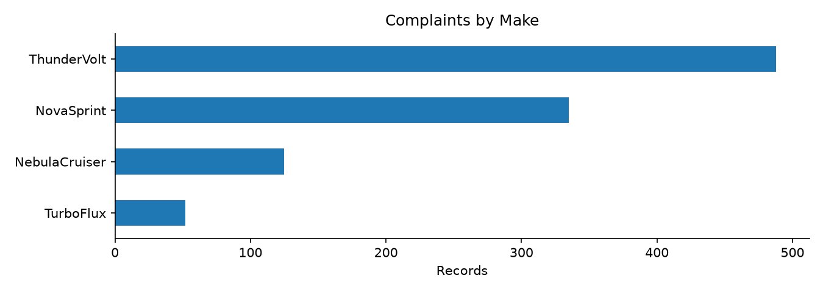
Figure 1 - Complaint volume by make.
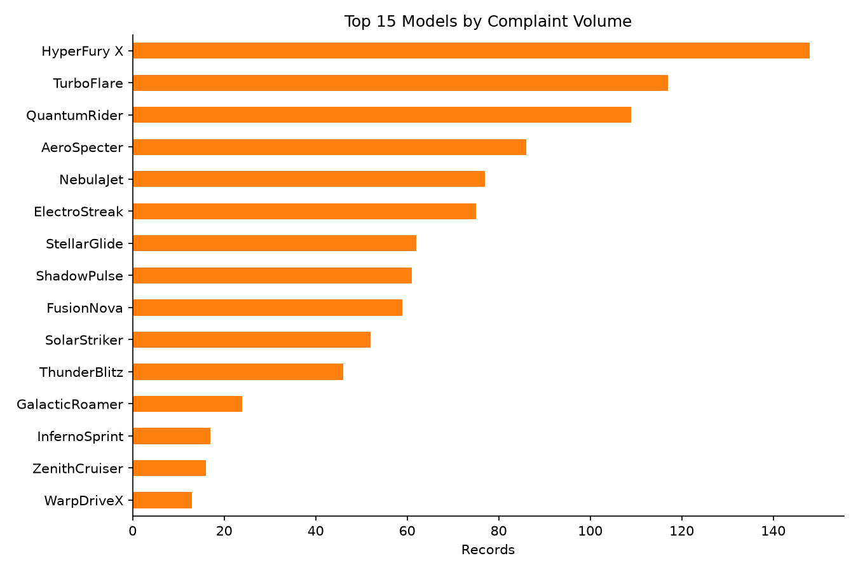
Figure 2 - Top 15 models by complaint volume.
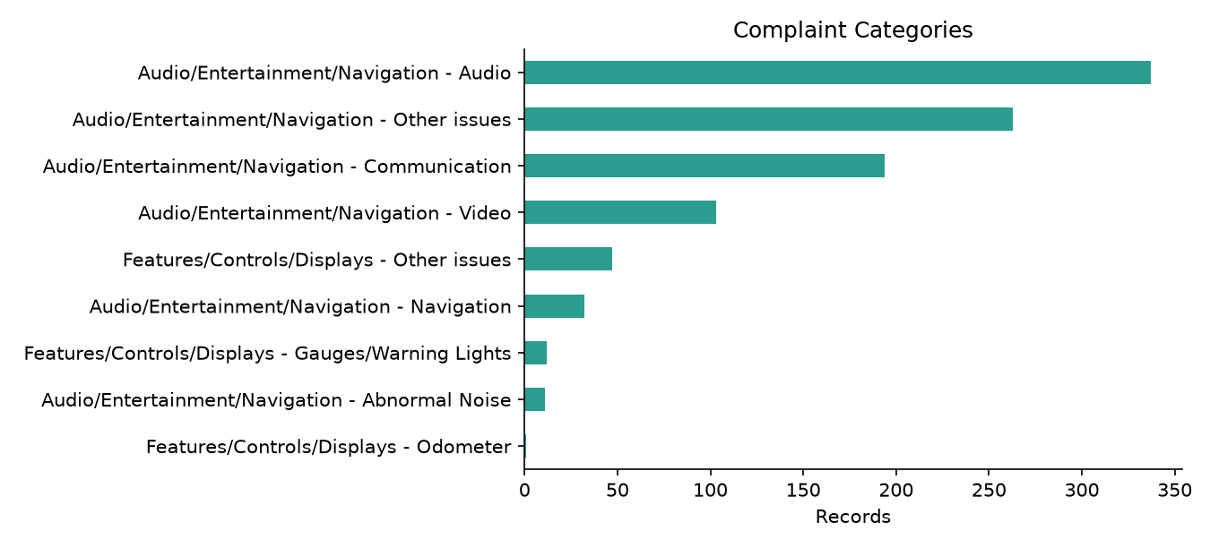
Figure 3 - Complaint categories.
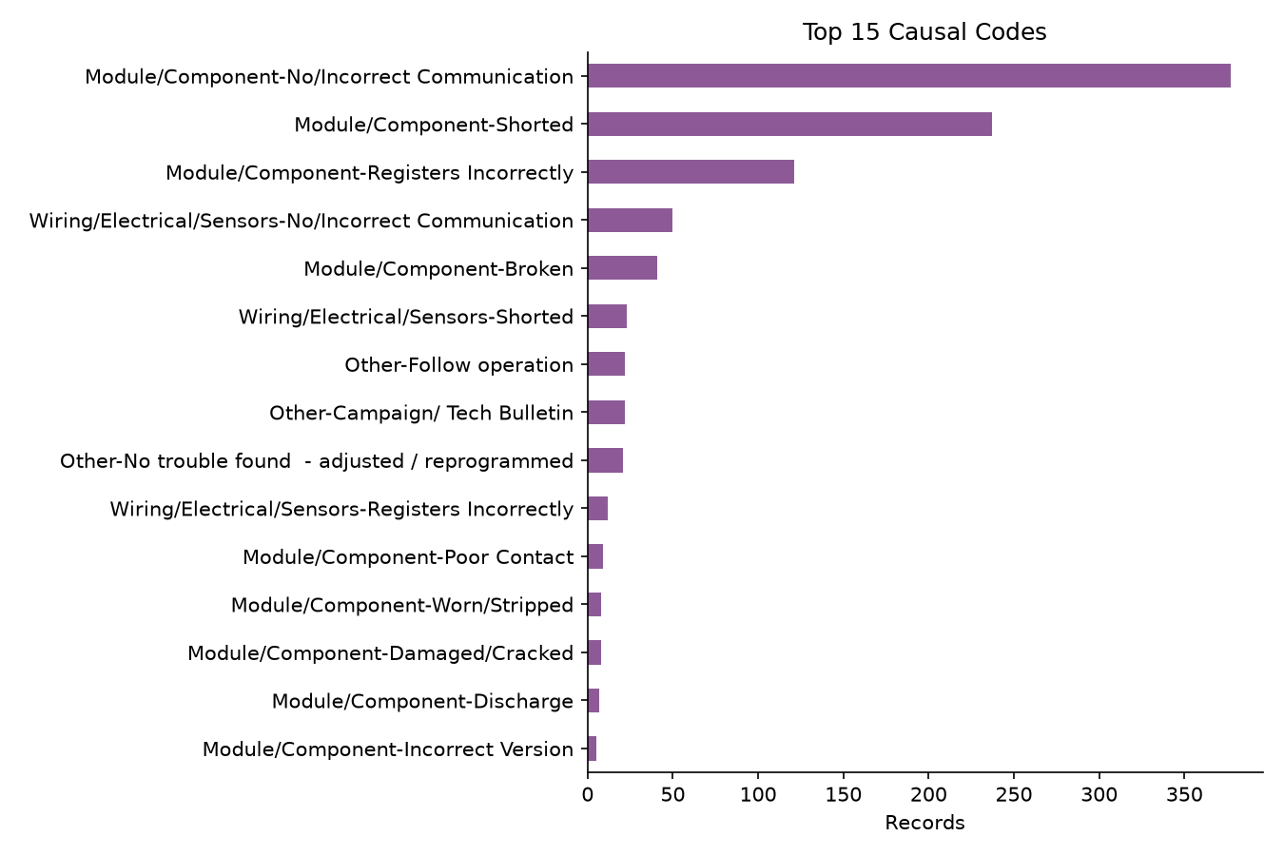
Figure 4 - Top causal codes.
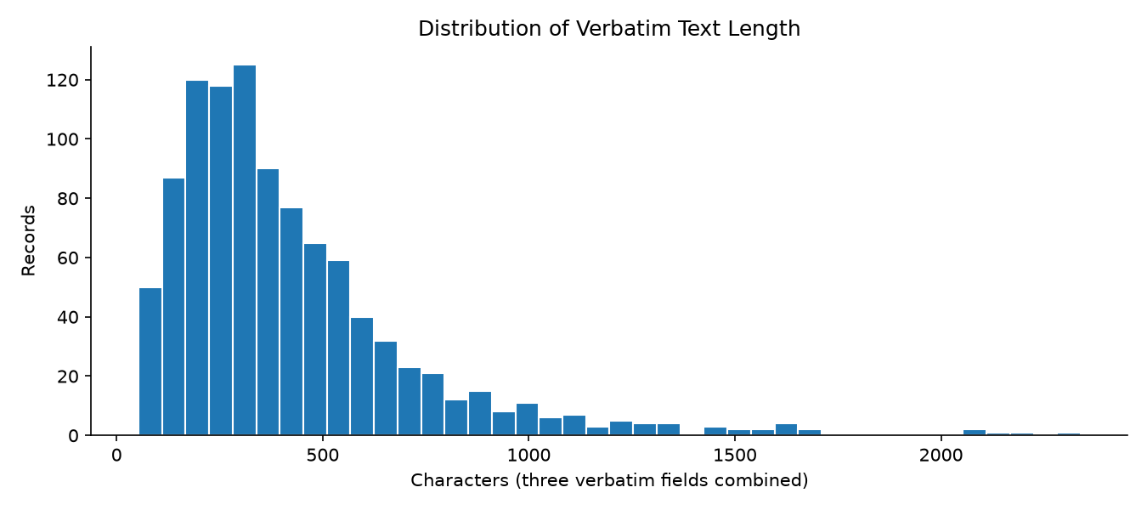
Figure 5 - Verbatim text length distribution.

4. Text mining and entity tagging

4.1 Methodology
- The three VERBATIM fields are concatenated and Unicode-normalised (NFKC, thin/non-breaking spaces folded, curly quotes folded).
- Spanish terms are normalised to English before matching (pantalla -> display, falla -> failure, bateria -> battery, modulo -> module, no funciona -> inoperative, and similar).
- A Spanish-language signal was detected in 4 records, confirming the need for bilingual dictionaries.
- Regex keyword dictionaries extract components (radio, display, amplifier, radio module, wiring, camera, USB/SD, and others), symptoms and error codes.
- Redacted numeric codes are detected as runs of two or more whitespace characters following a code token (for example 'SPS error code '). The surrounding context is preserved and the record is flagged.
- Issue categories are scored from keyword evidence plus the structured CAUSAL_CD_DESC label. The strongest category becomes primary and other supported categories are attached, so a record can carry more than one category.
256 records contain at least one redacted code (26%) and 509 records carry more than one issue category. The tagged dataset exports the original columns plus Components, Symptoms, ErrorCodes, RedactedCodeFlag, RedactedCodeContexts, SpanishFlag, IssueCategories and IssueCategory.

4.2 Issue categories
Issue category | Records tagged | Share | Primary records
Component Failure | 306 | 30.6% | 153
Electrical Issue | 764 | 76.4% | 552
Software Glitch | 505 | 50.5% | 287
Assembly Quality | 40 | 4.0% | 8

4.3 Top entities
name | count
Radio | 985
Display | 469
USB / SD | 329
Wiring | 189
Camera | 141
Radio Module | 104
Navigation | 69
Bluetooth | 41
OnStar | 40
Antenna | 40
Battery | 37
Amplifier | 32

name | count
Inoperative | 257
Intermittent | 121
Reset / Reboot | 114
No Sound | 100
Communication Loss | 94
Black / Blank Screen | 69
Frozen / Unresponsive | 48
Short Circuit | 44
Error Message | 35
Programming Failure | 7
Noise / Distortion | 5
Battery Drain | 5

name | count
SPS | 188
DTC | 100
OTA | 5

The error-code vocabulary is dominated by protocol-level tokens (DTC, SPS, OTA) because the actual numeric codes were redacted in the source data. The redaction flags and context snippets preserve the evidentiary value of those mentions.
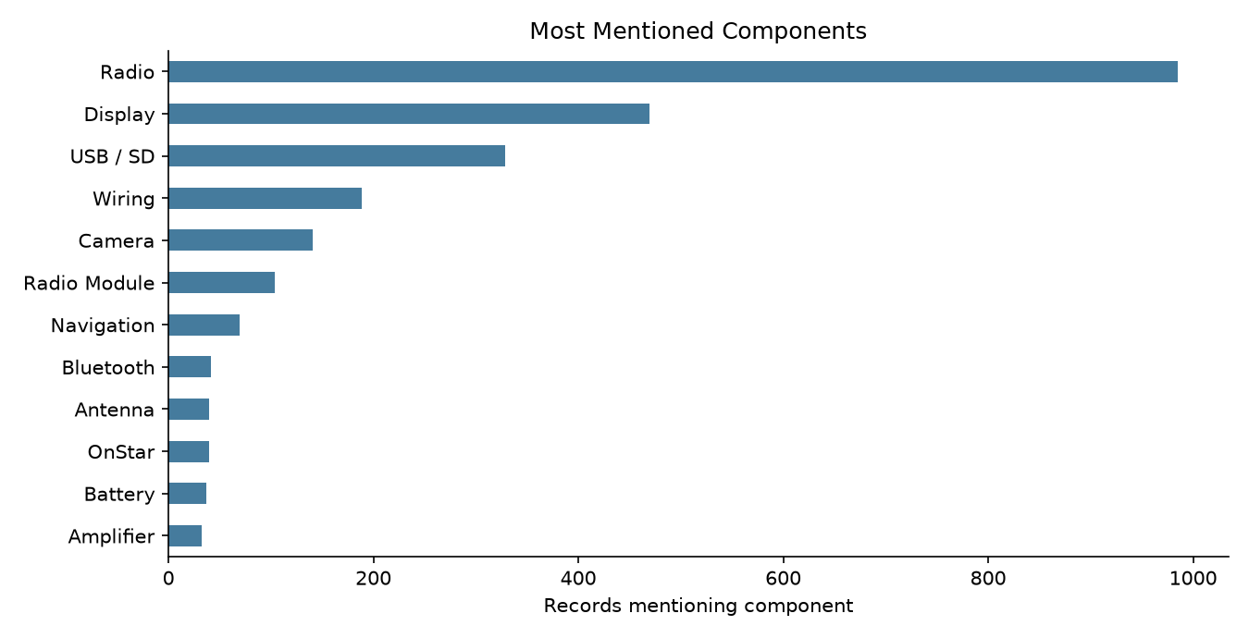
Figure 6 - Most mentioned components.
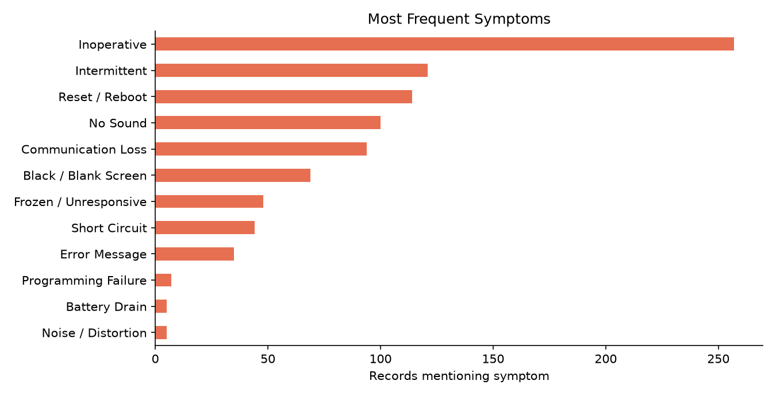
Figure 7 - Most frequent symptoms.

5. Clustering
Complaints were vectorised with TF-IDF (1-2 grams, sublinear TF, English stop words) and clustered with K-Means (K=5, fixed random seed 42). The implementation used the scikit-learn backend with inertia 908.8. Top distinguishing terms per cluster are shown below; they are the terms with the largest centroid weights.
Cluster | Size | Share | DominantIssueCategory | TopModel | TopTerms
0 | 167 | 0.167 | Electrical Issue | QuantumRider | radio, screen, radio screen, blank, goes, display, customer, screen goes, states...
1 | 314 | 0.314 | Software Glitch | HyperFury X | radio, usb, update, tac, vehicle, program, customer, code, codes, sps, case, per...
2 | 66 | 0.066 | Component Failure | NebulaJet | card, sd, sd card, radio, error, navigation, replace, scan, scan codes, replace ...
3 | 233 | 0.233 | Electrical Issue | TurboFlare | radio, xm, replaced, customer, states, programmed, customer states, internal, re...
4 | 220 | 0.22 | Electrical Issue | HyperFury X | radio, camera, module, code, communication, replaced, tested, ok, inop, screen, ...

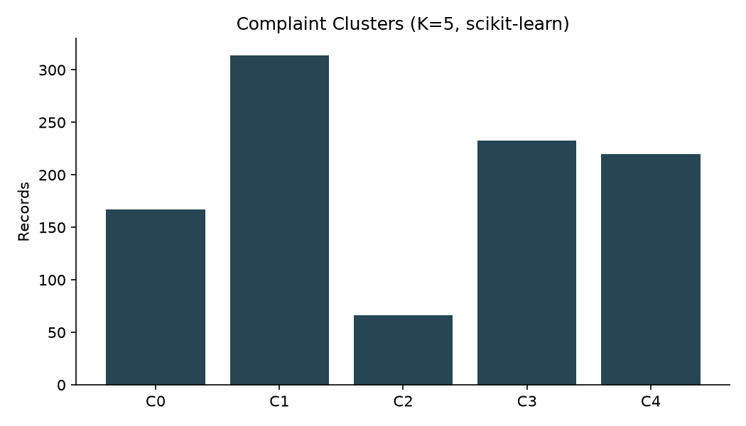
Figure 8 - Complaint cluster sizes.
Empty clusters are explicitly reinitialised: if no record is assigned to a centroid, the farthest point from its current centroid seeds that cluster and the iteration continues. The fallback assembles TF-IDF and K-Means from NumPy alone, so the analysis still runs if scikit-learn is unavailable on Python 3.15.

6. Root-cause analysis and trends

6.1 Cluster interpretation
Cluster | Size | Likely root cause | Top terms | Interpretation
C0 | 167 | Component Failure | radio, screen, radio screen, blank, goes, display | Hardware failure: the radio, screen, radio screen, blank, goes component fails internally and is resolved by replacement.
C1 | 314 | Software Glitch | radio, usb, update, tac, vehicle, program | Software/programming fault: repeated SPS/USB update attempts around radio, usb, update, tac, vehicle point to corrupted or unavailable calibration files.
C2 | 66 | Component Failure | card, sd, sd card, radio, error, navigation | Hardware failure: the card, sd, sd card, radio, error component fails internally and is resolved by replacement.
C3 | 233 | Software Glitch | radio, xm, replaced, customer, states, programmed | Software/programming fault: repeated SPS/USB update attempts around radio, xm, replaced, customer, states point to corrupted or unavailable calibration files.
C4 | 220 | Component Failure | radio, camera, module, code, communication, replaced | Hardware failure: the radio, camera, module, code, communication component fails internally and is resolved by replacement.

6.2 Temporal trends
The single busiest month is 2020-02 with 69 complaints. Complaint volume ramps up through late 2019 and peaks in early-to-mid 2020 before declining, consistent with a build population entering service and a subsequent field-fix campaign. Electrical and software complaints track each other closely, which supports a shared communication-bus root cause rather than independent defects.
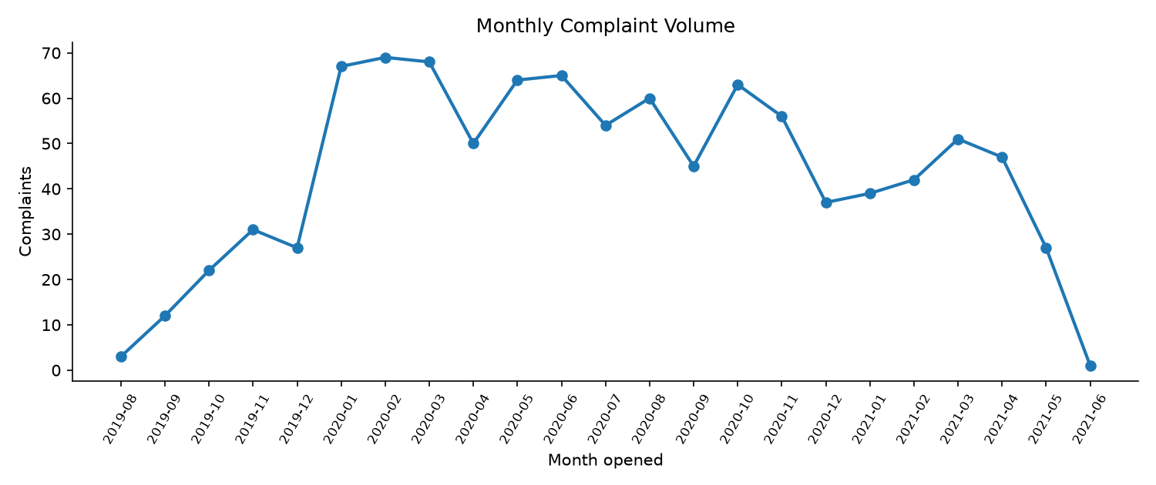
Figure 9 - Monthly complaint volume.
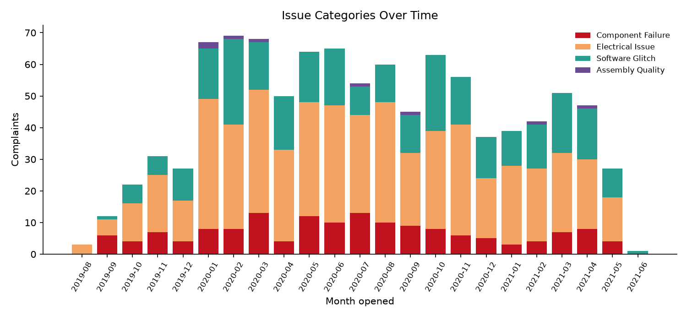
Figure 10 - Issue categories over time.

6.3 Category-wise trends
MODEL | Component Failure | Electrical Issue | Software Glitch | Assembly Quality | Total
HyperFury X | 16 | 90 | 39 | 3 | 148
TurboFlare | 15 | 59 | 43 | 0 | 117
QuantumRider | 11 | 62 | 35 | 1 | 109
AeroSpecter | 20 | 49 | 17 | 0 | 86
NebulaJet | 11 | 38 | 27 | 1 | 77
ElectroStreak | 14 | 38 | 23 | 0 | 75
StellarGlide | 9 | 28 | 23 | 2 | 62
ShadowPulse | 9 | 35 | 16 | 1 | 61
FusionNova | 17 | 31 | 11 | 0 | 59
SolarStriker | 13 | 29 | 10 | 0 | 52

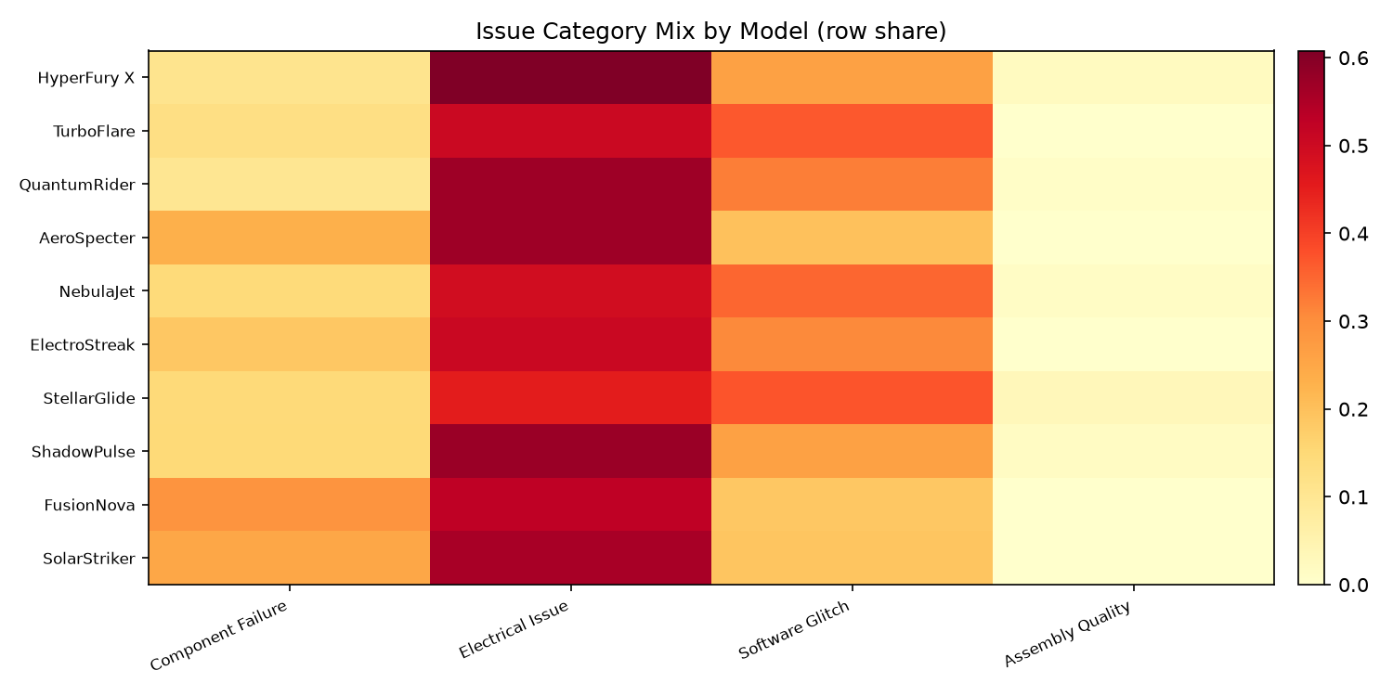
Figure 11 - Issue category mix by model.
The same four issue families recur across every model, and the electrical/software dominance is consistent from model to model. That pattern is itself a finding: the defect is platform-wide, not confined to a single model or plant. The dominant complaint categories are audio, other audio/entertainment issues and audio communication, all of which route through the same radio/display module.

7. Findings synthesis
- The radio/display assembly is the common failure point: it appears in almost every record and in every cluster.
- Most failures present as blank/black screens or complete inoperability, often intermittently, which complicates diagnosis and drives repeat visits.
- Software/programming failures (SPS, USB updates, OTA) are a distinct cluster and frequently co-occur with electrical communication faults.
- Redacted numeric codes in 26% of records limit exact fault isolation; flagging and contextual snippets preserve what can be recovered.
- The issue mix is stable across models and plants, pointing to a shared platform design or supplier problem.

8. Business impact
- Warranty cost: repeat radio/display replacements and reprogramming attempts are the highest-volume cost driver in the dataset.
- Customer experience: blank screens and no-sound conditions affect safety-adjacent functions (reverse camera, warnings) and generate repeat dealer visits.
- Supplier quality: a platform-wide pattern justifies a supplier-level corrective action rather than dealer-by-dealer repair.
- Engineering priority: stabilise the communication bus and programming pipeline before chasing low-frequency component defects.

9. Technical learnings and future improvements
- Keyword dictionaries plus Spanish normalisation extract useful structure without any external NLP model, and remain fully interpretable.
- TF-IDF/K-Means cleanly separates failure narratives even on short, noisy, bilingual free text.
- Redaction-aware mining is essential: collapsing whitespace early would have destroyed the only evidence of the removed codes.
- Future work: a supervised classifier trained on dealer repair codes, entity-level linking to parts catalogues, and drift monitoring by build month.
- Future work: include dealer labour time and parts cost to convert complaint volume into a warranty-cost estimate.

10. Limitations
- The dataset is a single model year (2020) and a single platform, so the findings may not generalise to other vehicle lines.
- Numeric error codes are redacted in the source; code-level root cause cannot be established beyond token and context evidence.
- Keyword matching can miss novel phrasing and can over-attribute generic maintenance language (for example battery disconnects) to electrical faults.
- K-Means with K=5 was chosen for interpretability; silhouette-based selection and hierarchical clustering are natural extensions.
- All processing is deterministic and offline; no external NLP service, transformer or pretrained embedding is used.

11. Reproduction
Run the full workflow from the project root:
.venv\Scripts\python.exe run_pipeline.py
The pipeline writes the tagged dataset, column profile, cluster summary, figures and this report.

