MASTER'S DEGREE PROJECT REPORT
DESIGN AND IMPLEMENTATION OF A CLOUD-BASED HEALTHCARE DATA PLATFORM MODERNIZATION
SQL Server to Databricks using Lakebridge, PySpark, Unity Catalog and Argo CronWorkflow

Academic Demonstration Project using Synthetic Data
Prepared as a technical portfolio / Master's-level project document

Author: ______________________________
Program / University: ______________________________
Academic Year: 2026

Declaration
I declare that this academic project document presents an independently reproducible demonstration of a healthcare data-platform modernization architecture using synthetic data. The implementation is designed to demonstrate data-engineering principles including SQL migration, distributed processing, data validation, governance, workflow orchestration, version control, and cloud-based delivery.
No confidential client source code, production data, credentials, private URLs, or internal configuration is required for the implementation described in this report.

Abstract
Healthcare organizations generate large volumes of structured data that must be processed reliably for analytics, reporting, operational workflows, and downstream data consumers. Legacy SQL Server environments can become difficult to scale and maintain when workloads depend on tightly coupled database logic and traditional scheduling platforms. This project presents a practical modernization architecture that migrates representative SQL Server workloads to Databricks using synthetic healthcare data.
The proposed implementation demonstrates an end-to-end migration lifecycle: analysis of legacy SQL logic, automated conversion using a migration accelerator, manual remediation of platform-specific constructs, implementation in Databricks SQL and PySpark, organization of target data through Unity Catalog, source-to-target reconciliation, and modernization of scheduled processing using Argo CronWorkflow. Git is used for version control and controlled deployment practices.
The project emphasizes that successful migration is not merely a syntax-conversion exercise. Functional equivalence, data quality, governance, orchestration, operational reliability, and environment consistency must also be established. The resulting architecture demonstrates a repeatable pattern for modernizing legacy data-processing workloads while maintaining traceability and validation.
Keywords: Databricks, SQL Server, SSMS, PySpark, Apache Spark, Lakebridge, Unity Catalog, Argo Workflows, CronWorkflow, ETL, data migration, data validation, reconciliation, healthcare analytics, Git.

Table of Contents
1. Introduction
2. Problem Statement
3. Aim and Objectives
4. Scope and Assumptions
5. Background and Technology Review
6. Proposed Architecture
7. Synthetic Healthcare Dataset Design
8. Migration Methodology
9. SQL Server to Databricks Implementation
10. PIVOT and Advanced SQL Transformations
11. PySpark Data Engineering Implementation
12. Unity Catalog and Data Governance
13. Data Validation and Reconciliation
14. Workflow Orchestration with Argo CronWorkflow
15. File Generation and S3/SFTP Delivery
16. Git and Deployment Strategy
17. Error Handling and Troubleshooting
18. Security and Confidentiality
19. Testing Strategy
20. Results and Expected Outcomes
21. Limitations
22. Future Enhancements
23. Conclusion
24. Interview / Viva Preparation
25. References and Appendix

1. Introduction
Data-platform modernization is the process of improving an existing data environment by moving from legacy technologies, tightly coupled processing models, or operationally difficult architectures to scalable and maintainable platforms. In healthcare, modernization is particularly important because analytical workloads can combine high data volume, complex business rules, sensitive information, frequent data refreshes, and multiple downstream consumers.
This project models the modernization of a legacy SQL Server environment into Databricks. The source platform contains representative healthcare claims and provider data, SQL views, transformations, and scheduled processing. The target platform uses Databricks SQL and PySpark for processing, Unity Catalog for governance, Argo CronWorkflow for scheduling, and Git for source control.
The project is intentionally implemented with synthetic data so that the technical architecture can be demonstrated publicly without exposing confidential information.

2. Problem Statement
A legacy SQL Server environment can contain complex views, stored procedures, joins, aggregations, PIVOT operations, database-specific functions, temporary objects, and scheduled file-processing jobs. Migrating these workloads to a cloud analytics platform introduces compatibility and data-quality challenges.
- SQL Server-specific syntax may not have a direct target-platform equivalent.
- Database/schema/table naming must be mapped to the target catalog structure.
- Different data types and implicit-conversion behavior can produce subtle differences.
- JOIN cardinality can change row counts after conversion.
- PIVOT and aggregation logic can produce different results if input grain is not preserved.
- Legacy schedulers must be translated into cloud-native workflow definitions.
- File-generation and transfer steps must be made reliable and environment-aware.
- A migration can execute successfully while still producing incorrect business results.
Therefore, the project treats migration as an engineering lifecycle rather than a one-time code conversion.

3. Aim and Objectives
The primary aim is to design and demonstrate a repeatable architecture for migrating a representative healthcare data workload from SQL Server to Databricks while preserving data quality and operational behavior.
- Design a synthetic healthcare dataset suitable for ETL and analytical processing.
- Implement representative SQL Server views and transformations.
- Demonstrate automated SQL conversion using a migration accelerator concept.
- Perform manual remediation of incompatible SQL constructs.
- Implement target transformations using Databricks SQL and PySpark.
- Organize target objects using Unity Catalog conventions.
- Implement systematic source-to-target validation and reconciliation.
- Modernize scheduled processing using Argo CronWorkflow YAML.
- Demonstrate file generation, archival, and downstream delivery patterns.
- Use Git for version control and controlled promotion of changes.
- Evaluate the architecture using functional, data-quality, and operational criteria.

4. Scope and Assumptions
The project is a Masters-level academic demonstration. It is not intended to reproduce a real client production environment exactly.
Included | Excluded
Synthetic patient/claim/provider data | Real patient or client data
Representative SQL Server logic | Proprietary production SQL
Databricks SQL and PySpark | Client-specific infrastructure
Unity Catalog object model | Private production permissions
Argo CronWorkflow design | Production Kubernetes administration
Git workflow | Private repositories or credentials
S3/SFTP delivery pattern | Real production endpoints

5. Background and Technology Review

5.1 SQL Server and SSMS
SQL Server is a relational database management system. SSMS is a client application used to query and administer SQL Server. In this project, SQL Server represents the legacy data-processing environment and SSMS represents the development/administration interface.

5.2 Databricks
Databricks provides a unified environment for data engineering, SQL analytics, distributed Spark processing, notebooks, workflows, and governed data access. It serves as the target processing platform in this project.

5.3 Apache Spark and PySpark
Apache Spark is a distributed processing engine. PySpark provides Python APIs for DataFrame and Spark SQL operations, allowing large datasets to be transformed in parallel across a cluster.

5.4 Unity Catalog
Unity Catalog provides centralized data governance and namespace management. The project uses the three-level naming pattern catalog.schema.object.

5.5 Lakebridge
Lakebridge is treated in this project as a migration accelerator for translating legacy SQL workloads. Automated output is reviewed and remediated because conversion tooling cannot guarantee business equivalence for every platform-specific construct.

5.6 Argo Workflows and CronWorkflow
Argo Workflows provides Kubernetes-native workflow orchestration. CronWorkflow adds recurring schedule semantics to workflow definitions.

5.7 Git
Git provides source control, branch isolation, change history, collaboration, review, and controlled integration of code and configuration.

6. Proposed Architecture
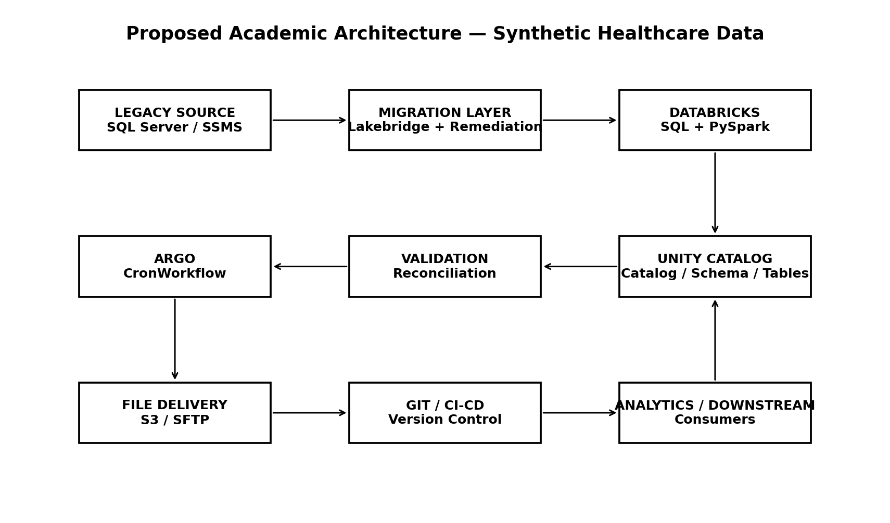
Figure 1. Proposed architecture for the synthetic healthcare data modernization project.
The architecture separates source analysis, migration, processing, governance, validation, orchestration, and delivery. This separation makes failures easier to isolate and supports controlled migration.

6.1 Architectural Flow
- Synthetic source data is created in a SQL Server-compatible relational model.
- Legacy views and transformation queries represent the source workload.
- Lakebridge-style migration produces an initial Databricks-compatible SQL representation.
- Manual remediation addresses incompatible functions, object references, data types, temporary constructs, and business rules.
- Databricks SQL and PySpark implement the target transformations.
- Unity Catalog provides target object naming and governance.
- Validation jobs compare source and target metrics.
- Argo CronWorkflow schedules processing and downstream delivery.
- Git maintains versioned code and configuration.
- Output files are generated and delivered through a synthetic S3/SFTP pattern.

7. Synthetic Healthcare Dataset Design
The dataset represents healthcare claims processing without containing real personally identifiable information. Identifiers are synthetic and are used only to demonstrate data engineering transformations.
Table | Important Columns | Purpose
patients | patient_id, birth_year, gender, state | Synthetic patient dimension
providers | provider_id, provider_name, specialty | Provider reference data
claims | claim_id, patient_id, provider_id, service_date, status, amount | Core transaction table
claim_metrics | claim_id, metric, value | Demonstrates PIVOT/conditional aggregation
A representative relationship is: one patient can have many claims, and one provider can service many claims. The project intentionally includes controlled duplicate and NULL scenarios in test data so that validation logic can be demonstrated.

7.1 Example Synthetic Records
patient_id | provider_id | claim_id | service_date | status | amount
P10001 | PR001 | C90001 | 2026-01-05 | PAID | 1250.00
P10002 | PR002 | C90002 | 2026-01-06 | DENIED | 820.00
P10003 | PR001 | C90003 | 2026-01-07 | PAID | 5400.00
P10004 | PR003 | C90004 | 2026-01-09 | PENDING | 2100.00

8. Migration Methodology
The methodology follows a controlled migration lifecycle.
Phase | Activity | Output
Discovery | Review source objects and dependencies | Migration inventory
Conversion | Accelerated SQL translation | Initial target SQL
Remediation | Fix incompatible constructs | Target-compatible logic
Implementation | Deploy SQL/PySpark | Databricks objects
Validation | Compare source and target | Reconciliation report
Orchestration | Configure scheduled workflows | Argo CronWorkflow
Testing | Functional and operational checks | Test evidence
Deployment | Version-controlled promotion | Release candidate
Monitoring | Observe execution and outputs | Operational status

9. SQL Server to Databricks Implementation

9.1 Legacy View
CREATE VIEW dbo.v_paid_claims AS
SELECT
c.claim_id,
c.patient_id,
c.provider_id,
c.service_date,
c.amount,
CASE
WHEN c.amount >= 5000 THEN 'HIGH'
ELSE 'STANDARD'
END AS claim_band
FROM claims c
WHERE c.status = 'PAID';

9.2 Databricks SQL Representation
CREATE OR REPLACE VIEW healthcare_dev.analytics.v_paid_claims AS
SELECT
claim_id,
patient_id,
provider_id,
service_date,
amount,
CASE
WHEN amount >= 5000 THEN 'HIGH'
ELSE 'STANDARD'
END AS claim_band
FROM healthcare_dev.raw.claims
WHERE status = 'PAID';
The important change is not only SQL syntax. The source object namespace is mapped into the target catalog/schema structure and the resulting data is validated.

10. PIVOT and Advanced SQL Transformations
Healthcare reporting frequently requires a long-to-wide transformation. The synthetic project uses claim metrics to demonstrate PIVOT.
SELECT
provider_id,
SUM(CASE WHEN metric = 'PAID'
THEN value ELSE 0 END) AS paid,
SUM(CASE WHEN metric = 'ALLOWED'
THEN value ELSE 0 END) AS allowed
FROM claim_metrics
GROUP BY provider_id;
The same business outcome can be represented using an engine-supported PIVOT construct. During migration, the pre-pivot grain and aggregation must be preserved.

10.1 Why PIVOT Can Cause Migration Issues
- The target engine may use different PIVOT syntax.
- The list of pivot columns may need to be explicit.
- Input duplicates can alter aggregation results.
- NULL values may behave differently.
- The aggregation function must remain equivalent.
- A different input grain can create unexpected output.

11. PySpark Data Engineering Implementation
from pyspark.sql import functions as F
claims = spark.table("healthcare_dev.raw.claims")
paid_summary = (
claims
.filter(F.col("status") == "PAID")
.groupBy("provider_id")
.agg(
F.countDistinct("claim_id").alias("claim_count"),
F.sum("amount").alias("total_paid")
)
)

11.1 DataFrame Operations
- filter: removes rows that do not meet a condition.
- select: projects required columns.
- withColumn: creates or replaces a column.
- join: combines related datasets.
- groupBy/agg: performs grouped aggregations.
- dropDuplicates: removes duplicate rows based on selected columns.

11.2 Lazy Evaluation
Spark transformations build a logical execution plan. Execution generally begins when an action such as count(), write(), show(), or collect() requires a result. This allows Spark to optimize the execution plan before processing data.

12. Unity Catalog and Data Governance
The target namespace follows a three-level structure:
catalog.schema.object
Example:
healthcare_dev.raw.claims
healthcare_dev.analytics.v_paid_claims
Layer | Example | Purpose
Catalog | healthcare_dev | Environment/domain boundary
Schema | raw | Source-aligned objects
Schema | analytics | Business/curated objects
Object | claims | Table or view
This organization separates raw and curated layers and makes environment-specific object mapping explicit.

13. Data Validation and Reconciliation
The validation framework is designed to demonstrate that the target workload preserves source behavior.

13.1 Core Checks
Check | Example | Expected Result
Row count | COUNT(*) | Equivalent unless transformation intentionally changes population
Distinct keys | COUNT(DISTINCT claim_id) | Equivalent
Duplicates | GROUP BY claim_id HAVING COUNT(*) > 1 | No unexpected duplicates
NULLs | COUNT(*) - COUNT(provider_id) | Equivalent
Amount | SUM(amount) | Equivalent within defined precision
Status distribution | GROUP BY status | Equivalent distribution

13.2 Reconciliation Query
SELECT
COUNT(*) AS row_count,
COUNT(DISTINCT claim_id) AS distinct_claims,
SUM(amount) AS total_amount,
SUM(CASE WHEN provider_id IS NULL THEN 1 ELSE 0 END) AS null_providers
FROM healthcare_dev.analytics.claims;

13.3 Mismatch Investigation
If row counts differ, the first step is to determine where the difference begins. The pipeline is validated stage by stage. This prevents a downstream mismatch from being incorrectly attributed to the final transformation.
- Validate source extraction.
- Validate filters.
- Validate each join.
- Validate UNION behavior.
- Validate aggregation and PIVOT.
- Validate final output.
- Compare affected keys and sample records.

14. Workflow Orchestration with Argo CronWorkflow
apiVersion: argoproj.io/v1alpha1
kind: CronWorkflow
metadata:
name: healthcare-claims-pipeline
spec:
schedule: "0 5 * * *"
workflowSpec:
entrypoint: main
templates:
- name: main
steps:
- - name: process-claims
template: databricks-processing
- - name: validate
template: validation
This simplified definition demonstrates scheduled execution and task sequencing. A production implementation would include environment parameters, secrets references, retries, resource settings, logging, and platform-specific integration configuration.

14.1 Workflow Lifecycle
- Cron schedule triggers the workflow.
- Processing task executes the Databricks workload.
- Validation task verifies the output.
- File-generation task creates downstream output.
- Transfer task delivers the file.
- Archive task moves the completed file.
- Failure paths are captured through workflow status and logs.

15. File Generation and S3/SFTP Delivery
The synthetic project includes a downstream delivery pattern to demonstrate operational data engineering.
Databricks
↓
Generate output
↓
Validate row count / file format
↓
S3 or SFTP destination
↓
Archive
A robust workflow should avoid assuming that successful transformation automatically means successful delivery. Each stage should have clear success criteria.

16. Git and Deployment Strategy
The public portfolio is represented as a Git repository containing only synthetic examples. Git provides traceability and supports a controlled development lifecycle.
feature branch
↓
development / testing
↓
review
↓
merge
↓
release / deployment
Practice | Purpose
Feature branch | Isolate a change
Commit | Record an atomic change
Pull/Merge Request | Review and collaboration
Merge | Integrate approved changes
Tag/Release | Identify a stable version
The academic repository should never contain production credentials, real healthcare records, private endpoints, or client-owned implementation artifacts.

17. Error Handling and Troubleshooting
Failure | Investigation
Table not found | Check catalog/schema/object and permissions
SQL function error | Identify unsupported legacy function and map to target equivalent
Row count mismatch | Trace filters, joins, UNION, duplicates and transformation stages
PIVOT mismatch | Validate pre-pivot grain and aggregation
YAML error | Validate indentation, keys, resource version and parameters
Scheduled workflow failure | Check schedule, timezone, identity, dependencies and parameters
S3/SFTP failure | Check source file, path, permissions, credentials and destination
Dev works, production fails | Check environment-specific object names/configuration

17.1 Root-Cause Analysis Method
- Capture the exact error.
- Identify the failing component.
- Classify the failure.
- Check recent changes.
- Compare with the last known-good execution.
- Reproduce in a controlled environment.
- Apply the smallest safe correction.
- Run functional and data validation.
- Promote through version control.
- Document the root cause and prevention.

18. Security and Confidentiality
Healthcare data engineering requires strong protection of sensitive information. This academic implementation therefore uses synthetic identifiers and does not reproduce real patient information.
- No real patient names, addresses, medical records, or claims are used.
- No passwords, access tokens, keys, or credentials are stored in source control.
- Environment-specific secrets should be managed outside source code.
- Public repositories should contain only independently recreated technical examples.
- Access to production data should follow organizational security and governance controls.
- Data minimization should be applied when creating demonstration datasets.

19. Testing Strategy
Test Level | Purpose | Example
Unit | Validate individual transformation | CASE / filter logic
Integration | Validate interaction of components | Join + aggregation
Data reconciliation | Compare source and target | Row counts / sums
Workflow | Validate orchestration | Argo dependencies
File validation | Validate downstream output | Filename / row count
Negative testing | Validate failure handling | Missing input / invalid path
Regression | Ensure changes do not break prior behavior | Rerun baseline cases
Testing is successful when the implementation meets both functional requirements and data-quality expectations.

20. Results and Expected Outcomes
Because this is a synthetic academic implementation, the results are evaluated against predefined functional and data-quality criteria rather than real client production metrics.
Objective | Expected Result
SQL conversion | Legacy query behavior reproduced in Databricks
Data validation | Source and target reconciliation completed
PIVOT | Equivalent business totals after reshaping
PySpark | Distributed transformation executes successfully
Unity Catalog | Target objects follow catalog/schema conventions
Workflow | Scheduled processing executes in correct dependency order
File delivery | Expected output is generated and transferred
Git | All implementation changes are traceable
The key architectural result is a repeatable migration pattern that separates conversion, remediation, validation, orchestration, and deployment.

21. Limitations
- Synthetic data does not represent the scale or complexity of a production healthcare environment.
- Performance results will differ from a real production cluster.
- The Argo configuration is a conceptual implementation and may require environment-specific fields.
- Cloud networking, identity management, and enterprise security are represented conceptually.
- Automated SQL conversion behavior varies by workload and tool version.
- Production migration requires detailed discovery of dependencies, SLAs, recovery requirements, and governance controls.

22. Future Enhancements
- Introduce automated schema-drift detection.
- Add automated source-to-target reconciliation reports.
- Implement data-quality thresholds and alerting.
- Add CI/CD automation for SQL, PySpark, and workflow validation.
- Introduce data lineage and impact analysis.
- Implement stronger workflow observability and SLA monitoring.
- Add automated rollback and recovery patterns.
- Evaluate Delta Lake optimization and partition/file-layout strategies.
- Extend the architecture with incremental and CDC-based ingestion.
- Introduce role-based governance and environment-specific access policies.

23. Conclusion
This project demonstrates how a legacy SQL Server data-processing environment can be modernized into a cloud-oriented Databricks architecture while maintaining a strong focus on functional equivalence, data quality, governance, orchestration, and operational reliability.
The central lesson is that migration is not equivalent to syntax translation. SQL constructs must be understood in terms of their business meaning; target objects must be mapped correctly; data must be reconciled at multiple levels; and scheduling and downstream file delivery must be redesigned as part of the overall platform.
The combination of Databricks, PySpark, Unity Catalog, migration acceleration, Argo CronWorkflow, Git, and systematic validation provides a strong foundation for a scalable and maintainable data-engineering architecture. The synthetic implementation also provides a safe public demonstration of the engineering principles without exposing confidential information.

24. Interview / Viva Preparation

Question: Why migrate SQL Server workloads to Databricks?
Answer: The goal is to modernize data processing for scalable distributed workloads, cloud-based analytics, centralized governance, and more flexible data engineering. The exact benefits depend on workload and organizational architecture.

Question: Why was Lakebridge used?
Answer: It accelerates initial SQL conversion and reduces repetitive migration effort. However, automated output still requires manual remediation and validation.

Question: What is the biggest risk in SQL migration?
Answer: Semantic differences. A query may run successfully but produce different results because of joins, NULL behavior, functions, data types, date logic, aggregation, or PIVOT behavior.

Question: How do you validate migration correctness?
Answer: Use multiple checks: schema, row counts, distinct counts, duplicates, NULLs, joins, filters, sample records, aggregates, and business distributions.

Question: Why can a LEFT JOIN increase row count?
Answer: Because the right-side key may not be unique, allowing one left row to match multiple right rows.

Question: What is PIVOT?
Answer: A transformation that turns values from rows into columns while applying an aggregation.

Question: What is Unity Catalog?
Answer: A Databricks governance and metadata layer that provides organized namespaces and centralized access control for supported data assets.

Question: What is lazy evaluation in Spark?
Answer: Transformations build an execution plan and are evaluated when an action requires a result.

Question: What is a shuffle?
Answer: A redistribution of data across partitions, commonly caused by grouping, distinct, sorting, and joins.

Question: What is a CronWorkflow?
Answer: An Argo resource that schedules workflow execution using a recurring cron schedule.

Question: How would you troubleshoot a failed workflow?
Answer: Start with the exact error and failing task, classify the failure, inspect recent changes and configuration, reproduce safely, implement a targeted fix, validate the output, and monitor the rerun.

Question: Why should a public portfolio use synthetic data?
Answer: It demonstrates technical capability without exposing client-owned data, proprietary code, credentials, or confidential infrastructure.

25. References and Appendix
The following are recommended authoritative references for extending this academic implementation. Accessed documentation should be cited according to the university's required citation style.
- Apache Spark Documentation — Spark SQL, DataFrames, transformations, actions, joins and performance concepts.
- Databricks Documentation — Databricks SQL, PySpark, Delta Lake and Unity Catalog.
- Argo Workflows Documentation — Workflows, CronWorkflows, parameters, steps and DAGs.
- Git Documentation — branching, commits, merge and version control concepts.
- Microsoft SQL Server Documentation — SQL Server, T-SQL, views, joins, PIVOT and stored procedures.

Appendix A — Repository Evidence
The public portfolio repository is intended to contain the synthetic implementation described in this report. The repository should contain README.md plus separate SQL, PySpark, validation, Argo, sample-data, and architecture directories.
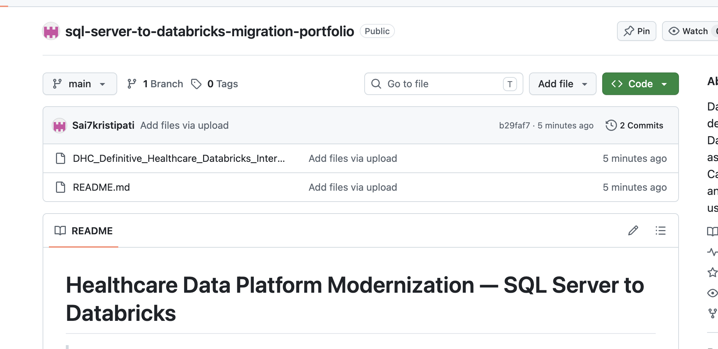
Figure A1. Example Git repository presentation showing the project README and repository structure.

Appendix B — Suggested Repository Structure
sql-server-to-databricks-migration-portfolio/
|
|-- README.md
|-- sql-migration/
| |-- sql-server-example.sql
| |-- databricks-sql-example.sql
| `-- pivot-example.sql
|
|-- pyspark/
| |-- etl-example.py
| `-- validation-example.py
|
|-- validation/
| `-- reconciliation.sql
|
|-- argo/
| `-- cronworkflow-example.yaml
|
|-- sample-data/
| `-- synthetic-claims.csv
|
`-- architecture/
`-- migration-architecture.png

