**EXP. 11 LAUNCH THE HADOOP 2.X AND PERFORM MAPREDUCE PROGRAM**

**FOR A WORD COUNT PROBLEM AIM:**

**PROCEDURE:**

**Step 1 - Open Terminal** $ su hduser

Password:

**Step 2 - Start dfs and mapreduce services**

$ cd /usr/local/hadoop/hadoop-2.7.2/sbin

$ start-dfs.sh

$ start-yarn.sh

$ jps

**Step 3 - Check Hadoop through web UI**

// Go to browser type http://localhost:8088 – All Applications Hadoop Cluster

// Go to browser type http://localhost:50070 – Hadoop Namenode

**Step 4 – Open New Terminal**

$ cd Desktop/

$ mkdir inputdata

$ cd inputdata/

$ echo “Hai, Hello, How are you? How is your health?” >> hello.txt

$ cat >> hello.txt

**Step 5 – Go back to old Terminal**

$ hadoop fs –copyFromLocal /home/hduser/Desktop/inputdata/hello.txt /folder/hduser

// Check in hello.txt in Namenode using Web UI

**Step 6 – Download and open eclipse by creating workspace**

Create a new java project.

**Step 7 – Add jar to the project**

You need to remove dependencies by adding jar files in the hadoop source folder. Now Click on **Project** tab and go to Properties.Under Libraries tab, click Add External JARs and select all the jars in the folder (click on 1st jar, and Press Shift and Click on last jat to select all jars in between and click ok)

**/usr/local/hadoop/hadoop-2.7.2/share/hadoop/common**and

**/usr/local/hadoop/hadoop-2.7.2/share/hadoop/mapreduce** folders.

**Step -8 – WordCount Program**

**Create 3 java files named**

* **WordCount.java**
* **WordCountMapper.java**
* **WordCountReducer.java**

**WordCount.java**

|  |
| --- |
| import org.apache.hadoop.conf.Configured; import org.apache.hadoop.fs.Path; import org.apache.hadoop.io.IntWritable; import org.apache.hadoop.mapred.FileInputFormat; import org.apache.hadoop.mapred.FileOutputFormat; import org.apache.hadoop.mapred.JobClient; import org.apache.hadoop.mapred.JobConf;  import org.apache.hadoop.util.Tool; import org.apache.hadoop.util.ToolRunner; import org.apache.hadoop.io.Text; public class WordCount extends Configured implements Tool {  @Override  public int run(String[] arg0) throws Exception { // TODO Auto-generated method stub  if(arg0.length<2)  {  System.out.println("check the command line arguments");  }  JobConf conf=new JobConf(WordCount.class);  FileInputFormat.setInputPaths(conf, new Path(arg0[0]));  FileOutputFormat.setOutputPath(conf, new Path(arg0[1])); conf.setMapperClass(WordMapper.class); conf.setReducerClass(WordReducer.class); conf.setOutputKeyClass(Text.class); conf.setOutputValueClass(IntWritable.class); conf.setOutputKeyClass(Text.class);  conf.setOutputValueClass(IntWritable.class); JobClient.runJob(conf);  return 0;  }  public static void main(String args[]) throws Exception  { int exitcode=ToolRunner.run(new WordCount(), args); System.exit(exitcode); |
| }  } |

**WordCountMapper.java**

|  |
| --- |
| import java.io.IOException;  import org.apache.hadoop.io.IntWritable; import org.apache.hadoop.io.LongWritable; import org.apache.hadoop.mapred.MapReduceBase; import org.apache.hadoop.mapred.OutputCollector; import org.apache.hadoop.mapred.Reporter; import org.apache.hadoop.io.Text; import org.apache.hadoop.mapred.Mapper;  public class WordCountMapper extends MapReduceBase implements Mapper<LongWritable,Text,Text,IntWritable>  {  @Override  public void map(LongWritable arg0, Text arg1, OutputCollector<Text, IntWritable> arg2, Reporter arg3) throws IOException {  // TODO Auto-generated method stub  String s=arg1.toString();  for(String word:s.split(" "))  { arg2.collect(new Text(word),new IntWritable(1));  }  }  } |

**WordCountReducer.java**

|  |
| --- |
| import java.io.IOException; import java.util.Iterator; import org.apache.hadoop.io.IntWritable; import org.apache.hadoop.mapred.JobConf; import org.apache.hadoop.mapred.OutputCollector; import org.apache.hadoop.mapred.Reducer; import org.apache.hadoop.mapred.Reporter; import org.apache.hadoop.io.Text;  public class WordCountReducer implements Reducer<Text,IntWritable,Text,IntWritable> {  @Override  public void configure(JobConf arg0) {  // TODO Auto-generated method stub  }  @Override  public void close() throws IOException {  // TODO Auto-generated method stub |
| }  @Override  public void reduce(Text arg0, Iterator<IntWritable> arg1, OutputCollector<Text, IntWritable>  arg2, Reporter arg3) throws IOException { // TODO Auto-generated method stub int count=0;  while(arg1.hasNext())  {  IntWritable i=arg1.next(); count+=i.get();  }  arg2.collect(arg0,new IntWritable(count));  }  } |

**Step 9 - Creatr JAR file**

Now Click on the Run tab and click Run-Configurations. Click on New Configuration button on the left-top side and Apply after filling the following properties.

**Step 10 - Export JAR file**

Now click on File tab and select Export. under Java, select Runnable Jar.

In Launch Config – select the config fie you created in **Step 9** (WordCountConfig).

Select an export destination (lets say desktop.)

Under Library handling, select Extract Required Libraries into generated JAR and click Finish.

Right-Click the jar file, go to Properties and under **Permissions**tab, Check Allow executing file as a program. and give Read and Write access to all the users

**Step 11 – Go back to old Terminal for Execution of WordCount Program**

**$hadoop jar** wordcount.jar**/**usr**/**local**/**hadoop**/**input**/**usr**/**local**/**hadoop**/**output

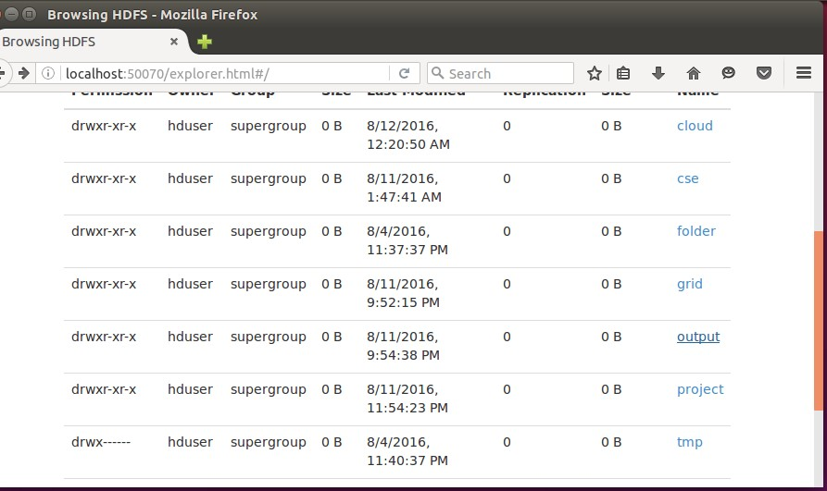

**Step 12 – To view results in old Terminal**

$**hdfs dfs -cat /usr/local/hadoop/output/part-r-00000**

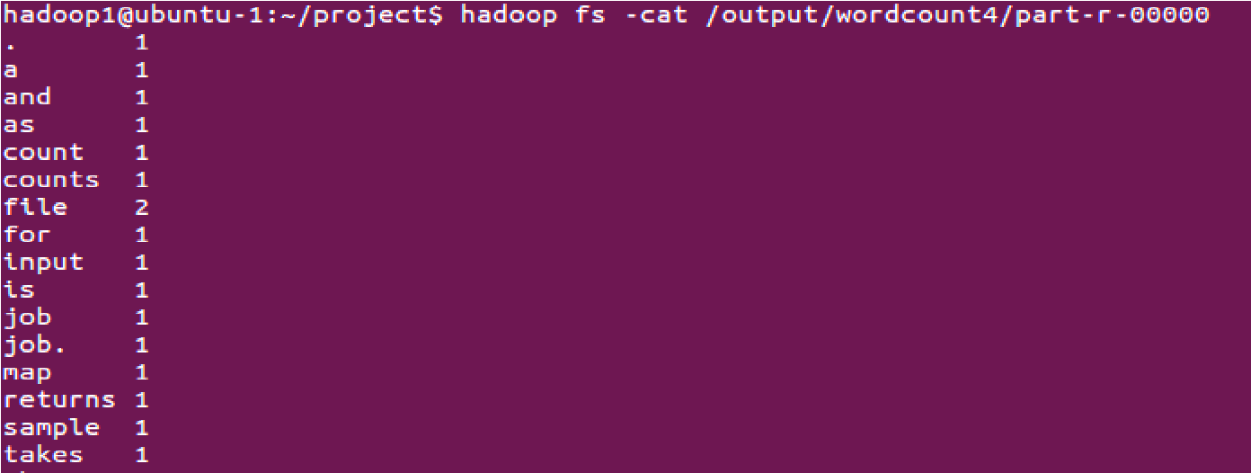

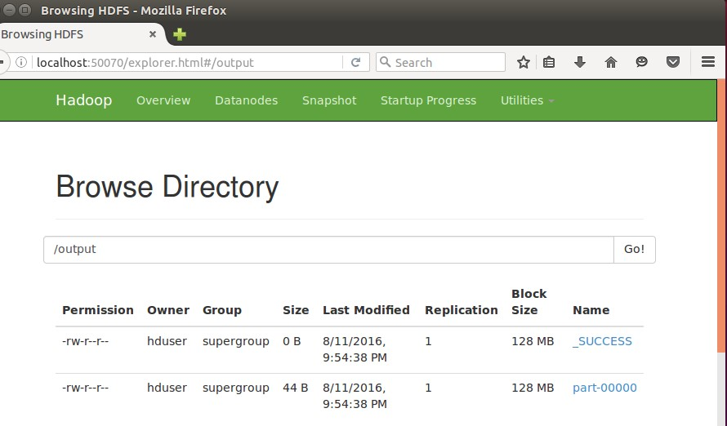

**Step 13 - To Remove folders created using hdfs**

**$ hdfs dfs -rm -R /usr/local/hadoop/output**

**RESULT:**