**AWS Sagemaker Cost analysis**

1. **Amazon SageMaker Studio Notebooks**

Amazon SageMaker Studio Notebooks are one-click Jupyter notebooks that can be spun up quickly.

**Pricing for notebook instance:**

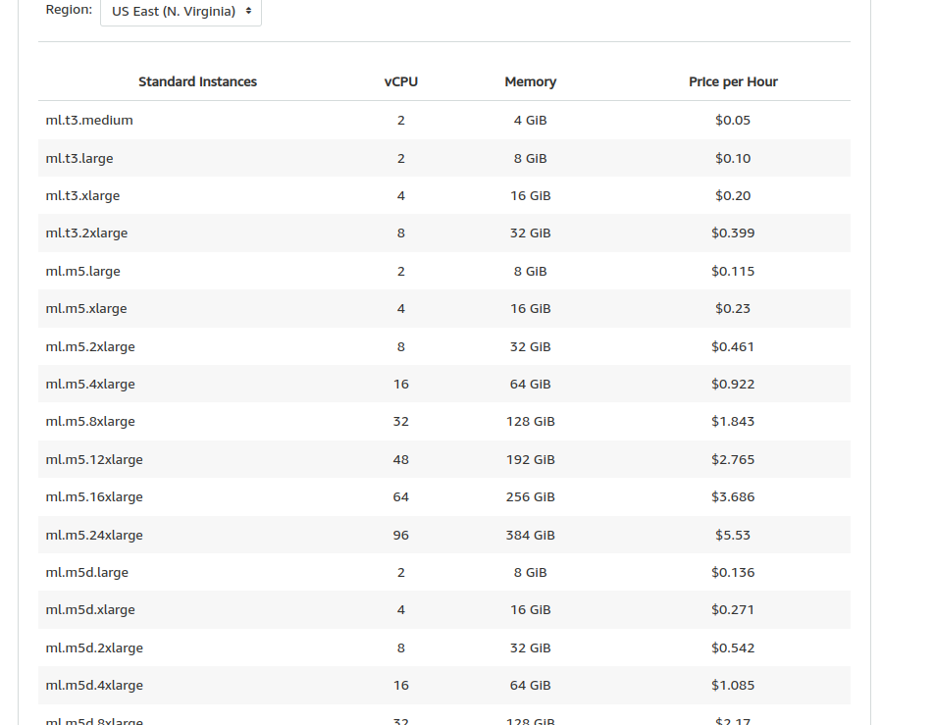

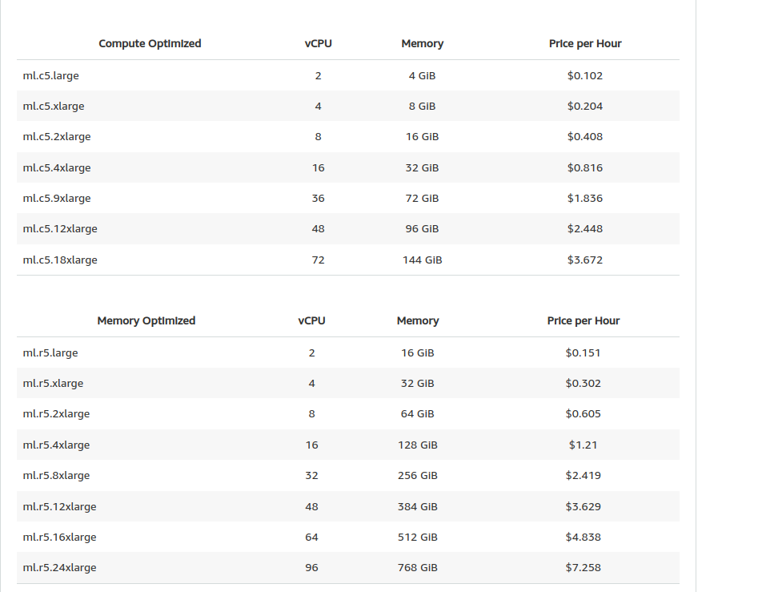

1. **Amazon SageMaker Studio:**

You can now access Amazon SageMaker Studio, the first fully integrated development environment (IDE) at no additional charge.

SageMaker Studio gives you complete access and visibility into each step required to build, train, and deploy models. Using SageMaker Studio, you pay only for the underlying compute and storage that you use within Studio.

You can use many services from SageMaker Studio, AWS SDK for Python (Boto3), or AWS CLI, including:

* **SageMaker Pipelines** to automate and manage ML workflows
* **SageMaker Autopilot** to automatically create ML models with full visibility
* **SageMaker Experiments** to organize and track your training jobs and versions
* **SageMaker Debugger** to debug anomalies during training
* **SageMaker Model Monitor** to maintain high-quality models
* **SageMaker Clarify** to better explain your ML models and detect bias
* **SageMaker JumpStart** to easily deploy ML solutions for many use cases. You may incur charges from other AWS Services used in the solution for the underlying API calls made by Amazon SageMaker on your behalf.
* **SageMaker Inference Recommender** to get recommendations for the right endpoint configuration

1. **Amazon SageMaker Studio Lab**

You can build and train ML models using Amazon SageMaker Studio Lab for free. SageMaker Studio Lab offers developers, academics, and data scientists a no-configuration development environment to learn and experiment with ML at no additional charge.

1. **Amazon SageMaker Canvas:**

SageMaker Canvas supports 2 category prediction (binary classification), 3+ category prediction (multi-class classification), and time-series forecasting for tabular models.

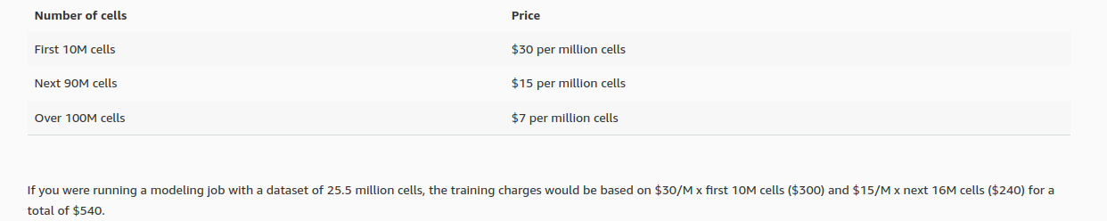

**Custom NLP and CV models:**

The prediction charge for custom NLP and CV models is based on the amount of time it takes to generate your predictions. SageMaker instances, priced at $0.408 per hour of prediction generation time, are used to render the model prediction and you will be charged directly from SageMaker.

Pricing link : <https://calculator.aws/#/>

1. **Amazon SageMaker Data Labeling Pricing:**

* **Reviewed objects (images, video frames, text documents, audio files, etc.)**

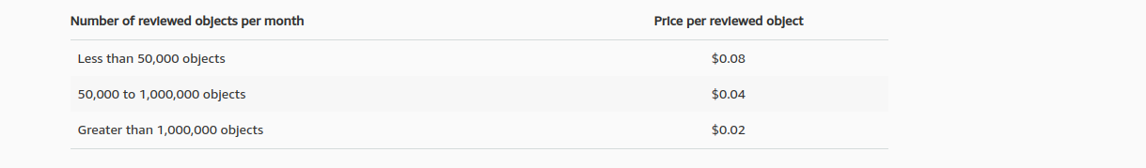

* **3D point clouds**

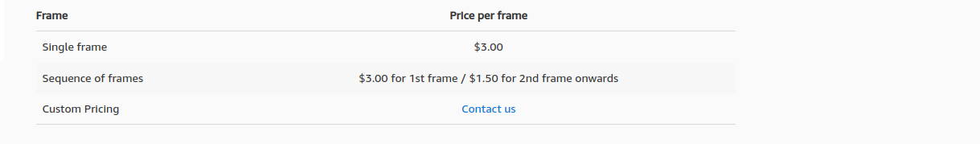

**Example 1: only notebook instance**

Instance: m4.C5.xlarge

Number of data scientists: 2

Number of studio notebook instances per data scientist: 2

Studio notebook hours per day: 5

Studio Notebook day(s) per month: 18

Monthly cost: 73.44 USD

Price calculator : https://calculator.aws/#/

**Example 2: notebook instance and training**

Instance: m4.C5.xlarge

Number of data scientists: 2

Number of studio notebook instances per data scientist: 2

Studio notebook hours per day: 5

Studio Notebook day(s) per month: 18

Number of training jobs per month: 1

Number of instances per job : 1  
Instane : ml.c4.4xlarge

Monthly cost : 92 USD

Price calculator : <https://calculator.aws/#/>