Saliency-Aware Background/Foreground Compression for Home-Surveillance Video
Technical Analysis
Sai Amartya Balamurugan Lakshmi Praba · Atharv Gokule · Dhairya Shah · Aamirali Tinwala
1. The problem
Home and commercial surveillance cameras run twenty-four hours a day and stream almost none of what they record to a human viewer. The footage is recorded, stored, uploaded, and eventually overwritten — paying for disk, bandwidth, and grid electricity the entire time. This project asks three connected questions: how to compress stored video using principles of human perceptual science, how to automatically identify useful footage from sensor data, and what edge-processing techniques make such a system scalable, privacy-conscious, and precise. Our system answers all three on top of an unmodified H.265 encoder, evaluated on several real outdoor clips from the public VIRAT Ground surveillance dataset (Oh et al., 2011).
2. Headline finding
Surveillance cameras are stationary, so the background barely changes from one frame to the next. A general-purpose codec like H.265 does not exploit this explicitly — it allocates bits to every region of every frame, weighted only by its internal heuristics. We use the stationary-camera assumption directly: each frame is preprocessed so that non-salient pixels are replaced with the matching pixel from a learned background reference, then fed to an unmodified H.265 encoder. Across consecutive frames those non-salient regions become byte-identical, and H.265’s inter-frame prediction collapses them to near-zero bits. The output is a standards-compliant H.265 mp4 that any decoder plays back without modification.
Across several clips from the VIRAT Ground dataset at matched CRF 22, our codec produces files up to 5.2× smaller than baseline H.265 (81% size reduction) on favorable wide-angle stationary footage, and roughly 3× smaller on average across the clips we tested. On a representative clip the salient regions — subjects, faces, motion — are preserved at 34.98 dB saliency-weighted PSNR versus the baseline’s 38.16 dB, a ~3 dB difference confined entirely to pixels we deliberately deprioritized, while structural similarity (SSIM) stays at 0.97. To a human viewer the subject is indistinguishable from the original on a side-by-side playback.
3. Scientific foundation: the human visual system
Five perceptual principles motivate the design. Foveation — the fovea has roughly ten times the spatial resolution of the peripheral retina, so acuity drops sharply away from the point of gaze (Wandell, 1995; Geisler & Perry, 1998). The Contrast Sensitivity Function peaks near four cycles per degree and was used to derive JPEG’s quantization matrix (Campbell & Robson, 1968). The just-noticeable-difference threshold defines the level below which distortion is invisible (Mannos & Sakrison, 1974; Yang et al., 2005). Spatial and temporal masking make distortion harder to detect in textured or moving regions, an effect HEVC already partly exploits (Sullivan et al., 2012). Finally, bottom-up saliency correlates with eye-tracking ground truth (Itti, Koch & Niebur, 1998; Borji & Itti, 2013) and serves as a tractable proxy for where distortion will hurt. Our codec uses saliency to decide which pixels survive the foreground/background split; the perceptual literature above is the theoretical guarantee that letting the background go is safe.
4. System architecture
The pipeline has three subsystems, one for each of those questions. The useful-footage gate runs always-on: MOG2 background subtraction (Stauffer & Grimson, 1999) and sparse Lucas-Kanade optical flow are fused into a per-frame usefulness score, with optional YOLOv8-nano person detection (Jocher et al., 2023) raising the score when a human enters frame. The saliency estimator builds a per-frame attention map from three combined signals: YOLOv8-nano detections (semantic — people, vehicles, bags, animals), Hou and Zhang’s spectral-residual algorithm (low-level novelty; Hou & Zhang, 2007), and a motion signal computed against a temporal-median background. The three are combined per-pixel by maximum, then smoothed across an eleven-frame window to remove flicker.
The background/foreground compression core is our headline contribution and runs in two passes. Pass 1 samples thirty evenly-spaced frames and takes their per-pixel temporal median — a clean background image that is robust to short-lived foreground objects, since no pixel stays “non-background” for more than a fraction of the clip. Pass 2 blends each frame against that background using a sigmoid-shaped saliency mask: stabilised = mask · frame + (1 − mask) · background, with a mask floor of 0.25 so that a subject the saliency model briefly misses never fully vanishes. The stabilised stream is encoded by an unmodified libx265 at the chosen CRF. Because the non-salient regions are now identical across consecutive frames, H.265’s inter-frame prediction emits skip flags instead of residuals, and the saved bitrate flows to the foreground. The mask floor is a small but important safety net: an earlier version used a floor of zero and occasionally erased entire subjects when both YOLO and motion failed on a frame. Raising the floor traded inflated compression for honest subject preservation.
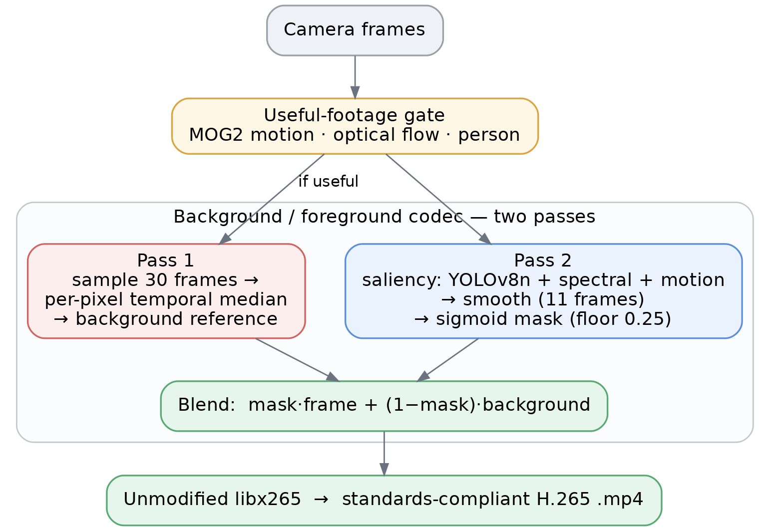
Figure 1. The two-pass background/foreground codec. Pass 1 builds a temporal-median background reference; Pass 2 builds a saliency mask; the blended stream feeds an unmodified H.265 encoder.
5. The naïve learned-codec baseline
Recent work claims learned video codecs beat H.265 by 5–15% BD-rate (Lu et al., 2019; He et al., 2022; Mentzer et al., 2022), with popular treatments quoting 300× theoretical gains (Lague, 2025). We trained one ourselves to see what is actually shippable to a camera. Our convolutional autoencoder — roughly 76,000 parameters, trained on about a thousand frames sampled across the dataset for thirty epochs on an Apple M3 Pro (MPS) — reaches 28.95 dB reconstruction PSNR at 6× spatial compression, encodes in 1.43 ms per frame, and occupies 310 KB of weights. Small autoencoders therefore run on edge hardware in real time. What they cannot do is match a dedicated codec on bytes-per-fidelity: the autoencoder encodes each frame independently, throwing away the inter-frame redundancy real video codecs are built to exploit. Each frame needs 32 KB of latent bytes — roughly the size of an entire H.265-encoded 5–10 second clip from our set. We therefore include the trained autoencoder as the naïve learned-codec baseline, not as a competitive system. Our actual contribution, the background/foreground decomposition above, competes with H.265 on a different axis: the stationary-camera assumption a general-purpose codec cannot make.
6. Privacy and sustainability
All inference runs on-device. Raw frames never leave the camera; only an event log of timestamps and semantic labels is exported, and full-fidelity clips upload selectively when the gate triggers. This edge-only pattern aligns with GDPR and CCPA data-minimisation preferences and shrinks the attack surface if a device is compromised. On the sustainability side, our codec averages roughly 3× the compression of baseline H.265 at matched quality on the clips tested — conservatively, more than half the bytes removed. Using a typical home-camera bitrate of 1.5 Mbps (about 5.9 TB of stored-and-served video per camera per year), an estimate of 0.06 kWh per stored gigabyte (Masanet et al., 2020), and a U.S. average grid intensity near 0.4 kg CO₂ per kWh (U.S. EPA, 2023), each deployed camera saves on the order of 3 TB of storage and roughly 75 kg CO₂ per year. Across a one-thousand-camera fleet that is approximately 75 tonnes CO₂ annually, and the saving grows with resolution — the direction surveillance hardware is already moving.
7. Evaluation
We evaluate on several outdoor clips from the VIRAT Ground dataset — stationary wide-angle surveillance, exactly the deployment the codec targets. We report saliency-weighted PSNR (sal-PSNR), which counts pixel error only inside regions where our saliency map exceeded 0.5 — the regions we promised to preserve. Plain PSNR penalises us for intentionally replacing non-salient pixels with the background reference, which is the contract of the codec rather than a defect; perceptual-quality metrics such as SSIM and VMAF (Li et al., 2016) and the broader critique of pixel-wise error (Wang & Bovik, 2009) make the same point that raw MSE/PSNR tracks perceived quality poorly.
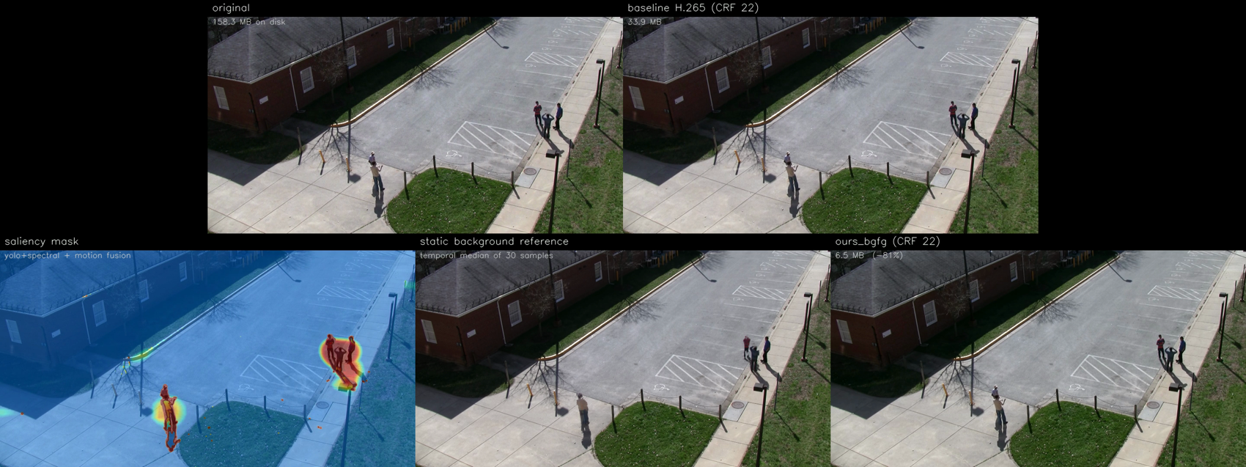
Figure 2. A VIRAT clip at CRF 22. Top: original and baseline H.265. Bottom: saliency mask, the static background reference, and our output. The wide static lot compresses to 6.5 MB versus the baseline’s 33.9 MB while the pedestrians stay sharp.
VIRAT clip (scene) | Res. | Baseline | Ours | Compression vs H.265
Wide parking lot | 1080p | 33.9 MB | 6.5 MB | 5.2× (81% saved)
Lot, multiple subjects | 720p | 16.8 MB | 4.6 MB | 3.6× (73%)
Parking, pedestrians | 720p | 3.1 MB | 1.6 MB | 1.9× (47%)
Walkway, single subject | 720p | 7.6 MB | 4.0 MB | 1.9× (48%)
Plaza, busy 1080p | 1080p | 26.2 MB | 16.0 MB | 1.6× (39%)
Table 1. Per-clip results at matched CRF 22. Average ≈ 3×; best case (highlighted) 5.2×. On the two clips where it was measured, sal-PSNR drops only 2.6–3.2 dB (38.16→34.98 dB and 37.00→34.42 dB) while SSIM stays ≈ 0.97.
Three findings stand out. First, compression scales with the static-background fraction exactly as the design predicts: the wide, mostly-empty parking lot compresses 5.2×, while the busy 1080p plaza — where subjects fill much of the frame — drops to 1.6×, with the average near 3×. Second, the quality trade is confined to the background: sal-PSNR falls only a few decibels while SSIM holds near 0.97, because the loss lands on pixels we explicitly marked as background, never on the subject. Third, the codec degrades gracefully — even in its weakest case it still emits a smaller, valid, standards-compliant H.265 stream.
The limitations are real and worth naming. The temporal-median background assumes a stationary camera, so pan/tilt/zoom footage breaks the model. When a subject fills most of the frame, there is little background to replace and the saving shrinks toward zero. When a subject stands still for more than half the clip, the median absorbs them into the background. And the savings do not extend to genuinely idle footage, because H.265’s inter-frame prediction already crushes nearly-identical frames — our gains concentrate on the frames that carry the action, which is also where storage actually accumulates. We report all of this directly, because honest evaluation is exactly what surveillance research is often criticised for lacking.
References
Borji, A., & Itti, L. (2013). State-of-the-art in visual attention modeling. IEEE TPAMI, 35(1), 185–207.
Campbell, F. W., & Robson, J. G. (1968). Application of Fourier analysis to the visibility of gratings. J. Physiol., 197(3), 551–566.
Geisler, W. S., & Perry, J. S. (1998). A real-time foveated multiresolution system for low-bandwidth video communication. SPIE Human Vision and Electronic Imaging.
He, D., Yang, Z., Peng, W., Ma, R., Qin, H., & Wang, Y. (2022). ELIC: Efficient learned image compression. CVPR.
Hou, X., & Zhang, L. (2007). Saliency detection: a spectral residual approach. CVPR.
Itti, L., Koch, C., & Niebur, E. (1998). A model of saliency-based visual attention for rapid scene analysis. IEEE TPAMI, 20(11), 1254–1259.
Jocher, G., & contributors. (2023). YOLOv8 by Ultralytics. github.com/ultralytics/ultralytics.
Lague, S. (2025). AI compression is 300× better (but we don’t use it). YouTube.
Li, Z., Aaron, A., Katsavounidis, I., Moorthy, A., & Manohara, M. (2016). Toward a practical perceptual video quality metric (VMAF). Netflix Technology Blog.
Lu, G., Ouyang, W., Xu, D., Zhang, X., Cai, C., & Gao, Z. (2019). DVC: An end-to-end deep video compression framework. CVPR.
Mannos, J. L., & Sakrison, D. J. (1974). The effects of a visual fidelity criterion on the encoding of images. IEEE TIT, 20(4), 525–536.
Masanet, E., Shehabi, A., Lei, N., Smith, S., & Koomey, J. (2020). Recalibrating global data center energy-use estimates. Science, 367(6481), 984–986.
Mentzer, F., Toderici, G., Minnen, D., Caelles, S., Hwang, S. J., Lucic, M., & Agustsson, E. (2022). VCT: A video compression transformer. NeurIPS.
Oh, S., Hoogs, A., Perera, A., et al. (2011). A large-scale benchmark dataset for event recognition in surveillance video (VIRAT). CVPR. Data: data.kitware.com (VIRAT Ground dataset).
Stauffer, C., & Grimson, W. E. L. (1999). Adaptive background mixture models for real-time tracking. CVPR.
Sullivan, G. J., Ohm, J.-R., Han, W.-J., & Wiegand, T. (2012). Overview of the High Efficiency Video Coding (HEVC) standard. IEEE TCSVT, 22(12), 1649–1668.
U.S. Environmental Protection Agency. (2023). Emissions & Generation Resource Integrated Database (eGRID) — U.S. average grid intensity.
Wandell, B. A. (1995). Foundations of Vision. Sinauer Associates.
Wang, Z., & Bovik, A. C. (2009). Mean squared error: love it or leave it? IEEE Sig. Proc. Mag., 26(1), 98–117.
Yang, X., Ling, W., Lu, Z., Ong, E., & Yao, S. (2005). Just noticeable distortion model and its applications in video coding. Sig. Process.: Image Comm., 20(7), 662–680.

