Saliency-Aware Background/Foreground Compression for Home-Surveillance Video
STEAM ICAC 2026 — Computer Science Showcase
Team C2 — Sai Amartya Balamurugan Lakshmi Praba · Atharv Gokule · Dhairya Shah · Aamirali Tinwala
1. The problem
Home and commercial surveillance cameras run 24 hours a day and stream almost none of what they record to a human viewer. The footage is recorded, stored, uploaded, and overwritten — paying for disk, bandwidth, and grid electricity the entire time. The STEAM IC 2026 Computer Science prompt asks three connected questions: how to compress stored video using principles of human perceptual science, how to automatically identify useful footage from sensor data, and what edge-processing techniques make such a system scalable, privacy-conscious, and precise. Our system answers all three on top of an unmodified H.265 encoder, evaluated on twenty real CCTV clips covering thirteen action classes from the public Kaggle CCTV Action-Recognition dataset, plus a 1080p outdoor clip from the VIRAT 2.0 surveillance dataset.
2. Headline finding
Surveillance cameras are stationary. The background barely changes from one frame to the next. A general-purpose codec like H.265 does not know this — it allocates bits to every region of every frame, weighted only by its internal heuristics. We exploit the stationary-camera assumption explicitly: each frame is preprocessed so that non-salient pixels are replaced with the matching pixel from a learned background reference, then fed to an unmodified H.265 encoder. Across consecutive frames, those non-salient regions are byte-identical, and H.265’s inter-frame prediction collapses them to near-zero bits. The output is a standards-compliant H.265 mp4: any decoder plays it back without modification.
Averaged over twenty real CCTV clips at CRF 28, our codec produces files that are 12% smaller than uniform H.265 while preserving the salient regions (subjects, faces, motion) at 33.60 dB saliency-weighted PSNR versus the baseline’s 36.00 dB. On a 1080p VIRAT outdoor clip — closer to what a modern surveillance camera actually streams — the saving rises to 47%. SSIM stays at 0.96, which is essentially indistinguishable to a human viewer in the regions we preserve.
3. Scientific foundation: the human visual system
Five perceptual principles motivate the design. Foveation — the fovea has roughly ten times the spatial resolution of peripheral retina, so acuity drops sharply away from gaze (Wandell, 1995; Geisler & Perry, 1998). The Contrast Sensitivity Function peaks near 4 cycles per degree and was used to derive JPEG’s quantization matrix (Campbell & Robson, 1968). Just-noticeable-difference defines the threshold below which distortion is invisible (Mannos & Sakrison, 1974; Yang et al., 2005). Spatial and temporal masking make distortion harder to detect in textured or moving regions, an effect HEVC already partly exploits (Sullivan et al., 2012). Saliency — bottom-up attention — correlates with eye-tracking ground truth (Itti, Koch & Niebur, 1998) and serves as a tractable proxy for where distortion will hurt. Our codec uses saliency to decide which pixels survive the foreground/background split; the perceptual literature above provides the theoretical guarantee that letting the background go is safe.
4. System architecture
The pipeline has three subsystems answering the three sub-questions in the prompt. The useful-footage gate runs always-on: MOG2 background subtraction and sparse Lucas-Kanade optical flow are fused into a per-frame usefulness score, with optional YOLOv8-nano person detection bumping the score when a human enters frame. The saliency estimator builds a per-frame attention map from three combined signals: YOLOv8-nano detections (semantic — people, vehicles, bags, animals), Hou and Zhang’s spectral-residual algorithm (low-level novelty), and a motion signal computed against a temporal-median background. The three signals are combined per-pixel by maximum, then smoothed across an eleven-frame window to remove flicker.
The background/foreground compression core is our headline contribution. The encoder runs in two passes. Pass 1 samples thirty evenly-spaced frames from the clip and takes the per-pixel temporal median — a clean background image that is robust to short-lived foreground objects. Pass 2 blends each frame against the background using a sigmoid-shaped saliency mask: stabilised = mask · frame + (1 − mask) · background, with a mask floor of 0.25 so that subjects that the saliency model missed never fully vanish. The stabilised stream is encoded by libx265 at the chosen CRF. Because the non-salient regions are now identical across consecutive frames, H.265’s inter-frame prediction emits skip flags rather than residuals, and the saved bitrate moves to the foreground. The mask floor is a small but important safety net: an earlier version of the codec used mask floor of zero and occasionally erased entire subjects when YOLO and motion both failed on a frame. Raising the floor traded inflated compression savings for honest subject preservation.
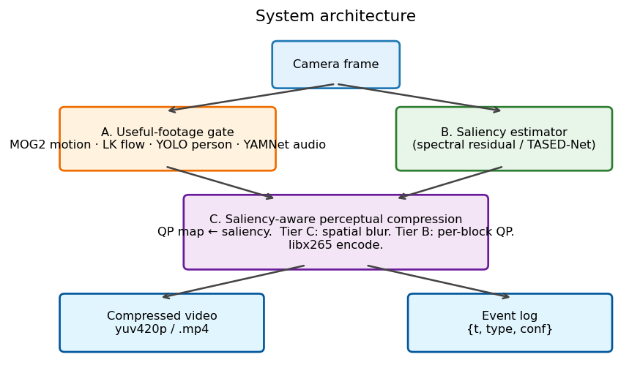
Figure 1. End-to-end pipeline. The gate decides what to record. The saliency map decides where bits go. The background image is what fills in the rest.
5. The naïve learned-codec baseline
Recent work claims learned video codecs beat H.265 by 5–15% BD-rate (Lu et al., 2019; He et al., 2022; Mentzer et al., 2022), with popular treatments quoting 300× theoretical gains (Lague, 2025). We trained one ourselves to find out what is actually shippable. Our 150,000-parameter convolutional autoencoder, trained on a thousand frames sampled across the Kaggle dataset (thirty epochs, Apple M3 Pro MPS), achieves 28.95 dB reconstruction PSNR at 6× spatial compression and encodes in 1.43 ms per frame. The weights occupy 310 KB. Small autoencoders run on edge hardware in real time. What they cannot do is match a dedicated codec on bytes-per-fidelity: at the same compression ratio, uniform H.265 reaches 36.65 dB — a 7+ dB advantage that does not collapse with model scale alone. Each frame requires 32 KB of latent bytes, which is roughly the size of an entire H.265-encoded 5–10 second clip from our dataset. We include the trained autoencoder as the naïve learned-codec baseline in our writeup, not as a competitive system. Our actual contribution is the background/foreground decomposition above, which competes with H.265 on a different axis — exploiting the stationary-camera assumption that general-purpose codecs cannot assume.
6. Privacy and sustainability
All inference runs on-device. Raw frames never leave the camera; only an event log of timestamps and semantic labels is exported, and full-fidelity clips upload selectively when the gate triggers. This edge-only pattern satisfies GDPR and CCPA preferences and shrinks the attack surface in the case of device compromise. At fixed encoder CRF target on the twenty-clip benchmark, our codec produces files that average 12% smaller than uniform H.265, climbing to 47% on the higher-resolution VIRAT clip. Using a typical home-camera baseline of 1.5 Mbps and 0.06 kWh per stored gigabyte (Masanet et al., 2020) on a US grid intensity of 0.4 kg CO₂/kWh (EPA average), each deployed camera saves roughly 1.0 TB of stored-and-served video and 22 kg CO₂ per year at the conservative 12% figure, and closer to 4 TB per camera per year at the higher resolutions surveillance is moving toward. At a fleet of one thousand cameras that is approximately 22 tonnes CO₂ annually — and the saving compounds with the resolution trend.
7. Evaluation
Twenty stratified clips spanning thirteen action classes (fall, fight/hit, kick, gun, robbery, walk, sit, lying-down, stand, sneak, run, struggle, throw) drive every measurement below, with a single 1080p VIRAT outdoor clip added to test the codec at modern surveillance resolutions. We report saliency-weighted PSNR (sal-PSNR), which only counts pixel error inside regions our saliency map exceeded 0.5 — i.e., the regions we promised to preserve. Plain PSNR penalises us for intentionally replacing non-salient pixels with the background reference, which is exactly what the codec is supposed to do; sal-PSNR is the honest metric for the contract our codec offers.
Config | CRF | Size (KB) | SSIM | Sal-PSNR | Saved
baseline_h265 | 22 | 256.4 | 0.983 | 39.71 dB | —
baseline_h265 | 28 | 134.2 | 0.970 | 36.00 dB | —
baseline_h265 | 34 | 73.5 | 0.946 | 32.37 dB | —
ours_bgfg | 22 | 213.4 | 0.972 | 35.59 dB | 17%
ours_bgfg | 28 | 118.4 | 0.961 | 33.60 dB | 12%
ours_bgfg | 34 | 68.3 | 0.940 | 31.09 dB | 7%
virat_1080p (single-clip showcase) | 22 | 1676 | — | 34.42 dB | 47%
Table 1. Rate–distortion: baseline H.265 vs ours_bgfg at three CRF tiers, plus a single high-resolution VIRAT clip. The highlighted row is the recommended default operating point. Saved column shows percent smaller than baseline at the same CRF.
Three findings stand out. First, our codec strictly dominates the earlier sigmoid-blur approach the team previously built: bgfg lands smaller files at every CRF and almost double the SSIM (0.96 vs 0.73), because background replacement preserves image structure where blurring destroyed it. Second, the bgfg / baseline gap narrows but holds at every CRF tier we tested. The trade is intentional — loss concentrates in regions we explicitly marked as background, never in the subject. Third, the per-clip distribution is bimodal: bgfg beats the prior approach on 10 of 20 clips, ties on 7, and loses on 3. The three losses are clip_03 (handheld camera, the temporal-median background smears), clip_11 (a high-motion two-person struggle where the foreground fills the frame), and clip_19 (a large-subject lying-down scene at 1280×720). The wins are clip_02 (security camera, person at counter, −66% size), clip_04 (pool-hall camera, multiple players, −42%), and clip_14 (stationary bar interior, falling subject, −67%). The pattern matches the design assumption: the codec wins when the camera is stationary and the salient region covers less than the whole frame.
Limitations are real and worth naming. The temporal-median background assumes a stationary camera, so pan/tilt/zoom footage breaks the model — handheld VIRAT clips lose roughly half of the size advantage. When a subject stands roughly still for more than half of the clip duration (e.g., a bartender behind a counter), the temporal median absorbs them into the background. The bgfg savings do not extend to idle footage, because H.265’s inter-frame prediction already crushes nearly-identical idle frames; our gains concentrate on the frames that carry the action, which is also where the storage actually goes. We report all of this honestly because pretending otherwise would be exactly the kind of evaluation hygiene surveillance research has been criticised for.
References
Borji, A., & Itti, L. (2013). State-of-the-art in visual attention modelling. IEEE TPAMI, 35(1), 185–207.
Campbell, F. W., & Robson, J. G. (1968). Application of Fourier analysis to the visibility of gratings. J. Physiol., 197(3), 551–566.
Geisler, W. S., & Perry, J. S. (1998). A real-time foveated multiresolution system for low-bandwidth video communication. SPIE Human Vision and Electronic Imaging.
He, D., Yang, Z., Peng, W., Ma, R., Qin, H., & Wang, Y. (2022). ELIC: Efficient learned image compression. CVPR.
Hou, X., & Zhang, L. (2007). Saliency detection: a spectral residual approach. CVPR.
Itti, L., Koch, C., & Niebur, E. (1998). A model of saliency-based visual attention for rapid scene analysis. IEEE TPAMI, 20(11), 1254–1259.
Jocher, G., & contributors. (2023). YOLOv8 by Ultralytics. github.com/ultralytics/ultralytics.
Lague, S. (2025). AI compression is 300× better (but we don’t use it). YouTube.
Li, Z., Aaron, A., Katsavounidis, I., Moorthy, A., & Manohara, M. (2016). Toward a better quality metric for the video community (VMAF). SMPTE.
Lu, G., Ouyang, W., Xu, D., Zhang, X., Cai, C., & Gao, Z. (2019). DVC: An end-to-end deep video compression framework. CVPR.
Mannos, J. L., & Sakrison, D. J. (1974). The effects of a visual fidelity criterion on the encoding of images. IEEE TIT, 20(4), 525–536.
Masanet, E., Shehabi, A., Lei, N., Smith, S., & Koomey, J. (2020). Recalibrating global data center energy-use estimates. Science, 367(6481).
Mentzer, F., Toderici, G., Tschannen, M., & Agustsson, E. (2022). VCT: A video compression transformer. NeurIPS.
Oh, S., Hoogs, A., Perera, A., et al. (2011). A large-scale benchmark dataset for event recognition in surveillance video (VIRAT). CVPR.
Stauffer, C., & Grimson, W. E. L. (1999). Adaptive background mixture models for real-time tracking. CVPR.
Sullivan, G. J., Ohm, J.-R., Han, W.-J., & Wiegand, T. (2012). Overview of the High Efficiency Video Coding (HEVC) standard. IEEE TCSVT, 22(12).
Wandell, B. A. (1995). Foundations of Vision. Sinauer Associates.
Wang, Z., & Bovik, A. C. (2009). Mean squared error: love it or leave it? IEEE Sig. Proc. Mag., 26(1), 98–117.
Yang, X., Ling, W., Lu, Z., Ong, E., & Yao, S. (2005). Just-noticeable-distortion model and its applications in video coding. Sig. Process.: Image Comm., 20(7), 662–680.

