

**LAB RECORD**

COURSE CODE:19CSE401

COURSE: COMPILER DESIGN

Submitted by CH.EN.U4CSE22050

SAI ANANYA YEDITHA

BACHELOR OF TECHNOLOGY IN

COMPUTER SCIENCE AND ENGINEERING

AMRITA VISHWA VIDYAPEETHAM AMRITA SCHOOL OF COMPUTING

CHENNAI 2025



**AMRITA VISHWA VIDYAPEETHAM AMRITA SCHOOL OF COMPUTING, CHENNAI**

**BONAFIDE CERTIFICATE**

This is to certify that the Lab Record work for 19CSE401 – “Compiler Design” Subject submitted by **CH.EN.U4CSE22050 Sai Ananya Yeditha** in “Computer Science and Engineering”

is a bonafide record of the work carried out under my guidance and supervision at Amrita School of Computing, Chennai.

**Dr.S.Suthir Dr. S Sountharrajan**

**Assistant Professor Asso.Prof. &Program Head Dept. of CSE Dept. of CSE**

This Lab examination held on 

**INTERNAL EXAMINER 1 INTERNAL EXAMINER 2**

|  |  |  |  |
| --- | --- | --- | --- |
| **EXPERIMENTNO** | **TOPIC NAME** | **DATE** | **PAGE NO** |
| **1** | Implementation  of lexical analyser using lex tool | **23/6/25** | **3** |
| **2** | Program to eliminate left recursion and factoring from  the given grammar | **7/7/25** | **6** |
| **3** | Implementation of LL(1) parsing | **14/7/25** | **10** |
| **4** | Parser  Generation using YACC | **25/8/25** | **13** |
| **5** | Implementation of Symbol Table | **1/9/25** | **16** |
| **6** | Implementation of Intermediate Code Generation | **8/9/25** | **18** |
| **7** | Implementation of Code Optimization  Techniques | **15/9/25** | **21** |
| **8** | Implementation of Target code generation | **22/9/25** | **24** |

# Experiment No. : 1

**Aim :** To implement Lexical Analyzer Using Lex Tool

**Algorithm :**

1. Open the gedit text editor from Accessories under Applications to write the LEX program.
2. Include the necessary header files between %{ and %} in the declaration section, such as stdio.h.
3. Define patterns for digits (0–9) and identifiers (a–z, A–Z).
4. Write translation rules using regular expressions to recognize elements like digits, keywords, identifiers, operators, and header files. When a match is found, display the value stored in yytext.
5. In the main() function, use yyin to specify the input file that the lexer should process.
6. Save the lexical analyzer specification as lexp.l in the LEX language.
7. Run the lexp.l file through the LEX compiler to generate an equivalent C program named lex.yy.c.
8. The lex.yy.c file contains a table generated from the regular expressions in lexp.l, along with standard routines that use the table to recognize tokens.
9. Finally, compile the lex.yy.c file using a C compiler to produce an executable file a.out, which acts as the lexical analyzer that converts an input stream into a sequence of tokens.

**Code :**

**1. analyzer.l**

%{

#include <stdio.h>

int COMMENT = 0;

%}

identifier [a-zA-Z][a-zA-Z0-9]*

%%

#.* { printf("\n%s is a preprocessor directive", yytext); }

int|float|char|double|while|for|struct|typedef|do|if|break|continue|void|switch|return|else|goto

{ printf("\n\t%s is a keyword", yytext); }

"/*" { COMMENT = 1; printf("\n\t%s is a COMMENT", yytext); }

"*/" { COMMENT = 0; }

{identifier}\( { if (!COMMENT) printf("\nFUNCTION \n\t%s", yytext); }

\{ { if (!COMMENT) printf("\nBLOCK BEGINS"); }

\} { if (!COMMENT) printf("\nBLOCK ENDS"); }

{identifier}(\[[0-9]*\])? { if (!COMMENT) printf("\n%s is an IDENTIFIER", yytext); }

\".*\" { if (!COMMENT) printf("\n\t%s is a STRING", yytext); }

[0-9]+ { if (!COMMENT) printf("\n%s is a NUMBER", yytext); }

\)(\:)? { if (!COMMENT) { printf("\n\t"); ECHO; printf("\n"); } }

\( { ECHO; }

= { if (!COMMENT) printf("\n\t%s is an ASSIGNMENT OPERATOR", yytext); }

<=|>=|==|>|< { if (!COMMENT) printf("\n\t%s is a RELATIONAL OPERATOR", yytext); }

%%

int main(int argc, char **argv) {

FILE *file;

file = fopen("var.c", "r"); // This program reads tokens from var.c

if (!file) {

printf("Could not open the file");

exit(0);

}

yyin = file;

yylex();

printf("\n");

return 0;

}

int yywrap() {

return 1;

}

**2. var.c**

#include<stdio.h> #include<conio.h> void main()

{ int a,b,c; a=1; b=2; c=a+b;

printf("Sum:%d",c);

}

**Output :**

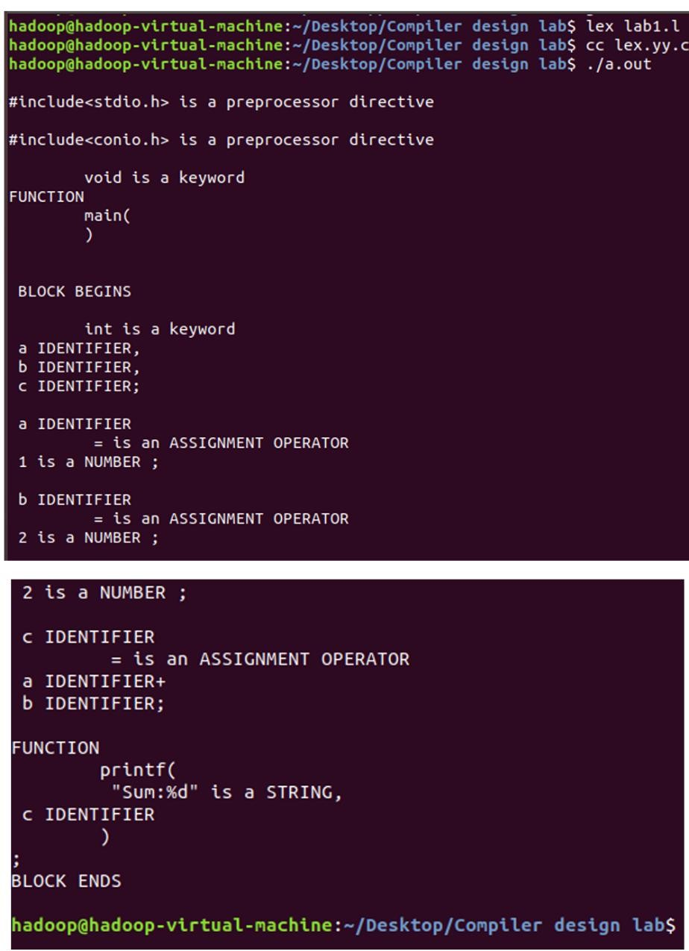

**Result :** The code has been executed and output displayed successfully.

# Experiment No. : 2

**Aim :** To implement eliminate left recursion and left factoring from the given grammar using C program.

**Algorithm :**

**Left Factoring :**

* Start the processes by getting the grammar and assigning it to the appropriate variables
* Find the common terminal and non-terminal elements and assign them in a separate grammar
* Display the new and modified grammar.

**Code :**

**leftfactoring.c**

#include<stdio.h>

#include<string.h>

int main()

{

char gram[20],part1[20],part2[20],modifiedGram[20],newGram[20],tempGram[20];

int i,j=0,k=0,l=0,pos;

printf("Enter Production : A->");

gets(gram);

for(i=0;gram[i]!='|';i++,j++)

part1[j]=gram[i];

part1[j]='\0';

for(j=++i,i=0;gram[j]!='\0';j++,i++)

part2[i]=gram[j];

part2[i]='\0';

for(i=0;i<strlen(part1)||i<strlen(part2);i++){

if(part1[i]==part2[i]){

modifiedGram[k]=part1[i];

k++;

pos=i+1;

}

}

for(i=pos,j=0;part1[i]!='\0';i++,j++){

newGram[j]=part1[i];

}

newGram[j++]='|';

for(i=pos;part2[i]!='\0';i++,j++){

newGram[j]=part2[i];

}

modifiedGram[k]='X';

modifiedGram[++k]='\0';

newGram[j]='\0';

printf("\nGrammar Without Left Factoring : : \n");

printf(" A->%s",modifiedGram);

printf("\n X->%s\n",newGram);

}

**Output :**

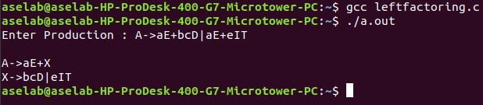

**Left Recursion.c**

**Aim :** To implement left recursion using C.

**Algorithm :**

* Start the processes by getting the grammar and assigning it to the appropriate variables.
* Check if the given grammar has left recursion.
* Identify the alpha and beta elements in the production.
* Print the output according to the formula to remove left recursion **Code :**

**recursion.c**

#include <stdio.h>

#include <string.h>

#define SIZE 10

int main() {

char non_terminal;

char beta, alpha;

int num;

char production[10][SIZE];

int index = 3; /* starting of the string following "->" */

printf("Enter Number of Production : ");

scanf("%d", &num);

printf("Enter the grammar as E->E-A :\n");

for (int i = 0; i < num; i++) {

scanf("%s", production[i]);

}

for (int i = 0; i < num; i++) {

printf("\nGRAMMAR : : : %s", production[i]);

non_terminal = production[i][0];

if (non_terminal == production[i][index]) {

alpha = production[i][index + 1];

printf(" is left recursive.\n");

while (production[i][index] != 0 && production[i][index] != '|') {

index++;

}

if (production[i][index] != 0) {

beta = production[i][index + 1];

printf("Grammar without left recursion:\n");

printf("%c->%c%c\'", non_terminal, beta, non_terminal);

printf("\n%c\'->%c%c\'|E\n", non_terminal, alpha, non_terminal);

} else {

printf(" can't be reduced\n");

}

} else {

printf(" is not left recursive.\n");

}

index = 3;

}

return 0;

}

**Output :**

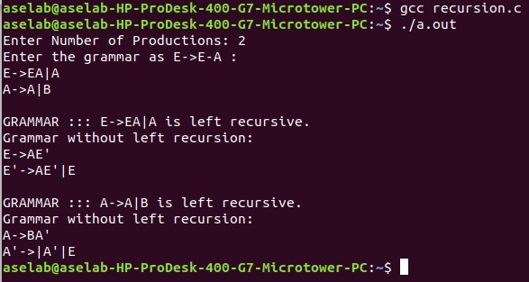

**Result :** The program to implement left factoring and left recursion has been successfully executed.

# Experiment No. : 3

**Aim :** To implement LL(1) parsing using C program.

**Algorithm :**

* Read the input string.
* Using predictive parsing table parse the given input using stack.
* If stack [i] matches with token input string pop the token else shift it repeat the process until it reaches to $.

**Code :**

**ll.c**

#include <stdio.h>

#include <string.h>

#include <stdlib.h>

char s[20], stack[20];

int main() {

char m[5][6][3] = {

{"tb", " ", " ", "tb", " ", " "},

{" ", "+tb"," ", " ", "n", "n"},

{"fc", " ", " ", "fc", " ", " "},

{" ", "n", "*fc","a", "n", "n"},

{"i", " ", " ", "(e)"," ", " "}

};

int size[5][6] = {

{2, 0, 0, 2, 0, 0},

{0, 3, 0, 0, 1, 1},

{2, 0, 0, 2, 0, 0},

{0, 1, 3, 1, 1, 1},

{1, 0, 0, 3, 0, 0}

};

int i, j, k;

int n, str1, str2;

printf("\nEnter the input string: ");

scanf("%s", s);

strcat(s, "$");

n = strlen(s);

stack[0] = '$';

stack[1] = 'e'; // starting symbol

i = 1; // stack top index

j = 0; // input index

printf("\nStack\tInput\n");

printf("________________\n\n");

while ((stack[i] != '$') && (s[j] != '$')) {

if (stack[i] == s[j]) {

i--;

j++;

}

switch (stack[i]) {

case 'e': str1 = 0; break;

case 'b': str1 = 1; break;

case 't': str1 = 2; break;

case 'c': str1 = 3; break;

case 'f': str1 = 4; break;

default: str1 = -1; break;

}

switch (s[j]) {

case 'i': str2 = 0; break;

case '+': str2 = 1; break;

case '*': str2 = 2; break;

case '(': str2 = 3; break;

case ')': str2 = 4; break;

case '$': str2 = 5; break;

default: str2 = -1; break;

}

if (str1 == -1 || str2 == -1 || m[str1][str2][0] == '\0') {

printf("\nERROR\n");

exit(0);

}

else if (m[str1][str2][0] == 'n') {

i--;

}

else if (m[str1][str2][0] == 'i') {

stack[i] = 'i';

}

else {

for (k = size[str1][str2] - 1; k >= 0; k--) {

stack[i] = m[str1][str2][k];

i++;

}

i--;

}

// Print stack content

for (k = 0; k <= i; k++)

printf("%c", stack[k]);

printf("\t");

// Print input string from current position

for (k = j; k <= n; k++)

printf("%c", s[k]);

printf("\n");

}

printf("\nSUCCESS\n");

return 0;

}

**Output :**

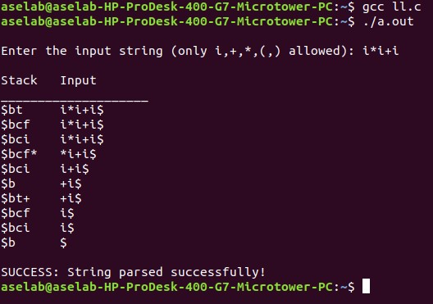

**Result :** Thus, the program to implement LL(1) has been successfully executed.

# Experiment No. : 4

**Aim :** To write a program in YACC for parser generation.

**Algorithm :**

1. Get the input from the user and Parse it token by token.
2. First identify the valid inputs that can be given for a program.
3. Define the precedence and the associativity of various operators like +,-,/,* etc.4) Write codes for saving the answer into memory and displaying the result on the screen.
4. Write codes for performing various arithmetic operations.
5. Display the possible Error message that can be associated with this calculation.7) Display the output on the screen else display the error message on the screen

**Code : calc.y**

%{

#include <stdio.h> #include <ctype.h> int yylex(void); void yyerror(const char *s);

#define YYSTYPE double

%}

%token NUMBER

%left '+' '-'

%left '*' '/'

%right UMINUS %%

lines:

lines expr '\n' { printf("Result: %g\n", $2); }

| lines '\n'

| /* empty */

;

expr:

expr '+' expr { $$ = $1 + $3; } | expr '-' expr { $$ = $1 - $3; }

| expr '*' expr { $$ = $1 * $3; }

| expr '/' expr { if ($3 == 0) { yyerror("Division by zero");

$$ = 0;

} else {

$$ = $1 / $3;

}

}

| '(' expr ')' { $$ = $2; }

| '-' expr %prec UMINUS { $$ = -$2; }

| NUMBER

;

%%

// Simple lexer int yylex(void) {

int c;

// Skip whitespace

while ((c = getchar()) == ' ' || c == '\t');

// Handle numbers

if (c == '.' || isdigit(c)) { ungetc(c, stdin); scanf("%lf", &yylval); return NUMBER;

}

return c;

}

// Error handling void yyerror(const char *s) { fprintf(stderr, "Error: %s\n", s);

}

int yywrap() { return 1;

}

int main() { printf("Enter expressions (CTRL+D to quit):\n"); yyparse(); return 0;

}

**Output :**

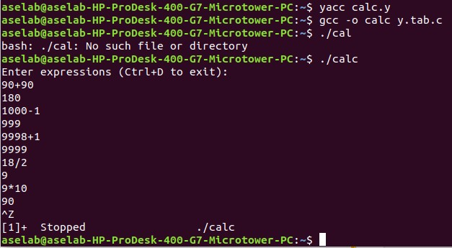

**Result :** Thus the program in YACC for parser generation has been executed successfully.

# Experiment No. : 5

**Aim :** To implement Symbol Table.

**Algorithm :**

1. Start the Program.
2. Get the input from the user with the terminating symbol ‘$’.
3. Allocate memory for the variable by dynamic memory allocation function.
4. If the next character of the symbol is an operator then only the memory is allocated.
5. While reading, the input symbol is inserted into symbol table along with its memory address.
6. The steps are repeated till “$” is reached.
7. To reach a variable, enter the variable to the searched and symbol table has been.
8. Checked for corresponding variable, the variable along its address is displayed as result.
9. Stop the program

**Code :**

**symbol_table.c**

#include <stdio.h>

#include <stdlib.h>

#include <string.h>

#include <ctype.h>

void main() {

int x = 0, n, i = 0, j = 0;

void *mypointer, *symbol_address[100];

char ch, search_char, input_expr[100], symbol_list[100], c;

printf("Input the expression ending with $ sign:\n");

// Read characters until '$'

while ((c = getchar()) != '$') {

input_expr[i++] = c;

}

n = i - 1;

// Display given expression

printf("\nGiven Expression: ");

for (i = 0; i <= n; i++) {

printf("%c", input_expr[i]);

}

// Display symbol table

printf("\n\nSymbol Table\n");

printf("Symbol\tAddress\t\tType\n");

while (j <= n) {

c = input_expr[j];

// If it's an alphabet, it's an identifier

if (isalpha(c)) {

mypointer = malloc(sizeof(char)); // allocate 1 byte

symbol_address[x] = mypointer;

symbol_list[x] = c;

printf("%c\t%p\tidentifier\n", c, mypointer);

x++;

}

// If it's an operator

else if (c == '+' || c == '-' || c == '*' || c == '=') {

mypointer = malloc(sizeof(char)); // allocate 1 byte

symbol_address[x] = mypointer;

symbol_list[x] = c;

printf("%c\t%p\toperator\n", c, mypointer);

x++;

}

j++;

}

}**Output :**

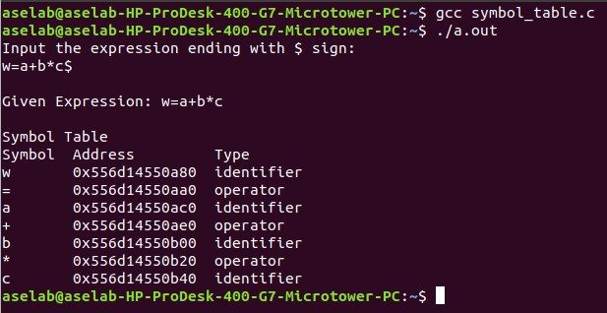

**Result :** Thus the program to implement symbol table has been executed successfully.

# Experiment No. : 6

**Aim :** To implementation of intermediate code generation.

**Algorithm :**

1) Take the parse tree tokens from the syntax analyser. 2) Generate intermediate code using temp variable

3) Assign the final temp variable to initial variable **Code :**

**icg.c**

#include <stdio.h>

#include <stdlib.h>

#include <string.h>

int i = 1, j = 0, no = 0, tmpch = 'Z';

char str[100], left[15], right[15];

struct exp {

int pos;

char op;

} k[15];

void findopr();

void explore();

void fleft(int);

void fright(int);

void main() {

printf("\t\tINTERMEDIATE CODE GENERATION\n\n");

printf("Enter the Expression (no spaces, like a=b+c*d): ");

scanf("%s", str);

printf("\nIntermediate Code:\n");

findopr();

explore();

}

void findopr() {

for (i = 0; str[i] != '\0'; i++) {

if (str[i] == '=') {

k[j].pos = i;

k[j++].op = '=';

}

}

for (i = 0; str[i] != '\0'; i++) {

if (str[i] == '/' || str[i] == '*') {

k[j].pos = i;

k[j++].op = str[i];

}

}

for (i = 0; str[i] != '\0'; i++) {

if (str[i] == '+' || str[i] == '-') {

k[j].pos = i;

k[j++].op = str[i];

}

}

}

void explore() {

i = 1;

while (k[i].op != '\0') {

fleft(k[i].pos);

fright(k[i].pos);

str[k[i].pos] = tmpch;

printf("\t%c := %s %c %s\n", tmpch, left, k[i].op, right);

tmpch--;

i++;

}

fright(-1);

if (no == 0) {

fleft(strlen(str));

printf("\t%s := %s\n", right, left);

exit(0);

}

printf("\t%s := %c\n", right, str[k[--i].pos]);

}

void fleft(int x) {

int w = 0, flag = 0;

x--;

while (x != -1 && str[x] != '+' && str[x] != '-' && str[x] != '*' &&

str[x] != '/' && str[x] != '=' && str[x] != '\0') {

if (str[x] != '$' && flag == 0) {

left[w++] = str[x];

left[w] = '\0';

str[x] = '$';

flag = 1;

}

x--;

}

}

void fright(int x) {

int w = 0, flag = 0;

x++;

while (x != -1 && str[x] != '+' && str[x] != '-' && str[x] != '*' &&

str[x] != '/' && str[x] != '=' && str[x] != '\0') {

if (str[x] != '$' && flag == 0) {

right[w++] = str[x];

right[w] = '\0';

str[x] = '$';

flag = 1;

}

x++;

}

}

**Output :**

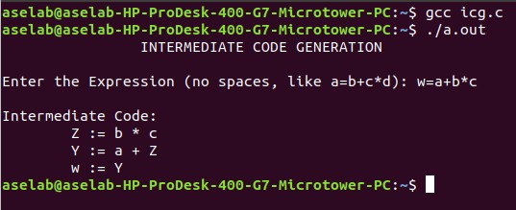

**Result :** Thus, the program to implement intermediate code generation has been executed successfully.

# Experiment No. : 7

**Aim :** To implementation of Code Optimization Techniques

**Algorithm :**

1. Start the program
2. Declare the variables and functions.
3. Enter the expression and state it in the variable a, b, c. 24
4. Calculate the variables b & c with ‘temp’ and store it in f1 and f2.
5. If(f1=null && f2=null) then expression could not be optimized.
6. Print the results.
7. Stop the program.

**Code :**

**code_optimization.c**

#include <stdio.h>

#include <string.h>

struct op {

char l;

char r[20];

} op[10], pr[10];

void main() {

int i, j, k, m, n, z = 0, a, q;

char temp, t;

char *p, *l, *tem;

printf("Enter the Number of Expressions: ");

scanf("%d", &n);

for (i = 0; i < n; i++) {

printf("Left: ");

scanf(" %c", &op[i].l);

printf("Right: ");

scanf(" %s", op[i].r);

}

printf("\nIntermediate Code:\n");

for (i = 0; i < n; i++) {

printf("%c = %s\n", op[i].l, op[i].r);

}

// Dead Code Elimination

for (i = 0; i < n - 1; i++) {

temp = op[i].l;

for (j = 0; j < n; j++) {

p = strchr(op[j].r, temp);

if (p) {

pr[z].l = op[i].l;

strcpy(pr[z].r, op[i].r);

z++;

break;

}

}

}

// Always keep the last instruction

pr[z].l = op[n - 1].l;

strcpy(pr[z].r, op[n - 1].r);

z++;

printf("\nAfter Dead Code Elimination:\n");

for (k = 0; k < z; k++) {

printf("%c = %s\n", pr[k].l, pr[k].r);

}

// Common Subexpression Elimination

for (m = 0; m < z; m++) {

tem = pr[m].r;

for (j = m + 1; j < z; j++) {

p = strstr(tem, pr[j].r);

if (p) {

t = pr[j].l;

pr[j].l = pr[m].l;

for (i = 0; i < z; i++) {

l = strchr(pr[i].r, t);

if (l) {

a = l - pr[i].r;

pr[i].r[a] = pr[m].l;

}

}

}

}

}

printf("\nAfter Common Subexpression Elimination:\n");

for (i = 0; i < z; i++) {

printf("%c = %s\n", pr[i].l, pr[i].r);

}

// Remove duplicates

for (i = 0; i < z; i++) {

for (j = i + 1; j < z; j++) {

q = strcmp(pr[i].r, pr[j].r);

if ((pr[i].l == pr[j].l) && !q) {

pr[i].l = '\0'; // Mark for deletion

}

}

}

printf("\nOptimized Code:\n");

for (i = 0; i < z; i++) {

if (pr[i].l != '\0') {

printf("%c = %s\n", pr[i].l, pr[i].r);

}

}

}

**Output :**

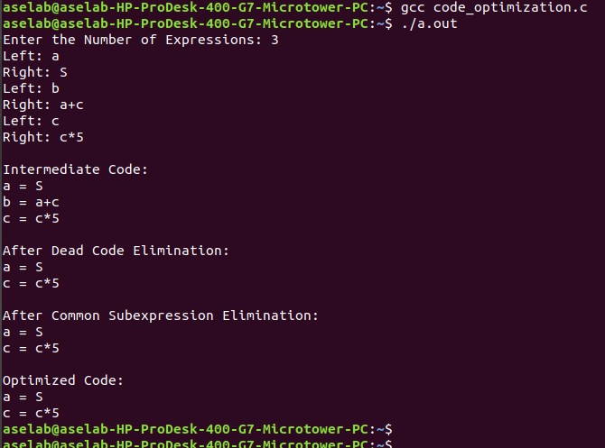

**Result :** Thus, the program to implement code optimization has been executed successfully.

# Experiment No. : 8

**Aim :** To write a program that implements the target code generation

**Algorithm :**

1. Read input string
2. Consider each input string and convert it to machine code instructions using switch case
3. Load the input variables into new variables as operands and display them using “load”
4. With the help of arithmetic operation, we will display arithmetic operations like add, sub, div, mul for the respective operations in switch case
5. Generate 3 address code for each input variable.
6. If ‘=‘ is seen as arithmetic operation, then store the result in a variable and display it with “store”.
7. Repeat this for each line in the input string.
8. Display the output which gives a transformed input string of assembly language code.

**Code :**

**1. target.c**

#include <stdio.h>

#include <stdlib.h>

#include <string.h>

int label[20];

int no = 0;

int check_label(int k) {

int i;

for (i = 0; i < no; i++) {

if (k == label[i])

return 1;

}

return 0;

}

int main() {

FILE *fp1, *fp2;

char fname[10], op[10], ch;

char operand1[8], operand2[8], result[8];

int i = 0, j = 0;

printf("\nEnter filename of the intermediate code: ");

scanf("%s", fname);

fp1 = fopen(fname, "r");

fp2 = fopen("target.txt", "w");

if (fp1 == NULL || fp2 == NULL) {

printf("\nError opening the file");

exit(0);

}

while (!feof(fp1)) {

fprintf(fp2, "\n");

fscanf(fp1, "%s", op);

i++;

if (check_label(i))

fprintf(fp2, "\nlabel#%d", i);

if (strcmp(op, "print") == 0) {

fscanf(fp1, "%s", result);

fprintf(fp2, "\n\tOUT %s", result);

}

if (strcmp(op, "goto") == 0) {

fscanf(fp1, "%s %s", operand1, operand2);

fprintf(fp2, "\n\tJMP %s, label#%s", operand1, operand2);

label[no++] = atoi(operand2);

}

if (strcmp(op, "[]=") == 0) {

fscanf(fp1, "%s %s %s", operand1, operand2, result);

fprintf(fp2, "\n\tSTORE %s[%s], %s", operand1, operand2, result);

}

if (strcmp(op, "uminus") == 0) {

fscanf(fp1, "%s %s", operand1, result);

fprintf(fp2, "\n\tLOAD -%s, R1", operand1);

fprintf(fp2, "\n\tSTORE R1, %s", result);

}

switch (op[0]) {

case '*':

fscanf(fp1, "%s %s %s", operand1, operand2, result);

fprintf(fp2, "\n\tLOAD %s, R0", operand1);

fprintf(fp2, "\n\tLOAD %s, R1", operand2);

fprintf(fp2, "\n\tMUL R1, R0");

fprintf(fp2, "\n\tSTORE R0, %s", result);

break;

case '+':

fscanf(fp1, "%s %s %s", operand1, operand2, result);

fprintf(fp2, "\n\tLOAD %s, R0", operand1);

fprintf(fp2, "\n\tLOAD %s, R1", operand2);

fprintf(fp2, "\n\tADD R1, R0");

fprintf(fp2, "\n\tSTORE R0, %s", result);

break;

case '-':

fscanf(fp1, "%s %s %s", operand1, operand2, result);

fprintf(fp2, "\n\tLOAD %s, R0", operand1);

fprintf(fp2, "\n\tLOAD %s, R1", operand2);

fprintf(fp2, "\n\tSUB R1, R0");

fprintf(fp2, "\n\tSTORE R0, %s", result);

break;

case '/':

fscanf(fp1, "%s %s %s", operand1, operand2, result);

fprintf(fp2, "\n\tLOAD %s, R0", operand1);

fprintf(fp2, "\n\tLOAD %s, R1", operand2);

fprintf(fp2, "\n\tDIV R1, R0");

fprintf(fp2, "\n\tSTORE R0, %s", result);

break;

case '%':

fscanf(fp1, "%s %s %s", operand1, operand2, result);

fprintf(fp2, "\n\tLOAD %s, R0", operand1);

fprintf(fp2, "\n\tLOAD %s, R1", operand2);

fprintf(fp2, "\n\tDIV R1, R0");

fprintf(fp2, "\n\tSTORE R0, %s", result);

break;

case '=':

fscanf(fp1, "%s %s", operand1, result);

fprintf(fp2, "\n\tSTORE %s, %s", operand1, result);

break;

case '>':

j++;

fscanf(fp1, "%s %s %s", operand1, operand2, result);

fprintf(fp2, "\n\tLOAD %s, R0", operand1);

fprintf(fp2, "\n\tJGT %s, label#%s", operand2, result);

label[no++] = atoi(result);

break;

case '<':

fscanf(fp1, "%s %s %s", operand1, operand2, result);

fprintf(fp2, "\n\tLOAD %s, R0", operand1);

fprintf(fp2, "\n\tJLT %s, label#%s", operand2, result);

label[no++] = atoi(result);

break;

}

}

fclose(fp2);

fclose(fp1);

fp2 = fopen("target.txt", "r");

if (fp2 == NULL) {

printf("Error opening the file\n");

exit(0);

}

do {

ch = fgetc(fp2);

printf("%c", ch);

} while (ch != EOF);

fclose(fp2);

return 0;

}}

**2. Input.txt**

/t3 t2 t2 uminus t2 t2 print t2 +t1 t3 t4 print t4

**Output :**

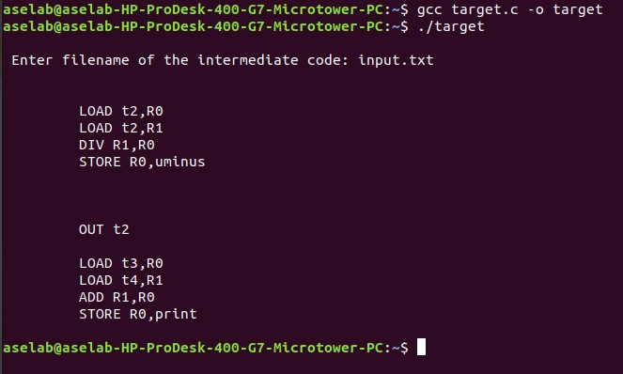

**Result :** Thus, the program to implement target code generation has been successfully executed.