**CS18412 COMPUTER NETWORKS LABORATORY**

**EX.NO:**

**DATE:**

**TITLE OF THE EXERCISE**

**AIM:**

**ALGORITHM:**

**CLIENT**

1. START
2. Create Instance for Socket Class by passing localhost and server port number in the parameterized constructor.
3. Create instance for DataOutputStream class,DataInputStream class.
4. Recive the message from server by using readUTF() method of DataInputStream.
5. Print the recived messsage.
6. Get the message to be sent using Scanner class object.
7. Send the message to the server by calling writeUTF() method of DataOutputStream .
8. Close the connection.
9. STOP

**SERVER**

1. START
2. Create instance for ServerSocket class,Socket class and DataInputStream class and DataOutputStream class
3. Initialize the ServerSocket instance by passing the port number as the parameter.
4. Initialize the Socket instance by calling accept() method of ServerSocket class.
5. Read the message to be sent by using Scanner class object.
6. Send the message to the client by using writeUTF() method of DataOutputStream class.
7. Create a string variable to hold the recived message.
8. Get the recived message by calling readUTF() method of DataInputStream class.
9. Print the recived message.
10. Close the connection
11. STOP

**PROGRAM:**

**SERVER**

import java.util.*;

import java.net.*;

import java.io.*;

class Server

{

static ServerSocket serversocket;

static Socket socket;

static Scanner scan;

static DataOutputStream dout;

static DataInputStream din;

static String message;

static String rmessage;

public static void main(String []args)

{

try

{

serversocket=new ServerSocket(4000);

socket=serversocket.accept();

scan=new Scanner(System.in);

dout=new DataOutputStream(socket.getOutputStream());

din=new DataInputStream(socket.getInputStream());

while(true)

{

System.out.print("Enter the messsage: ");

message=scan.nextLine();

if(message.equalsIgnoreCase("bye"))

{

break;

}

dout.writeUTF(message);

rmessage=din.readUTF();

System.out.print("Recived message: "+rmessage+"\n");

}

System.out.println("Connection closed");

socket.close();

}

catch(Exception e)

{

System.out.println(" client has left the chat");

}

}

}

**CLIENT**

import java.util.*;

import java.net.*;

import java.io.*;

class Client

{

static Socket socket;

static Scanner scan;

static DataOutputStream dout;

static DataInputStream din;

static String message;

static String rmessage;

public static void main(String []args)

{

try

{

socket=new Socket("localhost",4000);

scan=new Scanner(System.in);

dout=new DataOutputStream(socket.getOutputStream());

din=new DataInputStream(socket.getInputStream());

System.out.println("Waiting for server to join the chat");

while(true)

{

rmessage=din.readUTF();

System.out.print("Recived message: "+rmessage+"\n");

System.out.print("Enter the messsage: ");

message=scan.nextLine();

if(message.equalsIgnoreCase("bye"))

{

break;

}

dout.writeUTF(message);

}

System.out.println("Connection closed");

socket.close();

}

catch(Exception e)

{

System.out.println(e.toString());

}

}

}

**SAMPLE INPUT AND OUTPUT:**

CLIENT

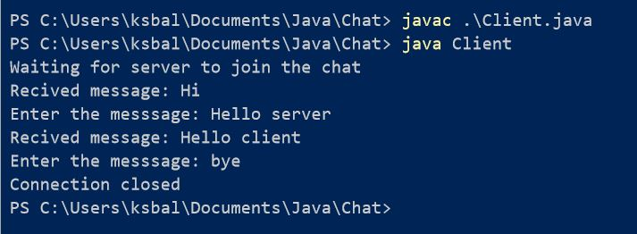

SERVER

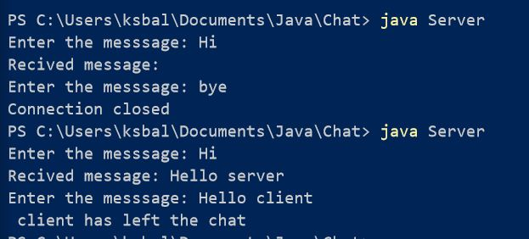

**RESULT:**