**CS18412 COMPUTER NETWORKS LABORATORY**

**EX.NO:**

**DATE:**

**TITLE OF THE EXERCISE**

**AIM:**

**ALGORITHM:**

**CLIENT**

1. START
2. Create Instance for Socket Class by passing localhost and server port number in the parameterized constructor.
3. Create instance for DataOutputStream class
4. Get the message to be sent using Scanner class object
5. Send the message to the server by calling writeUTF() method of DataOutputStream class.
6. Close the connection.
7. STOP

**SERVER**

1. START
2. Create instance for ServerSocket class,Socket class and DataInputStreamClass.
3. Initialize the ServerSocket instance by passing the port number as the parameter.
4. Initialize the Socket instance by calling accept() method of ServerSocket class.
5. Create a string variable to hold the recived message.
6. Get the recived message by calling readUTF() method of DataInputStream class.
7. Print the recived message.
8. Close the connection
9. STOP

**PROGRAM:**

**SERVER**

import java.net.*;

import java.io.*;

import java.util.*;

class Server

{

static ServerSocket serversocket;

static Socket socket;

static DataInputStream din;

static String rmessage;

public static void main(String[] args)

{

try

{

serversocket = new ServerSocket(1234);

socket=serversocket.accept();

din = new DataInputStream(socket.getInputStream());

rmessage = din.readUTF();

System.out.println("Message from Client "+socket.getInetAddress());

System.out.println(rmessage);

serversocket.close();

}

catch(Exception e)

{

System.out.print(e.toString());

}

}

}

**CLIENT**

import java.net.*;

import java.io.*;

import java.util.*;

class Client{

static Socket socket;

static Scanner scan;

static DataOutputStream dout;

static String message;

public static void main(String[] args)

{

try

{

socket = new Socket("localhost",1234);

scan = new Scanner(System.in);

dout = new DataOutputStream(socket.getOutputStream());

System.out.println("Enter the message to server");

message = scan.nextLine();

dout.writeUTF(message);

socket.close();

}

catch(Exception e)

{

System.out.println(e.toString());

}

}

}

**SAMPLE INPUT AND OUTPUT:**

CLIENT

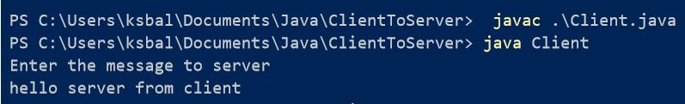

SERVER



**RESULT:**