**CS18412 COMPUTER NETWORKS LABORATORY**

**EX.NO:**

**DATE:**

**ECHO CLIENT**

**AIM:**

**ALGORITHM:**

**CLIENT**

1. START
2. Create Instance for Socket Class by passing localhost and server port number in the parameterized constructor.
3. Create instance for DataOutputStream class and DataInputStream class.
4. Get the recived message by calling readUTF() method of DataInputStream class.
5. Print the recived message.
6. Echo back the message to Client by using writeUTF() method of DataOutputStream class.
7. Close the connection
8. STOP

**SERVER**

1. START
2. Create instance for ServerSocket class,Socket class and DataInputStream class.
3. Initialize the ServerSocket instance by passing the port number as the parameter.
4. Initialize the Socket instance by calling accept() method of ServerSocket class.
5. Create a string variable to hold the recived message.
6. Create instance for DataOutputStream class.
7. Get the message to be sent using Scanner class object
8. Send the message to the server by calling writeUTF() method of DataOutputStream class.
9. Recive the echoed message by using readUTF() method of DataInputStream class.
10. Print the echoed message.
11. Close the connection.
12. STOP

**PROGRAM:**

**SERVER**

import java.util.*;

import java.net.*;

import java.io.*;

class Server

{

static ServerSocket serversocket;

static DataOutputStream dout;

static DataInputStream din;

static Socket socket;

static Scanner scan;

public static void main(String[] args)

{

try

{

serversocket = new ServerSocket(1234);

socket=serversocket.accept();

scan=new Scanner(System.in);

dout=new DataOutputStream(socket.getOutputStream());

din=new DataInputStream(socket.getInputStream());

System.out.println("Enter the message to client");

String message=scan.next();

dout.writeUTF(message);

System.out.println("Echoed message");

System.out.println(din.readUTF());

}

catch(Exception e)

{

System.out.println(e.toString());

}

}

}

**CLIENT**

import java.util.*;

import java.net.*;

import java.io.*;

class Client

{

static DataOutputStream dout;

static DataInputStream din;

static Socket socket;

static Scanner scan;

public static void main(String[] args)

{

try

{

socket = new Socket("localhost",1234);

din = new DataInputStream(socket.getInputStream());

dout = new DataOutputStream(socket.getOutputStream());

System.out.println("Message from server");

String m = din.readUTF();

System.out.println(m);

dout.writeUTF(m);

socket.close();

}

catch(Exception e)

{

System.out.println(e.toString());

}

}

}

**SAMPLE INPUT AND OUTPUT:**

CLIENT

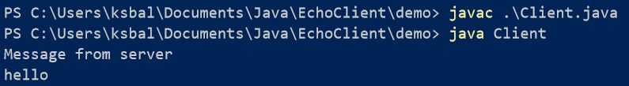

SERVER

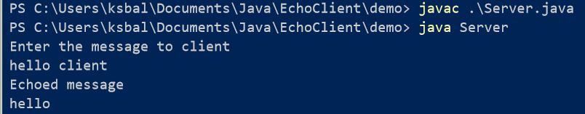

**RESULT:**