**CS18412 COMPUTER NETWORKS LABORATORY**

**EX.NO:**

**DATE:**

**TITLE OF THE EXERCISE**

**AIM:**

**ALGORITHM:**

**CLIENT**

1. START
2. Create Instance for Socket Class by passing localhost and server port number in the parameterized constructor.
3. Create instance for DataInputStream class.
4. Recive the message by using readUTF() method of DataInputStream class.
5. Print the recived message.
6. Close the connection.
7. STOP

**SERVER**

1. START
2. Create instance for ServerSocket class,Socket class and DataInputStreamClass.
3. Initialize the ServerSocket instance by passing the port number as the parameter.
4. Initialize the Socket instance by calling accept() method of ServerSocket class.
5. Create instance for DataOutputStream class
6. Get the message to be sent using Scanner class object.
7. Send the message to the server by calling writeUTF() method of DataOutputStream class.
8. Close the connection
9. STOP

**PROGRAM:**

**SERVER**

import java.util.*;

import java.io.*;

import java.net.*;

class Server

{

static DataOutputStream dout;

static ServerSocket serversocket;

static Socket s;

static Date d;

public static void main(String[] args)

{

try

{

serversocket = new ServerSocket(4000);

s=serversocket.accept();

dout=new DataOutputStream(s.getOutputStream());

d=new Date();

System.out.println("Sending message to client "+s.getInetAddress());

dout.writeUTF("DATE IS:"+d.toString());

//serversocket.close();

}

catch(Exception e)

{

System.out.println(e.toString());

}

}

}

**CLIENT**

import java.util.*;

import java.net.*;

import java.io.*;

class Client

{

static DataInputStream din;

static Socket socket;

public static void main(String[] args)

{

try

{

socket = new Socket("localhost",4000);

din = new DataInputStream(socket.getInputStream());

System.out.println("Message from server");

String rmessage = din.readUTF();

System.out.println(rmessage);

}

catch(Exception e)

{

System.out.println(e.toString());

}

}

}

**SAMPLE INPUT AND OUTPUT:**

CLIENT

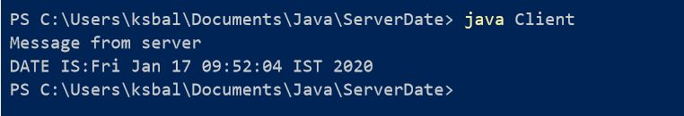

SERVER

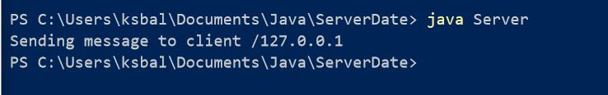

**RESULT:**