**IT18111 – PROGRAMMING FOR PROBLEM SOLVING LABORATORY**

**EX.NO:**

**DATE:**

**CS18412 COMPUTER NETWORKS LABORATORY**

**AIM:**

**ALGORITHM:**

**CLIENT**

1. START
2. Create Instance for Socket Class by passing localhost and server port number in the parameterized constructor.
3. Create instance for DataInputStream class
4. Get the message to be sent by using readUTF() method of DataInputStream class.
5. Print the recived message.
6. Close the connection.
7. STOP

**SERVER**

1. START
2. Create instance for ServerSocket class,Socket class and DataOutputStream Class.
3. Initialize the ServerSocket instance by passing the port number as the parameter.
4. Initialize the Socket instance by calling accept() method of ServerSocket class.
5. Read the message to be sent using Scanner class.
6. Send the message to the client by using writeUTF() method of DataOutputStream class.
7. Close the connection
8. STOP

**PROGRAM:**

**SERVER**

import java.net.*;

import java.io.*;

import java.util.*;

class Server2

{

static ServerSocket serversocket;

static Scanner scan;

static Socket socket;

static DataOutputStream dout;

static String message;

public static void main(String[] args)

{

try

{

serversocket = new ServerSocket(1234);

socket=serversocket.accept();

scan = new Scanner(System.in);

dout = new DataOutputStream(socket.getOutputStream());

System.out.println("Enter the message to Client "+socket.getInetAddress());

message=scan.nextLine();

dout.writeUTF(message);

serversocket.close();

}

catch(Exception e)

{

System.out.print(e.toString());

}

}

}

**CLIENT**

import java.net.*;

import java.io.*;

import java.util.*;

class Client2{

static Socket socket;

static Scanner scan;

static DataInputStream din;

static String message;

public static void main(String[] args)

{

try

{

socket = new Socket("localhost",1234);

scan = new Scanner(System.in);

din = new DataInputStream(socket.getInputStream());

message = din.readUTF();

System.out.println("Message From server "+message);

socket.close();

}

catch(Exception e)

{

System.out.println(e.toString());

}

}

}

**SAMPLE INPUT AND OUTPUT:**

CLIENT

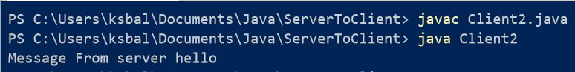

SERVER

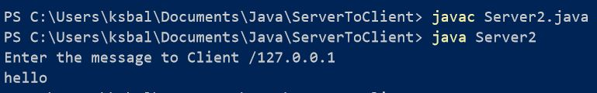

**RESULT:**