Game Design Document

Fill up the following document

1. Write the title of your project.

Shooting Range

1. What is the goal of the game?

At the starting of the game there will be a screen in which the player has a option to choose one of the 5 characters which are displayed. The goal of the game is to make sure that the player goes through levels and has to compete with NPC’s every level to advance. They will then reach the hardest level or the boss level and in order to win the game they need to defeat the boss.

1. Write a brief story of your game.

The brief story of my game is that there will be five levels with 5 NPC’s in each level. The name of the NPC in the first level is: John. The second level NPC’s name is: Matthew. The third level NPC’s name is: Brady. The fourth level NPC’s name is: Andrew. The last level which is the boss level and the name of that NPC is: King Jr.

1. Which are the playing characters of this game?

* Playing characters are the ones who respond to the user based on the input from the user.
* Cars, monkeys, dinos, wizards, etc., are the playing characters in the game.

|  |  |  |
| --- | --- | --- |
| Number | Character Name | What can this character do? |
| 1 | Michael | He has the extra strength power which gives him extra and a better firerate. |
| 2 | Mark | He has a fireproof suit and is protected against fireshots against the NPC’s and the boss. |
| 3 | Marcus | He has a stealth power so he is 50% less visible to enemies making it easier for attacks. |
| 4 | Mason | He has the power to make wind so when he uses his power he stuns the NPC’s for 5 seconds. |
| 5 |  |  |
| 6 |  |  |
| 7 |  |  |
| 8 |  |  |

1. Which are the Non-Playing Characters of this game?

* Non-Playing characters are the ones that don't have an action or behavior when the user interacts with the game.
* Hurdles, stones, bananas, coins, etc., are non-playing characters in the game.

|  |  |  |
| --- | --- | --- |
| Number | Character Name | What can this character do? |
| 1 | NPC 1,2,3,4 | This NPC has powers like rockets, lasers and ground attack power. The NPC’s will get harder every level that the player clears and once the player clears the level 4 NPC they will go on to the boss. |
| 2 | Sandbags | It will protect the player from the shots of the NPC. |
| 3 | NPC Level 5 | This is the boss NPC and if the player defeats him they win the game and the boss NPC has powers like sword attacks and stunning the player. |
| 4 | Shields | At the starting of the game the player will spawn with full shield and health and have 2 shields. Each shield that the player drinks will give them 50 shield. This will take 2 seconds to use. |
| 5 | Medkit | This medikit will be spawned along with the player and it will take 6 seconds to use. Once they use it the player can recover to full health. |
| 6 |  |  |
| 7 |  |  |
| 8 |  |  |

Draw your imagination of this game. What does this game look like?

* Draw the game either on your computer or on paper.
* Add images of the game scenes to show each of the playing and non-playing characters at least once.

NPC For Level 1,2,3,4

Mason

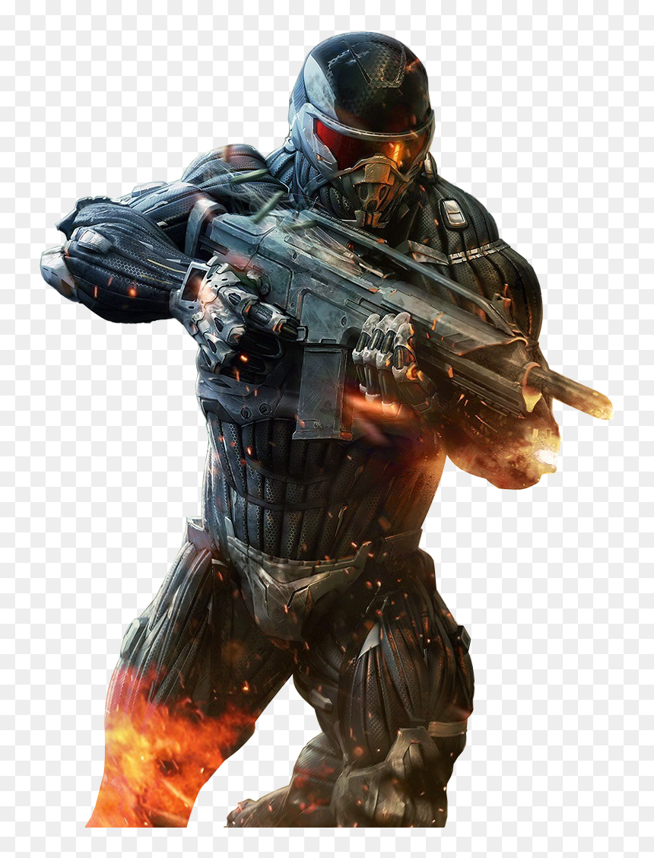

Mark

Marcus

Michael

Boss Image

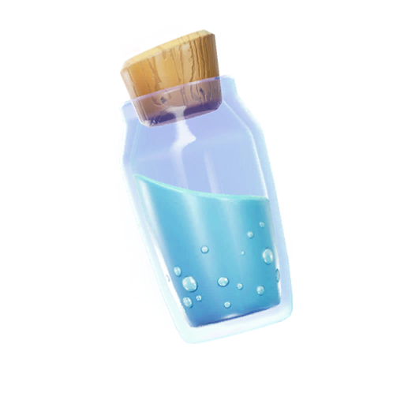

Shield Potion

Medkit

How do you plan to make your game engaging?

I plan to make the game engaging by letting the difficulty of the game get higher and more exciting for the player every time they enter a new level. Also, when the player is injured or hurt then they can use their heals which they get at spawn to help fight the boss longer.