physical networking 🡪connecting wires

logical networking 🡪based on ip addressing system

submarinecablemap.com

------------------------------------

<https://www.submarinecablemap.com/submarine-cable/south-atlantic-cable-system-sacs>

One region is connected using fibre optics

Internally network🡪Intranet

One Intranet is conneted with other is known as Internet

Connecting devices:

Workgroup mode:

No monitoring ,No administration,No security,No centralisation

client-server:

Adminstration,Centralisation

ipconfig🡪cmd

ncpa.cpl 🡪in wind+r

ping gateway(Check Network Connection)

or(domain /anything)

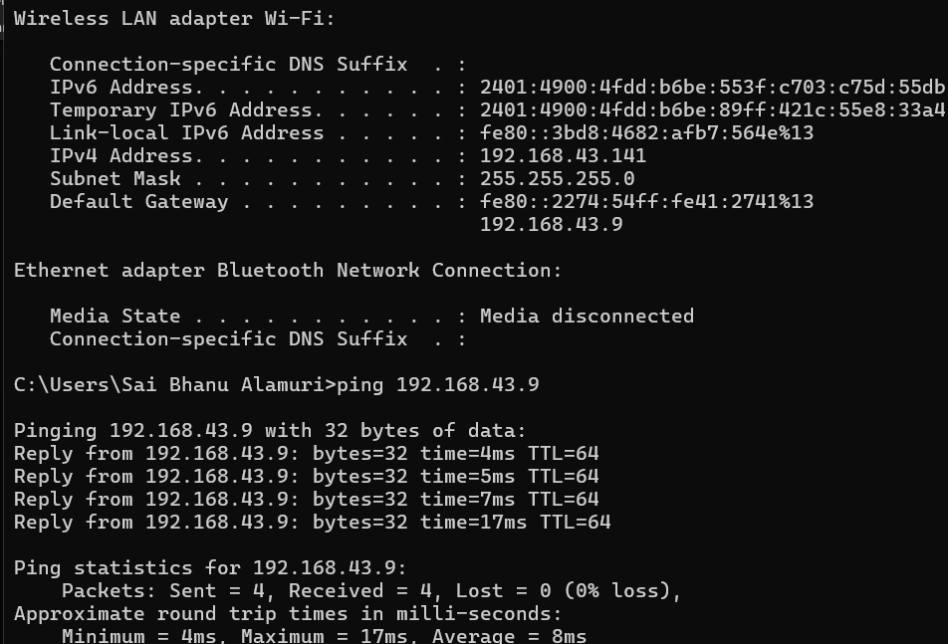

To disable firewall

start

firewall

check firewall status

Turn Windows Defender Firewall on or off:--

turn off

turn off

For sharing files /Directories with friends

Folder Level Sharing

Right Click

Properties

Sharing

Everyone

Enabling the service

sharing

manage advanced sharing settings

Private

Network discovery ON

file and printer sharing ON

PUBLIC

On/Off

On

ALL NETWORKS

On

On 🡪Off Disable password protected Sharing

ACCESS

[\\10.16.57.128](file:///\\10.16.57.128) 🡪In Wind+r

rdp -remote desktop protocol

give the access -take the access

settings

remote desktop settings

by default tuned off ,turn on

checkbox need to be disabled

remote desktop users

everyone

ACCESS

using run 🡪 mstsc

Give ipaddress of friend to connect

CLIENT-SERVER

Client-only access

Server-Give services

End Devices -pc,laptop,servers

intermediatory devices –Through which connection is happening(Switches,Routers,hub)

connections-cables,wired,wireless

Network Media

physical networking

Go To🡪netacad.com