**Python – Coding Challenge**

**Questions:**

1. **Explain pandas for data processing?**

Pandas is a popular open-source Python library used for data manipulation and analysis. It provides powerful data structures and functions designed to make working with structured data fast, easy, and expressive. This makes python highly flexible and extremely useful for data cleaning and manipulation. Pandas is highly flexible and provides functions for performing operations like merging, reshaping, joining, and concatenating data.

It provides powerful methods like read_csv (), .to_csv(), .head(), .tail(), .groupby (), . merge() and many more. It also have aggregation methods like sum, min, max, mean etc.

We can use them all just by importing the pandas. The most common way of importing pandas is ‘import pandas as pd’.

1. **Execute reading csv data using pandas?**

Below is the execution of the code that reads CSV data using pandas. I have used scores.csv file for the execution. And below is the scores.csv file.

Scores. csv

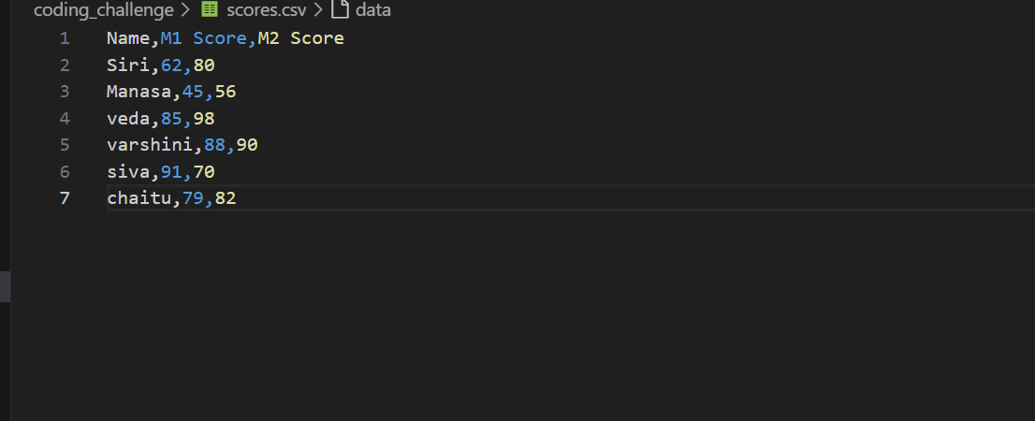

Execution:

I have used pd.read_csv() method to read the csv file and while printing I have used .head() method which prints the first five values in the file.

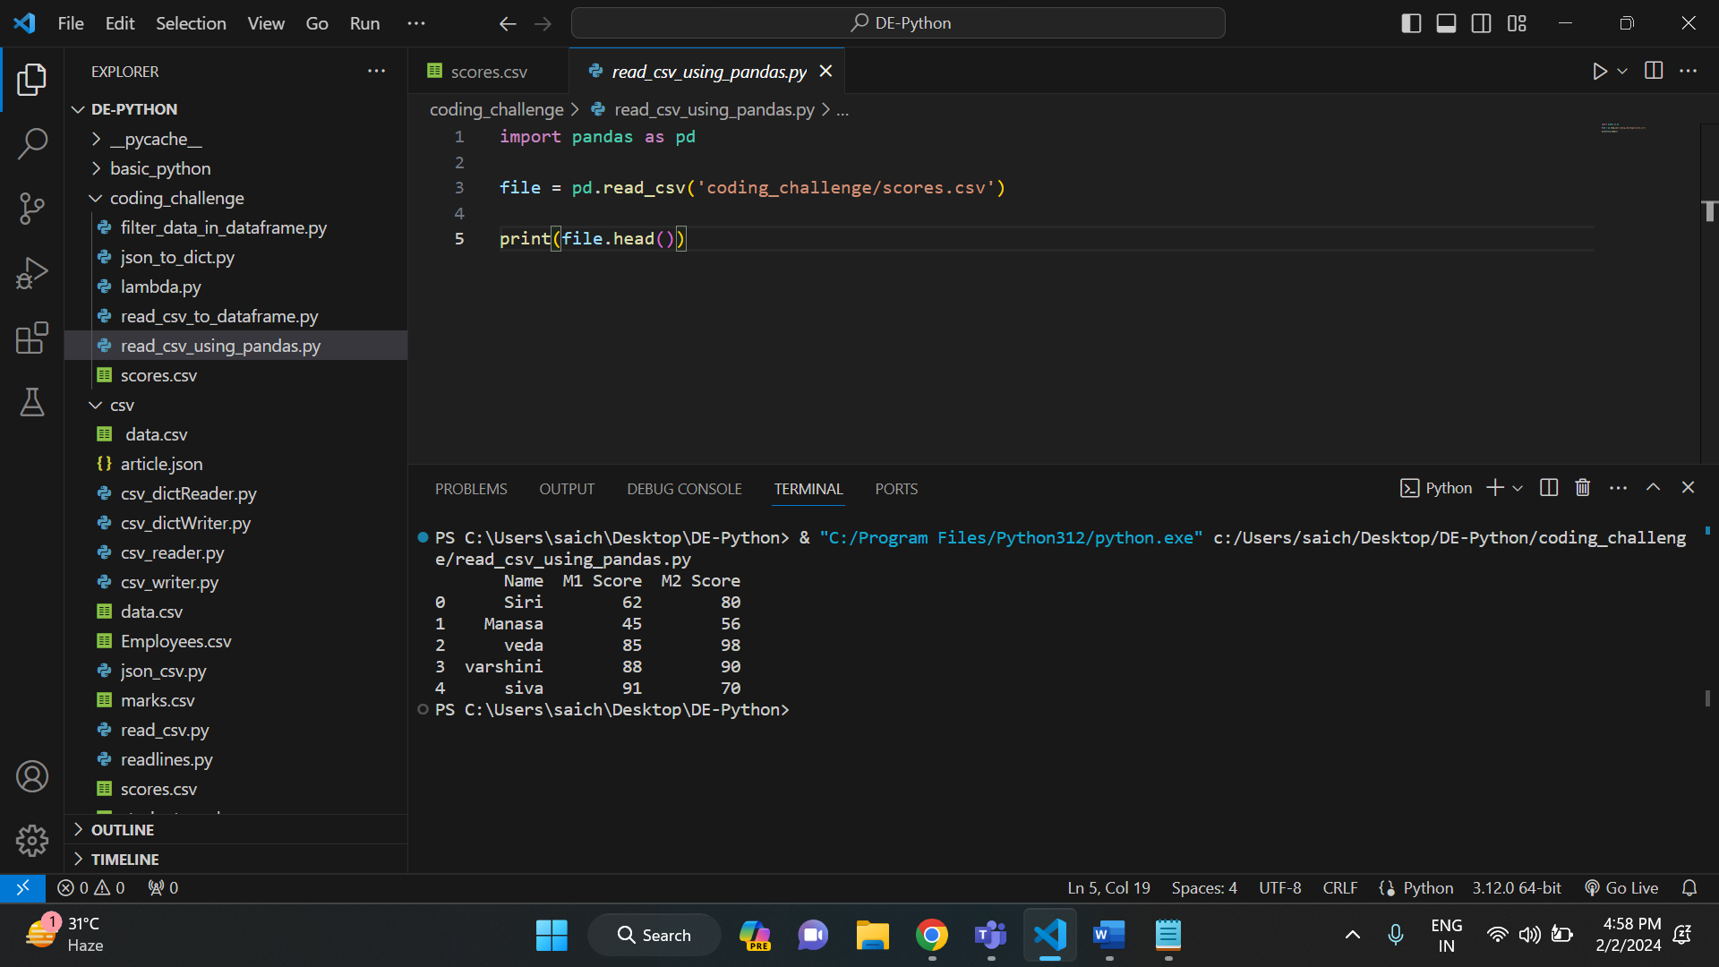

1. **Read Data from CSV Files to Pandas Dataframes:**

In pandas, we have dataframe () method which is used to create Dataframes. So, I have used that method to read the data which is in csv and convert it into pandas dataframes. And below is the execution illustrating the reading data from csv file to pandas dataframes.

Execution:

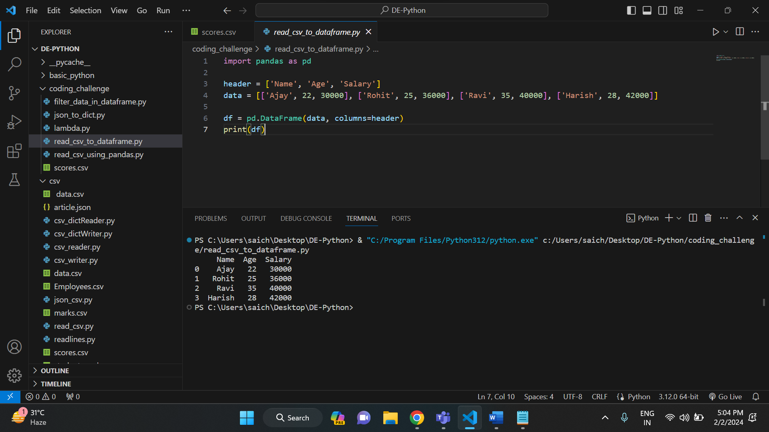

1. **Filter Data in Pandas Dataframe using query.**

In order to demonstrate it, I have taken an example and used to a query to filter the data inside it. Firstly, we need to create a pandas dataframe containing some values in it. Then we can query on that data. So, I have created a dataframe with employee’s details in it. And I have written some queries to filter the employee data based on age and salary.

In the first print statement, I have displayed the employees whose salary is greater than 13000.

And in the second print statement, I have displayed the employees whose age is greater than 25.

Execution:

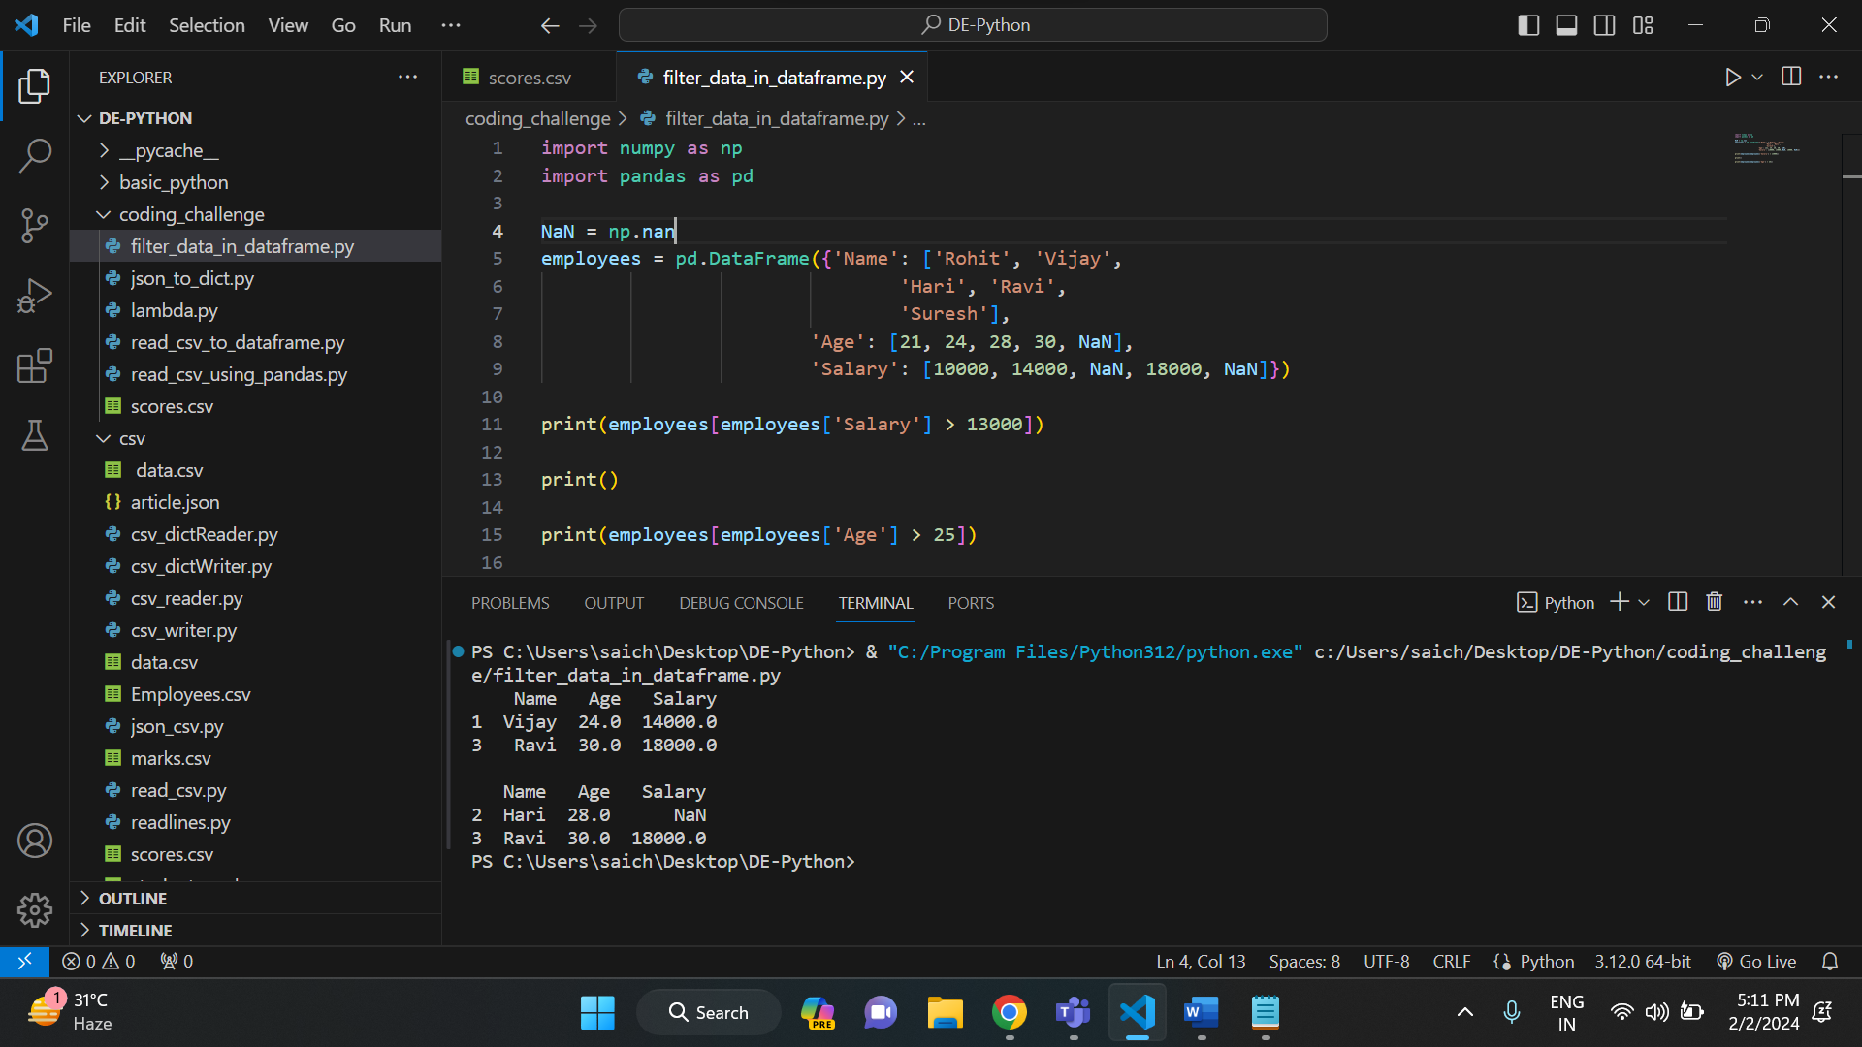

1. **Execute with one example Lambda Functions in Python**

Lambda functions in python are anonymous functions. They have no name. They are defined using the keyword lambda. Lambda functions can accept any number of arguments but it can have only one expression.

I have written a code to show the execution of lambda function. In that I have used a list which takes input values from the user. And the lambda function calculated the square root of all the values that are present in the list.

Execution:

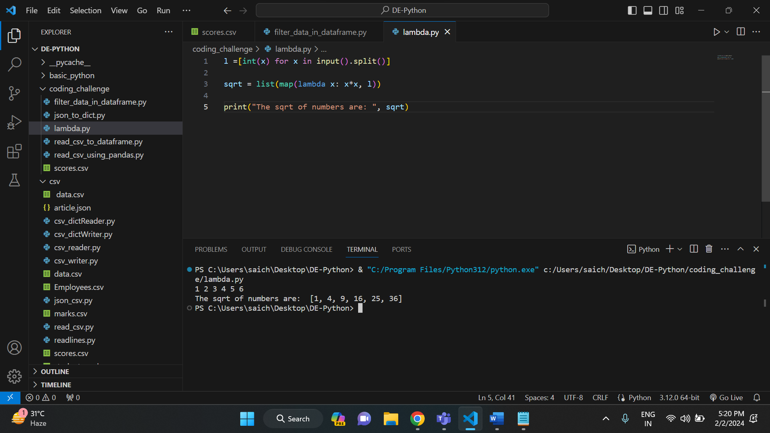

1. **Read JSON Strings to Python dicts or lists**

In order to read the JSON string, we have a method called .loads() in JSON. But in order to use that method, first we need to import JSON. Here in the below code, first I have imported JSON, and I have defined a JSON string. Then I have used the method to convert the JSON string to python dictionary.

Execution:

