**SQL – Coding Challenge (Question-1)**

**Question: 1**

* **OVER () and PARTITION BY clause:**

The over and partition by clause are used to perform calculations on a specific window of a data. These clauses are used together to define the scope of the window over which a particular calculation or aggregation is applied.

* The over () clause allows us to specific the partitioning, ordering and framing statements.
* The partition by clause is used to divide the result set into different partitions to which these window functions are applied independently.

Here is the execution of the over () and partition by clause.

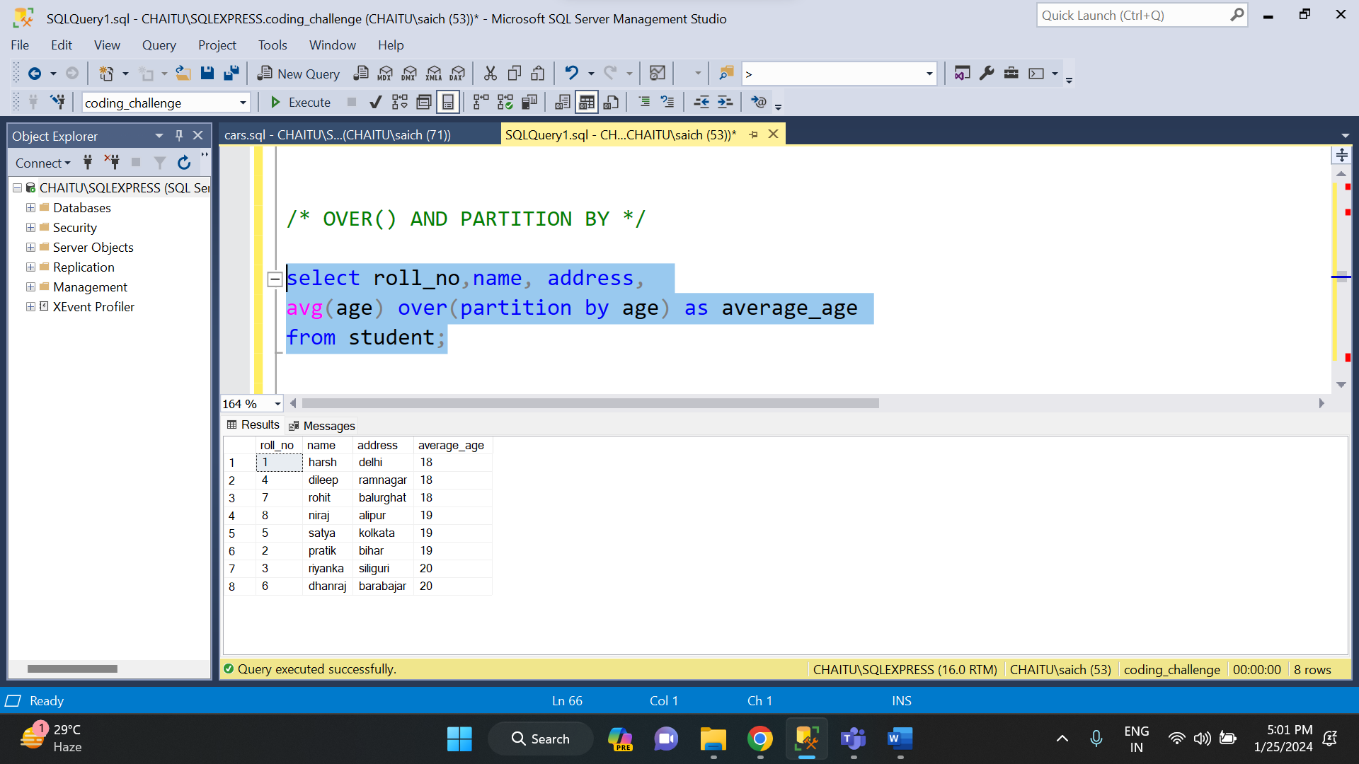

I have used the student table and have made partition on age column.

* **CREATING SUBTOTALS:**

A subtotal is a number that is formed by summing or adding similar sets of data. It only includes the summation of similar data but it does not include the final total. These subtotals are mainly used in sales and finance fields.

And in order to find the subtotal, we have to use rollup extension of group by clause. This rollup statement allows us to generate hierarchical subtotal rows according to the columns specified and it also adds a grand total row to the final result set.

In order to implement this subtotal, I have created a sales table and have inserted some records into it. Now based on the sales data, I will find the subtotal.

Here the execution on subtotal.

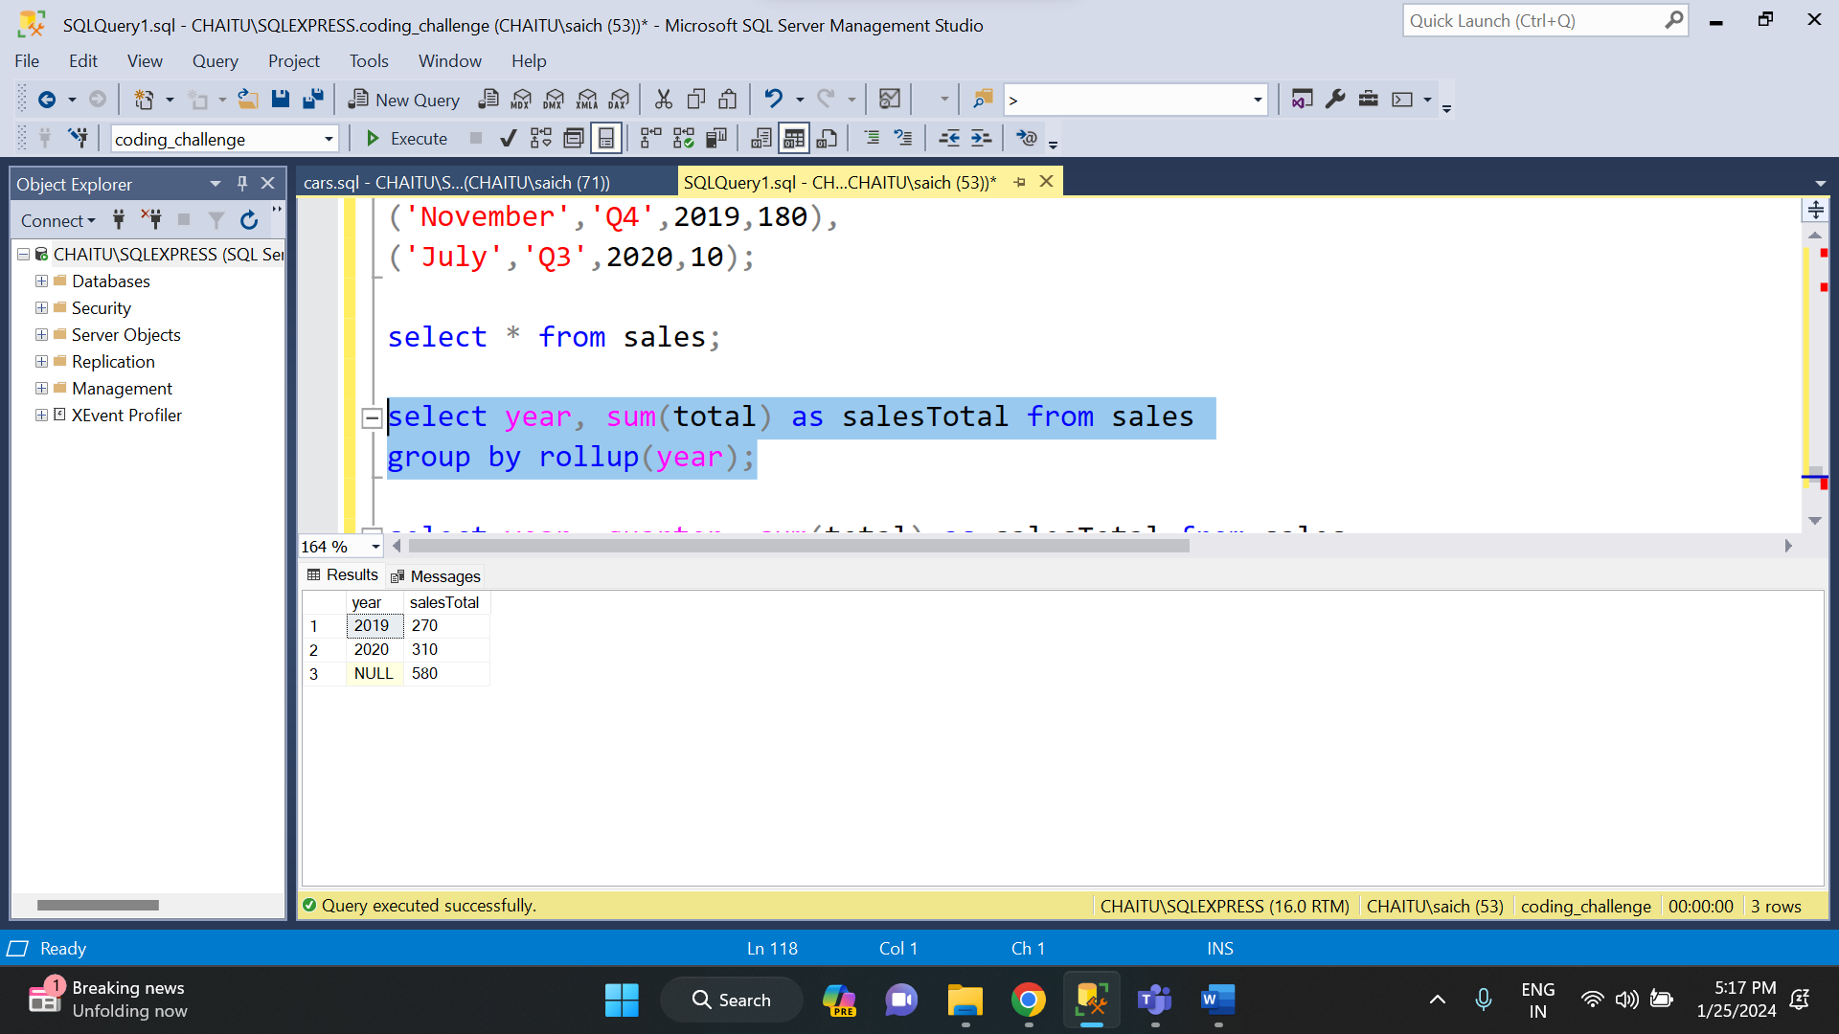

Based on the sales of a particular year, I have generated subtotals. There are two years (2019 and 2020) and subtotals for those years have been generated. And finally, the null value represents the final total of overall sales.

Here is another example of subtotal.

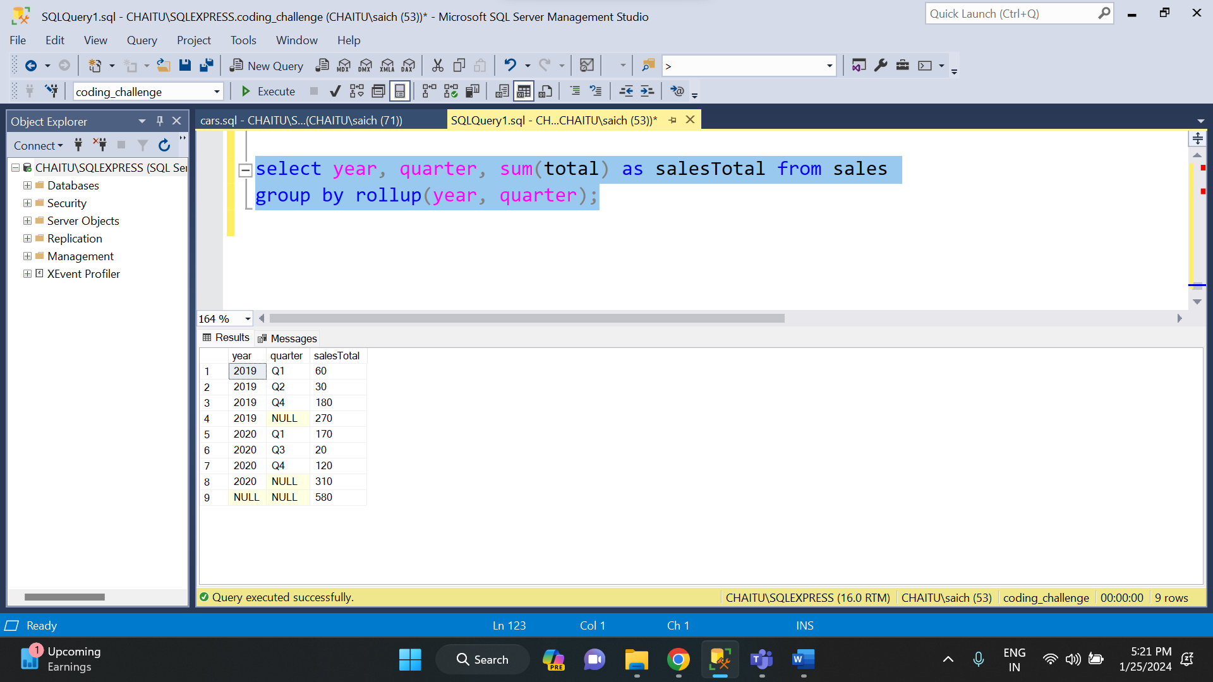

In the above example, I have displayed the sales according to quarter of that particular year and have calculated the subtotal for the year.

Here year, null represents subtotal,

Null, null represents grand total.

* **TOTAL AGGREGATIONS:**

Total aggregations are the aggregate functions combined with group by, order by etc. There are different aggregate functions in SQL. They are:

* AVG (): The average aggregate function is used to find the average of numeric values in a set.

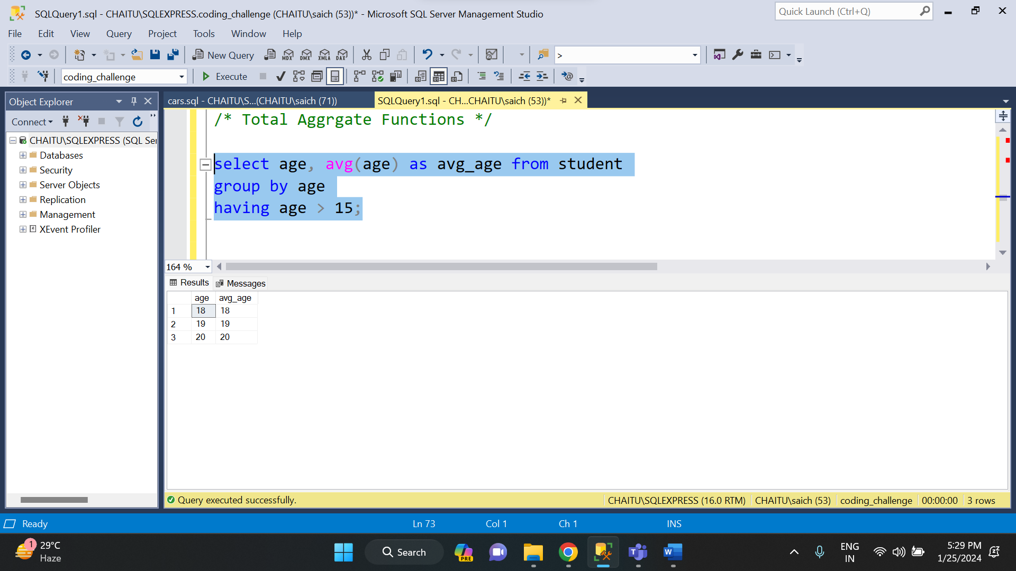

* COUNT (): This function is used to count the number of rows in a set.

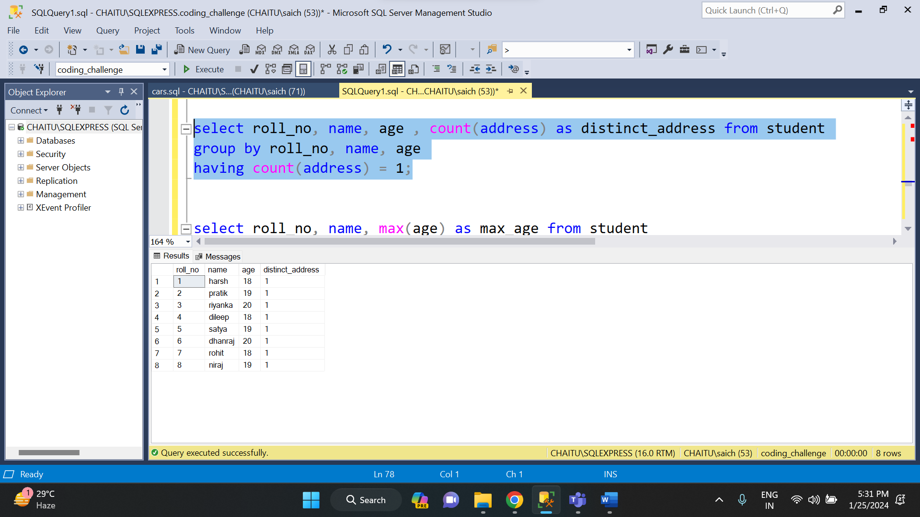

* MAX (): This function is used to return the maximum value in a set.

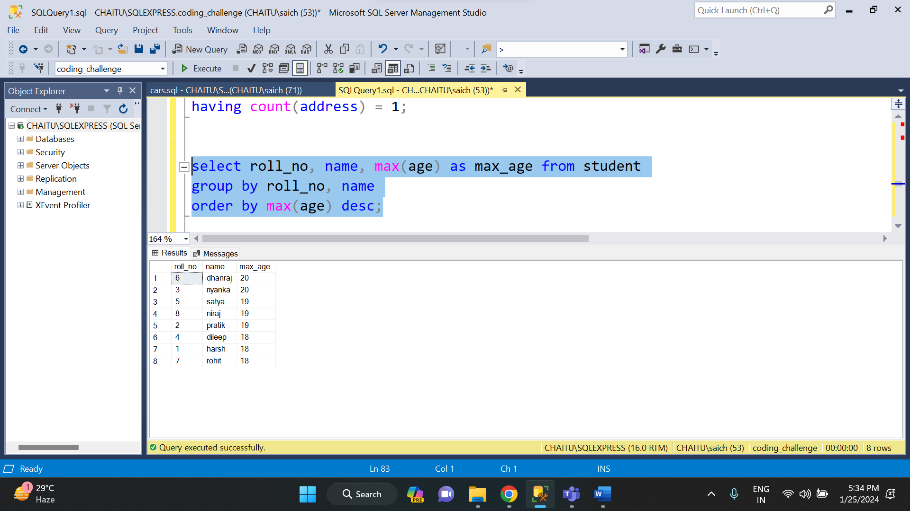

* MIN (): This function is used to return the minimum value in a set.

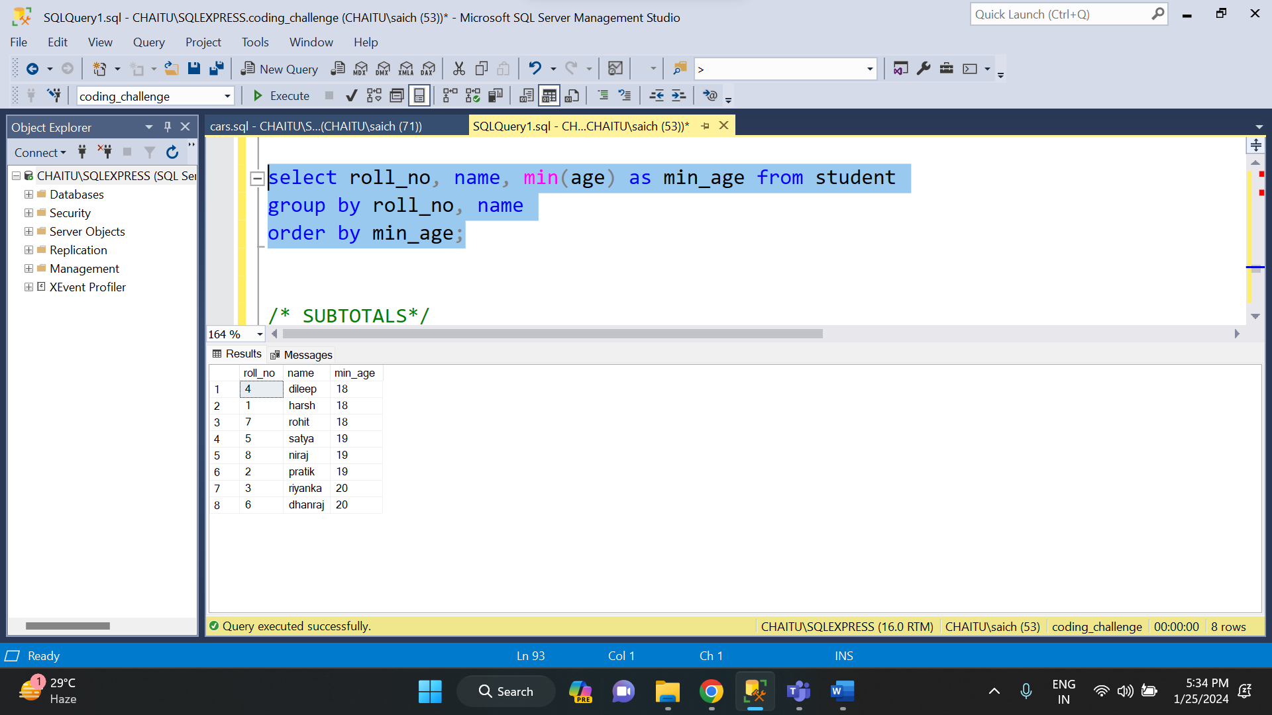

* SUM (): This function is used to calculate the sum of numeric values in a set.

