**SQL – Coding Challenge (Question-2)**

**Question: 2**

* **All joins with examples.**

SQL Join statement is used to combine data or rows from two or more tables based on a common field between them. There are different types of joins. They are as follows:

* **INNER JOIN:** The INNER JOIN keyword selects all rows from both the tables as long as the condition is satisfied. This keyword will create the result-set by combining all rows from both the tables where the condition satisfies.

Example for inner join:

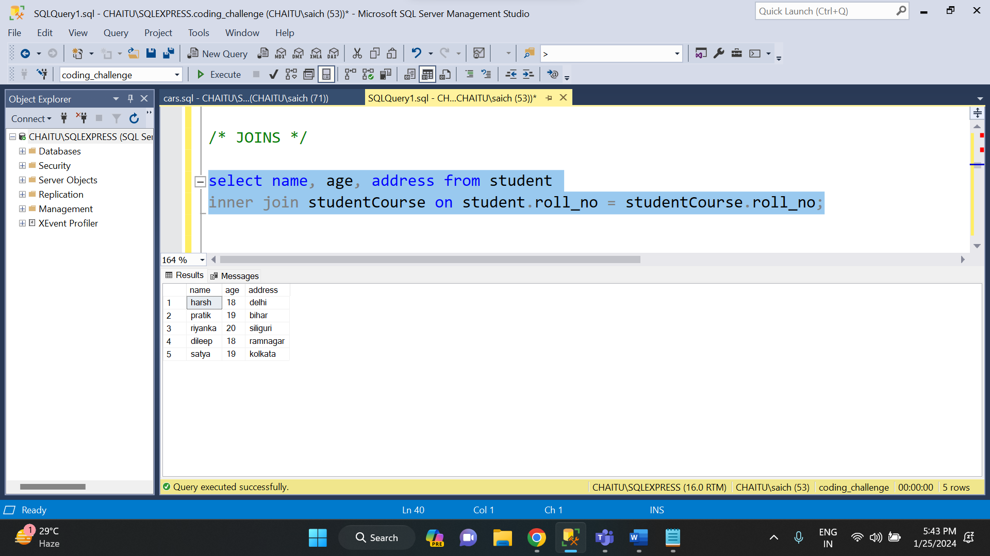

* **LEFT JOIN:** The left join returns all the rows of the table on the left side of the join and matches rows for the table on the right side of the join. For the rows for which there is no matching row on the right side, the result-set will contain null.

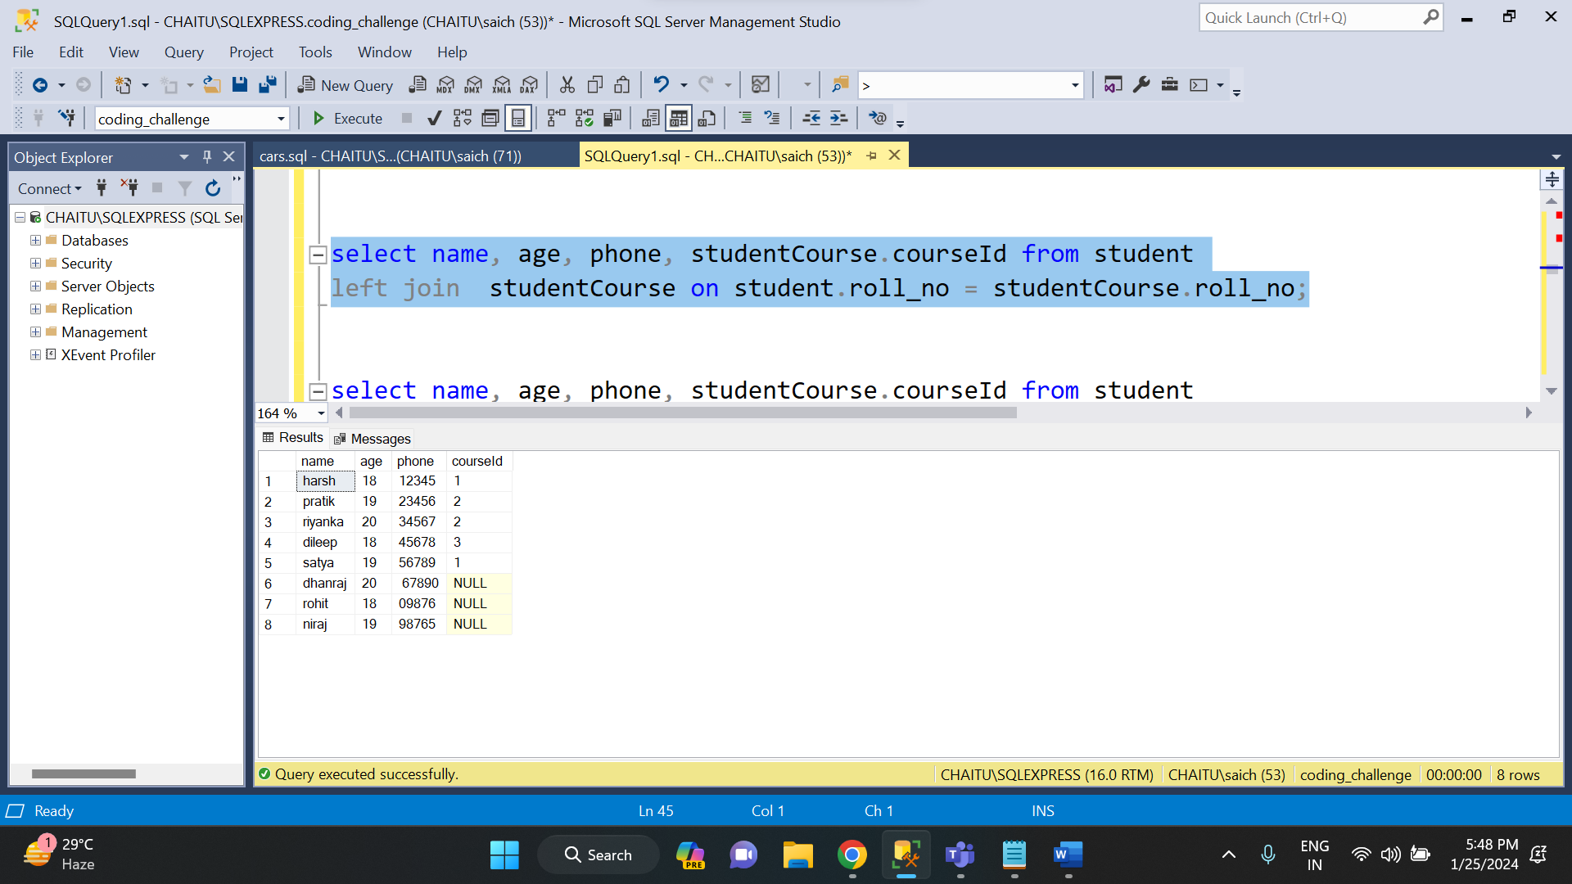

* **RIGHT JOIN:** RIGHT JOIN is similar to LEFT JOIN. This join returns all the rows of the table on the right side of the join and matching rows for the table on the left side of the join. For the rows for which there is no matching row on the left side, the result-set will contain null.

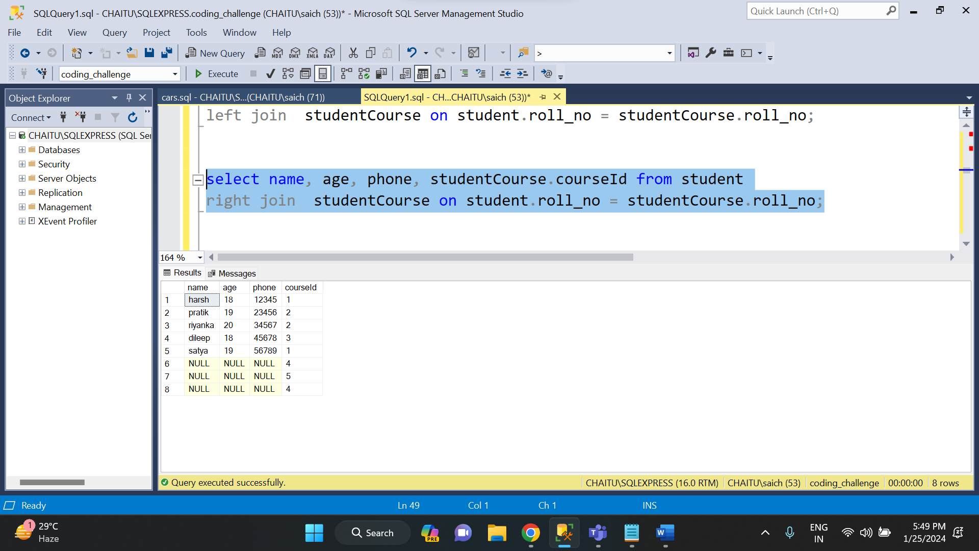

* **FULL JOIN:** FULL JOIN creates the result-set by combining results of both LEFT JOIN and RIGHT JOIN. The result-set will contain all the rows from both tables.

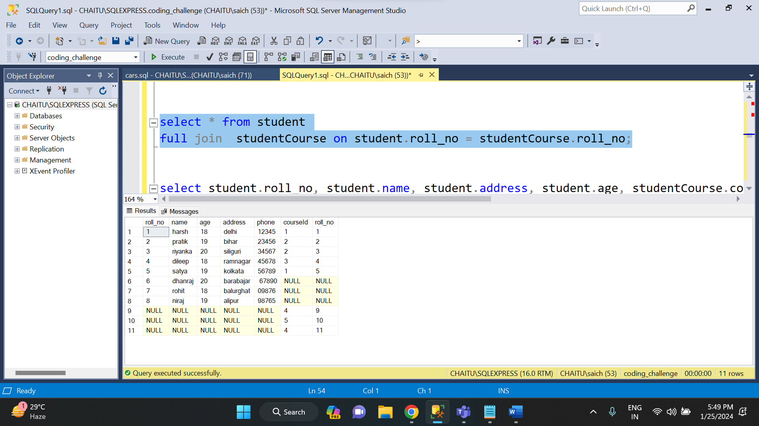

* **EQUI JOIN:** An equi join is the most common type of join. It involves the use of the equality operator (=) to match rows between tables based on related columns.

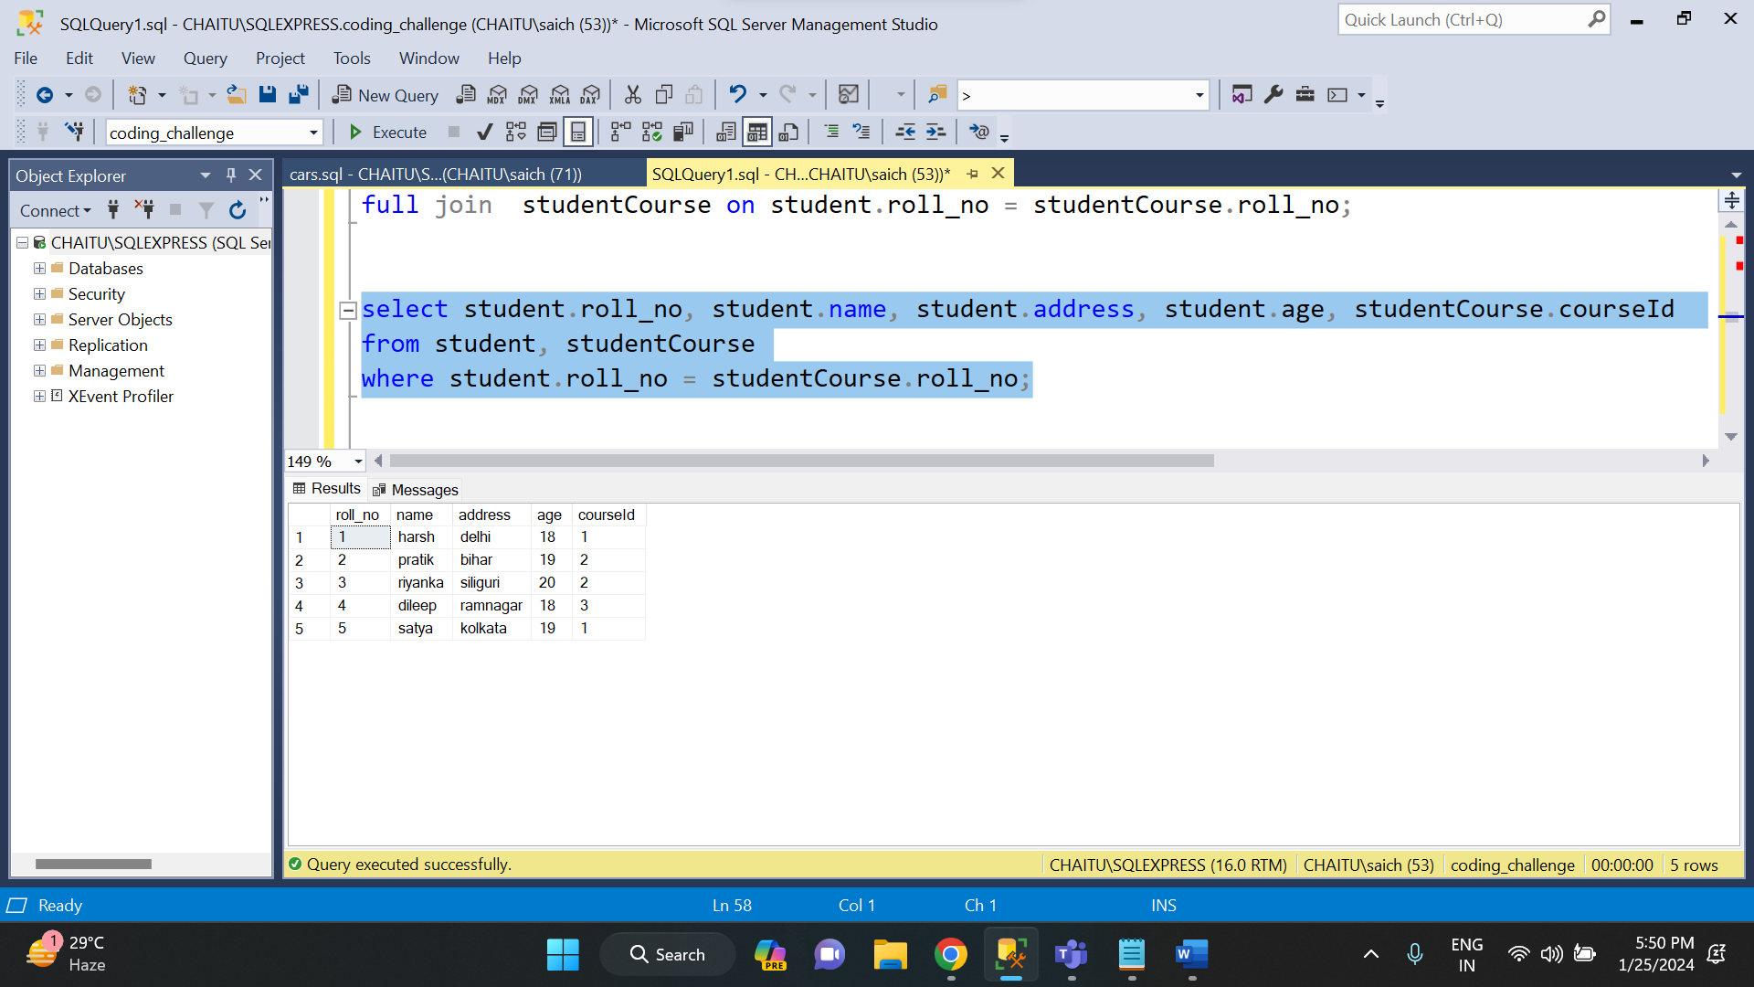

* **NON-EQUI JOIN:** A non-equi join involves using operators other than equality, such as <, >, <=, or >=, to join rows between tables based on related columns.

