This is my sample Requirement Template report

We would like to have a feature where a word template based report can be generated for any given requirement. It should dynamically generate the word report based on a template provided.

For example, it should say, embed <REQ:Name> here and it should embed the dynamic requirement name.

|  |  |  |
| --- | --- | --- |
| It should also | Support | Tables. |
| For example, I can embed | <REQ:Description> | Here |
| And | <REQ:Owner> | here |
|  |  |  |

The following requirements have to be met.

1. There should be a word template document called RequirementTemplate.docx in the folder where the requirement exists
2. All the tags should be marked as Hyperlinks
3. I want to be able to print some attributes. For example :
   1. REQ:Customer === [REQ:Customer](Req:customer)
   2. Req:Deliverability === <Req:Deliverability>
   3. Req:Impact to Customer === [Req:Impact to Customer](Req:Impact%20to%20Customer)
4. The Tag for the requirement : [REQ:tag](req:tag)
5. The requirement created Date : [REQ:created date](req:created date)
6. The requirement was created by : [REQ:created by](req:created%20by)
7. The requirement was approved by all on :[REQ:approved date](req:approved date)

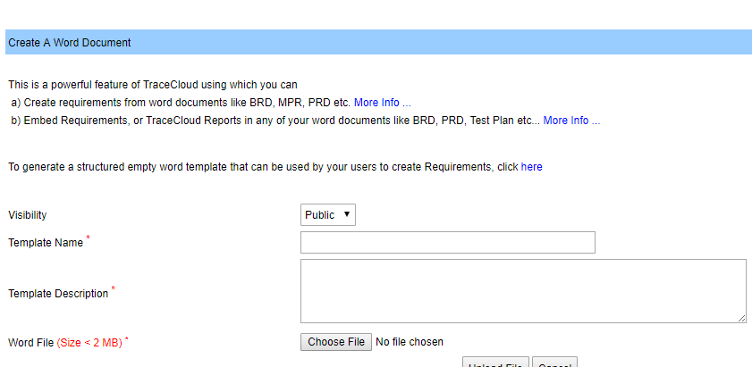

List of Approvers for this document :

<REQ:Approvers>

Best,

SpongeBob SquarePants