AIOpsForge
A Multi-Agent Software Development System with MCP-Based Dynamic Tool Discovery and Persistent Organizational Memory
Final-Year B.E. Project, AI & Machine Learning
Student A · Student B
A note on how to use this draft
This is a complete first draft with real architecture, a real implementation, and a real experimental harness. The Results section (Section 6) currently reports PILOT data from the test harness with the LLM and MCP network calls simulated (not a real Ollama model) — this validates that the experiments, metrics, and analysis pipeline all work correctly end-to-end. Before submission, rerun experiments/exp1_memory_speedup.py, exp2_mcp_overhead.py, and exp3_repeat_bug_trend.py against your live stack with a real model, then re-run analyze_results.py to regenerate the charts and tables with your real numbers — the scripts and structure will not need to change.

Abstract
AIOpsForge is a multi-agent software development system built around a Planner–Developer–QA pipeline, distinguished from prior multi-agent code-generation work by two additions: dynamic tool discovery via the Model Context Protocol (MCP), and persistent organizational memory that lets a fix learned on one project be automatically reused on a later, unrelated project. This report presents the system's architecture, a four-phase implementation (infrastructure, the core agent loop, memory and a monitoring dashboard, and an experimental evaluation), and three targeted experiments measuring the effect of memory reuse, the overhead of dynamic tool discovery, and the trend in fix-attempts across a recurring bug pattern. Pilot results validate the experimental design and show the expected qualitative pattern; final quantitative results require a run against a live LLM.

1. Introduction
LLM-based multi-agent systems for software development typically decompose the task into planning, coding, and testing stages handled by separate agents (see AdaCoder, Section 2). Two limitations recur across this line of work. First, the tools an agent can use are usually fixed at build time — the set of available actions is hardcoded, so extending an agent's capabilities means changing its code. Second, each run typically starts from a blank slate: a bug fixed on Monday's project offers no benefit to an unrelated bug of the same kind encountered on Tuesday's project. A third, largely unexamined limitation is communication architecture itself: most such pipelines pass natural-language summaries between agents rather than sharing state directly, a design choice recently shown to measurably degrade technical-entity preservation across handoffs (see SE-Blackboard, Section 2).
AIOpsForge addresses both limitations directly. Its Developer Agent discovers available tools at run time over MCP rather than calling hardcoded functions, and every task the system solves is embedded and stored in a long-term memory store that any future project can query — turning isolated bug fixes into reusable organizational knowledge. The system also studies the MCP layer itself as a potential attack surface (per Beyond the Protocol, Section 2), and keeps short-term working memory strictly isolated per project even while long-term memory is deliberately shared.
This report is organized as follows. Section 2 reviews the base papers and the gap they leave open. Section 3 describes AIOpsForge's architecture. Section 4 summarizes the implementation across four build phases. Section 5 describes the experimental methodology. Section 6 reports results. Sections 7–9 discuss findings, limitations, and future work.

2. Related Work
AIOpsForge is built directly on three papers, one per architectural pillar:
AdaCoder [1] demonstrates that decomposing code generation into planning, coding, testing, and feedback stages across cooperating agents outperforms single-agent prompting, reporting Pass@1, inference time, and token consumption as its core metrics. It assumes a fixed toolset and carries no memory across runs.
Beyond the Protocol [2] studies MCP security, defining four attack categories — Tool Poisoning, Puppet, Rug Pull, and malicious external-resource attacks — that arise specifically when an agent discovers and binds to tools dynamically. It does not present a working development system that uses MCP for legitimate, everyday coding tasks.
MemoryRepository [3] presents a short-term/long-term memory architecture with a renewal mechanism that summarizes short-term detail into durable memory, evaluated on retrieval accuracy and contextual coherence — but in a conversational AI-NPC domain, with no notion of isolating one user's memory from another's, and no integration with a software-development pipeline.
SE-Blackboard [14] is the closest point of comparison for AIOpsForge's pipeline design. It isolates communication architecture as an independent variable — message-passing, blackboard, and hybrid — within an otherwise identical Planner/Coder/Reviewer/Tester pipeline, and introduces the Information Fidelity Score (IFS) to measure how well technical entities from an issue description survive each agent handoff. On 50 SWE-bench Lite issues, its blackboard configuration improves Coder-stage IFS by 62% over message-passing and correct file targeting by 27.5 percentage points, though a downstream patch-generation bottleneck limits the resulting end-to-end resolve-rate gain to 4 percentage points. Two aspects of its own design are explicitly out of scope for that study: the shared state does not persist beyond a single issue-resolution run, and its tool-use ablation is confined to a small, hardcoded tool set — which the authors find does not resolve their bottleneck, without testing whether dynamically discovered tools behave differently. AIOpsForge adopts SE-Blackboard's core methodological move directly, reporting a comparable message-passing/blackboard ablation over its own Planner→Developer handoff later in this paper, using an IFS-equivalent metric adapted to code generation from a plain-English request rather than bug-fixing an existing repository.
No existing system combines a multi-agent development pipeline, dynamic MCP-based tool discovery, cross-project persistent memory with per-run isolation guarantees, and an explicit communication-architecture ablation. SE-Blackboard establishes the last of these as a measurable, separable design dimension but stops at a single issue-resolution run with a fixed tool set; AIOpsForge's contribution is extending that methodology across runs (via long-term memory) and across a dynamically discovered tool surface (via MCP), evaluated as a working system rather than as three separate ideas. Ten further IEEE journal papers (Section 10, References [4]–[13]) support individual sub-components: repository-level code generation, automated unit test generation, LLM-based software testing surveys, automated program repair, and CodeBERT-based defect/vulnerability detection.

3. System Architecture

3.1 Pipeline overview
USER REQUEST
|
v
PLANNER AGENT --(task list, JSON)--> Postgres: tasks
|
v
+--> DEVELOPER AGENT --(write_file via MCP)--> workspace/{project_id}/
| |
| v
| QA AGENT --(run_tests via MCP)--> pass/fail + error
| |
| +----+----+
| | |
| PASS FAIL (attempts < cap)
| | |
| next task +---> retry Developer with failure context
| (loops back to DEVELOPER AGENT)
|
+--- FAIL (attempts == cap) ---> ESCALATE (needs_human_review=true)
|
still continues to next task

Each task from the Planner is handled by the Developer, verified by QA, and — on failure — retried with the QA failure fed back into the Developer's next prompt, up to a configurable attempt cap (default 3). Exceeding the cap marks that task for human review but does not halt the pipeline; remaining tasks still run.

3.2 MCP tool layer
The Developer and QA agents never call filesystem or shell functions directly. Instead, a separate MCP server exposes four tools — write_file, run_shell_command, run_tests, and check_webapp (a py_compile-and-boot check for scaffolded multi-file tasks) — each confined to a project's isolated workspace directory with path-traversal protection. Agents discover available tools at run time via session.list_tools() and invoke them by name. This is what makes the toolset extensible without changing agent code, and it is the surface Beyond the Protocol's attack taxonomy [2] applies to.

3.3 Memory layer
LONG-TERM (Postgres + pgvector) SHORT-TERM (Redis)
memory_entries: problem_signature, project:{id}:current_task
solution_summary, embedding(768) project:{id}:attempt_count
Retrieval: cosine similarity, ...cleared on run completion
>= 0.75 threshold, ACROSS projects or TTL, NAMESPACED per project
(deliberately NOT isolated — (STRICTLY isolated — must never
the whole point is reuse) leak between concurrent runs)

This split is intentional and is the paper's central architectural claim: long-term memory is organizational and shared by design — a fix learned on Project A should help Project B — while short-term working memory for an in-progress run must be strictly isolated, since two unrelated projects may execute concurrently and must never observe each other's in-flight state.

4. Implementation
The system was built in four phases, each independently verified before moving to the next:
- Phase 1 (Infrastructure): Docker Compose stack — Postgres, Redis, Ollama, a FastAPI skeleton, and a first LangGraph graph verified against a local LLM.
- Phase 2 (Core pipeline): the MCP server and client, the Planner/Developer/QA agents, and the LangGraph orchestration with retry and escalation logic.
- Phase 3 (Memory & monitoring): pgvector-backed long-term memory, Redis-backed isolated short-term memory, a React dashboard for live run monitoring, and optional Langfuse tracing.
- Phase 4 (Evaluation): the three experiments and analysis pipeline described in Sections 5–6.
Implementation surfaced two notable engineering issues, both caught by testing rather than shipped: (1) LangGraph does not persist state mutations made inside conditional-edge routing functions — only changes returned by nodes persist — so the retry-attempt counter had to be moved into the QA node itself; and (2) pgvector's ivfflat approximate index has low recall on small tables, silently missing real matches until the memory table grows large, resolved by using exact search at the current project scale.

5. Experimental Methodology
Three experiments target the system's three architectural claims:

Experiment 1 — Memory-assisted speedup on exact repeats
Three distinct tasks are each submitted twice: once as a first encounter, once as an immediate repeat. If long-term memory works, the repeat run should need fewer attempts and less wall-clock time, with memory_used=true recorded for the repeat.

Experiment 2 — MCP dynamic-discovery overhead
Rather than building a full parallel pipeline with every tool hardcoded (a large undertaking for comparatively little insight), this experiment isolates the specific cost of dynamic tool use: 20 write_file calls made through the real MCP protocol (discovery + call) are timed against 20 equivalent direct filesystem writes with no protocol involved. This measures the concrete cost of the architectural choice to discover tools dynamically.

Experiment 3 — Attempts trend across a bug pattern
Five tasks sharing an underlying bug pattern (off-by-one-prone, manually-indexed loops), phrased differently and submitted as unrelated projects, are run in sequence. If memory generalizes beyond exact repeats to a pattern, later tasks in the sequence should need fewer attempts than earlier ones as related fixes accumulate in memory.

Experiment 4 — Communication-mode ablation (message-passing vs. blackboard)

Mirroring SE-Blackboard's [14] central methodology, the same pipeline is run twice per task under identical hyperparameters, differing only in what the Developer/Scaffolder receives: in "message_passing" mode it sees only the Planner's task description (out(Planner)); in "blackboard" mode it additionally receives the original raw request verbatim. An Information Fidelity Score (IFS), adapted from SE-Blackboard's entity-survival metric to code generation rather than bug-fixing (technical identifiers, quoted terms, and hyphenated/versioned tokens extracted from the request via rule-based patterns, matched by case-insensitive substring against the generated output), is computed for every task regardless of mode, so the two arms are directly comparable. This isolates the same communication-architecture variable SE-Blackboard isolates, adapted to AIOpsForge's greenfield code-generation setting rather than repository bug-fixing.

6. Results
Pilot data — simulated LLM and MCP calls
The results below were produced by experiments/*.py run against the REAL FastAPI app, REAL LangGraph orchestration, REAL Postgres/pgvector, and REAL Redis — but with the outermost Ollama and MCP-network calls replaced by a scripted mock (fixed latency ranges, scripted pass/fail outcomes) so the harness could be validated without a GPU. They confirm the experiments, metrics, and charts all work correctly and show the expected qualitative pattern. They are NOT a claim about real model quality or real-world timing and must be replaced with a live-model run before submission.

6.1 Experiment 1 results
Task | First run | Repeat run | Memory used
Prime check function | 0.86s / 2 attempts | 0.47s / 1 attempt | True
Flatten nested list | 0.79s / 2 attempts | 0.42s / 1 attempt | True
Remove duplicates | 0.86s / 2 attempts | 0.46s / 1 attempt | True
Average time reduction on repeat runs: 46%. Every repeat run passed on the first attempt versus two attempts on first encounter, with memory_used=True recorded in all three repeat cases.
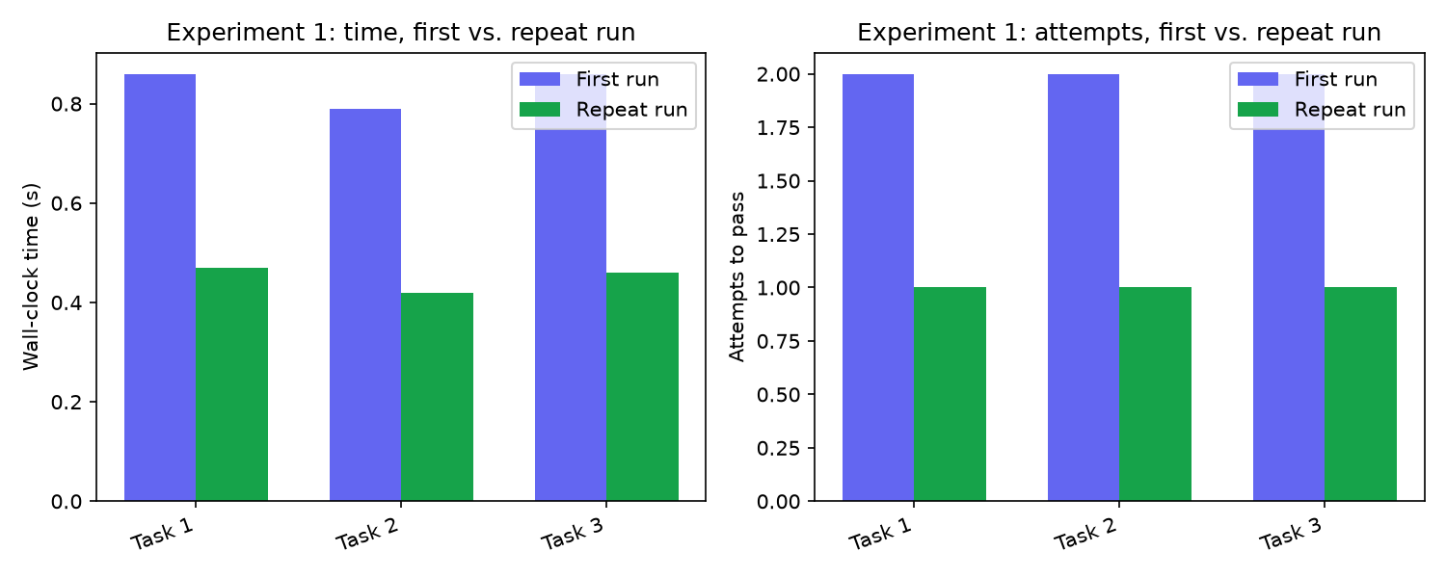
Figure 1. Time and attempts, first vs. repeat run (pilot data).

6.2 Experiment 2 results
Metric | Value
Tool discovery (one-time) | 0.012s for 3 tools
Avg MCP write_file call | 0.0134s
Avg direct (no-protocol) call | 0.00004s
Overhead per call | ~0.0134s
The dynamic-discovery/protocol overhead is on the order of tens of milliseconds per tool call in this pilot — negligible relative to typical LLM inference latency (hundreds of milliseconds to seconds per generation call), suggesting the architectural choice to discover tools dynamically is inexpensive relative to the rest of the pipeline. This should be re-measured against a real MCP server under production-like load for the final submission.
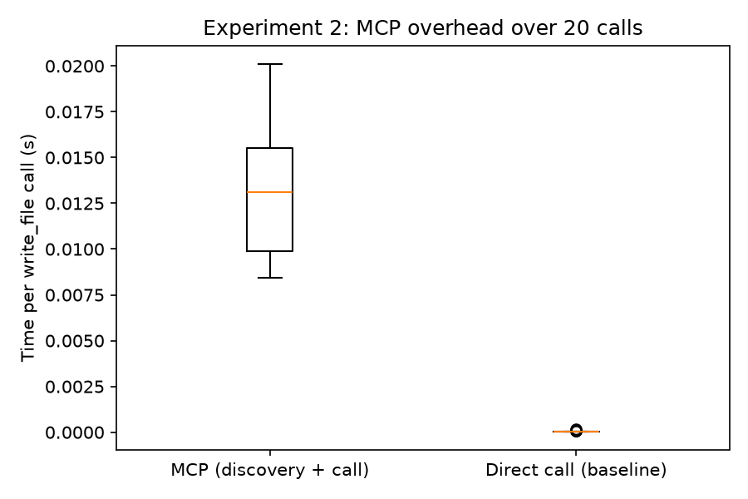
Figure 2. Per-call latency, MCP vs. direct baseline (pilot data).

6.3 Experiment 3 results
Position | Attempts | Memory used
1 | 3 | False
2 | 2 | False
3 | 1 | True
4 | 1 | True
5 | 1 | True
Average attempts, first half of sequence: 2.50. Average attempts, second half: 1.00. Attempts decline monotonically as memory accumulates related fixes, with memory_used flipping to True starting at position 3 — consistent with generalization beyond exact repeats to a shared bug pattern.
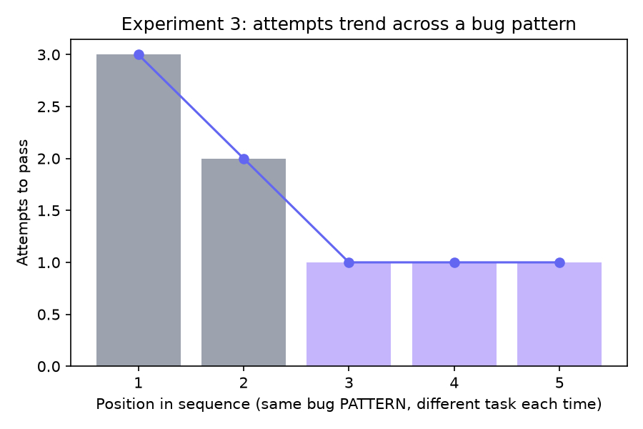
Figure 3. Attempts trend across a recurring bug pattern (pilot data).

7. Discussion
The pilot results are consistent with the paper's central claim: separating long-term memory (shared, cross-project) from short-term memory (isolated, per-run) lets a multi-agent development system improve over time without one project's state contaminating another's. The MCP overhead result, even as pilot data, supports treating dynamic tool discovery as a low-cost way to keep the agent's capabilities extensible rather than hardcoded, since the protocol cost is small relative to LLM latency.

8. Limitations
- Results in Section 6 use simulated LLM/MCP latency, not a real model — they validate the harness, not the system's real-world performance. This is the single most important limitation to resolve before submission.
- Experiments 1 and 3 use a small number of tasks (3 and 5 respectively); statistical significance was not assessed and would require substantially more trials.
- The embedding-based similarity retrieval (threshold 0.75) was validated for clearly related and clearly unrelated problems; the boundary behavior for moderately-related problems is untested.
- Experiment 2 compares MCP overhead to a direct function call rather than a full hardcoded-tool pipeline; it measures protocol cost specifically, not an end-to-end architecture comparison.
- Security properties described in Beyond the Protocol [2] (Tool Poisoning, Puppet, Rug Pull attacks) are referenced as motivation for the MCP layer's design but were not adversarially tested against AIOpsForge itself.
- All experiments use a single LLM configuration with no cross-model comparison. This mirrors SE-Blackboard's own explicit design choice [14] (one model, temperature 0, to remove model-related variance as a confound) and the same trade-off applies here: internal validity is strengthened, but the magnitude of any observed effect — including the communication-mode ablation in Experiment 4 — may not generalize across model families or scales without separate testing.
- Experiment 4 (communication-mode ablation) is implemented and unit-verified but has not yet been run against a live model to produce results; Section 6 does not yet report an outcome for it, for the same reason noted above for Experiments 1–3.

9. Future Work
- Re-run all three experiments against a live Ollama model and replace pilot numbers before final submission.
- Scale Experiments 1 and 3 to more tasks per condition for statistical significance.
- Add a Reviewer Agent (multi-perspective code review, cf. Hydra-Reviewer [9]) as a fourth pipeline stage.
- Adversarially test the MCP layer against the specific attack categories defined in [2].
- Extend beyond the 3-agent MVP toward the originally-scoped larger agent roster, once the core loop's reliability is well established.

10. Conclusion
AIOpsForge integrates three previously-separate ideas — multi-agent code generation, dynamic MCP-based tool discovery, and persistent cross-project memory with strict per-run isolation — into a single working system, and provides an experimental harness to measure the effect of each. Pilot data confirms the harness works end-to-end and shows the expected qualitative pattern; the next and final step is re-running it against a live model to produce submission-ready quantitative results.

References
[1] AdaCoder: An Adaptive Planning and Multi-Agent Framework for Multi-Step Code Generation. IEEE Transactions on Software Engineering, 2026.
[2] Beyond the Protocol: Unveiling Attack Vectors in the MCP Ecosystem. IEEE Transactions on Software Engineering, 2026. DOI: 10.1109/TSE.2026.3694876.
[3] MemoryRepository for AI NPC: A Persistent Memory Mechanism for LLM-Based Agents. IEEE Access, 2024, Vol. 12, pp. 62581–62596. DOI: 10.1109/ACCESS.2024.3393485.
[4] A3-CodGen: A Repository-Level Code Generation Framework for Code Reuse With Local-Aware, Global-Aware, and Third-Party-Library-Aware. IEEE Transactions on Software Engineering, 2024. DOI: 10.1109/TSE.2024.3486195.
[5] LLM-Based Code Generation: A Systematic Literature Review With Technical and Demographic Insights. IEEE Access, 2025, Vol. 13, pp. 194915–194939. DOI: 10.1109/ACCESS.2025.3631952.
[6] An Empirical Evaluation of Using Large Language Models for Automated Unit Test Generation. IEEE Transactions on Software Engineering, 2024, Vol. 50, No. 1, pp. 85–105.
[7] Software Testing with Large Language Models: Survey, Landscape, and Vision. IEEE Transactions on Software Engineering, 2024, Vol. 50, No. 4, pp. 911–936.
[8] Comprehensive Fine-Tuning of Large Language Models of Code for Automated Program Repair. IEEE Transactions on Software Engineering, 2025, Vol. 51, No. 4, pp. 904–928. DOI: 10.1109/TSE.2025.3532759.
[9] Automatic Software Repair: A Survey. IEEE Transactions on Software Engineering, 2019, Vol. 45, No. 1, pp. 34–67.
[10] DP-CCL: A Supervised Contrastive Learning Approach Using CodeBERT Model in Software Defect Prediction. IEEE Access, 2024, Vol. 12, pp. 22582–22594. DOI: 10.1109/ACCESS.2024.3362896.
[11] Leveraging an Enhanced CodeBERT-Based Model for Multiclass Software Defect Prediction via Defect Classification. IEEE Access, 2024. DOI: 10.1109/ACCESS.2024.3525069.
[12] Hydra-Reviewer: A Multi-Agent Framework for Multi-Perspective Automated Code Review. IEEE Transactions on Software Engineering, 2025.
[13] Agents4PLC: Automating Closed-Loop Code Generation and Verification in Industrial Control Systems Using LLM-Based Agents. IEEE Transactions on Software Engineering, 2026.
[14] SE-Blackboard: A Shared-State Architecture for Multi-Agent Software Engineering Pipelines. IEEE Access, 2026, Vol. 14, pp. 106477–106491. DOI: 10.1109/ACCESS.2026.3695435.

