Homework 2

sai charan talipineni

31 January 2017

#**Question 1:**  
setwd("D:/semester/2nd sem/DATA_MINING/hw2")  
audit<-read.csv("audit.csv")  
audit[1:2,]

## ID Age Employment Education Marital Occupation Income Gender  
## 1 1004641 38 Private College Unmarried Service 81838 Female  
## 2 1010229 35 Private Associate Absent Transport 72099 Male  
## Deductions Hours RISK_Adjustment TARGET_Adjusted  
## 1 0 72 0 0  
## 2 0 30 0 0

#RISK_Adjustment, TARGET_Adjusted are the response variables and the other variables including Age, #Employment, Education, Marital, Occupation, Income, Gender, Deductions, Hours are predictors.

#**Missing values:**  
  
sapply(audit, function(x) sum(is.na(x)))

## ID Age Employment Education   
## 0 0 100 0   
## Marital Occupation Income Gender   
## 0 101 0 0   
## Deductions Hours RISK_Adjustment TARGET_Adjusted   
## 0 0 0 0

getmode <- function(v) {  
 uniqv <- unique(v)  
 uniqv[which.max(tabulate(match(v, uniqv)))]  
}  
  
mode_employ<-getmode(audit$Employment)  
mode_occup<-getmode(audit$Occupation)  
  
audit$Employment[is.na(audit$Employment)] <- mode_employ  
audit$Occupation[is.na(audit$Occupation)] <- mode_occup

#**Question 2:**  
#**(a)**   
summary(audIt)

## ID Age Employment Education   
## Min. :1004641 Min. :17.00 Private :1511 HSgrad :660   
## 1st Qu.:3437052 1st Qu.:28.00 Consultant: 148 College :442   
## Median :5638451 Median :37.00 PSLocal : 119 Bachelor :345   
## Mean :5624348 Mean :38.62 SelfEmp : 79 Master :102   
## 3rd Qu.:7876535 3rd Qu.:48.00 PSState : 72 Vocational: 86   
## Max. :9996101 Max. :90.00 PSFederal : 69 Yr11 : 74   
## (Other) : 2 (Other) :291   
## Marital Occupation Income   
## Absent :669 Executive :390 Min. : 609.7   
## Divorced :266 Professional:247 1st Qu.: 34433.1   
## Married :917 Clerical :232 Median : 59768.9   
## Married-spouse-absent: 22 Repair :225 Mean : 84688.5   
## Unmarried : 67 Service :210 3rd Qu.:113842.9   
## Widowed : 59 Sales :206 Max. :481259.5   
## (Other) :490   
## Gender Deductions Hours RISK_Adjustment   
## Female: 632 Min. : 0.00 Min. : 1.00 Min. : -1453   
## Male :1368 1st Qu.: 0.00 1st Qu.:38.00 1st Qu.: 0   
## Median : 0.00 Median :40.00 Median : 0   
## Mean : 67.57 Mean :40.07 Mean : 2021   
## 3rd Qu.: 0.00 3rd Qu.:45.00 3rd Qu.: 0   
## Max. :2904.00 Max. :99.00 Max. :112243   
##   
## TARGET_Adjusted  
## 0:1537   
## 1: 463   
##   
##   
##   
##   
##

#From the above summary we can know that Age, Income, Deductions, Hours, RISK_Adjustment are numerical variables. The summary table is as follows.  
  
Age = c(summary(audit$Age), sd(audit$Age))  
Income = c(summary(audit$Income), sd(audit$Income))  
Deductions = c(summary(audit$Deductions), sd(audit$Deductions))  
Hours = c(summary(audit$Hours), sd(audit$Hours))  
RISK_Adjustment = c(summary(audit$RISK_Adjustment), sd(audit$RISK_Adjustment))  
result = rbind(Age, Income, Deductions, Hours,RISK_Adjustment)  
result = as.data.frame(result)  
colnames(result)[7] = c("sd")  
result

## Min. 1st Qu. Median Mean 3rd Qu. Max. sd  
## Age 17.0 28 37 38.62 48 90 13.58475  
## Income 609.7 34430 59770 84690.00 113800 481300 69621.64450  
## Deductions 0.0 0 0 67.57 0 2904 340.70470  
## Hours 1.0 38 40 40.07 45 99 12.15372  
## RISK_Adjustment -1453.0 0 0 2021.00 0 112200 8341.87229

#**(b)**  
library(e1071)

## Warning: package 'e1071' was built under R version 3.3.2

plot(density(audit$Age))

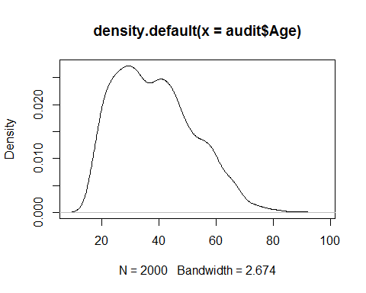

skewness(audit$Age)

## [1] 0.4990696

#right skewed  
  
plot(density(audit$Income))

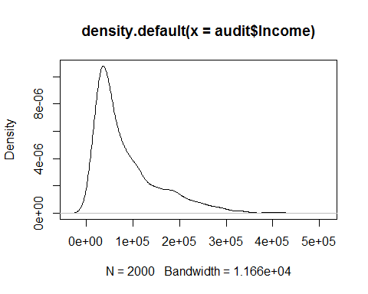

skewness(audit$Income)

## [1] 1.488821

#right skewed  
  
plot(density(audit$Deductions))

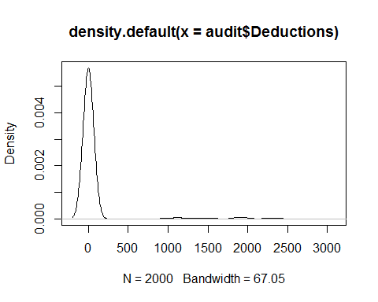

skewness(audit$Deductions)

## [1] 5.249432

#right skewed  
  
plot(density(audit$Hours))

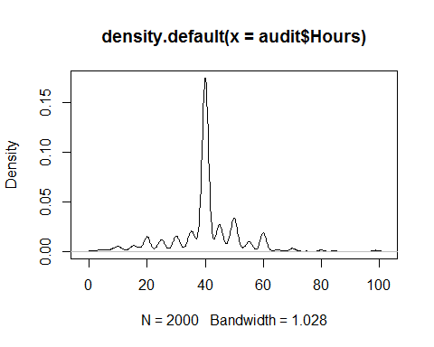

skewness(audit$Hours)

## [1] 0.1323312

#right skewed  
  
plot(density(audit$RISK_Adjustment))  
skewness(audit$RISK_Adjustment)

## [1] 9.591535

#right skewed  
  
  
#correlation  
library(car)

## Warning: package 'car' was built under R version 3.3.2

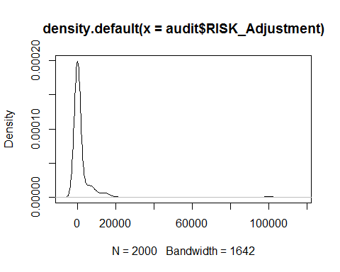

dt = audit[,c('Age','Income','Deductions','Hours','RISK_Adjustment')]  
cor(dt)

## Age Income Deductions Hours  
## Age 1.00000000 -0.22686777 0.08399899 0.04236487  
## Income -0.22686777 1.00000000 -0.05734147 -0.21269065  
## Deductions 0.08399899 -0.05734147 1.00000000 0.01365124  
## Hours 0.04236487 -0.21269065 0.01365124 1.00000000  
## RISK_Adjustment 0.12274079 -0.08339021 0.06559720 0.09060735  
## RISK_Adjustment  
## Age 0.12274079  
## Income -0.08339021  
## Deductions 0.06559720  
## Hours 0.09060735  
## RISK_Adjustment 1.00000000

#scatterplot  
suppressWarnings(scatterplotMatrix(dt, spread = FALSE, lty.smooth = 2, main = 'Scatter Plot Matrix'))

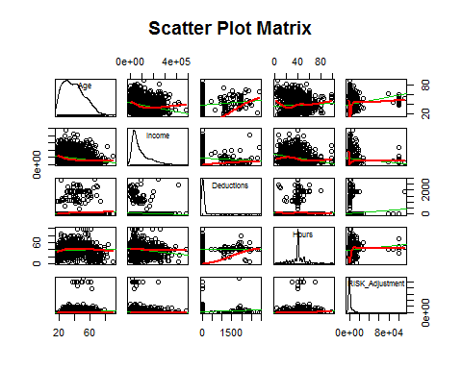

#**(c)**  
library(lattice)  
library(nutshell)

## Warning: package 'nutshell' was built under R version 3.3.2

## Loading required package: nutshell.bbdb

## Warning: package 'nutshell.bbdb' was built under R version 3.3.2

## Loading required package: nutshell.audioscrobbler

## Warning: package 'nutshell.audioscrobbler' was built under R version 3.3.2

histogram(~TARGET_Adjusted|Employment,data=audit,layout=c(2,4),col="black")

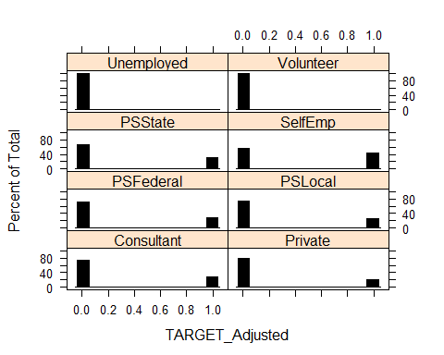

histogram(~TARGET_Adjusted|Education,data=audit,layout=c(4,4),col="black")

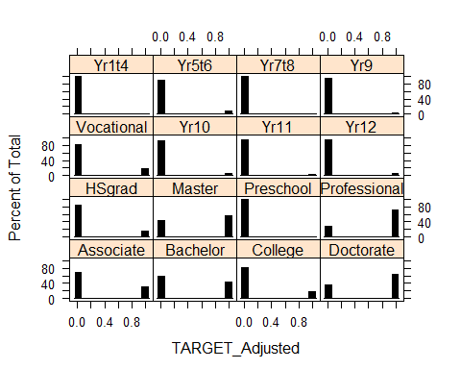

histogram(~TARGET_Adjusted|Marital,data=audit,layout=c(2,3),col="black")

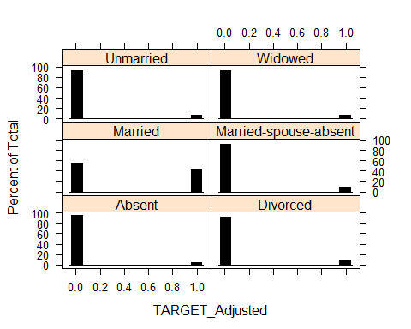

histogram(~TARGET_Adjusted|Occupation,data=audit,layout=c(3,5),col="black")

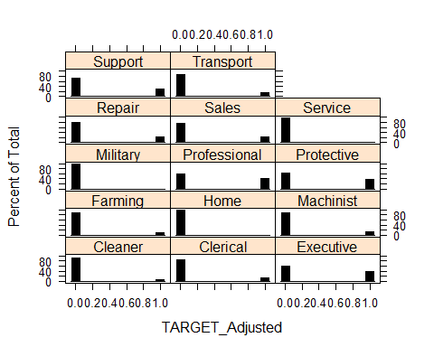

histogram(~TARGET_Adjusted|Gender,data=audit,layout=c(1,2),col="black")

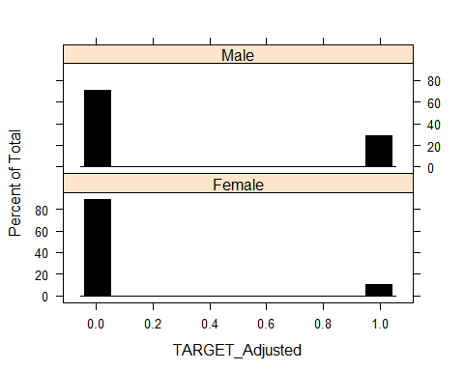

histogram(~RISK_Adjustment|Employment,data=audit,layout=c(2,4),col="black")

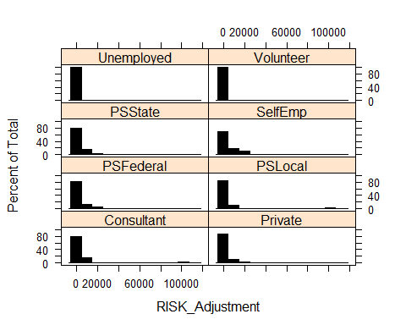

histogram(~RISK_Adjustment|Education,data=audit,layout=c(4,4),col="black")

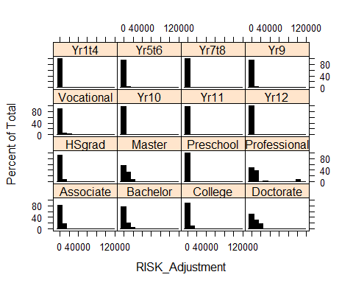

histogram(~RISK_Adjustment|Marital,data=audit,layout=c(2,3),col="black")

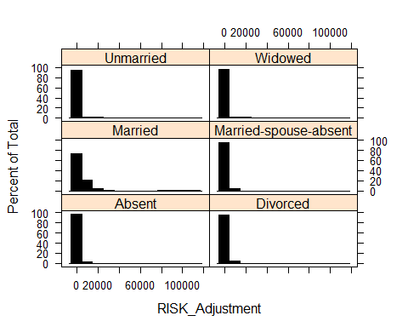

histogram(~RISK_Adjustment|Occupation,data=audit,layout=c(3,5),col="black")

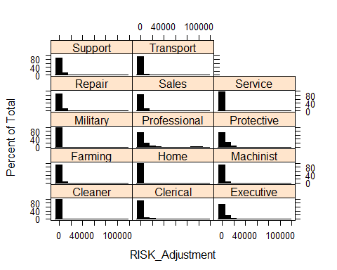

histogram(~RISK_Adjustment|Gender,data=audit,layout=c(1,2),col="black")

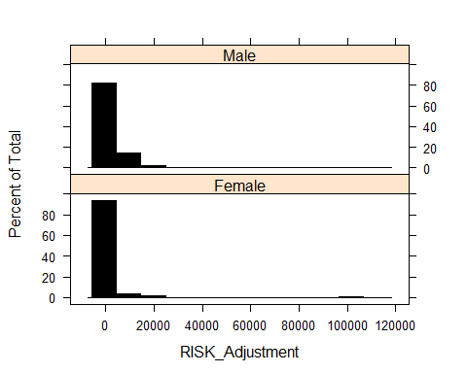

#**Question 3:**  
require(boot)

## Loading required package: boot

##   
## Attaching package: 'boot'

## The following object is masked from 'package:lattice':  
##   
## melanoma

## The following object is masked from 'package:car':  
##   
## logit

audit_t<-audit[,c(-1,-11)]  
audit_r<-audit[,c(-1,-12)]  
  
###############  
xaudit_t <- model.matrix(TARGET_Adjusted~.,data=audit_t)[,-1]  
dfxaudit_t<-as.data.frame(xaudit_t)  
Audit_t<-data.frame(targetadj=audit_t$TARGET_Adjusted,dfxaudit_t)  
audit_t_t<-Audit_t  
audit_t_t<-audit_t_t[sample(nrow(audit_t_t)),] #randomly shuffle data  
  
#Create 10 equally size folds  
folds <- cut(seq(1,nrow(audit_t_t)),breaks=10,labels=FALSE)  
result<-NULL  
temp<-NULL  
#Perform 10 fold cross validation  
for(i in 1:10){  
 testIndexes <- which(folds==i,arr.ind=TRUE)  
 testData <- audit_t_t[testIndexes, ]  
 trainData <- audit_t_t[-testIndexes, ]  
 m1 = glm(targetadj~.,family=binomial,data=trainData)  
 ptest = predict(m1,newdata=data.frame(testData),type="response")  
 temp<-cbind(ptest,testData$targetadj)  
 result<-rbind(result,temp)  
   
}

## Warning in predict.lm(object, newdata, se.fit, scale = 1, type =  
## ifelse(type == : prediction from a rank-deficient fit may be misleading  
  
## Warning in predict.lm(object, newdata, se.fit, scale = 1, type =  
## ifelse(type == : prediction from a rank-deficient fit may be misleading  
  
## Warning in predict.lm(object, newdata, se.fit, scale = 1, type =  
## ifelse(type == : prediction from a rank-deficient fit may be misleading

result<-as.data.frame(result)  
names(result)<-c("ptest","ttest")  
btest=floor(result$ptest+0.5)   
conf.matrix = table(result$ttest,btest)  
error=(conf.matrix[1,2]+conf.matrix[2,1])/2000  
accuracy=1-error  
accuracy

## [1] 0.837

precision=conf.matrix[1,1]/(conf.matrix[1,1]+conf.matrix[2,1])  
precision

## [1] 0.8730746

Recall=conf.matrix[1,1]/(conf.matrix[1,1]+conf.matrix[1,2])  
Recall

## [1] 0.9219258

F1score=2*precision*Recall/(precision+Recall)  
F1score

## [1] 0.8968354

library(pROC)

## Warning: package 'pROC' was built under R version 3.3.2

## Type 'citation("pROC")' for a citation.

##   
## Attaching package: 'pROC'

## The following objects are masked from 'package:stats':  
##   
## cov, smooth, var

aucc=auc(result$ttest, result$ptest)  
aucc

## Area under the curve: 0.8767

#liftchart  
df <- result  
rank.df=as.data.frame(df[order(result$ptest,decreasing=TRUE),])  
colnames(rank.df) = c('predicted','actual')  
baserate=mean(result$ttest)  
ax=dim(result$ttest)  
ay.base=dim(result$ttest)  
ay.pred=dim(result$ttest)  
ax[1]=1  
ay.base[1]=baserate  
ay.pred[1]=rank.df$actual[1]  
for (i in 2:2000) {  
 ax[i]=i  
 ay.base[i]=baserate*i ## uniformly increase with rate xbar  
 ay.pred[i]=ay.pred[i-1]+rank.df$actual[i]  
}  
  
df=cbind(rank.df,ay.pred,ay.base)  
plot(ax,ay.pred,xlab="number of cases",ylab="number of successes",main="Lift: Cum successes sorted by pred val/success prob")  
points(ax,ay.base,type="l")

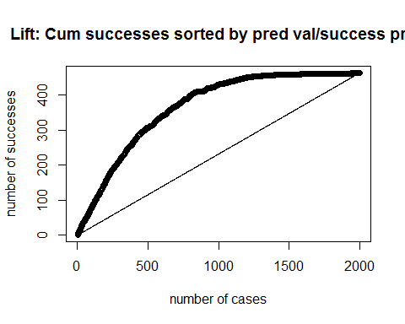

#roc  
cut=1/2  
truepos <- result$ttest==1 & result$ptest>=cut   
trueneg <- result$ttest==0 & result$ptest<cut  
# Sensitivity (predict default when it does happen)  
sum(truepos)/sum(result$ttest==1)

## [1] 0.5550756

suppressWarnings( library(ROCR))

## Loading required package: gplots

##   
## Attaching package: 'gplots'

## The following object is masked from 'package:stats':  
##   
## lowess

data<-result  
pred <- prediction(result$ptest,result$ttest)  
perf <- performance(pred, "sens", "fpr")  
plot(perf)

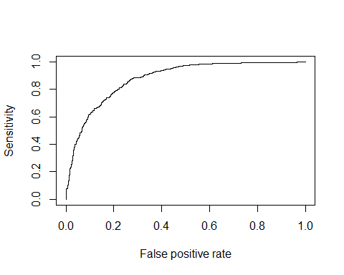

#######################  
  
###############  
xaudit_t2 <- model.matrix(TARGET_Adjusted~Age+Education+Income,data=audit_t)[,-1]  
dfxaudit_t2<-as.data.frame(xaudit_t2)  
Audit_t2<-data.frame(targetadj=audit_t$TARGET_Adjusted,dfxaudit_t2)  
audit_t2_t2<-Audit_t2  
audit_t2_t2<-audit_t2_t2[sample(nrow(audit_t2_t2)),] #randomly shuffle data  
  
#Create 10 equally size folds  
folds <- cut(seq(1,nrow(audit_t2_t2)),breaks=10,labels=FALSE)  
result<-NULL  
temp<-NULL  
testIndexes<-NULL  
trainData<-NULL  
ptest<-NULL  
#Perform 10 fold cross validation  
for(i in 1:10){  
 testIndexes <- which(folds==i,arr.ind=TRUE)  
 testData <- audit_t2_t2[testIndexes, ]  
 trainData <- audit_t2_t2[-testIndexes, ]  
 m2 = glm(targetadj~Age+EducationBachelor+EducationCollege+EducationHSgrad+EducationProfessional+EducationVocational+EducationYr10+EducationYr5t6+EducationYr7t8+Income,family=binomial,data=trainData)  
 ptest = predict(m2,newdata=data.frame(testData),type="response")  
 temp<-cbind(ptest,testData$targetadj)  
 result<-rbind(result,temp)  
   
}  
conf.matrix<-NULL  
result<-as.data.frame(result)  
names(result)<-c("ptest","ttest")  
btest=floor(result$ptest+0.5)   
conf.matrix = table(result$ttest,btest)  
error=(conf.matrix[1,2]+conf.matrix[2,1])/2000  
accuracy1=1-error  
accuracy1

## [1] 0.783

precision1=conf.matrix[1,1]/(conf.matrix[1,1]+conf.matrix[2,1])  
precision1

## [1] 0.8015309

Recall1=conf.matrix[1,1]/(conf.matrix[1,1]+conf.matrix[1,2])  
Recall1

## [1] 0.9538061

F1score1=2*precision1*Recall1/(precision1+Recall1)  
F1score1

## [1] 0.8710636

auc1=auc(result$ttest, result$ptest)  
auc1

## Area under the curve: 0.7555

#liftchart  
df <- result  
rank.df=as.data.frame(df[order(result$ptest,decreasing=TRUE),])  
colnames(rank.df) = c('predicted','actual')  
baserate=mean(result$ttest)  
ax=dim(result$ttest)  
ay.base=dim(result$ttest)  
ay.pred=dim(result$ttest)  
ax[1]=1  
ay.base[1]=baserate  
ay.pred[1]=rank.df$actual[1]  
for (i in 2:2000) {  
 ax[i]=i  
 ay.base[i]=baserate*i ## uniformly increase with rate xbar  
 ay.pred[i]=ay.pred[i-1]+rank.df$actual[i]  
}  
  
df=cbind(rank.df,ay.pred,ay.base)  
plot(ax,ay.pred,xlab="number of cases",ylab="number of successes",main="Lift: Cum successes sorted by pred val/success prob")  
points(ax,ay.base,type="l")

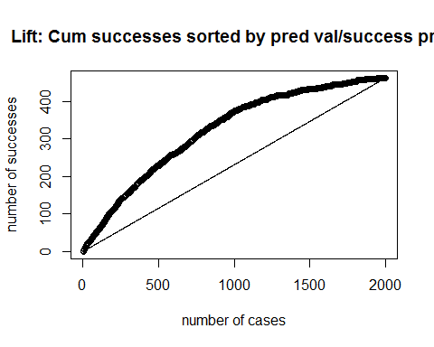

#roc  
cut=1/2  
truepos <- result$ttest==1 & result$ptest>=cut   
trueneg <- result$ttest==0 & result$ptest<cut  
# Sensitivity (predict default when it does happen)  
sum(truepos)/sum(result$ttest==1)

## [1] 0.2159827

suppressWarnings( library(ROCR))  
data<-result  
pred <- prediction(result$ptest,result$ttest)  
perf <- performance(pred, "sens", "fpr")  
plot(perf)

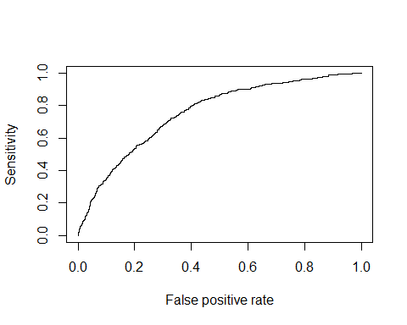

#######################  
****(b)****

Based on the high accuracy , precision, f1score and low recall values model m1 found out to be the best one and following odds ratio has been done to it. The higher the value for the respective coefficient, mostly likely to be highly significant.  
  
  
m1 = glm(targetadj~.,family=binomial,data=audit_t_t)  
oddsratio<-exp(m1$coefficients)  
oddsratio

## (Intercept) Age   
## 1.527647e-03 1.027856e+00   
## EmploymentPrivate EmploymentPSFederal   
## 1.292340e+00 1.330603e+00   
## EmploymentPSLocal EmploymentPSState   
## 1.084127e+00 1.372124e+00   
## EmploymentSelfEmp EmploymentUnemployed   
## 1.156585e+00 6.587216e-06   
## EmploymentVolunteer EducationBachelor   
## 2.315650e-08 1.114277e+00   
## EducationCollege EducationDoctorate   
## 4.213370e-01 2.443580e+00   
## EducationHSgrad EducationMaster   
## 3.086031e-01 1.618500e+00   
## EducationPreschool EducationProfessional   
## 1.639066e-07 5.467535e+00   
## EducationVocational EducationYr10   
## 3.741225e-01 2.106021e-01   
## EducationYr11 EducationYr12   
## 1.826574e-01 1.717699e-01   
## EducationYr1t4 EducationYr5t6   
## 3.736186e-08 9.311356e-02   
## EducationYr7t8 EducationYr9   
## 5.602639e-08 5.171519e-02   
## MaritalDivorced MaritalMarried   
## 9.892897e-01 1.465774e+01   
## MaritalMarried.spouse.absent MaritalUnmarried   
## 1.372207e+00 1.839084e+00   
## MaritalWidowed OccupationClerical   
## 8.179417e-01 3.206893e+00   
## OccupationExecutive OccupationFarming   
## 3.852266e+00 9.630579e-01   
## OccupationHome OccupationMachinist   
## 3.820315e-06 1.606481e+00   
## OccupationMilitary OccupationProfessional   
## 2.184832e-06 3.324473e+00   
## OccupationProtective OccupationRepair   
## 6.210526e+00 1.922544e+00   
## OccupationSales OccupationService   
## 2.518477e+00 6.807038e-01   
## OccupationSupport OccupationTransport   
## 3.487010e+00 1.262662e+00   
## Income GenderMale   
## 1.000002e+00 1.199613e+00   
## Deductions Hours   
## 1.001051e+00 1.037710e+00

#**Question 4**  
leave.one.out <- function(formula, audit_r){  
 n = length(audit_r$RISK_Adjustment)  
 error = dim(n)  
 for(k in 1:n){  
 id = c(1:n)  
 id.train = id[id != k]  
 fit = lm(formula, data = audit_r[id.train, ])  
 predicted = predict(fit)  
 observation = audit_r$RISK_Adjustment[-id.train]  
 error[k] = predicted - observation  
 }  
 me=mean(error)  
 rmse = sqrt(mean(error^2))  
 return(rmse)  
}  
  
#linear  
formA<-RISK_Adjustment~.  
formB<-RISK_Adjustment~Education+Income+Deductions+Hours  
formC<-RISK_Adjustment~Employment+Income+Deductions  
  
suppressWarnings(rmseA<-leave.one.out(formA, audit_r))  
rmseA

## [1] 8390.117

suppressWarnings(rmseB<-leave.one.out(formB, audit_r))  
rmseB

## [1] 8402.807

suppressWarnings(rmseC<-leave.one.out(formC, audit_r))  
rmseC

## [1] 8359.086

#non-linear  
formD<-RISK_Adjustment~poly(Age, degree = 2) + poly(Income, degree = 2)+Occupation  
formE<-RISK_Adjustment~poly(Deductions, degree = 2) + poly(Income, degree = 3) +Education+Employment  
  
suppressWarnings(rmseD<-leave.one.out(formD, audit_r))  
rmseD

## [1] 8376.185

suppressWarnings(rmseE<-leave.one.out(formE, audit_r))  
rmseE

## [1] 8415.921

***(b)***

Based on the low RMSE values the below model has found to be the best one and StepAIC has been applied to find significant predictors. All are found to be significant.

library(MASS)  
fit = lm(RISK_Adjustment~poly(Age, degree = 2) + poly(Income, degree = 2)+Occupation, data = audit_r)  
stepAIC(fit, direction="backward")

## Start: AIC=36062.36  
## RISK_Adjustment ~ poly(Age, degree = 2) + poly(Income, degree = 2) +   
## Occupation  
##   
## Df Sum of Sq RSS AIC  
## <none> 1.3306e+11 36062  
## - poly(Income, degree = 2) 2 595916295 1.3366e+11 36067  
## - Occupation 13 2135245816 1.3520e+11 36068  
## - poly(Age, degree = 2) 2 1678817312 1.3474e+11 36083

##   
## Call:  
## lm(formula = RISK_Adjustment ~ poly(Age, degree = 2) + poly(Income,   
## degree = 2) + Occupation, data = audit_r)  
##   
## Coefficients:  
## (Intercept) poly(Age, degree = 2)1   
## 1977.4 32886.8   
## poly(Age, degree = 2)2 poly(Income, degree = 2)1   
## -29423.6 -18627.3   
## poly(Income, degree = 2)2 OccupationClerical   
## 18751.1 -302.4   
## OccupationExecutive OccupationFarming   
## 919.2 -1416.5   
## OccupationHome OccupationMachinist   
## -1154.3 -1225.3   
## OccupationMilitary OccupationProfessional   
## -103.8 1784.5   
## OccupationProtective OccupationRepair   
## 556.3 -613.2   
## OccupationSales OccupationService   
## 350.8 -946.8   
## OccupationSupport OccupationTransport   
## 1012.0 -1783.8