Homework1

Sai Charan Talipineni

17 January 2017

**1-**  
Response variable: AmountSpent

Predictor variables: Age, Gender, OwnHome, Married, Location, Salary, Children, History, Catalogs.

**2-**  
**a-**  
There are no explicit missing values in the dataset. The values in the "History" coulmn were set to 'NA' means 'not yet purchased'(according to data description).so, I changed 'NA' to 'not_yet_purchased' to make work easier.

orgdata<-read.csv("D:/semester/2nd sem/DATA_MINING/hw1/DirectMarketing.csv")  
orgdata$History<-as.character(orgdata$History)  
orgdata$History[is.na(orgdata$History)]<-"not_yet_purchased"  
orgdata$History<-as.factor(orgdata$History)

**2b-**

summary(orgdata)

## Age Gender OwnHome Married Location   
## Middle:508 Female:506 Own :516 Married:502 Close:710   
## Old :205 Male :494 Rent:484 Single :498 Far :290   
## Young :287   
##   
##   
##   
## Salary Children History Catalogs   
## Min. : 10100 Min. :0.000 High :255 Min. : 6.00   
## 1st Qu.: 29975 1st Qu.:0.000 Low :230 1st Qu.: 6.00   
## Median : 53700 Median :1.000 Medium :212 Median :12.00   
## Mean : 56104 Mean :0.934 not_yet_purchased:303 Mean :14.68   
## 3rd Qu.: 77025 3rd Qu.:2.000 3rd Qu.:18.00   
## Max. :168800 Max. :3.000 Max. :24.00   
## AmountSpent   
## Min. : 38.0   
## 1st Qu.: 488.2   
## Median : 962.0   
## Mean :1216.8   
## 3rd Qu.:1688.5   
## Max. :6217.0

print("Salary")

## [1] "Salary"

summary(orgdata$Salary)

## Min. 1st Qu. Median Mean 3rd Qu. Max.   
## 10100 29980 53700 56100 77020 168800

sd(orgdata$Salary)

## [1] 30616.31

print("Children")

## [1] "Children"

summary(orgdata$Children)

## Min. 1st Qu. Median Mean 3rd Qu. Max.   
## 0.000 0.000 1.000 0.934 2.000 3.000

sd(orgdata$Children)

## [1] 1.05107

print("Catalogs")

## [1] "Catalogs"

summary(orgdata$Catalogs)

## Min. 1st Qu. Median Mean 3rd Qu. Max.   
## 6.00 6.00 12.00 14.68 18.00 24.00

sd(orgdata$Catalogs)

## [1] 6.622895

print("AmountSpent")

## [1] "AmountSpent"

summary(orgdata$AmountSpent)

## Min. 1st Qu. Median Mean 3rd Qu. Max.   
## 38.0 488.2 962.0 1217.0 1688.0 6217.0

sd(orgdata$AmountSpent)

## [1] 961.0686

**2c-**

require(ggplot2)

## Loading required package: ggplot2

## Warning: package 'ggplot2' was built under R version 3.3.2

ggplot(orgdata, aes(x=Salary)) + geom_density() #right skewed/positive skewed distribution

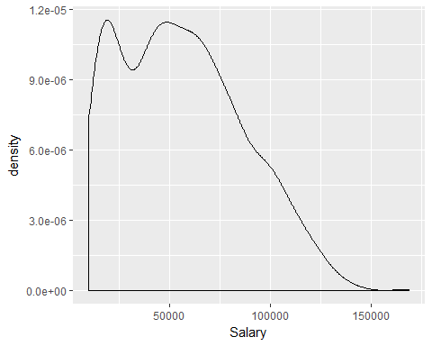

ggplot(orgdata, aes(x=AmountSpent)) + geom_density() #right skewed/positive skewed distribution

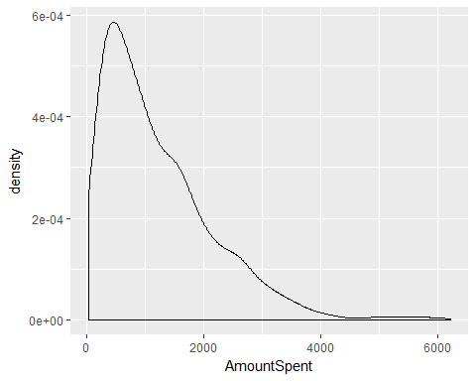

**2d-**

cor(orgdata$Salary, orgdata$AmountSpent)

## [1] 0.6995957

#Positive correlation

plot(orgdata$Salary, orgdata$AmountSpent, xlab="Salary", ylab="AmountSpent")

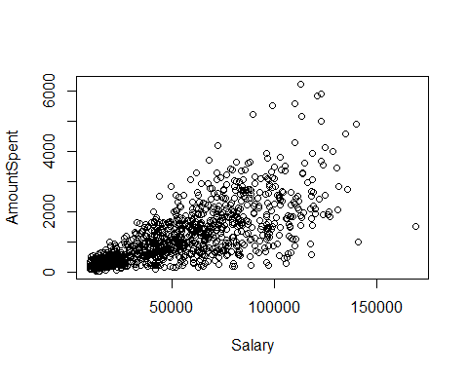

cor(orgdata$Children, orgdata$AmountSpent)

## [1] -0.2223082

#Negative correlation

plot(orgdata$Children, orgdata$AmountSpent, xlab="children", ylab="AmountSpent")

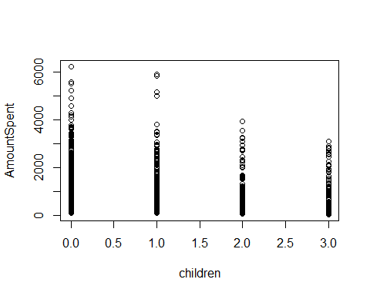

cor(orgdata$Catalogs, orgdata$AmountSpent)

## [1] 0.4726499

#Positive correlation but less than Salary

plot(orgdata$Catalogs, orgdata$AmountSpent, xlab="catalogs", ylab="AmountSpent")

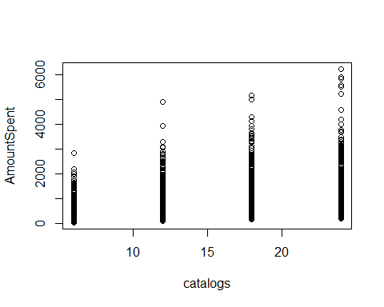

**2e-**

ggplot(orgdata, aes(x = AmountSpent, fill = Age)) + geom_density(alpha = 0.5)

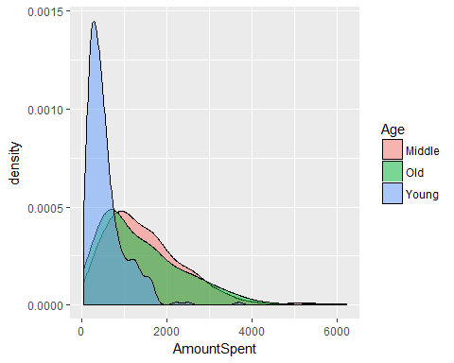

ggplot(orgdata, aes(x = AmountSpent, fill = Gender)) + geom_density(alpha = 0.5)

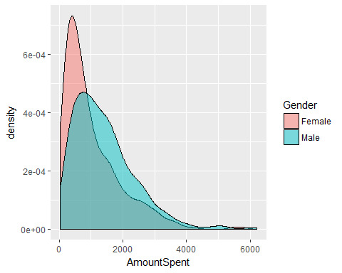

ggplot(orgdata, aes(x = AmountSpent, fill = OwnHome)) + geom_density(alpha = 0.5)

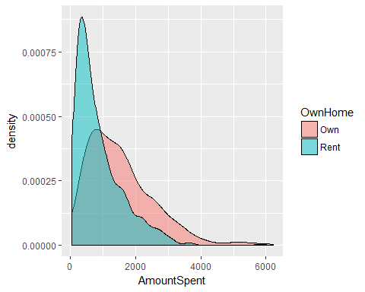

ggplot(orgdata, aes(x = AmountSpent, fill = Married)) + geom_density(alpha = 0.5)

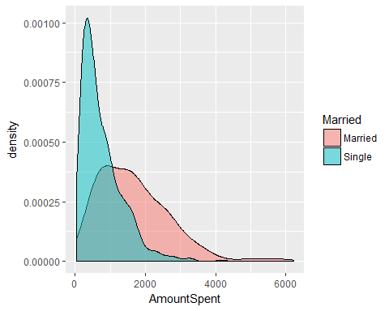

ggplot(orgdata, aes(x = AmountSpent, fill = Location)) + geom_density(alpha = 0.5)

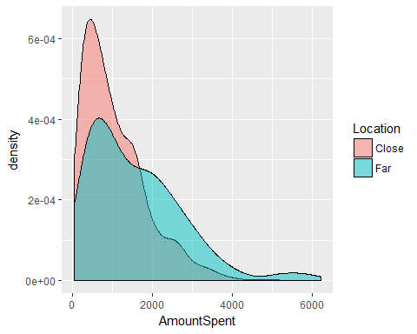

ggplot(orgdata, aes(x = AmountSpent, fill = History)) + geom_density(alpha = 0.5)

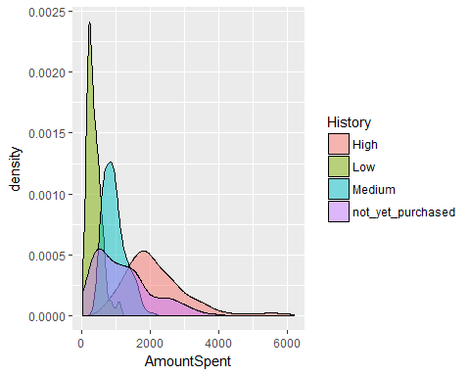

**2f-**

#Amountspent and Age  
Middle_sum<-0  
Middle_count<-0  
Young_sum<-0  
Young_count<-0  
Old_sum<-0  
Old_count<-0  
for(i in 1:1000){  
 if(orgdata$Age[i]=="Young"){  
 Young_sum<-Young_sum+(orgdata$AmountSpent)[i]  
 Young_count<-Young_count+1  
 }  
 else if(orgdata$Age[i]=="Middle"){  
 Middle_sum<-Middle_sum+(orgdata$AmountSpent)[i]  
 Middle_count<-Middle_count+1  
 }  
 else if(orgdata$Age[i]=="Old"){  
 Old_sum<-Old_sum+(orgdata$AmountSpent)[i]  
 Old_count<-Old_count+1  
 }  
}  
  
Age_Young_Mean<-(Young_sum/Young_count)  
Age_Middle_Mean<-(Middle_sum/Middle_count)  
Age_Old_Mean<-(Old_sum/Old_count)  
Age_Young_Mean

## [1] 558.6237

Age_Middle_Mean

## [1] 1501.691

Age_Old_Mean

## [1] 1432.127

#From the above observations, we can say that Middle>Old>Young (Means)

#Amountspent and Gender  
Male_sum<-0  
Male_count<-0  
Female_sum<-0  
Female_count<-0  
for(i in 1:1000){  
 if(orgdata$Gender[i]=="Female"){  
 Female_sum<-Female_sum+(orgdata$AmountSpent)[i]  
 Female_count<-Female_count+1  
 }  
 else if(orgdata$Gender[i]=="Male"){  
 Male_sum<-Male_sum+(orgdata$AmountSpent)[i]  
 Male_count<-Male_count+1  
 }  
}  
Gender_Female_Mean<-(Female_sum/Female_count)  
Gender_Male_Mean<-(Male_sum/Male_count)  
Gender_Female_Mean

## [1] 1025.34

Gender_Male_Mean

## [1] 1412.85

#From the above observations, we can say that Male>Female (Means)

#Amountspent and Location  
Far_sum<-0  
Far_count<-0  
Close_sum<-0  
Close_count<-0  
for(i in 1:1000){  
 if(orgdata$Location[i]=="Close"){  
 Close_sum<-Close_sum+(orgdata$AmountSpent)[i]  
 Close_count<-Close_count+1  
 }  
 else if(orgdata$Location[i]=="Far"){  
 Far_sum<-Far_sum+(orgdata$AmountSpent)[i]  
 Far_count<-Far_count+1  
 }  
}  
Location_Close_Mean<-(Close_sum/Close_count)  
Location_Far_Mean<-(Far_sum/Far_count)  
Location_Close_Mean

## [1] 1061.686

Location_Far_Mean

## [1] 1596.459

#From the above observations, we can say that Far>Close (Means)

#Amountspent and History  
High_sum<-0  
High_count<-0  
Medium_sum<-0  
Medium_count<-0  
Low_sum<-0  
Low_count<-0  
not_yet_purchased_sum<-0  
not_yet_purchased_count<-0  
for(i in 1:1000){  
 if(orgdata$History[i]=="Medium"){  
 Medium_sum<-Medium_sum+(orgdata$AmountSpent)[i]  
 Medium_count<-Medium_count+1  
 }  
 else if(orgdata$History[i]=="High"){  
 High_sum<-High_sum+(orgdata$AmountSpent)[i]  
 High_count<-High_count+1  
 }  
 else if(orgdata$History[i]=="Low"){  
 Low_sum<-Low_sum+(orgdata$AmountSpent)[i]  
 Low_count<-Low_count+1  
 }  
 else if(orgdata$History[i]=="not_yet_purchased"){  
 not_yet_purchased_sum<-not_yet_purchased_sum+(orgdata$AmountSpent)[i]  
 not_yet_purchased_count<-not_yet_purchased_count+1  
 }  
}  
  
History_Medium_Mean<-(Medium_sum/Medium_count)  
History_High_Mean<-(High_sum/High_count)  
History_Low_Mean<-(Low_sum/Low_count)  
History_not_yet_purchase_Mean<-(not_yet_purchased_sum/not_yet_purchased_count)  
History_Medium_Mean

## [1] 950.4009

History_High_Mean

## [1] 2186.137

History_Low_Mean

## [1] 357.087

History_not_yet_purchase_Mean

## [1] 1239.901

#From the above observations, we can say that High>not_yet_purchased>Medium>Low (Means)

For the remaining categorical attributes, with the above numerical data and conditional density plots, we can conclude that, (Means)

OwnHome:

Own>Rent

Marriage:

Married>Single

**3a-**

as_lr<-lm(AmountSpent~(Age)+ (Gender)+ (OwnHome)+ (Married)+ (Location)+ Salary+ Children+ (History)+ Catalogs, data=orgdata)  
summary(as_lr)

##   
## Call:  
## lm(formula = AmountSpent ~ (Age) + (Gender) + (OwnHome) + (Married) +   
## (Location) + Salary + Children + (History) + Catalogs, data = orgdata)  
##   
## Residuals:  
## Min 1Q Median 3Q Max   
## -1711.44 -292.41 -17.56 237.87 2876.91   
##   
## Coefficients:  
## Estimate Std. Error t value Pr(>|t|)   
## (Intercept) -285.74892 116.39444 -2.455 0.0143 *   
## AgeOld 63.36828 47.79586 1.326 0.1852   
## AgeYoung 8.90120 49.70059 0.179 0.8579   
## GenderMale -46.99837 32.85192 -1.431 0.1529   
## OwnHomeRent -16.63382 36.64327 -0.454 0.6500   
## MarriedSingle 32.74314 44.54067 0.735 0.4624   
## LocationFar 436.50575 35.92138 12.152 < 2e-16 ***  
## Salary 0.01920 0.00103 18.652 < 2e-16 ***  
## Children -162.73555 18.00348 -9.039 < 2e-16 ***  
## HistoryLow -352.89534 65.57529 -5.382 9.23e-08 ***  
## HistoryMedium -404.41014 52.94420 -7.638 5.19e-14 ***  
## Historynot_yet_purchased 6.99218 51.32915 0.136 0.8917   
## Catalogs 41.86880 2.45796 17.034 < 2e-16 ***  
## ---  
## Signif. codes: 0 '***' 0.001 '**' 0.01 '*' 0.05 '.' 0.1 ' ' 1  
##   
## Residual standard error: 485.7 on 987 degrees of freedom  
## Multiple R-squared: 0.7476, Adjusted R-squared: 0.7446   
## F-statistic: 243.7 on 12 and 987 DF, p-value: < 2.2e-16

#RMSE  
n = length(orgdata$AmountSpent)  
error = dim(n)  
for (k in 1:n) {  
 train1 = c(1:n)  
 train = train1[train1!=k]  
 m2 = lm(AmountSpent~(Age)+ (Gender)+ (OwnHome)+ (Married)+ (Location)+ Salary+ Children+ (History)+ Catalogs, data=orgdata[train, ])  
 pred = predict(m2, newdat=orgdata[-train ,])  
 obs = orgdata$AmountSpent[-train]  
 error[k] = obs-pred  
}  
me=mean(error)  
rmse=sqrt(mean(error^2))  
rmse

## [1] 489.3011

**3b-**

#linear  
Y<-orgdata$AmountSpent  
as_lr1<-lm(Y~Salary+Children+Catalogs, data=orgdata)  
summary(as_lr1)

##   
## Call:  
## lm(formula = Y ~ Salary + Children + Catalogs, data = orgdata)  
##   
## Residuals:  
## Min 1Q Median 3Q Max   
## -1775.9 -348.7 -38.7 255.5 3211.3   
##   
## Coefficients:  
## Estimate Std. Error t value Pr(>|t|)   
## (Intercept) -4.428e+02 5.372e+01 -8.242 5.29e-16 ***  
## Salary 2.041e-02 5.929e-04 34.417 < 2e-16 ***  
## Children -1.987e+02 1.709e+01 -11.628 < 2e-16 ***  
## Catalogs 4.770e+01 2.755e+00 17.310 < 2e-16 ***  
## ---  
## Signif. codes: 0 '***' 0.001 '**' 0.01 '*' 0.05 '.' 0.1 ' ' 1  
##   
## Residual standard error: 562.5 on 996 degrees of freedom  
## Multiple R-squared: 0.6584, Adjusted R-squared: 0.6574   
## F-statistic: 640 on 3 and 996 DF, p-value: < 2.2e-16

#evaluation_linear_rmse  
n = length(Y)  
error = dim(n)  
for (k in 1:n) {  
 train1 = c(1:n)  
 train = train1[train1!=k]  
 m2 = lm(AmountSpent ~ (Salary+Children+Catalogs), data=orgdata[train, ])  
 pred = predict(m2, newdat=orgdata[-train ,])  
 obs = orgdata$AmountSpent[-train]  
 error[k] = obs-pred  
}  
me=mean(error)  
rmse=sqrt(mean(error^2))  
rmse

## [1] 564.2606

#linear  
as_lr2<-lm(Y~Salary+Catalogs+Location+History, data=orgdata)  
summary(as_lr2)

##   
## Call:  
## lm(formula = Y ~ Salary + Catalogs + Location + History, data = orgdata)  
##   
## Residuals:  
## Min 1Q Median 3Q Max   
## -1388.30 -317.28 -18.88 260.36 3085.80   
##   
## Coefficients:  
## Estimate Std. Error t value Pr(>|t|)   
## (Intercept) -1.025e+02 8.210e+01 -1.249 0.212041   
## Salary 1.629e-02 6.682e-04 24.379 < 2e-16 ***  
## Catalogs 4.218e+01 2.576e+00 16.373 < 2e-16 ***  
## LocationFar 3.822e+02 3.729e+01 10.252 < 2e-16 ***  
## HistoryLow -6.573e+02 6.104e+01 -10.770 < 2e-16 ***  
## HistoryMedium -5.582e+02 5.288e+01 -10.555 < 2e-16 ***  
## Historynot_yet_purchased -1.824e+02 5.034e+01 -3.623 0.000306 ***  
## ---  
## Signif. codes: 0 '***' 0.001 '**' 0.01 '*' 0.05 '.' 0.1 ' ' 1  
##   
## Residual standard error: 510.4 on 993 degrees of freedom  
## Multiple R-squared: 0.7197, Adjusted R-squared: 0.718   
## F-statistic: 424.9 on 6 and 993 DF, p-value: < 2.2e-16

#evaluation_linear_rmse  
n = length(Y)  
error = dim(n)  
for (k in 1:n) {  
 train1 = c(1:n)  
 train = train1[train1!=k]  
 m2 = lm(AmountSpent ~ (Salary+Catalogs+Location+History), data=orgdata[train, ])  
 pred = predict(m2, newdat=orgdata[-train ,])  
 obs = orgdata$AmountSpent[-train]  
 error[k] = obs-pred  
}  
me=mean(error)  
rmse=sqrt(mean(error^2))  
rmse

## [1] 512.6858

#non_linear  
summary(lm(Y ~ (poly(Salary,degree = 3)+poly(Children, degree=3)+poly(Catalogs,degree = 3)), data = orgdata))

##   
## Call:  
## lm(formula = Y ~ (poly(Salary, degree = 3) + poly(Children, degree = 3) +   
## poly(Catalogs, degree = 3)), data = orgdata)  
##   
## Residuals:  
## Min 1Q Median 3Q Max   
## -1446.17 -341.91 -40.52 245.91 3154.38   
##   
## Coefficients:  
## Estimate Std. Error t value Pr(>|t|)   
## (Intercept) 1216.770 17.732 68.620 <2e-16 ***  
## poly(Salary, degree = 3)1 19783.922 573.256 34.512 <2e-16 ***  
## poly(Salary, degree = 3)2 627.740 564.356 1.112 0.2663   
## poly(Salary, degree = 3)3 -952.588 562.780 -1.693 0.0908 .   
## poly(Children, degree = 3)1 -6725.880 568.229 -11.837 <2e-16 ***  
## poly(Children, degree = 3)2 -9.906 563.149 -0.018 0.9860   
## poly(Children, degree = 3)3 971.219 562.656 1.726 0.0846 .   
## poly(Catalogs, degree = 3)1 10035.034 577.331 17.382 <2e-16 ***  
## poly(Catalogs, degree = 3)2 843.720 563.770 1.497 0.1348   
## poly(Catalogs, degree = 3)3 -941.450 561.343 -1.677 0.0938 .   
## ---  
## Signif. codes: 0 '***' 0.001 '**' 0.01 '*' 0.05 '.' 0.1 ' ' 1  
##   
## Residual standard error: 560.7 on 990 degrees of freedom  
## Multiple R-squared: 0.6627, Adjusted R-squared: 0.6596   
## F-statistic: 216.1 on 9 and 990 DF, p-value: < 2.2e-16

#evaluation_nonlinear_rmse  
n = length(Y)  
error = dim(n)  
for (k in 1:n) {  
 train1 = c(1:n)  
 train = train1[train1!=k]  
 m2 = lm(AmountSpent ~ (poly(Salary,degree = 3)+poly(Children, degree=3)+poly(Catalogs,degree = 3)), data=orgdata[train, ])  
 pred = predict(m2, newdat=orgdata[-train ,])  
 obs = orgdata$AmountSpent[-train]  
 error[k] = obs-pred  
}  
me=mean(error)  
rmse=sqrt(mean(error^2))  
rmse

## [1] 569.2569

#non_linear  
summary(lm(Y ~ (poly(Salary,degree = 3)+poly(Catalogs, degree=3)+Location+History), data = orgdata))

##   
## Call:  
## lm(formula = Y ~ (poly(Salary, degree = 3) + poly(Catalogs, degree = 3) +   
## Location + History), data = orgdata)  
##   
## Residuals:  
## Min 1Q Median 3Q Max   
## -1719.57 -319.57 -17.76 260.99 3062.65   
##   
## Coefficients:  
## Estimate Std. Error t value Pr(>|t|)   
## (Intercept) 1434.00 42.93 33.401 < 2e-16 ***  
## poly(Salary, degree = 3)1 15705.85 653.97 24.016 < 2e-16 ***  
## poly(Salary, degree = 3)2 517.74 547.25 0.946 0.344340   
## poly(Salary, degree = 3)3 267.42 528.00 0.506 0.612632   
## poly(Catalogs, degree = 3)1 8853.43 540.22 16.389 < 2e-16 ***  
## poly(Catalogs, degree = 3)2 325.67 513.77 0.634 0.526304   
## poly(Catalogs, degree = 3)3 -424.28 514.36 -0.825 0.409648   
## LocationFar 379.49 37.39 10.148 < 2e-16 ***  
## HistoryLow -669.63 62.66 -10.687 < 2e-16 ***  
## HistoryMedium -553.04 54.67 -10.115 < 2e-16 ***  
## Historynot_yet_purchased -184.90 50.75 -3.644 0.000283 ***  
## ---  
## Signif. codes: 0 '***' 0.001 '**' 0.01 '*' 0.05 '.' 0.1 ' ' 1  
##   
## Residual standard error: 510.8 on 989 degrees of freedom  
## Multiple R-squared: 0.7203, Adjusted R-squared: 0.7175   
## F-statistic: 254.7 on 10 and 989 DF, p-value: < 2.2e-16

#evaluation_nonlinear_rmse  
n = length(Y)  
error = dim(n)  
for (k in 1:n) {  
 train1 = c(1:n)  
 train = train1[train1!=k]  
 m2 = lm(AmountSpent ~ (poly(Salary,degree = 3)+poly(Catalogs, degree=3)+Location+History), data=orgdata[train, ])  
 pred = predict(m2, newdat=orgdata[-train ,])  
 obs = orgdata$AmountSpent[-train]  
 error[k] = obs-pred  
}  
me=mean(error)  
rmse=sqrt(mean(error^2))  
rmse

## [1] 522.0549

#non_linear  
summary(lm(Y ~ (poly(Salary,degree = 3)+poly(Catalogs, degree=3)+Location+History+Age+Children+Gender), data = orgdata))

##   
## Call:  
## lm(formula = Y ~ (poly(Salary, degree = 3) + poly(Catalogs, degree = 3) +   
## Location + History + Age + Children + Gender), data = orgdata)  
##   
## Residuals:  
## Min 1Q Median 3Q Max   
## -1726.91 -293.42 -17.49 245.35 2871.56   
##   
## Coefficients:  
## Estimate Std. Error t value Pr(>|t|)   
## (Intercept) 1420.27 52.49 27.058 < 2e-16 ***  
## poly(Salary, degree = 3)1 18172.66 816.81 22.248 < 2e-16 ***  
## poly(Salary, degree = 3)2 242.65 569.36 0.426 0.670   
## poly(Salary, degree = 3)3 -80.06 507.75 -0.158 0.875   
## poly(Catalogs, degree = 3)1 8751.93 514.60 17.007 < 2e-16 ***  
## poly(Catalogs, degree = 3)2 520.24 489.21 1.063 0.288   
## poly(Catalogs, degree = 3)3 -519.18 489.77 -1.060 0.289   
## LocationFar 434.20 35.98 12.067 < 2e-16 ***  
## HistoryLow -357.41 67.32 -5.309 1.36e-07 ***  
## HistoryMedium -396.82 54.31 -7.307 5.66e-13 ***  
## Historynot_yet_purchased 10.11 51.84 0.195 0.845   
## AgeOld 56.57 46.19 1.225 0.221   
## AgeYoung -12.67 51.01 -0.248 0.804   
## Children -163.47 18.02 -9.070 < 2e-16 ***  
## GenderMale -43.39 32.92 -1.318 0.188   
## ---  
## Signif. codes: 0 '***' 0.001 '**' 0.01 '*' 0.05 '.' 0.1 ' ' 1  
##   
## Residual standard error: 485.8 on 985 degrees of freedom  
## Multiple R-squared: 0.748, Adjusted R-squared: 0.7445   
## F-statistic: 208.9 on 14 and 985 DF, p-value: < 2.2e-16

#evaluation_nonlinear_rmse  
n = length(Y)  
error = dim(n)  
for (k in 1:n) {  
 train1 = c(1:n)  
 train = train1[train1!=k]  
 m2 = lm(AmountSpent ~ (poly(Salary,degree = 3)+poly(Catalogs, degree=3)+Location+History+Age+Children+Gender), data=orgdata[train, ])  
 pred = predict(m2, newdat=orgdata[-train ,])  
 obs = orgdata$AmountSpent[-train]  
 error[k] = obs-pred  
}  
me=mean(error)  
rmse=sqrt(mean(error^2))  
rmse

## [1] 498.0905

**3c-**

I considered the best model as the one (3a) with highest R2 and low RMSE as the linear regression model with all numerical and categorical variables.

library(MASS)  
fit = lm(AmountSpent~(Age)+ (Gender)+ (OwnHome)+ (Married)+ (Location)+ Salary+ Children+ (History)+ Catalogs, data=orgdata)  
stepAIC(fit, direction="backward")

## Start: AIC=12384.2  
## AmountSpent ~ (Age) + (Gender) + (OwnHome) + (Married) + (Location) +   
## Salary + Children + (History) + Catalogs  
##   
## Df Sum of Sq RSS AIC  
## - Age 2 443097 233304046 12382  
## - OwnHome 1 48616 232909565 12382  
## - Married 1 127499 232988448 12383  
## <none> 232860949 12384  
## - Gender 1 482863 233343812 12384  
## - Children 1 19276638 252137587 12462  
## - History 3 28426404 261287353 12493  
## - Location 1 34838025 267698974 12522  
## - Catalogs 1 68455782 301316731 12640  
## - Salary 1 82083034 314943983 12684  
##   
## Step: AIC=12382.1  
## AmountSpent ~ Gender + OwnHome + Married + Location + Salary +   
## Children + History + Catalogs  
##   
## Df Sum of Sq RSS AIC  
## - Married 1 55318 233359364 12380  
## - OwnHome 1 147202 233451248 12381  
## <none> 233304046 12382  
## - Gender 1 664803 233968849 12383  
## - Children 1 24879626 258183672 12481  
## - History 3 28889456 262193501 12493  
## - Location 1 35011045 268315091 12520  
## - Catalogs 1 68392954 301697000 12637  
## - Salary 1 107651722 340955767 12760  
##   
## Step: AIC=12380.33  
## AmountSpent ~ Gender + OwnHome + Location + Salary + Children +   
## History + Catalogs  
##   
## Df Sum of Sq RSS AIC  
## - OwnHome 1 162809 233522173 12379  
## <none> 233359364 12380  
## - Gender 1 634446 233993810 12381  
## - Children 1 24825054 258184418 12479  
## - History 3 29027254 262386618 12492  
## - Location 1 34961973 268321337 12518  
## - Catalogs 1 68354217 301713581 12635  
## - Salary 1 153879921 387239285 12885  
##   
## Step: AIC=12379.03  
## AmountSpent ~ Gender + Location + Salary + Children + History +   
## Catalogs  
##   
## Df Sum of Sq RSS AIC  
## <none> 233522173 12379  
## - Gender 1 670888 234193061 12380  
## - Children 1 24994947 258517120 12479  
## - History 3 29194376 262716549 12491  
## - Location 1 34842146 268364319 12516  
## - Catalogs 1 68330846 301853019 12634  
## - Salary 1 177237435 410759607 12942

##   
## Call:  
## lm(formula = AmountSpent ~ Gender + Location + Salary + Children +   
## History + Catalogs, data = orgdata)  
##   
## Coefficients:  
## (Intercept) GenderMale   
## -228.38437 -54.28354   
## LocationFar Salary   
## 436.04608 0.01892   
## Children HistoryLow   
## -171.98225 -355.05647   
## HistoryMedium Historynot_yet_purchased   
## -408.81287 -0.03510   
## Catalogs   
## 41.74594

The most important predictors are seem to be above all from the observations and the probabilities of corresponding values in the summary of the above best model. In all these, Salary predictor is seems to be the best one with low probability and correlation with AmountSpent and an important predictor from StepAIC.