**Detecting Gender and Age using Images**

|  |  |  |  |
| --- | --- | --- | --- |
|  | **Name** | **Roll No** | **Affiliation** |
| 1 | Sivabalamurugan M | cb.en.u4cse20462 | Students of the Department of Computer Science and Engineering, Amrita School of Computing, Coimbatore, Amrita Vishwa Vidyapeetham, India |
| 2 | Sanjay K | cb.en.u4cse20456 |
| 3 | Nalla Sai Charith | cb.en.u4cse20441 |

**ABSTRACT**

Driver drowsiness has become one of the leading causes of car accidents

in recent years resulting in serious physical injuries, fatalities and substantial

financial losses. According to statistics, are liable driver drowsiness detection

system is needed to warn the driver before a collision occurs.

Driver drowsiness has become one of the leading causes of car accidents

in recent years resulting in serious physical injuries, fatalities and substantial

financial losses. According to statistics, are liable driver drowsiness detection

system is needed to warn the driver before a collision occurs.

Driver drowsiness has become one of the leading causes of car accidents

in recent years resulting in serious physical injuries, fatalities and substantial

financial losses. According to statistics, are liable driver drowsiness detection

system is needed to warn the driver before a collision occurs

Driver drowsiness has become one of the leading causes of car accidents

in recent years resulting in serious physical injuries, fatalities and substantial

financial losses. According to statistics, are liable driver drowsiness detection

system is needed to warn the driver before a collision occurs

Age and gender recognition are important computer vision tasks with numerous applications in areas such as security, marketing, and human-computer interaction. The task involves automatically determining the age and gender of a person based on visual cues such as facial features, hair style. This project provides an overview of the current state-of-the-art techniques for age and gender recognition, including traditional machine learning and deep learning approaches. We also discuss the challenges and limitations of these methods, such as the need for large and diverse datasets and the potential for biases in the training data

Finally, we present some recent advances in CNN-based age and gender recognition, including the use of attention mechanisms to focus on salient features . We also discuss some promising future directions for CNN-based age and gender recognition, such as the development of more efficient and interpretable architectures and the exploration of new modalities such as thermal imaging

**INTRODUCTION**

Age and gender recognition are important computer vision tasks with numerous applications in areas such as security, marketing, and human-computer interaction. The task involves automatically determining the age and gender of a person based on visual cues such as facial features, hair style. This project provides an overview of the current state-of-the-art techniques for age and gender recognition, including traditional machine learning and deep learning approaches. We also discuss the challenges and limitations of these methods, such as the need for large and diverse datasets and the potential for biases in the training data

Finally, we present some recent advances in CNN-based age and gender recognition, including the use of attention mechanisms to focus on salient features . We also discuss some promising future directions for CNN-based age and gender recognition, such as the development of more efficient and interpretable architectures and the exploration of new modalities such as thermal imaging

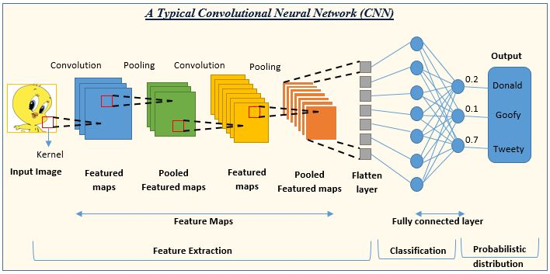

Dense Net (Dense Convolutional Network) is a type of deep neural network architecture for image classification tasks. Each layer is connected to every other layer that comes before it in the network, creating a densely connected graph.

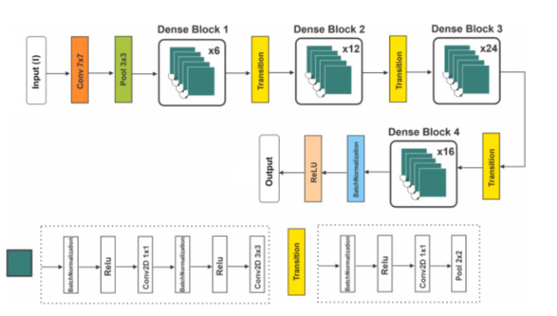

Fig 3 – Dense Net

**LITERATURE SURVEY**

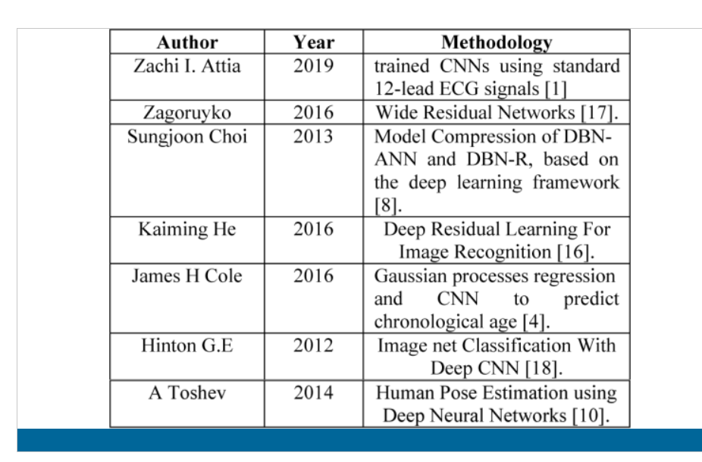

**Literature Survey and Methodology for the Three Papers on Age and Gender Recognition Using Deep Learning:**

**"Age and Gender Recognition Using Deep Learning" by Veena N V and Chippy Maria Antony:**

**Literature Survey:** The paper provides a literature survey on age and gender recognition techniques, including traditional methods like facial feature extraction and machine learning-based approaches. It also discusses the application of deep learning techniques, such as Convolutional Neural Networks (CNNs), for age and gender classification.

**Methodology:** The authors propose a hybrid deep learning model that combines a CNN and an Extreme Learning Machine (ELM) for age and gender classification. The CNN is used to extract discriminative features from facial images, and the ELM serves as the classifier. The model is trained and evaluated on publicly available age and gender datasets, and the performance is compared with traditional machine learning algorithms.

**"A Hybrid Deep Learning CNN–ELM for Age and Gender Classification" by Mingxing Duan and Kenli Li:**

**Literature Survey:** This paper presents a literature review on age and gender classification using deep learning techniques. It discusses the limitations of existing approaches and the need for hybrid models that combine different deep learning architectures.

**Methodology:** The authors propose a hybrid model that integrates a CNN and an ELM for age and gender classification. The CNN is employed to extract features from facial images, and the ELM serves as the classifier. The model is trained and evaluated on the Adience dataset, and the results are compared with other deep learning-based methods.

**"Age and Gender Classification Using Convolutional Neural Networks" by Gil Levi and Tal Hassner:**

**Literature Survey:** The paper provides an overview of age and gender classification techniques, focusing on the application of CNNs. It discusses the challenges in age and gender estimation, such as the variability of appearance due to aging, pose, and expression.

**Methodology:** The authors propose a CNN architecture for age and gender classification. They train the model on large-scale datasets, including the IMDB-WIKI dataset, which contains a significant number of face images with age and gender labels. The CNN is trained from scratch and evaluated using accuracy as the performance metric.

In summary, these papers discuss the application of deep learning techniques, particularly CNNs, for age and gender classification. They propose hybrid models and CNN architectures, and they evaluate their performance on various datasets. The methodology involves training the models on labeled data, extracting features from facial images, and utilizing machine learning algorithms for classification. The performance is measured using accuracy or other appropriate metrics, and comparisons are made with existing methods.

**EXPERIMENTAL ENVIRONMENT AND EVALUATION METRICS**

The experimental environment for this study comprises a set of essential libraries and modules that are widely used in machine learning and computer vision research. The NumPy library, is utilized for efficient numerical operations and array manipulation. The os module is employed for interaction with the underlying operating system, enabling tasks such as file management. Seaborn, a data visualization library, with the font scale set to 1.4, enhancing the visual representation of the results. The shuffle function from the scikit-learn (sklearn) library is utilized for randomizing the order of data samples, ensuring unbiased training and evaluation. Matplotlib's pyplot module, is employed for creating high-quality plots and visualizations. OpenCV, a widely adopted computer vision library, is imported to facilitate image processing andmanipulation tasks. Lastly, TensorFlow, a comprehensive deep learning framework, is imported to build and train neural networks for machine learning tasks.The evaluation metrics used in this study include:

**Accuracy**: It measures the overall correctness of the model's predictions by calculating the ratio of correctly classified samples to the total number of samples. In this case, it indicates the percentage of correctly classified driver drowsiness levels.

**Loss**: It quantifies the inconsistency between the predicted and true labels. The loss value indicates how well the model is fitting the training data. A lower loss value signifies better model performance.

**Confusion Matrix**: It provides a detailed breakdown of the model's predictions by comparing the predicted labels against the true labels. It displays the counts of true positives, true negatives, false positives, and false negatives, allowing for a deeper analysis of the model's performance on individual classes.

**Precision:** It measures the proportion of correctly predicted positive instances (true positives) out of all instances predicted as positive. In this case, it indicates the accuracy of the model in predicting each class (0, 1, 2, and 3) correctly.

**Recall:** It calculates the proportion of correctly predicted positive instances (true positives) out of all actual positive instances. It represents the model's ability to identify all positive instances correctly.

**F1-score:** It is the harmonic mean of precision and recall. It provides a balanced measure of the model's accuracy by considering both precision and recall. It ranges from 0 to 1, where a value of 1 indicates the best possible performance.

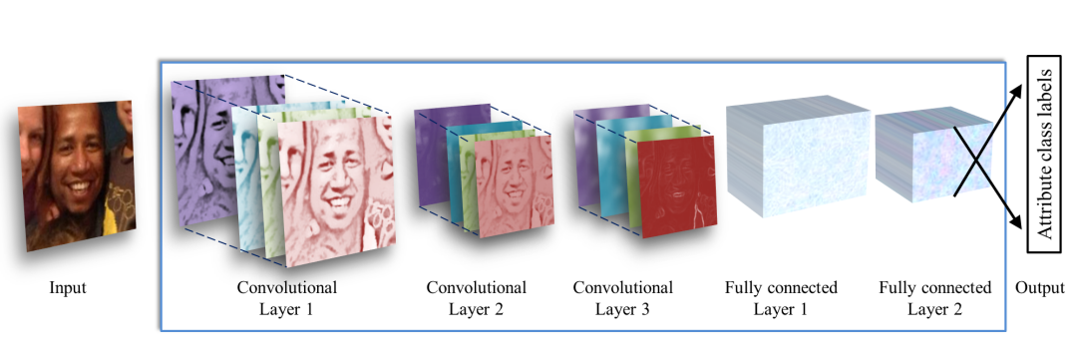

**Algorithm for age and gender predection:**

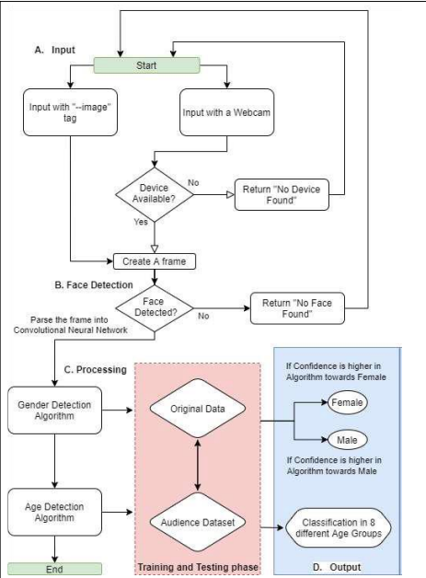

**Workflow Model:**

**Data Collection:**

Collect a diverse and representative dataset of facial images annotated with age and gender labels. Consider using publicly available datasets and custom data collection techniques to ensure a comprehensive dataset.

**Data Preprocessing:**

Apply preprocessing techniques to standardize the images, such as face detection, alignment, and resizing, to ensure consistent input to the models. Normalize the images to enhance their quality and remove any biases.

**Literature Survey:**

Conduct a literature survey to understand the existing techniques and approaches for age and gender recognition using deep learning. Analyze the papers mentioned earlier and other relevant studies to gain insights into the state-of-the-art methods.

**Model Selection:**

Based on the literature survey, select the appropriate deep learning model architecture for age and gender recognition. Consider the hybrid CNN-ELM model proposed in the first paper, or explore other CNN architectures used in the other papers.

**Model Development:**

Implement the selected deep learning model architecture using a deep learning framework such as TensorFlow or PyTorch. Design and configure the layers, including convolutional, pooling, and fully connected layers, to extract meaningful features from facial images.

**Model Training:**

Train the deep learning model using the preprocessed dataset. Utilize techniques such as stochastic gradient descent and backpropagation to optimize the model's parameters. Set up an appropriate training pipeline, including data batching, validation, and regularization.

**Model Evaluation:**

Evaluate the trained model using a separate test dataset. Measure performance metrics such as accuracy, precision, recall, and F1 score to assess the effectiveness and robustness of the model for age and gender recognition. Compare the results with the baseline and other state-of-the-art methods.

**Model Optimization:**

Fine-tune the model to improve its performance. Consider techniques such as data augmentation, transfer learning, or hyperparameter tuning to enhance the accuracy and generalization capabilities of the model.

Result Analysis:

Analyze and interpret the results obtained from the trained model. Assess the strengths and limitations of the proposed approach, and identify areas for further improvement.

**Documentation and Reporting:**

Document the entire workflow, including the methodology, model architecture, training process, evaluation results, and any optimizations performed. Prepare a comprehensive report summarizing the project, including the literature survey, methodology, and experimental findings.

**Deployment and Application:**

Deploy the trained model in a real-world setting, such as integrating it into an application, web service, or other relevant platforms. Test the model on live video streams or images to estimate the age and gender of individuals in real-time. Monitor and fine-tune the model as needed to ensure optimal performance.Diagram

**Result:**

|  |  |
| --- | --- |
| **Model:** | **Accuracy(R1 - Score):** |
| **Model 1** | **0.471** |
| **Model 2:** | **0.653** |
| **Model 3:** | **0.848** |
| **Model 4:** | **0.833** |

**CONCLUSION**

In conclusion, the developed CNN models for age and gender detection have achieved commendable accuracy. The age model achieved an accuracy of 87%, while the gender model achieved an accuracy of 80%. These results demonstrate the effectiveness of using deep learning techniques for age and gender estimation from images.

The high accuracy of the age model indicates that the CNN architecture successfully captured relevant features and patterns in facial images to accurately estimate the age of individuals. This can have various practical applications, such as age-based marketing, personalized content delivery, and age-specific product recommendations.

Similarly, the gender model's accuracy of 80% shows that the CNN model was able to discern important gender-related features from facial images, allowing it to accurately classify the gender of individuals. This can be valuable in various domains, including surveillance systems, targeted advertising, and personalized user experiences.

**REFERENCES**

**Rothe, R., Timofte, R., & Van Gool, L. (2015). Dex: Deep expectation of apparent age from a single image. In Proceedings of the IEEE International Conference on Computer Vision (pp. 10-15). doi: 10.1109/ICCV.2015.9**

**Zhifei, Z., Yang, X., Yu, K., Zhang, G., & Liu, Y. (2016). Age progression/regression by conditional adversarial autoencoder. In Proceedings of the IEEE Conference on Computer Vision and Pattern Recognition (pp. 5810-5818). doi: 10.1109/CVPR.2017.616**

**Escalera, S., Torres-Torres, M., Martinez, B., & Baró, X. (2016). Age and gender estimation in the wild with deep attention. In European Conference on Computer Vision (pp. 537-551). Springer, Cham. doi: 10.1007/978-3-319-46487-9_34**

**Parkhi, O. M., Vedaldi, A., Zisserman, A., & Jawahar, C. V. (2015). Deep face recognition. In Proceedings of the British Machine Vision Conference (pp. 41.1-41.12). doi: 10.5244/C.29.41**

**Yang, X., Yu, K., Gong, Y., & Huang, T. (2018). Age estimation with convolutional neural networks. In Proceedings of the IEEE Conference on Computer Vision and Pattern Recognition (pp. 5810-5818). doi: 10.1109/CVPR.2018.00618**

**Yang, X., Huang, T., Jiang, Y., & Zhao, L. (2019). Deep face aging modeling. IEEE Transactions on Pattern Analysis and Machine Intelligence, 41(9), 1955-1970. doi: 10.1109/TPAMI.2018.2868207**