Home Page :

Initially without users will be as follows.

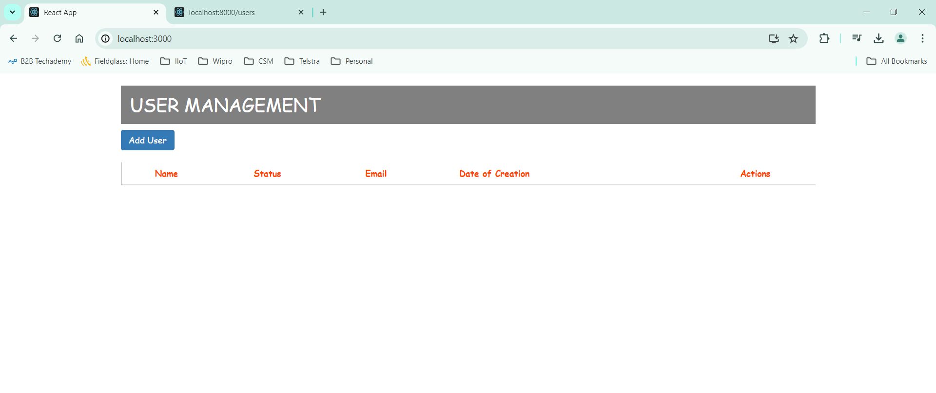

AddUser Page :

Validation:

Home Page :

After adding users, it will be as follows,

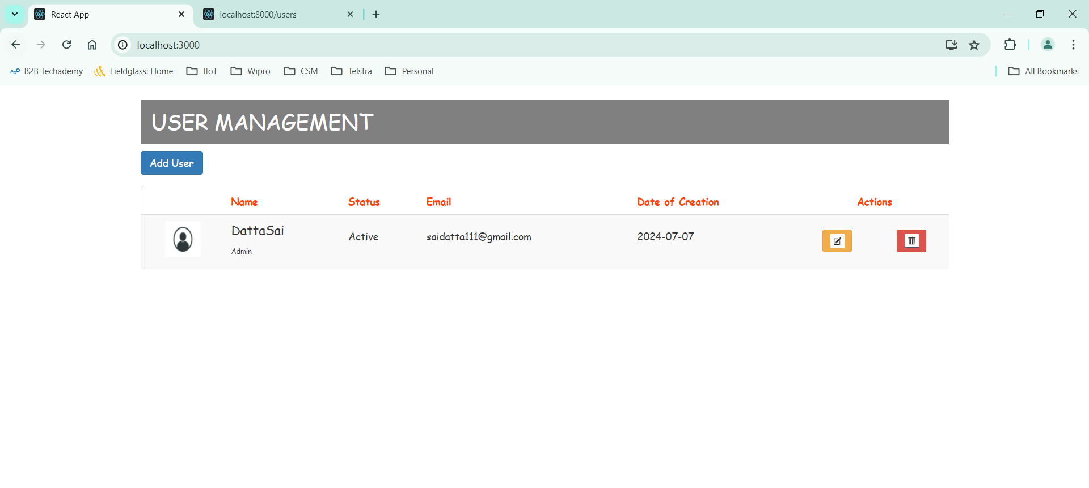

Edit Page :

Edit page will be same as add details page where the details will be populated as shown :

Updated email for the user:

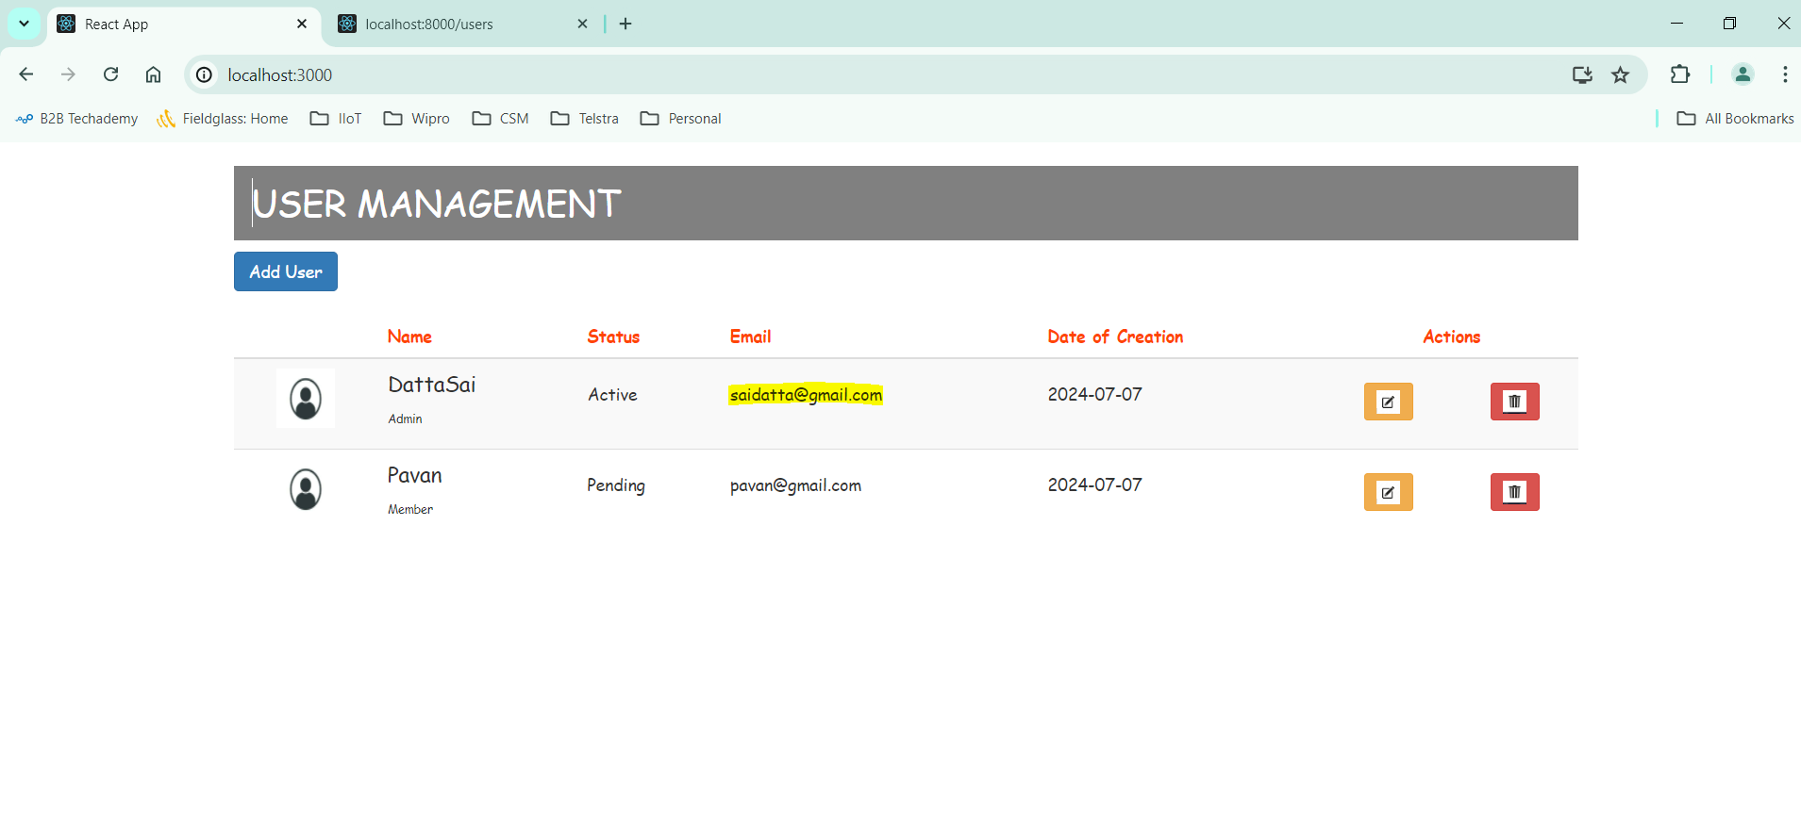

Deleting user :

Alert will be shown to verify for delete as shown below.

Post Deletion :

JSON-Server:

Observations :

1. Adding user won’t ask for date of creation and while editing the user , we cannot edit that field. It will consider current date of user creation.
2. Edit page is same as Create page, where only the heading of the page will be displayed as edit and add user respectively.
3. Back button is also provided if user wants to go back to home page either from Add User page or Edit page.
4. Role and Status fields are dropdowns which needs to be selected from the list provided.
5. Validations are done on every field , making all the fields are mandatory.