**Pizza Hut Sales Analysis**

**Prepared by: Sai Deepak**

**Introduction**

In the competitive landscape of the food and beverage industry, businesses like Pizza Hut must continuously adapt to shifting customer preferences and market trends. One of the most effective ways to achieve this is through data-driven analysis. With the increasing availability of transactional and behavioural data, companies have a valuable opportunity to uncover insights that can influence product offerings, marketing strategies, and overall customer experience.

This assignment revolves around analysing Pizza Hut’s sales data using SQL—a powerful tool for querying and interpreting structured data. By applying SQL techniques to real-world business data, we aim to identify patterns and trends that can provide a clearer picture of customer ordering behaviour. These insights not only help in understanding what customers like and when they are most likely to order, but also in evaluating which product categories contribute most to the company’s revenue. Ultimately, this analysis enables strategic recommendations that can enhance decision-making across departments.

**Problem Statement**

Pizza Hut is seeking to improve its business performance by gaining a deeper understanding of its customers' preferences and purchasing habits. Despite having access to a substantial volume of sales data, the company lacks a structured approach to extracting insights that can inform key decisions. Specifically, Pizza Hut wants to know which pizzas are the most popular, what times of the day or week see the highest order volumes, and how different pizza categories contribute to overall revenue.

Currently, this information is locked within raw datasets, making it difficult to derive clear and actionable conclusions. Without targeted analysis, opportunities for optimization—such as adjusting inventory, tailoring promotions, or refining menu offerings—remain untapped. This assignment aims to bridge that gap by using SQL to perform a comprehensive analysis of the available data, highlighting trends, customer behaviours, and revenue patterns. The insights gathered will serve as the foundation for business recommendations that align with customer needs and market demands.

**Pizza Hut Sales Dataset – Description**

The dataset consists of **four CSV files** forming a relational database:

* + orders.csv
  + order_details.csv
  + pizzas.csv
  + pizza_types.csv

**1. orders.csv – General Order Information**

* Each row represents a unique **customer order**.
* Key fields:
  + order_id: Identifier of each order and a unique identifier for each order.
  + date and time: Timestamp of when the order was placed.
* Useful for:
  + **Time-based analysis** (e.g., peak hours, daily trends, etc).

**2. order_details.csv – Line Items in Each Order**

* Contains the **specific items** included in each order.
* Key fields:
  + order_details_id: Unique identifier for each order line item.
  + order_id: Identifier of each order and a foreign key linking to orders.csv.
  + pizza_id: Identifier of each pizza and a foreign key linking to pizzas.csv Identifier for each pizza
  + quantity: Number of pizzas ordered.
* Enables:
  + Analysis of **order composition** and **item-level sales frequency**.

**3. pizzas.csv – Pizza Variants and Pricing**

* Describes each **pizza variant**, including its **size and price**.
* Key fields:
  + pizza_id: Unique ID combining pizza type and size (e.g., bbq_chicken_l).
  + pizza_type_id: Identifier of each pizza type and a foreign key linking to pizza_types.csv.
  + size: Size of the pizza (e.g., S, M, L, XL).
  + price: Price of that pizza variant.
* Useful for:
  + **Revenue calculation**, pricing strategy analysis, and size-based trends.

**4. pizza_types.csv – Pizza Type Metadata**

* Contains **descriptive details** about each base pizza type.
* Key fields:
  + pizza_type_id: Identifier of each pizza type and a unique identifier (e.g., bbq_chicken).
  + name: pizza name.
  + category: Type of pizza (e.g., Classic, Veggie, Meat).
  + ingredients: List of ingredients in the pizza.
* Enables:
  + **Category-based segmentation**, ingredient popularity insights, and preference trends.

**ANALYSIS**

**BASIC ANALYSIS – QUESTIONS AND ANSWERS**

1. Total Orders Count

Find the total number of orders placed.

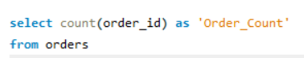



1. Revenue Calculation

Calculate the total revenue from pizza sales.

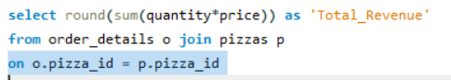



1. Most Expensive Pizza

Identify the highest-priced pizza.

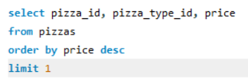

**BASIC ANALYSIS – QUESTIONS AND ANSWERS**

1. Most Ordered Pizza Size

Determine the most frequently ordered pizza size.

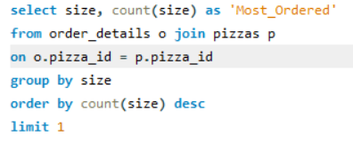



1. Top 5 Popular Pizzas

List the top 5 pizzas by order quantity.

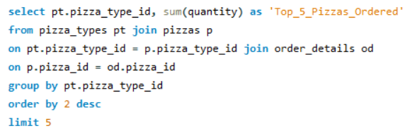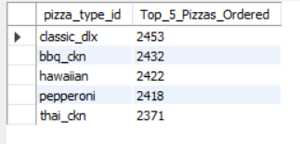

**INTERMEDIATE ANALYSIS – QUESTIONS AND ANSWERS**

1. Pizza Quantity by Category

Calculate the total quantity ordered for each pizza category.

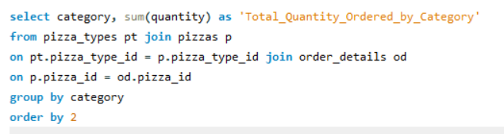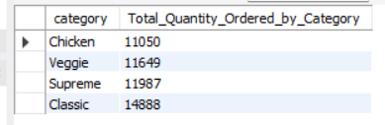

1. Order Trends by Hour

Analyze the distribution of orders by hour of day.

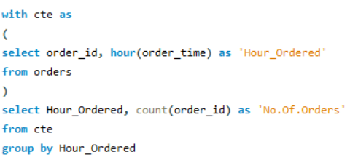

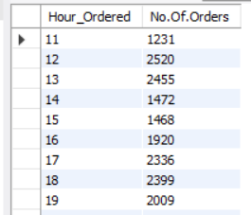

1. Pizza Distribution by Category.

Determine the order distribution of pizzas by category.

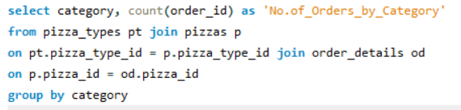

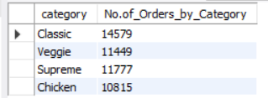

1. Average Daily Pizza Orders

Calculate the average number of pizzas ordered each day.

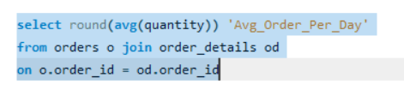



1. Top Pizza Types by Revenue.

Identify the top 3 pizzas based on revenue.

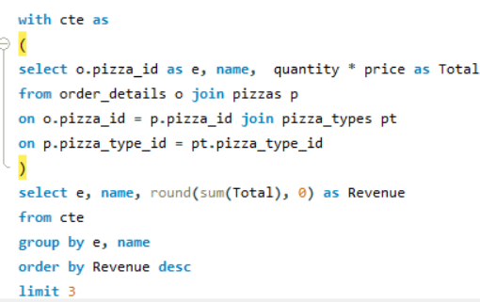

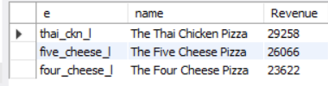

**ADVANCED ANALYSIS – QUESTIONS AND ANSWERS**

1. Revenue Contribution by Pizza Type .

Calculate each pizza type’s percentage contribution to total revenue.

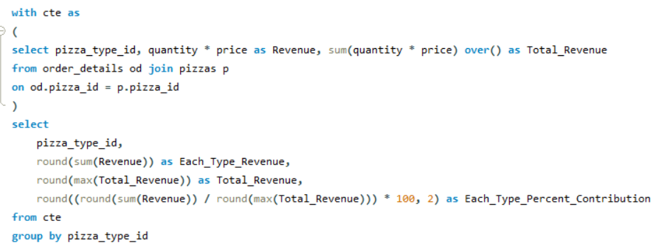

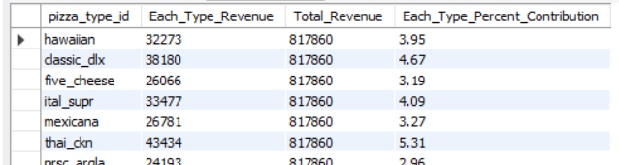

1. Cumulative Revenue Over Time

Track cumulative revenue growth over time.

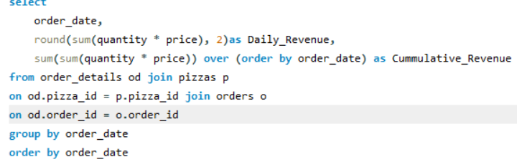

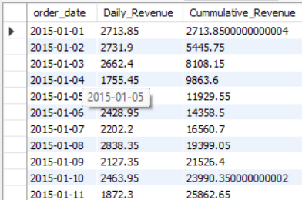

1. Top 3 Pizza Types by Revenue in Each Category

Determine the top 3 pizzas by revenue within each category.

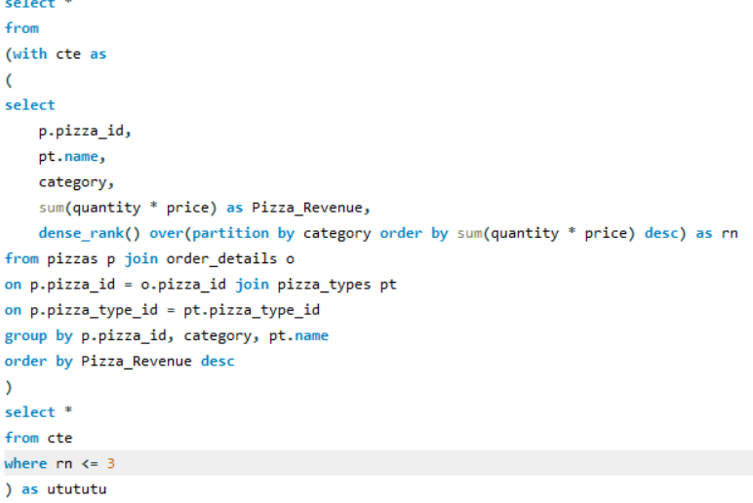

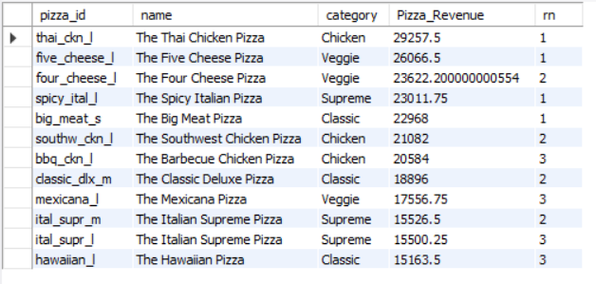

**ANALYSIS & INSIGHTS**

**1. Top 5 Popular Pizzas by Order Quantity**

* Most Ordered Pizzas (Analysis):
  + The top 5 pizzas by quantity indicate strong customer preferences.
  + These are consistently from popular categories like Classic and Chicken.
* Insight:
  + High demand is clustered around a few specific variants, showing clear customer favourites.

**2. Most Ordered Pizza Size**

* **Top Size (Analysis)**: The **Large (L)** size is the most ordered by a significant margin.
* **Insight**:
  + Customers prefer **value-for-money** options or are likely ordering for sharing.
  + Smaller sizes (S/M) trail behind, while XL may be limited by pricing or portion preference.

**3. Order Distribution by Category**

* Top Categories (Analysis):
  + Classic pizzas dominate, followed by Meat and Supreme.
  + Veggie and Chicken categories have lower order volumes.
* Insight:
  + Traditional flavours resonate more with customers.
  + Vegetarian options might be under-promoted or less appealing in current form.

**4. Revenue Contribution**

* **Top Contributors (Analysis)**:
  + Revenue is **not evenly distributed**. A handful of pizzas bring in the bulk of sales revenue.
  + Some lower-quantity items contribute high revenue due to **higher price points**.
* **Insight**:
  + Focus not just on popularity — high-value items even with low sales are crucial to profitability.

**5. Top 3 Pizzas in Each Category**

* **Bestsellers within every category** (Analysis):
  + Classic: Big Meat Pizza, Classic Deluxe Pizza
  + Supreme: Spicy Italian Pizza, Italian Supreme Pizza
  + Chicken: Thai Chicken Pizza, Southwest Chicken Pizza
  + Veggie: Five Cheese Pizza, Four Cheese Pizza
* **Insight**:
  + There’s room to phase out underperformers or cross-promote top items within each category.

**6. Overall Top 3 Pizzas**

* These are **absolute leaders** in quantity (Analysis) :
  + Classic Deluxe Pizza
  + Barbecue Chicken Pizza
  + Hawaiian Pizza
* **Insight:** Likely to be strong for
  + Promotions
  + Bundle deals
  + Flagship branding (menu highlights, combos, etc.)

**Recommendations**

1. **Promote Top Performers**
   * Use the top 3–5 pizzas as anchors in **meal deals and combo offers**.
   * Feature them prominently in marketing campaigns like social media, flyers, banners.
2. **Focus on Large Size**
   * Given the popularity of **large pizzas**, offer value bundles and family packs centered on the L size.
   * Consider adding a loyalty incentive for repeat large-size orders.
3. **Rethink Underperforming Categories**

* Veggie and Chicken categories may benefit from:
  + Menu revamp
  + Creative ingredient combinations
  + Special discounts or awareness campaigns

1. **Capitalize on High-Revenue Pizzas**
   * Highlight pizzas with high revenue-per-order even if they are not most ordered.
   * These can boost profit margins when upsold effectively.
2. **Category-Specific Promotions**
   * Run rotating “Category of the Week” campaigns to test engagement with different groups.
   * Helps test if lower-demand categories simply suffer from visibility or price resistance.
3. **Inventory and Supply Chain Optimization**
   * Use insights to stock ingredients for high-demand items more efficiently.
   * Reduce waste by lowering inventory for low-selling pizzas.
4. **Customer Targeting & Promotions**

* **Segmented Campaigns**:
  + Target meat-lovers and classic fans with loyalty programs.
  + Offer limited-time offers for low-performing categories to test engagement.
* **Occasion-Based Bundles**:
  + Large-size preference = group ordering → target game nights, parties, weekends.
  + Create seasonal/holiday bundles centered on large, classic pizzas.

1. **Sales & Marketing Strategy**

**Highlight High-Revenue Pizzas:**

* **Use premium pizzas in upselling scripts, online ordering, and combo deals.**

**Size-Based Campaigns:**

* **Offer tiered bundles (e.g., Buy 2 Large, Get 1 Medium Free).**
* **Test price elasticity on XL pizzas — slight price drops could unlock new demand.**

**Conclusion**

This is the detailed analysis of Pizza Hut sales data, highlighting key customer preferences and performance patterns:

* Most orders and revenue come from a few popular pizzas and large sizes
* Classic and Meat categories are customer favourites
* High-priced pizzas, though less ordered, contribute significantly to profits
* Streamlining the menu and promoting bestsellers can boost efficiency and sales
* A focused product and marketing strategy will enhance both revenue and customer satisfaction.