Pizza Sales Analysis
Prepared by: Sai Deepak

Introduction

In the competitive landscape of the food and beverage industry, businesses like Pizza Hut must continuously adapt to shifting customer preferences and market trends. One of the most effective ways to achieve this is through data-driven analysis. With the increasing availability of transactional and behavioural data, companies have a valuable opportunity to uncover insights that can influence product offerings, marketing strategies, and overall customer experience.
This assignment revolves around analysing Pizza Hut’s sales data using SQL—a powerful tool for querying and interpreting structured data. By applying SQL techniques to real-world business data, we aim to identify patterns and trends that can provide a clearer picture of customer ordering behaviour. These insights not only help in understanding what customers like and when they are most likely to order, but also in evaluating which product categories contribute most to the company’s revenue. Ultimately, this analysis enables strategic recommendations that can enhance decision-making across departments.

Problem Statement
Pizza Hut is seeking to improve its business performance by gaining a deeper understanding of its customers' preferences and purchasing habits. Despite having access to a substantial volume of sales data, the company lacks a structured approach to extracting insights that can inform key decisions. Specifically, Pizza Hut wants to know which pizzas are the most popular, what times of the day or week see the highest order volumes, and how different pizza categories contribute to overall revenue.
Currently, this information is locked within raw datasets, making it difficult to derive clear and actionable conclusions. Without targeted analysis, opportunities for optimization—such as adjusting inventory, tailoring promotions, or refining menu offerings—remain untapped. This assignment aims to bridge that gap by using SQL to perform a comprehensive analysis of the available data, highlighting trends, customer behaviours, and revenue patterns. The insights gathered will serve as the foundation for business recommendations that align with customer needs and market demands.

A. KPI’s
1. Total Revenue:
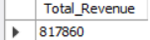

2. Average Order Value
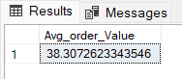

3. Total Pizzas Sold
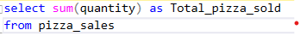
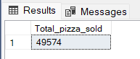

4. Total Orders
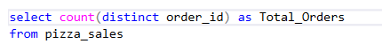
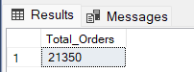

5. Average Pizzas Per Order
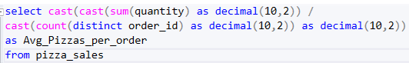
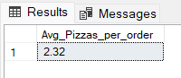
B. Daily Trend for Total Orders
Output:
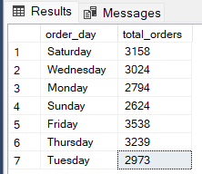

C. Monthly Trend for Orders
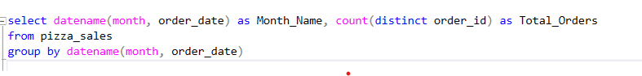
Output:
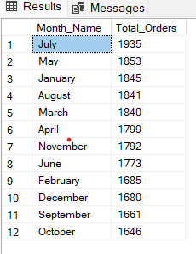

D. % of Sales by Pizza Category
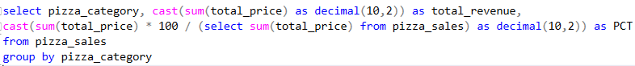Output:
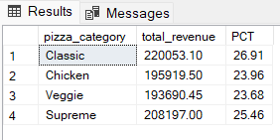

E. % of Sales by Pizza Size
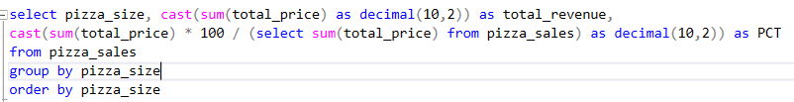Output:
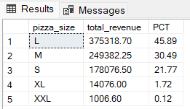

F. Total Pizzas Sold by Pizza Category
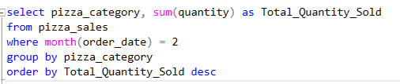
Output
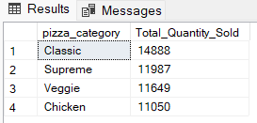

G. Top 5 Pizzas by Revenue
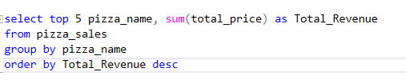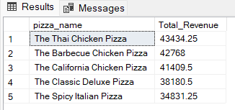

H. Bottom 5 Pizzas by Revenue
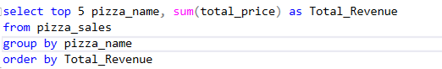
Output
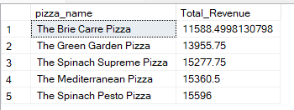

I. Top 5 Pizzas by Quantity
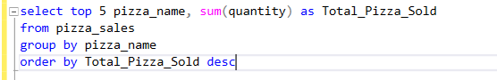
Output
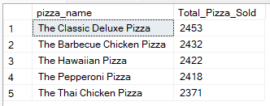

J. Bottom 5 Pizzas by Quantity
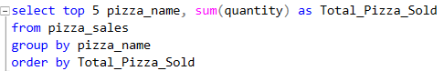
Output
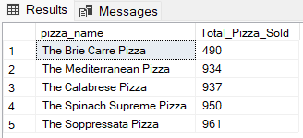

K. Top 5 Pizzas by Total Orders
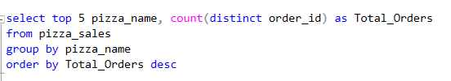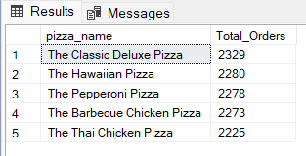

L. Bottom 5 Pizzas by Total Orders
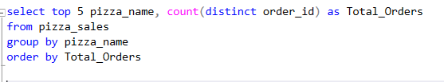
Output:
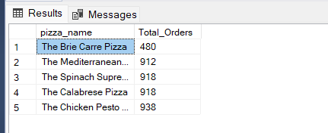

ANALYSIS & INSIGHTS
1. Top 5 Popular Pizzas by Order Quantity
- Most Ordered Pizzas (Analysis):
  - The top 5 pizzas by quantity indicate strong customer preferences.
  - These are consistently from popular categories like Classic and Chicken.
- Insight:
  - High demand is clustered around a few specific variants, showing clear customer favourites.

2. Most Ordered Pizza Size
- Top Size (Analysis): The Large (L) size is the most ordered by a significant margin.
- Insight:
  - Customers prefer value-for-money options or are likely ordering for sharing.
  - Smaller sizes (S/M) trail behind, while XL may be limited by pricing or portion preference.

3. Order Distribution by Category
- Top Categories (Analysis):
  - Classic pizzas dominate, followed by Meat and Supreme.
  - Veggie and Chicken categories have lower order volumes.
- Insight:
  - Traditional flavours resonate more with customers.
  - Vegetarian options might be under-promoted or less appealing in current form.

4. Revenue Contribution
- Top Contributors (Analysis):
  - Revenue is not evenly distributed. A handful of pizzas bring in the bulk of sales revenue.
  - Some lower-quantity items contribute high revenue due to higher price points.
- Insight:
  - Focus not just on popularity — high-value items even with low sales are crucial to profitability.

5. Top 3 Pizzas in Each Category
- Bestsellers within every category (Analysis):
  - Classic: Big Meat Pizza, Classic Deluxe Pizza
  - Supreme: Spicy Italian Pizza, Italian Supreme Pizza
  - Chicken: Thai Chicken Pizza, Southwest Chicken Pizza
  - Veggie: Five Cheese Pizza, Four Cheese Pizza
- Insight:
  - There’s room to phase out underperformers or cross-promote top items within each category.

6. Overall Top 3 Pizzas
- These are absolute leaders in quantity (Analysis) :
  - Classic Deluxe Pizza
  - Barbecue Chicken Pizza
  - Hawaiian Pizza

- Insight: Likely to be strong for
  - Promotions
  - Bundle deals
  - Flagship branding (menu highlights, combos, etc.)

Recommendations
- Promote Top Performers
  - Use the top 3–5 pizzas as anchors in meal deals and combo offers.
  - Feature them prominently in marketing campaigns like social media, flyers, banners.
- Focus on Large Size
  - Given the popularity of large pizzas, offer value bundles and family packs centered on the L size.
  - Consider adding a loyalty incentive for repeat large-size orders.
- Rethink Underperforming Categories
- Veggie and Chicken categories may benefit from:
  - Menu revamp
  - Creative ingredient combinations
  - Special discounts or awareness campaigns
- Capitalize on High-Revenue Pizzas
  - Highlight pizzas with high revenue-per-order even if they are not most ordered.
  - These can boost profit margins when upsold effectively.
- Category-Specific Promotions
  - Run rotating “Category of the Week” campaigns to test engagement with different groups.
  - Helps test if lower-demand categories simply suffer from visibility or price resistance.
- Inventory and Supply Chain Optimization
  - Use insights to stock ingredients for high-demand items more efficiently.
  - Reduce waste by lowering inventory for low-selling pizzas.

- Customer Targeting & Promotions
- Segmented Campaigns:
  - Target meat-lovers and classic fans with loyalty programs.
  - Offer limited-time offers for low-performing categories to test engagement.
- Occasion-Based Bundles:
  - Large-size preference = group ordering → target game nights, parties, weekends.
  - Create seasonal/holiday bundles centered on large, classic pizzas.
- Sales & Marketing Strategy
Highlight High-Revenue Pizzas:
- Use premium pizzas in upselling scripts, online ordering, and combo deals.
Size-Based Campaigns:
- Offer tiered bundles (e.g., Buy 2 Large, Get 1 Medium Free).
- Test price elasticity on XL pizzas — slight price drops could unlock new demand.

Conclusion

This is the detailed analysis of Pizza Hut sales data, highlighting key customer preferences and performance patterns:
- Most orders and revenue come from a few popular pizzas and large sizes
- Classic and Meat categories are customer favourites
- High-priced pizzas, though less ordered, contribute significantly to profits
- Streamlining the menu and promoting bestsellers can boost efficiency and sales
- A focused product and marketing strategy will enhance both revenue and customer satisfaction.

