**AGRIBOT: AN INTELLIGENT AUTONOMOUS SYSTEM FOR SMART AGRICULTURE**

A Report submitted in partial fulfillment of the requirements for the Degree of

#### Bachelor of Technology

in

#### Computer Science and Engineering (Internet of Things)

by

#### Reddymalla Sai Deepak Goud 2111CS050110

#### Suram Srinath 2111CS050096

#### Velma Gangamanikanta Reddy 2111CS050076

Under the esteemed guidance of

**D. Arpitha Rani**

**Assistant Professor**



**Department of Computer Science and Engineering (Internet of Things) School of Engineering**

## MALLA REDDY UNIVERSITY

Maisammaguda, Dulapally, Hyderabad, Telangana 500100

**2025**

#### AGRIBOT: AN INTELLIGENT AUTONOMOUS SYSTEM FOR SMART AGRICULTURE

A Report submitted in partial fulfillment of the requirements for the Degree of

#### Bachelor of Technology

in

#### Computer Science and Engineering (Internet of Things)

by

#### Reddymalla Sai Deepak Goud 2111CS050110

#### Suram Srinath 2111CS050096

#### Velma Gangamanikanta Reddy 2111CS050076

Under the esteemed guidance of

**D. Arpitha Rani**

**Assistant Professor**



**Department of Computer Science and Engineering (Internet of Things) School of Engineering**

## MALLA REDDY UNIVERSITY

Maisammaguda, Dulapally, Hyderabad, Telangana 500100

#### 2025



**Department of Computer Science and Engineering (Internet of Things)**

**CERTIFICATE**

This is to certify that the project report entitled **“AGRIBOT: AN INTELLIGENT AUTONOMOUS SYSTEM FOR SMART AGRICULTURE”**, submitted by **Reddymalla Sai Deepak Goud(2111CS050110), Suram Srinath(2111CS050096),**

**Velma Gangamanikanta Reddy(2111CS050076),** towards the partial fulfillment for the award of Bachelor’s Degree in Computer Science and Engineering – Internet of Things from the Department of Internet of Things, Malla Reddy University, Hyderabad, is a record of bonafide work done by him/ her. The results embodied in the work are not submitted to any other University or Institute for award of any degree or diploma.

#### Internal Guide Head of the Department

D. Arpitha Rani Dr. G. Anand Kumar Assistant Professor CSE(Cyber Security & IoT)

#### External Examiner

**DECLARATION**

We hereby declare that the project report entitled **“AGRIBOT: AN INTELLIGENT AUTONOMOUS SYSTEM FOR SMART AGRICULTURE”** has been carried out by us and this work has been submitted to the **Department of Computer Science and Engineering (Internet of Things), Malla Reddy University,** Hyderabad in partial fulfillment of the requirements for the award of degree of Bachelor of Technology. We further declare that this project work has not been submitted in full or part for the award of any other degree in any other educational institutions.

Place:

Date:

Reddymalla Sai Deepak Goud 2111CS050110

Suram Srinath 2111CS050096

Velma Gangamanikanta Reddy 2111CS050076

## ACKNOWLEDGEMENT

We extend our sincere gratitude to all those who have contributed to the completion of this project report. Firstly, We would like to extend our gratitude to **Dr. V. S. K Reddy, Vice-Chancellor**, for his visionary leadership and unwavering commitment to academic excellence.

We would also like to express my deepest appreciation to our project guide **D. Arpitha Rani Assistant Professor**, whose invaluable guidance, insightful feedback, and unwavering support have been instrumental throughout the course of this project for successful outcomes.

We extend our gratitude to **Dr. G. Latha, PRC-convenor,** for giving valuable inputs and timely guidelines to improve the quality of our project through a critical review process. We thank our project coordinator **Dr.B. Nageshwar Rao,** for his timely support.

We are also grateful to **Dr. G. Anand Kumar, Head of the Department of Internet of Things,** for providing us with the necessary resources and facilities to carry out this project

We are deeply indebted to all of them for their support, encouragement, and guidance, without which this project would not have been possible.

Reddymalla Sai Deepak Goud 2111CS050110

Suram Srinath 2111CS050096

Velma Gangamanikanta Reddy 2111CS050076

## ABSTRACT

In the evolving landscape of Smart Agriculture, robotics has emerged as a key enabler for addressing critical challenges such as labour shortages, climatic uncertainties, and the need for increased agricultural productivity. The transition from manual labour to automation is driven by the demand for time-efficient, energy-saving, and scalable solutions to meet the needs of modern farming. Robotic systems not only enhance efficiency but also minimize repetitive labour-intensive tasks, ensuring consistent and precise agricultural operations. These advancements contribute significantly to improving crop yield, aligning with the goals of sustainable farming and food security.

A fundamental aspect of successful crop production is the automation of essential farming processes, which directly impacts yield, efficiency, and sustainability. Precision in irrigation, pesticide spraying, ploughing, digging, weed cutting, and crop cutting is crucial for optimizing plant growth, conserving resources, and improving productivity. In this project, a multi-purpose agricultural robot has been developed to automate these tasks, reducing human labour while enhancing farming precision.

This robotic system is powered by an Arduino microcontroller and operates via Bluetooth, RF, or IoT-based communication, ensuring wireless and remote-control capabilities. The robot efficiently performs smart irrigation, pesticide spraying, ploughing, weed cutting, and crop cutting, ensuring uniformity, precision, and optimal field coverage.

|  |  |
| --- | --- |
| **INDEX** |  |
| **Contents** | **Page No.** |
| Chapter 1 Introduction | 1-2 |
| 1.1 Problem Definition & Description | 1 |
| 1.2 Objective of the Project | 1-2 |
| 1.3 Scope of the Project | 2 |
| Chapter 2 System Analysis | 3-14 |
| 2.1 Existing System | 3 |
| 2.1.1 Background & Literature Survey | 4-5 |
| 2.1.2 Limitations of Existing System | 5 |
| 2.2 Proposed System | 5-6 |
| 2.2.1 Advantages of Proposed System | 6 |
| 2.3 Software & Hardware Requirements | 7-13 |
| 2.3.1 Software Requirements | 7 |
| 2.3.1 Hardware Requirements | 7-13 |
| 2.4 Feasibility Study | 13 |
| 2.4.1 Technical Feasibility | 14 |
| 2.4.2 Robustness & Reliability | 14 |
| 2.4.3 Economical Feasibility | 14 |
| Chapter 3 Architectural Design | 15-24 |
| 3.1 Modules Design | 15-16 |
| 3.2. Methodology | 16-17 |
| 3.3 Project Architecture | 17 |
| 3.3.1 Complete Architecture | 17-18 |
| 3.3.2 Class Diagram | 19 |

3.3.3 Activity Diagram 20

3.3.4. Use Case Diagram 21

3.3.5. Sequence Diagram 22

3.3.6 Data Flow Diagram 23

Chapter 4 Implementation

* 1. Coding Block 24-26
  2. Sample Code 26-28

Chapter 5 Testing and Results

* 1. Resulting Screens 29-30

|  |  |
| --- | --- |
| 5.1.1 | Login Page 29 |
| 5.1.2 | Connecting Bluetooth Screen 29 |
| 5.1.3 | Terminal Screen 30 |
| 5.1.4 | Working model 30 |

Chapter 6 Conclusions & Future Scope 31

* 1. Conclusion 31
  2. Future Scope 31

Bibliography 32-33

Paper Publication 34-40

Github Link:[**https://github.com/SaiDeepakgoud-03/Agribot**](https://github.com/SaiDeepakgoud-03/Agribot)

#### List of Diagrams

**Contents Page No.**

Figure 3.2 Methodology 16-17

Figure 3.3.1 Complete Architecture 17-18

Figure 3.3.2 Class Architecture 19

Figure 3.3.3 Activity Diagram 20

Figure 3.3.4 Use Case Diagram 21

Figure 3.3.5 Sequence Diagram 22

Figure 3.3.6 Data Flow Diagram 23

**List of Screenshots**

|  |  |  |
| --- | --- | --- |
| **Contents** |  | **Page No.** |
| Screenshot 5.1.1 | Login Page | 29 |
| Screenshot 5.1.2 | Connecting Bluetooth Screen | 29 |
| Screenshot 5.1.3 | Terminal Screen | 30 |
| Screenshot 5.1.4 | Working Model | 30 |

## CHAPTER - 1 INTRODUCTION

### 1.1 PROBLEM DEFINITION & DESCRIPTION

Agriculture plays a crucial role in sustaining human life, yet it faces numerous challenges such as labor shortages, unpredictable climatic conditions, and the need for enhanced productivity. Traditional farming methods heavily rely on manual labor, which is not only time-consuming but also prone to inefficiencies. As global food demand rises, there is an urgent need to adopt innovative solutions that can improve farming efficiency while reducing human effort. Robotics and automation have emerged as powerful technologies to address these challenges by streamlining agricultural operations and ensuring precision in farming practices.

The transition from manual farming to automated systems is essential to meet the growing demands of modern agriculture. Conventional methods of seed sowing, irrigation, pesticide spraying, and plowing require significant effort, often leading to inconsistencies and excessive resource consumption. Climate variability further complicates farming, making it necessary to adopt smart systems that can optimize agricultural activities. Automation in farming not only reduces the physical burden on farmers but also ensures greater accuracy, leading to improved crop yields and resource conservation.

To tackle these issues, a multi-purpose agricultural robot has been designed to automate essential farming tasks such as smart irrigation,Cutting. pesticide spraying, and plouging. This robot is powered by an Arduino microcontroller and operates using Bluetooth, RF, or IoT-based communication, enabling remote and wireless control. By leveraging real-time data, the system optimizes resource utilization, ensuring effective and efficient agricultural practices.

### 1.2 OBJECTIVES OF THE PROJECT

The primary objective of this project is to develop a multi-purpose agricultural robot that automates essential farming tasks such as Cutting, smart irrigation, pesticide spraying, and ploughing. By reducing human labor and improving operational efficiency, the system aims to enhance productivity and precision in agricultural practices. Traditional farming methods often involve repetitive and labor-intensive tasks that are prone to errors, leading to inconsistent crop yields. By leveraging automation, this project seeks to address these inefficiencies and provide farmers with a reliable and effective solution to streamline their farming activities.

Another key objective of this project is to integrate sensor-based monitoring and adaptive control mechanisms into the robotic system. This enhances the accuracy of agricultural processes by optimizing water usage, ensuring proper seed placement, and applying fertilizers or pesticides as needed. Such precision farming techniques help in conserving resources while maximizing crop yield, contributing to sustainable agricultural practices.

The project also aims to enhance accessibility and ease of use by implementing wireless control through Bluetooth, RF, or IoT-based communication. This allows farmers to operate and monitor the robot remotely, reducing their physical workload and enabling efficient farm management. The system is designed to be user-friendly, making it suitable for small-scale and large-scale farmers alike. By integrating wireless communication, the robot provides greater flexibility and adaptability to various farming environments, ensuring efficient agricultural operations regardless of field conditions.

### 1.3 SCOPE OF THE PROJECT

This project focuses on developing a multi-purpose agricultural robot that automates essential farming tasks such as cutting, smart irrigation, pesticide spraying, and ploughing. By integrating an Arduino-based control system with wireless communication technologies like Bluetooth, RF, and IoT, the robot ensures efficient, remote-controlled farming operations. The robot’s ability to perform precise and repetitive tasks reduces human labor, minimizes errors, and enhances farming efficiency, making it a valuable solution for both small and large-scale agricultural applications.

Beyond automation, the project contributes to the advancement of precision farming by integrating real-time data monitoring and adaptive decision-making. With IoT-based connectivity, farmers can remotely monitor field conditions and make data-driven decisions to improve productivity and sustainability. The modular design of the robot allows for future expansions, such as automated fertilization or harvesting, making it a scalable solution for evolving agricultural needs. By reducing resource wastage, improving efficiency, and addressing labor shortages, this project aligns with global efforts to modernize agriculture, ensuring food security and sustainable farming practices.

## CHAPTER - 2 SYSTEM ANALYSIS

System Analysis is the process of collecting and interpreting facts, identifying the problems, and decomposition of a system into its components. It is conducted for the purpose of studying a system or its parts in order to identify its objectives. It is a problem-solving technique that improves the system and ensures that all the components of the system work efficiently to accomplish their purpose. Analysis specifies what the system should do.

### 2.1 EXISTING SYSTEM

Several existing agricultural automation systems and robotic solutions have been developed to address challenges in modern farming. Traditional automated farming systems primarily focus on individual tasks such as precision seeding, automated irrigation, or pesticide spraying. For example, **seed sowing machines** and **mechanized ploughs** have been widely used in large-scale farming, but they often require human operation and lack adaptability to varying soil and environmental conditions. Similarly, **smart irrigation systems** with soil moisture sensors and automated sprinklers help optimize water usage, but they function independently rather than as part of an integrated robotic system.

More advanced agricultural robots, such as **autonomous tractors and drone-based sprayers**, have been introduced in modern farming. Autonomous tractors use GPS-based navigation to automate plowing and harvesting, while drones are used for aerial pesticide spraying and crop monitoring. However, these systems are expensive and primarily designed for large-scale commercial farms. Additionally, **multi-functional robots** capable of performing various farming tasks exist but often rely on complex AI-based decision-making, making them less accessible to small-scale farmers. The proposed multi-purpose agricultural robot improves upon these existing systems by combining multiple functions—seed sowing, irrigation, pesticide spraying, and plowing—into a single, cost-effective solution that can be controlled wirelessly, making it a more accessible and scalable option for farmers of all level.

### 2.1.1 BACKGROUND AND LITERATURE SURVEY

### Solar Powered Autonomous Multipurpose Agricultural Robot Using Bluetooth

In India nearly about 70 percentage of people are depending on agriculture. Numerous operations are performed in the agricultural field like seed sowing, grass cutting, ploughing etc. The present methods of seed sowing, pesticide spraying and grass cutting are difficult. The equipment's used for above actions are expensive and inconvenient to handle. So the agricultural system in India should be encouraged by developing a system which will reduce the man power and time. This work aims to design, develop and design of the robot which can sow the seeds, cut the grass and spray the pesticides, this whole system is powered by solar energy. The designed robot gets energy from solar panel and is operated using Bluetooth/Android App which sends the signals to the robot for required mechanisms and movement of the robot. This increases the efficiency of seed sowing, pesticide spraying and grass cutting and also reduces the problem encountered in manual planting

**Automated seed sowing agribot using Arduino**

The Discovery of Agriculture is the first big step towards civilized life, advancement of agricultural tools is the basic trend of agricultural improvement. Now the qualitative approach of this project is to develop a system which minimizes the working cost and also reduces the time for digging operation and seed sowing operation by utilizing solar energy to run the agribot. In this machine, solar panel is used to capture solar energy and then it is converted into electrical energy which is used to charge battery, which then gives the necessary power to a shunt wound DC motor. Ultrasonic Sensor and Digital Compass Sensor are used with the help of Wi-Fi interface operated on Android Application to manoeuvre robot in the field. This brings down labour dependency. Seed sowing and digging robot will move on various ground contours and performs digging, sowing the seed and covers the ground by closing it. The paper spells out the complete installation of the agribot including hardware and software facet.

**Design of Solar Power based Multipurpose Agriculture Robot**

The Design of Solar Power-Based Multipurpose Agriculture Robo**t** presents an innovative solution to enhance farming efficiency through automation and renewable energy. This robot is designed to perform essential agricultural tasks such as seed sowing, watering, and ploughing, reducing manual labor and improving productivity. Equipped with a solar panel, the robot harnesses sunlight to generate electrical energy, which is stored in a rechargeable battery for continuous operation. This eco-friendly approach minimizes reliance on conventional electricity, promoting sustainable farming practices.The robot is controlled remotely via a Bluetooth-enabled mobile application, allowing farmers to manage tasks conveniently from a distance. The intuitive mobile interface ensures user-friendly operation, enabling precise control of movement, seed dispensing, and irrigation. With its automated mechanisms, the robot optimizes water usage, ensures even seed distribution, and performs efficient ploughing, enhancing crop growth and resource management.

**IoT Based Solar Powered Multipurpose Agriculture Robot**

In India, farming employs 70% of the labor force. In agriculture, there are several methods, including seed sowing and ploughing. The existing methods of seeding, spraying pesticides, and ploughing are inefficient. Costly and unwieldy equipment is necessary for the aforementioned activities. As a consequence, developing a system that decreases the need for labor and time can help India's agricultural sector. The proposed study intends to construct a robot capable of ploughing, seed planting, and water spraying. The suggested robot is powered by solar photovoltaic (PV) panels, eliminating the requirement for an external power source. The whole architecture is restricted by an Android application that interfaces with an IoT ESP8266 and sends signals to the robot for needed activities. As a result, DC motors are used to plough the ground and plant the seeds. Consistent spacing is maintained for seed sowing. To irrigate the crop, a sprinkler with revolving nozzles is used. This mechanical vehicle will save labor costs while also speeding up and improving accuracy. It combines many activities, so it is cost-effective. When compared to tractors or other agricultural instruments such as electric pumps, this equipment requires less energy.

**2.1.2 LIMITATIONS OF EXISTING SYSTEM**

**High Cost of Implementation**

Most advanced agricultural robots, such as autonomous tractors and drone-based sprayers, are expensive and primarily accessible to large-scale commercial farms. Small and medium-scale farmers often struggle to afford these technologies due to high initial investment costs and maintenance expenses.

**Limited Multi-Functionality**

Existing automated farming systems typically focus on specific tasks, such as seed sowing, irrigation, or pesticide spraying. Few robots integrate multiple agricultural functions, requiring farmers to use separate machines for different activities, which increases operational complexity and costs.

**Dependency on GPS and Network Connectivity**

Many modern autonomous farming machines rely on GPS for navigation and IoT-based connectivity for data transmission. However, in rural areas with weak internet access or GPS signal disruptions, these systems may face performance issues, limiting their widespread adoption.

**Lack of Adaptability to Varying Environmental Conditions**

Some existing agricultural robots lack adaptability to different soil types, moisture levels, and climatic variations. They often require manual recalibration, reducing efficiency and making them less practical for farms with diverse environmental conditions.

**High Energy Consumption and Maintenance Requirements**

Many agricultural robots rely on power-intensive components such as high-capacity batteries, motors, and complex electronic circuits. Frequent recharging, maintenance, and repair requirements increase downtime and add to operational costs, making them less efficient for long-term use.

### 2.2 PROPOSED SYSTEM

The proposed system is a multi-purpose agricultural robot designed to automate key farming activities such as seed sowing, smart irrigation, pesticide spraying, and plowing. Powered by an Arduino microcontroller, the robot integrates soil moisture, temperature, humidity, and pH sensors to adapt to varying environmental conditions. By utilizing wireless communication technologies like Bluetooth, RF, and IoT, farmers can remotely control and monitor field activities, reducing labor dependency and enhancing operational efficiency. The sensor-driven automation ensures optimal use of resources, such as activating irrigation only when soil moisture levels drop below a threshold, minimizing water wastage while improving crop health.

This robotic system overcomes the limitations of existing technologies by providing an affordable, scalable, and energy-efficient solution accessible to both small and large-scale farmers. With real-time data monitoring and automated decision-making, the system enhances farming precision and sustainability. The modular design allows for future expansions, such as automated fertilization or harvesting, making it adaptable to diverse agricultural needs. By integrating smart farming techniques, the project contributes to improving productivity, ensuring food security, and reducing the environmental impact of traditional farming methods, making agriculture more sustainable and efficient in the long run.

### 2.2.1 ADVANTAGES OF PROPOSED SYSTEM

**Multi-Functionality** – The robot automates multiple farming tasks, including seed sowing, irrigation, pesticide spraying, and plowing, eliminating the need for separate machines and reducing costs.

**Remote Operation** – The system can be controlled wirelessly via Bluetooth, RF, or IoT, allowing farmers to operate it from a distance, reducing manual labor and increasing convenience.

**Precision and Efficiency** – Integrated soil moisture, temperature, humidity, and pH sensors ensure precise farming operations, optimizing seed placement, irrigation, and pesticide application, leading to higher crop yield.

**Resource Optimization** – Automated irrigation and pesticide spraying help reduce water and chemical wastage, making farming more sustainable and cost-effective.

**Adaptability to Environmental Conditions** – The system adjusts operations based on real-time sensor data, making it suitable for different soil types, climatic conditions, and farming needs.

**Cost-Effective and Scalable** – Compared to expensive autonomous tractors and drones, this robot provides an affordable alternative for small and medium-scale farmers while offering modular expansion options for future upgrades.

**Energy-Efficient Design** – The system is designed to consume minimal power, making it suitable for farms with limited access to electricity or requiring battery/solar-powered operation.

**Reduction in Human Labor** – By automating repetitive and labor-intensive tasks, the system helps address labor shortages, especially in rural areas where skilled agricultural workers may be scarce.

**Improved Sustainability and Food Security** – The system contributes to environmentally friendly farming by minimizing resource wastage, reducing manual errors, and increasing productivity, ensuring long-term food security.

### 2.3 SOFTWARE AND HARDWARE REQUIREMENTS

### 2.3.1 SOFTWARE REQUIREMENTS

A software requirements specification (SRS) is a comprehensive description of the intended purpose and environment for software under development.

**Arduino IDE**

* Used to write and upload programs to the Arduino microcontroller for robot control.
* Supports C/C++ programming to implement automation tasks like seed sowing and irrigation.
* Provides a serial monitor for debugging and real-time data visualization.
* Compatible with various sensor and motor driver libraries for seamless integration.
* Enables firmware updates for improving system performance over time.
* Open-source and lightweight, making it accessible for embedded system development.

**ThingSpeak (IoT Cloud Platform)**

* Used for real-time monitoring and visualization of sensor data from the robot.
* Supports cloud-based data storage, helping analyze long-term farming trends.
* Provides APIs for remote access, allowing farmers to check conditions via a web or mobile app.
* Enables alert notifications for critical environmental conditions like low soil moisture.
* Can be integrated with MATLAB for advanced analytics and predictive modeling.
* Facilitates IoT-based automation, enabling decision-making based on real-time data.

### 2.3.2 HARDWARE REQUIREMENTS

These requirements include the minimum processor speed, memory, and disk space required for the implementation of this project.

* Arduino (micro controller)
* Wheels (x4)
* Chassis (using mdf board)
* L clamp (for motor and wheel support)
* 12v dc motor (x 2)
* L293d motor driver module
* Water motor pump
* Water container
* Seed dispensor unit
* Servo motor (x3)
* Jumper wires
* Bluetooth module hc-05
* Battery/power supply
* Ic 7805
* 1k ohm resistance
* Capacitors 1000uf, 100uf
* Diode 1n4007n
* Berg sticks (plough)
* Switches

**1. ARDUINO UNO**

The most common version of Arduino is the Arduino Uno. This board is what most people are talking about when they refer to an Arduino. The Uno is one of the more popular boards in the Arduino family and a great choice for beginners. There are different revisions of Arduino Uno, below detail is the most recent revision (Rev3 or R3).

The Arduino Uno is a microcontroller board based on the ATmega328. It has 14 digital input/output pins (of which 6 can be used as PWM outputs), 6 analog inputs, a 16 MHz ceramic resonator, a USB connection, a power jack, an ICSP header, and a reset button. It contains everything needed to support the microcontroller; simply connect it to a computer with a USB cable or power it with an AC-to-DC adapter or battery to get started.

Microcontroller   : ATmega328

Operating Voltage     : 5V

Input Voltage (recommended)             : 7-12V

Input Voltage (limits)                           : 6-20V

Digital I/O Pins                                     : 14 (of which 6 provide PWM output)

Analog Input Pins                                 : 6

DC Current per I/O Pin                         : 40 mA

DC Current for 3.3V Pin                       : 50 mA

Flash Memory                              : 32 KB (ATmega328) of which 0.5 KB used by  bootloader

SRAM                                                  : 2 KB (ATmega328)

EEPROM                                             :  1 KB (ATmega328)

Clock Speed                                         : 16 MHz

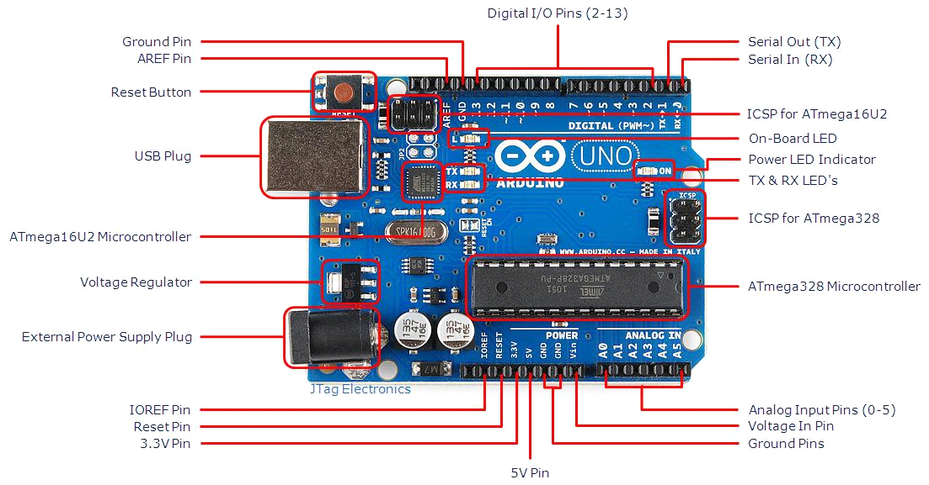

**fig 2.3.2.1 ArduinoUno R3 Board**

**2. WATER PUMP**

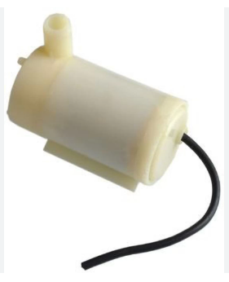

**fig 2.3.2.2 Water Pump**

The Water Quality Monitoring Module, often referred to as the Water Quality Sensor Module, is a vital component for assessing the physical and chemical properties of water. These modules are designed to provide real-time data on various parameters, such as pH, turbidity, temperature, dissolved oxygen, and conductivity. This information is crucial for applications in environmental monitoring, aquaculture, agriculture, and public health.

Water quality modules typically consist of several sensors that work together to measure different aspects of water quality. For instance, a pH sensor detects the acidity or alkalinity of water, while a turbidity sensor measures the cloudiness or clarity, indicating the presence of suspended particles. Temperature sensors help monitor thermal changes, which can impact aquatic life, and dissolved oxygen sensors are essential for assessing the health of water bodies.

These modules are often integrated into larger monitoring systems, allowing for remote data collection and analysis. They can be deployed in rivers, lakes, reservoirs, and treatment plants, providing valuable insights for water resource management and pollution control. Data collected can help identify contamination sources, evaluate treatment efficacy, and ensure compliance with environmental regulations.

**3. BLUETOOTH**

HC-05 module is an easy to use Bluetooth SPP (Serial Port Protocol) module, designed for transparent wireless serial connection setup.

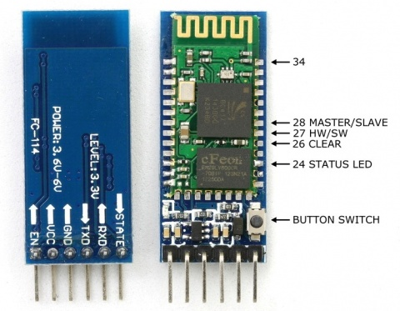Serial port Bluetooth module is fully qualified Bluetooth V2.0+EDR (Enhanced Data Rate) 3Mbps Modulation with complete 2.4GHz radio transceiver and baseband. It uses CSR Bluecore 04-External single chip Bluetooth system with CMOS technology and with AFH(Adaptive Frequency Hopping Feature). It has the footprint as small as 12.7mmx27mm. Hope it will simplify your overall design/development cycle.

**fig 2.3.2.3 Bluetooth**

**Hardware Features**

* Typical -80dBm sensitivity
* Up to +4dBm RF transmit power
* Low Power 1.8V Operation ,1.8 to 3.6V I/O
* PIO control
* UART interface with programmable baud rate
* With integrated antenna
* With edge connector

**Software Features**

* Default Baud rate: 38400, Data bits:8, Stop bit:1,Parity:No parity, Data control: has.Supported baud rate: 9600,19200,38400,57600,115200,230400,460800.
* Given a rising pulse in PIO0, device will be disconnected.
* Status instruction port PIO1: low-disconnected, high-connected;PIO10 and PIO11 can be connected to red and blue led separately. When master and slave are paired, red and blue led blinks 1time/2s in interval, while disconnected only blue led blinks 2times/s.
* Auto-connect to the last device on power as default.
* Permit pairing device to connect as default.
* Auto-pairing PINCODE:”0000” as default
* Auto-reconnect in 30 min when disconnected as a result of beyond the range of connection.

**4. L298N**

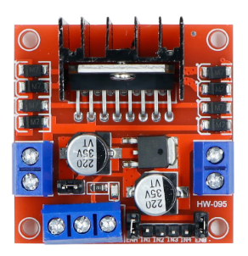The **L298N** is a **dual H-Bridge motor driver IC** used to control **DC motors and stepper motors**. It is widely used in **robotics and embedded systems** for motor control applications. The L298N allows **bidirectional control** of **two DC motors** simultaneously, making it ideal for **robotic vehicles, automation systems, and industrial applications**.

**fig 2.3.2.4 L298N**

**Features of L298N**

* Dual H-Bridge Design – Controls two DC motors or one stepper motor.
* Voltage Range – Operates between 5V to 35V, making it compatible with various motor types.
* Current Handling – Provides up to 2A per channel (continuous) and peak current of 3A.
* Built-in Heat Sink – Helps dissipate excess heat and prevents overheating during prolonged use.
* Logic Control Voltage – Operates at 5V, making it compatible with Arduino, Raspberry Pi, and other microcontrollers.

**Pin Configuration of L298N**

| **Pin No.** | **Name** | **Description** |
| --- | --- | --- |
| 1 | Enable A | Enables Motor A (PWM input for speed control) |
| 2 | Input 1 | Motor A Direction Control |
| 3 | Output 1 | Connects to one terminal of Motor A |
| 4 | GND | Ground Connection |
| 5 | GND | Ground Connection |
| 6 | Output 2 | Connects to the second terminal of Motor A |
| 7 | Input 2 | Motor A Direction Control |
| 8 | VCC | Motor Supply Voltage (5V–35V) |
| 9 | Enable B | Enables Motor B (PWM input for speed control) |
| 10 | Input 3 | Motor B Direction Control |
| 11 | Output 3 | Connects to one terminal of Motor B |
| 12,13 | GND | Ground Connection |
| 14 | Output 4 | Connects to the second terminal of Motor B |
| 15 | Input 4 | Motor B Direction Control |
| 16 | 5V Logic Supply | Provides power to internal logic circuit |

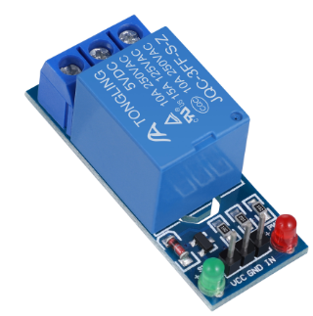**5. RELAY**

**fig 2.3.2.5 Relay Module**

A relay module is an essential electronic component used to control high-power devices with low-power signals, making it a crucial element in automation and electrical projects. It acts as an electrically operated switch, allowing low-power circuits like microcontrollers (e.g., Arduino, Raspberry Pi) to safely control high-power appliances such as lights, fans, motors, or even home appliances

A relay module typically consists of a coil, an armature, and a set of contacts. When a low-power signal is applied to the coil, it generates a magnetic field, causing the armature to move and either open or close the circuit, thereby controlling the flow of current to the connected high-power device. This switching mechanism ensures that microcontrollers or other low-power circuits are isolated from the high-power circuits, protecting them from damage.

Relay modules come in different configurations, such as single-channel or multi-channel, allowing them to control multiple devices simultaneously. They can be operated in either Normally Open (NO) or Normally Closed (NC) modes, depending on the application.

In home automation, relay modules are used to automate devices like fans, lights, and other appliances based on sensor inputs or pre-set conditions. Their reliability, simplicity, and ability to handle high voltages make relay modules indispensable for projects involving the automation of electrical devices.

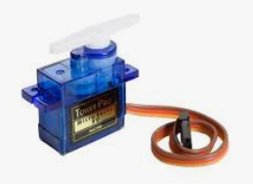**6. SERVO MOTOR**

**fig 2.3.2.6 Servo Motor**

A servo motor is a specialized motor designed to provide precise control of angular or linear position, velocity, and acceleration. It operates through a closed-loop system, which uses feedback to ensure the output shaft reaches and maintains the desired position. This feedback is typically provided by a potentiometer or an encoder, which continuously monitors the motor's position.

Servo motors are integral to applications requiring high precision and reliability. They are commonly used in robotics, CNC machinery, automated manufacturing, and even in consumer electronics like RC vehicles and drones. These motors usually consist of a DC motor, a gear reduction unit, a control circuit, and a position sensor.

The working principle of a servo motor involves sending a control signal that specifies the desired position. The motor's control circuit compares this signal with the feedback from the position sensor. If there is a discrepancy, the motor adjusts its position until the feedback matches the control signal, thus ensuring accurate positioning.

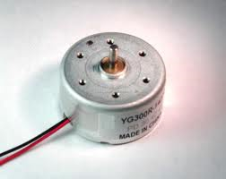**7. DC MOTORS**

**fig 2.3.2.7 DC Motor**

DC motors are configured in many types and sizes, including brush less, servo, and gear motor types. A motor consists of a rotor and a permanent magnetic field stator. The magnetic field is maintained using either permanent magnets or electromagnetic windings. DC motors are most commonly used in variable speed and torque

Motion and controls cover a wide range of components that in some way are used to generate and/or control motion. Areas within this category include bearings and bushings, clutches and brakes, controls and drives, drive components, encoders and resolves, Integrated motion control, limit switches, linear actuators, linear and rotary motion components, linear position sensing, [motors](http://dc-motors.globalspec.com/Industrial-Directory/motors) (both AC and DC motors), orientation position sensing, pneumatics and pneumatic components, positioning stages, slides and guides, power transmission (mechanical), seals, slip rings, solenoids, springs.

Motors are the devices that provide the actual speed and torque in a drive system.  This family includes AC motor types (single and multiphase motors, universal, servo motors, induction, synchronous, and gear motor) and DC motors (brush less, servo motor, and gear motor) as well as linear, stepper and air motors, and motor contactors and starters.

In any electric motor, operation is based on simple electromagnetism. A current-carrying conductor generates a magnetic field; when this is then placed in an external magnetic field, it will experience a force proportional to the current in the conductor, and to the strength of the external magnetic field. As you are well aware of from playing with magnets as a kid, opposite (North and South) polarities attract, while like polarities (North and North, South and South) repel. The internal configuration of a DC motor is designed to harness the magnetic interaction between a current-carrying conductor and an external magnetic field to generate rotational motion.

**2.4 FEASIBILITY STUDY**

The feasibility of the project is analysed in this phase and a business proposal is put forth with a very general plan for the project and some cost estimates. During system analysis the feasibility study of the proposed system is to be carried out. This is to ensure that the proposed system is not a burden to the company. For feasibility analysis, some understanding of the major requirements for the system is essential.

Three key considerations involved in the feasibility analysis are:

* Technical Feasibility
* Robustness & Reliability
* Economical Feasibility

### 2.4.1 TECHNICAL FEASIBILITY

The proposed agricultural robot is technically feasible as it integrates widely available and cost-effective electronic components such as the Arduino microcontroller, DC motors, servo motors, Bluetooth modules, and various sensors for soil monitoring and automation. These components are well-documented, easy to program, and compatible with agricultural automation tasks. The system utilizes wireless communication technologies (Bluetooth and IoT-based control) to allow farmers to operate the robot remotely, reducing physical effort and increasing efficiency. The software is developed using C/C++ programming, which ensures smooth processing of commands and real-time data collection. The modular design allows for future upgrades, such as adding machine learning algorithms for predictive farming and GPS navigation for autonomous movement. Additionally, since Arduino-based platforms have a strong developer community, troubleshooting and enhancements can be easily performed, ensuring long-term reliability

### 2.4.2 ROBUSTNESS & RELIABILITY

The multi-purpose agricultural robot is designed to be highly robust and reliable, ensuring efficient operation in diverse and challenging farming environments. Its chassis, made from durable MDF board or metal, provides structural integrity, allowing it to withstand rough terrain, vibrations, and mechanical stress. The 12V DC motors, secured with L-clamps, offer high torque and stability, enabling smooth movement across various soil conditions without performance degradation. The L293D motor driver module ensures efficient power distribution, while the IC 7805 voltage regulator stabilizes the power supply, preventing voltage fluctuations that could damage the system. Additionally, weather-resistant components make the robot suitable for use in high humidity, temperature fluctuations, and dusty agricultural environments, ensuring longevity and consistent performance.

### 2.4.3 ECONOMICAL FEASIBILITY

The development and implementation of the agricultural robot are economically viable, especially when compared to the long-term costs of manual labor. Traditional farming relies heavily on human resources, which leads to increased expenses over time, particularly in large-scale farms. By automating repetitive tasks such as seed sowing, irrigation, pesticide spraying, and ploughing, this robot reduces dependency on labor while maintaining efficiency. The initial cost includes purchasing sensors, motors, controllers, and power sources, but these are one-time investments. Additionally, using locally available materials for the chassis and low-cost electronic components helps in keeping the cost affordable. In comparison to high-end commercial farming robots, which are often expensive and inaccessible to small-scale farmers, this system provides a budget-friendly alternative. Moreover, with proper maintenance, the robot has a long operational life, ensuring a return on investment through increased agricultural productivity.

## CHAPTER - 3 ARCHITECTURAL DESIGN

### 3.1. MODULES DESIGN

The multi-purpose agricultural robot is designed using a modular approach, ensuring that each function operates independently while contributing to the overall automation of farming tasks. Each module is responsible for a specific agricultural function, such as movement, seed sowing, irrigation, pesticide spraying, ploughing, and communication. The modular architecture makes the system scalable, maintainable, and adaptable to different farming conditions. Below is a detailed breakdown of the major modules that form the core of this robotic system.

**1. Control and Processing Module**

The Arduino microcontroller acts as the brain of the robot, processing sensor data and controlling all operations. It receives inputs from sensors and sends signals to actuators such as motors, pumps, and servos.

* The Arduino board is programmed using C/C++, which enables real-time decision-making and efficient task execution.
* The module is responsible for coordinating seed sowing, irrigation, pesticide spraying, and ploughing based on programmed algorithms.
* The system supports manual and automatic modes, allowing farmers to control it remotely via Bluetooth (HC-05 module) or let it run autonomously.

**2. Seed Dispensing Module**

This module automates the seed sowing process, ensuring accurate seed placement for optimal crop growth.

* A servo motor-controlled seed dispenser precisely controls the number of seeds dropped at each location.
* The module allows for adjustable seed spacing and depth, optimizing planting conditions for different crop types.
* The dispensing mechanism is designed to minimize seed wastage, improving efficiency over manual sowing.
* The robot ensures that seeds are planted at a uniform depth and distance, enhancing germination rates.

**3. Smart Irrigation Module**

Water management is crucial for agricultural productivity, and this module automates irrigation based on real-time soil conditions.

* A soil moisture sensor detects the water content in the soil and sends data to the microcontroller.
* Based on moisture levels, the system automatically activates a water motor pump to irrigate the field as needed.
* Water is drawn from a built-in water container and distributed to the crops using controlled spraying.
* The module ensures water conservation by preventing overwatering and only supplying water when necessary.
* This feature is particularly useful in regions facing water scarcity, optimizing irrigation efficiency.

**4. Pesticide Spraying Module**

This module automates the spraying of pesticides, fertilizers, or nutrients, reducing labor effort and ensuring even coverage.

* A servo motor-controlled spraying unit releases a fine mist of pesticide over the crops.
* The amount of pesticide sprayed is adjustable to avoid excessive use, preventing chemical wastage and environmental harm.
* This system reduces human exposure to harmful chemicals, making farming safer.
* The spraying mechanism ensures uniform coverage, protecting crops from pests and diseases effectively.

**5. Ploughing and Digging Module**

The ploughing module prepares the soil before seed sowing, ensuring proper aeration and soil conditioning.

* Berg sticks (ploughing tools) are attached to the robot to dig through the soil.
* Servo motors control the ploughing depth, ensuring the soil is properly tilled before sowing.
* This module helps break compact soil, improving water absorption and root penetration.
* By reducing manual effort, it makes soil preparation more efficient and less time-consuming.

### 3.2. METHODOLOGY

### Power Supply:

### The robot uses solar panels to harness solar energy, which charges the onboard battery. This stored energy powers the robot and its components, ensuring continuous operation even in remote areas.

### Mobile Control:

### The robot is equipped with a Bluetooth module, allowing wireless control via a mobile application. The user can issue commands to move the robot forward, backward, left, or right and activate specific functions.

### Watering Mechanism:

### An onboard water tank and pump are integrated into the robot. The pump is activated to sprinkle water along the planted rows, promoting efficient irrigation.

### Ploughing Mechanism:

### The ploughing tool is mounted at the rear and is designed to till the soil efficiently. The tool depth can be adjusted manually based on soil conditions.

### Control System:

### An Arduino microcontroller coordinates the robot's movements and task execution. The control signals are sent via Bluetooth from a mobile application, providing the operator full control over the robot's activities.

### Navigation:

### The robot moves on rugged wheels, designed to withstand uneven terrain commonly found in agricultural fields.

### 

**Figure 3.2.1 Methodology**

### 3.3. PROJECT ARCHITECTURE

Project architecture refers to the high-level structure and organisation of a project, including its components, modules, interactions, and technologies used. In the context of our project, the project architecture encompasses the following key aspect:

**3.3.1. COMPLETE ARCHITECTURE**

The architecture of the multi-purpose agricultural robot is designed to integrate hardware and software components for seamless automation of farming activities such as seed sowing, irrigation, pesticide spraying, and ploughing. The system follows a modular approach, ensuring scalability, reliability, and adaptability to different agricultural environments. The project architecture consists of three main layers:

1. **Hardware Layer** – Physical components such as microcontroller, sensors, motors, and actuators.
2. **Processing & Control Layer** – The Arduino-based control system that processes sensor data and controls actions.
3. **Communication & User Interface Layer** – Wireless connectivity, remote monitoring, and manual control via mobile applications.

**1. Hardware Layer**

The hardware components form the foundation of the agricultural robot. These components work together to execute different agricultural tasks effectively.

Arduino Microcontroller – Acts as the central processing unit, executing programmed instructions.

Power Supply (Battery, IC 7805, Diodes, Capacitors) – Provides stable voltage for motors, sensors, and communication modules.

**Motors & Locomotion System**

* + **12V DC Motors** (x2) – Drives the wheels for mobility.
  + **L293D Motor Driver Module** – Controls motor speed and direction.
  + **Wheels (x4) & L-clamps** – Provides stability and support.

**Sensors for Smart Farming**

* + **Soil Moisture Sensor** – Detects soil water content to automate irrigation.
  + **Temperature & Humidity Sensors** – Monitors environmental conditions.
  + **pH Sensor** – Helps determine soil acidity for proper crop growth.

**Farming Actuators**

* + **Servo Motors (x3)** – Controls movement of seed dispenser, pesticide sprayer, and plough.
  + **Seed Dispenser Unit** – Ensures precise placement of seeds in soil.
  + **Water Motor Pump & Container** – Automates irrigation and pesticide spraying.
  + **Berg Sticks (Ploughing Tools)** – Prepares soil before planting.

The hardware layer ensures real-world data collection and physical actions through precise control of motors, sensors, and actuators.

**2. Processing & Control Layer**

This layer is responsible for data processing, decision-making, and execution of commands. It ensures that the system operates autonomously or can be controlled remotely.

**Processing Workflow:**

**Sensor Data Collection:**

* + Soil moisture, temperature, humidity, and pH sensors provide real-time data.

**Decision-Making (Arduino Processing Unit):**

* + Based on sensor readings, the **Arduino executes predefined algorithms** to determine when to irrigate, sow seeds, or spray pesticides.

**Actuator Control:**

* + The Arduino sends signals to actuators (servo motors, pumps, and motor driver) to perform tasks like moving, ploughing, sowing, and spraying.

**Feedback Mechanism:**

* + The system continuously **monitors sensor data** and **adjusts actions accordingly**, ensuring **precision farming**.

This layer acts as the brain of the robot, processing data and making real-time decisions for efficient agricultural operations.

**3. Communication & User Interface Layer**

This layer ensures **wireless control, real-time monitoring, and remote operation** of the agricultural robot.

**Wireless Communication Features:**

* **Bluetooth Module (HC-05):**
  + Enables remote control using a **smartphone or computer**.
  + Farmers can **start/stop** the robot, select specific operations, and adjust parameters wirelessly.
* **IoT Connectivity (Future Integration):**
  + With IoT integration, data can be sent to cloud platforms for **real-time monitoring** of soil conditions and farming activities.
  + Farmers can access insights remotely via mobile apps.

**User Interface (Mobile Application or Remote Control):**

* **Manual Mode:**
  + Users can **manually control** movement and farming functions.
* **Automatic Mode:**
  + The system operates based on **predefined conditions and sensor readings**, requiring

minimal human intervention.

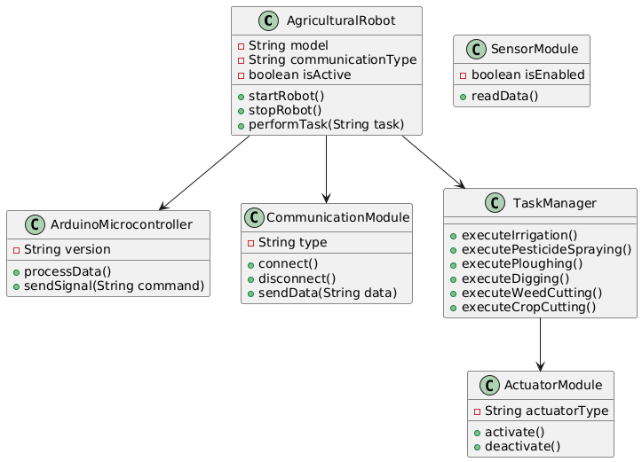**3.3.2.CLASS DIAGRAM**

**Figure 3.3.2 Class Diagram**

The **class diagram** represents the key components of the **Multi-Purpose Agricultural Robot** and their interactions. It consists of several classes, each responsible for a specific function within the system.

**1. AgriculturalRobot (Main System)**

* Acts as the central control unit that manages all robotic functions.
* Controls task execution, communication, and movement.
* Provides start, stop, and task execution functionalities.

**2. ArduinoMicrocontroller (Processing Unit)**

* Processes commands and controls robotic actions.
* Interfaces with sensors, actuators, and communication modules.
* Sends signals to execute specific farming tasks.

**3. CommunicationModule (Wireless Control Unit**)

* Enables remote control via Bluetooth, RF, or IoT.
* Handles data transmission between the robot and the user.
* Supports connect, disconnect, and send data functionalities.

**4. ActuatorModule (Execution Unit)**

* Controls robotic movements and farming tools.
* Executes ploughing, cutting, irrigation, and spraying actions.
* Can be activated or deactivated as per task requirements.

**5. TaskManager (Farming Operations Control)**

* Manages all farming operations performed by the robot.
* Provides functions to execute specific tasks like weed cutting and irrigation.
* Ensures task coordination and precision in execution.

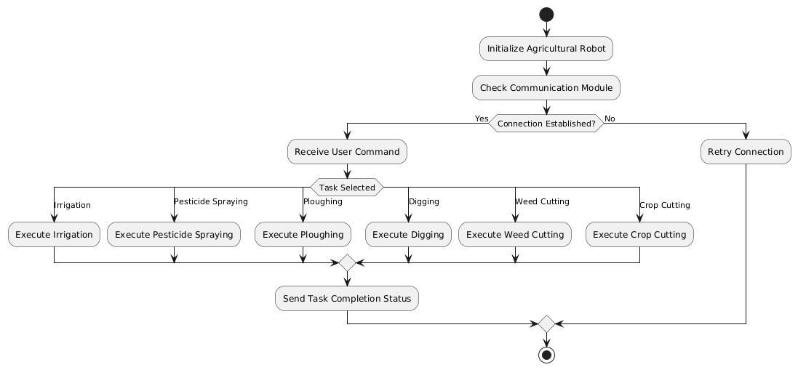**3.3.3 ACTIVITY DIAGRAM**

**Figure 3.3.3 Activity Diagram**

The Activity Diagram represents the step-by-step workflow of the Multi-Purpose Agricultural Robot, illustrating how it processes commands and executes various farming tasks.

**1. AgriculturalRobot (Main System)**

* The robot initializes and prepares for operation.
* Checks the communication module for connectivity.
* Receives user commands once the connection is established.

**2. ArduinoMicrocontroller (Processing Unit)**

* Processes the received task command from the user.
* Sends signals to the respective actuator modules.
* Ensures precise execution of farming tasks.

**3. CommunicationModule (Wireless Control Unit)**

* Establishes and maintains wireless communication.
* If the connection fails, it retries until successful.
* Transmits the task completion status after execution.

**4. SensorModule (Environmental Data Collection - Optional)**

* Can provide real-time data for smart farming decisions.
* Supports automation for precision agriculture.

**5. ActuatorModule (Execution Unit)**

* Controls mechanical operations like ploughing, spraying, and cutting.
* Executes the selected task with precision.
* Provides status feedback after completing the operation.

6. **TaskManager (Farming Operations Control)**

* Receives and processes user-selected tasks.
* Executes specific farming operations

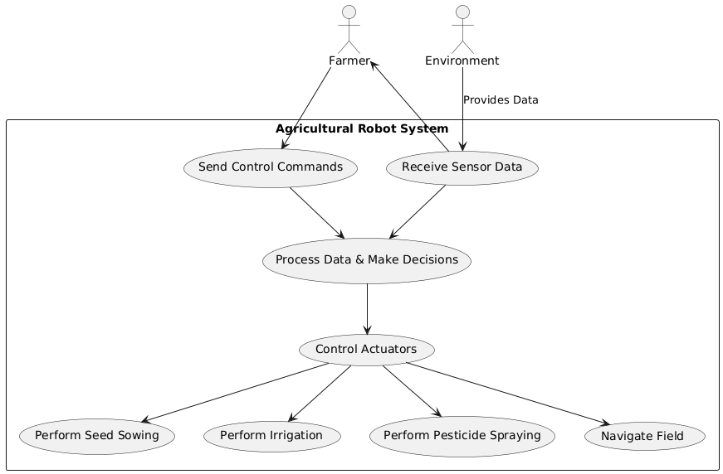**3.3.4 USECASE DIAGRAM**

**Figure 3.3.4 Usecase Diagram**

The Use Case Diagram represents the interactions between the Farmer, the Agricultural Robot System, and the Environment to automate farming tasks efficiently.

Actors in the System:

Key Use Cases:

1. Send Control Commands:
   * The farmer sends operational commands (e.g., seed sowing, irrigation, pesticide spraying) via a mobile application or remote control.
2. Receive Sensor Data:
   * The robot collects real-time environmental data (e.g., soil moisture, temperature, humidity) and sends it to the farmer for monitoring.
3. Process Data & Make Decisions:
   * The system processes incoming data and determines the necessary farming action.
4. Control Actuators:
   * The system activates actuators such as seed dispensers, water pumps, sprayers, and motorized wheels.
5. Perform Irrigation:
   * Based on soil moisture data, the system activates the water pump to irrigate the field efficiently.
6. Perform Pesticide Spraying:
   * The robot sprays pesticides uniformly over the crops to prevent pest infestations.
7. Navigate Field:
   * The robot moves across the field autonomously or via remote control to perform various agricultural tasks.

**3.3.5 SEQUENCE DIAGRAM**

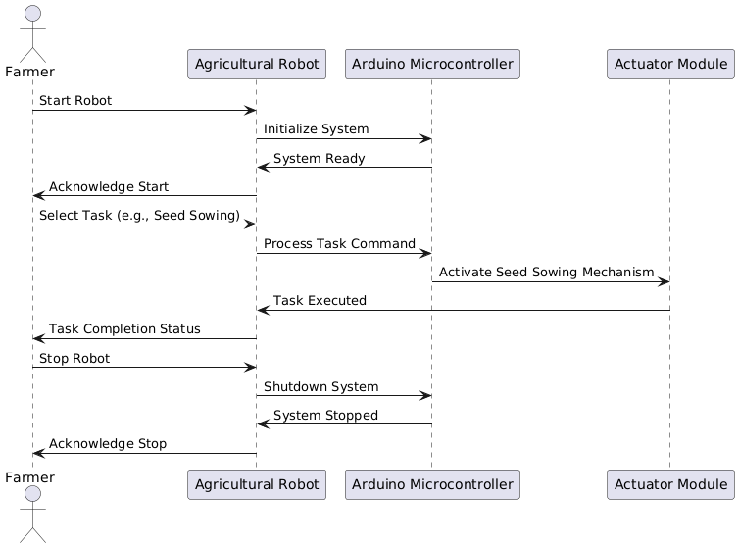

**Figure 3.3.5 Sequence Diagram**

The Sequence Diagram illustrates the interaction between the Farmer, Mobile App, Agricultural Robot, Sensors, and Actuators during the operation of the Multi-Purpose Agricultural Robot. It shows the flow of control, data, and decision-making in an automated farming process.

1. Initiation of Commands

* The Farmer sends a command (e.g., seed sowing, irrigation, pesticide spraying) via the Mobile App.
* The Mobile App transmits the command to the Agricultural Robot using Bluetooth or IoT communication.

2. Decision-Making Process

* The Robot processes the received sensor data to determine the appropriate farming action based on predefined conditions.

3. Execution of Tasks

* Based on the selected operation, the robot activates the corresponding Actuators:
  + Irrigation: If the soil moisture level is low, the robot activates the water pump to irrigate the field.
  + Pesticide Spraying: If pesticide application is required, the sprayer is activated to ensure uniform distribution.
  + Navigation: The robot moves to the required location based on its programmed path.

4. Task Confirmation and Status Update

* After completing each task, the Actuators confirm execution with the Robot.
* The Robot sends a status update to the Mobile App.
* The Mobile App displays the task completion status to the Farmer.

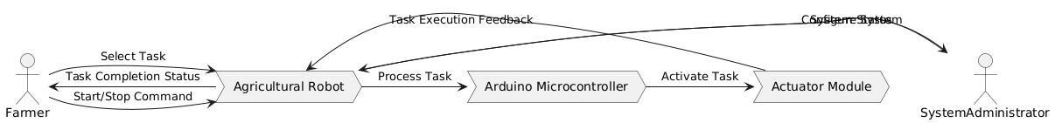**3.3.6 DATAFLOW DIAGRAM**

**Figure 3.3.6 Data Flow Diagram**

The Data Flow Diagram (DFD) represents the interaction and data exchange between different entities involved in the Multi-Purpose Agricultural Robot System. This includes the Farmer, Mobile App, Agricultural Robot, Sensors, Actuators, and Database.

**Actors (External Entities):**

* **Farmer:** The primary user who interacts with the agricultural robot to start, stop, and select farming tasks.
* **System Administrator:** A secondary user responsible for configuring the system and monitoring its status.

**Processes:**

* **Agricultural Robot:** The central processing unit that receives commands from the farmer and system administrator and executes farming operations.
* **Arduino Microcontroller:** The core controller that processes commands from the robot and sends signals to activate necessary actions.
* **Actuator Module:** The mechanism responsible for executing physical actions such as ploughing, irrigation, seed sowing, pesticide spraying, weed cutting, and crop cutting.

**Farmer's Interaction:**

1. **Start/Stop Command:** The farmer sends a command to start or stop the agricultural robot.
2. **Select Task**: The farmer selects a farming operation (e.g., seed sowing, irrigation, etc.).
3. **Process Task:** The robot processes the command and forwards it to the Arduino microcontroller.
4. **Activate Task**: The Arduino sends signals to the actuator module to perform the selected task.
5. **Task Execution Feedback**: The actuator sends execution status back to the robot.
6. **Task Completion Status**: The robot informs the farmer about task completion.

**System Administrator's Interaction:**

1. Configure System: The system administrator configures the robot’s settings.
2. Monitor System Status: The robot sends system status updates back to the system administrator.

## CHAPTER - 4 IMPLEMENTATION

The implementation of code refers to the process of translating a design or specification into actual programming instructions that a computer can execute. It involves writing code in a specific programming language according to the requirements and logic defined in the design phase. Here are the key steps involved in the implementation of code

### 4.1 CODING BLOCKS

### 

### Movement Control (Forward, Backward, Left, Right, Stop)

### // Function to move forward

### void forward() {

### digitalWrite(in1, HIGH);

### digitalWrite(in2, LOW);

### digitalWrite(in3, HIGH);

### digitalWrite(in4, LOW);

### }

### // Function to move backward

### void backward() {

### digitalWrite(in1, LOW);

### digitalWrite(in2, HIGH);

### digitalWrite(in3, LOW);

### digitalWrite(in4, HIGH);

### }

### // Function to turn left

### void left() {

### digitalWrite(in1, LOW);

### digitalWrite(in2, HIGH);

### digitalWrite(in3, HIGH);

### digitalWrite(in4, LOW);

### }

### // Function to turn right

### void right() {

### digitalWrite(in1, HIGH);

### digitalWrite(in2, LOW);

### digitalWrite(in3, LOW);

### digitalWrite(in4, HIGH);

### }

### // Function to stop motors

### void stopMotors() {

### digitalWrite(in1, LOW);

### digitalWrite(in2, LOW);

### digitalWrite(in3, LOW);

### digitalWrite(in4, LOW);

### }

### Water Pump Control (ON/OFF)

### // Function to turn ON the water pump

### void pumpOn() {

### digitalWrite(pump, LOW); // LOW = ON (Active Low)

### Serial.println("Pump ON");

### }

### // Function to turn OFF the water pump

### void pumpOff() {

### digitalWrite(pump, HIGH); // HIGH = OFF

### Serial.println("Pump OFF");

### }

### Cutter Control (ON/OFF)

### // Function to turn ON the cutter

### void cutterOn() {

### digitalWrite(cutter, LOW); // LOW = ON (Active Low)

### Serial.println("Cutter ON");

### }

### // Function to turn OFF the cutter

### void cutterOff() {

### digitalWrite(cutter, HIGH); // HIGH = OFF

### Serial.println("Cutter OFF");

### }

### Plough Control (Up/Down using Servo Motor)

### // Function to raise the plough (0° position)

### void ploughUp() {

### ploughServo.write(0);

### Serial.println("Plough Up (0°)");

### }

### // Function to lower the plough (120° position)

### void ploughDown() {

### ploughServo.write(120);

### Serial.println("Plough Down (120°)");

### }

### Loop()

### void loop() {

### if (Serial.available()) {

### char command = Serial.read(); // Read Bluetooth command

### switch (command) {

### case 'F': forward(); break;

### case 'B': backward(); break;

### case 'L': left(); break;

### case 'R': right(); break;

### case 'S': stopMotors(); break;

### case 'P': pumpOn(); break;

### case 'O': pumpOff(); break;

### case 'C': cutterOn(); break;

### case 'X': cutterOff(); break;

### case 'U': ploughUp(); break;

### case 'D': ploughDown(); break;

### default: Serial.println("Invalid Command"); break;

### }

### }

### }

### Sample Code

### #include <Servo.h>

### // Pin definitions

### #define in1 2 // Motor1 L298 Pin in1

### #define in2 3 // Motor1 L298 Pin in2

### #define in3 4 // Motor2 L298 Pin in3

### #define in4 5 // Motor2 L298 Pin in4

### #define pump 8 // Pump control pin

### #define servoPin 9 // Servo motor control pin

### #define cutter 10 // Cutter control pin

### char command; // Variable to store Bluetooth command

### Servo ploughServo; // Create a servo object

### void setup() {

### // Initialize serial communication

### Serial.begin(9600);

### Serial.println("Grass cutter Robot with Plough and Cutter");

### // Motor control pins

### pinMode(in1, OUTPUT);

### pinMode(in2, OUTPUT);

### pinMode(in3, OUTPUT);

### pinMode(in4, OUTPUT);

### // Pump and cutter control pins

### pinMode(pump, OUTPUT);

### pinMode(cutter, OUTPUT);

### // Attach servo to the defined pin

### ploughServo.attach(servoPin);

### // Set initial states

### digitalWrite(in1, LOW);

### digitalWrite(in2, LOW);

### digitalWrite(in3, LOW);

### digitalWrite(in4, LOW);

### digitalWrite(pump, HIGH); // Pump OFF initially

### digitalWrite(cutter, HIGH); // Cutter OFF initially

### ploughServo.write(0); // Initial plough position

### }

### void loop() {

### // Check if data is available from Bluetooth

### if (Serial.available()) {

### command = Serial.read(); // Read the Bluetooth command

### // Execute corresponding action

### switch (command) {

### case 'F': // Move forward

### forward();

### Serial.println("Moving Forward");

### break;

### case 'B': // Move backward

### backward();

### Serial.println("Moving Backward");

### break;

### case 'L': // Turn left

### left();

### Serial.println("Turning Left");

### break;

### case 'R': // Turn right

### right();

### Serial.println("Turning Right");

### break;

### case 'S': // Stop

### stopMotors();

### Serial.println("Stopping");

### break;

### case 'P': // Turn on pump

### digitalWrite(pump, LOW);

### Serial.println("Pump ON");

### break;

### case 'O': // Turn off pump

### digitalWrite(pump, HIGH);

### Serial.println("Pump OFF");

### break;

### case 'C': // Turn on cutter

### digitalWrite(cutter, LOW);

### Serial.println("Cutter ON");

### break;

### case 'X': // Turn off cutter

### digitalWrite(cutter, HIGH);

### Serial.println("Cutter OFF");

### break;

### case 'U': // Plough up (0 degrees)

### ploughServo.write(0);

### Serial.println("Plough Up (0°)");

### break;

### case 'D': // Plough down (120 degrees)

### ploughServo.write(120);

### Serial.println("Plough Down (120°)");

### break;

### default:

### Serial.println("Invalid Command");

### break;

### }

### }

### delay(100); // Small delay for stability

### }

### // Function to move forward

### void forward() {

### digitalWrite(in1, HIGH);

### digitalWrite(in2, LOW);

### digitalWrite(in3, HIGH);

### digitalWrite(in4, LOW);

### }

### // Function to move backward

### void backward() {

### digitalWrite(in1, LOW);

### digitalWrite(in2, HIGH);

### digitalWrite(in3, LOW);

### digitalWrite(in4, HIGH);

### }

### // Function to turn left

### void left() {

### digitalWrite(in1, LOW);

### digitalWrite(in2, HIGH);

### digitalWrite(in3, HIGH);

### digitalWrite(in4, LOW);

### }

### // Function to turn right

### void right() {

### digitalWrite(in1, HIGH);

### digitalWrite(in2, LOW);

### digitalWrite(in3, LOW);

### digitalWrite(in4, HIGH);

### }

### // Function to stop motors

### void stopMotors() {

### digitalWrite(in1, LOW);

### digitalWrite(in2, LOW);

### digitalWrite(in3, LOW);

### digitalWrite(in4, LOW);

### }

## CHAPTER - 5 TESTING & RESULTS

### 5.1. RESULTING SCREENS

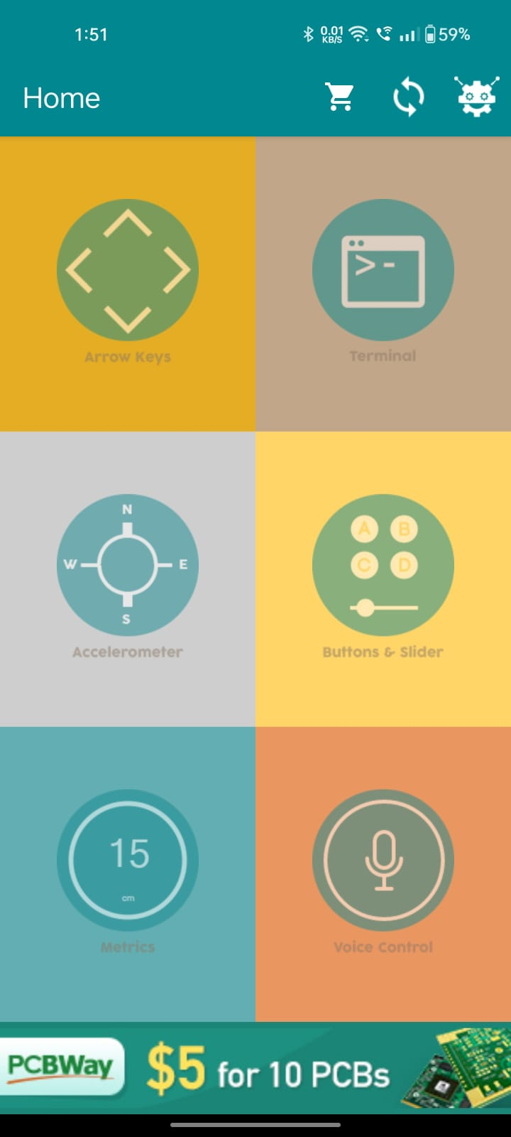**5.1.1 Home Screen**

**5.1.2 Connecting Bluetooth Screen**

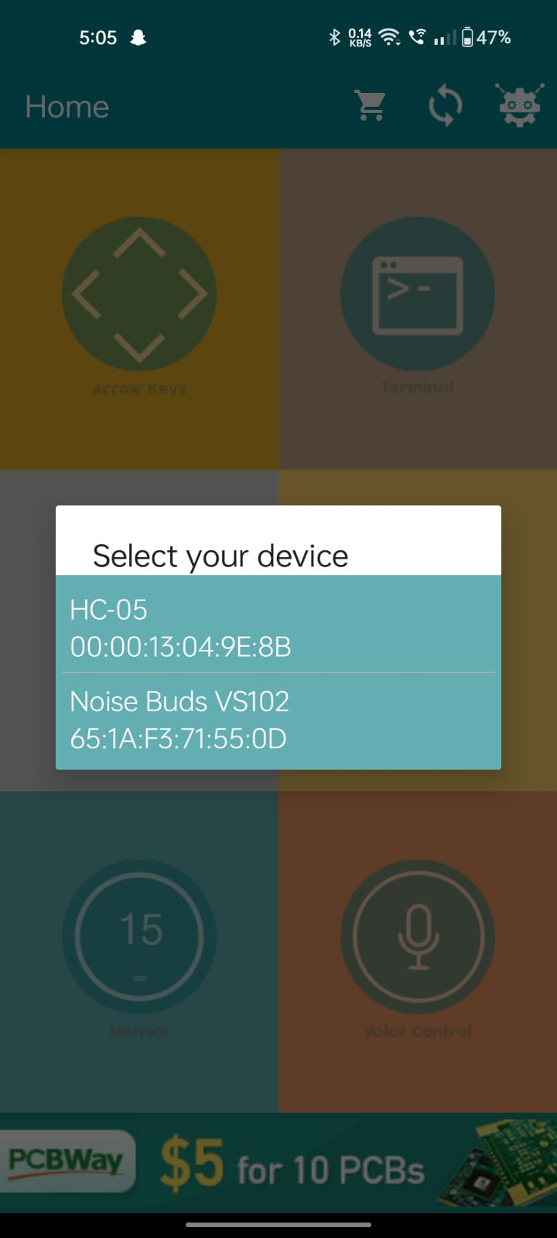

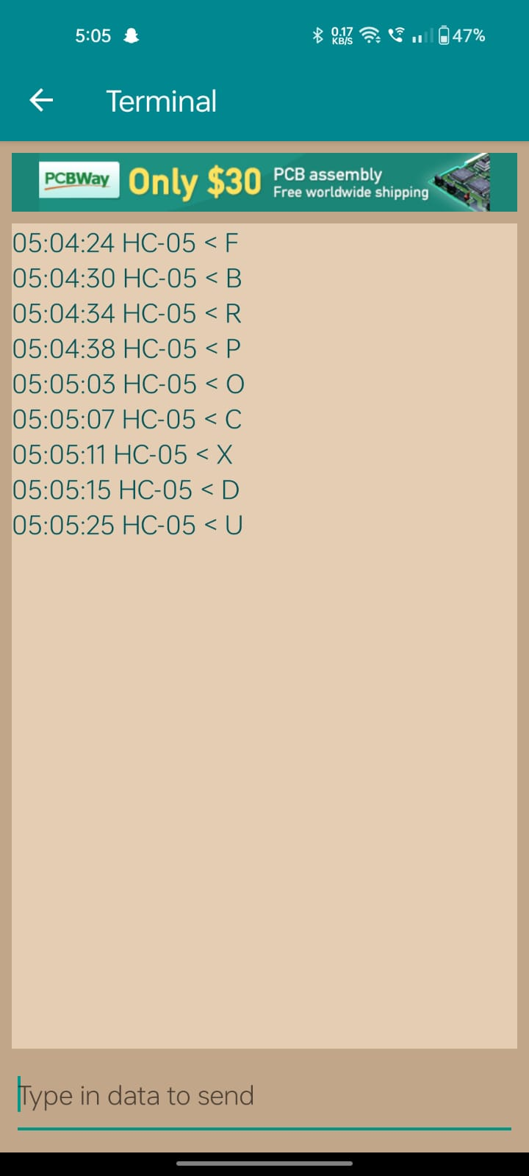**5.1.3 Terminal Screen**

**5.1.4 Working Model**

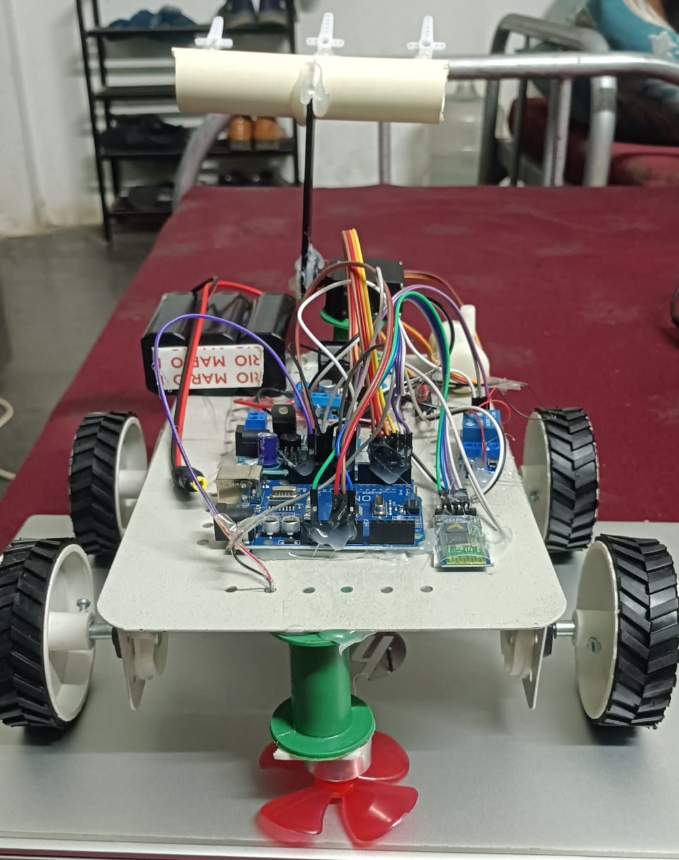

**CHAPTER - 6**

## CONCLUSION & FUTURE SCOPE

### 6.1. CONCLUSION

The development of a multi-purpose agricultural robot marks a significant step towards automation in smart farming. By integrating an Arduino microcontroller with Bluetooth-based remote control, the robot efficiently executes essential farming tasks such as movement control, irrigation, weed cutting, crop cutting, and ploughing. The system eliminates the need for excessive manual labor, ensuring precision, uniformity, and time efficiency in agricultural operations. The use of a servo motor for plough control, along with motor-driven movement and cutter mechanisms, enhances the robot's adaptability to different farming conditions.

This project contributes to sustainable agriculture by optimizing resource utilization and minimizing human intervention in repetitive tasks. By further incorporating IoT-based monitoring, AI-driven automation, and sensor-based precision farming, the system can be enhanced for even greater efficiency. Future advancements may include autonomous navigation, obstacle detection, and real-time data analytics to support decision-making in modern farming. Ultimately, this innovation serves as a foundation for the next generation of smart agricultural robots, improving crop yield while reducing environmental impac

### 6.2. FUTURE WORKS

### The Solar-Powered Smart Agriculture Robot can be further enhanced with advanced features like GPS navigation for autonomous movement across larger fields. Integrating AI-based sensors can enable the robot to analyze soil conditions, predict irrigation needs, and detect pests or diseases. Future developments may also include cloud-based data storage for monitoring crop growth patterns and environmental conditions. With these advancements, the robot can become an intelligent system that empowers farmers with data-driven insights, improving decision-making and further promoting sustainable agricultural practices.

## BIBLOGRAPHY

[1]. Rai, H.M., Gupta, D., Mishra, S. and Sharma, H., 2021, August. Agri-Bot: IoT Based Unmanned Smart Vehicle for Multiple Agriculture Operations. In 2021 International Conference on Simulation, Automation & Smart Manufacturing (SASM) (pp. 1-6). IEEE.

[2]. Mada, D. A., and Sunday Mahai. "The role of agricultural mechanization in the economic development for small scale farms in Adamawa State." Journal of Engineering and Science 2 (2013): 91-96.

[3]. Jin, Yucheng, Jizhan Liu, Zhujie Xu, Shouqi Yuan, Pingping Li, and Jizhang Wang. "Development status and trend of agricultural robot technology." International Journal of Agricultural and Biological Engineering 14, no. 4 (2021): 1-19.

[4]. Wang, C., Tang, Y., Chen, M., Luo, L., Li, J., Lian, G. and Zou, X., 2020. Recognition and localization methods for vision-based fruit picking robots: A review. Frontiers in Plant Science, 11, p.510.

[5]. Liu, J., Xu, Z., Yuan, S., Li, P. and Wang, J., 2021. Development status and trend of agricultural robot technology. International Journal of Agricultural and Biological Engineering, 14(4), pp.1-19.

[6]. Chen, Huang, C.H., P.J., Lin, Y.J., Chen, B.W. and Zheng, J.X., 2021. A robot-based intelligent management design for agricultural cyber-physical systems. Computers and Electronics in Agriculture, 181, p.105967.

[7]. Kim, J., Ju, C., Seol, J. and Son, H.I., 2022. A review on multi-robot systems in agriculture. Computers and Electronics in Agriculture, 202, p.107336.

[8]. Gupta P, Matholiya, Chirag S., Vishal V. Agravat, Ulpa V. Patel, and Piyush R. Balas. "Automatic guidance systems in agricultural autonomous robotic machine: a review." Pharm Innov J sp-11 (3) (2022): 307-312.

[9]. Patel, Dhruv, Meet Gandhi, H. Shankaranarayanan, and Anand D. Darji. "Design of an Autonomous Agriculture Robot for Real-Time Weed Detection Using CNN." In Advances in VLSI and Embedded Systems: Select Proceedings of AVES 2021, pp. 141-161. Singapore: Springer Nature Singapore, 2022.

[10]. Yang, Jiachen, Jingfei Ni, Yang Li, Jiabao Wen, and Desheng Chen. "The intelligent path planning system of agricultural robot via reinforcement learning." Sensors 22, no. 12 (2022): 4316.

[11] S. Umarkar and A. Karwankar, “Automated Seed Sowing Agribot using Arduino," in IEEE Conference on Communication and Signal Processing, April 2016, pp. 1379-1383.

[12] M.D.I. Sujon, R. Nasir, M.M.I. Habib, M.I. Nomaan J. Baidya and M.R. Islam “Agribot: Arduino Controlled Autonomous Multipurpose Farm Machinery Robot for Small to medium scale cultivation," in IEEE conference on intelligent autonomous systems, March 2018, pp. 155-159.

[13] H. Pota, R. Eaton, J. Katapriya and S. D. Pathirana, “Agricultural robotics: A streamlined approach to realization autonomous farming,” in IEEE conference on industrial and information systems, 2007, pp. 85-90.

[14] S. Kareemulla, E. Prajwal, B. Sujeshkumar, B. Mahesh, and V Reddy, “GPS based Autonomous Agriculture Robot,” in IEEE International conference on design innovations for 3Cs compute communicate control, 2018, pp. 100-105.

[15] HC-05 - Bluetooth Module, Available: <https://components101.com/wireless/hc-05-bluetoothmodule>", accessed in September 2018.

[16] P.V. Santhi, N. Kapileswar, V.K.R.Chenchela, and C.H.V.S Prasad, “Sensor and vision-based autonomous agribot for sowing seeds,” in IEEEE International conference on energy communication, data analysis and soft computing(ICECDS), 2017, pp. 242-245.

[17] Nitin Kumar Mishra, Shashwat Khare, Sumit Singh, Mithun Dabur.” Multi-Purpose Agriculture Machine” International Journal of Advances in Science Engineering and Technology, ISSN: 2321-9009, Vol-5, Iss-1, Spl. Issue-2 Feb.-2017.

[18] Akshatha.T, Bharathi Malakreddy A, Harinath K “Street Light Automation using IoT” International Journal of Scientific Research and Engineering Trends, in volume 04, Issue 02, Mar-Apr 2018, Page 301-303.

[19] Teja Reddy, Bharathi Malakreddy A, Harinath K “An Application of Vehicular Networks: Vehicle Tracking“ International Conference on Computer Networks and Inventive Communication Technologies, April 2018.

[20] Shubo Liu, Liqing Guo, Heather Webb, Xiao Ya1, And Xiao Change “Internet of Things Monitoring System of Modern Eco-Agriculture Based on Cloud Computing” IEEE transaction on IoT Monitoring System of Modern Eco-Agriculture Based on Cloud Computing-April 2019.

[21] K Durga Sowjanya1, R Sindhu1, M Parijatham1, K Srikanth1, PBhargav “Multipurpose Autonomous Agricultural Robot “International Conference on Electronics, Communication and Aerospace Technology ICECA 2017.

[22] Ram Krishna Jha ; Santosh Kumar ; Kireet Joshi ; RajneeshPandey “Field monitoring using IOT in agriculture” IEEE 23April 2018. pp 1417-1420.

[23] M.D.I. Sujon, R. Nasir, M.M.I. Habib, M.I. Nomaan J.Baidya and M.R. Islam “Agribot: Arduino Controlled Autonomous Multipurpose Farm Machinery Robot for Small to medium scale cultivation [ICECA 2019] IEEE Conference, pp. 155-159.

[24] Edwina G Rodriguez, Kannan S A, Renjith G, Karishma.Raju, Anju Parvathy N , Soumya Sunny , Amrutha .I. Nair:“Agricultural Automation System with Field Assisting Robot” IJARSE(2017).

[25] M.U. Hassan, M. Ullah and J. Iqbal, “Towards autonomous agriculture: Design and prototyping of a robotic vehicle with seed selector,” in IEEEE International conference on robotics and artificial intelligence (ICRAI), 2016, pp.37-44.

## PAPER PUBLICATION

**AGRIBOT: AN INTELLIGENT AUTONOMOUS SYSTEM FOR SMART AGRICULTURE**

**Reddymalla Sai Deepak Goud1,** **Suram Srinath2, Velma Gangamanikanta Reddy3,**

**Mrs. D. Arpitha Rani4**

1-3Department Of Internet of Things, Malla Reddy University, Hyderabad, Telangana, India.

4Assistant Professor, Department of Internet of Things, Malla Reddy University, Hyderabad, Telangana, India.

[**2111cs050110@mallareddyuniversity.ac.in**](mailto:2111cs050110@mallareddyuniversity.ac.in)**1,** [**2111cs050096@mallareddyuniversity.ac.in**](mailto:2111cs050096@mallareddyuniversity.ac.in)**2,** [**2111cs050076@mallareddyuniversity.ac.in**](mailto:2111cs050076@mallareddyuniversity.ac.in)**3,** [**arpitharani@mallareddyuniversity.ac.in**](mailto:arpitharani@mallareddyuniversity.ac.in)**4**

**ABSTRACT**

In the evolving landscape of Smart Agriculture, robotics has emerged as a key enabler for addressing critical challenges such as labour shortages, climatic uncertainties, and the need for increased agricultural productivity. The transition from manual labour to automation is driven by the demand for time-efficient, energy-saving, and scalable solutions to meet the needs of modern farming. Robotic systems not only enhance efficiency but also minimize repetitive labour-intensive tasks, ensuring consistent and precise agricultural operations. These advancements contribute significantly to improving crop yield, aligning with the goals of sustainable farming and food security.

A fundamental aspect of successful crop production is the automation of essential farming processes, which directly impacts yield, efficiency, and sustainability. Precision in seed placement, irrigation, pesticide spraying, ploughing, digging is crucial for optimizing plant growth, conserving resources, and improving productivity. In this project, a multi-purpose agricultural robot has been developed to automate these tasks, reducing human labour while enhancing farming precision.

This robotic system is powered by an Arduino microcontroller and operates via Bluetooth, RF, or IoT-based communication, ensuring wireless and remote-control capabilities. The integration of sensors (soil moisture, temperature, humidity, and pH) enables the system to adapt to varying climatic conditions and soil types, making it suitable for diverse agricultural environments. The robot efficiently performs seed sowing, smart irrigation, pesticide spraying, ploughing, ensuring uniformity, precision, and optimal field coverage.

**Keywords**: Multi purpose robot, seed sowing, spraying

**I. INTRODUCTION**

In modern agriculture, the demand for increased productivity, resource optimization, and sustainability has led to the need for automation in farming practices. Traditional manual labor in farming is not only labor-intensive but also inefficient in addressing challenges like labor shortages, varying climatic conditions, and the need for precise and scalable farming techniques. Ensuring uniformity in critical tasks such as seed sowing, irrigation, pesticide spraying, and ploughing is essential for maximizing crop yield, conserving resources, and achieving sustainability. The lack of precision, excessive use of resources, and human errors in manual farming practices often result in suboptimal agricultural output and environmental harm. Thus, there is a pressing need for an intelligent, automated, and precise farming solution that can tackle these challenges effectively.

The automation of essential farming tasks, such as seed sowing, irrigation, pesticide spraying, and ploughing, plays a crucial role in enhancing agricultural productivity. However, existing solutions are often limited by the lack of adaptability to diverse farming environments, inefficiencies in resource utilization, and the inability to integrate seamlessly with modern communication technologies. Current systems often struggle to provide real-time feedback or fail to adjust to changing climatic conditions and soil type.

The robot integrates key sensors to enable real-time monitoring and precise adjustments to its operations. The robot's key tasks—seed sowing, irrigation, pesticide spraying, and ploughing—are automated to ensure accuracy, efficiency, and uniformity in farming operations. The system's ability to adapt to varying soil conditions and environmental factors ensures optimized resource use, improved crop yield, and a reduction in human labor. This project aims to contribute to sustainable farming practices, ultimately enhancing food security and environmental conservation.

The objective of this project is to develop a multi-purpose agricultural robot that automates essential farming tasks such as seed sowing, irrigation, pesticide spraying, and ploughing, aimed at improving farming efficiency and productivity. By automating these tasks, the project seeks to reduce human labor, minimize errors, and ensure consistent operations, ultimately increasing crop yield and resource efficiency. The integration of sensors for soil moisture, temperature, humidity, and pH allows the robot to adapt to diverse soil types and climatic conditions, providing a more precise approach to farming and addressing the challenges posed by varying environmental factors.

The robot is designed to operate through wireless communication technologies like Bluetooth, RF, or IoT-based systems, enabling farmers to remotely control and monitor the robot's operations. Ultimately, the project aims to contribute to the evolution of smart agriculture by providing an efficient, scalable, and cost-effective solution for modern farming. Through automation, precision, and adaptability, the robot will reduce operational costs, improve agricultural productivity, and promote sustainable farming practices. This project supports the vision of addressing global food security challenges while minimizing environmental impact, making it a valuable tool for farmers in diverse agricultural environments.

The aim of this project is to design and develop an automated multi-purpose agricultural robot that enhances farming efficiency, precision, and sustainability by performing essential tasks such as seed sowing, smart irrigation, pesticide spraying, and ploughing. The robot aims to reduce human labor, optimize resource usage, and ensure uniformity in agricultural operations, ultimately improving crop yield and contributing to sustainable farming practices. By integrating advanced sensors and wireless communication technologies, the project seeks to provide a versatile, adaptable, and cost-effective solution to address the challenges faced by modern agriculture.

**II. LITERATURE SURVEY**

The development of a robotic system is aimed at enabling tasks that cannot be done by human workers or replacing human tasks that are considered to be inefficient or subject to danger. Today there are over one million robots in the world, and many of them are successfully operated in factory environments. This population continues to grow and due to the existence of a number of laborious human tasks, robotisation in outdoor environments has received considerable attention in the last decade. This includes mining, agricultural, underwater and space industries.

There have, however, not been successful implementations of robots in outdoor environments. This is also true for agricultural industry. The difficulty for handling an outdoor environment in comparison to an indoor environment is largely due to the facts that

* The outdoor environment is larger in area,
* The structure of the outdoor environment is much more complicated and unknown, which characterizes outdoor robotics as?

1. There are a number of different tasks to be conducted.
2. Each task requires high-level intelligence in sensing, planning and actuating.

The first objective of this article is to review ongoing research activities of groups who are developing agricultural robots.

Many sub-problems necessary for the automation have not been even solved yet. The second objective of this article is thus to classify problems existing in agricultural robotics as sub-problems, briefly review updated research projects to solve each sub-problem and introduce problem setups for agricultural robotics.

Researchers at Carnegie Mellon University developed an autonomous harvesting machine known as Demeter system (Pilarski et al., 2002). The robotic machine harvested more than 40 hectares of crop without human intervention. The base machine was a retrofitted New Holland 2550 self- propelled windrower. Researchers at the Technical University of Denmark (Madsen and Jakobsen, 2001) developed an autonomous robot prototype specifically for weed mapping. This robot was developed to mitigate the adverse effects of weed species like water hemp that are developing glyphosate resistance (Grift et al., 2006). French and Spanish institutions in collaboration with equipment manufacturers developed a citrus harvesting robot (IVIA, 2004). This robot is different from weeding or scouting robots as it has an on-board manipulator to identify and harvest citrus fruit. Similar research efforts to develop citrus harvesting robots were conducted at the University of Florida by Hannan et al. (2004).

Robotic harvesters for specialty crops like cherry tomatoes (Konda et al., 1996), cucumbers (van Henten et al., 2002) mushrooms (Reed et al., 2001), cherries (Tanigaki et al., 2008) and others fruits (Kondo et al., 1995) have also been developed. Although, autonomous robotic manipulators are commercially available. The most sophisticated tractors available today feature automation of numerous machine functions but, require an operator to closely monitor the tasks being performed.

John Deere Company is currently working on a project to enable a single, remote user to supervise a fleet of semi-autonomous tractors mowing and spraying in an orchard (Zeitzew 2006, Moorehead et al., 2009). In a similar effort, three autonomous peat harvesting machines performed 100 field test missions during tests conducted with end users (Johnson et al., 2009). The successful implementation of a multi-robot system by these researchers is a testimony to the fact that Ag-robots can work in real-world applications and the field of agriculture is evolving in to a high-tech work environment. Although autonomous, these first generation systems require close supervision by human operators and require further improvements to transform them into intelligent autonomous machines.

**III. SYSTEM ANALYSIS AND DESIGN**

**Existing System:**

**1. Autonomous Tractors**

Autonomous tractors, such as those developed by companies like John Deere, automate the process of ploughing, planting, and sometimes even spraying pesticides. These systems often rely on GPS and sensor-based technology to navigate fields and execute tasks with precision.

**2.Precision Irrigation Systems**

These systems focus on automating irrigation based on real-time environmental data, including soil moisture levels, weather forecasts, and plant needs. Examples include solutions from companies like Netafim and CropX.

**3.Robotic Harvesters**

Harvesting robots, like those developed by Octinion's Rubion, focus on automating the picking and gathering of crops like fruits. These robots use machine learning and computer vision to detect ripe produce and gently harvest it without damaging the crop.

**4.Drones for Monitoring and Spraying**

Drones have been widely used in agriculture for monitoring crop health, aerial imaging, and even spraying pesticides or fertilizers. Companies like DJI and Parrot offer drones equipped with advanced imaging sensors and sprayers.

Air pollution is a growing global concern, impacting public health, ecosystems, and climate stability. In coastal regions, the problem is further exacerbated by industrial activities, urbanization, and heavy marine traffic, which contribute significantly to the degradation of air quality. These areas face unique environmental challenges due to their proximity to large bodies of water and concentrated human activity. Monitoring and mitigating air pollution in these regions are critical to minimizing health risks and preserving the environment.

Traditional methods of air quality monitoring are often expensive, complex, and limited in geographical scope, which hinders the ability to track pollution levels continuously and accurately. With the advent of Internet of Things (IoT) technology, it has become feasible to develop cost-effective, scalable, and real-time monitoring systems. IoT-based solutions allow for the integration of various sensors that can detect multiple air pollutants, enabling a more comprehensive understanding of air quality patterns.

This research presents the development of an IoT-based air quality monitoring system, specifically designed for the eastern coastal regions of the country. The system utilizes the Arduino Uno R4 microcontroller and is equipped with sensors to detect particulate matter (PM10, PM2.5), carbon monoxide (CO), carbon dioxide (CO2), nitrogen dioxide (NO2), and environmental factors such as humidity and temperature using the DHT22 sensor. The collected data is transmitted to the Amazon Web Services (AWS) Cloud for real-time processing, visualization, and storage, providing an accessible platform for environmental monitoring.

The aim of this project is not only to facilitate continuous monitoring of air quality in coastal areas but also to perform a comparative analysis across different locations. Furthermore, the system's predictive capabilities are designed to analyze environmental conditions and provide insights relevant to marine applications, particularly in ship hull manufacturing zones. By enabling real-time monitoring and analysis, this system offers a valuable tool for both environmental management and industrial processes.

The Internet of Things (IoT) is a network of connected

smart devices, digital and mechanical systems, items,

animals, or people that may exchange data across a network

without having social or machines interaction. An IoT

environment is comprised of smart devices having sensors,

integrated processors, and networking equipment to gather,

share, and respond on environmental data. IoT systems

exchange the sensor information they gathered, by linking to

an IoT connection or any other system, where information is

either transferred to a cloud or evaluated locally. The things

get associated with internal or external conditions due to

embedded development, which affects the decisions that are

made [1].

Everyone wants to be safe, whether that protection is in

regards to his possessions or his own priceless life. We have

now been taking numerous efforts to achieve a stress-

free lifestyle. Smart door control system is highly demanded

& applicable project [2]. A door acts as a first line of defence

to keep the house physically secure. A physical key was

initially required to open or close a door, but as technology

advanced, a highly sophisticated smart door lock has been

invented, which can unlock or lock doors without needing a

physical key [3]. The majority of people act carelessly

while in an urgent circumstances. This may be the reason

they missed to lock the door of their residence or business.

Additionally, storing multiple sets of keys at once could be a

challenge. If we lose or misplace the keys and cannot access

our place in any other way than by making another set of

spare keys, it is also a problem. In addition, if a disabled

person finds it difficult to move near the entrance, it may be

difficult for them to lock and unlock the door [4]. The main

aim of this Smart door project is to simplify and improve our

lifestyle and help users to access the doors within a specific

range. Through this approach, we can control the lock using

buttons or either by voice command using our own

smartphone [5]. This Arduino based smart lock system uses

Bluetooth to wirelessly communicate and control device

using app on their own smartphone [6]. LCD is connected

which is used for displaying lock or unlock doors state and

relay is attached to show door position. With the smart lock,

no need to worry about handling physical key, remotely we

can lock or unlock the door [7].

The Internet of Things (IoT) is a network of connected

smart devices, digital and mechanical systems, items,

animals, or people that may exchange data across a network

without having social or machines interaction. An IoT

environment is comprised of smart devices having sensors,

integrated processors, and networking equipment to gather,

share, and respond on environmental data. IoT systems

exchange the sensor information they gathered, by linking to

an IoT connection or any other system, where information is

either transferred to a cloud or evaluated locally. The things

get associated with internal or external conditions due to

embedded development, which affects the decisions that are

made [1].

Everyone wants to be safe, whether that protection is in

regards to his possessions or his own priceless life. We have

now been taking numerous efforts to achieve a stress-

free lifestyle. Smart door control system is highly demanded

& applicable project [2]. A door acts as a first line of defence

to keep the house physically secure. A physical key was

initially required to open or close a door, but as technology

advanced, a highly sophisticated smart door lock has been

invented, which can unlock or lock doors without needing a

physical key [3]. The majority of people act carelessly

while in an urgent circumstances. This may be the reason

they missed to lock the door of their residence or business.

Additionally, storing multiple sets of keys at once could be a

challenge. If we lose or misplace the keys and cannot access

our place in any other way than by making another set of

spare keys, it is also a problem. In addition, if a disabled

person finds it difficult to move near the entrance, it may be

difficult for them to lock and unlock the door [4]. The main

aim of this Smart door project is to simplify and improve our

lifestyle and help users to access the doors within a specific

range. Through this approach, we can control the lock using

buttons or either by voice command using our own

smartphone [5]. This Arduino based smart lock system uses

Bluetooth to wirelessly communicate and control device

using app on their own smartphone [6]. LCD is connected

which is used for displaying lock or unlock doors state and

relay is attached to show door position. With the smart lock,

no need to worry about handling physical key, remotely we

can lock or unlock the door [7].

The Internet of Things (IoT) is a network of connected

smart devices, digital and mechanical systems, items,

animals, or people that may exchange data across a network

without having social or machines interaction. An IoT

environment is comprised of smart devices having sensors,

integrated processors, and networking equipment to gather,

share, and respond on environmental data. IoT systems

exchange the sensor information they gathered, by linking to

an IoT connection or any other system, where information is

either transferred to a cloud or evaluated locally. The things

get associated with internal or external conditions due to

embedded development, which affects the decisions that are

made [1].

Everyone wants to be safe, whether that protection is in

regards to his possessions or his own priceless life. We have

now been taking numerous efforts to achieve a stress-

free lifestyle. Smart door control system is highly demanded

& applicable project [2]. A door acts as a first line of defence

to keep the house physically secure. A physical key was

initially required to open or close a door, but as technology

advanced, a highly sophisticated smart door lock has been

invented, which can unlock or lock doors without needing a

physical key [3]. The majority of people act carelessly

while in an urgent circumstances. This may be the reason

they missed to lock the door of their residence or business.

Additionally, storing multiple sets of keys at once could be a

challenge. If we lose or misplace the keys and cannot access

our place in any other way than by making another set of

spare keys, it is also a problem. In addition, if a disabled

person finds it difficult to move near the entrance, it may be

difficult for them to lock and unlock the door [4]. The main

aim of this Smart door project is to simplify and improve our

lifestyle and help users to access the doors within a specific

range. Through this approach, we can control the lock using

buttons or either by voice command using our own

smartphone [5]. This Arduino based smart lock system uses

Bluetooth to wirelessly communicate and control device

using app on their own smartphone [6]. LCD is connected

which is used for displaying lock or unlock doors state and

relay is attached to show door position. With the smart lock,

no need to worry about handling physical key, remotely we

can lock or unlock the door [7].

The Internet of Things (IoT) is a network of connected

smart devices, digital and mechanical systems, items,

animals, or people that may exchange data across a network

without having social or machines interaction. An IoT

environment is comprised of smart devices having sensors,

integrated processors, and networking equipment to gather,

share, and respond on environmental data. IoT systems

exchange the sensor information they gathered, by linking to

an IoT connection or any other system, where information is

either transferred to a cloud or evaluated locally. The things

get associated with internal or external conditions due to

embedded development, which affects the decisions that are

made [1].

Everyone wants to be safe, whether that protection is in

regards to his possessions or his own priceless life. We have

now been taking numerous efforts to achieve a stress-

free lifestyle. Smart door control system is highly demanded

& applicable project [2]. A door acts as a first line of defence

to keep the house physically secure. A physical key was

initially required to open or close a door, but as technology

advanced, a highly sophisticated smart door lock has been

invented, which can unlock or lock doors without needing a

physical key [3]. The majority of people act carelessly

while in an urgent circumstances. This may be the reason

they missed to lock the door of their residence or business.

Additionally, storing multiple sets of keys at once could be a

challenge. If we lose or misplace the keys and cannot access

our place in any other way than by making another set of

spare keys, it is also a problem. In addition, if a disabled

person finds it difficult to move near the entrance, it may be

difficult for them to lock and unlock the door [4]. The main

aim of this Smart door project is to simplify and improve our

lifestyle and help users to access the doors within a specific

range. Through this approach, we can control the lock using

buttons or either by voice command using our own

smartphone [5]. This Arduino based smart lock system uses

Bluetooth to wirelessly communicate and control device

using app on their own smartphone [6]. LCD is connected

which is used for displaying lock or unlock doors state and

relay is attached to show door position. With the smart lock,

no need to worry about handling physical key, remotely we

can lock or unlock the door [7].

The Internet of Things (IoT) is a network of connected

smart devices, digital and mechanical systems, items,

animals, or people that may exchange data across a network

without having social or machines interaction. An IoT

environment is comprised of smart devices having sensors,

integrated processors, and networking equipment to gather,

share, and respond on environmental data. IoT systems

exchange the sensor information they gathered, by linking to

an IoT connection or any other system, where information is

either transferred to a cloud or evaluated locally. The things

get associated with internal or external conditions due to

embedded development, which affects the decisions that are

made [1].

Everyone wants to be safe, whether that protection is in

regards to his possessions or his own priceless life. We have

now been taking numerous efforts to achieve a stress-

free lifestyle. Smart door control system is highly demanded

& applicable project [2]. A door acts as a first line of defence

to keep the house physically secure. A physical key was

initially required to open or close a door, but as technology

advanced, a highly sophisticated smart door lock has been

invented, which can unlock or lock doors without needing a

physical key [3]. The majority of people act carelessly

while in an urgent circumstances. This may be the reason

they missed to lock the door of their residence or business.

Additionally, storing multiple sets of keys at once could be a

challenge. If we lose or misplace the keys and cannot access

our place in any other way than by making another set of

spare keys, it is also a problem. In addition, if a disabled

person finds it difficult to move near the entrance, it may be

difficult for them to lock and unlock the door [4]. The main

aim of this Smart door project is to simplify and improve our

lifestyle and help users to access the doors within a specific

range. Through this approach, we can control the lock using

buttons or either by voice command using our own

smartphone [5]. This Arduino based smart lock system uses

Bluetooth to wirelessly communicate and control device

using app on their own smartphone [6]. LCD is connected

which is used for displaying lock or unlock doors state and

relay is attached to show door position. With the smart lock,

no need to worry about handling physical key, remotely we

can lock or unlock the door [7].

The Internet of Things (IoT) is a network of connected

smart devices, digital and mechanical systems, items,

animals, or people that may exchange data across a network

without having social or machines interaction. An IoT

environment is comprised of smart devices having sensors,

integrated processors, and networking equipment to gather,

share, and respond on environmental data. IoT systems

exchange the sensor information they gathered, by linking to

an IoT connection or any other system, where information is

either transferred to a cloud or evaluated locally. The things

get associated with internal or external conditions due to

embedded development, which affects the decisions that are

made [1].

Everyone wants to be safe, whether that protection is in

regards to his possessions or his own priceless life. We have

now been taking numerous efforts to achieve a stress-

free lifestyle. Smart door control system is highly demanded

& applicable project [2]. A door acts as a first line of defence

to keep the house physically secure. A physical key was

initially required to open or close a door, but as technology

advanced, a highly sophisticated smart door lock has been

invented, which can unlock or lock doors without needing a

physical key [3]. The majority of people act carelessly

while in an urgent circumstances. This may be the reason

they missed to lock the door of their residence or business.

Additionally, storing multiple sets of keys at once could be a

challenge. If we lose or misplace the keys and cannot access

our place in any other way than by making another set of

spare keys, it is also a problem. In addition, if a disabled

person finds it difficult to move near the entrance, it may be

difficult for them to lock and unlock the door [4]. The main

aim of this Smart door project is to simplify and improve our

lifestyle and help users to access the doors within a specific

range. Through this approach, we can control the lock using

buttons or either by voice command using our own

smartphone [5]. This Arduino based smart lock system uses

Bluetooth to wirelessly communicate and control device

using app on their own smartphone [6]. LCD is connected

which is used for displaying lock or unlock doors state and

relay is attached to show door position. With the smart lock,

no need to worry about handling physical key, remotely we

can lock or unlock the door [7].

The Internet of Things (IoT) is a network of connected

smart devices, digital and mechanical systems, items,

animals, or people that may exchange data across a network

without having social or machines interaction. An IoT

environment is comprised of smart devices having sensors,

integrated processors, and networking equipment to gather,

share, and respond on environmental data. IoT systems

exchange the sensor information they gathered, by linking to

an IoT connection or any other system, where information is

either transferred to a cloud or evaluated locally. The things

get associated with internal or external conditions due to

embedded development, which affects the decisions that are

made [1].

Everyone wants to be safe, whether that protection is in

regards to his possessions or his own priceless life. We have

now been taking numerous efforts to achieve a stress-

free lifestyle. Smart door control system is highly demanded

& applicable project [2]. A door acts as a first line of defence

to keep the house physically secure. A physical key was

initially required to open or close a door, but as technology

advanced, a highly sophisticated smart door lock has been

invented, which can unlock or lock doors without needing a

physical key [3]. The majority of people act carelessly

while in an urgent circumstances. This may be the reason

they missed to lock the door of their residence or business.

Additionally, storing multiple sets of keys at once could be a

challenge. If we lose or misplace the keys and cannot access

our place in any other way than by making another set of

spare keys, it is also a problem. In addition, if a disabled

person finds it difficult to move near the entrance, it may be

difficult for them to lock and unlock the door [4]. The main

aim of this Smart door project is to simplify and improve our

lifestyle and help users to access the doors within a specific

range. Through this approach, we can control the lock using

buttons or either by voice command using our own

smartphone [5]. This Arduino based smart lock system uses

Bluetooth to wirelessly communicate and control device

using app on their own smartphone [6]. LCD is connected

which is used for displaying lock or unlock doors state and

relay is attached to show door position. With the smart lock,

no need to worry about handling physical key, remotely we

can lock or unlock the door [7].

The Internet of Things (IoT) is a network of connected

smart devices, digital and mechanical systems, items,

animals, or people that may exchange data across a network

without having social or machines interaction. An IoT

environment is comprised of smart devices having sensors,

integrated processors, and networking equipment to gather,

share, and respond on environmental data. IoT systems

exchange the sensor information they gathered, by linking to

an IoT connection or any other system, where information is

either transferred to a cloud or evaluated locally. The things

get associated with internal or external conditions due to

embedded development, which affects the decisions that are

made [1].

Everyone wants to be safe, whether that protection is in

regards to his possessions or his own priceless life. We have

now been taking numerous efforts to achieve a stress-

free lifestyle. Smart door control system is highly demanded

& applicable project [2]. A door acts as a first line of defence

to keep the house physically secure. A physical key was

initially required to open or close a door, but as technology

advanced, a highly sophisticated smart door lock has been

invented, which can unlock or lock doors without needing a

physical key [3]. The majority of people act carelessly

while in an urgent circumstances. This may be the reason

they missed to lock the door of their residence or business.

Additionally, storing multiple sets of keys at once could be a

challenge. If we lose or misplace the keys and cannot access

our place in any other way than by making another set of

spare keys, it is also a problem. In addition, if a disabled

person finds it difficult to move near the entrance, it may be

difficult for them to lock and unlock the door [4]. The main

aim of this Smart door project is to simplify and improve our

lifestyle and help users to access the doors within a specific

range. Through this approach, we can control the lock using

buttons or either by voice command using our own

smartphone [5]. This Arduino based smart lock system uses

Bluetooth to wirelessly communicate and control device

using app on their own smartphone [6]. LCD is connected

which is used for displaying lock or unlock doors state and

relay is attached to show door position. With the smart lock,

no need to worry about handling physical key, remotely we

can lock or unlock the door [7].

The Internet of Things (IoT) is a network of connected

smart devices, digital and mechanical systems, items,

animals, or people that may exchange data across a network

without having social or machines interaction. An IoT

environment is comprised of smart devices having sensors,

integrated processors, and networking equipment to gather,

share, and respond on environmental data. IoT systems

exchange the sensor information they gathered, by linking to

an IoT connection or any other system, where information is

either transferred to a cloud or evaluated locally. The things

get associated with internal or external conditions due to

embedded development, which affects the decisions that are

made [1].

Everyone wants to be safe, whether that protection is in

regards to his possessions or his own priceless life. We have

now been taking numerous efforts to achieve a stress-

free lifestyle. Smart door control system is highly demanded

& applicable project [2]. A door acts as a first line of defence

to keep the house physically secure. A physical key was

initially required to open or close a door, but as technology

advanced, a highly sophisticated smart door lock has been

invented, which can unlock or lock doors without needing a

physical key [3]. The majority of people act carelessly

while in an urgent circumstances. This may be the reason

they missed to lock the door of their residence or business.

Additionally, storing multiple sets of keys at once could be a

challenge. If we lose or misplace the keys and cannot access

our place in any other way than by making another set of

spare keys, it is also a problem. In addition, if a disabled

person finds it difficult to move near the entrance, it may be

difficult for them to lock and unlock the door [4]. The main

aim of this Smart door project is to simplify and improve our

lifestyle and help users to access the doors within a specific

range. Through this approach, we can control the lock using

buttons or either by voice command using our own

smartphone [5]. This Arduino based smart lock system uses

Bluetooth to wirelessly communicate and control device

using app on their own smartphone [6]. LCD is connected

which is used for displaying lock or unlock doors state and

relay is attached to show door position. With the smart lock,

no need to worry about handling physical key, remotely we

can lock or unlock the door [7].

The Internet of Things (IoT) is a network of connected

smart devices, digital and mechanical systems, items,

animals, or people that may exchange data across a network

without having social or machines interaction. An IoT

environment is comprised of smart devices having sensors,

integrated processors, and networking equipment to gather,

share, and respond on environmental data. IoT systems

exchange the sensor information they gathered, by linking to

an IoT connection or any other system, where information is

either transferred to a cloud or evaluated locally. The things

get associated with internal or external conditions due to

embedded development, which affects the decisions that are

made [1].

Everyone wants to be safe, whether that protection is in

regards to his possessions or his own priceless life. We have

now been taking numerous efforts to achieve a stress-

free lifestyle. Smart door control system is highly demanded

& applicable project [2]. A door acts as a first line of defence

to keep the house physically secure. A physical key was

initially required to open or close a door, but as technology

advanced, a highly sophisticated smart door lock has been

invented, which can unlock or lock doors without needing a

physical key [3]. The majority of people act carelessly

while in an urgent circumstances. This may be the reason

they missed to lock the door of their residence or business.

Additionally, storing multiple sets of keys at once could be a

challenge. If we lose or misplace the keys and cannot access

our place in any other way than by making another set of

spare keys, it is also a problem. In addition, if a disabled

person finds it difficult to move near the entrance, it may be

difficult for them to lock and unlock the door [4]. The main

aim of this Smart door project is to simplify and improve our

lifestyle and help users to access the doors within a specific

range. Through this approach, we can control the lock using

buttons or either by voice command using our own

smartphone [5]. This Arduino based smart lock system uses

Bluetooth to wirelessly communicate and control device

using app on their own smartphone [6]. LCD is connected

which is used for displaying lock or unlock doors state and

relay is attached to show door position. With the smart lock,

no need to worry about handling physical key, remotely we

can lock or unlock the door [7].

The Internet of Things (IoT) is a network of connected

smart devices, digital and mechanical systems, items,

animals, or people that may exchange data across a network

without having social or machines interaction. An IoT

environment is comprised of smart devices having sensors,

integrated processors, and networking equipment to gather,

share, and respond on environmental data. IoT systems

exchange the sensor information they gathered, by linking to

an IoT connection or any other system, where information is

either transferred to a cloud or evaluated locally. The things

get associated with internal or external conditions due to

embedded development, which affects the decisions that are

made [1].

Everyone wants to be safe, whether that protection is in

regards to his possessions or his own priceless life. We have

now been taking numerous efforts to achieve a stress-

free lifestyle. Smart door control system is highly demanded

& applicable project [2]. A door acts as a first line of defence

to keep the house physically secure. A physical key was

initially required to open or close a door, but as technology

advanced, a highly sophisticated smart door lock has been

invented, which can unlock or lock doors without needing a

physical key [3]. The majority of people act carelessly

while in an urgent circumstances. This may be the reason

they missed to lock the door of their residence or business.

Additionally, storing multiple sets of keys at once could be a

challenge. If we lose or misplace the keys and cannot access

our place in any other way than by making another set of

spare keys, it is also a problem. In addition, if a disabled

person finds it difficult to move near the entrance, it may be

difficult for them to lock and unlock the door [4]. The main

aim of this Smart door project is to simplify and improve our

lifestyle and help users to access the doors within a specific

range. Through this approach, we can control the lock using

buttons or either by voice command using our own

smartphone [5]. This Arduino based smart lock system uses

Bluetooth to wirelessly communicate and control device

using app on their own smartphone [6]. LCD is connected

which is used for displaying lock or unlock doors state and

relay is attached to show door position. With the smart lock,

no need to worry about handling physical key, remotely we

can lock or unlock the door [7].

**Proposed System:**

The proposed system is a multi-purpose agricultural robot designed to automate essential farming tasks, improving efficiency, precision, and sustainability. It integrates multiple functions—seed sowing, smart irrigation, pesticide spraying, and ploughing—into a single robotic platform. Powered by an Arduino microcontroller, the robot operates via Bluetooth, RF, or IoT-based communication, allowing for wireless and remote control.

Key features include:

1. **Integrated Sensors**: Soil moisture, temperature, humidity, and pH sensors allow the robot to adjust its operations to different soil types and climatic conditions.
2. **Automation of Critical Tasks**: The robot efficiently handles seed sowing, irrigation, pesticide spraying, and ploughing, ensuring precision and consistency across fields.
3. **Wireless Control**: Users can control the robot remotely using Bluetooth, RF, or IoT, providing flexibility and ease of operation.
4. **Sustainability**: By automating processes and reducing the need for manual labor, the system helps conserve resources like water and energy, while also contributing to more sustainable farming practices.

This system is adaptable to a wide range of agricultural environments, addressing challenges like labor shortages, climate variability, and the need for scalable farming solutions. It offers a comprehensive, time-saving solution that improves crop yields and supports food security goals.

**Advantages of proposed System:**

**1. Increased Efficiency**

* Time-Saving: Automation of tasks like seed sowing, irrigation, pesticide spraying, and ploughing reduces the time spent on manual labor, allowing farmers to focus on other important aspects of farm management.
* Precision: The robot performs tasks with high accuracy, ensuring optimal field coverage and uniformity, which can improve crop yield and reduce resource wastage.

**2. Reduction in Labor Costs**

* Labor Shortages: The robot minimizes the need for manual labor, addressing labor shortages in agriculture, especially in regions where finding farm workers is challenging.
* Cost Reduction: By automating repetitive and labor-intensive tasks, farmers can reduce the number of workers required and lower operational costs.

**3. Sustainability and Resource Conservation**

* Efficient Use of Water: With smart irrigation features powered by sensors, the robot can ensure that crops receive the right amount of water, preventing over-irrigation and conserving water.
* Reduced Chemical Usage: For pesticide spraying, the robot can apply chemicals precisely where needed, reducing waste and minimizing environmental impact.

**4. Adaptability to Diverse Agricultural Environments**

* Sensor Integration: With sensors that monitor soil moisture, temperature, humidity, and pH, the robot can adapt to different soil types and weather conditions, making it suitable for a variety of crops and climates.

**IV SYSTEM DESCRIPTION**

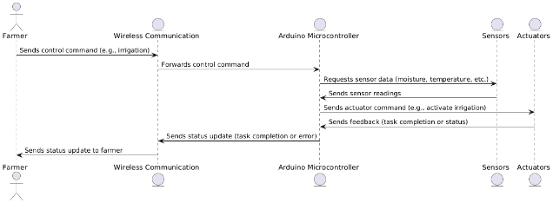

**Figure 1: Flow chart**

**HARDWARE AND SOFTWARE REQUIREMENTS:**

**Hardware Components:**

* ARDUINO (MICRO CONTROLLER)
* WHEELS (X4)
* CHASSIS (USING MDF BOARD)
* L CLAMP (FOR MOTOR AND WHEEL SUPPORT)
* 12V DC MOTOR (X 2)
* L293D MOTOR DRIVER MODULE
* WATER MOTOR PUMP
* WATER CONTAINER
* SEED DISPENSOR UNIT
* SERVO MOTOR (X3)
* JUMPER WIRES
* BLUETOOTH MODULE HC-05
* BATTERY/POWER SUPPLY
* IC 7805
* 1K Ohm RESISTANCE
* CAPACITORS 1000UF, 100UF
* DIODE 1N4007N
* BERG STICKs (plough)
* SWITCHES

**Software Components:**

**Arduino IDE:**

The Integrated Development Environment (IDE) used for programming the Arduino Uno board. It provides libraries for sensor integration and data processing.

**IV. IMPLEMENTATION**

**Hardware Assembly:**

The methodology of the project follows a structured approach to design, develop, and implement a multi-purpose agricultural robot for automating key farming tasks. The methodology can be broken down into the following phases:

**1. System Design and Component Selection:**

In this phase, the appropriate components, including sensors, actuators, motors, and communication modules, are selected based on their suitability for agricultural environments. A system architecture is designed to integrate these components into a cohesive robotic system.

**2. Robot Development and Integration:**

The physical structure of the robot is constructed, and components like sensors and actuators are integrated with the Arduino microcontroller for task automation. This phase ensures that all hardware works together to perform essential farming tasks like seed sowing and irrigation.

**3. Software Development and Communication Setup:**

Software is developed to program the robot’s operations, enabling precise control over tasks like irrigation and pesticide spraying. Communication protocols, such as Bluetooth or IoT, are implemented for remote control and real-time monitoring.

**4. Testing and Calibration:**

The robot undergoes rigorous testing to ensure that all tasks are executed accurately. Sensors are calibrated for correct data collection, and task performance is evaluated under different environmental conditions.

**5. Field Deployment and Data Collection:**

After successful testing, the robot is deployed in real farming conditions. Data from the field is collected to monitor performance, evaluate efficiency, and assess adaptability to varying soil types and environmental factors.

**6. Optimization and Final Adjustments:**

Based on field data and feedback, adjustments are made to the robot’s systems to improve performance. The robot is optimized for better resource efficiency, precision in task execution, and seamless operation.

**Future Trends:**

The future trends for the "East Coast Weather Monitoring on Air Quality Using IoT Framework" project point toward a transformative evolution in both technology and environmental monitoring strategies. One key trend will be the integration of artificial intelligence (AI) and machine learning (ML) models to enhance the system’s predictive capabilities. These algorithms can analyze large datasets from real-time sensor inputs and historical records to forecast air pollution levels and detect trends in coastal weather patterns, leading to more effective decision-making and response strategies.

Edge computing is also poised to play a significant role, where data processing occurs closer to the sensors rather than relying heavily on cloud computing. This reduces latency and enables faster, real-time analytics, making the system more responsive in dynamic environmental conditions. Additionally, there will be an increased focus on community engagement and citizen science, where mobile applications will enable individuals to participate in monitoring and reporting air quality, creating a collaborative effort to address pollution and climate concerns.

**V. RESULTS & DISCUSSION**

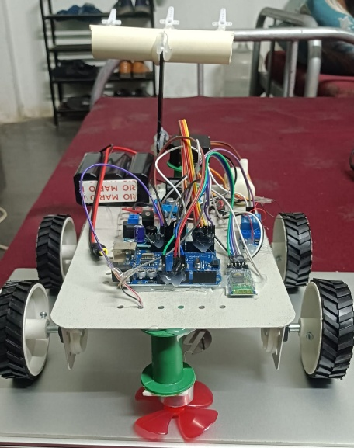 **Expected Results:**

Fig: Experimental Setup

**VI. CONCLUSION**

In agriculture, the opportunities for robot-enhanced productivity are immense – and the robots are appearing on farms in various guises and in increasing numbers. The other problems associated with autonomous farm equipment can probably be overcome with technology. This equipment may be in our future, but there are important reasons for thinking that it may not be just replacing the human driver with a computer. It may mean a rethinking of how crop production is done. Crop production may be done better and cheaper with a swarm of small machines than with a few large ones.

One of the advantages of the smaller machines is that they may be more acceptable to the non-farm community. The jobs in agriculture are a drag, dangerous, require intelligence and quick, though highly repetitive decisions hence robots can be rightly substituted with human operator. The higher quality products can be sensed by machines (colour, firmness, weight, density, ripeness, size, shape) accurately. Robots can improve the quality of our lives but there are downsides.

The present situation in our country all the agricultural machine is working on manual operation otherwise by petrol engine or tractor is expensive, farmer can’t work for long time manually to avoid this problem, we need to have some kind of power source system to operate the digging machine.

**VII. FUTURE SCOPE**

The system can be advanced for sowing seeds in farm with particular distance between seed is adjusted. It cans automatically sowing seed in land, when providing water supply to this system. It can be also used fertilizer sowing instead of seed. The system can further be modified by one or many systems can be monitored through GSM system.

With fully-automated farms in the future, robots can perform all the tasks like mowing, fertilizing, monitoring of pests and diseases, harvesting, tilling, etc. This also enables the farmers to just supervise the robots without the need to operate them.

The following additions are expected to be incorporated in the second phase of investigation

1) Investigation of human robot interaction.

2) Modifying the chassis to accommodate more electronics and adding more powerful motors.

3) Testing the concept of multi robot coordination system.

4) Use of hydraulic equipments can be implemented.

5) Adding onboard motion detection sensor for faster detection.

6) Adding High resolution cameras.

**VIII. REFERENCE**

[1]. Rai, H.M., Gupta, D., Mishra, S. and Sharma, H., 2021, August. Agri-Bot: IoT Based Unmanned Smart Vehicle for Multiple Agriculture Operations. In 2021 International Conference on Simulation, Automation & Smart Manufacturing (SASM) (pp. 1-6). IEEE.

[2]. Mada, D. A., and Sunday Mahai. "The role of agricultural mechanization in the economic development for small scale farms in Adamawa State." Journal of Engineering and Science 2 (2013): 91-96.

[3]. Jin, Yucheng, Jizhan Liu, Zhujie Xu, Shouqi Yuan, Pingping Li, and Jizhang Wang. "Development status and trend of agricultural robot technology." International Journal of Agricultural and Biological Engineering 14, no. 4 (2021): 1-19.

[4]. Wang, C., Tang, Y., Chen, M., Luo, L., Li, J., Lian, G. and Zou, X., 2020. Recognition and localization methods for vision-based fruit picking robots: A review. Frontiers in Plant Science, 11, p.510.

[5]. Liu, J., Xu, Z., Yuan, S., Li, P. and Wang, J., 2021. Development status and trend of agricultural robot technology. International Journal of Agricultural and Biological Engineering, 14(4), pp.1-19.

[6]. Chen, Huang, C.H., P.J., Lin, Y.J., Chen, B.W. and Zheng, J.X., 2021. A robot-based intelligent management design for agricultural cyber-physical systems. Computers and Electronics in Agriculture, 181, p.105967.

[7]. Kim, J., Ju, C., Seol, J. and Son, H.I., 2022. A review on multi-robot systems in agriculture. Computers and Electronics in Agriculture, 202, p.107336.

[8]. Gupta P, Matholiya, Chirag S., Vishal V. Agravat, Ulpa V. Patel, and Piyush R. Balas. "Automatic guidance systems in agricultural autonomous robotic machine: a review." Pharm Innov J sp-11 (3) (2022): 307-312.

[9]. Patel, Dhruv, Meet Gandhi, H. Shankaranarayanan, and Anand D. Darji. "Design of an Autonomous Agriculture Robot for Real-Time Weed Detection Using CNN." In Advances in VLSI and Embedded Systems: Select Proceedings of AVES 2021, pp. 141-161. Singapore: Springer Nature Singapore, 2022.

[10]. Yang, Jiachen, Jingfei Ni, Yang Li, Jiabao Wen, and Desheng Chen. "The intelligent path planning system of agricultural robot via reinforcement learning." Sensors 22, no. 12 (2022): 4316.

[11] S. Umarkar and A. Karwankar, “Automated Seed Sowing Agribot using Arduino," in IEEE Conference on Communication and Signal Processing, April 2016, pp. 1379-1383.

[12] M.D.I. Sujon, R. Nasir, M.M.I. Habib, M.I. Nomaan J. Baidya and M.R. Islam “Agribot: Arduino Controlled Autonomous Multipurpose Farm Machinery Robot for Small to medium scale cultivation," in IEEE conference on intelligent autonomous systems, March 2018, pp. 155-159.

[13] H. Pota, R. Eaton, J. Katapriya and S. D. Pathirana, “Agricultural robotics: A streamlined approach to realization autonomous farming,” in IEEE conference on industrial and information systems, 2007, pp. 85-90.