**Scipy Testing**

Our moto is for each module and bundle in Scipy to have a well-organized set of unit tests. These tests should demonstrate the complete use of a specified daily plan as well as its vigour in the face of incorrect or shocking information contentions. All-around designed tests with high inclusion have a significant impact on the ease of refactoring. When another problem is discovered on a daily basis.

**Testing methodology**

For testing purpose, I write my own test cases of some scipy functions. Then I used a module of python called coverage to find the coverage of the tests I written.

**File level coverage**:

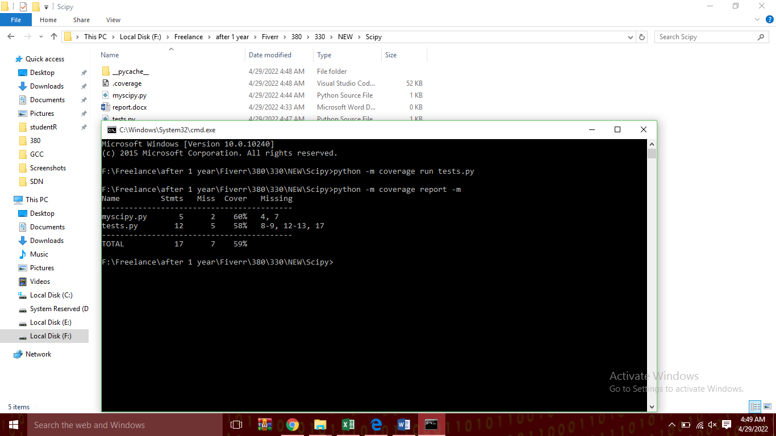

The above figure shows the file level coverage of the work.

**Test files and assert statements in files:**

As I write all test cases in one file, so the following assert statements I get and the result shows.

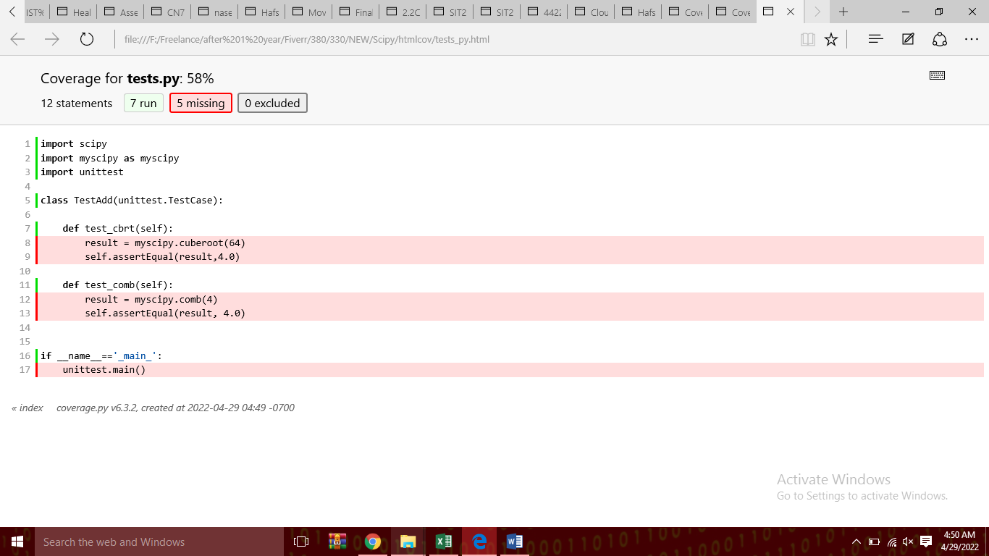

The total coverage of the work is given below generated by the coverage module,

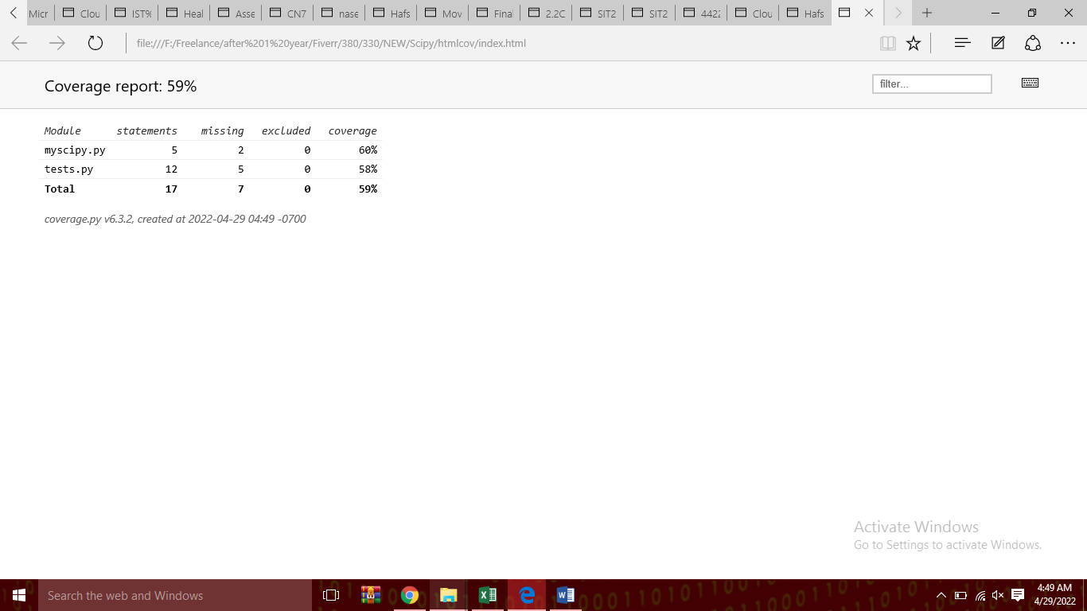

At the end I used pydriller to work with repositories.

Assuming you are composing a bundle that you might want to turn out to be essential for NumPyIf it's not too much bother, compose the tests as you foster the bundle record in py Pytest searches these documents for test techniques (described as test*) and test classes (described as Test*).

I can basically add a test work:

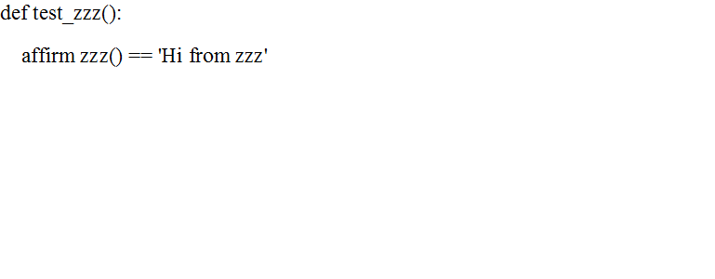

On a more regular basis, we really want to gather various tests, so we make a test class:

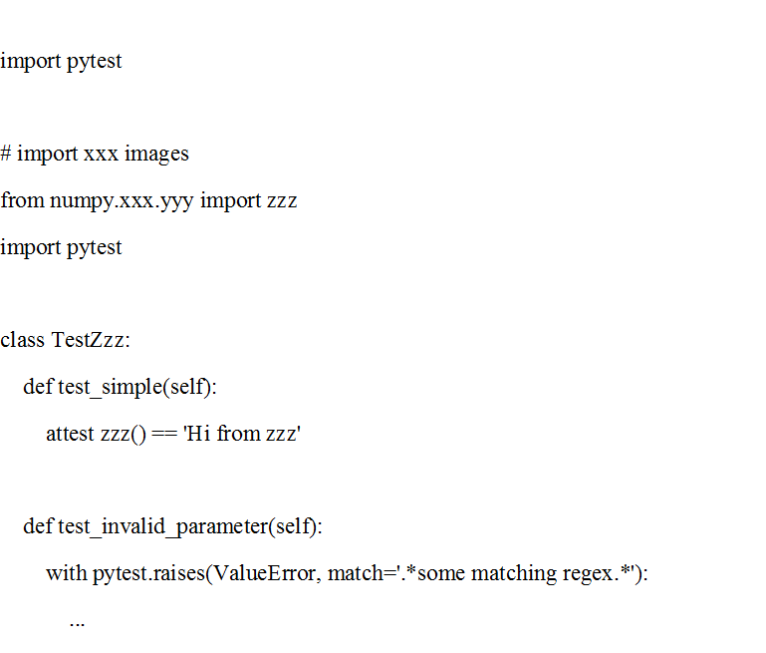

Inside these test techniques, state and related capacities are utilized to test whether a specific supposition that is substantial. Assuming that the affirmation comes up short, the test fizzles. pytest inside reworks the attest articulation to give useful result when it comes up short, so ought to be liked over the inheritance variation numpy.testing.assert_. Though plain affirm articulations are disregarded.

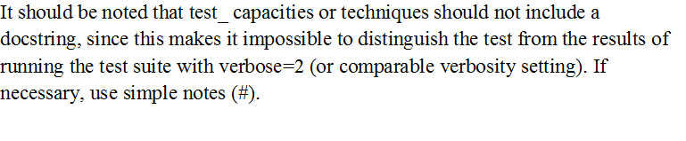

Unlabeled tests:

Simpler arrangement and teardown capacities/strategies

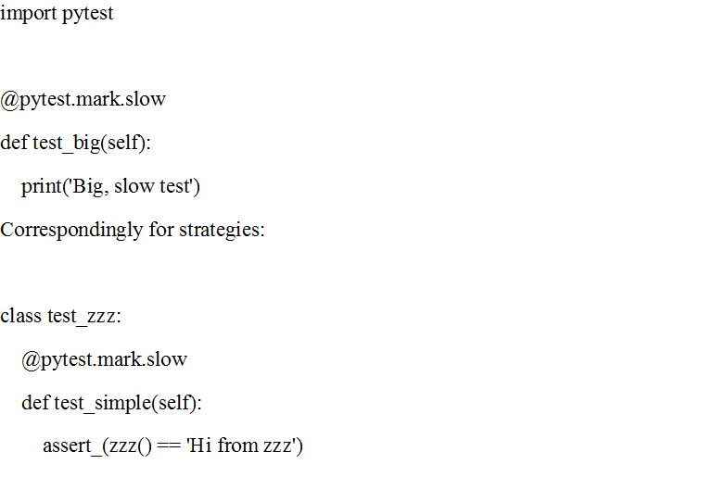

By name, testing looks for module-level or class-level organisation and deconstruction capabilities; thus:

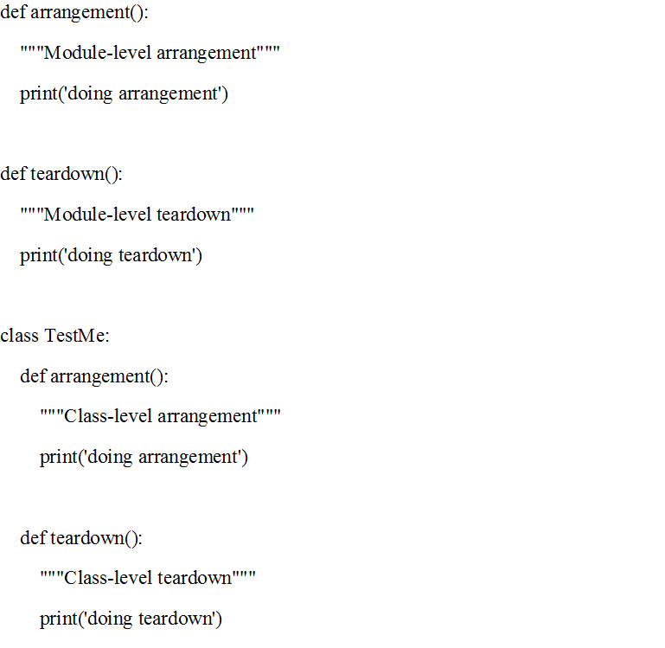

Tests of metric

Allowing straightforward testing over a range of limits is a very enjoyable aspect of testing - a terrible issue for ordinary unit tests. Use the decorator pytest.mark.parametrize.

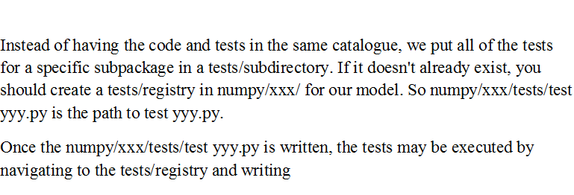

assessments on arbitrary information are excellent, but on account that check disappointments are meant to find new bugs or relapses, a take a look at that sits again but bombs at instances.

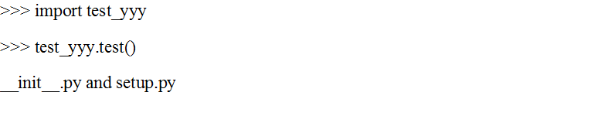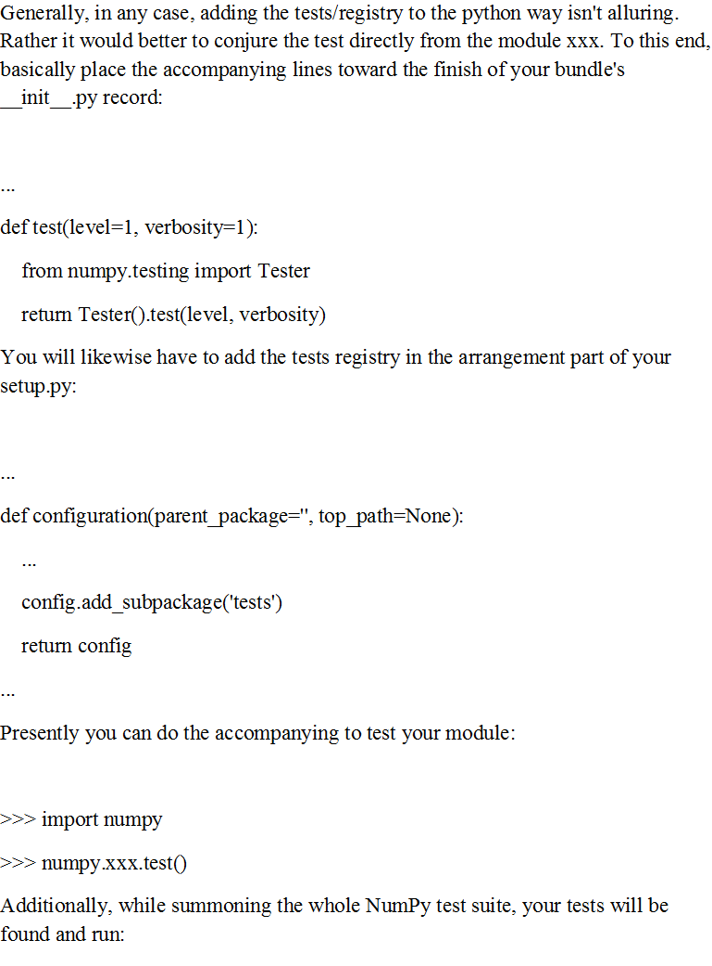

On the other hand, you can utilize Hypothesis to produce inconsistent information. Theory oversees both Python. And Numpy' arbitrary values and gives an exceptionally succinct and strong method for portraying information (counting hypothesis.extra.numpy, for example for a bunch of commonly broadcastable shapes).

The benefits over irregular age incorporate instruments to replay and share disappointments without requiring a decent seed, announcing insignificant models for every disappointment, and better-than-innocent arbitrary methods for setting off bugs.