SOLUTION OF ASSIGNMENT -1

Ans.Q1) Idnetify the Data type for the Following:
Activity | Data Type
Number of beatings from Wife | Discrete Data
Results of rolling a dice | Discrete Data
Weight of a person | Continuous Data
Weight of Gold | Continuous Data
Distance between two places | Continuous Data
Length of a leaf | Continuous Data
Dog's weight | Continuous Data
Blue Color | Discrete Data
Number of kids | Discrete Data
Number of tickets in Indian railways | Discrete Data
Number of times married | Discrete Data
Gender (Male or Female) | Discrete Data

Discrete Data: Discrete Data involves whole number and that can’t be divided based on the nature of what they are. For example integers like 1, 10 or 356 like the number of people or children in a class, the number of fingers on our hand. We can’t have 1.9 children in a family.
Continuous Data : Continuous Data involves divided up as much as we want, and measured to many decimal places. For example weight of a car calculated as many decimal places even temperature as 38.965 degrees and speed of airplane is 943.6 km/hr.

Ans.Q2) Identify the Data types, which were among the following:
Nominal, Ordinal, Interval, Ratio.

Nominal Data : Nominal Data are used to label variables without any quantitative value. For examples include male/female, hair color, nationalities, names of people, and so on.

Ordinal Data : Ordinal Data are used to remember that ordinal sounds like order and it’s the order of the variables which matters. Not so much the differences between those values. For example include measure of satisfaction, happiness, sad, emotion and so on.
Interval Data : Interval Data is fun and useful because it’s concerned with both the order and difference between your variables. This allows to measure Standard Deviation and Central Tendency. For example of interval data is temperatures in degrees Celsius. The difference between 10 and 0 is also 10 degrees.
Ratio Data : Ratio Data tells us about the order of variables, the differences between them, and they have that absolute zero. Which allows all sorts of calculations and inferences to be performed and drawn. Ratio Data is very similar to Interval Data, For Ratio Data not possible to have negative values. For instance, height is ratio data. It is not possible to have negative height.
Data | Data Type
Gender | Discrete Data - Nominal
High School Class Ranking | Discrete Data - Ordinal
Celsius Temperature | Continuous Data - Interval
Weight | Continuous Data - Ratio
Hair Color | Discrete Data - Nominal
Socioeconomic Status | Continuous Data - Ordinal
Fahrenheit Temperature | Continuous Data - Interval
Height | Continuous Data - Ratio
Type of living accommodation | Discrete Data - Nominal
Level of Agreement | Discrete Data - Ordinal
IQ(Intelligence Scale) | Discrete Data - Interval
Sales Figures | Discrete Data - Ratio
Blood Group | Discrete Data - Nominal
Time Of Day | Continuous Data - Ordinal
Time on a Clock with Hands | Continuous Data - Interval
Number of Children | Discrete Data - Nominal
Religious Preference | Discrete Data - Nominal
Barometer Pressure | Continuous Data - Ratio
SAT Scores | Continuous Data - Interval
Years of Education | Discrete Data - Ratio

Q3) Three Coins are tossed, find the probability that two heads and one tail are obtained?
Answer : Possible outcomes for the three coins tossed : (HHH, HHT, HTH, THH, HTT, THT, TTH, TTT )
Probability that two heads and one tail is : (HHT, HTH, THH)
Hence P = 3/8
Q4) Two Dice are rolled, find the probability that sum is
- Equal to 1
- Less than or equal to 4
- Sum is divisible by 2 and 3
Answer : S = { (1,1),(1,2),(1,3),(1,4),(1,5),(1,6)
(2,1),(2,2),(2,3),(2,4),(2,5),(2,6)
(3,1),(3,2),(3,3),(3,4),(3,5),(3,6)
(4,1),(4,2),(4,3),(4,4),(4,5),(4,6)
(5,1),(5,2),(5,3),(5,4),(5,5),(5,6)
(6,1),(6,2),(6,3),(6,4),(6,5),(6,6) }
Possible total number of outcomes = 6 x 6 = 36
- Equal to 1 : When the sum is equal to '1' the Probability will be Zero.
P(E) = n(E) / n(S) = 0 / 36 = 0
(b) Less than or equal to 4
P(AorB)=P(A)+P(B)
Three possible outcomes give a sum less than 4: E = {(1,1),(1,2),(2,1)}, hence. P(A) =3/36
Three possible outcomes give a sum equal to 4: E = {(1,3),(2,2),(3,1)}, hence. P(B)=3/36
P(AorB)=P(A)+P(B) = 3/36+3/36=6/36=1/6
(c) Sum is divisible by 2 and 3
Total number of events =36
Interested number of events = {(1,5),(2,4),(3,3),(4,2),(5,1),(6,6)} =6
P(Sum is divisible by 2 and 3) =6/36=1/6.

Q5) A bag contains 2 red, 3 green and 2 blue balls. Two balls are drawn at random. What is the probability that none of the balls drawn is blue?

Answer : Total number of events {(R,R),(R,G),(R,B),(G,R),(G,G),(G,B),(B,R),(B,G),(B,B)}=9
Interested number of events =4
Probability =4/9
Q6) Calculate the Expected number of candies for a randomly selected child
Below are the probabilities of count of candies for children (ignoring the nature of the child-Generalized view)
CHILD | Candies count | Probability
A | 1 | 0.015
B | 4 | 0.20
C | 3 | 0.65
D | 5 | 0.005
E | 6 | 0.01
F | 2 | 0.120
Child A – probability of having 1 candy = 0.015.
Child B – probability of having 4 candies = 0.20
Answer : Expected number of candies for a randomly selected child is given by
∑Xp(X)=1*0.015+4*0.20+3*0.65+5*0.65+5*0.005+6*0.01+2*0120
∑Xp(X)=0.015+0.8+1.95+0.025+0.06+0.24=3.09$≈3$
Q7) Calculate Mean, Median, Mode, Variance, Standard Deviation, Range & comment about the values / draw inferences, for the given dataset
- For Points,Score,Weigh>
Find Mean, Median, Mode, Variance, Standard Deviation, and Range and also Comment about the values/ Draw some inferences.
Use Q7.csv file
Answer: Solution in Assignment-1-Q7(Basic Statistics Level-1).ipynb
Q8) Calculate Expected Value for the problem below
The weights (X) of patients at a clinic (in pounds), are
108, 110, 123, 134, 135, 145, 167, 187, 199
Assume one of the patients is chosen at random. What is the Expected Value of the Weight of that patient?
Answer: Given,The weights (X) of patients at a clinic (in pounds), are 108, 110, 123, 134, 135, 145, 167, 187, 199
one of the patients is chosen at random.
To Find : Expected Value
Expected Value = ∑ ( probability * Value )
∑ P(x).E(x)
there are 9 patients
Probability of selecting each patient = 1/9
E(x) = 108, 110, 123, 134, 135, 145, 167, 187, 199
P(x) = 1/9 1/9 1/9 1/9 1/9 1/9 1/9 1/9 1/9
Expected Value, E(x) = (1/9)(108) + (1/9)(110) + (1/9)(123) + (1/9)(134) + (1/9)(135) + (1/9)(145) + (1/9(167) + (1/9)(187) + (1/9)(199)
= (1/9) x ( 108 + 110 + 123 + 134 + 135 + 145 + 167 + 187 + 199)
= (1/9) x ( 1308)
= 145.33
Expected Value of the Weight of that patient = 145.33 $≈145$
Q9) Calculate Skewness, Kurtosis & draw inferences on the following data
Cars speed and distance
Use Q9_a.csv
Answer: Solution in Assignment-1-Q9_a(Basic Statistics Level-1).ipynb
SP and Weight(WT)
Use Q9_b.csv
Answer: Solution in Assignment-1-Q9_b(Basic Statistics Level-1).ipynb

Q10) Draw inferences about the following boxplot & histogram

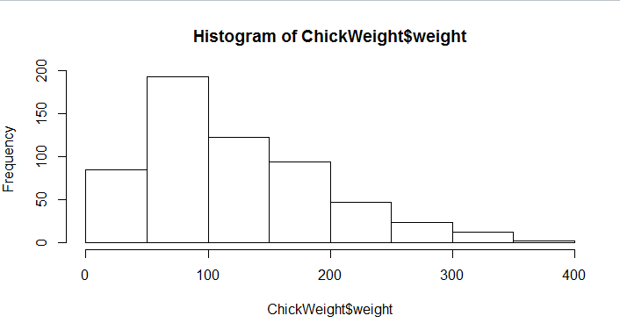
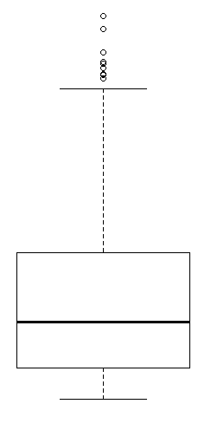

Answer : The maximum of the data points is present in the range 50-100 with frequency 200.
minimum range of weight is 400 and its frequency around 0-10.
Skewness- we can notice a long tail towards right so it is heavily right skewed.

Boxplot : Median is less than mean right skewed and we have outlier on the upper side of box plot and there is less data points between Q1 and bottom point.
Q11)Suppose we want to estimate the average weight of an adult male in Mexico. We draw a random sample of 2,000 men from a population of 3,000,000 men and weigh them. We find that the average person in our sample weighs 200 pounds, and the standard deviation of the sample is 30 pounds. Calculate 94%,98%,96% confidence interval?
Answer: Answer: Solution in Assignment-1(Basic Statistics Level-1).ipynb
Q12) Below are the scores obtained by a student in tests
34,36,36,38,38,39,39,40,40,41,41,41,41,42,42,45,49,56
Find mean, median, variance, standard deviation.
- What can we say about the student marks?
- What can we say about the student marks?
Answer: Solution in Assignment-1-Q12(Basic Statistics Level-1).ipynb
Q13) What is the nature of skewness when mean, median of data are equal?
Answer: Symmetrical
Q14) What is the nature of skewness when mean > median ?
Answer: Right Skewed
Q15) What is the nature of skewness when median > mean?
Answer: Left Skewed
Q16) What does positive kurtosis value indicates for a data ?
Answer: The data is normally distributed and kurtosis value is 0.
Q17) What does negative kurtosis value indicates for a data?
Answer: The distribution of the data has lighter tails and a flatter peaks than the normal distribution.

Q18) Answer the below questions using the below boxplot visualization.
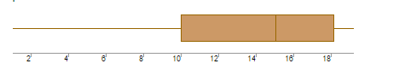
(a)What can we say about the distribution of the data?
Answer: Let’s assume above box plot is about ages of the students in a school.
50% of the people are above 10 yrs. old and remaining are less.
And students whose age is above 15 are approx. 40%.
(b)What is nature of skewness of the data?
Answer: Left skewed, median is greater than mean.
(c)What will be the IQR of the data (approximately)?
Answer: Approximately= -8
Q19) Comment on the below Boxplot visualizations?
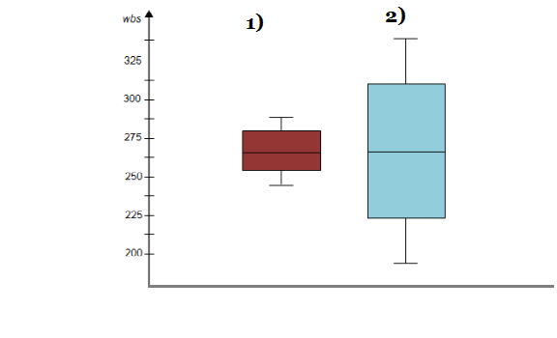
Draw an Inference from the distribution of data for Boxplot 1 with respect Boxplot 2.
Answer: By observing both the plots whisker’s level is high in boxplot 2, mean and median are equal hence distribution is symmetrical.

Q 20) Calculate probability from the given dataset for the below cases
Data _set: Cars.csv
Calculate the probability of MPG of Cars for the below cases.
MPG<- Cars$MPG
  - P(MPG>38)
  - P(MPG<40)
c. P (20<MPG<50)
Answer: Solution in Assignment-1-Q20(Basic Statistics Level-1).ipynb
Q 21) Check whether the data follows normal distribution
- Check whether the MPG of Cars follows Normal Distribution
Dataset: Cars.csv
Answer: Solution in Assignment-1-Q21_a(Basic Statistics Level-1).ipynb
b). Check Whether the Adipose Tissue (AT) and Waist Circumference(Waist) from wc-at data set follows Normal Distribution
Dataset: wc-at.csv
Answer: Solution in Assignment-1-Q21_b(Basic Statistics Level-1).ipynb
Q 22) Calculate the Z scores of 90% confidence interval,94% confidence interval, 60% confidence interval
Answer: Solution in Assignment-1-Q22(Basic Statistics Level-1).ipynb
Q 23) Calculate the t scores of 95% confidence interval, 96% confidence interval, 99% confidence interval for sample size of 25
Answer: Solution in Assignment-1-Q23(Basic Statistics Level-1).ipynb
Q 24)A Government companyclaims that an average light bulb lasts 270 days. A researcher randomly selects 18 bulbs for testing. The sampled bulbs last an average of 260 days, with a standard deviation of 90 days. If the CEO's claim were true, what is the probability that 18 randomly selected bulbs would have an average life of no more than 260 days
Hint:
rcodept(tscore,df)
df degrees of freedom
Answer: Solution in Assignment-1-Q24(Basic Statistics Level-1).ipynb .

