Linux Basics – Assignment 1
Name : Kanaparthi Sai Dheeraj
Course : DevOps
Assignment : Linux Basics – Assignment 1

Objective
The objective of this assignment is to understand the fundamental Linux commands used for file management, file viewing, searching, compression, downloading files, file permissions, and environment variables. These commands form the foundation for Linux system administration and DevOps practices.

Task 1: Creating and Renaming Files/Directories
Objective
To learn how to create directories, create files, and rename files in Linux.
Commands Used
mkdir test_dir
cd test_dir
touch example.txt
mv example.txt renamed_example.txt
Explanation
- mkdir creates a new directory.
- touch creates an empty file.
- mv renames or moves files.
Output
]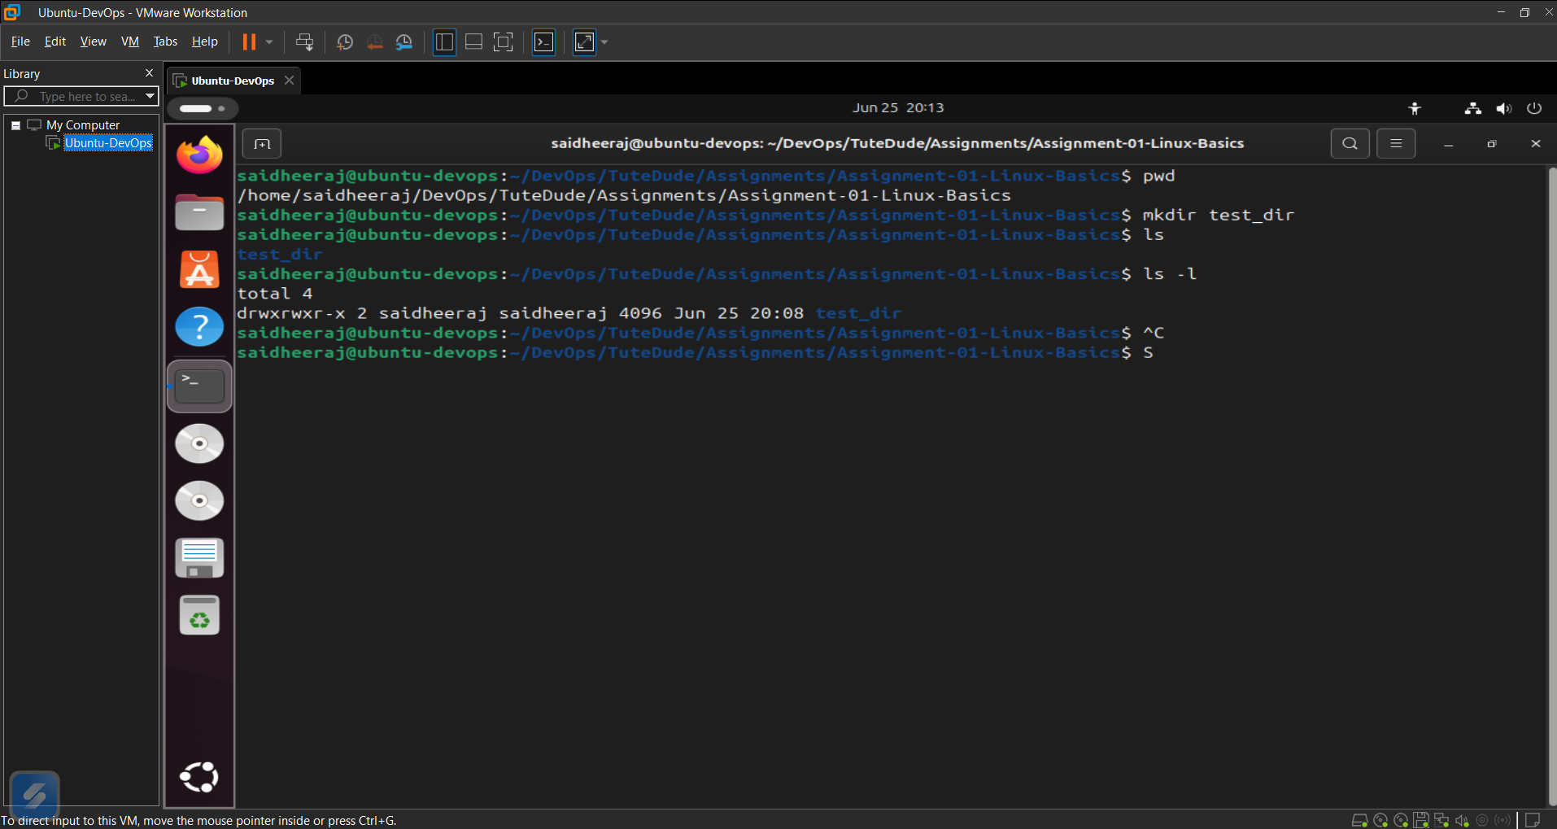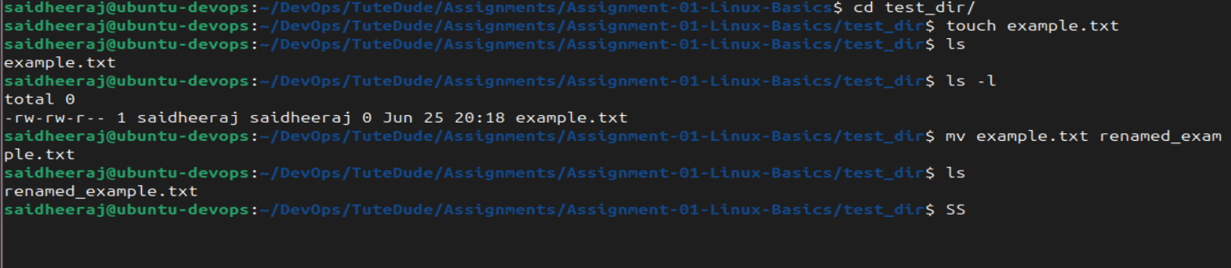

Task 2: Viewing File Contents
Objective
To learn how to view complete and partial contents of files.
Commands Used
cat /etc/passwd
head -5 /etc/passwd
tail -5 /etc/passwd
Explanation
- cat displays the entire file.
- head displays the first few lines.
- tail displays the last few lines.
Output
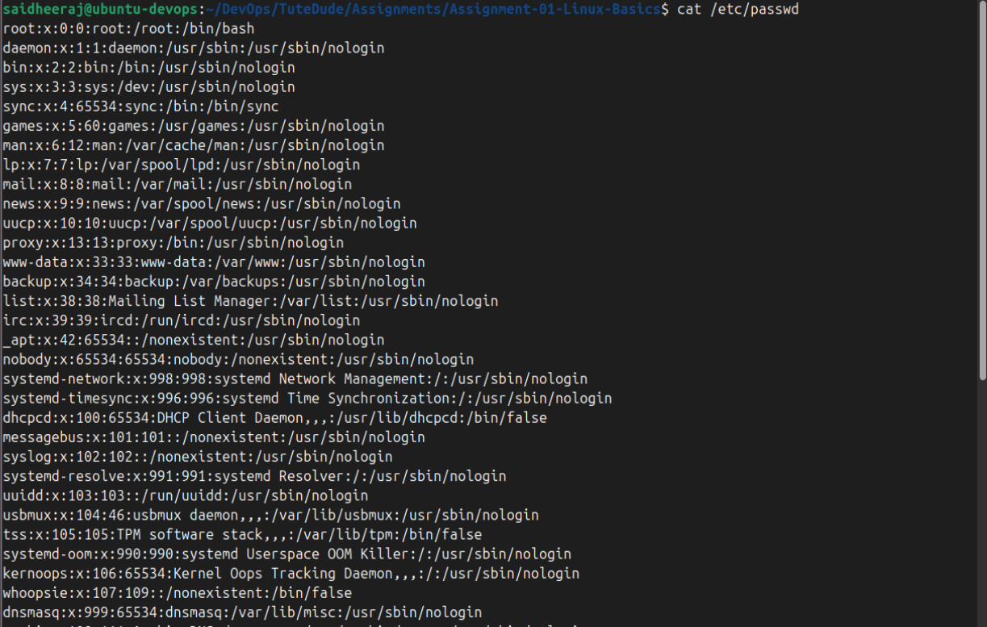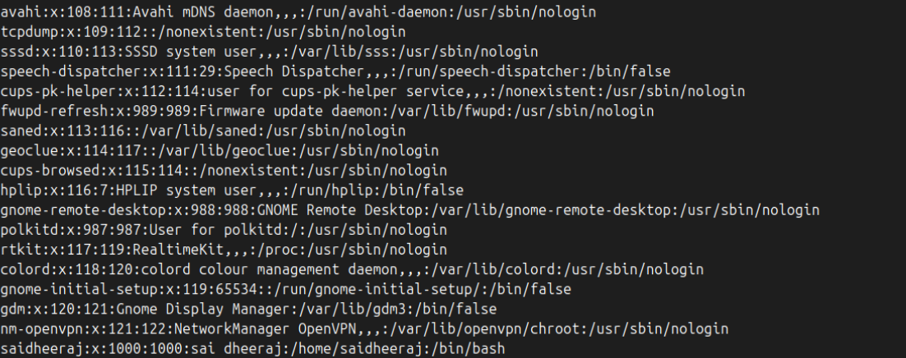
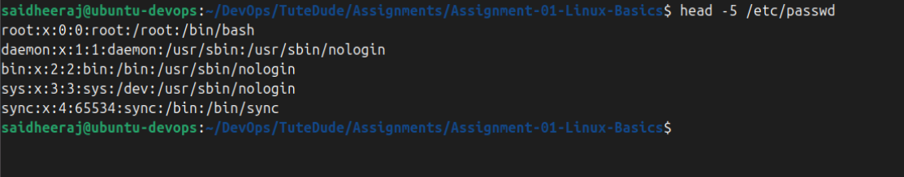
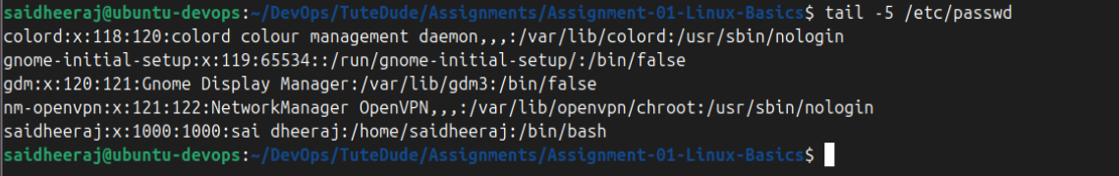

Task 3: Searching for Patterns
Objective
To search for specific text inside a file.
Command Used
grep "root" /etc/passwd
Explanation
The grep command searches a file and prints only the lines containing the specified pattern.
Output
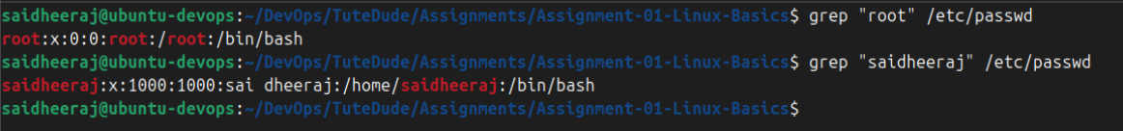

Task 4: Zipping and Unzipping
Objective
To compress and extract directories.
Commands Used
zip -r test_dir.zip test_dir
mkdir unzipped_dir
unzip test_dir.zip -d unzipped_dir
Explanation
- zip compresses files and directories.
- unzip extracts compressed files.
Output
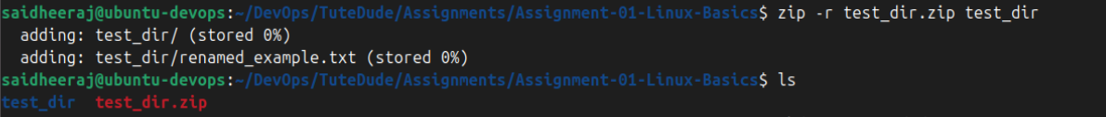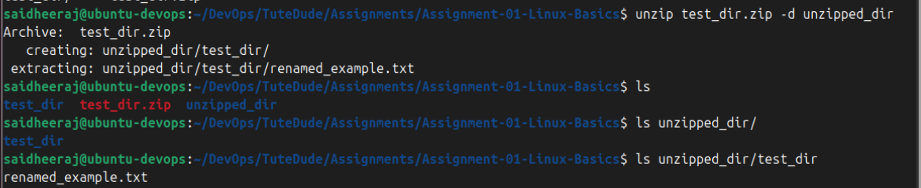

Task 5: Downloading Files
Objective
To download files from the internet using the Linux terminal.
Command Used
wget https://www.google.com/robots.txt
Explanation
wget downloads files directly from a specified URL.
Output
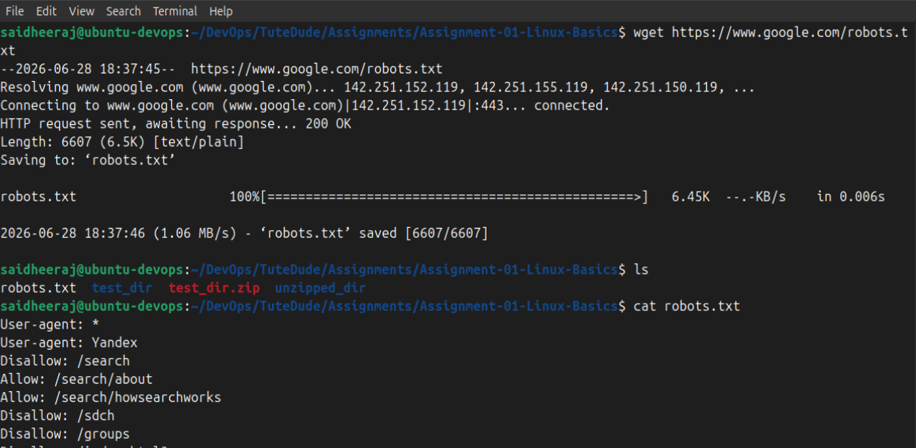

Task 6: Changing File Permissions
Objective
To understand Linux file permissions.
Commands Used
touch secure.txt
chmod 444 secure.txt
ls -l secure.txt
Explanation
chmod 444 makes the file read-only for the owner, group, and others.
Output
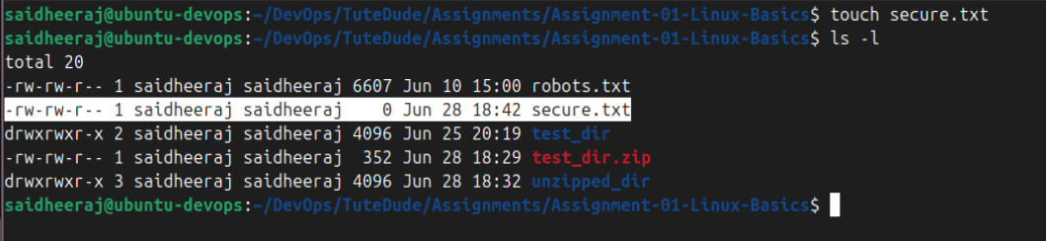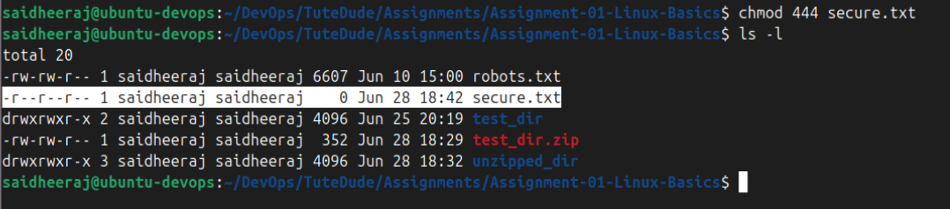

Task 7: Environment Variables
Objective
To create and verify environment variables.
Commands Used
export MY_VAR="Hello, Linux!"
echo $MY_VAR
Explanation
export creates an environment variable, and echo displays its value.
Output
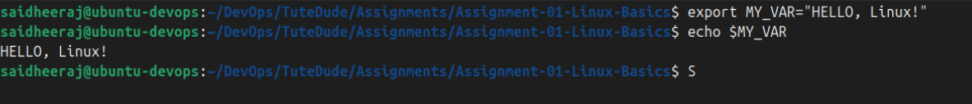

Conclusion
In this assignment, I learned the basic Linux commands required for file and directory management, viewing file contents, searching for patterns, compressing and extracting files, downloading files, managing file permissions, and working with environment variables. These commands are essential for Linux administration and serve as a strong foundation for DevOps practices.

