Part 1: Initial Architecture - GCP VertexAI Based (Failed Attempt)
Overview
In the first version of the project, the plan was to create a fully cloud-based solution using Google Cloud Platform (GCP).
The idea was to build everything around VertexAI, including uploading documents, processing them, generating embeddings, and eventually answering user queries via a chatbot interface.
At first, this seemed like a good approach.However, as the project progressed, multiple challenges came up which made this approach difficult to continue.

Step 1: Document Loading and Text Extraction
The first step was to upload insurance brochures and policy documents into the VertexAI environment. I used JupyterLab (offered by VertexAI) to start working on these files.
Since PDF documents come in two types — text-based and scanned images — I had to use two different methods to extract the text:
- Text-based PDFs → Used PyPDF2, which reads the embedded text directly from the PDF.
- Scanned PDFs (images) → Used OCR (Optical Character Recognition) through pytesseract, which reads text from images.
Both techniques were combined together in the script to make sure we extracted the maximum amount of information.
The text was then preprocessed (cleaned up) and saved into JSON files along with metadata like company name, file name, and extracted text.
This part of the workflow worked quite well. The script was able to process folders of PDFs and generate nicely structured text files for further processing.

Step 2: Chunking and Embedding Generation
After extracting the text from the pdfs the next goal was to break it into smaller parts or "chunks". This is important because AI models work better with shorter pieces of text and it also helps in better search and retrieval later.
For this, I used a technique called RecursiveCharacterTextSplitter which smartly splits text into ~1000 character chunks with some overlap to preserve context.
Once chunks were ready, the next step was to create embeddings.
I used an open-source model called all-MiniLM-L6-v2 from Sentence Transformers, which offers a good balance of speed and performance.
The embedding generation was done efficiently using GPU and all chunk embeddings were saved in another set of JSON files, along with metadata.
After generating the embeddings successfully for all the extracted text from insurance documents, the next step was to make them searchable.
The idea was simple — when a user asks a question, I should be able to convert the question into an embedding and find the closest matching document parts (chunks) from my data.
This is how modern AI-powered search generally works.
To do this, I decided to use Vertex AI (Vector Search) which is specially designed for this purpose in GCP.
Uploading Embeddings to GCS and Creating Index
The first step was to upload all the generated embeddings to Google Cloud Storage (GCS).
These embeddings were prepared in a format suitable for Vertex AI Vector Search (JSONL format) and were stored in a staging folder in the GCS bucket.
Next, I created a Vector Search Index in Vertex AI. This Index stores the embeddings and allows for fast similarity search.
- I used Tree-AH index type, which is suitable for high accuracy and speed.
- Defined the embedding dimensions (384) and other parameters.
- The index creation process completed successfully.
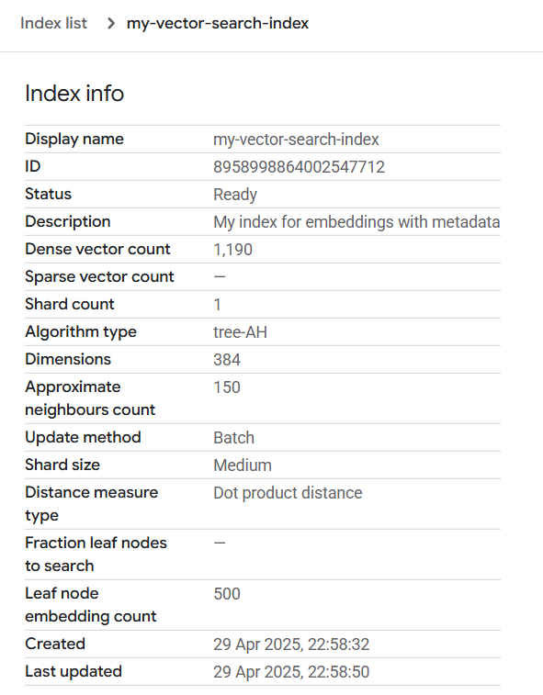
Creating Index Endpoint and Deploying Index
Once the Index was ready, I needed a way to send queries to it.
So, I created an Index Endpoint, which acts like a gateway to talk to the Index.
I made this endpoint public (so that I could easily test from anywhere without complex VPC setup).
Then, I deployed the created Index onto this endpoint. This process also went smoothly.
At this point, everything seemed ready — the Index was deployed and ready to receive queries.

Step 3 — Querying the Index (Where Things Started Going Wrong)
The last step was to send actual queries to the deployed Index.
For this, I used the match() method which takes a query embedding and returns the closest matches.
I wrote the code properly:
- Converted my query (like "Tell me about ICICI plans") to an embedding using the same embedding model.
- Sent the embedding to the deployed Index endpoint along with some filters (for example, company_name = "ICICI").
- Expected the results to come back with the most relevant document chunks.
But unfortunately, this is where everything broke.
- The queries were either failing, or returning strange errors.
- Sometimes it would say that the deployed index is not ready (even though it showed "Ready" in console).
- Other times, connection errors or internal server errors were showing up.
- I double-checked everything → Project ID, Region, Endpoint ID, Deployed Index ID, Machine type → all were correct.
I tried various troubleshooting approaches:
- Restarted and deleted + recreated the Index and Endpoints.
- Tried modifying firewall and VPC settings (thinking maybe it was a networking issue).
- Upgraded SDK versions and libraries.
- Also checked online forums and documentation.
But nothing fixed the problem.
Some people mentioned these types of errors happen when using LangChain or Sentence Transformers with Vertex AI Matching Engine, but there were no clear solutions found.
Here, is the error below
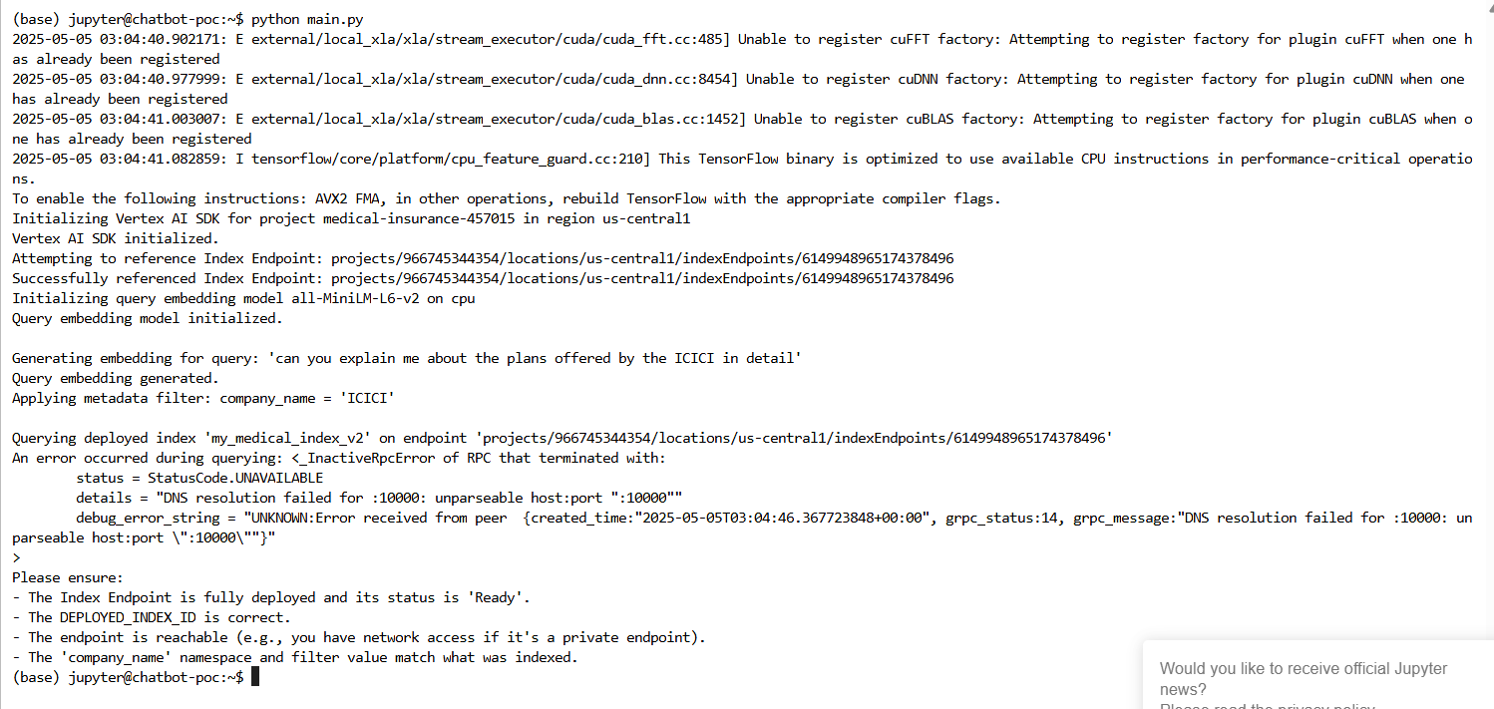

Part 2 - Modified Architecture (Working Solution)
When I shifted my project from VertexAI to a simpler and more controllable architecture, I knew I didn’t want to lose the work I had already done.
I had already generated embeddings for all the insurance documents. These were carefully prepared and stored in Google Cloud Storage (GCS) for use with VertexAI’s vector search, but since that plan did not work out, I decided to make good use of them in my new design.
Rather than starting over and re-generating embeddings, I chose to reuse those existing embeddings and load them directly into ChromaDB, which would now serve as the core search engine for my chatbot.
Getting the embeddings ready
First, I needed to get those embeddings from GCS to my local working environment.
To do that, I created a simple program that securely connects to Google Cloud using service account credentials, which were safely stored in a .env file. This is important because it prevents sensitive details like API keys and file paths from being directly exposed in the code.
Once authenticated, I used Google’s Python library to connect to my GCS bucket, find the file that had all the embeddings, and download it.
The downloaded file was in JSON format, and each record inside had:
- ID → a unique identifier for the text chunk
- Document Text → the actual text extracted from the PDF
- Embedding → a list of numbers representing the text in vector space
- Metadata → additional details like the source document and company name
Having all this data neatly organized made it much easier for the next steps.

Preparing for ChromaDB
After I loaded the file, I needed to get the data into a format that ChromaDB understands.
Chroma expects separate lists for:
- IDs
- Document texts
- Embeddings
- Metadata
So I wrote logic to loop through the JSON data and create these lists.
By the end of this process, I had everything structured and ready for insertion into ChromaDB.
Why I chose persistent storage
Before inserting the data, I had to make an important decision — whether to use in-memory Chroma (temporary) or persistent Chroma (saved to disk).
I chose persistent storage because:
- I didn’t want to reload embeddings every time I restarted the app.
- Persistent storage meant that once I inserted the data, it would stay saved on disk permanently.
- This makes the system more stable and production-ready, as the vector database will always be ready when the API or chatbot starts up.
- I also wanted the ability to easily expand later by adding new documents without affecting the existing data.
To enable this, I used Chroma’s PersistentClient, which simply creates a folder on my machine (./chroma_db) and saves everything there automatically.

Adding the embeddings to Chroma
With persistent Chroma ready, I created a collection named "insurance_documents".
This collection acts like a dedicated space inside Chroma for all my insurance-related embeddings.
I then inserted all the prepared data — the IDs, document texts, embeddings, and metadata.
Once the data was inserted, Chroma took care of indexing it, which means it became ready for fast semantic search.
To verify everything was working properly, I ran a simple test query. I asked a general question about health insurance coverage, and Chroma immediately returned the most relevant chunks of documents from the collection.
This confirmed that the embeddings were successfully loaded and searchable.
Building the API Layer with FastAPI and Gemini for ChromaDB
Once I had the embeddings successfully loaded and searchable in ChromaDB, the next step in project was to make them usable. I wanted to make the system accessible to other services or userseasily.
For that, I decided to build a simple API layer using FastAPI.
This API would do two important jobs:
- Accept user questions, search ChromaDB for relevant document chunks, and
- Send those chunks to a Large Language Model (LLM) — in this case, Google Gemini — to generate the final response.
This setup allowed me to connect the document database with an intelligent language model in real-time and create a smooth chatbot experience.

Setting up FastAPI and ChromaDB Connection
The first step was to initialize the FastAPI app.
FastAPI is a modern Python framework that makes it very easy to build web APIs. It is fast, simple, and perfect for this kind of use case where I just needed a few endpoints.
Along with FastAPI, I initialized the connection to ChromaDB using PersistentClient.
This allowed the API server to directly interact with the previously saved vector database stored in ./chroma_db.
- I used the collection "insurance_documents" which already contained all the embeddings and metadata.
- By calling get_or_create_collection(), the code makes sure that the collection is available and ready for queries every time the API server starts.
This step completed the backend connection part, so now my FastAPI server could talk to ChromaDB directly.

Integrating Gemini API for LLM Responses
Next, I set up the connection to Google Gemini API, which would generate natural language answers based on retrieved documents.
For security, I saved the Gemini API key in a .env file and loaded it using dotenv.
I then configured the Gemini client using:
genai.configure(api_key=GEMINI_API_KEY)
This allowed me to easily call the Gemini model later when needed.
I used the GenerativeModel class from Gemini with the model version "gemini-1.5-pro".
Creating API Endpoints
Once FastAPI and Gemini were set up, I created two main API endpoints:
1️.Health Check Endpoint (/health)
This was a simple endpoint to verify that the API server was running and healthy.
Whenever I or anyone else calls /health This helps in monitoring and debugging
2️ Ask Endpoint (/ask)
This was the core endpoint where user queries are handled.
Here’s how it works step-by-step:
a) Accept User Query
- The endpoint accepts a JSON request that includes the user’s question (query) and the number of results to fetch from Chroma (n_results).
- It uses Pydantic models (AskRequest) to automatically validate and structure the incoming request.
b) Perform Semantic Search in ChromaDB
- Once the query is received, it is directly passed to ChromaDB’s query method.
- Chroma performs a semantic search and returns the most relevant document chunks based on vector similarity.
c) Prepare Context for Gemini
- The retrieved document chunks are combined together as context.
- This context forms the knowledge base for Gemini to use when answering the user’s question.
d) Generate Answer Using Gemini
- I prepared a simple and clear prompt that tells Gemini:
"You are a helpful assistant. Use the following context to answer the user’s question. If there’s not enough info, say you don’t know."
- This prompt, along with the context and user query, is sent to Gemini.
- The model processes this and generates a natural language answer.
e) Return Response to User
- The generated answer, along with the original query and the context documents, is packaged into a JSON response and sent back to the user.
- This makes it easy for any chatbot frontend or application to display the results.
Here, is the example usage attached below for reference,
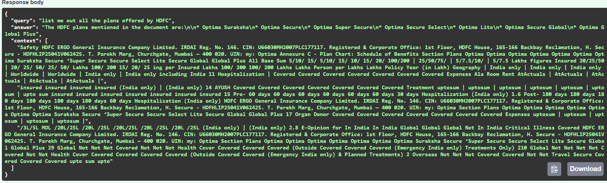
Once the query was received, FastAPI handled it and first forwarded it to ChromaDB, which was already loaded with all the document embeddings.
Chroma performed a semantic search using the query embedding.
Instead of keyword matching, it used vector similarity to find the chunks of documents which were closest in meaning to the query.
In this case, Chroma retrieved multiple document chunks from HDFC-related documents which contained plan names and details.
These retrieved chunks form what we call the context.

Building a Simple Frontend UI to Interact with the Chatbot
After setting up the FastAPI backend and integrating ChromaDB and Gemini for processing insurance document queries, the next step was to create a simple user interface.
The goal here was to allow users to easily:
- Upload their own insurance policies
- Ask health insurance related questions in natural language
- Get answers that combine their document information and general insurance knowledge
For this purpose, I created a basic but functional web application using Streamlit, a Python library perfect for quickly building data apps and chatbots.
Uploading Insurance Policy Documents
- The user can upload PDF or TXT files directly from the UI.
- Once uploaded, the app reads and extracts the text from the PDF using PyPDF2.
- It tries to detect basic policy details like:
  - Policy Number
  - Plan Name
  - Sum Insured
This is done using simple text search patterns.
- The extracted policy details and full document text are saved into the app’s session state.
This allows them to be used later when generating answers.
User Asking a Question (Chat)
- The user can enter a question in the text box.
- Once they submit the question → the app starts processing:
a) Retrieve additional knowledge from ChromaDB:
- The app sends the query to ChromaDB (PersistentClient) locally.
- It fetches the top 3 most similar document chunks from the general insurance database.
- This acts as the general insurance knowledge context.
b) Prepare the full context:
The app then combines 3 key sources:
- Uploaded policy details (Policy Number, Plan, Sum Insured)
- Uploaded document text content (PDF content)
- ChromaDB fetched general insurance chunks
This creates a rich context, containing:
Everything the user uploaded + Everything the system knows about general health insurance.
c) Build the final prompt for FastAPI
- A well-structured prompt is prepared which includes:
  - User’s policy details
  - General insurance knowledge
  - User’s question
This prompt is sent to FastAPI’s /ask endpoint using a simple HTTP POST request.

FastAPI + Gemini Generate the Answer
- FastAPI receives the prompt and passes it to Gemini LLM.
- Gemini reads the full context and generates a natural language answer.
- FastAPI returns this answer to Streamlit.

Display the Answer in Chatbot
- The Streamlit app receives the answer and displays it just like a chatbot.
- The conversation (user’s question + bot’s answer) is saved in session and shown as chat history.
This creates a smooth conversational experience for the user, just like asking questions to a real insurance agent.

